MySQL and WordPress Security Assessment
  - Service Validation, Credential Resilience, Database Impact, and Recovery Controls
ETHICAL HACKING | CONTROLLED LAB | EVIDENCE BASED

An authorized database-security lab tracing an exposed MySQL service from version detection through credential-resilience testing, database review, and controlled WordPress administrative-impact validation.
Authorization and safety boundary: This report documents an instructor-provided, isolated training exercise. No real users, public targets, production systems, or real credentials were used. Commands are presented with placeholders for portfolio safety. Original screenshots are retained as execution evidence and may show transient private lab addresses.
ASSESSMENT TYPE | Authorized training-lab exercise
OBJECTIVE | Demonstrate how weak database authentication can become application-level administrative compromise in a closed training environment.
ENVIRONMENT | Instructor-provided Kali Linux and intentionally vulnerable MySQL/WordPress target on an isolated RFC1918 network.
EVIDENCE | 11 original screenshots retained unchanged and presented in execution order.

Professional Skills Demonstrated
- MySQL service enumeration
- Exploit research
- Credential-resilience testing
- Database impact analysis
- WordPress security validation
- Remediation planning

Assessment Workflow and Evidence

1. Identify the MySQL Exposure
Objective: Confirm the database service and collect version evidence.
A targeted Nmap scan limited collection to TCP 3306. Version information informed follow-up research but was not treated as proof that a public exploit would apply.

Lab Commands
nmap -sV -sC -p3306 TARGET_IP -oA evidence/mysql-enumeration
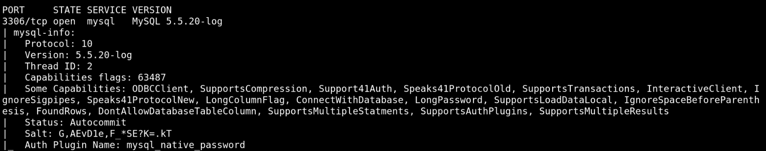
Evidence 01 - MySQL version and service discovery. Original lab screenshot retained unchanged.
Analyst observation: The database listener was reachable from the assessment host and exposed enough information to guide risk analysis.

2. Research Relevant Weaknesses
Objective: Compare the observed version with local exploit references.
Searchsploit was used as a research index. Results were reviewed for applicability rather than executed automatically.

Lab Commands
searchsploit MySQL 5.5
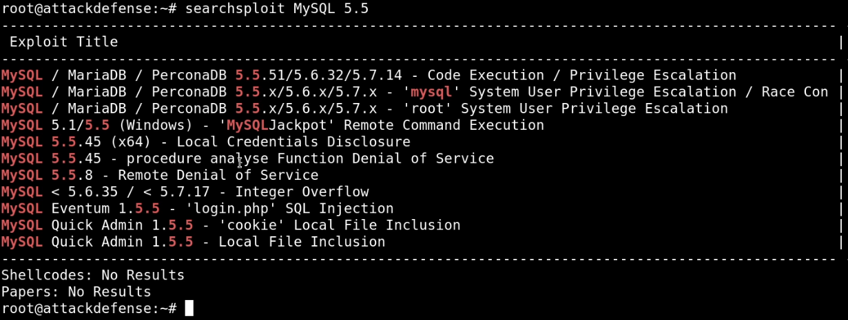
Evidence 02 - Local exploit-reference search for the observed MySQL family. Original lab screenshot retained unchanged.
Analyst observation: Exploit search results are hypotheses that require version, configuration, architecture, and safety validation.

3. Perform a Controlled Credential-Resilience Test
Objective: Determine whether the database accepts a weak or blank privileged credential.
A Metasploit scanner module was run only against the assigned target with the instructor-provided lab wordlist. The result showed a blank root password, a critical configuration failure.

Lab Commands
use auxiliary/scanner/mysql/mysql_login
set RHOSTS TARGET_IP
set PASS_FILE <LAB_WORDLIST>
run
Evidence 03 - Controlled MySQL login audit and blank-password result. Original lab screenshot retained unchanged.
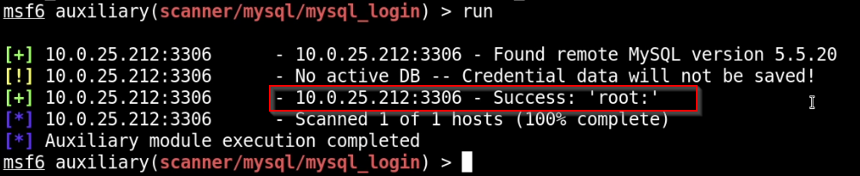
Evidence 04 - Controlled MySQL login audit and blank-password result. Original lab screenshot retained unchanged.
Analyst observation: A remotely reachable privileged account with a blank password permits unauthorized database administration without exploiting software memory corruption.

4. Confirm Database Impact
Objective: Authenticate with the lab-approved account and determine accessible application data.
The MySQL client confirmed administrative access. Database and table enumeration identified the WordPress data store and user table, establishing impact while keeping the assessment inside the assigned scope.

Lab Commands
mysql -u root -p -h TARGET_IP
SHOW DATABASES;
USE wordpress;
SHOW TABLES;
SELECT ID,user_login,user_email FROM wp_users;
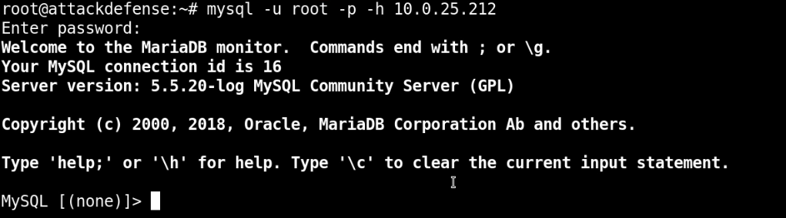
Evidence 05 - Database authentication, schema review, and WordPress user-table evidence. Original lab screenshot retained unchanged.
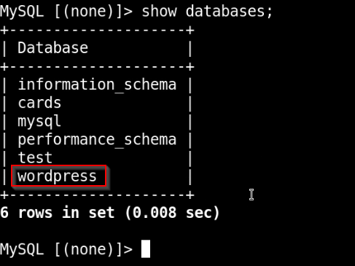
Evidence 06 - Database authentication, schema review, and WordPress user-table evidence. Original lab screenshot retained unchanged.
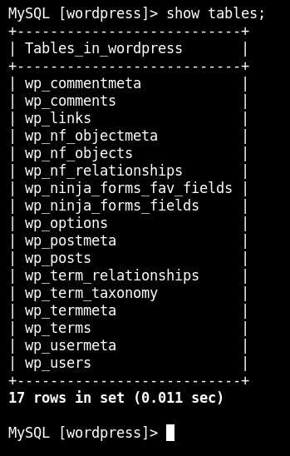
Evidence 07 - Database authentication, schema review, and WordPress user-table evidence. Original lab screenshot retained unchanged.
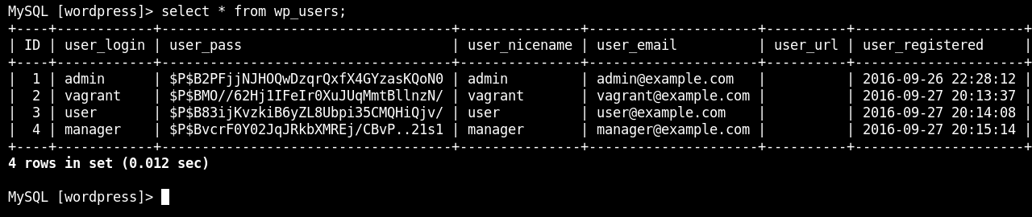
Evidence 08 - Database authentication, schema review, and WordPress user-table evidence. Original lab screenshot retained unchanged.
Analyst observation: Database-level compromise exposed application identity records and the password-hash field, creating a direct path to application takeover.

5. Validate Administrative Impact
Objective: Use a reversible lab-only password change to prove application impact.
The training workflow changed the disposable WordPress administrator password and confirmed access to the dashboard. A production assessment would require explicit approval, backup, logging, and immediate restoration.

Lab Commands
UPDATE wp_users SET user_pass = MD5('<LAB_TEST_PASSWORD>') WHERE user_login = 'admin';
# Verify access, document impact, then restore the approved state
Evidence 09 - Controlled WordPress password reset and dashboard access validation. Original lab screenshot retained unchanged.
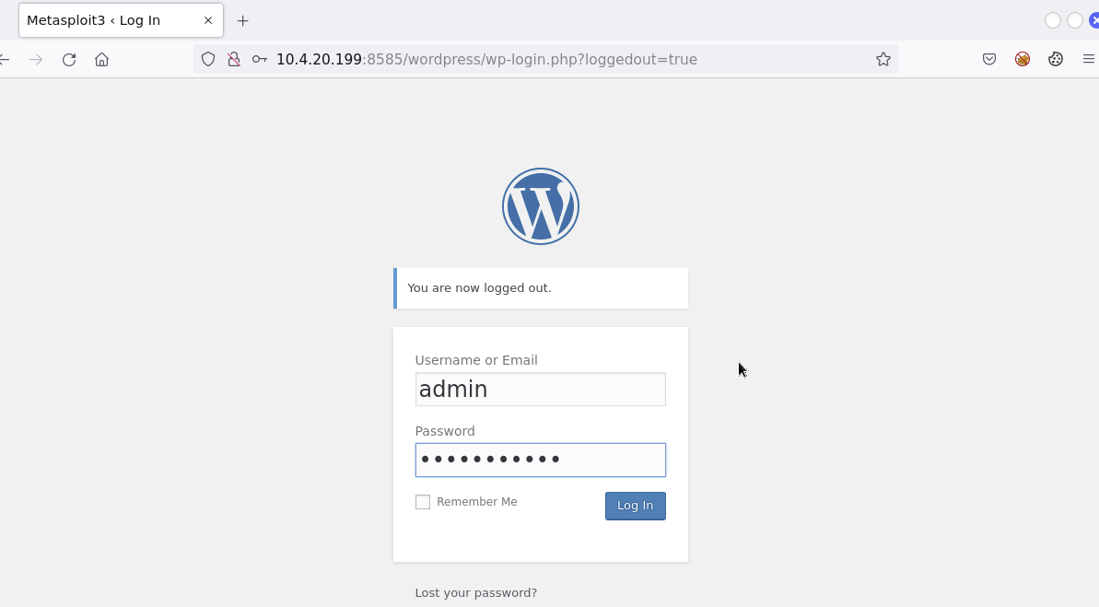
Evidence 10 - Controlled WordPress password reset and dashboard access validation. Original lab screenshot retained unchanged.
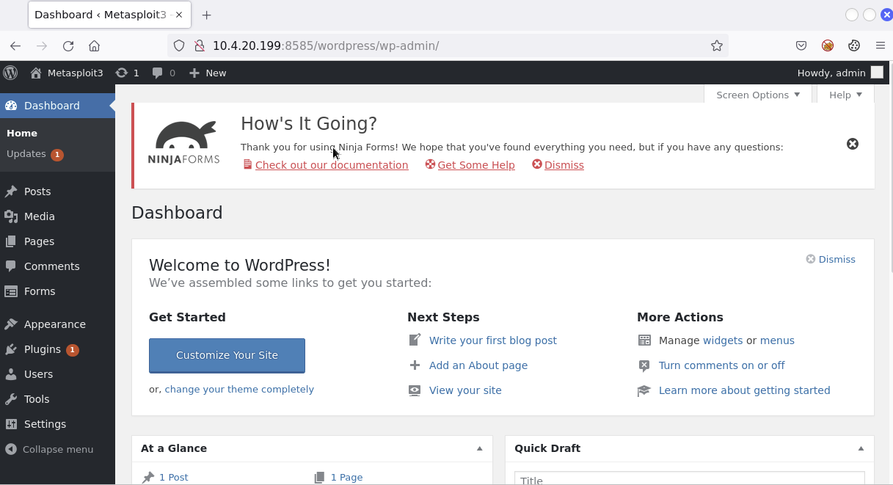
Evidence 11 - Controlled WordPress password reset and dashboard access validation. Original lab screenshot retained unchanged.
Analyst observation: The result connected database weakness to application control and demonstrated why impact validation must be scoped and reversible.

Findings and Risk
Severity | Finding | Evidence-based impact
CRITICAL | Blank privileged database password | The MySQL root account accepted remote authentication without a password in the intentionally vulnerable lab.
CRITICAL | Database compromise enabled application takeover | Write access to the WordPress user table allowed controlled modification of the administrator credential.
HIGH | Database service exposed to the assessment network | TCP 3306 was reachable from a system that did not require routine database administration.
HIGH | Legacy password handling | The lab used an outdated direct MD5 update workflow, illustrating weak and obsolete credential handling.

Defensive Recommendations
- Remove remote root login, assign a strong unique secret, and use separate least-privilege application and administration accounts.
- Restrict TCP 3306 to approved application or management hosts through host and network firewalls.
- Use current MySQL/MariaDB and WordPress releases with supported password hashing and secure authentication plugins.
- Rotate exposed database and WordPress credentials and invalidate active sessions after suspected compromise.
- Audit database grants, WordPress administrator accounts, plugin integrity, file changes, and authentication logs.
- Alert on remote privileged logins, repeated failures, changes to wp_users, and unexpected database clients.

Reflection and Next Step
The key lesson was that configuration weakness can be more damaging than a complex software exploit. A blank database password created a clean path from network exposure to application administration. Future work should emphasize recovery evidence, audit logging, and credential rotation.
Evidence note: The screenshots are original lab captures retained unchanged. The surrounding narrative has been rewritten for clarity, public safety, and recruiter review. Training-provider names, marks, and course materials remain the property of their respective owners; this portfolio is not an endorsement or affiliation claim.

