By students, for students: Development of custom virtual reality applications for teaching and learning in engineering courses

Daniel H. Cortes   
Department of Mechanical Engineering  
The Pennsylvania State University  
State College, USA  
dhc13@psu.edu  
  
Andrea Gregg   
Department of Mechanical Engineering  
The Pennsylvania State University  
State College, USA  
axg251@psu.edu  
  
Minkyung Lee  
Leonhard Center  
The Pennsylvania State University  
State College, USA  
mzl263@psu.edu  
  
  
Laura L. Pauley   
Department of Mechanical Engineering  
The Pennsylvania State University  
State College, USA  
llp1@psu.edu

Ibukun Osunbunmi  
Leonhard Center  
The Pennsylvania State University  
State College, USA  
iso5023@psu.edu

*Abstract*—Virtual reality (VR) holds significant promise for enhancing teaching and learning, particularly in disciplines like engineering. However, developing custom applications for engineering education is a significant hurdle for the widespread adoption of VR in class. This paper explores a novel approach to overcome those hurdles. The study presents a strategy where multidisciplinary teams of students in senior design projects design and develop VR applications for teaching Machine Design for the Mechanical Engineering program at Penn State University.

The methodology involves collaborative efforts between Mechanical Engineering and Computer Science students, guided by instructors and project sponsors (a director of learning experience design and an associate professor in charge of the Machine Design course). Through the utilization of Unity software and pedagogical guidance, teams embark on a design journey, integrating machine design instruction with learner experience design principles. Two iterations of a VR application for Machine Design course have been successfully developed, offering immersive experiences ranging from fixing a hospital bed mechanism to time-traveling assembly tasks.

Evaluations demonstrate the efficacy of VR-enhanced learning, showcasing improved student engagement and conceptual understanding of the course. The scalability and sustainability of this approach are highlighted, underscoring its potential for broader application across engineering disciplines. By fostering student-driven innovation and iterative improvement, this study lays a foundation for leveraging VR technology to enrich engineering education, paving the way for continuous advancement and enhancement in teaching and learning practices.

Keywords—Machine Design, VR, Custom Application, Student Led Design (key words)

# Introduction

Virtual reality (VR) provides a simulated world that can improve student learning in a course. A virtual reality learning environment has been used effectively in engineering education. Bairaktarova, et al. [1] provides a review of VR used in engineering education. There are three primary benefits of using VR in a course: improved communication, motivation, and cognition.

Communication of complex concepts can be improved using VR [2]. Engineering applications often involve three-dimensional moving objects that interact with each other. In some cases, such as for gear systems, the parts move fast and may be hidden in an enclosure. Virtual reality simulations can slow the motions and expose key components for observation by the student. The VR simulations can also simplify the configuration to show only the important aspects required to understand the concepts.

Virtual reality has been shown to motivate students to learn an engineering topic [3]. The novelty of using a virtual reality headset can attract students to learn a new and difficult subject. When the learning process is posed as a video game with goals (learning objectives), the competitive nature of the activity makes learning entertaining. Learning can be measured as progress or scores through the VR activity.

Furthermore, Virtual reality simulations have also been shown to improve cognition [4]. Sensory experiences (embodied cognition) can be used to organize concepts and ideas that the student is learning. VR allows simulations, say a gear system, to be presented along with equations and concepts. Presenting concepts using different modes at the same time (multi-modal learning) has been shown to improve student understanding [5]. Virtual reality has been used in mechanical engineering courses to demonstrate design concepts [6-9]. Applications included simple and planetary gear trains, cantilever beam, and spring/mass vibration systems. The use of VR was shown to be effective, but the development of learning modules was costly and time intensive.

The present paper describes an opportunity to reduce the instructor time required to develop VR simulations for an engineering course. In two different semesters, a senior capstone design team was given the task of developing VR instructional materials for the machine design course. The design team was sponsored and advised by the machine design course instructor and an instructional designer. This paper describes the process of defining the project, supervising the team, and evaluating the VR simulations that resulted. Also presented is the qualitative evaluation of the student learning experience of the machine design course using virtual reality. Dr. Ibukun Osunbunmi, from the Leonhard Center for the Enhancement of Engineering Education, led the assessment team that handled the evaluation of the impact of the developed virtual reality technology on the student's learning experiences in the Machine Element Design Course. While a mixed-method evaluation design was used for the assessment of the overall learning experience, we present the qualitative result in this work, as it provides a rich description of the students’ VR application user experience. In assessing the student learning experience, two evaluation questions were asked:

EQ1: What influence does the VR application have on the learning experience of students in the machine design course?

EQ2: How can the VR application be improved to enhance the learning experience of the students in the machine design course future offering?

# Methods

## Machine Design Course

Machine Design is a required course in mechanical engineering that focuses on the principles, methodologies, and practices involved in the design and analysis of machine components and systems. This course provides a comprehensive introduction to the principles and methodologies essential for designing efficient and reliable mechanical systems. Through a blend of theoretical concepts and practical applications, students gain a deep understanding of engineering design processes, stress analysis, and failure theories. The first portion of the course covers static and dynamic failure theories. Then, we learn how to design and select common machine elements like gears, bearings, shafts, and others. An important assignment of the course is a project that focuses on combining all these concepts for the design of a gear box. Therefore, this course provides students with the foundational knowledge and skills needed to conceptualize, plan, and create innovative machines that meet the desired performance requirements.

## Overall strategy for the development of the VR application

The strategy consisted of assembling multidisciplinary teams of students working on their senior design projects, tasking them with the development of the VR application as a product development. Capstone design in engineering majors at Penn State is managed at the college level. The engineering college, through a facility named the Learning Factory, collects projects (internal and external) for the teams, assembles the student teams with students from different majors according to the needs of the project, and assigns instructors to guide students in the design process. The development of the VR application was submitted to the Learning Factory as an internal project. The Learning Factory assigned the project to teams composed of students from Mechanical Engineering and Computer Science. The team was assigned an instructor for guidance in the product design methodology. Additionally, the team also worked with the ‘sponsors’ of the project, in this case, the sponsors were Dr. Cortes and Dr. Gregg. The sponsors provide guidance to the team in technical aspects for the product. In this particular case, Dr. Cortes, an instructor of the Machine Design course, provided guidance related to the technical needs for the VR application. On the other hand, Dr. Gregg, an instructional designer, provided guidance in pedagogical approaches through a Learner Experience Design approach (explained below). Students started by acquiring the necessary information and learning the tools needed for the development of the project. Particularly, learning how to program in Unity (the free software for VR development), learning about the specific needs of the VR app for the Machine Design course, and learning about instructional pedagogy. This is followed by a regular design process that includes brainstorming, evaluation and down selection of solutions, multiple rounds prototype design and testing, and communication.

## Technical details of the development of the VR application

The process of developing virtual reality (VR) applications using Blender and Unity combined the power of 3D modeling and animation with the robustness of game development engines. This approach enabled students to create an immersive VR experience that featured the use of machine elements. Specific elements of the VR development included:

* *Conceptualization and Storyboarding*: The development process begins with conceptualizing the VR experience and creating storyboards to outline the narrative flow, user interactions, and key features. This stage involved brainstorming ideas, defining objectives, and sketching out scenes and sequences.
* *3D Modeling in Blender*: Blender, a versatile 3D modeling and animation software, was utilized to create detailed machine elements that were featured in the story. Students created and animated assets in Blender, ensuring they were optimized for real-time rendering and interaction in Unity.
* *Asset Import and Scene Setup in Unity*: Once assets were created in Blender, they were exported and imported into Unity, a powerful game development engine. Students organized assets, created scenes, and set up lighting, cameras, and audio sources in Unity to build the virtual environment.
* *Interaction Design and User Interface*: Students designed user interactions and interfaces within Unity, defining how users navigate the VR environment, interact with objects, and access menus or controls.
* *Scripting and Programming*: Unity's scripting capabilities, using C# or JavaScript, were used to implement game logic, physics simulations, animations, and user interactions. Students wrote scripts to control object behaviors and handled input from VR controllers.
* *Optimization and Performance Tuning*: To ensure smooth performance and optimal frame rates in VR, students optimized assets, textures, and scripts.
* *Testing and Quality Assurance*: testing is conducted to validate the VR experience (see more details below). Students performed functional testing, usability testing, and bug fixing to ensure the application met quality standards and delivered a compelling user experience.
* *Deployment and Distribution*: Once the VR application was finalized and tested, students made sure that the application could be used in the headsets available in the VR facilities where the application was going to be used by Machine Design students.

## Learner Experience Design

A central part of the capstone design course is the development and user testing of prototypes. These are typically physical prototypes at various stages of development. However, this project focused on developing and evaluating a digital product. In the engineering education world, digital products can include things like websites for products, online learning materials, virtual reality (VR), and augmented reality (AR) applications. One of the biggest failures of interface design is the failure to sufficiently test with users, including those tests early enough in the process to iterate based on what is observed. Therefore, it is important to work with students to model and scaffold a learner experience testing the VR application they are designing and developing. The following are the steps used to guide the student team in the design of the application:

* *Prioritize student ownership*. Designing and developing the VR application requires significant effort and time. Therefore, it is important that students feel invested in the process. To promote this, students were in charge of the creative process of the design, recruiting users, identifying tasks for users to complete, and conducting debriefs with individual users.
* *Balance with scaffolding and structure*. There are a few cases, though, where it was crucial faculty advisors (project sponsor) take the lead. For instance, we required students to do user testing. Sponsors asked the teams to do user testing at least two times. Additionally, user experience mentality was emphasized throughout the process.
* *Create an atmosphere where it is safe to fail*. It was okay to laugh when something didn’t work. Even the most advanced developers produce things that don’t align with user needs. Be sure they understand it’s all part of the design process.
* *Keep track of your own observations throughout the user testing*. This enabled sponsors to ensure that nothing was missed or overlooked students described what they observed about the user experiences.
* *Call on the quiet students*. Some students naturally talk more than others and are more outspoken about what they observed. Quite students made excellent observations about where users struggled.
* *If possible, provide food*. Food was provided for the user testing sessions. This created a fun environment where not only the prototype was tested, but also celebrated.

## Data collection and analysis

Pre- and post-survey design was used as a data collection method for this study. A mixed questionnaire that included both Likert scale questions and open-ended questions for exploring students’ experience was administered online via the University Qualtrics website [10] (Johnson and Christensen (2019). Pre-surveys were administered before the concepts were taught in the classroom, and post-surveys were administered after students had experienced VR in the classroom. While the quantitative assessment of this study has been reported by Gregg et al. [11], this study presents the qualitative exploration of the student learning experience using VR applications in the machine design course during Fall 2023.

Thematic analysis of collected data, was the form of qualitative analysis conducted for this study [12]. Specifically, students' responses to two open-ended questions were thematically analyzed. The two questions are: 1) Please provide your overall reflections on this VR application as a learning experience, and 2) Do you have any other feedback on the VR application for this class? As a reminder, we are planning to improve on it and implement it in future offerings of machine design courses. In total, ninety-four students in their sophomore year who took the machine design course responded to at least one of these two open-ended questions investigated in this study. Seventy-seven of them were males, and seventeen of them were females. Students' responses were exported from the Qualtrics website in Comma-separated Values CSV format. Two coders were involved in this qualitative analysis. The coders familiarized themselves with the data by reading through the student's responses repeatedly while taking memos. The two coders via collaborative effort, identified, refined, and finalized the themes. One of the coders is a trained graduate research assistant in qualitative research, and the other coder is a faculty with expertise in engineering education research and assessment.

# Results

## VR Applications

Two teams have successfully participated in this process. The first team developed an application where the main objective was to fix the raising mechanism of a hospital bed. Prior to fixing the bed, the player had to complete several tasks including sorting of machine elements, calculating speed ratios of gears, and assembling a gear box. The second team tested the already existing application from the first team and decided which elements to keep and which elements to redesign. Instructional activities like sorting and assembling of machine mechanisms were kept from the first version of the application.

However, the plot of the game was completely redesigned. For the second version of the application, the player had to time travel to three different times (past, present, future). The past scenario took place in Davinci’s workshop. Where players had to build the mechanism of an antique flying machine. The present scenario was a movie set where students had to assemble the mechanism to move a camera. The future scenario was a space station where students had to fix the hinge of an airlock door. In each of these times the player had to perform different assembling activities with different machine elements. Theory about the machine elements was available to the player through a magic book that was available throughout the time travel

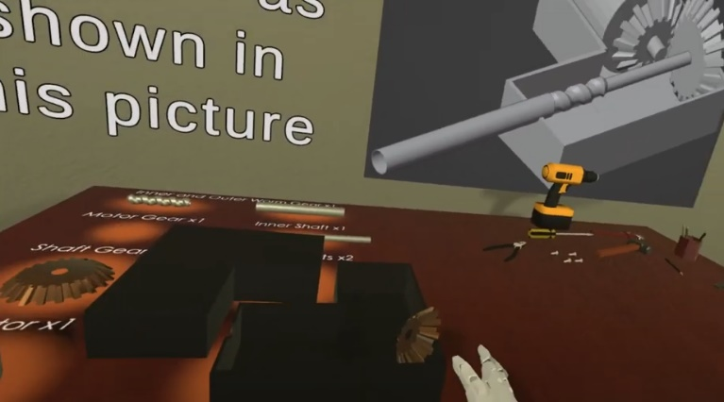

Figure 1. One of the main tasks of the VR application was the assembly of gear box.

a)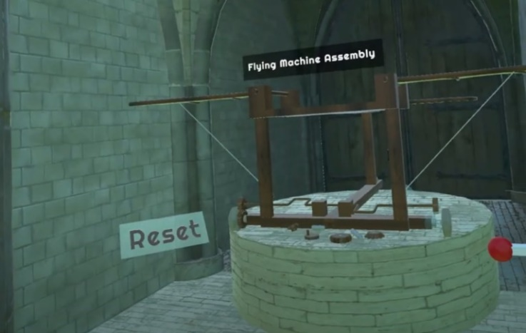

b)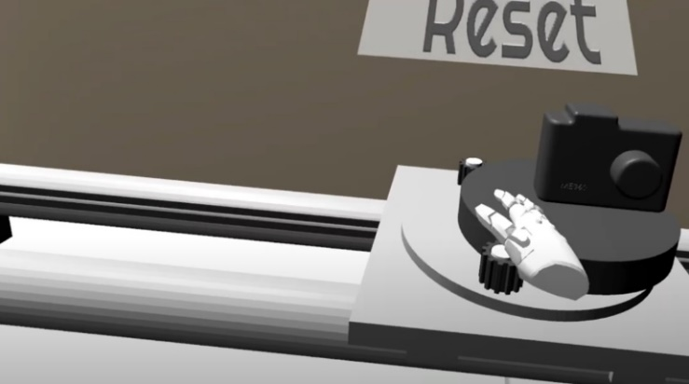

Figure 2. One innovative feature of the 2nd version of the VR application was the time travel. Shown in here, there are screenshots of the past (a, Davinci’s flying machine), present (b, camera motion mechanism) and future (c, airlock of a spaceship) scenarios.

Mechanical engineering students and computer science students collaborated effectively by forming multidisciplinary teams, leveraging their complementary skill sets, and defining clear project roles and tasks. They jointly brainstormed ideas, design solutions, and prototyped VR applications, with mechanical engineering students focusing on physical components and systems while computer science students develop virtual environments and interactive features using Unity. Adopting an iterative development process, they nd @integrated mechanical and computational elements seamlessly, conducting rigorous testing and validation to ensure functionality and performance. Throughout the process, they documented their collaborative efforts, presented their findings, and iterated based on feedback, ultimately creating immersive VR experiences.

## ASSESSMENT OF VR APPLICATION ON STUDENTS' LEARNING EXPERIENCE

### Understanding students' learning experiences with VR in a Mechanical engineering course

To understand students' learning experiences with VR, a few open-ended questions were particularly investigated. The study found several aspects of what students appreciated and the challenges they had while learning with VR. About 73 percent of responses from students were positive regarding their learning with VR and the potential future usage of VR in other classes.

* *New and fun experience.* Their primary response included the new and fun experience and the learning value provided by the visualization of learning content. Students found it to be a unique and refreshing change from traditional lectures. They expressed enthusiasm for learning with new technology, particularly those who had little to no prior VR experience. The application sparked a new interest in VR as an educational tool. One student mentioned that the application "exceeded all of my expectations and would be excited to do something similar in the future." Another reflected, "VR application was a new, unique, and overall, very fun learning experience," while a third added, "It was pretty fun, especially since I don't have any VR equipment of my own."
* *Increased Engagement via Experiential Learning*. Students appreciated the interactive and hands-on approach to learning they experienced while using the VR application. The experiential learning provided via VR application was seen as a valuable experience in their formation as mechanical engineers. One student noted, “The VR applications are very engaging and allow for a better understanding.” Another student related, “I thought it was a great learning experience and was way more effective than just reading or listening to a lecture.” A similar comment was made by another student, “It is nice to do something besides sitting in a lecture.”
* *Visual support for conceptual understanding*. The VR application enabled students to visualize machine components and concepts that are challenging to grasp through lectures alone. Visual learners particularly found it beneficial, as interacting with the parts in a virtual space provided a clearer understanding of their functions. One student stated, "Helped me learn a lot. As a visual learner, it helped me see exactly how each part worked." Another noted, "Interesting experience to use VR to learn about these machine components," while a third emphasized, "A lot of potential in this subject for using VR as a learning tool." Additionally, a student highlighted that it is "a good way to showcase different machine elements."
* *Potentials of the VR application.* Students recognized the potentials of the VR as a valuable educational tool for their future classes. Several students expressed a desire to see similar VR applications in other courses. One student stated, "Overall, I think more classes should incorporate interactive learning like this." Another added, "I loved it and would 100% do it again."

Despite the positive aspects, students faced several technical challenges that impacted their learning experience. Bugs and glitches were common issues, with students reporting problems such as parts getting stuck or issues with the game's mechanics. One student specifically mentioned, "The biggest issue I see with the game right now is that there are some bugs that can be annoying to work with." Others suggested improvements in controls and navigation to make the experience more intuitive and user-friendly.

### Improvement Suggestions for the VR Application

The student responses to the VR application for the mechanical engineering course revealed several common themes, such as technical and design improvement, highlighting key areas for improvement and potential enhancements.

* *Technical and VR design improvements*. Students highlighted several technical and design areas that required refinement. Many emphasized the need to improve the movement system, making it smoother and more intuitive for beginners. One student stated, "The only big thing I would change would be the movement system. Making it smoother would be more intuitive for people who have never used VR before." Another student similarly recommended, "An easy way to physically move around the game so it feels more natural."
* *The refinement of item interaction was also a common suggestion.* One student emphasized the need for teleporting and improved item interaction mechanics, stating, "Allow teleporting and picking up items from both hands and have hint options for test questions and gearbox assembly." Additionally, another participant noted, "It would be helpful if pieces snapped into place easier." Furthermore, the thematic design of the application could be improved considering the following suggestions, "The setting of the whole game could be better. It looked like a rundown school. It would be cool to make the map themed to a steampunk city or something".
* *Content and learning design modification*. Students recommended a range of enhancements to improve the interactivity and depth of the VR application. Some proposed incorporating quizzes and expanding game features to reinforce learning, stating, "I would just add more to the game. Maybe even do questions after to really know if you learned something". Another student similarly suggested, "Maybe a comprehensive quiz afterward can improve content retention." Additionally, participants believed the application could be improved by relating topics to real-world applications. For instance, one student specifically noted, "For the VR application, try to relate some topics to real-world applications, for example, gearbox for a car, rolling bearing, and a shaft for aviation cargo, etc." Moreover, the idea of creating an immersive, cinematic experience to illustrate mechanical dynamics and component interactions was proposed by a student: "Something cool would be maybe an immersive, 'movie-like' experience that would run through the movement of the various components in a gearbox to show the stress points, what to look out for, why the selection of a certain gear, bearing, or shaft is wrong vs. a better option"

Integrating the VR application more effectively into the course structure was a prominent theme. Students expressed a desire for better alignment of the VR sessions with the course schedule and academic content. One student said, "I thought it was a good idea, and as a student, it was fun to do! I would have liked if the information were posted on Canvas, but overall, it was fun and a good way to learn!". Another emphasized the importance of utilizing class time, suggesting that the VR application "should be completed during class time."

Because of the unpleasant physical comfort suggestions about safety were also addressed. One student recommended, "I would have the students sit for 10 mins after taking the headset off because you are very disoriented after, and it can be dangerous to have to walk outside afterward". Another emphasized providing breaks for those who feel uncomfortable, stating, "Maybe giving breaks for people who feel uncomfortable or giving an estimated time for how long the activity will take rather than waiting to tell them how long it will take once they get there."

# Discussion

The approach presented in this study enabled our teams to create VR applications by overcoming limitations like the limited availability of expertise in game development at our institution and the cost of paying for external development. Capstone design teams blended mechanical engineering and computer science expertise, guided by instructors and sponsors, to create immersive experiences. Initial trials show promise, suggesting VR's potential for enhancing engineering education.

The fact that the two capstone design teams achieved notable success in the development of virtual reality (VR) applications suggests that the proposed approach is sustainable. These teams embraced a collaborative approach, leveraging their diverse skill sets and interdisciplinary expertise. The first team focused on addressing a practical problem by designing an application aimed at fixing the raising mechanism of a hospital bed. The first team found that Blender-Unity pipeline worked much better than SolidWorks-Unity. This finding saved substantial time and effort for the second team. Building upon this foundation, the second team innovatively redesigned the application, introducing a time-traveling narrative where players journeyed through different eras—past, present, and future—engaging in varied assembly tasks set in historical, contemporary, and futuristic environments. The second team not only saved time by avoiding pitfalls from the first team but also by heavily leveraging the use of the asset store. A substantial portion of the environment for the different eras was purchased from the asset store. This improvement in sequential courses has also been previously observed in VR development by students (). Takala et al., reported that the quality of the VR applications developed in later versions of their course was significantly better [13].

Our approach to VR development by students distinguishes itself from existing studies through its emphasis on collaborative innovation and interdisciplinary teamwork. Unlike traditional approaches, where VR applications are often developed by professionals or instructors, our strategy empowers students from mechanical engineering and computer science backgrounds to take the lead in designing and implementing custom VR experiences. By integrating pedagogical guidance with hands-on project-based learning, we enable students to use their creativity to develop VR applications for teaching in engineering. There are many studies reporting either teaching VR to undergraduate students or students using VR as part of their learning experience. For instance, Takala et al., [13] showed that students can create VR applications as part of a course focused on teaching VR. However, our approach is unique in that students develop applications for teaching and applications to be used in courses they have already taken. Students leverage the infrastructure and resources provided by the university's Learning Factory, facilitating seamless project management and mentorship. Through this student-driven approach, we not only overcome barriers to VR development in education but also foster a culture of innovation, collaboration, and lifelong learning.

Finally, the qualitative results presented in this study provide evidence that the VR application in the machine design improved student engagement, deeper conceptual understanding, and increased student exposure to interacting with VR technology. These findings align with previous studies on VR applications in STEM [14].

##### Acknowledgment

Funding from the Penn State Leonhard Center for Enhancement of Engineering Education is acknowledged. We also want to acknowledge Dr. Stephanie Cutler of the Leonhard Center, who provided support during the development of the assessment tool for this study.

##### References

1. Bairaktarova, D., Valentine, A., & Ghannam, R. (2023). The Use of Extended Reality (XR), Wearable, and Haptic Technologies for Learning Across Engineering Disciplines, In International Handbook of Engineering Education Research, Chapter 23. https://www.taylorfrancis.com/books/oa-edit/10.4324/9781003287483/international-handbook-engineering-education-research-aditya-johri
2. Radianti, J., Majchrzak, T., Fromm, J., & Wohlgenannt, I. (2020). A systematic review of immersive virtual reality applications for higher education: Design elements, lessons learned, and research agenda. *Computers and Education*, *147*, 103778. doi:10.1016/j.compedu.2019.103778.
3. Hamilton, D., McKechnie, J., Edgerton, E. *et al.* (2021). Immersive virtual reality as a pedagogical tool in education: a systematic literature review of quantitative learning outcomes and experimental design. *J. Comput. Educ.* **8**, 1–32. https://doi-org.ezaccess.libraries.psu.edu/10.1007/s40692-020-00169-2
4. Wilson, M. (2002). Six views of embodied cognition. *Psychonomic Bulletin & Review* **9**, 625–636. https://doi-org.ezaccess.libraries.psu.edu/10.3758/BF03196322
5. Moreno, R., & Mayer, R. (2007). Interactive multimodal learning environments. *Educational Psychology Review*, *19*(3), 309–326.
6. Potkonjak, V., Gardner, M., Callaghan, V., Mattila, P., Guetl, C., Petrovic, V. M., & Jovanovic, K. (2016, April). Virtual laboratories for education in science, technology, and engineering: A review. *Computers & Education*, *95*, 309–327. doi:10.1016/j.compedu.2016.02.002
7. Yousif, M. (2022). VR/AR environment for training students on engineering applications and concepts. *Artificial Intelligence & Robotics Development Journal*, 173–186.
8. Aziz, E.-S.S., Esche, S.K. and Chassapis, C. (2009), Content-rich interactive online laboratory systems. Comput. Appl. Eng. Educ., 17: 61-79. <https://doi.org/10.1002/cae.20210>
9. Aziz, E.-S. S., Chang, Y., Esche, S. K., & Chassapis, C. (2014). A multi-user virtual laboratory environment for gear train design. Computers Applications in Engineering Education (John Wiley & Sons), 22(4), 788e80
10. Johnson, R. B., & Christensen, L. (2019). *Educational research: Quantitative, qualitative, and mixed approaches*. Sage publications.
11. Gregg A,, Cortes D. H., Osunbunmi I. S., Pauley L. L., Lee M., (2024, June) Designing and Evaluating Virtual Reality Applications for a Machine Design Course. In *2024 ASEE Annual Conference & Exposition*. 2023. [Accepted].
12. Kiger, M. E., & Varpio, L. (2020). Thematic analysis of qualitative data: AMEE Guide No. 131. *Medical teacher*, 42(8), 846-854.
13. Takala, T. M., Malmi, L., Pugliese, R., & Takala, T. (2016). Empowering students to create better virtual reality applications: A longitudinal study of a VR capstone course. *Informatics in Education*, 15(2), 287-317.
14. Qorbani, H. S., Arya, A., Nowlan, N., & Abdinejad, M. (2021, November). ScienceVR: A virtual reality framework for STEM education, simulation and assessment. *In 2021 IEEE international conference on artificial intelligence and virtual reality (AIVR)* (pp. 267-275). IEEE.