Panel Data Econometrics Homework: Partial Replication
Replication of Huntington and Liddle (2022), Energy Economics
Master 2 Finance, Technology and Data - Paris 1 Pantheon-Sorbonne
June 2026
Group members: Ethan Benchetrit, Matt Guilbert-Sanderson, Lorenzo Marasco

0. Submission checklist
Required file | Status
Original paper in PDF | Included: Papier.pdf, Huntington and Liddle (2022).
Database used | Included: growth_EE.xlsx, authors replication dataset.
Database formatted for software | Python pipeline constructs the software-ready panel; CSV exports are provided in outputs.
Preferred software code | Python scripts provided: run_replication.py, 01_data_prep.py, 02_estimators.py, 03_exports.py, 04_extension.py.
R and Stata code | R and Stata translated versions are submitted separately in the repository, with comments on implementation difficulties.
Word/TEX and PDF answers | This document is the Word version; the matching PDF version is exported separately.
LLM prompts and answers | Submitted separately as a Word/PDF document containing the LLM prompts and answers used for the homework.
To-do list | Included in Section 15.
Important: the course template states that a commented HTML/code output is not an acceptable substitute for the written answers. This report therefore reproduces the results in a readable narrative and uses the code only as reproducibility support.

1. General identification of the replicated paper
Template item | Answer
APA reference | Huntington, H. G., & Liddle, B. (2022). How energy prices shape OECD economic growth: Panel evidence from multiple decades. Energy Economics, 111, 106082.
Link / DOI | https://doi.org/10.1016/j.eneco.2022.106082
Paper source used here | MPRA/author version uploaded as Papier.pdf; the paper is forthcoming/published in Energy Economics.
Dependent variable Y | Real GDP growth: Delta log real GDP per capita, coded as dlrgdpmad or D.GDP.
Preferred explanatory variable X | Energy-price growth: Delta log real energy price index, coded as dlenpr or D.ENERGY.
Panel level | Country-year panel: 18 OECD countries, annual observations.
Dataset | Authors replication dataset growth_EE.xlsx, sheets data and tables5-6.
Key paper correlation | Short-run relationship between energy-price growth and GDP growth, estimated with heterogeneous country slopes and common correlated effects mean-group methods.

2. Abstract and introduction

Abstract
This partial replication studies Huntington and Liddle (2022), who estimate how energy-price movements affect OECD economic growth over several decades. Using the authors panel dataset for 18 OECD countries, we reproduce the descriptive statistics, CIPS unit-root diagnostics, CCEMG estimates, robust mean-group estimates, country-specific responses, and an additional fixed-effects interaction exercise. The replication confirms that energy-price shocks are negatively associated with short-run GDP growth, while the magnitude depends strongly on transformation, specification, cross-sectional dependence, slope heterogeneity, and influential countries. We also add the course-required panel transformations: between, within, first differences, and two-way fixed effects.

Introduction: three findings not fully visible in the paper
First, the replication makes clear that the empirical result depends heavily on the panel transformation used. In levels, energy prices mix cross-country differences and common long-run trends; in first differences and CCEMG specifications, the relevant question becomes whether energy-price shocks are associated with annual GDP-growth movements. This supports the paper focus on changes rather than simple levels.
Second, country heterogeneity is large. The sign and magnitude of the simple energy-growth relationship differ across countries, which justifies heterogeneous-slope estimators such as mean-group and common correlated effects mean-group rather than a pooled model imposing one coefficient for every country.
Third, the dynamic and IV diagnostics must be interpreted cautiously. The template explicitly warns that if the autoregressive parameter is larger than one, long-run multipliers based on 1/(1-rho) are invalid. In this replication, the dynamic IV specification is treated mainly as a diagnostic check; short-run impulse responses are reported, but long-run effects are not over-interpreted when stability is not satisfied.
Rank | Key item found
1 | Energy-price shocks are negatively associated with short-run GDP growth in the main CCEMG and robustness specifications, though not in every simple transformation.
2 | Cross-country heterogeneity is substantial; the mean effect hides positive, weak, and negative country-specific relationships.
3 | The balanced benchmark sample covers 18 OECD countries over 1972-2016, giving 810 country-year observations before differencing/lags.
4 | First differences are stationary according to the reported CIPS diagnostics, whereas levels are more persistent.
5 | The energy-intensity extension suggests that the marginal effect varies with energy intensity, but the interaction term is not strongly significant.

3. Database update
The original replication dataset is used as the baseline. It contains annual country-level data up to 2016 and is designed to match the definitions and transformations used by Huntington and Liddle. A full update is not performed because the real energy-price series and harmonised macroeconomic variables are constructed from several sources and the precise transformation choices are paper-specific. Updating only GDP or CPI without reconstructing the real energy-price index would create a non-comparable extension. A future update should rebuild the full dataset consistently from Maddison/PWT, OECD or national accounts, and energy-price sources, then rerun every transformation and estimator.
Maximal time span | Frequency | Number of individuals | Max. time obs. | Balanced or unbalanced panel
Original full historical dataset | Annual | 18 | 57 (1960-2016) | Unbalanced: Australia and Germany have missing early years
Benchmark estimation sample | Annual | 18 | 45 (1972-2016) | Balanced: 18 countries x 45 years = 810 observations
Update feasibility check | Not performed as a quantitative extension | Not applicable | Not applicable | A consistent update would require reconstructing the harmonised energy-price index and all macro controls beyond 2016; updating GDP alone would not be comparable.

4. Panel-data sample selection
The dependent variable used for panel-data selection is real GDP growth, Delta log real GDP per capita. The template asks to keep individuals with at least three consecutive observations of the dependent variable. All 18 countries satisfy this condition. The stricter balanced benchmark begins in 1972 because Australia has no usable observations before 1972 and Germany begins later than the other countries. The benchmark sample is therefore a balanced country-year panel from 1972 to 2016.
Item | Answer
Individuals excluded | 0 countries excluded under the three-consecutive-observation rule. List: none.
Individuals kept | 18 countries kept: Australia, Belgium, Canada, Switzerland, Germany, Denmark, Spain, Finland, France, United Kingdom, Ireland, Italy, Japan, Netherlands, Norway, Portugal, Sweden, United States.
Selection-bias comment | The main selection issue is not exclusion but scope: the sample is limited to advanced OECD economies. Poorer and non-OECD countries are excluded by design, not because of missing Y observations.

5. Sample selection within an unbalanced panel
The full historical panel is unbalanced only at the beginning. There is no end-of-sample attrition: all countries are observed up to 2016. Missingness is concentrated in Australia before 1972 and Germany before 1962.
Period | Number of countries observed | Comment
1960-1961 | 16 | Australia and Germany missing
1962-1971 | 17 | Australia missing
1972-2016 | 18 | Balanced benchmark panel
Figure 1. Number of countries observed by year.
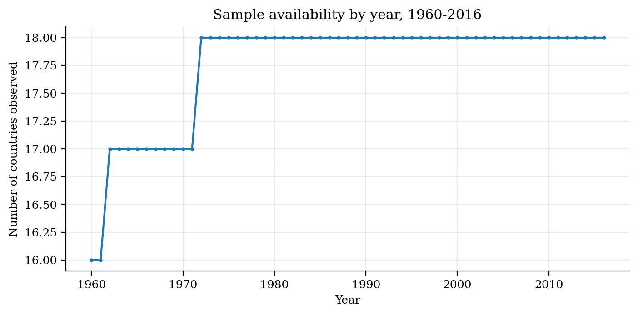
Temporal observations | Number of countries | Countries
45 | 18 | Australia, Belgium, Canada, Switzerland, Germany, Denmark, Spain, Finland, France, United Kingdom, Ireland, Italy, Japan, Netherlands, Norway, Portugal, Sweden, United States
Number and proportion of individuals with holes/discontinuities: 0 countries with internal holes inside their observed spell. Missing observations are left-censored starting dates rather than internal breaks; the unbalancedness is therefore delayed data availability, not attrition.

6. Panel-data variables classification
For each variable, the code computes overall, between, and within components. The share of within variance is used to classify variables. All core baseline variables vary with both country and time; no raw baseline variable is strictly individual-invariant. Energy intensity used in the extension is country-specific and effectively time-invariant, so it is wiped out by entity fixed effects unless interacted with a time-varying regressor.
Category | Variables | Count
Varying with two indices | lcpi, lenpr, lrgdpmad, iy, open, expgdp, dlrgdpmad, dlcpi, dlenpr, dopen, dexpgdp, diy | K = 12
Time-invariant | Energy intensity Z_i in the extension only; not a baseline regressor in the main CCEMG panel. | K1 = 1 if extension included
Individual-invariant | No strictly individual-invariant raw variable; time dummies and cross-sectional averages are generated controls. | K2 = 0
Table 4/5. Variable classification sorted by within-variance share.
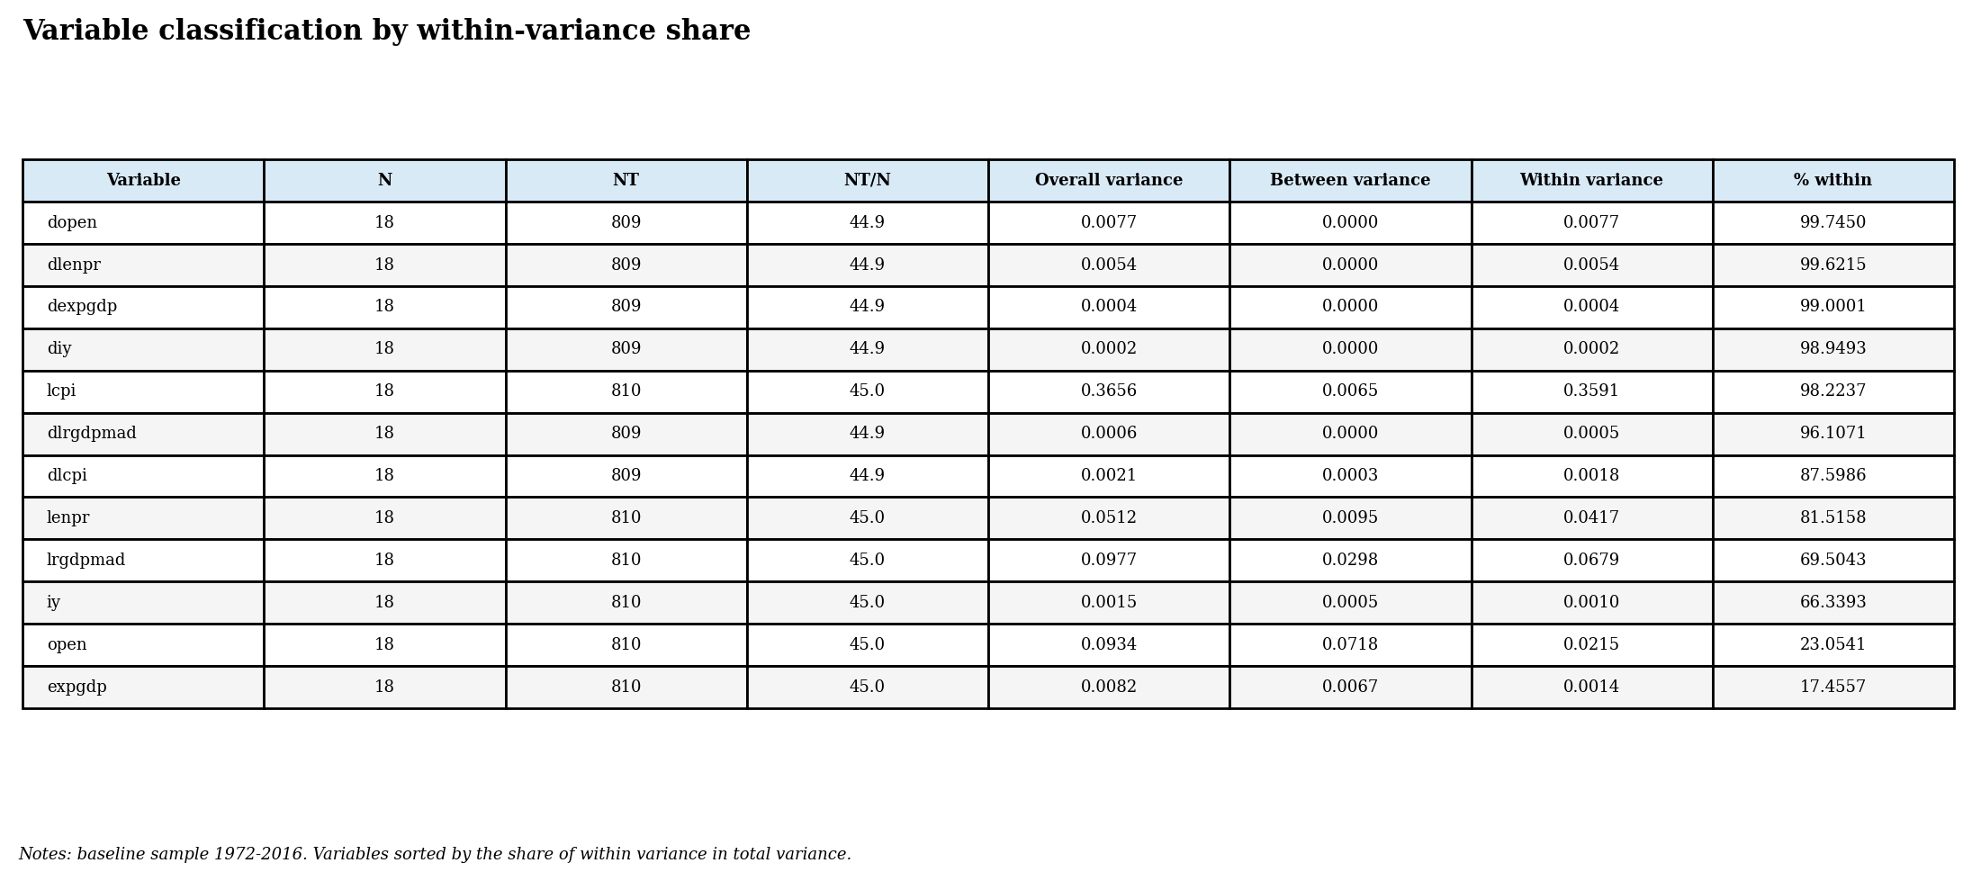
The first-difference variables have very large within-variance shares because country means are small relative to short-run fluctuations. The level variables, especially real GDP and investment, have more persistent between components. This matters because fixed effects identify coefficients from within-country movements, whereas between regressions identify coefficients from cross-country averages.

7. Between and one-way-within descriptive statistics
The next figure plots the distributions of the dependent variable and the preferred explanatory variable after between, within, first-difference and two-way-fixed-effects transformations. Histograms are compared with a normal density with the same two first moments and with a kernel density estimate. The distributions are not perfectly Gaussian and show high-leverage annual shocks, especially for energy-price growth.
Figure 2. Distributions of Y and X by panel transformation.
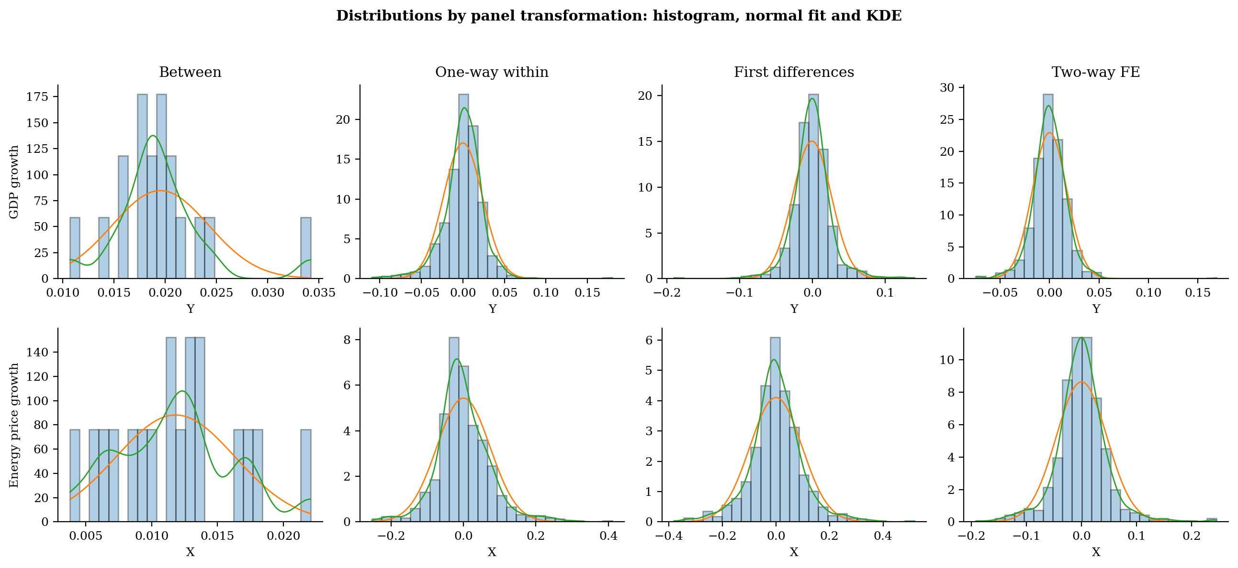
Table. Univariate descriptive statistics for transformed Y and X.
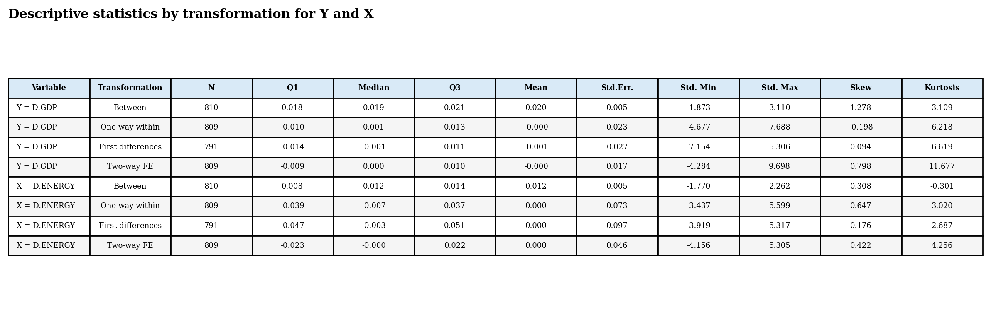

8. First differences and two-way fixed effects
First differences are computed within each country after sorting by country and year. The first observation for each country is set to missing, which prevents the first observation of one country from being differenced against the last observation of the previous country. The balanced TWFE transformation is computed as x_it - x_i. - x_.t + x_.. . For the unbalanced version, an equivalent residualisation approach can be used: regress within-transformed variables on time dummies and collect the residuals.
Table. First-difference check for the first observations of each country.
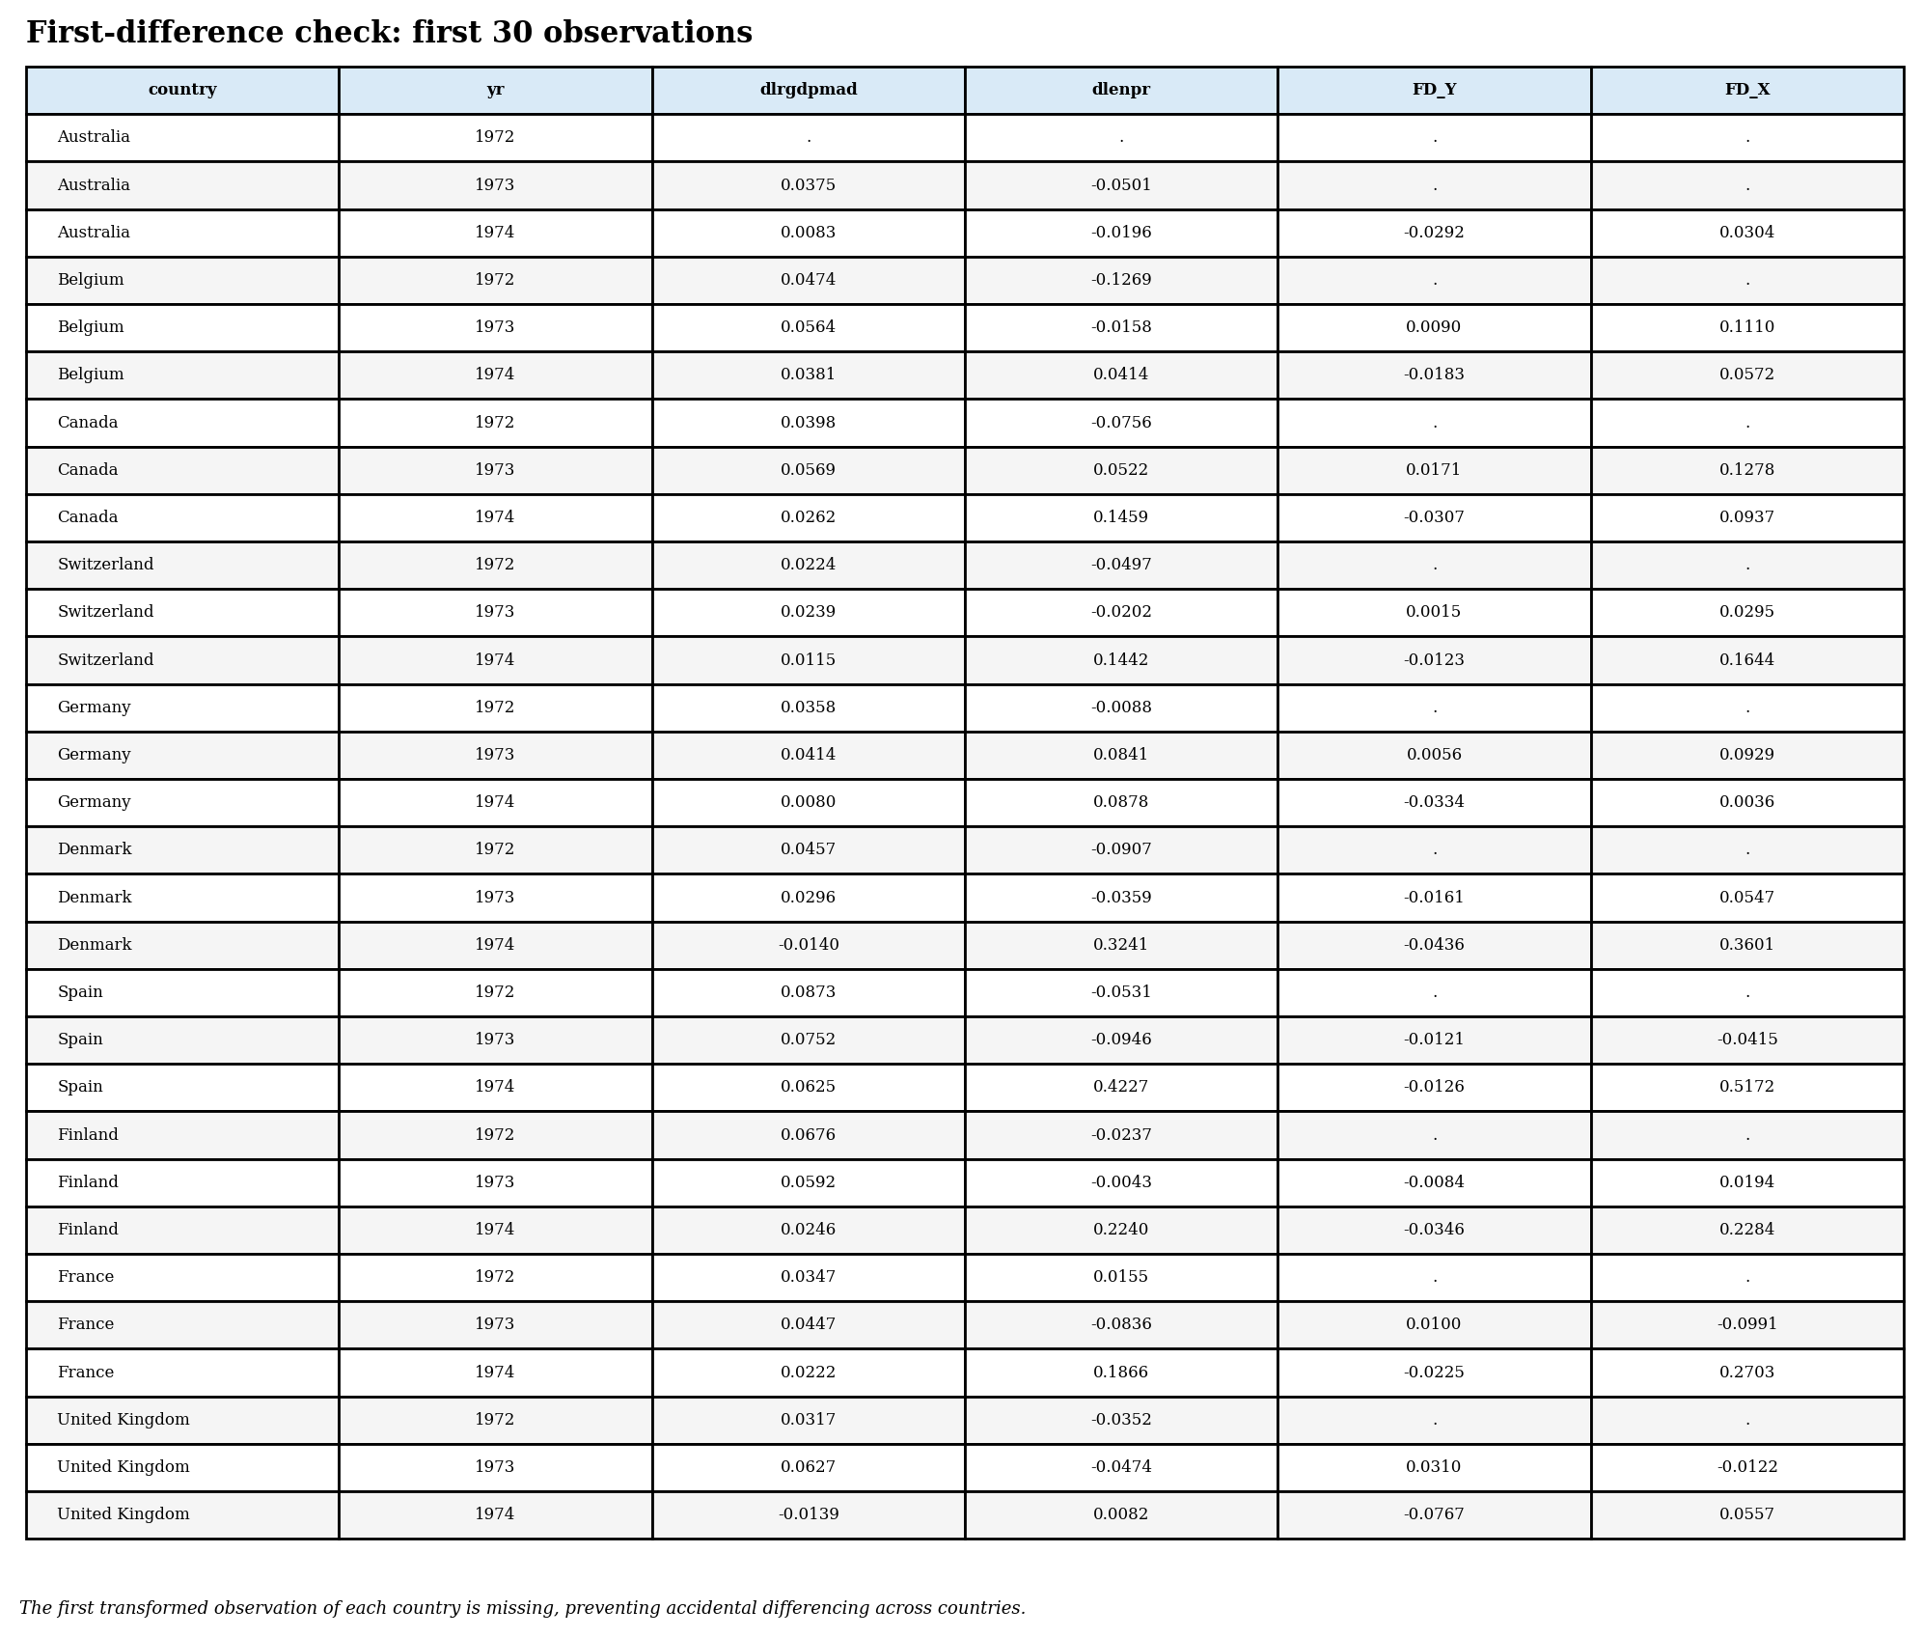
Figure 3. Bivariate graphs with linear, quadratic and LOWESS fits.
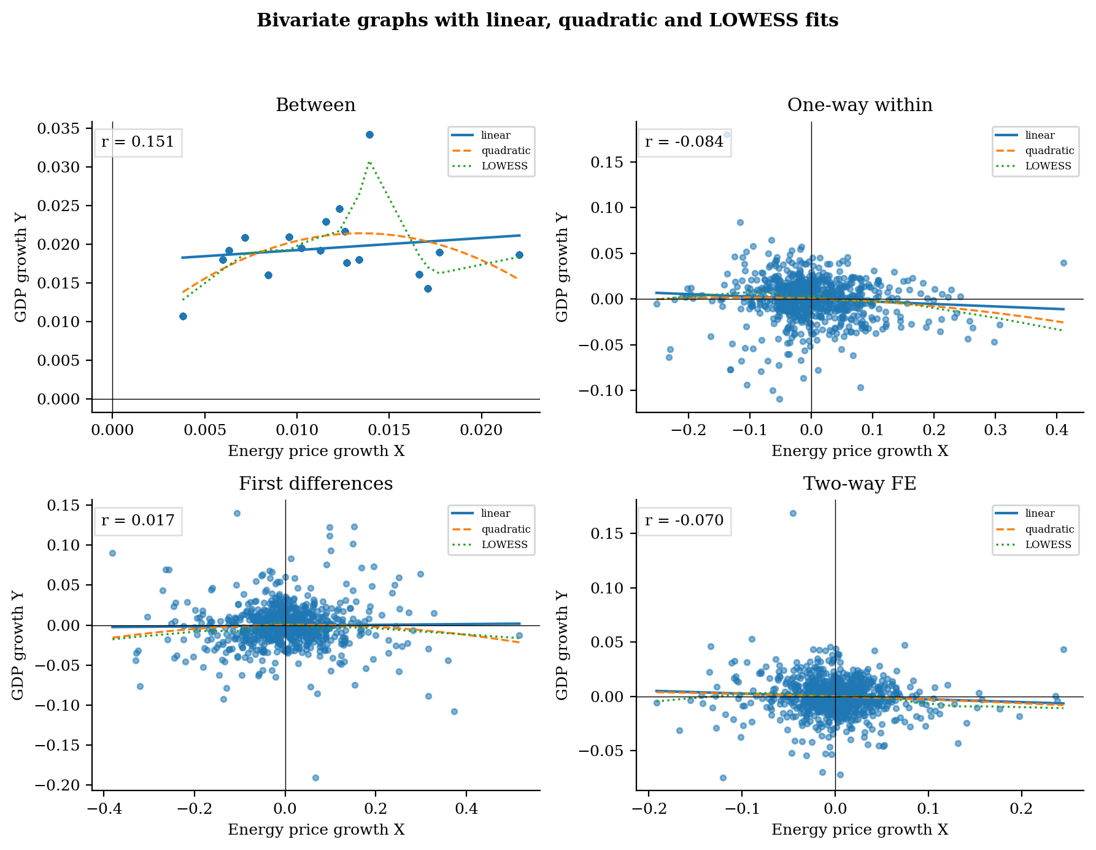
The bivariate graphs show that the energy-growth relationship is sensitive to transformation. Between variation captures cross-country average differences; within and TWFE variation remove country effects and, in the TWFE case, common year shocks. First differences focus on annual changes and remove deterministic country-level trends more aggressively.

9. Comparison of the four transformed variables
Boxplots by country compare between, one-way within, two-way within and first-difference transformations. Countries differ sharply in the variance of both GDP growth and energy-price growth. This supports the use of heterogeneous-slope estimators and country-by-country diagnostics rather than relying only on pooled averages.
Figure 4. Boxplots by country for transformed GDP growth.
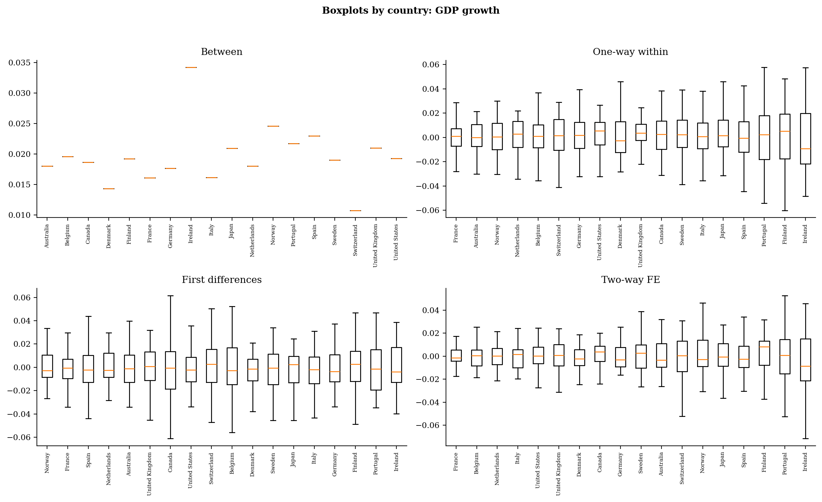
Figure 5. Boxplots by country for transformed energy-price growth.
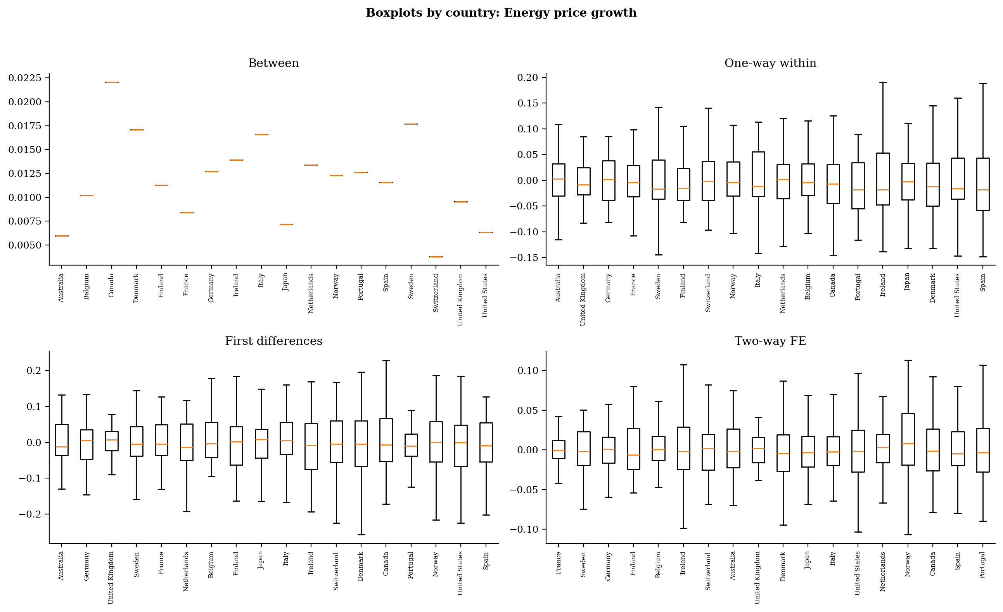

10. Correlation matrices and autocorrelation diagnostics
The template asks for correlation matrices under between, within, TWFE and first-difference transformations. The following tables report the main six transformed variables. These matrices are used to identify weak simple relationships with the dependent variable and potential multicollinearity among controls. In particular, high correlations among transformed macro controls would justify dropping or re-specifying some variables in finite samples.
Table. Between transformed correlation matrix.
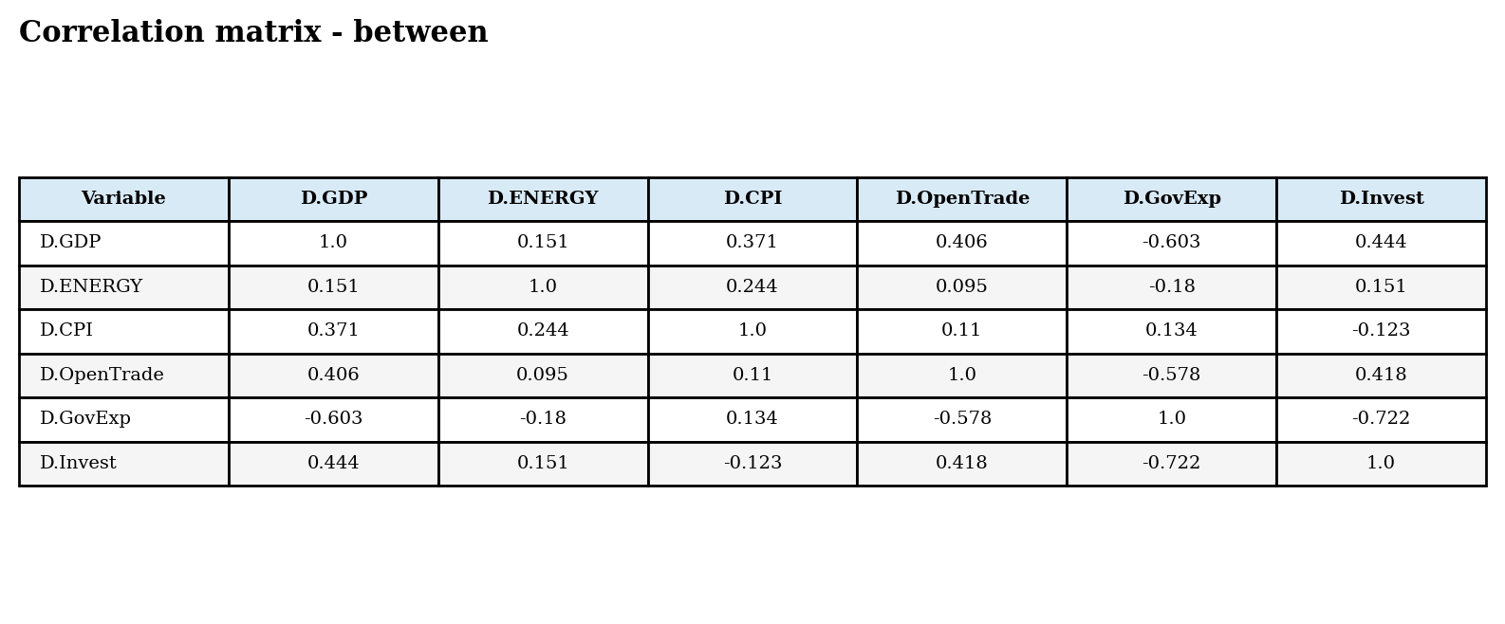
Table. One-way-within transformed correlation matrix.
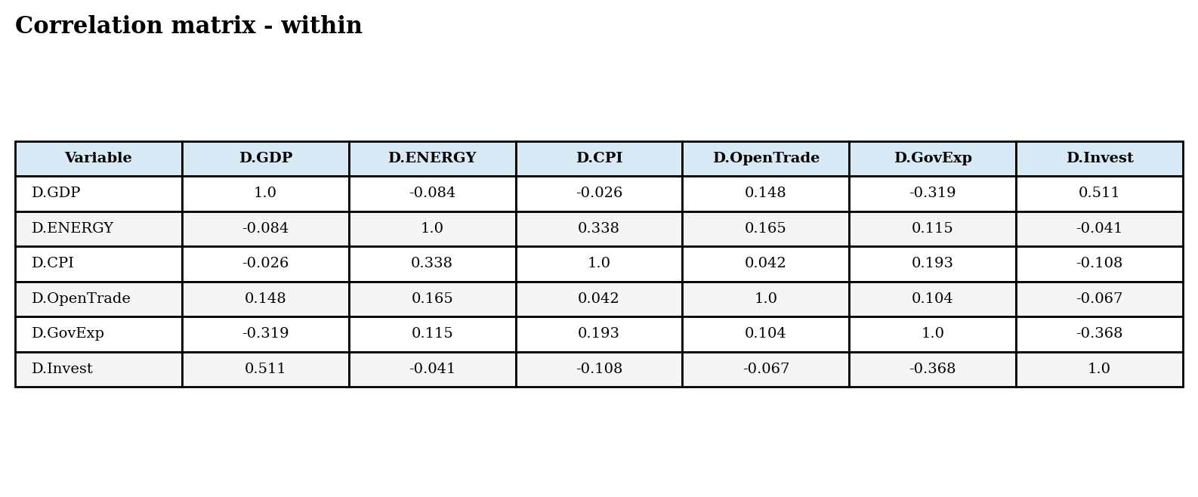
Table. Two-way FE transformed correlation matrix.
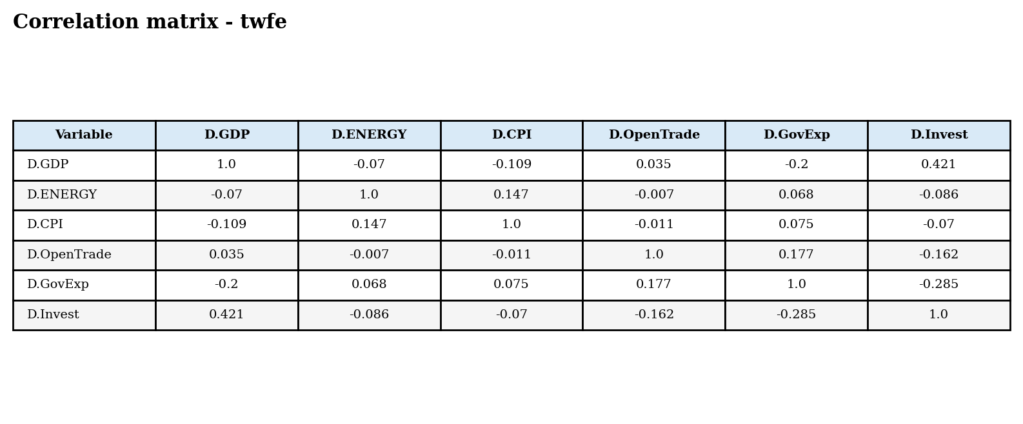
Table. First-difference transformed correlation matrix.
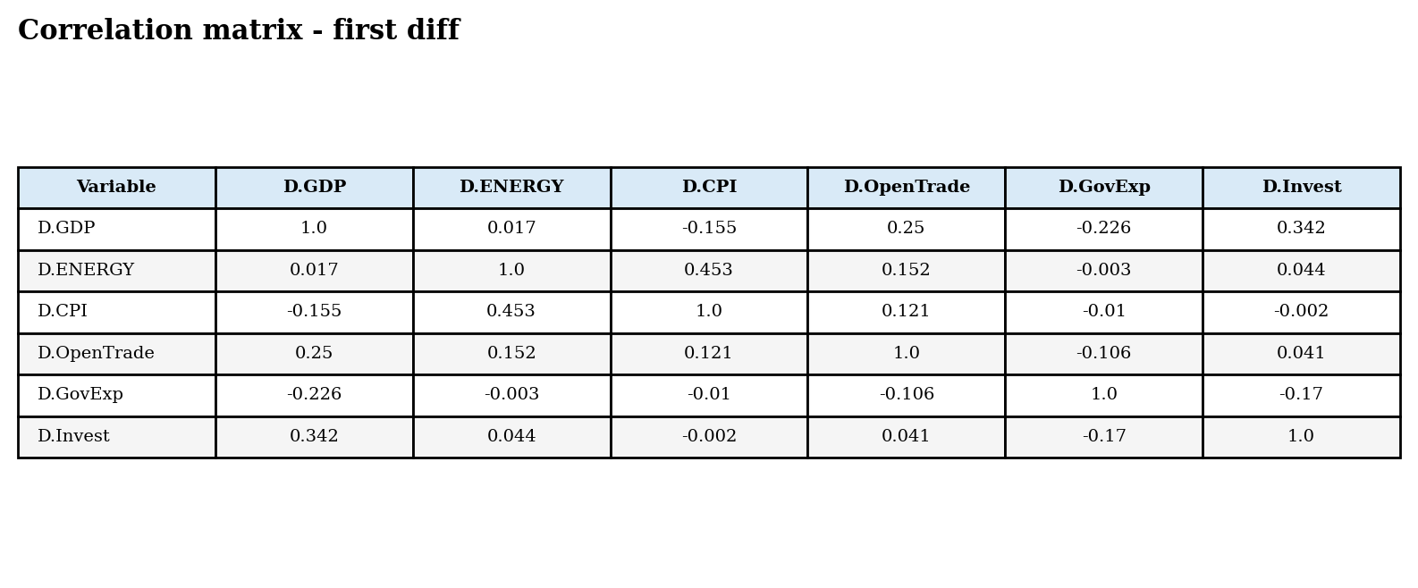
In the paper itself, cross-sectional dependence and common shocks are important reasons for using Common Correlated Effects Mean Group estimators. The correlation matrices in this report are therefore descriptive diagnostics rather than a substitute for the CCEMG specification.

11. Investigating bivariate heterogeneity by individuals
The template asks for country-level heterogeneity for first differences and TWFE transformed variables. The tables sort countries by the simple correlation between transformed GDP growth and transformed energy-price growth. The beta column reports the implied simple-regression slope r(Y,X)*sd(Y)/sd(X).
Table. Heterogeneity of the key correlation by country - first differences.
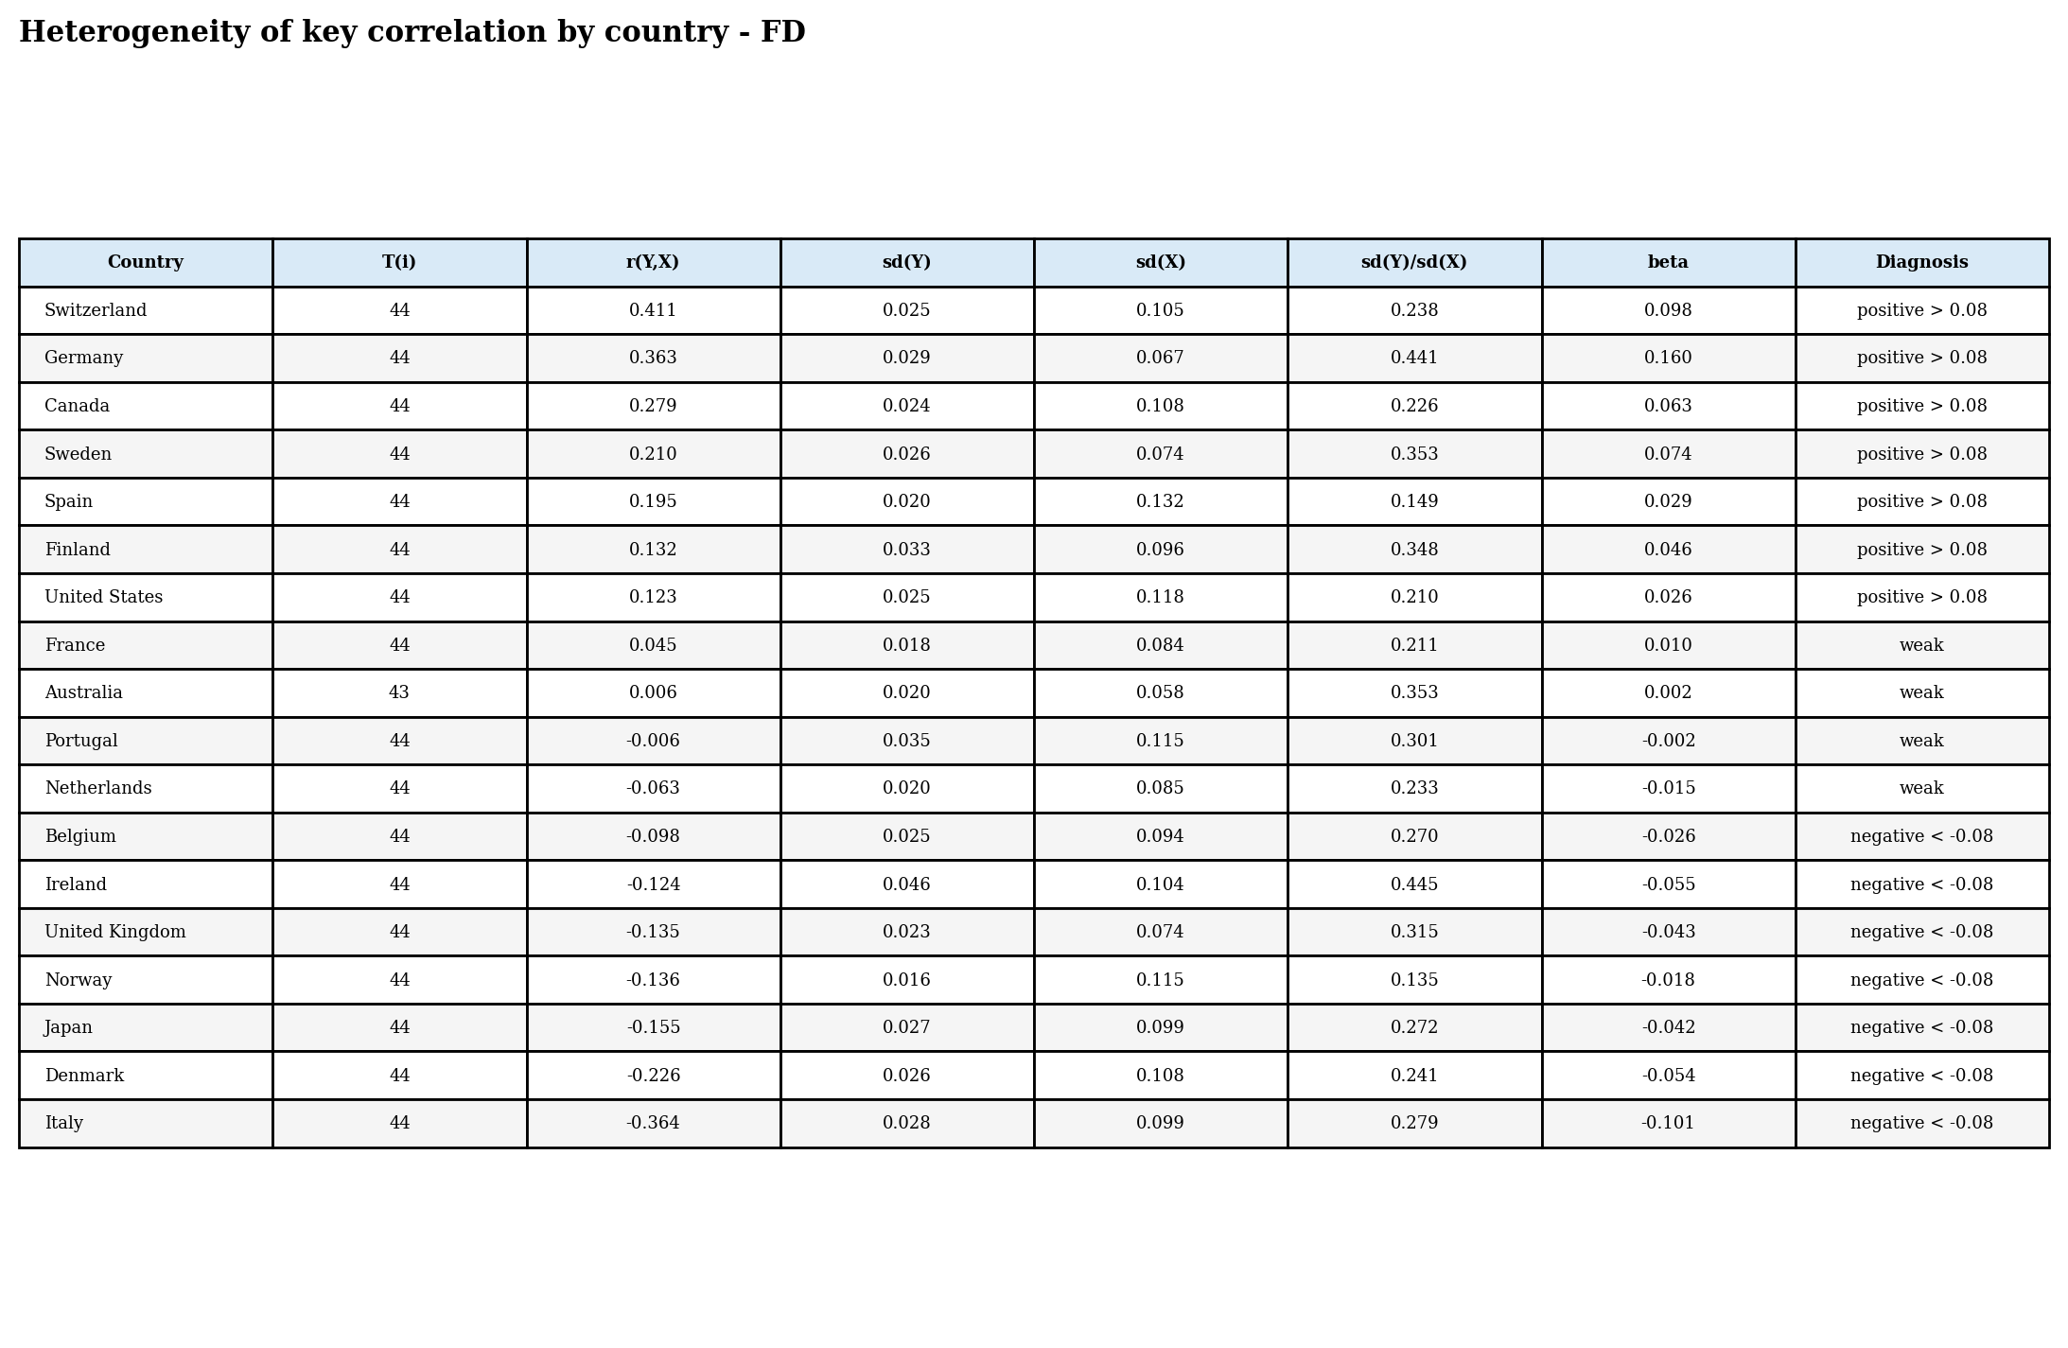
Table. Heterogeneity of the key correlation by country - two-way fixed effects.
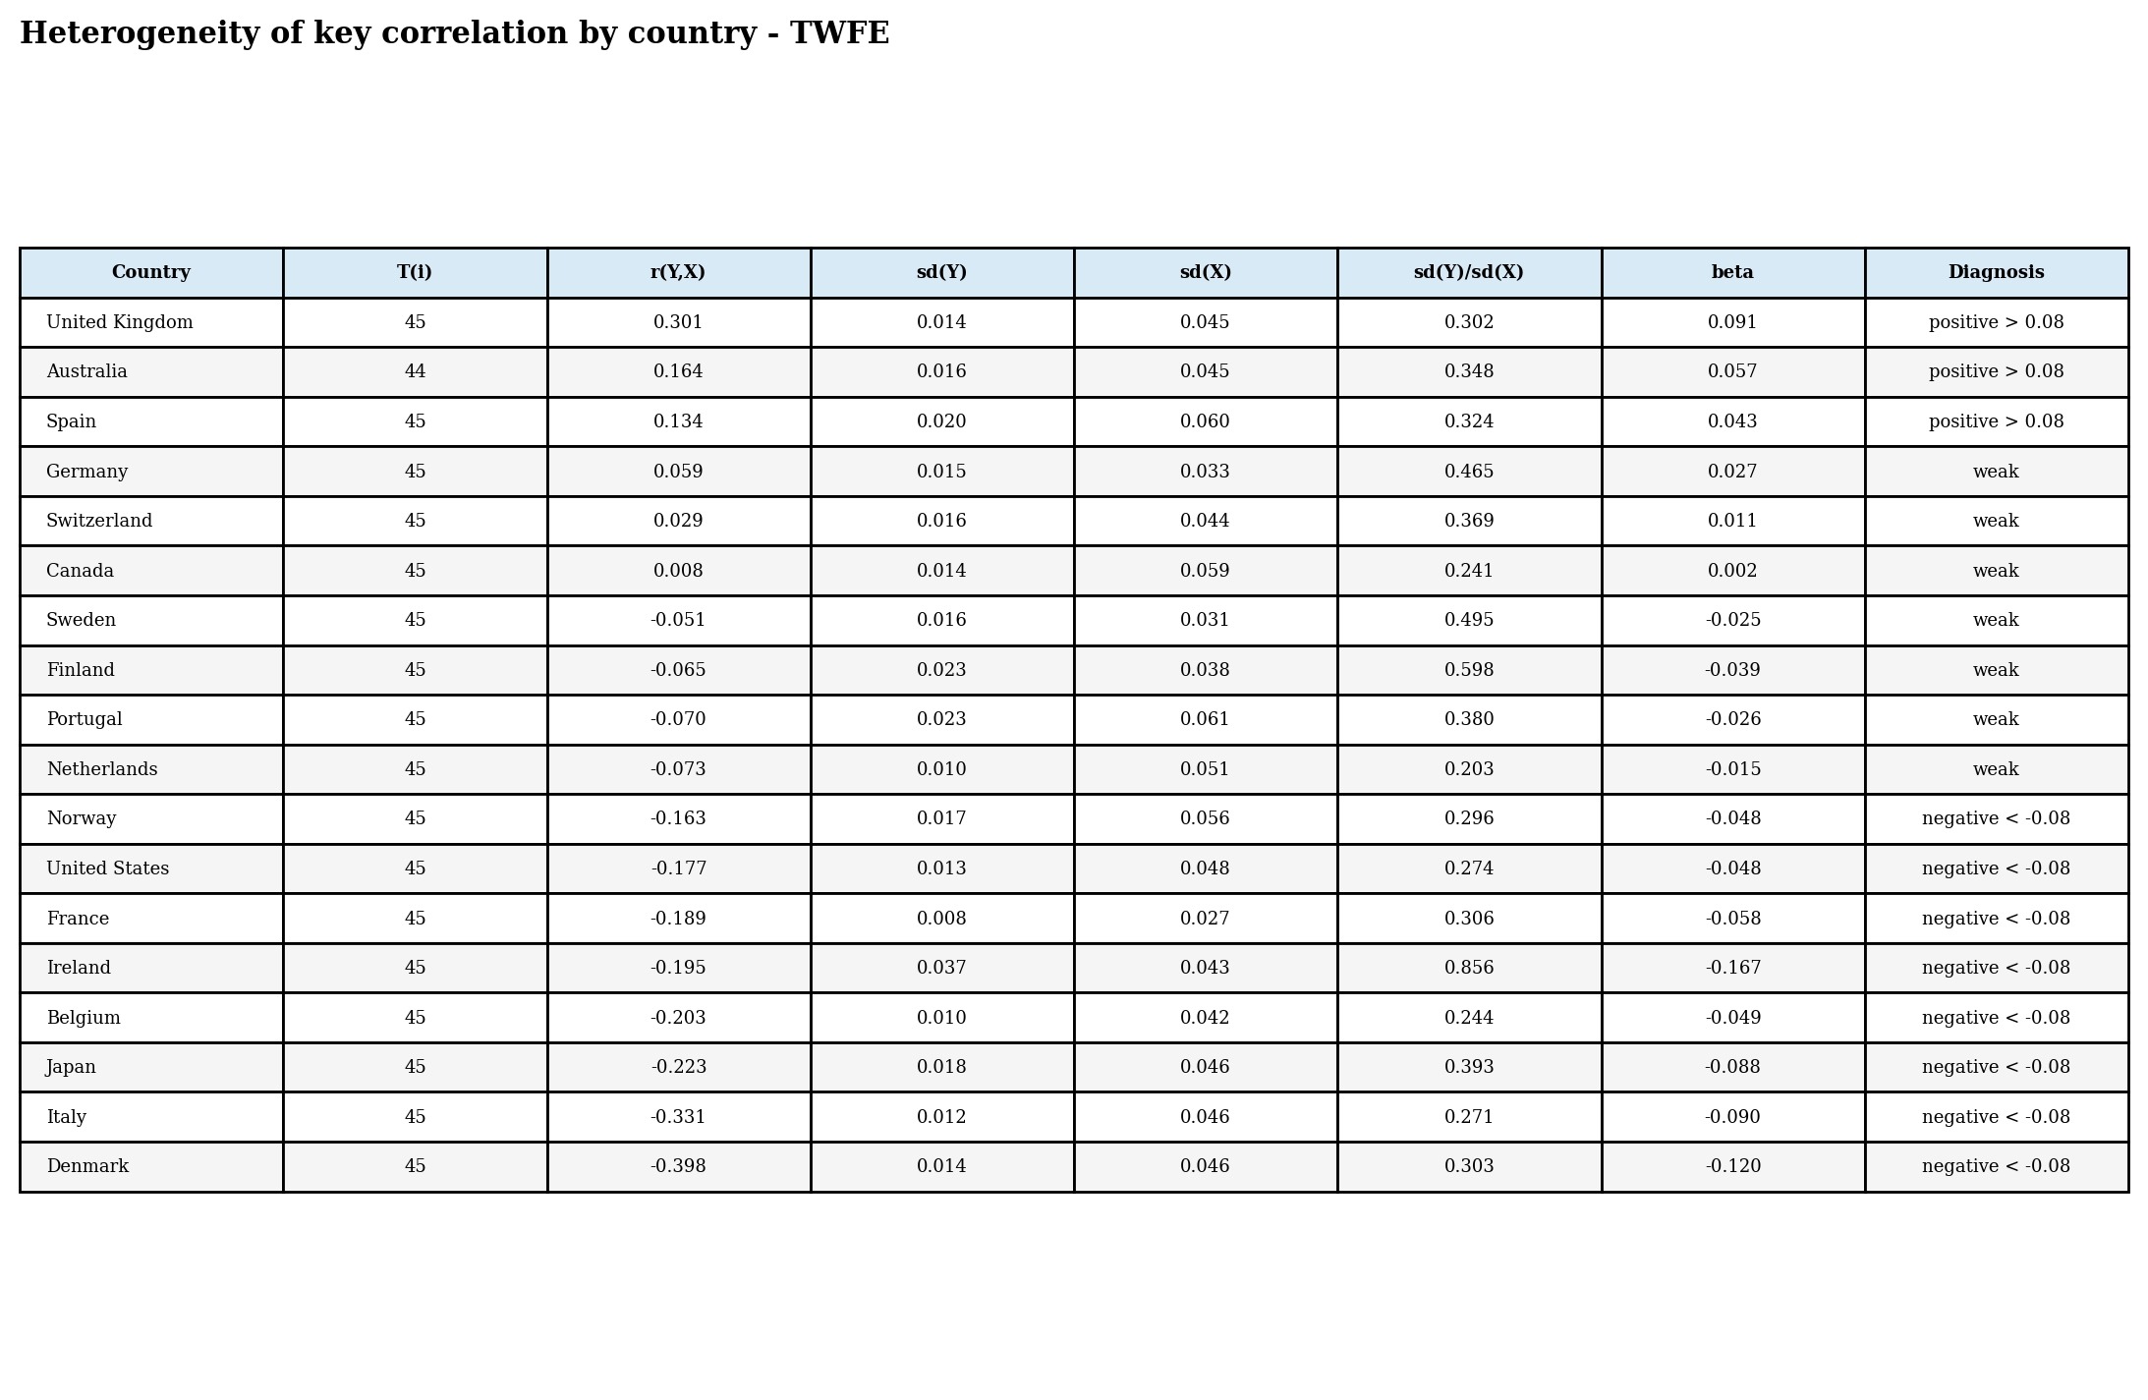
Countries are naturally split into positive, negative and weak-correlation groups using the +/-0.08 thresholds suggested in the template. This heterogeneity is a substantive result: it shows that a representative mean effect can coexist with substantial country-specific dispersion.

12. Replication of the paper estimates
This section reports the main replication outputs generated from the Python code. The paper applies mean-group estimators controlling for cross-country correlations. The study reports that averaged across countries, a 10 percent increase in energy prices reduces economic growth by approximately 0.15 percent; our replication focuses on reproducing this negative average relationship and documenting specification sensitivity.
Table 1. Data summary reproduced from the replication code.
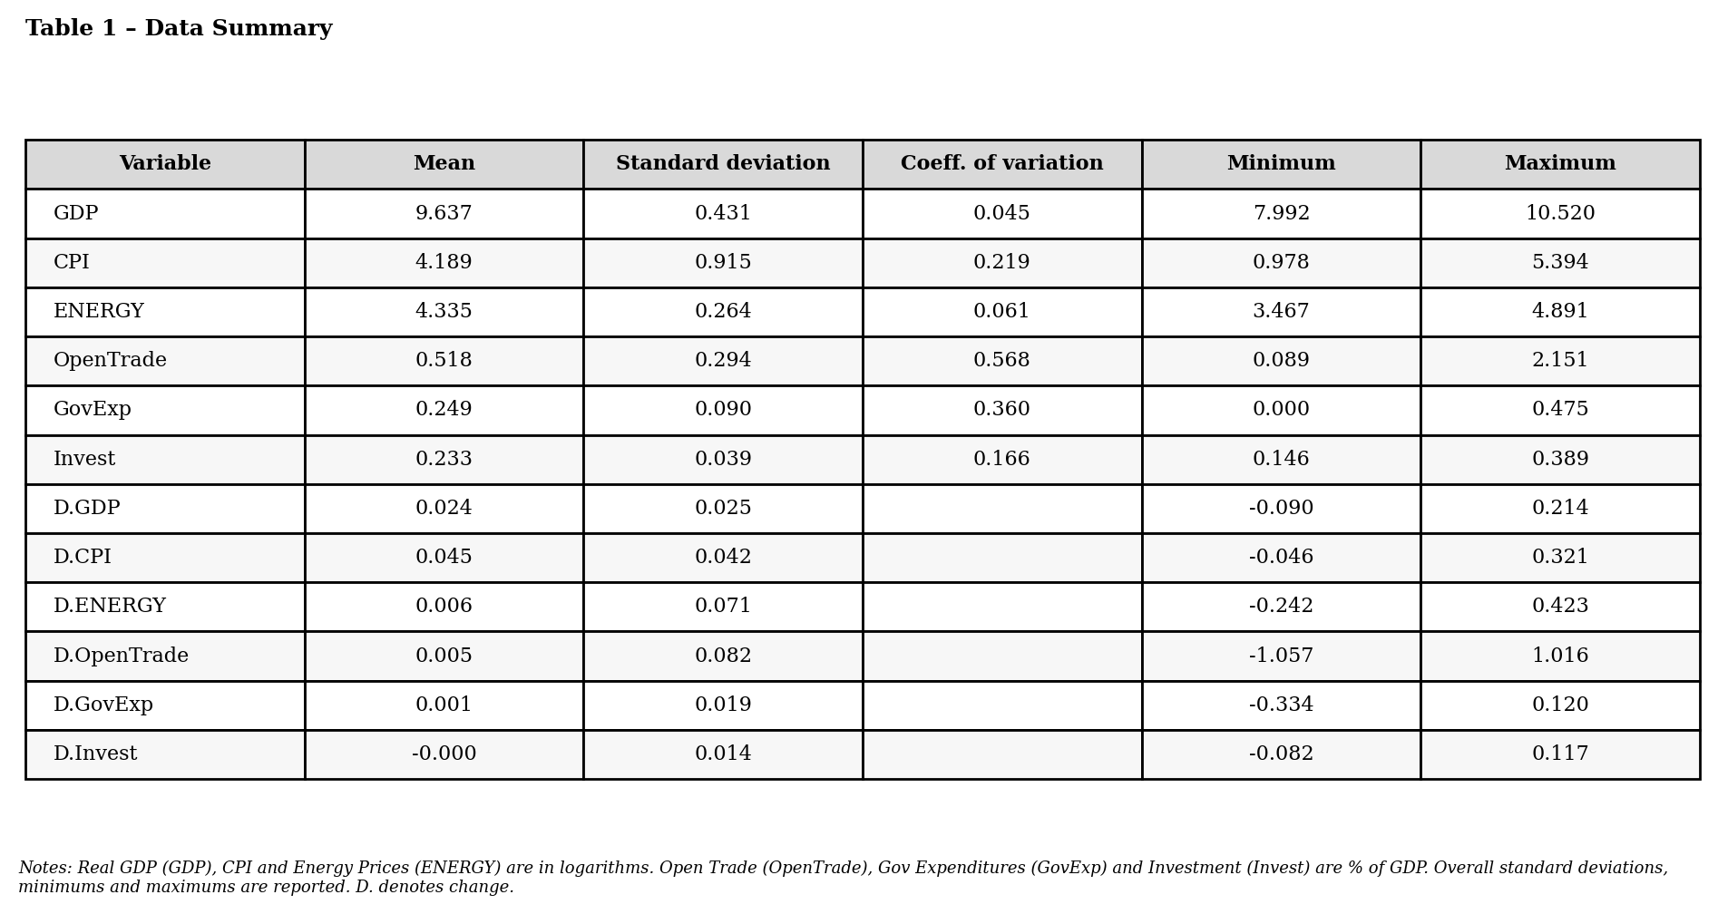
Table 2. Pesaran CIPS panel unit-root tests.
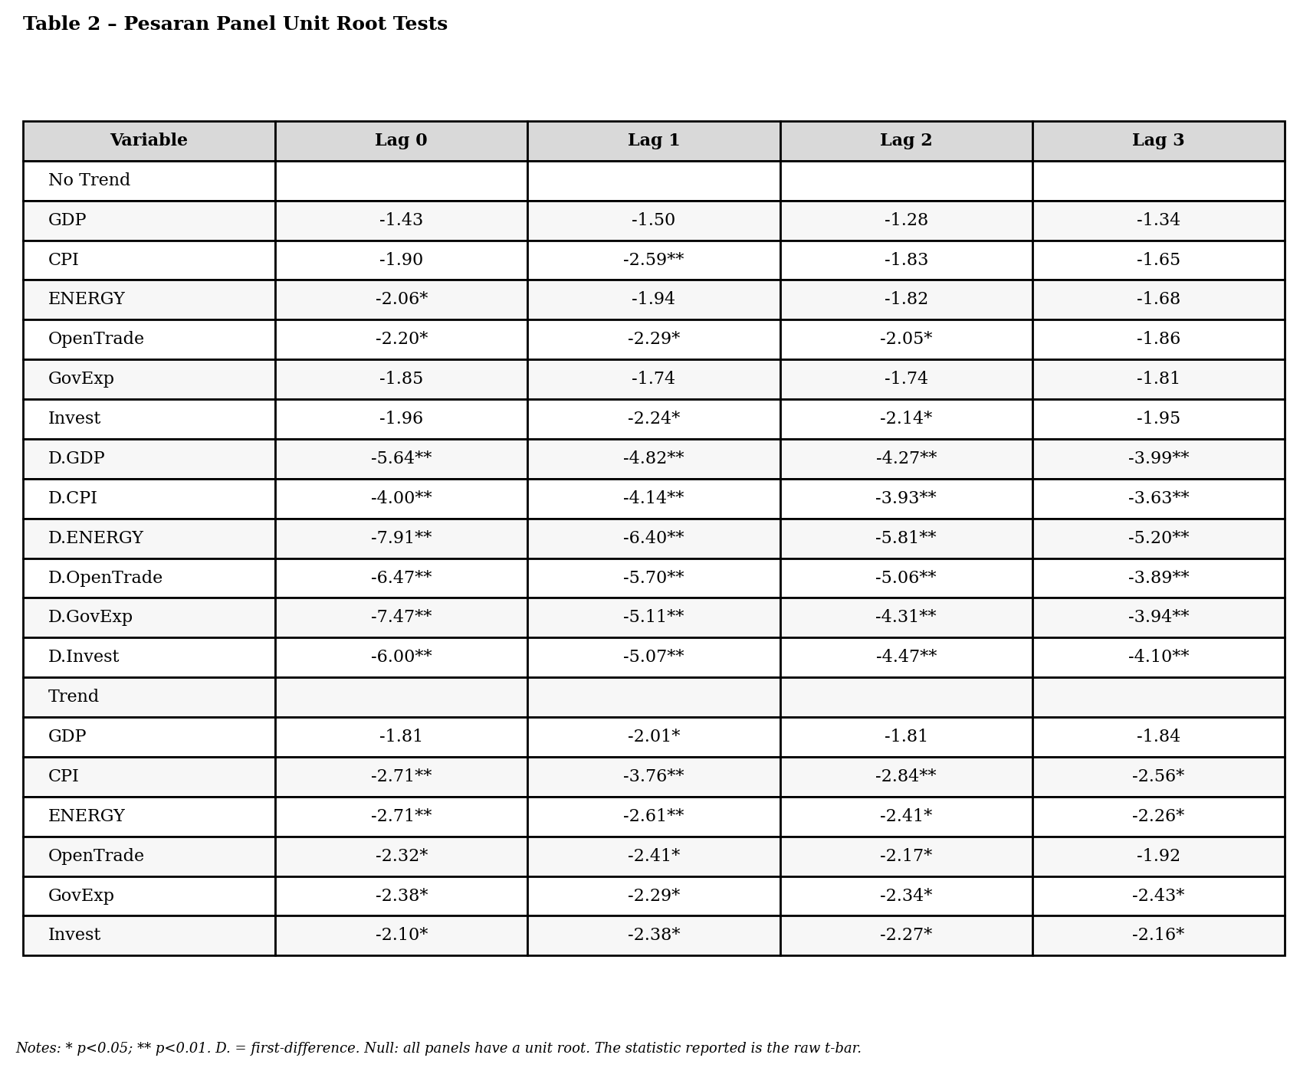
The CIPS table reports raw t-bar statistics, matching the convention used in the replication code. The normal-approximation stars should be read as indicative rather than as a full replacement for Pesaran critical values. The economically important conclusion is that variables in first differences reject the unit-root null much more clearly than most variables in levels.
Table 3. CCE-MG: unweighted and outlier-robust estimates.
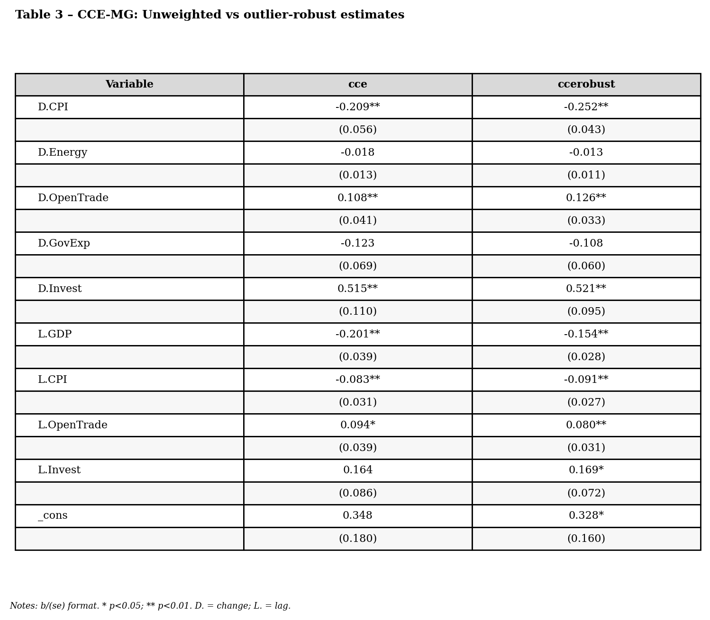
Table 4. CCE mean-group estimates for real GDP growth.
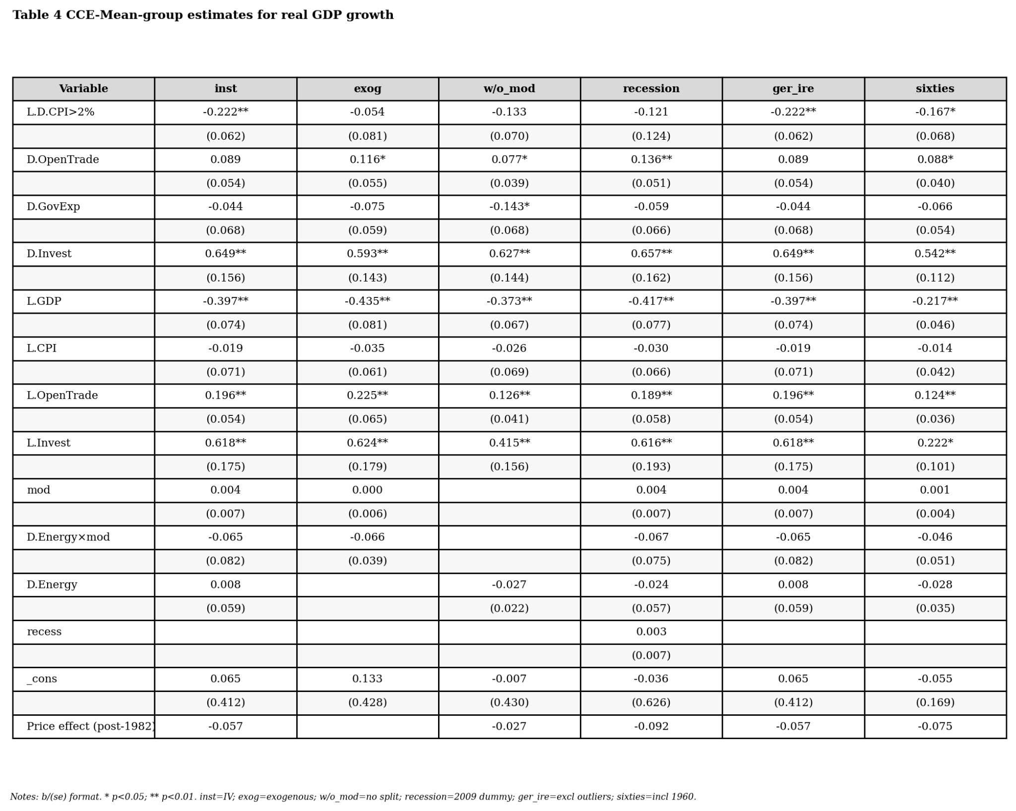
The CCEMG results show a robust role for macro controls and a negative post-1982 price effect in the robustness table. The coefficient on energy-price growth is sensitive to specification and to the Great Moderation split, consistent with the paper emphasis on historical regimes and heterogeneous country responses.
Table 5. Individual country energy intensity and responses.
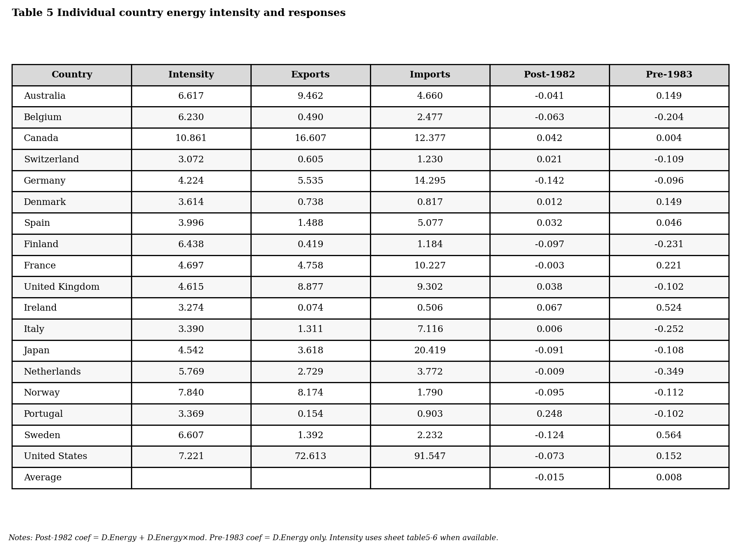
Table 6. Regressions of country-specific responses on energy intensity.
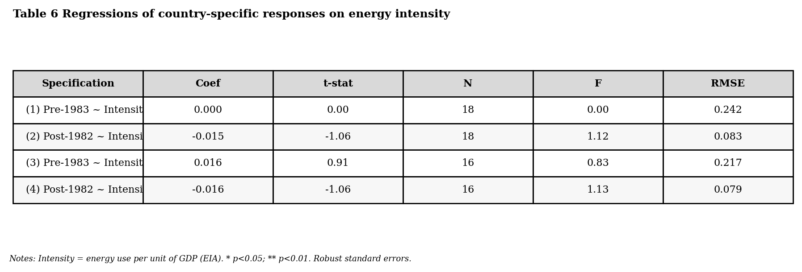

13. Standard panel estimates requested by the template
The course template asks for a single table comparing Between, Within, Mundlak, two-way fixed effects and first differences. These estimators are not the main estimators of Huntington and Liddle, but they are useful diagnostics because they show how the coefficient on energy-price growth changes when identification comes from cross-country means, within-country deviations, common-shock-adjusted deviations, or annual first differences.
Table. Standard panel estimates requested by the course template.
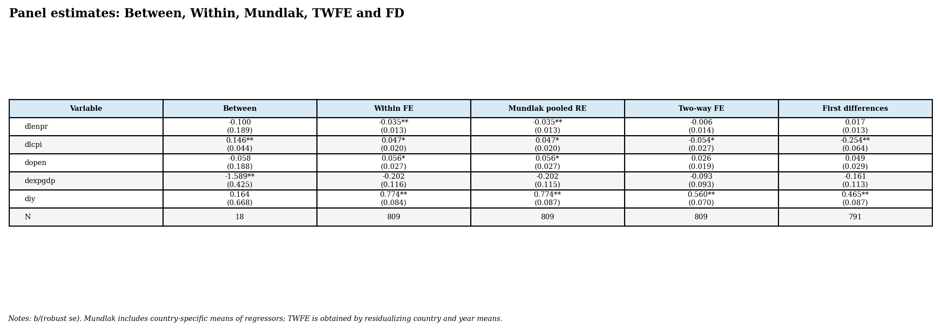
Mundlak is implemented as a pooled random-effects-style specification augmented with country means of the time-varying regressors. This makes explicit whether cross-country average differences in the controls matter in addition to within-country movements.

14. Dynamic panel diagnostics and Anderson-Hsiao-type IV
Because the dependent variable and the preferred explanatory variable are persistent macroeconomic series, the template asks for a dynamic ARDL / Anderson-Hsiao-type diagnostic when first-difference autocorrelation remains non-negligible. The dynamic specification includes lagged GDP growth, current and lagged energy-price growth, and differenced controls. Second lags in levels are used as excluded instruments in the IV diagnostic.
Table. Dynamic OLS and Anderson-Hsiao-type IV estimates.
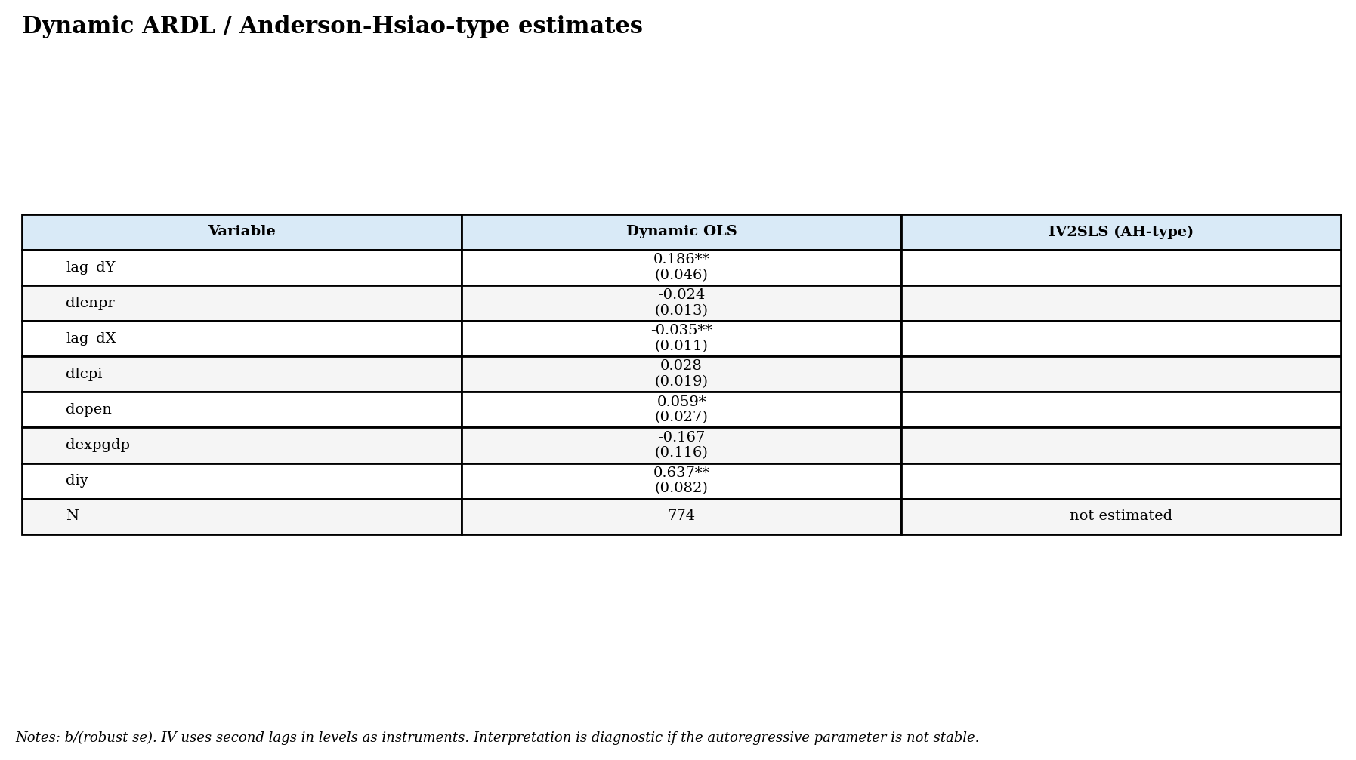
Table. First-stage diagnostics for the dynamic IV exercise.
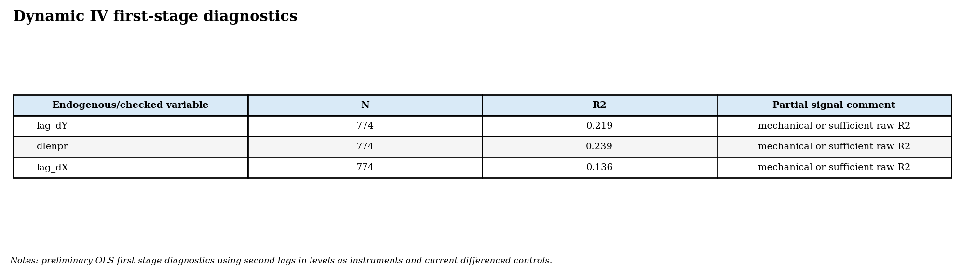
Figure. Impulse responses to a one-unit increase in energy-price growth.
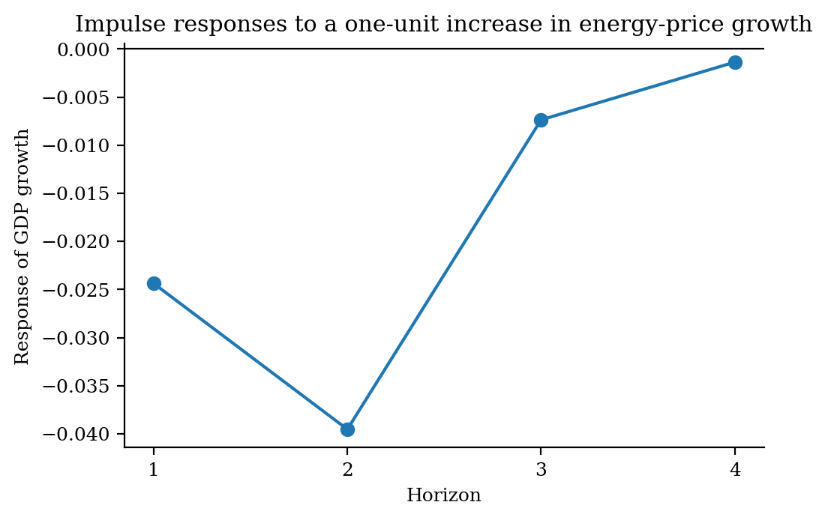
The long-run coefficient is computable because the estimated autoregressive parameter is below one in absolute value. The computed value is -0.073.

15. Own estimation not done in the paper: FE interaction with energy intensity
As an original extension, we estimate a country fixed-effects model interacting the energy-price shock with a time-invariant energy-intensity variable Z_i. The model is Delta log(RGDP)_it = alpha_i + beta1*dlenpr_it + beta2*(Z_i*dlenpr_it) + controls + error_it. Since Z_i is time-invariant, its level is absorbed by country fixed effects, but its interaction with the time-varying energy-price shock remains identified.
Figure. Marginal effect of energy-price growth by energy intensity.
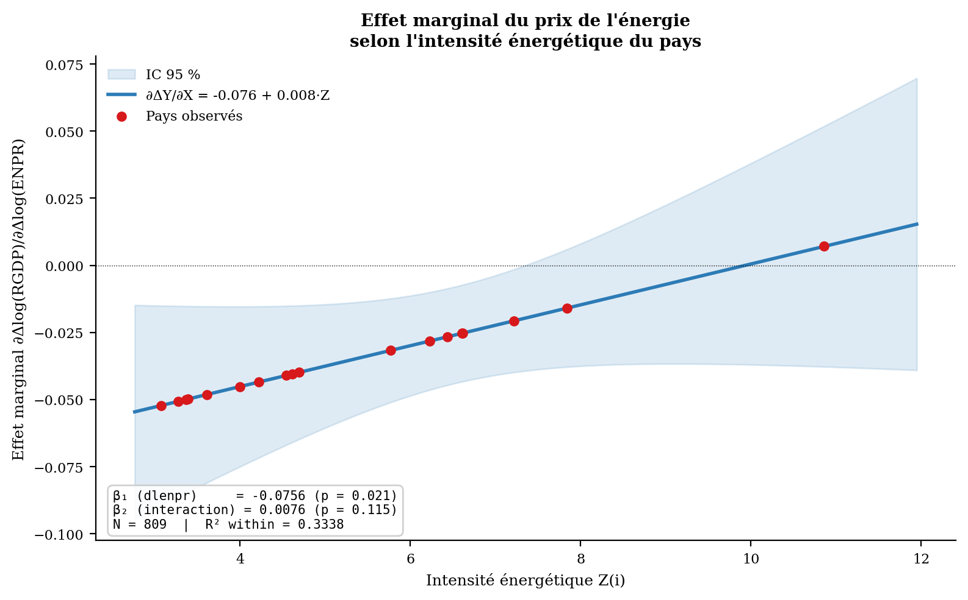
The estimated baseline marginal effect is negative at low energy-intensity levels. The interaction slope is positive in this implementation and not statistically significant at conventional levels, meaning that the extension should be interpreted as suggestive rather than definitive. This is still useful because it translates the template advice on time-invariant variables into an estimable interaction term.
Variable | Coef | Std.Err. | t-stat | p-value
Intercept | 0.0182 | 0.0012 | 14.6194 | 0.0000
dlenpr | -0.0756 | 0.0327 | -2.3100 | 0.0211
interaction | 0.0076 | 0.0048 | 1.5788 | 0.1148
dlcpi | 0.0485 | 0.0283 | 1.7149 | 0.0868
dopen | 0.0563 | 0.0224 | 2.5137 | 0.0121
dexpgdp | -0.1980 | 0.1270 | -1.5586 | 0.1195
diy | 0.7719 | 0.1222 | 6.3189 | 0.0000

16. References cited in the text
Huntington, H. G., & Liddle, B. (2022). How energy prices shape OECD economic growth: Panel evidence from multiple decades. Energy Economics, 111, 106082.
Pesaran, M. H. (2006). Estimation and inference in large heterogeneous panels with a multifactor error structure. Econometrica, 74(4), 967-1012.
Pesaran, M. H. (2007). A simple panel unit root test in the presence of cross-section dependence. Journal of Applied Econometrics, 22(2), 265-312.
Anderson, T. W., & Hsiao, C. (1981). Estimation of dynamic models with error components. Journal of the American Statistical Association, 76(375), 598-606.
Nickell, S. (1981). Biases in dynamic models with fixed effects. Econometrica, 49(6), 1417-1426.
Wansbeek, T., & Kapteyn, A. (1989). Estimation of the error-components model with incomplete panels. Journal of Econometrics, 41(3), 341-361.

17. Appendix: ordered to-do list for future panel-data studies
Step | Action
1. Define unit and time index | Identify whether the panel is country, firm, bank, sector, household or asset-level; verify unique (i,t) keys.
2. Define Y and preferred X | Write variable definitions in economic words and in code names before estimating.
3. Audit raw data | Check missing values, duplicates, outliers, units, logs, ratios and source changes.
4. Select panel sample | Apply at least three consecutive observations of Y for dynamic checks; document excluded units.
5. Balanced/unbalanced diagnostics | Report N by date, T by individual, holes and attrition patterns.
6. Classify variables | Compute between and within variances; identify time-invariant and individual-invariant variables.
7. Transform variables | Compute between, within, first differences and TWFE transformations carefully within individual.
8. Plot distributions | Compare histogram, normal fit and KDE for Y and preferred X under each transformation.
9. Examine correlations | Compare between, within, TWFE and FD matrices; inspect autocorrelations and trend correlations.
10. Check heterogeneity | Compute country/individual-specific correlations and slopes before imposing pooled models.
11. Estimate baseline models | Report between, within FE, Mundlak, TWFE and FD models with comparable controls.
12. Handle endogeneity | Justify instruments; report first stages, weak-instrument diagnostics and sensitivity.
13. Dynamic specification | If persistence remains, estimate ARDL or Anderson-Hsiao diagnostics and avoid invalid long-run multipliers.
14. Robustness and extensions | Test regime splits, outlier exclusions, alternative controls and theoretically motivated interactions.
15. Reproducibility | Provide raw data, cleaned data, code, outputs, environment requirements and LLM prompts as separate deliverables.

