Numerical Differentiation

The process of computing the value of the derivative  for some particular value of x from the given data when the actual form of the function is not known is called numerical differentiation.

When the values of the arguments are equally spaced and we are to find the derivative for some given x lying near the beginning of the table, we can represent the function by Newton’s forward interpolation formula. When the value of is required at the point near the end of the table we use Newton’s backward interpolation formula and we may use suitable central difference interpolation formula when the derivation is to be found at some point lying near the middle of the tabulated values. If the values of arguments x are not equally spaced, we should use Newton’s divided difference formula to approximate the function y = f (x).

Derivatives using Newton’s forward interpolation formula

Consider Newton’s forward interpolation formula
y = y₀ + u y₀ + 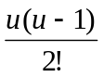 ² y₀ + 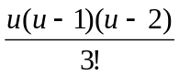 ³ y₀ + ….. --------- (1)
where u = 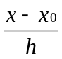 ----------- (2)

Differentiating (1) with respect to u we get,
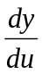 = y₀ + 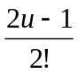² y₀ + 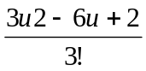 ³ y₀ ₊ ….. ----------- (3)
Differentiating (2) with respect to x we get,
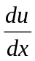 = 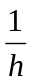 ----------- (4)
Now from equations (3) and (4)
= .
=> = [y₀ + ² y₀ + ³ y₀ +….. ] ----- (5)
Expression (5) gives the value of at any x which is not tabulated.

For tabulated values of x, particularly when x = x₀ and u = 0, we have
() _{x = x0} = [ y₀ -  ² y₀ + ³ y₀ -  ⁴ y₀ + ……]

Differentiating (5) with respect to x we get
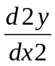= 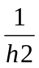 [ ² y₀ + (u – 1)³ y₀ + 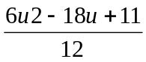⁴ y₀ +….. ]
Putting u = 0 we have
() _{x = x0} = [² y₀ - ³ y₀ + 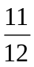⁴ y₀ - ……]

Formula for computing higher order derivation may be obtained by successive differentiation.

Example 1: From the table of values given bellow find and for x = 1.

x | y | ❒ | ² | ³ | ⁴ | ⁵
1  2  3  4  5  6 | 1  8  27  64  125  216 | 7  19  37  61  91 | 12  18  24  30 | 6  6  6 | 0  0 | 0

We have, x₀ =1, h = 1, x = 1.
u = 0

()_{x = x0} = [ y₀ - ² y₀ + ³ y₀ - ⁴ y₀ + ……]

( )_{x = 1} = [ 7 – (12) + (6) – 0 ]
= 7 – 6 + 2
= 3

( )_{x = 1} = [² y₀ - ³ y₀ + ⁴ y₀ - ……]
= (12 – 6 + 0)
= 6

Home Task: Find and for x = 2 and x = 1.5 for the above table.

Example 2: Page 153 [G. Shanker Rao].

Derivation using Newton’s Backward Interpolation Formula

We know, Newton’s backward interpolation formula
y = y_{n} + u y_{n} + 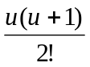² y_{n} + 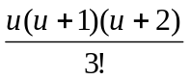³ y_{n} + ..… ------- (1)
where, u = 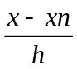 ----------- (2)
Differentiating (1) with respect to u we get
= y_{n} + 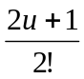² y_{n} + 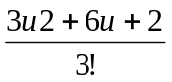 ³ y_{n} + ….. ----------- (3)
and differentiating (2) w. r. to x, we get,
= ----------- (4)
Now from equation (3) and (4),
= .
= [y_{n} + ² y_{n} + ³ y_{n} + .... ] ------- (5)
Expression (5) gives the value of at any x, which is not tabulated.
For tabulated values of x particularly when x = x_{n} and u = 0, we have
()_{x = xn} = [ y_{n} + ² y_{n} + ³ y_{n} + ⁴ y_{n} + ……]

Differentiating (5) w. r. to x, we get
= [ ² y_{n} + (u+1)³ y_{n} + 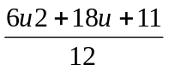⁴ y_{n} + ……]

Putting u = 0 we have,
()_{x = xn} = [² y_{n} + ³ y_{n} + ⁴ y_{n} + ……]

Similarly we can find higher order derivatives.

Example 2: From the table of values given bellow find 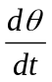and 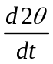 for t = 0.7

T | Θ | ⬧ | ² | ³ | ⁴ | ⁵
0.0  0.2  0.4  0.6  0.8  1.0 | 0.0  0.12  0.48  1.10  2.0  3.20 | 0.12  0.36  0.62  0.90  1.20 | 0.24  0.26  0.28  0.30 | 0.02  0.02  0.02 | 0  0 | 0
We have, x_{n} = t_{n} = 1.0, h = 0.2, x = t = 1.
u = (0.7 – 1.0) / 0.2 = -1.5

( )_{t = tn} = [y_{n} + ² y_{n} + ³ y_{n} +.. ]

()_{t = 0.7} = 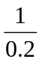[ 1.20 – 0.30 + 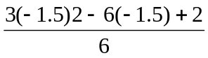 (0.02) ]
= 5(1.20 – 0.30 – 0.0008)
= 4.496 radian / sec

()_{t= 0.7} = (² y_{n} + (u+1)³ y_{n} + .. )
= (1/(0.2)²) (0.30 – 0.5 * 0.02)
= 25 * 0.29
= 7.25 radian / sec²

Derivatives using Stirling’s formula

The Stirling’s formula is,
y = y₀+ 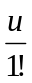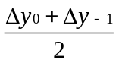+ 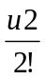² y₋₁ + 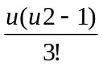 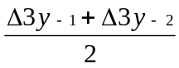+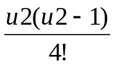⁴ y₋₂
+ 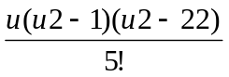 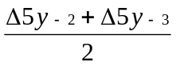 + …… ----------- (1)
Where, u = ----------- (2)
Differentiating (1) with respect to u we get,
= + 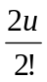² y₋₁ +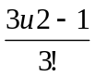+ 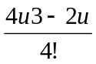^{4 y}₋₂
+ 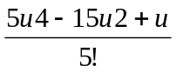+….. ----------- (3)

Differentiating (2) with respect to x we get,
= ----------- (4)
Now from equation (3) and (4),
=
= [+ ² y₋₁ + + ⁴ y₋₂
+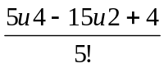+… ] ----------- (5)
At x = x₀ u = 0 .
Putting u = 0 in equation (5) we have
()_{x = x0} = [ -  +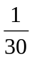-……]
Differentiating (5) w. r. to x we have
= [² y₋₁ + u + 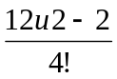⁴ y₋₂
+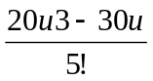+… ] ----------- (6)
and putting x= x₀ we get,
() _{x = x0} = [² y₋₁ - 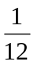⁴ y₋₂ + 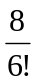⁶ y₋₃ + ……]

Example 4: Page 155 [G. Shanker Rao]

Maximum and Minimum Values of a Tabulated Function

We know that the maximum and minimum values of a function can be found by equating the first derivative to zero and solving for the variable. The same procedure can be applied to determine the maxima and minima of a tabulated function.

Example 5.6: From the following table find x, correct to two decimal places, for which y is maximum and find this value of y.

x | y | ❒ | ² | ³ | ⁴
1.2  1.3  1.4  1.5  1.6 | 0.9320  0.9636  0.9855  0.9975  0.9996 | 0.0316  0.0219  0.0120  0.0021 | -0.0097  -0.0099  -0.0099 | -0.0002  0 | 0.0002

Let, x₀ = 1.2
For maxima value of y we have = 0
Differentiating Newton’s forward interpolation formula with respect to u and neglecting terms after second differences we get
0 = 0.0316 +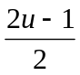 (- 0.0097)
u = 3.8

x = x₀ + uh
= 1.2 + 3.8 * 0.1 = 1.58
The value 1.58 is closer to x = 1.6, hence we use Newton’s backward difference formula
y (1.58) = 0..9996 – 0.2 (0.0021) – (-0.2 (-0.2 + 1) / 2) (-0.0099)
= 0.9996 – 0.0004 + 0.0008 = 1.0
The maximum value occurs at x = 1.58 and the maximum value is 1.0.

Example 5 & 6: Page 156 – 158 [G. Shanker Rao].

