

دانشگاه صنعتی امیرکبیر  
 (پلی‌تکنیک تهران)

دانشکده مهندسی کامپیوتر

آزمایشگاه فیزیک 2

گزارش کار آزمایش 5

نگارش

محمدمهدی نظری

شماره دانشجویی

9931061

استاد آزمایشگاه

آقای منصور اسماعیلی سنجوانمره

ترم اول 1402

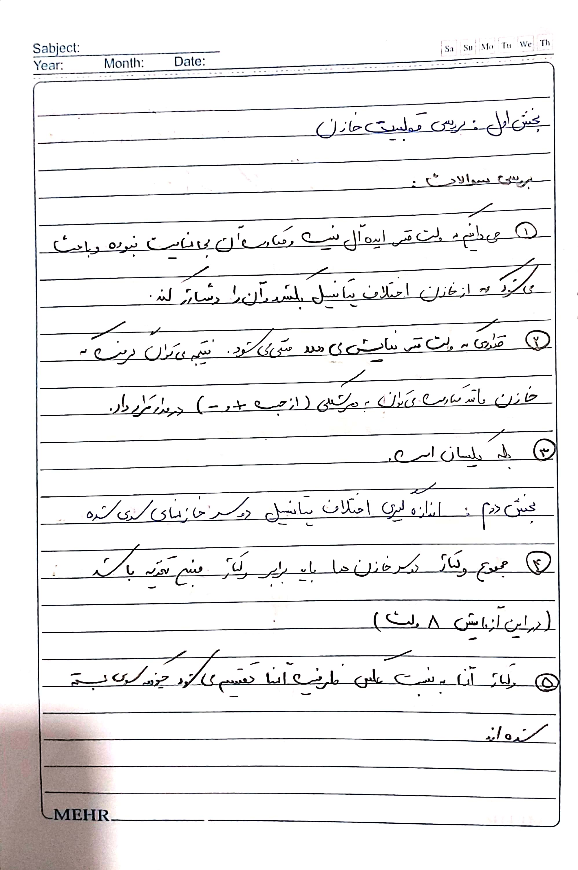

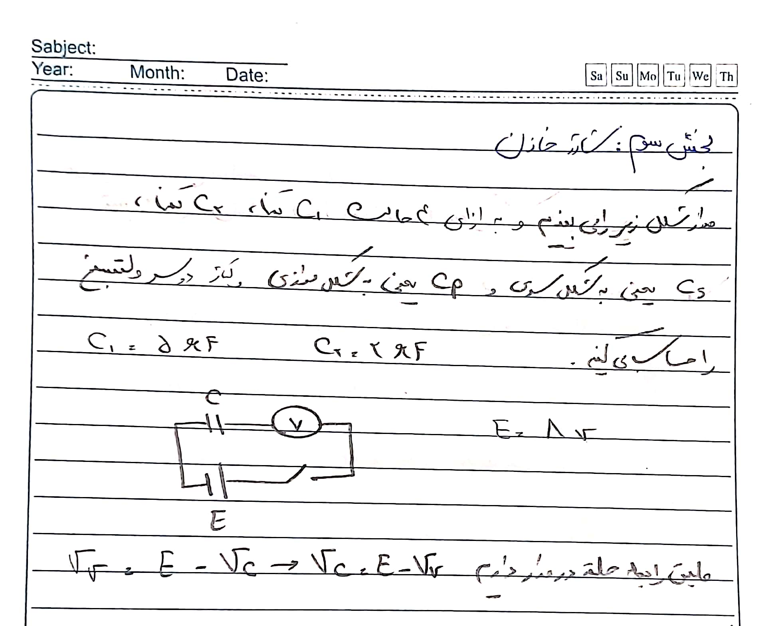

|  |  |  |  |  |
| --- | --- | --- | --- | --- |
| t(s) | C1 | | C2 | |
| VV(v) | VC1(v) = E - VV | VV(v) | VC2(v) = E - VV |
| 0 | 8 | 0 | 8 | 0 |
| 5 | 5.7 | 2.3 | 5.6 | 2.4 |
| 10 | 5 | 3 | 4.2 | 3.8 |
| 15 | 4.4 | 3.6 | 3.1 | 4.9 |
| 20 | 3.9 | 4.1 | 2.4 | 5.6 |
| 25 | 3.5 | 4.5 | 1.6 | 6.4 |
| 30 | 3 | 5 | 1.3 | 6.7 |
| 35 | 2.6 | 5.4 | 1.05 | 6.95 |
| 40 | 2.4 | 5.6 | 0.8 | 7.2 |
| 45 | 2.1 | 5.9 | 0.66 | 7.34 |
| 50 | 1.8 | 6.2 | 0.52 | 7.48 |
| 55 | 1.6 | 6.4 | 0.41 | 7.59 |
| 60 | 1.5 | 6.5 | 0.33 | 7.67 |
| 65 | 1.3 | 6.7 | 0.27 | 7.73 |
| 70 | 1.2 | 6.8 | 0.22 | 7.78 |
| 75 | 1.13 | 6.87 | 0.19 | 7.81 |
| 80 | 1.03 | 6.97 |  |  |
| 85 | 0.94 | 7.06 |  |  |
| 90 | 0.87 | 7.13 |  |  |
| 95 | 0.77 | 7.23 |  |  |
| 100 | 0.71 | 7.29 |  |  |
| 105 | 0.66 | 7.34 |  |  |
| 110 | 0.59 | 7.41 |  |  |
| 115 | 0.55 | 7.45 |  |  |
| 120 | 0.52 | 7.48 |  |  |
| 125 | 0.48 | 7.52 |  |  |
| 130 | 0.45 | 7.55 |  |  |
| 135 | 0.42 | 7.58 |  |  |
| 140 | 0.4 | 7.6 |  |  |
| 145 | 0.37 | 7.63 |  |  |
| 150 | 0.35 | 7.65 |  |  |
| 155 | 0.33 | 7.67 |  |  |
| 160 | 0.32 | 7.68 |  |  |
| 165 | 0.3 | 7.7 |  |  |
| 170 | 0.29 | 7.71 |  |  |
| 175 | 0.28 | 7.72 |  |  |
| 180 | 0.27 | 7.73 |  |  |
| 185 | 0.26 | 7.74 |  |  |
| 190 | 0.25 | 7.75 |  |  |
| 195 | 0.24 | 7.76 |  |  |
| 200 | 0.23 | 7.77 |  |  |
| 205 | 0.22 | 7.78 |  |  |
| 210 | 0.22 | 7.78 |  |  |
| 215 | 0.219 | 7.781 |  |  |
| 220 | 0.214 | 7.786 |  |  |
| 225 | 0.21 | 7.79 |  |  |
| 230 | 0.207 | 7.793 |  |  |
| 235 | 0.203 | 7.797 |  |  |
| 240 | 0.19 | 7.81 |  |  |
| 245 |  |  |  |  |
| 250 |  |  |  |  |

|  |  |  |  |
| --- | --- | --- | --- |
| CS | | CP | |
| VV(v) | VS(v) = E - VV | VV(v) | VP(v) = E - VV |
| 8 | 0 | 8 | 0 |
| 5.1 | 2.9 | 7.1 | 0.9 |
| 3.6 | 4.4 | 6.6 | 1.4 |
| 2.4 | 5.6 | 6 | 2 |
| 1.2 | 6.8 | 5.6 | 2.4 |
| 0.96 | 7.04 | 5.1 | 2.9 |
| 0.64 | 7.36 | 4.7 | 3.3 |
| 0.47 | 7.53 | 4.3 | 3.7 |
| 0.4 | 7.6 | 4 | 4 |
| 0.37 | 7.63 | 3.6 | 4.4 |
| 0.26 | 7.74 | 3.3 | 4.7 |
| 0.21 | 7.79 | 3.1 | 4.9 |
| 0.18 | 7.82 | 2.8 | 5.2 |
|  |  | 2.6 | 5.4 |
|  |  | 2.4 | 5.6 |
|  |  | 2.2 | 5.8 |
|  |  | 2.04 | 5.96 |
|  |  | 1.9 | 6.1 |
|  |  | 1.76 | 6.24 |
|  |  | 1.63 | 6.37 |
|  |  | 1.52 | 6.48 |
|  |  | 1.43 | 6.57 |
|  |  | 1.32 | 6.68 |
|  |  | 1.22 | 6.78 |
|  |  | 1.15 | 6.85 |
|  |  | 1.07 | 6.93 |
|  |  | 1 | 7 |
|  |  | 0.95 | 7.05 |
|  |  | 0.88 | 7.12 |
|  |  | 0.82 | 7.18 |
|  |  | 0.77 | 7.23 |
|  |  | 0.71 | 7.29 |
|  |  | 0.68 | 7.32 |
|  |  | 0.65 | 7.35 |
|  |  | 0.61 | 7.39 |
|  |  | 0.58 | 7.42 |
|  |  | 0.54 | 7.46 |
|  |  | 0.5 | 7.5 |
|  |  | 0.49 | 7.51 |
|  |  | 0.46 | 7.54 |
|  |  | 0.44 | 7.56 |
|  |  | 0.42 | 7.58 |
|  |  | 0.4 | 7.6 |
|  |  | 0.38 | 7.62 |
|  |  | 0.36 | 7.64 |
|  |  | 0.35 | 7.65 |
|  |  | 0.33 | 7.67 |
|  |  | 0.32 | 7.68 |
|  |  | 0.31 | 7.69 |
|  |  | 0.3 | 7.7 |
|  |  | 0.29 | 7.71 |

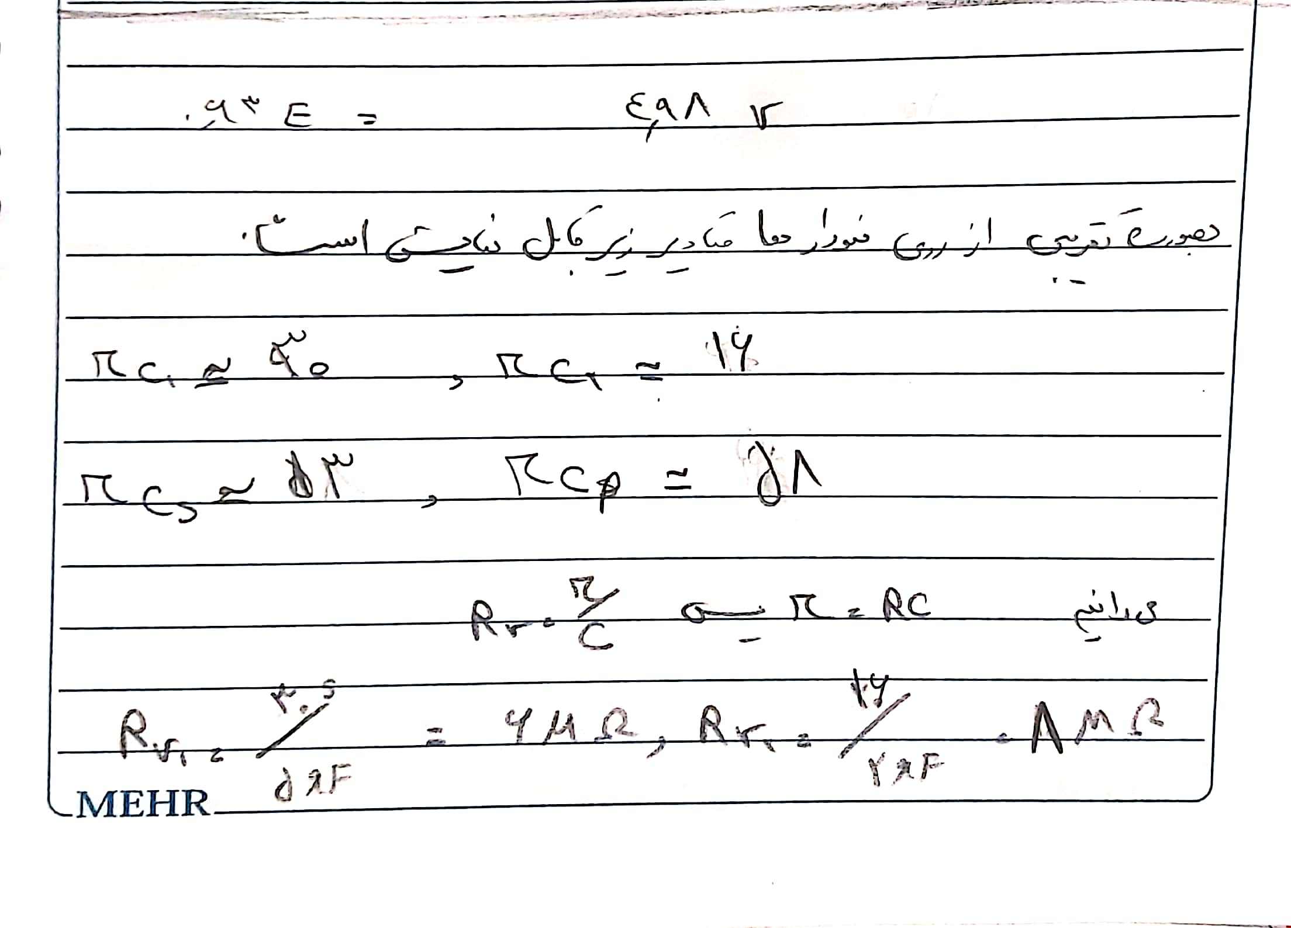

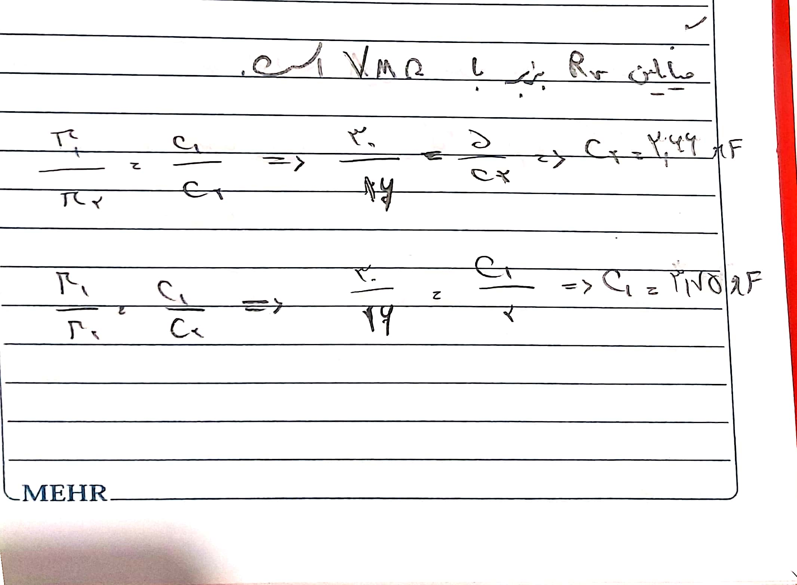

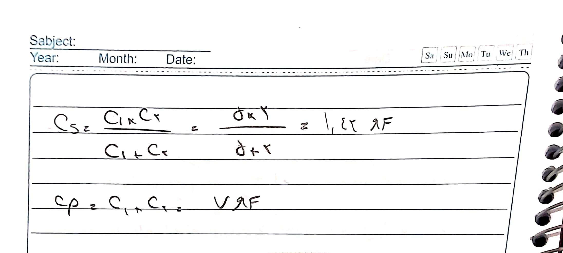

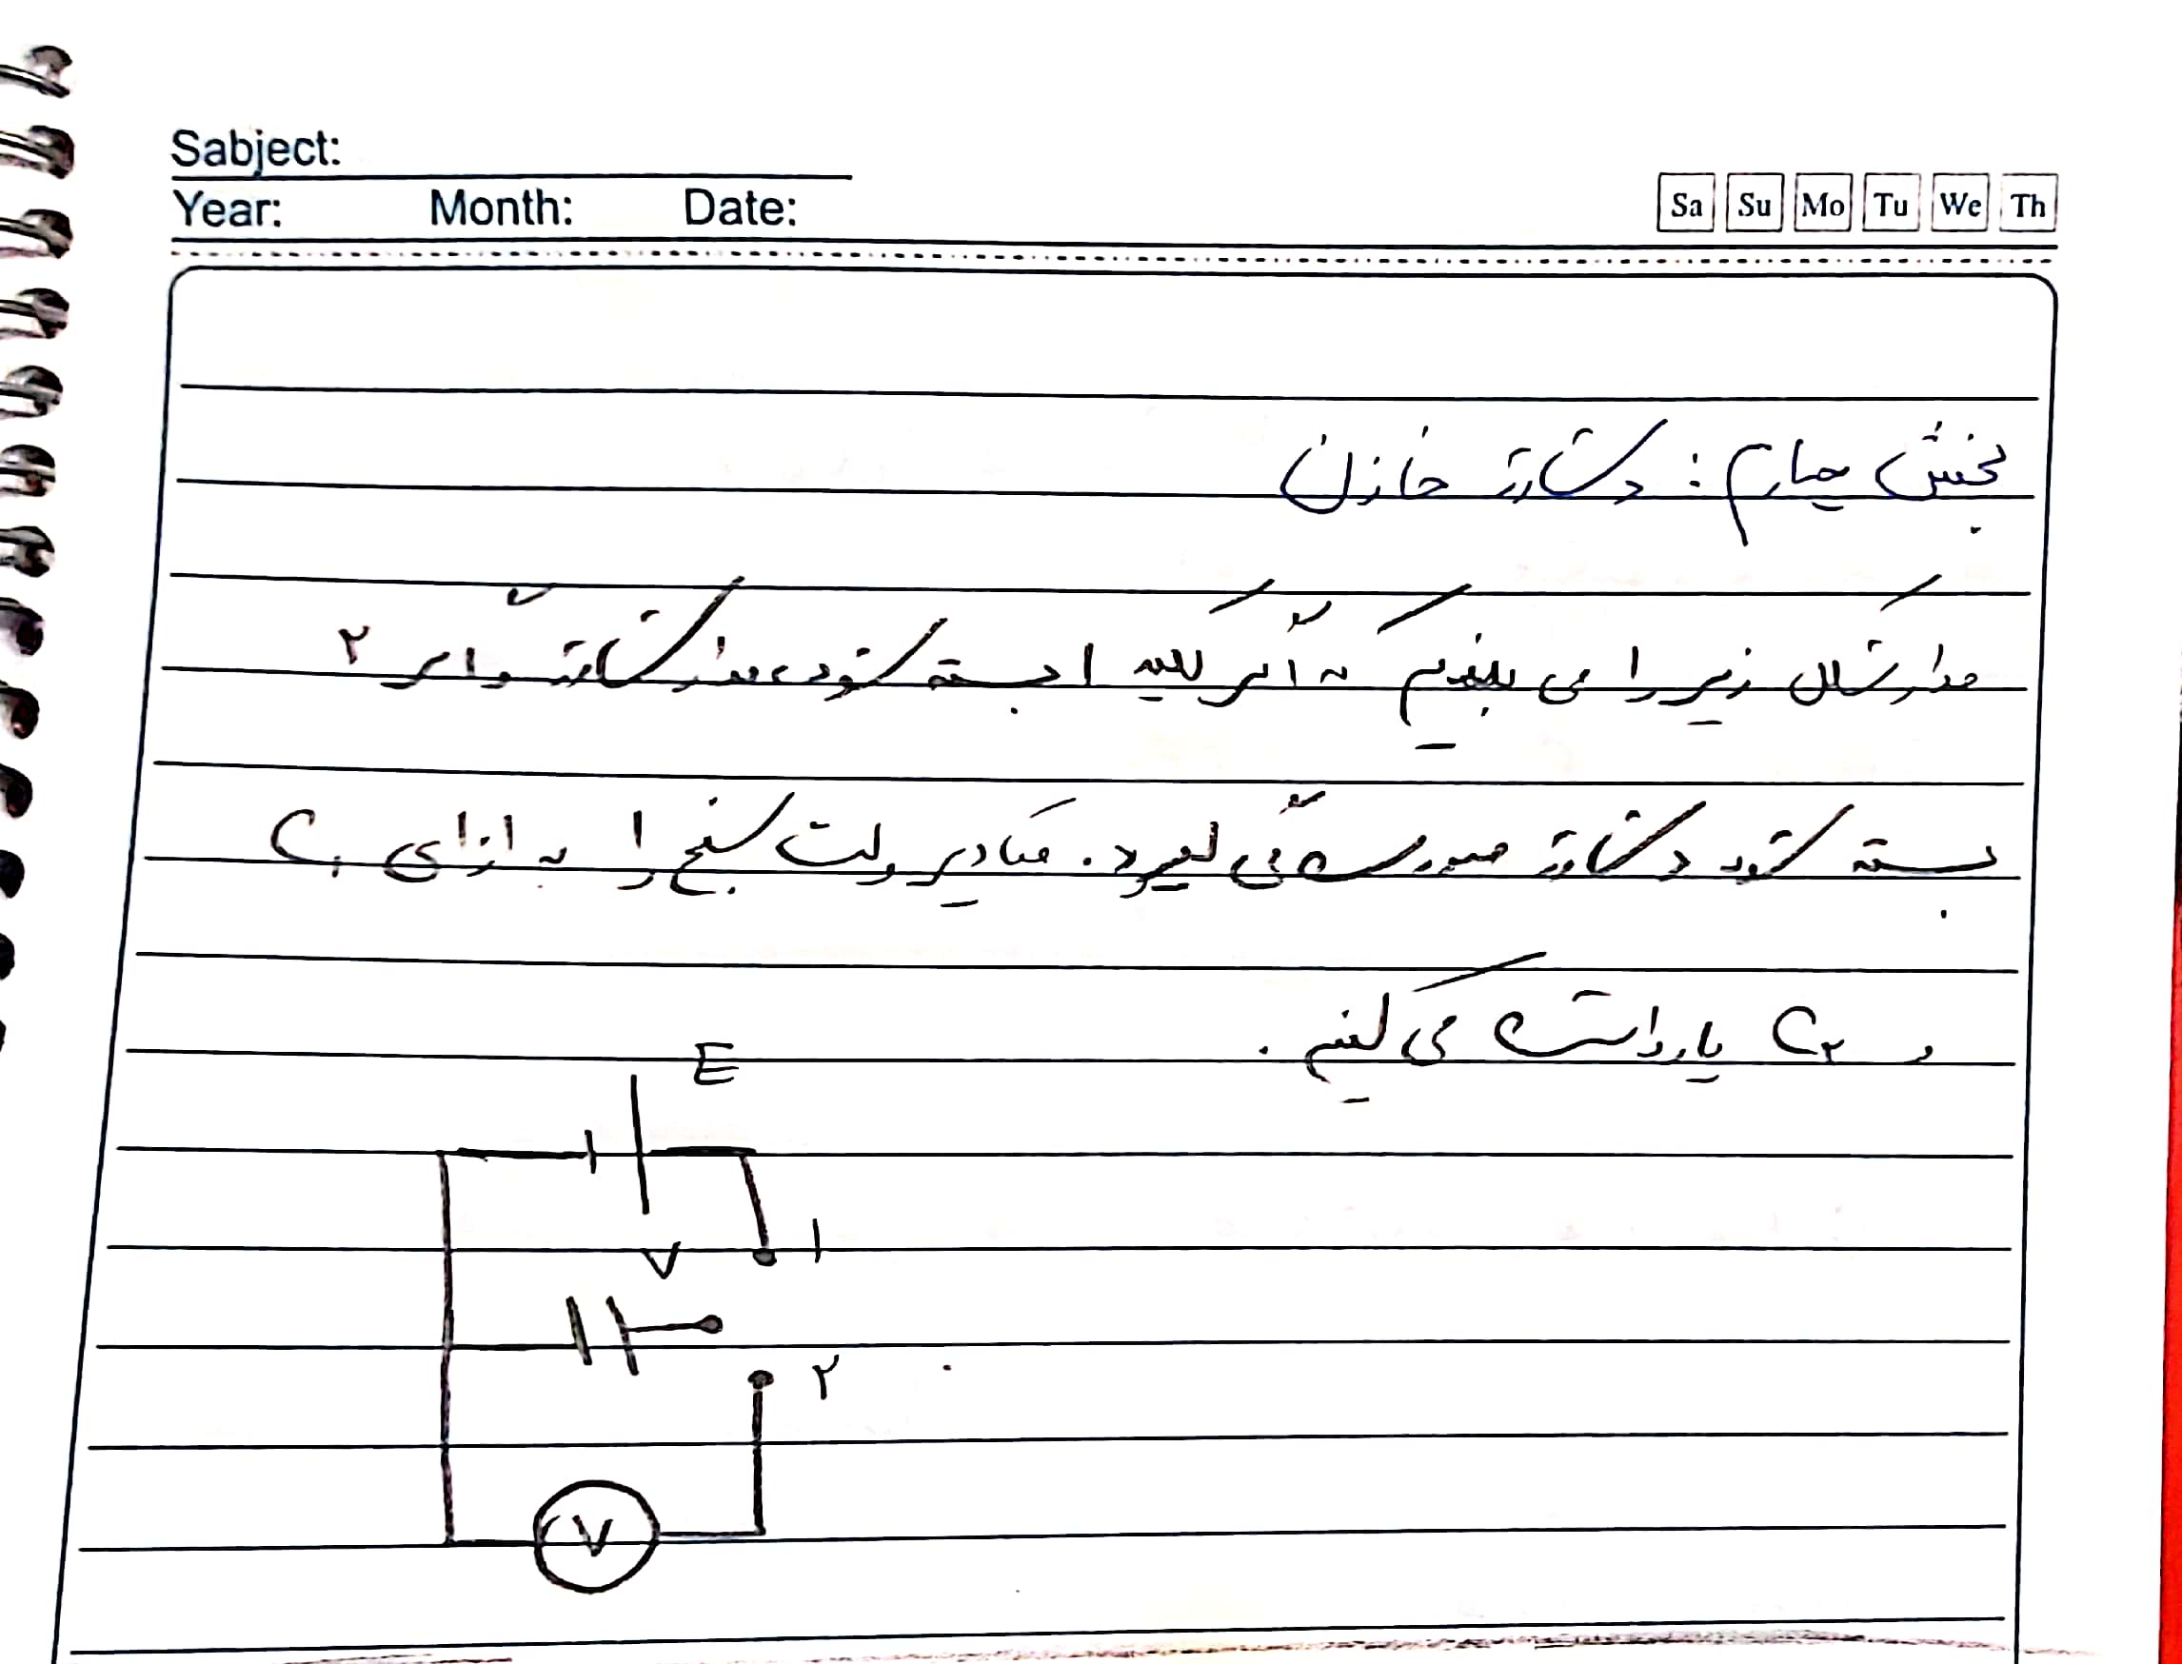

|  |  |  |
| --- | --- | --- |
| t(s) | VC1(v) | VC2(v) |
|
| 0 | 8 | 8 |
| 5 | 6.8 | 6.3 |
| 10 | 6.1 | 4.8 |
| 15 | 5.3 | 3.5 |
| 20 | 4.7 | 2.5 |
| 25 | 4.2 | 1.9 |
| 30 | 3.8 | 1.4 |
| 35 | 3.3 | 1.1 |
| 40 | 3.1 | 0.8 |
| 45 | 2.8 | 0.69 |
| 50 | 2.5 | 0.56 |
| 55 | 2.3 | 0.45 |
| 60 | 2.15 | 0.36 |
| 65 | 1.95 | 0.3 |
| 70 | 1.8 | 0.25 |
| 75 | 1.65 | 0.21 |
| 80 | 1.55 | 0.18 |
| 85 | 1.42 |  |
| 90 | 1.32 |  |
| 95 | 1.24 |  |
| 100 | 1.16 |  |
| 105 | 1.05 |  |
| 110 | 1 |  |
| 115 | 0.95 |  |
| 120 | 0.87 |  |
| 125 | 0.82 |  |
| 130 | 0.77 |  |
| 135 | 0.73 |  |
| 140 | 0.68 |  |
| 145 | 0.64 |  |
| 150 | 0.6 |  |
| 155 | 0.56 |  |
| 160 | 0.53 |  |
| 165 | 0.51 |  |
| 170 | 0.48 |  |
| 175 | 0.45 |  |
| 180 | 0.43 |  |
| 185 | 0.41 |  |
| 190 | 0.39 |  |
| 195 | 0.37 |  |
| 200 | 0.35 |  |
| 205 | 0.34 |  |
| 210 | 0.32 |  |
| 215 | 0.31 |  |
| 220 | 0.3 |  |
| 225 | 0.29 |  |
| 230 | 0.28 |  |
| 235 | 0.26 |  |
| 240 | 0.25 |  |
| 245 | 0.24 |  |
| 250 | 0.24 |  |

