Development Trajectory: From Spoken Dialogue Models to Voice Agents
Positioning the starting point. The engineering precursor appeared in duplex task systems, but this collection treats dGSLM (March 2022) as the opening of the generative spoken-dialogue-model track because it directly learns textless, two-channel dialogue generation. The subsequent mainline is a progressive coupling of speech representation, interaction timing, low-latency duplex generation, external tools, and explicit reasoning/action.
Phase | Period | Representative milestones | Technical shift | Capability boundary
Engineering precursor | 2021 | Duplex Conversation in Outbound Agent System | Modular duplex control demonstrates interruption-aware task delivery before a unified generative dialogue model exists. | Controller-centered task completion; speech understanding, dialogue policy, and synthesis remain separately orchestrated.
Model-track opening | 2022.03-05 | Generative Spoken Dialogue Language Modeling (dGSLM); Duplex Conversation | Textless dual-channel generation and learned conversational timing move the field from pipeline behavior toward dialogue modeling. | Naturalistic speech and turn-taking emerge, but instruction following, external knowledge, and tool use remain limited.
Speech-native foundation models | 2023.05 | SpeechGPT | Discrete speech units, an LLM backbone, and cross-modal instruction tuning unify speech perception and generation. | Instruction-following speech interaction becomes feasible, while most systems still depend on turn-based exchanges.
Real-time full-duplex models | 2024.09-10 | Synchronous LLMs; Moshi; OmniFlatten | Streaming token generation, parallel user/system streams, and staged half-to-full-duplex training remove explicit turn boundaries. | Low-latency overlap, interruption, and backchannels improve naturalness; external action and long-horizon planning are not yet central.
Tool-augmented voice assistants | 2025.10 | Stream RAG; VoiceAgentBench | Speech-in/speech-out systems issue tool calls during incoming speech, while benchmarks introduce multi-tool and multi-turn agentic tasks. | Grounded task execution emerges, but robust orchestration and long-horizon planning remain open problems.
Agentic spoken dialogue | 2026.04-07 | Full-Duplex-Bench-v3; DuplexSLA; VoxMind | Think-before-speak reasoning, dynamic tool management, synchronized language/action generation, and realistic tool-use evaluation converge. | The reason-plan-act loop is integrated with speech; persistent memory, safety, and reliable long-horizon autonomy remain unresolved.

The Mainline
- Representation: ASR/text/TTS pipelines -> discrete speech units -> parallel semantic and acoustic streams.
- Interaction: explicit turn boundaries -> streaming and controlled barge-in -> full-duplex overlap and backchannels.
- Capability: dialogue generation -> cross-modal instruction following -> retrieval and tool use -> reason-plan-act behavior.
- Evaluation: speech quality and turn timing -> latency/interruption -> multi-tool correctness and end-to-end task completion.
Scope note. All representative milestones above are already listed in the earlier Datasets, Evaluation & Benchmarks, Models, or Training Methods sections; no additional bibliography entry was introduced solely for this trajectory.

Conceptual Development Curve
The curve summarizes capability integration across representative milestones. Its vertical position is qualitative and must not be interpreted as a benchmark score or a claim that every newer system dominates every earlier system.
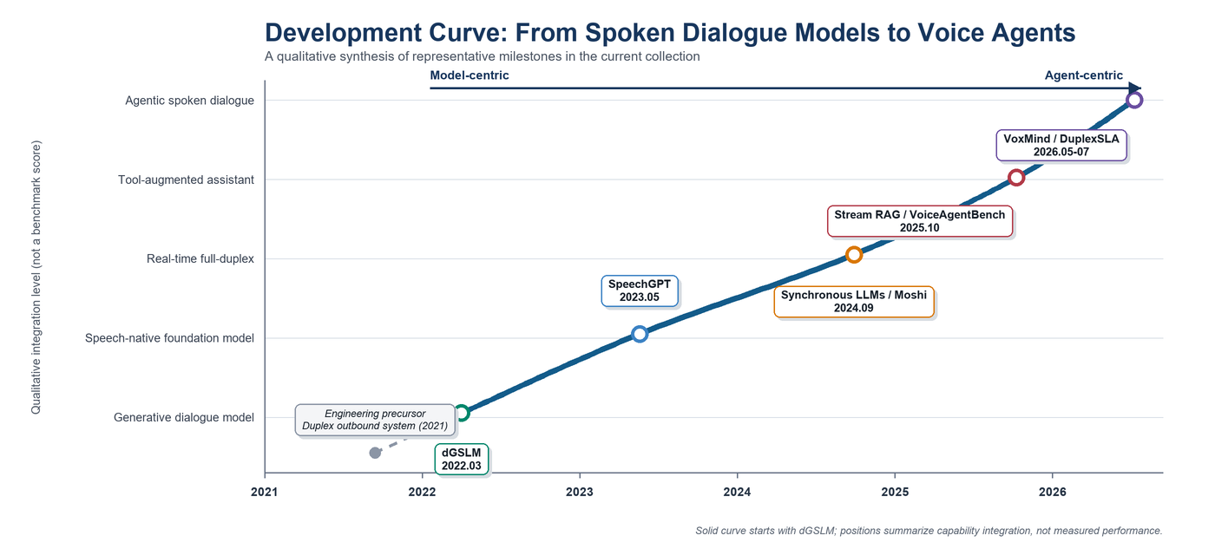
Figure 1. Conceptual development curve from generative spoken dialogue models to agentic voice systems. The dotted segment denotes engineering context; the solid curve begins with dGSLM in March 2022.
Interpretation. The decisive transition is not speech synthesis quality alone. Model-centric systems learn to represent and generate conversational speech; interaction-centric systems add real-time synchrony; agent-centric systems close the loop by deciding when to reason, which tool or action to invoke, and how to continue speaking under latency and conversational constraints.

