# Software Requirements

**Specification**

**For**

# Graphology App

### Version 1.0 approved

**Prepared by:-**

**Abhinav Narang (101803411)**

**Muskaan Munjal (101803413)**

**Priyanshi Tiwari (101803417)**

**Aneesh Jindal (101853025)**

**Team Enigma**

**23-SEP-2020**

**Table of Contents**

#### Table of Contents Revision History

1. **Introduction**
   1. Purpose
   2. Project Scope
   3. References
2. **Overall Description**
   1. Product Perspective
   2. User Classes and Characteristics
   3. Operating Environment
   4. Tools/Languages used in development
3. **System Features**

3.1 Letter Size

3.2 Word Spacing

3.3 Pen Pressure

1. **External Interface Requirements**
   1. User Interfaces
   2. Hardware Interfaces
2. **Other Nonfunctional Requirements**
   1. Performance Requirements
   2. Software Quality Attributes
3. **Introduction**
   1. **Purpose**

Our interest in handwriting stems from the wealth of information that it can provide about the social and cultural life of individuals and communities, as well as the neurocognitive and physiological mechanisms of the human body. The Description of the physical aspects of the written word, its production and Perception is a central basic research that feeds the discussion of handwriting at a higher level.

Graphology is a technique for analyzing an individual’s personality based on the given sample of their handwriting. Graphology considers the fact that the movement of our hand is directly related to the state of our brain.

The objective of this project is to develop a system that takes an image document containing the handwriting of a person and output a few of his/her personality traits based on some selected handwriting features.

Carefully analyzing all the significant characteristics of a person’s handwriting manually is not only time consuming but prone to errors as well. Automating the analysis on a few selected characteristics of handwriting will speed up the process and reduce the errors.

### Project Scope

### The app is implemented using various handwriting features such as baseline, size, slant, spacing, margin, pressure etc. and more number of features like fluency, continuity of handwriting can be included to make the analysis more accurate. A Language independent human personality analysis tool can be created, which can be used for different handwritings written in different languages. A fully automated system can be formulated that requires no human interaction, a system that can recognize the changes in the past and present personality of a person through the change in the handwriting. The software is very helpful in the field of psycho analysis by psychiatrists along with other psycho assessment tools.

### References

1. Prachi Joshi. (2017). Handwriting Analysis for Detection of Personality Traits using Machine Learning Approach. Retrieved 24 September 2020, from

<https://www.researchgate.net/publication/284205700_Handwriting_Analysis_for_Detection_of_Personality_Traits_using_Machine_Learning_Approach>

1. Devin Soni. (2018). Introduction to k-Nearest-Neighbors. Retrieved 23 September 2020, from

<https://towardsdatascience.com/introduction-to-k-nearest-neighbors-3b534bb11d26>

1. (2019). Retrieved 24 September 2020, from

<https://www.ijitee.org/wp-content/uploads/papers/v9i1/A3973119119.pdf>

1. **Overall Description**

### Product Perspective

Every individual has a unique personality some of which are comprehended on the basis of the books they read, the songs they hear and the kind of music taste they have. It is a lesser known fact that handwriting conveys your personality. Simple evidence to this statement is that the human brain controls all activities done by a human and the same brain helps to write. Thus, handwriting is used as a medium for studying the brain’s behavior. This is called as graphology. The physical, mental and emotional state of an individual influences their handwriting. Graphology does not focus on the content that has been written but the way it is written.

This app simplifies the task of personality prediction to a great extent thus saving time and energy and predicting results with a high accuracy.

There are several factors based on which graphology works. Some of them are as follows:

* **Margin and slant:** Under this category, the spacing of the paragraph along with the four margins and the slant of letters, whether it is left or right, is considered. The variation of spacing from all the marginal sides plays a major role in determining their personality.
* **Pen Pressure:** Every person has a different level of exerting pressure on a pen as they write. The pen pressure can be light, medium, heavy, distinct, lateral, pasty, sharp and so on. Thus, varying levels of darkness are obtained based on the pen pressure. This can be used to determine the energy level and ego of the person.
* **Size and Baseline:** The size of the letters indicates the self-esteem that a person possesses. On the other hand, the baseline of their handwriting indicates the disposition of the person, that is, the organizational capabilities that a person holds.
* **Features of letters:** Each letter has a particular feature such as looping, curves, arcs, strokes etc. This paper focuses on many such features of handwriting to detect the personality of the individual.

**Context Level DFD (Level 0):**

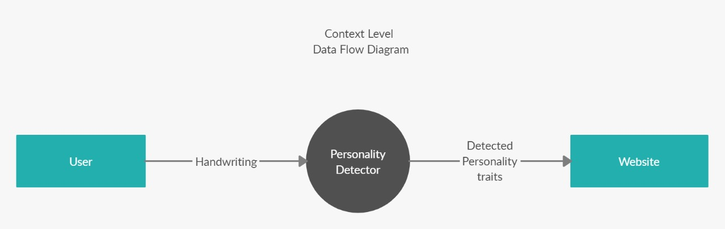

**Level 1 DFD:**

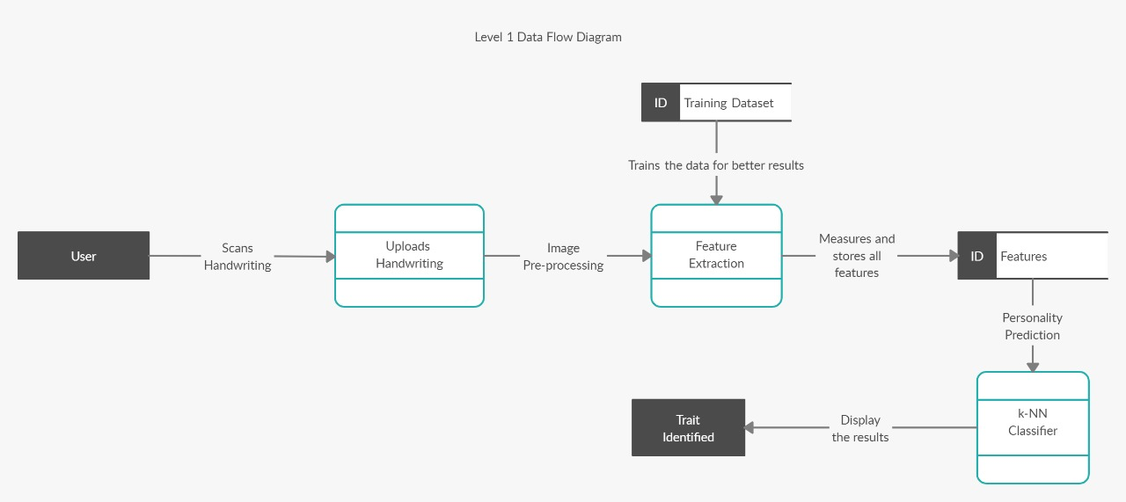

### User Classes and Characteristics

##### Admin:

* Access to app features- FULL
* Database access - allowed

##### User:

##### Access to app features: Partial

##### Upload/Change Document Picture

##### View predicted results

### Operating Environment

*The app runs on Windows OS. The updated versions may also include an android or ios based app*

### Tools/Languages used in development:

* **Python:** Python is an interpreted high-level programming language for general-purpose programming. Python is chosen over MATLAB because it is easier to install and readily available. Python has extensive free libraries for image processing and machine learning, which makes it an ideal language for the project.
* **OpenCV library:** This open source library for Python provides various implementations of image processing algorithms used extensively in the project.
* **Sci-kit Learn library:** This free library for Python provides implementations of support vector machine algorithms and various other machine learning algorithms.
* **Tensor-Flow:** This library of python isused for various deep learning and neural network applications that will be used to build the training set and predict the results on its basis.

## System Features

### Letter Size

To determine the size of a handwriting sample, the middle zone letters are principally looked at. These should be 1/8th of an inch or 3 millimeters high to fall within the normal, book category.

* + - * Normal or Average Book Size: People who write with a normal sized script can be expected to fit into conventional or prevailing circumstances with adaptability and balance of mind. They are practical and realistic.

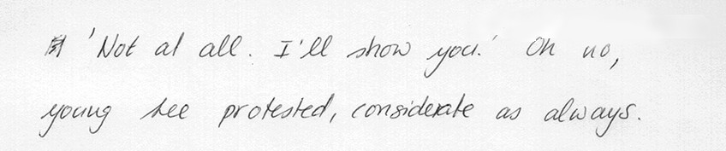

Figure 2.10: A handwriting sample with average letter size.

* + - * Larger than Average Size: It shows the writers need to make an impression, to be observed, to win recognition. These people need and enjoy attention and admiration; they do not like to be alone. They can act with boldness, enthusiasm, and optimism, but are also capable of boastfulness, restlessness, and lack of concentration and discipline.

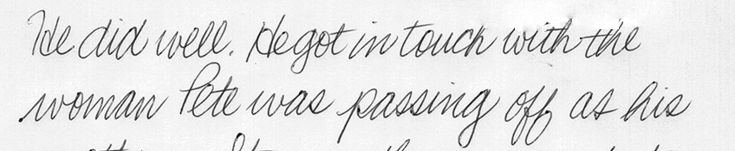

Figure 2.11: A handwriting sample with large letter size.

* + - * Smaller than Average Size: It denotes an introspective person, one not apt to seek the limelight and who is not very communicative except with close friends. Small writers often have an academic mentality and can concentrate for long periods of time in their studies and projects. Although they are modest, sometimes to the point of feelings of inferiority, the talent of these writers for detail and for organizing often gives them good executive ability.

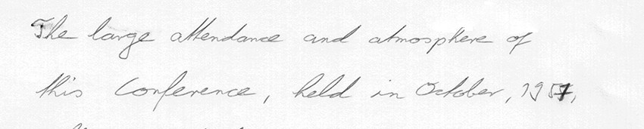

Figure 2.12: A handwriting sample with small letter size

### Word Spacing

The space left between the written words represents the distance that the writer would like to maintain between him and society at large. As with the single letter, the writer is representing himself as he places each word unit on the page; between the words lies the distance he needs for emotional comfort with others, his territorial boundaries.

* + - * **Normal or well-balanced spacing:** This always gives evidence of the writer’s social maturity, intelligence, and inner organization. He will be able to deal flexibly and objectively with himself and with other people.

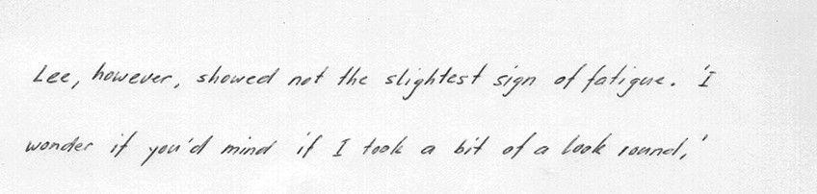

Figure 2.16: A handwriting sample with normal word spacing.

* + - * **Narrow spacing:** The writer will crowd others for attention, craving constant contact and closeness. He can be selfish in his demands and unwilling to give of his own time and energies to others. The combination of narrow letters with cramped spacing between the words shows a person who is fearful and dependent, who cannot give himself (or others) enough space in life.

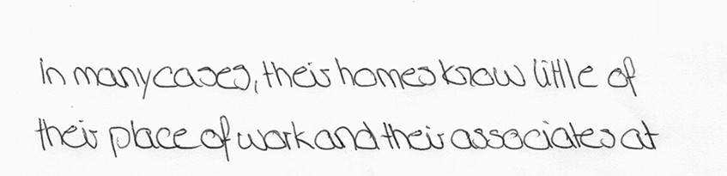

Figure 2.17: A handwriting sample with narrow word spacing.

* + - * **Wide spacing:** It indicate the writers need to maintain his distance from social contact, either due to an inner need for privacy or to a tendency toward isolation sometimes reinforced by difficulty in communicating with others. The combination of wide letters with wide spaces between the words denotes a person who demands attention in an extravagant or exaggerated manner, stemming from a need to be noticed, to be important.

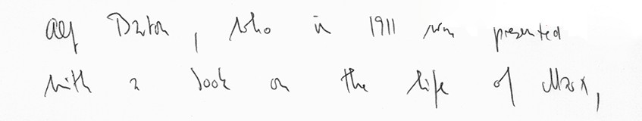

Figure 2.18: A handwriting sample with wide word spacing.

### Pen Pressure

### Heavy Pressure: These types of writers make an impression. There is a great deal of energy available to them for their actions. They express in a heavy manner, are strong willed, firm and easily excited to hot-blooded actions. Those with forceful pressure can inspire others. Negatively, they can be stern, stubborn and inclined to morose thoughts or depression. Their presence is definitely known.

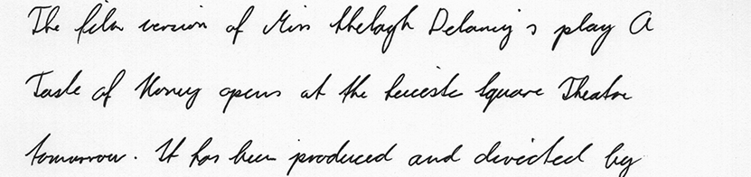

Figure 2.21: A handwriting sample with heavy pen pressure.

* **Light Pressure:** These people possess a certain delicacy of feeling. The personality is sensitive and impressionable. There is often great creative ability, but the potential is seldom fulfilled as these writers seem unable to absorb their experiences. The willpower is not strong, so the light-pressure writer can easily succumb to the dominance of a heavier writer. They are far more tolerant and genial than their counterparts, and though they can lapse into superficiality, their lack of inhibition can be refreshing. When the rest of the writing is harmonious, the finest peaks of spirituality and idealism are reached. With unharmonious writing, light pressure is an indicator of fragility and weak nerves.

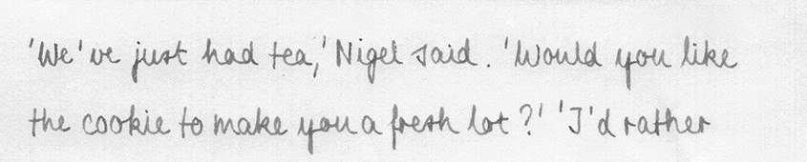

Figure 2.22: A handwriting sample with light pen pressure.

* **Medium Pressure:** This is the norm between the extremes and is an indication of healthy vitality and willpower.

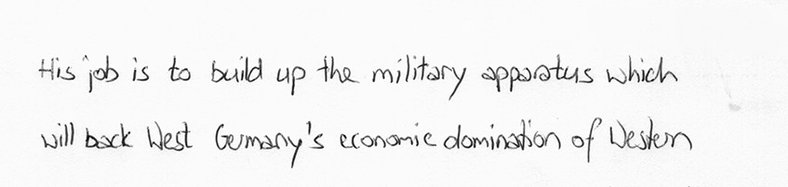

Figure 2.23: A handwriting sample with medium pen pressure.

1. **External Interface Requirements**
   1. **User Interfaces**

* Application - The main portal where user can access the various features of the system.
* Web portal - The users can even access the system features on a web portal which is in sync with the application data and the online database.
  1. **Hardware Interfaces**
* Camera module: Any type of camera will be used to scan the picture of your handwriting.

1. **Other Nonfunctional Requirements**
   1. **Performance Requirements**

* **Good quality camera :**

Camera quality matters when scanning the handwriting to be uploaded.

* **Clear handwriting :**

For an easy and more accurate personality prediction.

* 1. **Software Quality Attributes**
* **Availability**:

The application is available as a web portal.

* **Correctness:**

The results will be displayed as a probability and the system should display accurate data except if there is a problem with the internet connection or uploading a clearer picture of the user’s handwriting.

##### Flexibility:

The application currently runs on web portal and a separate android application is under process.

##### Portability:

The application is a simple web portal thus is highly portable and can be easily accessed.

**Activity Diagram:**

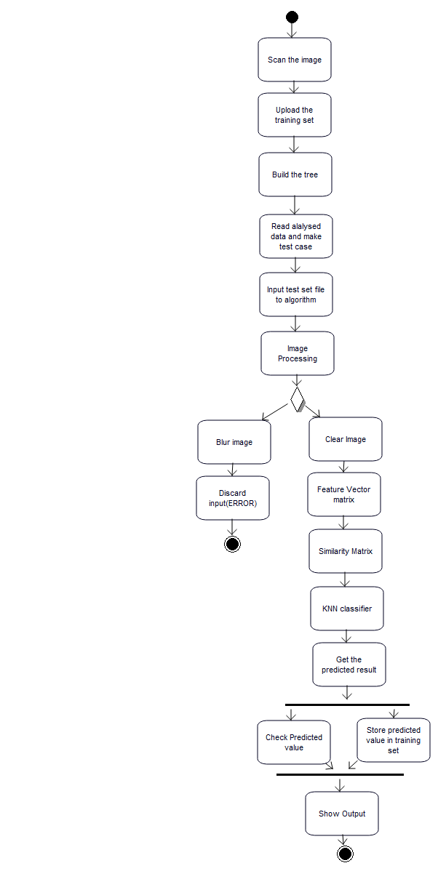

If image not processed

If handwriting detected

**Use Case Diagram:**

