**Part A – Morphological Boundary Extraction**

**Process & Tools Used:**

**Black and White Conversion:** Grayscale image converted to binary.

**Custom Tools:**

**Erode:** Shrinks white areas to remove noise.

**Dilate:** Expands white areas to fill small holes.

**Morphological Operations:**

**Opening (Erode → Dilate):** Removed small noise, smoothed edges.

**Closing (Dilate → Erode):** Filled small holes and cracks.

**Boundary Detection:**

**External Boundary:** Found by subtracting the eroded image from the original — shows outer edges of parts.

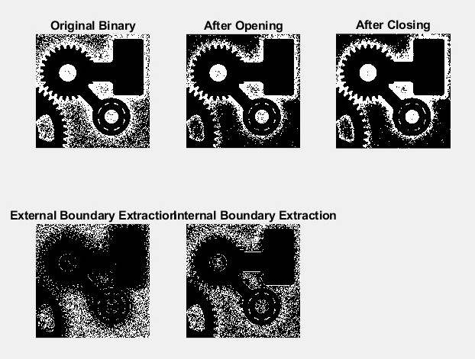**Internal Boundary:** Found by subtracting the original from the dilated image — highlights internal structures like holes.

**Observations:**

* **Original Image:** Messy with fuzzy edges.
* **After Opening:** Cleaner, smoother shapes.
* **After Closing:** Holes/cracks filled, solid-looking parts.
* **Boundaries:** Clear outlines (external) and internal edges (internal) visible.

**Part B – Bit Plane Slicing & Feature Analysis**

**Concept:**

Image split into 8 bit planes, each showing different levels of detail.

**Results:**

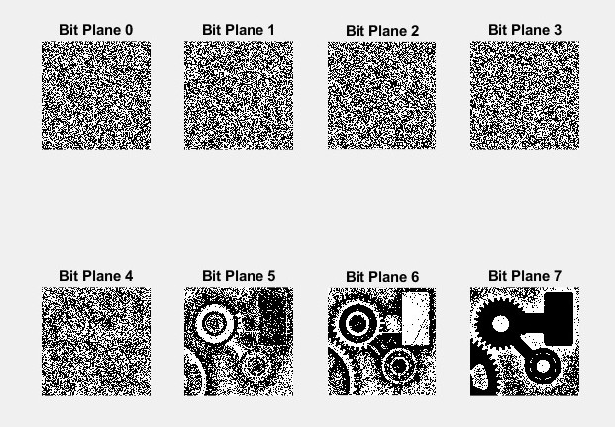

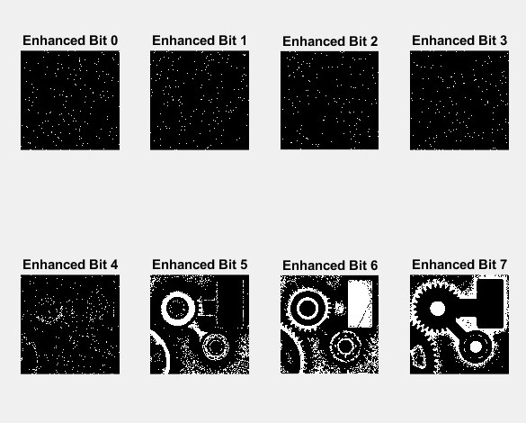

**Enhanced Bit Planes:** After applying tools, images had reduced noise and clearer shapes.

**Key Differences:**

* **Original Bit Plane 6:** Some detail, but fuzzy.
* **Original Bit Plane 7:** Clear main shapes but lacks fine detail.
* **Enhanced Bit Plane 6:** Best detail — shows small parts like gear teeth and cracks.
* **Enhanced Bit Plane 7:** Very clean outlines, but can miss finer details.

**Conclusion:**

* **Bit Plane 7:** Best for overall shape.
* **Bit Plane 6 (Enhanced):** Most useful for fine structural analysis and identifying small defects.