Software Requirements Specification

for

Online Cinema Booking System: CineMate
Version 1.0 approved
Prepared by Group 7
Carson Glenn Wijaya, Edward Wibowo, Karel Nathanael Tanoe
BINUS University
25 February 2026
Table of Contents
1. Introduction 1
1.1 Purpose 1
1.2 Document Conventions 1
1.3 Intended Audience and Reading Suggestions 1
1.4 Product Scope 1
1.5 References 3
2. Overall Description 3
2.1 Product Perspective 3
2.2 Product Functions 3
2.3 User Classes and Characteristics 3
2.4 Operating Environment 3
2.5 Design and Implementation Constraints 3
2.6 User Documentation 4
2.7 Assumptions and Dependencies 4
3. External Interface Requirements 4
3.1 User Interfaces 4
3.2 Hardware Interfaces 4
3.3 Software Interfaces 4
3.4 Communications Interfaces 5
4. System Features 5
4.1 System Feature 1 5
4.2 System Feature 2 (and so on) 6
5. Other Nonfunctional Requirements 6
5.1 Performance Requirements 6
5.2 Safety Requirements 6
5.3 Security Requirements 6
5.4 Software Quality Attributes 6
5.5 Business Rules 6
6. Other Requirements 7

Revision History
Name | Date | Reason For Changes | Version
Group 7 | 25/02/26 | Progress Chapter 1 content according to team discussion | 1.0
Group 8 | 04/03/26 | Progress Chapter 2 | 2.0
Group 8 | 07/03/26 | Adding Use Case | 2.1
Group 8 | 25/03/26 | Progress Chapter 3 | 3.0
Group 8 | 27/03/26 | Figma Design and Description | 3.1
Group 8 | 02/04/26 | Progress Chapter 4 | 4.0

Introduction

Purpose
This Software Requirements Specification (SRS) serves to describe the functional and non-functional requirements for an Online Cinema Booking System named CineMate. This document provides a comprehensive description of the system’s expected behavior, features, interfaces to support its development, testing, and deployment activities.
As the specified product is a working interface prototype that covers the function of a web-based cinema booking system, the SRS will also be mentioning features needed to be included and features that will just act as a simulation within the product. The document serves as a reference for stakeholders such as developers and the project manager to ensure a shared understanding of system requirements and project scope.

Document Conventions
High-level functioning requirements should always be identified with a unique ID, and it is assumed that any priority assigned to a parent requirement is automatically inherited by its detailed sub-requirements, and within the text, all User Interface Elements (such as buttons or menu items) must be bolded, while User Roles such as Admins or Customers, should be italicized. These conventions are designed to ensure that all developers and testers can quickly scan the document for actionable technical details without misinterpretation in the hierarchy of needs

Intended Audience and Reading Suggestions
This document is intended for the following stakeholders:
Stakeholder | Role
Project Manager (Lecturer) | Acts as the project manager and evaluator who reviews, validates, and approves system requirements and overall project direction.
Development Team (Group 8) | Responsible for designing, implementing, and integrating the CineMate prototype according to the specified requirements.

Product Scope
The CineMate Online Cinema Booking System will be developed as a web-app, with the intent of being developed as a functional prototype that demonstrates the workflow and user interface of a modern web-based cinema ticket booking platform. The system aims to simulate real-world cinema booking services by allowing user interaction such as movie browsing, showtime viewing,seat selection, and complete booking interactions within a controlled prototype environment.

CineMate is intended primarily for academic and demonstration purposes, providing a realistic representation of online cinema booking processes without integrating actual cinema infrastructure or live payment services. The prototype supports usability evaluation, requirement validation, and interaction design exploration for online booking systems.
In Scope
Features or systems that are within the product’s scope are as follows:
- User Interface Module: As CineMate is a web-app, it will require a web-based responsive interface enabling users to navigate the system, browse content, and perform booking activities.
- Movie Catalog Management: Display of available movies including titles, descriptions, posters, and duration information.
- Showtime Browsing Module: Presentation of scheduled showtimes associated with movies and cinema halls.
- Seat Selection Simulation: Interactive seat layout allowing customer accounts to select available seats and visualize booking status.
- Booking Simulation Module: Workflow that enables users to confirm reservations and generate simulated booking records.
- Basic User Account Features: Simple user registration and login for both customer and admin accounts. Customer accounts will include booking history viewing feature, while admin accounts will include movie upload history viewing feature.
- Administrative Content Management: Basic interface for managing movie listings, showtimes, and seat availability data.
- Backend / Database Layer: Storage of prototype data such as users, movies, schedules, and bookings using local or lightweight database solutions.
Out of Scope
As CineMate is only intended as an interface prototype that simulates real-world cinema booking services, the following features are excluded from this phase of the project:
- Integration with real cinema management systems or third-party ticketing platforms
- Implementation of multi-location cinema support, including management of multiple cinema branches
- Implementation of live online payment gateways or financial transaction processing
- Real-time synchronization with physical seat occupancy in cinemas
- Advanced security mechanisms beyond basic authentication
- Mobile application development

References
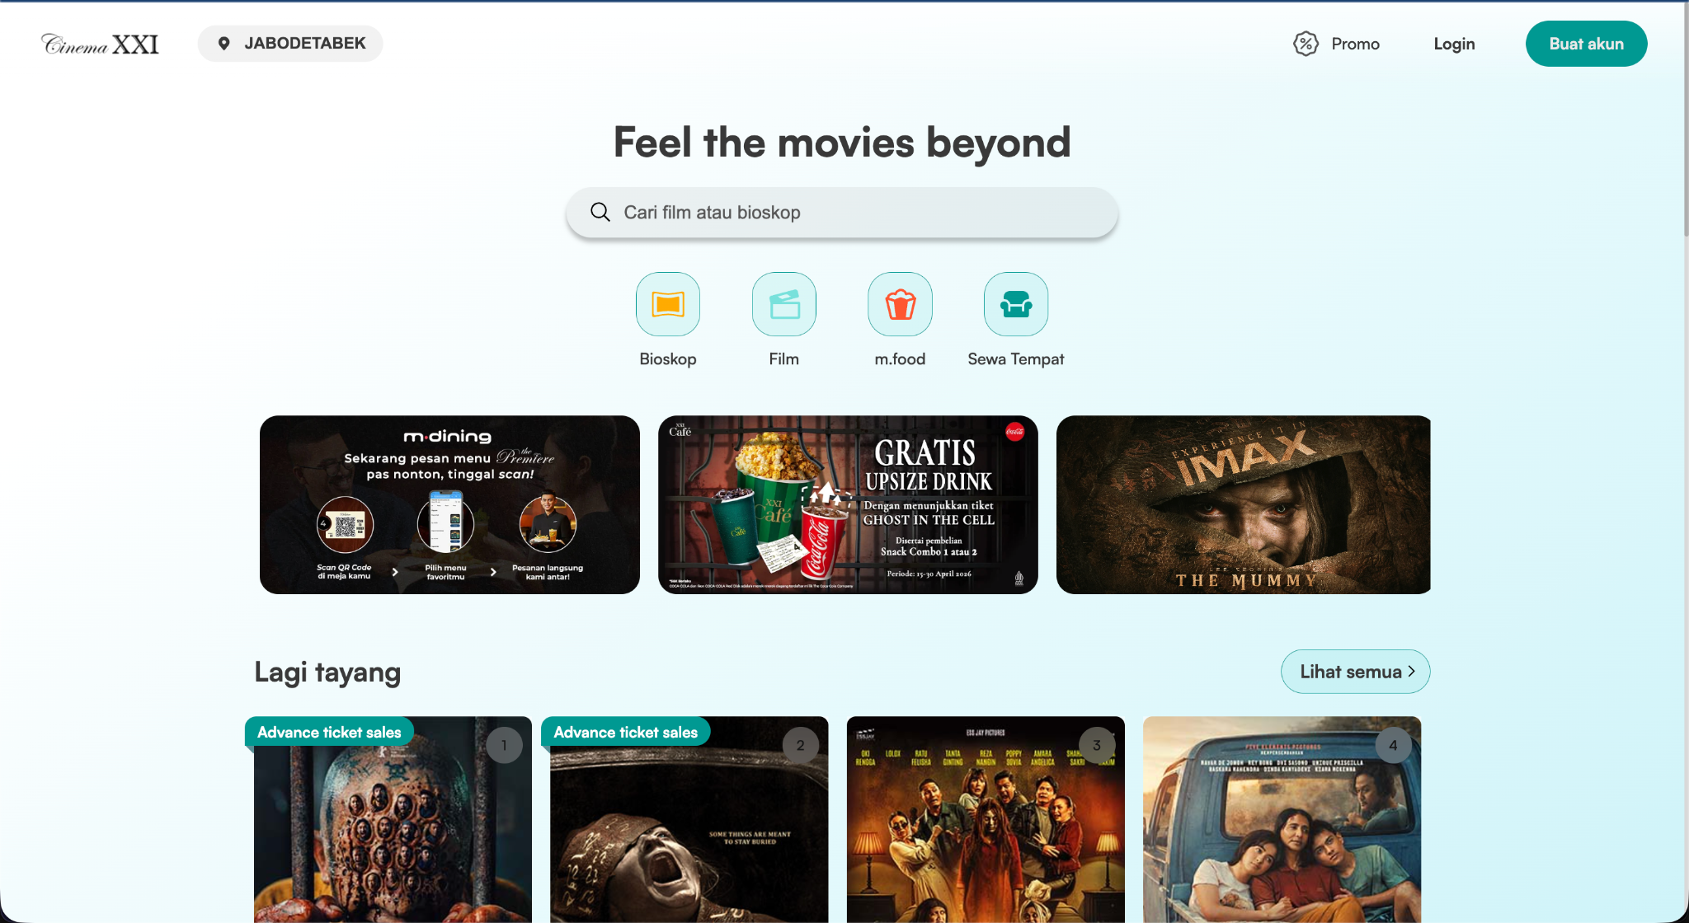

Overall Description

Product Perspective
CineMate is a new and self-contained web-based application designed as a functional prototype. It is not intended to replace or integrate with existing cinema infrastructure or third-party ticketing platforms at this stage. Instead, it serves as a standalone simulation to demonstrate the workflow and user interface of a modern cinema booking service for academic and demonstration purposes.

Furthermore, the system is developed to provide a seamless digital experience that bridges the gap between movie selection and seat reservation. By operating as an independent entity, CineMate allows for a focused evaluation of core features such as schedule browsing and intuitive booking flows without the complexities of external dependencies. This approach ensures that the prototype serves as a solid foundation for future scalability, potentially evolving into a fully integrated platform within a commercial cinema ecosystem

The system's relationship to other components is defined as follows:
- System Interfaces: CineMate will feature a responsive user interface accessible via standard web browsers
- Data Management: The product includes its own backend and database layer to manage prototype data, such as movie listings, schedules, and simulated booking records
- User Roles: The system is built to support interactions for two primary roles, the first one is Customers, who browse and book tickets, and Admins, who manage the movie catalog and system data

Product Functions
The CineMate system provides several core functions that allow users to interact with the platform based on their roles. For general users or customers, the system supports account registration and login, browsing available movies, viewing showtimes, selecting seats, and completing a simulated booking process. Users are also able to view their booking history through their account profile.
For administrative users, the system provides basic content management capabilities, including adding, updating, and removing movie data, managing schedules, and monitoring seat availability. These functions are designed to reflect the essential operations required to maintain a cinema booking platform. Overall, the system focuses on delivering a smooth and intuitive booking experience while maintaining a clear separation of responsibilities between customers and administrators.
Use Case Diagram :
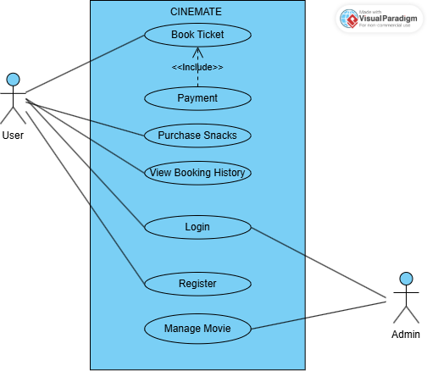

User Classes and Characteristics
The system is intended to be used by two primary user classes, which are customers and administrators. Each user class has different roles and characteristics as described below:
- Customer / User :
Customers are general users who interact with the system to browse movies and perform booking activities. They can register and log in to the system, search for movies, view showtimes, select seats, and complete booking processes. Customers are expected to have basic knowledge of using web applications, such as navigating pages and filling out forms.
- Administrator :
Administrators are users with higher access privileges who are responsible for managing system data. Their tasks include adding, updating, and deleting movie information, managing schedules, and monitoring seat availability. Administrators are expected to have a better understanding of the system compared to customers, as their actions directly affect the content and functionality of the platform.

Operating Environment
The CineMate system is designed to operate within a standard web based environment that supports accessibility and ease of use. As a web application, it does not require installation on user devices and can be accessed through commonly available browsers. The system is intended to run on widely used operating systems and devices, ensuring compatibility and flexibility for users in an academic setting.

Category | Description
Application Type | Web based application
Platform | Accessible through modern web browsers
Supported Browsers | Google Chrome, Microsoft Edge, Safari
Operating System | Windows, macOS
Device Type | Desktop and laptop
Network Requirement | Stable internet connection is required for system access

Design and Implementation Constraints
The development of CineMate is subject to several constraints that influence the system design and implementation:
- The system is developed as a prototype for academic purposes and does not include full real world integration.
- The application does not support real payment gateway integration or external cinema systems.
- The system is limited to web based implementation and does not include mobile application development.
- Development is constrained by time limitations based on the project schedule.
- The system is expected to use standard web technologies for both frontend and backend development.
- The database used is limited to handling prototype level data and does not support large scale production usage.

User Documentation
CineMate will be supported by basic user documentation to guide users in understanding how to operate the system. This includes simple instructions for account registration, login procedures, browsing movies, selecting seats, and completing bookings.
The documentation may be provided in the form of a user guide or integrated help sections within the application interface. Since the system is designed to be intuitive, the documentation serves as a supporting resource rather than a primary requirement for system usage.

Assumptions and Dependencies
The development and operation of the CineMate system are based on several assumptions and dependencies as described below:
Assumptions
The following assumptions are made during the design and development of the system:
- Users have access to a stable internet connection when using the application.
- Users access the system using modern web browsers that support standard web technologies.
- All movie data, schedules, and seat availability are manually managed within the system as part of the prototype.
- Users have basic knowledge of using web applications, such as navigating pages and filling out forms.
- The system is used primarily for academic and demonstration purposes rather than real world commercial use.
Dependencies
The system depends on several external and internal factors for proper functionality:
- Availability of web technologies used for development, including frontend and backend frameworks.
- Database system used to store and manage application data such as users, movies, and bookings.
- Browser compatibility to ensure the interface can be properly displayed and used.
- Hosting or local server environment to run the web application.
- Development tools and environments used by the team during implementation.

External Interface Requirements

User Interfaces
The CineMate system provides a web based user interface designed to be simple, clear, and easy to navigate for both customers and administrators. The interface is accessible through modern web browsers and is structured to guide users through the main functionalities of the system without requiring technical knowledge.

Web Figma Design Cinemate : https://www.figma.com/design/SoiUpL9zlbsrn0Sn8jJosL/Web-Design-CineMate?node-id=110-222&t=dw5wJ8y6S8IHbOja-1

Interface Page | Description
Login Page | The login page allows users to access their accounts by entering their email address and password. Users can choose to log in using a third party account. A link is also available for users who do not have an account, directing them to the registration page.
Register Page | The registration page allows new users to create an account. It includes input fields for email address, password, and password confirmation. A register button is provided to complete the process, along with a link that redirects existing users to the login page.
Home Page | The home page serves as the main entry point of the system. It includes a navigation bar with menu options and a user profile icon. A featured movie banner is displayed with a “Buy Ticket” button to start the booking process. Below the banner, movie categories such as Now Playing and Upcoming Movie are presented in a card layout showing movie details.
Movie Page | The movie page provides a complete list of available movies. It includes filtering options such as “Now Playing” and “Upcoming Movie,” allowing users to switch between categories. A search bar is also provided to help users find specific movies quickly. Movies are displayed in a grid layout using cards, making it easy for users to browse multiple options efficiently.
Food & Beverage Page | This page allows users to browse and purchase food and beverage items such as popcorn, drinks, and promotional bundles. Users can search for items, filter by category, and add selected items to their cart before proceeding to purchase.
Movie Details Page | This page displays detailed information about a selected movie, including poster, title, genre, duration, and description. Users can also select available showtimes and choose a preferred date before proceeding to seat selection.
Seat Selection Page | This page allows users to choose their preferred seats based on a visual seat layout. It shows seat availability status and provides feedback on selected seats before continuing to the payment process.
Payment Page | This page enables users to complete their transaction by selecting a payment method and entering the required details. It also displays an order summary including selected movie, seats, and total price before confirming the payment.
E-Ticket Page | This page displays the booking confirmation after a successful payment. It provides ticket details such as movie, seats, and schedule, and allows users to download or send the ticket via email.

Hardware Interfaces
CineMate does not require any specialized hardware interfaces to operate. The system is designed to run on standard computing devices such as desktops and laptops. Users interact with the system using common input devices such as a keyboard and mouse or trackpad.
Since the system is web based, no direct communication with external hardware components is required. All interactions are handled through the browser interface, making the system independent of specific hardware configurations.

Software Interfaces
The CineMate system interacts with several software components that support its functionality :
Interface Component | Description
Web Browser | Acts as the client side interface where users interact with the system, including initiating booking and payment processes.
Frontend Application | Handles user interactions, displays payment options, and communicates with the backend to initiate payment transactions.
Backend Application | Processes business logic, manages booking data, and integrates with the payment gateway API to handle transaction requests and responses.
Database System | Stores system data including user accounts, movie details, booking records, and payment transaction status.
Payment Gateway API | External service used to process online payments. It handles payment authorization, transaction processing, and returns payment status to the system.
Communication Protocol | Uses HTTP or HTTPS to securely exchange data between frontend, backend, and external services.

Communications Interfaces
The CineMate system relies on standard web communication mechanisms to enable interaction between the client side interface, backend server, and external services such as the payment gateway. Communication plays a critical role in ensuring that user requests, including booking and payment processes, are transmitted and processed accurately. The system is designed to use secure and reliable protocols to maintain data integrity and support smooth operation.
Communication Aspect | Description
Protocol | The system uses HTTP or HTTPS for communication between client, server, and external payment services.
Data Exchange | User actions such as booking and payment generate requests that are processed by the backend and forwarded to the payment gateway for transaction handling.
External Communication | The system communicates with a third party payment gateway through API calls to process payments and receive transaction results.
Network Requirement | A stable internet connection is required to ensure proper communication, especially during payment transactions.
Security Consideration | Secure communication using HTTPS is required to protect sensitive data such as payment information and transaction details.
Synchronization | Payment transactions depend on responses from the external payment gateway, which determine whether a booking is confirmed or not.

System Features
<This template illustrates organizing the functional requirements for the product by system features, the major services provided by the product. You may prefer to organize this section by use case, mode of operation, user class, object class, functional hierarchy, or combinations of these, whatever makes the most logical sense for your product.>

User Authentication
4.1.1 Description and Priority
The User Authentication feature allows users to create an account and securely access the CineMate system. This feature includes user registration, login, and basic session handling to ensure that only authorized users can access personalized functionalities such as booking tickets and viewing transaction history

This feature is essential for enabling user-specific interactions and maintaining system security

Priority: High

4.1.2 Stimulus/Response Sequences

User Action | System Response
User selects the Register option | System displays the registration form
User enters email, password, and confirmation password, then clicks Register | System validates input and creates a new user account
User selects the Login option | System displays the login form
User enters valid credentials and clicks Login | System authenticates user and redirects to the home page
User enters invalid credentials | System displays an error message and prompts user to retry
User selects third party login (e.g., Google) | System authenticates via external provider and grants access
User logs out from the system | System ends the session and redirects to the login page

4.1.3 Functional Requirements
REQ-1: The system shall allow users to register by providing a valid email address and password
REQ-2: The system shall validate that the password and confirmation password match during registration
REQ-3: The system shall prevent registration if the email address is already in use
REQ-4: The system shall allow users to log in using a registered email and password
REQ-5: The system shall authenticate user credentials before granting access to the system
REQ-6: The system shall display an error message when login credentials are invalid
REQ-7: The system shall allow users to log in using a third party authentication method such as Google
REQ-8: The system shall create and manage a user session after successful login
REQ-9: The system shall allow users to log out and terminate the active session
REQ-10: The system shall restrict access to authenticated features for users who are not logged in

Movie Browsing
4.2.1 Description and Priority
The Movie Browsing feature allows users to explore available movies within the CineMate system. Users can view movie listings categorized as Now Playing and Upcoming Movie, search for specific titles, and access basic movie information such as posters, ratings, and duration

This feature is important as it provides the primary entry point for users to discover movies before proceeding to booking

Priority: High

4.2.2 Stimulus/Response Sequences

User Action | System Response
User accesses the Movie page | System displays a list of available movies
User selects a category such as Now Playing or Upcoming Movie | System filters and displays movies based on the selected category
User enters a keyword in the search bar | System displays movies matching the search query
User clicks on a movie card | System redirects user to the Movie Details page

4.2.3 Functional Requirements
REQ-11: The system shall display a list of movies available in the system.
REQ-12: The system shall categorize movies into Now Playing and Upcoming Movie.
REQ-13: The system shall allow users to filter movies based on category selection.
REQ-14: The system shall allow users to search for movies using keywords.
REQ-15: The system shall display movie information including title, poster, rating, and duration.
REQ-16: The system shall allow users to select a movie to view detailed information.

Movie Details and Showtime Selection
4.3.1 Description and Priority
The Movie Details and Showtime Selection feature allows users to view detailed information about a selected movie and choose a preferred showtime. The system provides additional information such as movie description, genre, duration, and available schedules across different dates and studios.

This feature acts as a transition between browsing and booking, enabling users to make informed decisions before proceeding to seat selection.

Priority: High

4.3.2 Stimulus/Response Sequences

User Action | System Response
User selects a movie from the Movie page | System displays the Movie Details page
User views movie information | System displays details such as title, genre, duration, and description
User selects a date | System updates and displays available showtimes for the selected date
User selects a showtime | System records the selected schedule and proceeds to the Seat Selection page
User clicks “See Trailer” | System plays or redirects to the movie trailer

4.3.3 Functional Requirements
REQ-17: The system shall display detailed information for a selected movie, including title, genre, duration, and description.
REQ-18: The system shall display available showtimes for each movie.
REQ-19: The system shall allow users to select a preferred date for viewing.
REQ-20: The system shall update showtime availability based on the selected date.
REQ-21: The system shall allow users to select a showtime.
REQ-22: The system shall store the selected movie, date, and showtime for the booking process.
REQ-23: The system shall allow users to view the movie trailer.

Seat Selection
4.4.1 Description and Priority
The Seat Selection feature allows users to choose their preferred seats for a selected movie and showtime. The system provides a visual representation of the cinema seating layout, indicating seat availability status such as available, selected, or occupied.

This feature is critical in the booking process, as it determines the exact seats reserved by the user before proceeding to payment.

Priority: High

4.4.2 Stimulus/Response Sequences

User Action | System Response
User is redirected to the Seat Selection page | System displays the seating layout for the selected movie and showtime
User views seat availability | System shows seat status such as available, selected, or occupied
User selects a seat | System marks the seat as selected and updates the selection list
User selects multiple seats | System updates the list of selected seats accordingly
User selects an already occupied seat | System prevents selection and displays a notification
User clicks “Continue” | System saves selected seats and proceeds to the Payment page

4.4.3 Functional Requirements
REQ-24: The system shall display a seating layout for the selected movie and showtime.
REQ-25:The system shall indicate seat availability status, including available, selected, and occupied seats.
REQ-26: The system shall allow users to select one or more available seats.
REQ-27: The system shall prevent users from selecting occupied seats.
REQ-28: The system shall update and display selected seats in real time.
REQ-29: The system shall store selected seat information for the booking process.
REQ-30:The system shall allow users to proceed to the payment process after seat selection.

Booking and Payment
4.5.1 Description and Priority
The Booking and Payment feature allows users to confirm their ticket reservation and complete the payment process. After selecting seats, users are presented with an order summary that includes movie details, selected seats, schedule, and total price. Users can then choose a payment method and provide the required information to complete the transaction.

This feature is critical as it finalizes the booking process and determines whether a reservation is successfully confirmed. It also integrates with an external payment gateway to process transactions and return payment status.

Priority: High

4.5.2 Stimulus/Response Sequences

User Action | System Response
User enters the Payment page | System displays order summary including movie, seats, schedule, and total price
User selects a payment method | System updates the payment option and displays required input fields
User enters payment details | System validates the input data
User clicks “Buy” or “Confirm Payment” | System sends transaction request to the payment gateway
Payment is successful | System confirms booking and redirects to E-Ticket page
Payment fails or is rejected | System displays an error message and allows user to retry
Payment is pending | System displays pending status and waits for confirmation from payment gateway

4.5.3 Functional Requirements
REQ-31: The system shall display a booking summary including movie details, selected seats, schedule, and total price.
REQ-32: The system shall allow users to select a payment method.
REQ-33: The system shall allow users to input required payment details.
REQ-34: The system shall validate payment input data before processing.
REQ-35: The system shall send payment requests to the external payment gateway.
REQ-36: The system shall receive and process payment status from the payment gateway.
REQ-37: The system shall confirm the booking if the payment is successful.
REQ-38: The system shall display an error message if the payment fails.
REQ-39: The system shall handle pending payment status and update booking accordingly.
REQ-40: The system shall store transaction and booking data in the database.

E-Ticket and Booking Confirmation
4.6.1 Description and Priority
The E-Ticket and Booking Confirmation feature provides users with confirmation of a successful booking after completing the payment process. The system generates an electronic ticket containing booking details such as movie title, selected seats, schedule, and transaction information.

This feature ensures that users receive proof of their reservation and can access their booking details for future reference.

Priority: High

4.6.2 Stimulus/Response Sequences

User Action | System Response
Payment is successfully completed | System generates booking confirmation and displays the E-Ticket page
User views booking details | System displays movie, seats, schedule, and total payment information
User clicks “Download Ticket” | System generates and downloads the E-Ticket file
User clicks “Send to Email” | System sends the E-Ticket to the user’s registered email
User clicks “Book Again” | System redirects user to the home or movie page

4.6.3 Functional Requirements
REQ-41: The system shall generate an electronic ticket after successful payment.
REQ-42: The system shall display booking details including movie, seats, schedule, and total payment.
REQ-43: The system shall allow users to download the E-Ticket.
REQ-44: The system shall allow users to send the E-Ticket to their registered email.
REQ-45: The system shall allow users to navigate back to the main page to make another booking.
REQ-46: The system shall store booking confirmation details in the database.

Other Nonfunctional Requirements

Performance Requirements
The CineMate system is expected to provide responsive and efficient performance during user interactions. The system should be able to load pages such as the home page, movie listings, and booking interface within a reasonable time to ensure a smooth user experience. Additionally, the system should handle multiple user requests simultaneously without significant delays, especially during critical processes such as seat selection and payment.

Safety Requirements
The system is designed primarily for booking and browsing purposes and does not involve critical safety risks. However, it ensures that user data such as booking details and transaction information are handled properly to prevent data loss or incorrect processing. Basic safeguards are implemented to ensure that user actions, such as booking confirmation, are processed accurately.

Security Requirements
The CineMate system ensures that user data and transactions are protected through secure communication protocols. User authentication is required to access personalized features, and sensitive information such as login credentials and payment details are handled securely. The system uses HTTPS to encrypt data transmission and relies on a trusted payment gateway to process financial transactions securely.

Software Quality Attributes
The system is designed with several quality attributes to ensure a good user experience and maintainability:
- Usability: The interface is designed to be intuitive and easy to navigate, allowing users to complete tasks such as browsing and booking without difficulty.
- Reliability: The system consistently performs its intended functions, especially during booking and payment processes.
- Scalability: The system is designed to handle an increasing number of users and data as needed.
- Maintainability: The system structure allows for easy updates and modifications by developers.
- Availability: The system is accessible as long as there is an internet connection and server availability.

Business Rules
The CineMate system follows several business rules that define how users interact with the system and how certain operations are controlled. These rules help ensure proper system behavior and maintain consistency in the booking process.
- Only registered users are allowed to perform ticket booking and payment transactions.
- Users must log in before accessing personalized features such as seat selection and booking confirmation.
- A selected seat cannot be booked by more than one user for the same movie and showtime.
- Seats that have already been reserved or booked are not available for selection by other users.
- A booking is only confirmed after a successful payment transaction.
- If a payment fails or is not completed, the booking will not be confirmed.
- Users are required to provide valid information during registration and payment processes.
- Administrators have the authority to manage movie data, schedules, and system content.
- Users can only select showtimes that are available for the chosen movie and date.
- The system must ensure that all booking and transaction data are stored and recorded properly.

Other Requirements
Appendix A: Glossary

Term | Definition
User | A person who interacts with the system, including customers and administrators
Customer | A user who browses movies and performs booking transactions
Administrator | A user who manages system data such as movies and schedules
Booking | The process of reserving movie tickets
Showtime | The scheduled time when a movie is played
Seat Selection | The process of choosing seats before booking
Payment Gateway | An external service used to process payment transactions
E-Ticket | An electronic ticket generated after successful booking
Authentication | The process of verifying a user's identity
Database | A system used to store and manage application data

Appendix B: Analysis Models
Activity Diagram :

- Login User
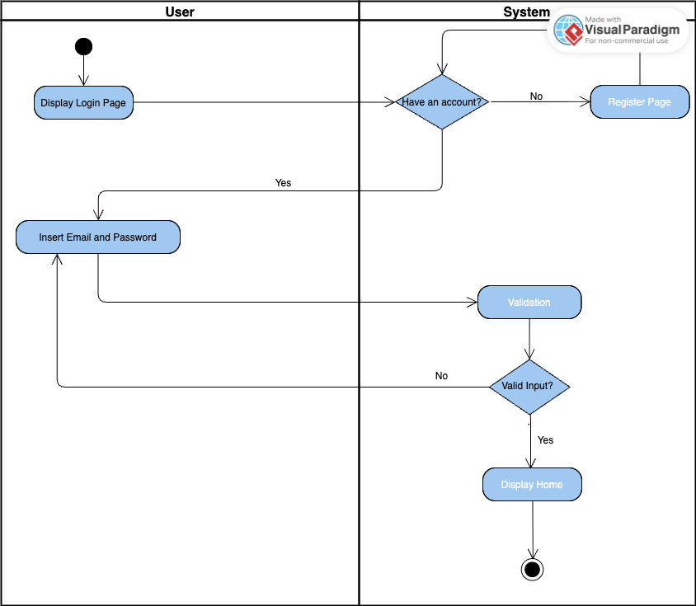

- Login Admin
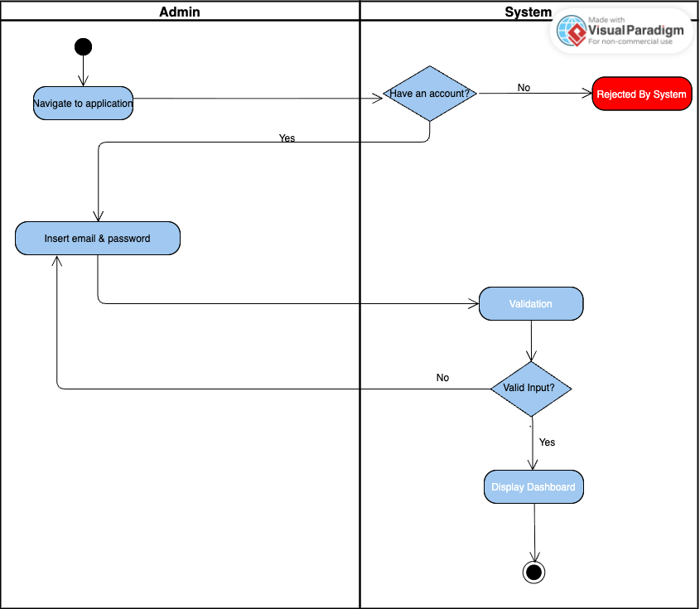

- Register
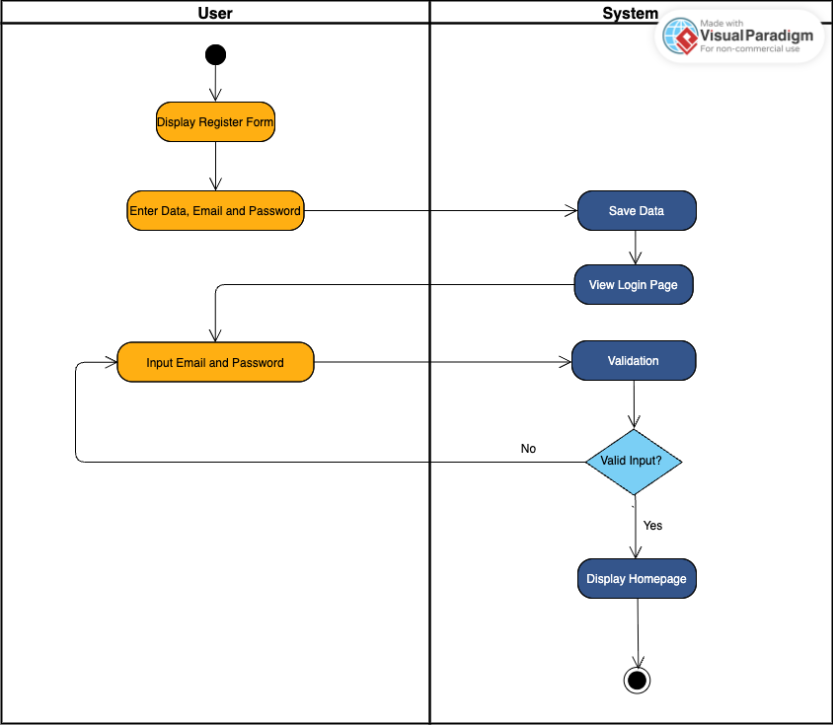

- Book or Buy Tickets
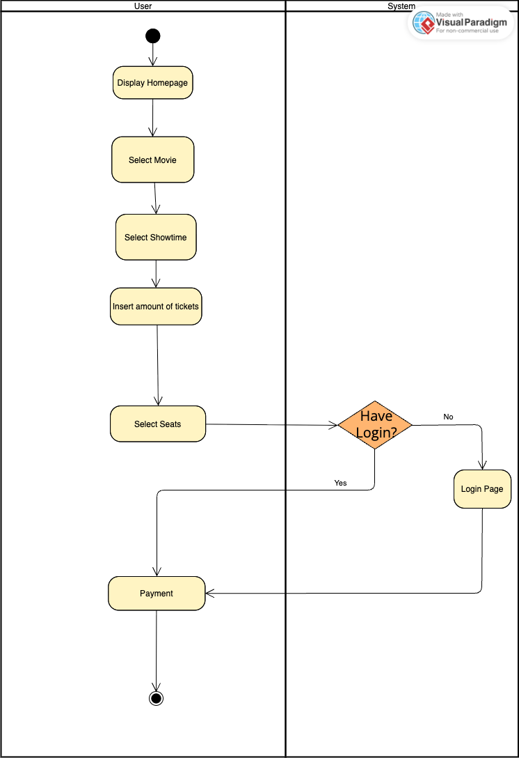

- Payments
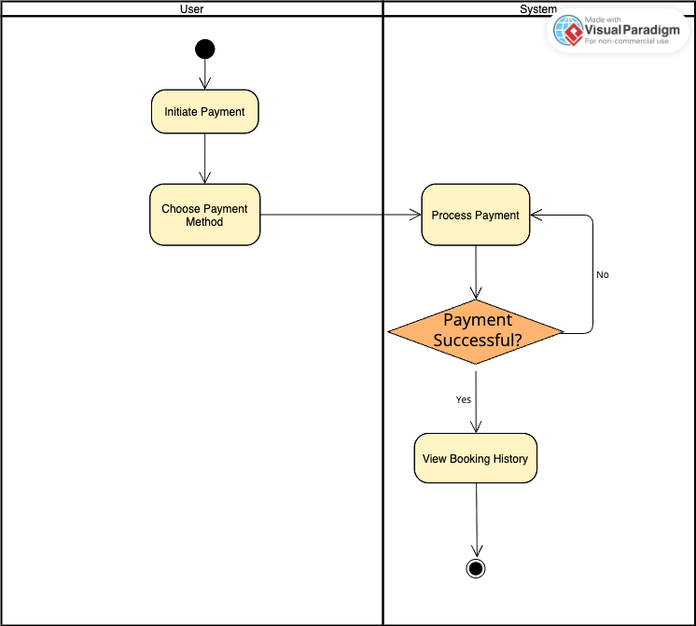

- Buy Snacks
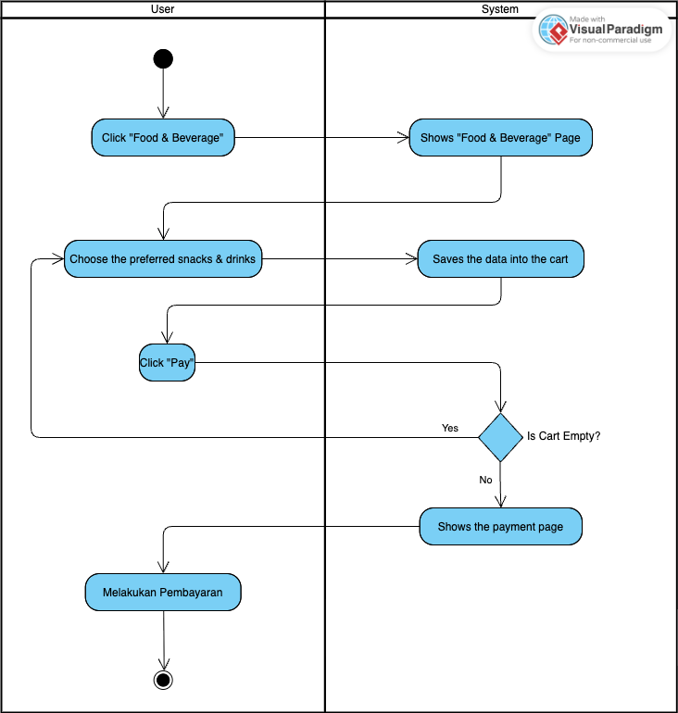

- View Booking History
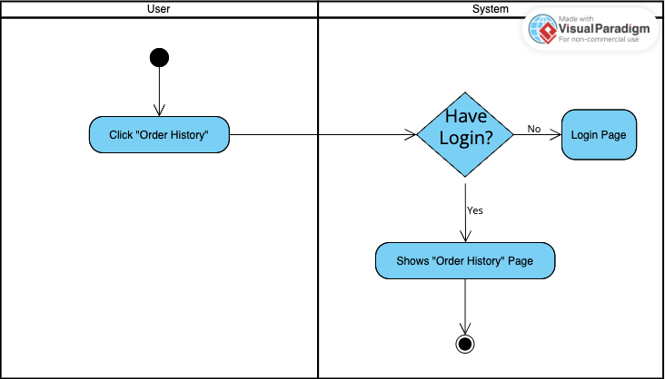

- Manage Movie
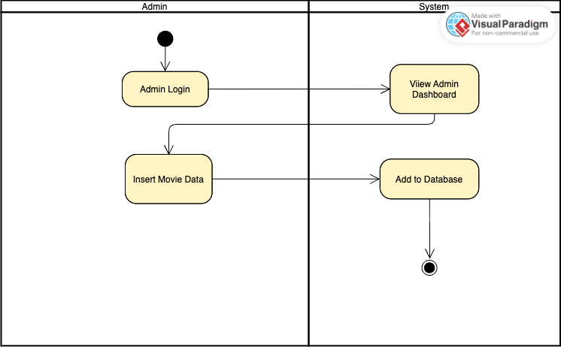

Class Diagrams :

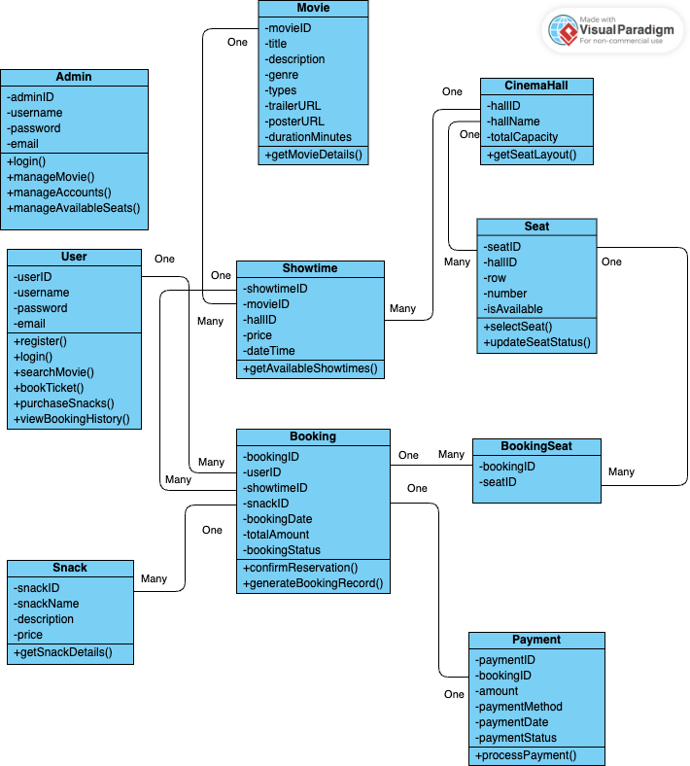

Sequence Diagram :
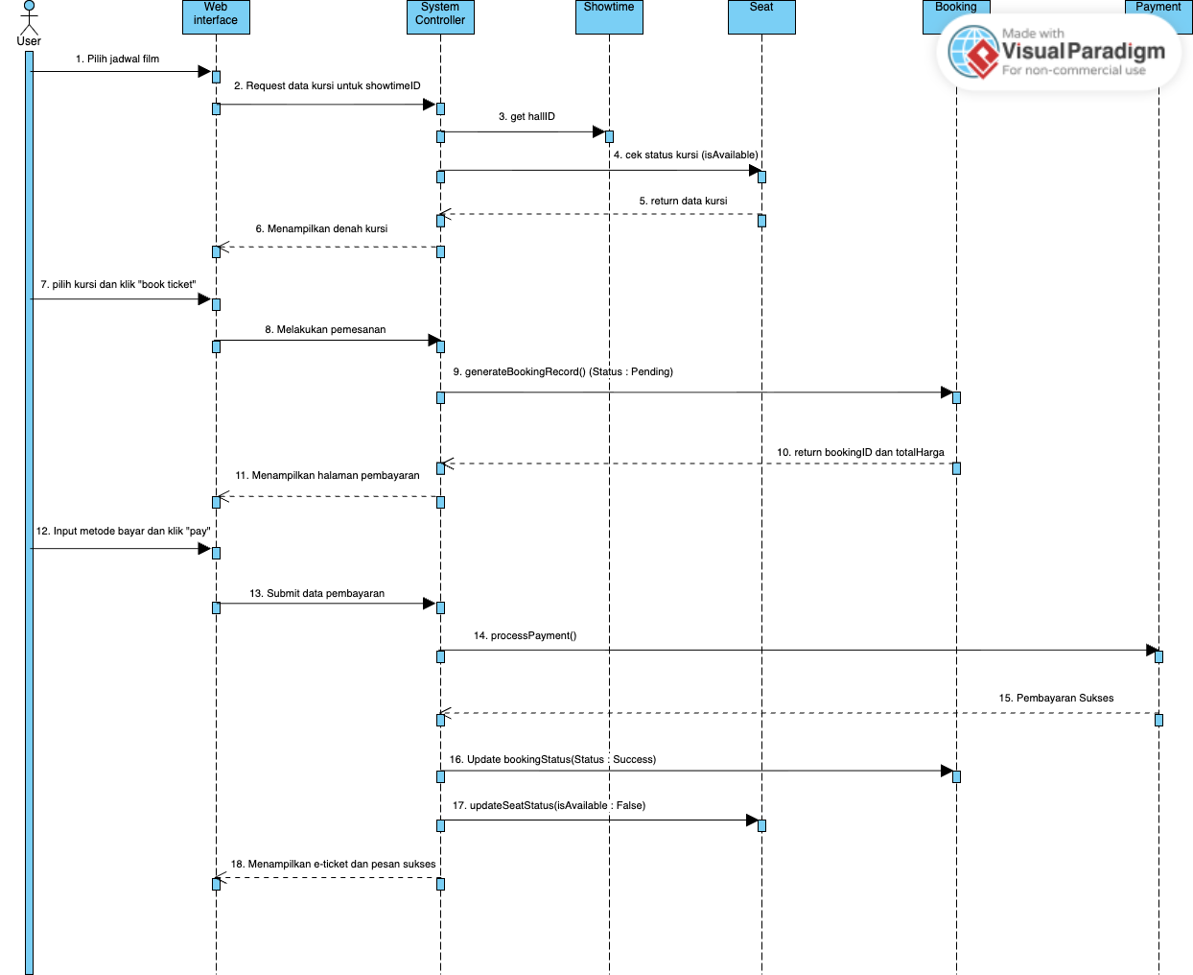

Appendix C: To Be Determined List
<Collect a numbered list of the TBD (to be determined) references that remain in the SRS so they can be tracked to closure.>

