**Event Management System**

**EventSphere**

List of similar products:

|  |  |  |
| --- | --- | --- |
| Product Name | Features | URL |
| |  |  |  | | --- | --- | --- | | **Zoho Backstage** |  |  |  |  |  | | --- | --- | |  |  | | Custom branding, RSVP tracking, session management, analytics | https://www.zoho.com/backstage |
| **Airmeet** | Virtual event hosting, engagement tools, networking lounges, Q&A | <https://www.airmeet.com> |

Roll Number : 927623BAD038

Name: GOPIKRISHNAN.S

Official Mail_id:[927623bad038@mkce.ac.in](mailto:927623bad038@mkce.ac.in%20%20gopi15062006@gmail.com)

Personal Mail_id: gopi15062006@gmail.com

Phone Number : +91 9043603313

**Contribution : Table Normalization ,form design ,Connecting to the database, Reports , Schema Design**

sites.google.com

portfolio

github: https://github.com/MMAVERICK06

leetcode: https://leetcode.com/u/gopikrishnan_15/

Table Name: (Master Table)

Events,

* + - * Event_name(primary key)
      * Event_id
      * Locations

(Transaction Table)

Accessories.

* + - Accessories_id(PK)
    - Event_id(foreign_key)
    - Accessories_quantity
    - Accessories_name.

Report Generation Table

Event_name(Primary Key)

Event_id(foreign Key)

Revenue

Total_people

Create table Events;

Insert table Events

Create View

**Keywords**

relation -Events

Attribute-Event_id

Domain- Start with Ev-001

Tuple- ('Ev-001', 'TechFest 2025', 'MKCE Campus')

Database Normalisation :

1-NF

2-NF

3-NF

4-NF

5-NF

**Events**

My table is an 1-NF because it has a primary key named Event_id

**2-NF**

My table is an 2-NF because it has primary key – Event_id , all other columns are dependent on the primary key – Event_name, Event_date, Event venue.

**3-NF**

Should be in 2-NF , no transitive partial dependency

Example : student_id , name , job_id ,job name, state_id , state name

927623BAD038 ,GOPIKRISHNAN, J_0138, Software Engineer, TN056, Namakkal

**1NF**- student_id,name because it has no duplicate values

**2NF** – student id , job id

Student info table

Student_id, student_name, , state_id, state_name

Job table

Jod_id, Job_name

**3NF** -Student role table , student info table

Student_id , student_name , State_id

Job Info Table

Job_id,Job_name,state_id,state_name

**Front-end :** HTML, CSS, React Js,TailWind CSS,Flask, android , Flutter

**Back-end** MySql,Oracle,Mongo DB, JSON,SQLLite,FireBase

**Server : :** XAMPP V3.3.0,

**Editor :** VS code

**Frame-Work:** Node Js

**Language : Python**

Example: Events-Parent tag

Column name : Event_name,E vent_venue, Event_date – sales tag

<XML>

<Events>

<event_id>ev-001</event_id>

<Event_name>Birthday</event_name>

<event_date>01/01/2025</event_date>

<event_id>ev-002</event_id>

<Event_name>Anniversary</event_name>

<event_date>02/02/2025</event_date>

<event_id>ev-003</event_id>

<Event_name>Party</event_name>

<event_date>03/03/2025</event_date>

</Events>

</XML>

DTD

sdgdgb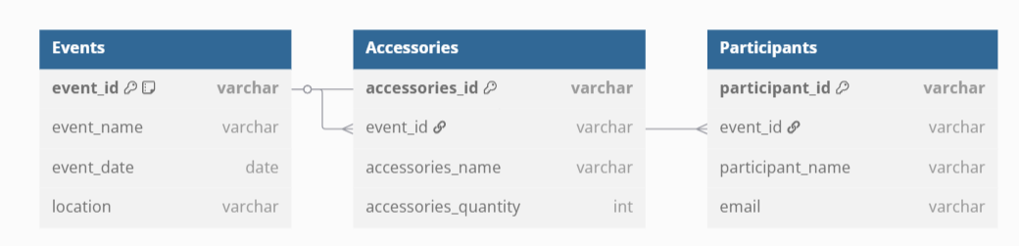

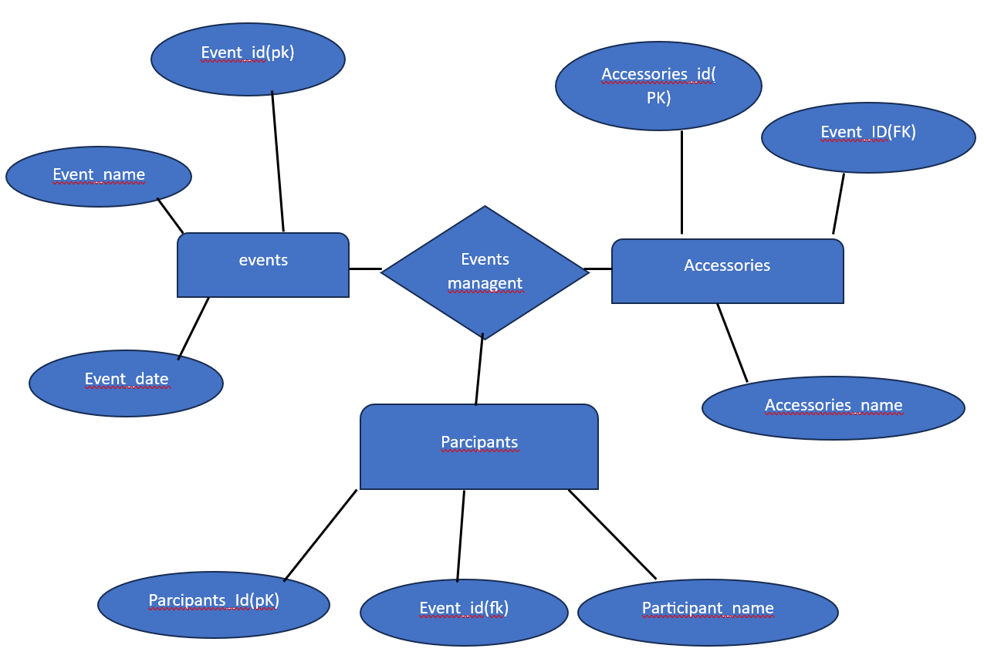

DTD with no elements

XML FILE

<login> timeout=100</login>

DTD

<!ELEMENT login EMPTY>

<!ATTLIST timeout CDATA”1”>

**JOIN**

Inner Join

SELECT

Events.event_id,

Events.event_name,

Accessories.accessories_name,

Accessories.accessories_quantity

FROM Events

INNER JOIN Accessories ON Events.event_id = Accessories.event_id;

Module Details

Module name submodule details description

|  |  |  |
| --- | --- | --- |
| Module Name | Sub module name | Description |
| |  |  |  | | --- | --- | --- | | Event Manager |  |  | | Create Event | Allows users to create new events |
| Edit Event | Modify details of existing events |
| Delete Event | Remove an event from the system |

|  |  |  |  |  |
| --- | --- | --- | --- | --- |
| Module name/submodule name | Form name/ type | Form description | Table name type | Table description |
| Event Management | Create Event | Form to add new events | Events (Master) | Stores event_id, name, date, location |
| |  | | --- | | Edit/Delete Event |  |  | | --- | |  |  |  | | --- | |  |  |  | | --- | |  | | Modify or remove existing events | Events (Master) | Updates or deletes event records |