硕士学位论文

中国商品期货市场对海外市场过度反应的实证研究

**EMPIRICAL STUDY ON CHINESE FUTURE MARKETS’ OVERREACTION TO FOREIGN MARKETS**

作者：李琼

导师：郭明教授

上海交通大学上海高级金融学院二○一三年四月

**Empirical Study on Chinese Commodity Future Markets' Overreaction to Foreign Markets**

**By**

**Li Qiong**

**Under the Supervision of Professor Guo Ming**

**Submitted in Partial Fulfilment of the Requirements For the Degree of Master in Finance**

Shanghai Advanced Institute of Finance Shanghai Jiaotong University

April 2013

**Contents**

目 录

**Abstract** 3

摘 要 3

**Chapter 1****Introduction** 3

**1.1****Background** 3

**1.2****Research purpose** 3

**1.3****Structure of this paper** 4

**Chapter2****Literature review** 4

**2.1****Researches on dynamic relation of two related markets** 4

**2.2****Researches onthe overreaction of the financial market** 4

**Chapter 3****Overreaction** 4

**3.1****Definition:** 5

**3.2****The psychological basis for Overreaction** 5

**3.2.1****Cognitive biases of Institutionalinvestors** 5

**3.2.2****Cognitive biases of Individualinvestors** 5

**3.3****Trading rules make the overreaction more significant** 5

**Chapter 4****Methodology** 6

**4.1****Unit Root Test&Granger Causality Test** 6

**4.2****Regression Models** 7

**Chapter 5****Empirical Study** 7

**5.1****Data collection andpre-processing:** 7

**5.2****Result of Unit Root test & Granger Causality test** 8

**5.3****Results of Regression Model** 11

**5.4****Results of regression model with high-frequency data** 13

2.5 hour, which is the close price in the morning. The equations are as follows, 13

**Chapter 6****Trading Strategy** 14

**6.1****Build a trading strategy** 14

**6.2****The result of the trading strategy** 15

**Chapter 7****Conclusion** 19

**Bibliography** 19

**Abstract**

This paper researches the Shanghai Future Exchange markets‟overreaction to the London Metal Exchange, and mainly focuses on non-ferrous metal futures, copper, aluminium and zinc

We do theoretical analysis on the potential reasons for overreaction phenomena. The cognitive bias of investors is one of the main reasons. Trading ruleslike T+0 transaction system, margin system, close position system and shortposition systemmake the overreaction more significant.

In the empirical study, we find copper, aluminium and zinc in Shanghai Future Exchangeand London Metal Exchange have a lead-lag relationship. Then we do tests to analysis how the informationtransfers from the London market to Shanghai marketand test our initial hypothesis. We find that the copper future in the Shanghai market used to overreact to London market, but the market is more efficient in recent years and such overreaction no longer existed. For aluminium and zinc, there is a significant overreaction and there is an arbitrage opportunity.

**Keywords: Overreaction; Non-ferrous metal future; Foreign market**

摘 要

本文研究了中国上海期货交易所的有色金属期货对伦敦金属交易所的过度反应，主要研究铜，铝，锌三个期货品种。

我们首先分析了造成商品期货市场过度反应的心理学原因，机构投资者与个人投资者各自的认知偏差反应到了他们的投资决策中，从而造成了过度反应。另外，期货市场的一些固有交易机制更是加强了过度反应的程度。

在实证部分，我们首先证明了伦敦市场的铜，铝和锌的价格变动，即收益率的确对上海市场存在引导作用。其次，我们进一步发现在引导的过程上海市场对伦敦的信息存在过度的反应。铜期货在早期对伦敦市场存在过度反应，但是2007年后市场变得更为有效，这种现象不在存在。铝期货和锌期货均存在一定程度的过度反应，以此构造的投资策略能获得显著的正收益。

**关键字：过度反应有色金属期货海外市场**

# **Chapter 1** **Introduction**

## **1.1** **Background**

In the highly developed financial world, financial products are more and more diversified nowadays. Among them, future is one of the most important derivative securities. Futures have lots of good features, like high liquidity and standard structure. The major roles offutures in the financial markets are price discovery and hedging. Price discovery means with the transactions in the futures market, the information of the underlying asset will reflect in the futures prices. Hedging refers to the investment strategythat people use the relationship between the futures contracts and the underlying asset or the relationship between different contracts to construct portfolios to avoid risk to some extent.

Currently, the Chinese commodity future exchanges include Shanghai Futures Exchange, Dalian Commodity Exchange, and Zhengzhou Commodity Exchange. There are many kinds of commodity futuresproducts, including agricultural futures, energy futures and non-ferrous metals futures. In domestic future markets, copper and aluminium in Shanghai Futures Exchange (SFE), soybeans in the Dalian Commodity Exchange (DCE) and thewheat in Zhengzhou Commodity Exchange (ZCE) are quite active. While in the international future markets, thecopper and aluminium in London Metal Exchange (LME) and the soybean and wheat in Chicago Board of Trade (CBOT) are quite active. The active commodity futures are mainly agricultural futures and non-ferrous metals futures. This paper will mainly focus on non-ferrous metals futures, since agricultural futures are more fluctuatedand have quite close relationship with weather and many other factors. Non-ferrous metals futures are relatively maturein the future markets so far. Currently, the world's non-ferrous metals futures mainly trade in the London Metal Exchange, New York Mercantile Exchange and the Tokyo Commodity Exchange. Especially, the trading price of the London Metal Exchange futures contracts are recognized as the bench price of non-ferrous metals

Trading all around the world. And the trading of copper futures in Shanghai Futures Exchange grows rapidly in recent years. Now the trading volume of copper futures in Shanghai Futures Exchange is ranking firstplace in the world, more than that in London Metal Exchange and New York Mercantile Exchange,

China is the biggest country in non-ferrous metal production and consumption in the world. The supply and demand of copper, aluminium and zinc are all rankingthe first place among all the countries. The average annual copper tradingvolume reached

5.2 millionhands(unilateral) in SHFE from 2010 to 2012. Suppose the average price of copper is 58000 yuan per ton, the average annual trading value will be 1.5 billion yuan, that is, about 2.2 trillion dollar. The average annual zinc tradingvalue reached9.5 quadrillion dollars (unilateral) in SHFE. However, the average annual turnover volume of LME futures from 2010 to 2012 is about 4 millions hands (unilateral), or about 800 billion dollar, close to the 1/3amount of the that in SHFE.

Unit: $ million

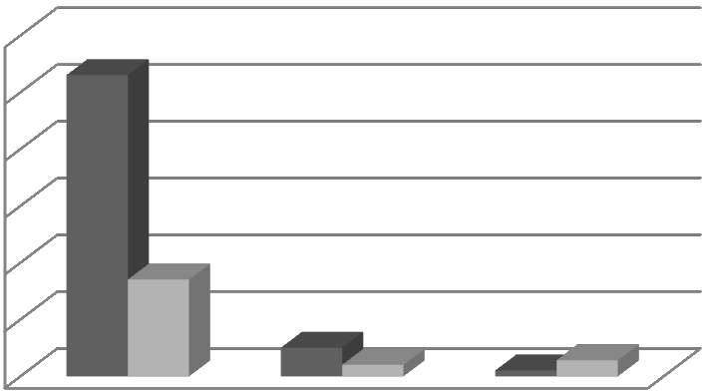

3000000

2500000

2000000

1500000

SHFE

LME

1000000

500000

0

copper

zinc

aluminium

**Figure 1：The Trading Volume of Non-ferrous Metal in 2012 (unilateral)**

With the development of the world economy integration and China trade policy being more and more opening, the prices of materials in domestic market are getting closer and closer with that in the international markets. Since the 1990s,

Chinesefutures market has become an important part of China's economy. Especially, in the recent years, the degree of standardization in Chinese futures market has improved significantly, the future markets have become more efficient and international than ever before. The interaction impact between domestic future markets and the international future markets is becoming more and more apparent.

In fact, if the market is fully open and completely competed, there is no barrier for international trading, and the information of goods, both supply and demand, can be quickly reflected in commodity prices. Then, the price of the same commodity in different markets tends to be the same, due to the non-arbitrage theory. On one hand, because of the reasons we have mentioned above, future prices of the same commodity all over the world share the similar related information, like supply and demand. It is reasonable to believe future price has interactive relationship between the domestic futures market and the international futures market. On the other hand, the prices also depend on the different standards of underlying asset, the specific design of the futures contracts and rules of transactions and delivery. What‟s more important, the world‟s market is surly not fully open and completely competed. It is also possible that the future prices in domestic future markets and international futures markets change independently.

## **1.2** **Research purpose**

In the later literature review part, we can find that there are many papers on the relationship between domestic future market and the international future market, but there is few research on the topic whether domestic future market overreacts to international future market or not.

Actually, the literature on overreaction phenomenon in Chinese future market is also limited. And most of their research method is trying to define the information according to the initial price series and then test how the price behaves after the information through event study. There is one important problem is that it is really

Subjective to define a good or bad information.

In this paper, we study on the Chinese future markets‟overreaction to the international future market. We regard the international future market‟s performance as information and avoid being subjective.

By studying this topic, we can find the dynamic relationship between the Chinese future market and the international future market and how the informationtransfers from one market to another. By testing whether there is overreaction or not we can see if there is any arbitrage opportunity, and analysis the market efficiency from this aspect.

## **1.3** **Structure of this paper**

Firstly, we do some literature review on dynamic relations of two related markets and researches on the overreaction of the financial market.

Then, we make theoretical analysis on the psychological basis for overreaction. We analysis the potential reasons which may lead overreaction, including the cognitive bias of institutional investors and individual investors, and the trading rules in the future market.

In the empirical study, we do granger causality tests to find whether the price of a commodity future on one exchange will necessarily move according to its price change on another exchange, which is a premise for my later study.

Then we look deep into how the informationtransfers from one market to anotherand figure out whether the market reacts to the information from other market rationally or notwith data of opening and closing prices and analysis the intraday and overnight returns of different markets.

At last, we build a trading strategy according to the results in empirical study and test whether there is any arbitrage opportunity or not.

# **Chapter2** **Literature review**

## **2.1** **Researches on dynamic relation of two related markets**

Large empirical studies have been conducted in dynamic relations of the prices between future and the underlying assets (Garbade and Silber, 1983; Wahab and Lashgari, 1993; Hung and Zhang, 1995; Pizzi, Economopoulos and O. Neill, 1998). And also, many researches have been done to find the relationships between different markets as well. They try to figure out the relationship between markets, the price linkages across the markets and how the price transfer from one to another in the related markets. These researches are conducted in many different econometrics ways, in calculating correlation coefficient, doing regression, doing co-integration test and granger causality test, building bivariate asymmetric GARCH model and so on.

The most widely used method used to find the relationships between different markets is to use co-integrationtest and the Grangercausality test. Shyy and Lee (1995) use Granger causality test to analysis the German government bond futures traded in London international financial futures exchange (LIFFE) and German bond exchange (DTB). They find that the price in London international financial futures exchange leads the price in German bond exchange, but the result is not significant in the opposite way. Tse and Booth (1995) find that US treasury and Euro-dollar future

Prices are co-integrated. Booth、Lee and Tse ( 1996) do a research on Nikkei 225

Index Futures traded on Singapore international currency Futures exchange (SIMEX), the London international financial Futures exchange (LIFFE) and the international monetary market (IMM). They find that all the prices in these three markets are co-integrated with each other. ShyyandShen (1997) do a granger test for prices of Japanese government bond future traded in the Tokyo stock exchange (TSE) and Singapore international currency futures exchange (SIMEX) and find they are the granger cause for each other. Booth, Brockman and Tse(1998) conduct a research on the relationship between US and Canadian Wheat futures prices and find the two

Series are co-integrated as well. And the wheat future price in Chicago board of trade (CBOT) is the granger causality of the price in Winnipeg Commodity Exchange (WCE), but not the opposite.

Hua and Chen (2004) study the dynamic relationship between the Chinese future markets and the world futures markets of copper, aluminium, soybean and wheat, using co-integration test and the Granger causality test. They find that some futures prices are co-integrated with the foreign markets and some don‟t. The price of copper and aluminium traded in the Shanghai Future Exchange (SHFE) is co-integrated with the ones traded in the London Metal Exchange (LME). The price of soybean future traded in Dalian Commodity Exchange (DCE) is co-integrated with the ones traded in Chicago board of trade (CBOT). The price of wheat future traded inZhengzhou Commodity Exchange (ZCE) is not co-integrated with the ones traded in Chicago board of trade (CBOT). Zhang, Fang and Huang (2006) find that the price changes in copper, aluminium, soybean and wheat future in foreign market is the granger cause of these in domestic future market, but the price changes in the domestic market are not the granger cause for the foreign market. Zhang, Fang and Huang (2006) do a future research on how the price information transfers from foreign market to domestic and find that the domestic market is lagged in reflecting the foreign information.

There is also another way to figure the relationship, to use a bivariate asymmetric GARCH model to examine how the information flows across different markets. As Xu and Fung(2005) do forsilver, gold and platinum futures contracts traded both in the U. S. and Japanese markets and test the spill-over effect between them.

There is another important and ingenious way to analysis the price linkages across the markets and how the price transfer from one to another in the related markets. They focus on opening and closing stock prices and analysis the intraday and overnight returns of different markets. One of the most important conditions to conduct such research is the trading hours of these two markets should not overlap on each other, which is naturally suitable to do the research on international markets with

Jet lag, the use of daily opening and closing prices for the analysis allows them to address more attention on the timing of the information transfer to other markets, it is more precisely than other methods.

Becker, Finnerty and Gupta (1990) have a research on the daily opening and closing data for S& P 500 and Nikkei index over three years. The S& P index‟s performance has significant influence on both the overnight and intraday returns of the Nikkei index. And on the other hand, the Nikkei index has significant influence on the intraday return of S& P 500, but not overnight returns. Hamao, Masulis and Ng (1990) employ GARCH model on market indexes of the U. K, U. S. and Japan. They find a spill-over effect of conditional variances from U. S. to the other two, but not vice versa. And they also find that for these three markets, the open-to-close, that is the intraday returns of the foreign markets have significant positive impact on opening price. Lau and Diltz (1994) use the daily opening and closing data of seven Japanese companies‟ stocks that are both listed on the Tokyo Stock Exchange (TSE) andthe New York Stock Exchange (NYSE), concluding that market barriersthat may prevent information transfer between stock returnsin TSE and NYSE are not significant. And they also tested that two exchange listings do not provide any opportunities to arbitrage. Bae, Cha, Cheung (1999) provide further research in a similar way with a larger sample. They use the data of eighteen corporations and a longer sample period. What‟s more importantly, with a growing concern on thedeveloping markets, they investigate stocks which are dually listed on an developing market and a developed market, with the data the London Stock Exchange (LSE) andStock Exchange of Hong Kong (SEHK), showing that the information transmission between these two markets runs in both ways and that most of the transmissions do not finish overnight and will be continued during the following day.

## **2.2** **Researches onthe overreaction of the financial market**

The overreaction phenomenon in a security market was proposed by DeBondt and Thaler, in 1985. They did an empirical test based on The Centre for Research in

Security Prices (CRSP) return datamonthly, finding it consistent with the over-reaction hypothesis, which is the first attempt to use a behavioural finance way to predict a new kind of market anomaly. They find that the historical„Loser Portfolio‟can have better performance than historical„Winner Portfolio. After that there has been considerable interest on investors‟possible overreaction. Lots of researches have been done on US, European and Chinese stock market and also in other financial markets.

In international stock market, Spanish securities market (Alonso, A., &Rubio,), Brazil securities market (da Costa) and UK securities market (Clare &Thomas) are proved to have overreaction phenomenon. In Asian securities market, Alexander

K. -W. Fung (1999) does a research on the HK stock market. De Bondt and Thaler use arithmetical average method to computer market yield, and Alexander K. -W. Fung make an improvement and use geometric average method to reduce error when calculating the market yield caused by the bid-ask spread. He finds that the„Loser Portfolio‟performances better than„Winner Portfolio‟in 33 stock in Hang Seng Index (HSI), then he concludes that overreaction phenomenon has also existed in HK securities market.

In Chinese stock markets, Zhang, Zhu and Wang (1998) study on the trading data of companies in Shanghai Stock Exchange; they conclude that overreaction phenomenon didn‟t occur in Shanghai securities market. However, Shen and Wu (1999) used the trading data in Shenzhen Stock Exchange to study the„Winner Portfolio‟(top ten percentage stocks) and„Loser Portfolio‟(bottom ten percentage stocks) performance in the following 46 weeks, and they conclude that overreaction phenomenon didn‟t exist in Shenzhen securities market.

There are considerable researches in China and foreign countries on the overreaction phenomenon in stock markets, since overreaction was firstly been proposed there. While, they pay less attention on future market, the literature on overreaction phenomenon in future market is relative limited.

In international market, Ma, Rao and Sears (1989) study the bond future price

Fluctuation in Chicago future market, they conclude that overreaction phenomenon occurred in bond future market. Ma, Dare and Donaldson (1990) do a research on the US future market, they conclude that agricultural futures price overreaction to important events, but financial futures price under reaction to important events. Gay, Kale and Kolb (1994) find that there is under reaction of future contract in US futures market, while there is not enough evidence for overreaction. And futures contract price react more strongly to bad news than good news. Haiwei Chen (1998) study 19 future contracts in US futures market, he concludes that it is hard to conclude whether there is overreaction or not and the results depend on the standard. And we haven‟t got sufficient evidence that there is overreaction in US future market. J. Barry Lin (1999) studies the daytime price reversal in the US futures market, he finds the universal existence of profit reversal, and he concludes that overreaction exists in US future market. Changyun Wang and Min Yu(2004) studied weekly price inversion phenomenon in US future market, they find that the phenomenon is significant when holding period is one week, while the phenomenon is not significant when holding period is two, four and eight weeks. They conclude that overreaction phenomenon occurs in US future market in short period.

In Chinese futures market, Liu and Bao (2004) do an empirical study in Shanghai futures market, they conclude that rubber market is not an efficient market, but it did not show reverse in price, and that is, there is no overreaction in futures market. Instead, there is under reaction. Zhou and Tang(2006) use event study method to test whether overreaction phenomenon occurs in Chinese futures market. They find that overreaction to good or bad news did not occur in Chinese commodity future markets and aluminium in one month and rubber in three month under reaction to good news. Jiang and Wu (2007) do a research on five major products (Shanghai copper, Shanghai aluminium, Shanghai rubber, Dalian soybean, Zhengzhou wheat) in Chinese commodity futuresmarket. They find that no matter good news sample or bad news sample, all the five products‟reverse trading strategy cannot get significant returns. Therefore they conclude that there is no overreaction and Chinese commodity future

Markets are efficient.

# **Chapter 3** **Overreaction**

## **3.1** **Definition:**

According to traditional Efficient Markets Hypothesis (EMH), the price of a financial security is already contained all the relevant information and price is the true value of the underlying asset all the time, so they are always traded at their fair value on exchanges. Thoughthe EMH is the fundamental of modern financial theory, it is highly controversial and often being debated in the recent decades. And lots of empirical studies have showed that it's not always the case.

One of the phenomena inconsistent with the EMH is the markets have over-reactions and under-reactions to new information. Overreaction happens when certain good new information release in a security market, it causes big movement of the price, which is higher than its true value. And afterwards, the price will retrace to the normal level. Of course the movement can be up and down, when bad news come, the price may drop to a really low level and back to the normal level later. For example, suppose that company ABC releases its annual report to the market. And it is not consistent with analysts‟expectations a little bit difference per share. Investors will somehowpush the stock price to unprecedented high levels. After several days of trading, the stock price will fall down near to the normal level before the report release, which is the stock's intrinsic valuecurrently. The same things happen in future market.

## **3.2** **The psychological basis for Overreaction**

Overreaction theory is one of the important theories in western investment psychology. Due to psychological factors such as a series of emotional and cognitive, People do the investment process. Past researches have shown that investors, when making investment decisions, tend to have some cognitive biases. The researches

Suppose that the reasons caused investor cognition biases are the factors including investor attitude, capacity and limited information and so on. And sometimes such biases are human nature, investors simply based on the inherent psychological mode to make investment decisions. Some cognitive biases are important reasons for market overreaction.

Not all the investors in future markets are rational; their psychological cognitive and behavioural biases will affect their investment decisions. There are mainly two kinds of investors in the market, institutional investorsandIndividualinvestors.

### **3.2.1** **Cognitive biases of Institutionalinvestors**

Institutionalinvestors in future markets have the following kinds of cognitive and behavioural biases:

**a. Overconfidence**

Institutional investors of future markets own a large number of professional knowledge, professional tools and professional teams. When they make investment decisions, they tend to being over confidence and over-estimate their judgments. According to the psychological study, when people claim to be 90% certain about something, things actually happen with a probability of 70%. So, when investors trade in the financial market, the same things happen. They may fully convinced by the information they already receive and they wish to believe, and ignore the ones go against their judgment to some extent. Once they make judgment, they will stick to it and it is very difficult for them to change their opinions. In addition, selfattributionexists in majority of institutional investors. They tend to attribute success to their own professional skills, and underestimate the role of luck and opportunities, and attribute the failure to other objective reasons. All these contributed to institutional investors‟overconfidence.

**B. Institutional investors try to manipulate the market**

The amount of fundsinstitutional investors hold in future markets is adequate.

Therefore institutional investors‟investment decisions will have a huge impact on the market. Individual investors will follow institutionalinvestors to avoid significant losses. Institutional investors use their capital advantage and market power to affect individual investor's decision. China's commodity future market is arelatively small and closed market. In this case, some institutional investors with large fund may manipulate the market in order to seek more profits.

**C. Regret aversion**

Institutional investors usually make investment decisions through a certain decision procedures. Most of decisions are usually made by the highest leaders in the department since the ordinary staff inthe institution would try to avoid making wrong decision. And they may keep silence even if they have different opinions with the highest leaders; in order to avoid bearing the responsibility if they make mistakes. On the other hand, the decision makers often choose the same or similar investment strategy with the most investor in the marketbecause of regret aversion.

### **3.2.2** **Cognitive biases of Individualinvestors**

Individualinvestors in future markets have the following kinds of cognitive and behavioural biases:

**A. Individual investors are lack of knowledge of the future markets:**

Most of individual investors do not fully understand the basic knowledge of the future markets, they believe that if they can master policy information in advance or insider information, they are able to grasp the market trend and somehow get a considerable benefit. As a result, the individual investor‟s desire for the policy information or insider information is stronger than the basic information in the market.

**B. Individual investors' main purpose is to speculate.**

As mentioned above, individual investors' knowledge of the future markets is usually limited. And their financial resources are limited as well. So, their investment

Purpose is to speculate. Therefore, most of the individual investors in Chinesefuture markets are so-called noise traders.

**C. Herdbehaviour of individual investors**

In future markets, individual investors‟knowledge and ability are limited, and the number and quality of information sources are also hardly to meet the demand of the market analysis. What‟s more, the majority of individual investors‟financial ability is limited, so they are easily influenced by institutional investors. Then they will make similar decision to institutional investors. In addition, individual investors are also easily influenced by each other, because of" regret aversion", investors will take the same strategy with others in order to reduce regret after they make the decision. Therefore, there is" herdbehaviour".

**D. Excessive panic of the individual investors**

The Chinese future market is relatively small compare to other financial market, so the effect of large funds in the market is very significant. If large funds run into future markets, the market is able to gone against the wind. The amount of individual investors‟capital is not worth mentioning in the whole future markets, so many individual investors pay great attention to operation trend of large funds and pray to make the same position as people or institution with large funds. In addition, individual investors will also change their futures contract frequently in order to make a lot of money. However, it make them unable to establish consciousness of long-term investment and rational investment. Therefore, individual investors‟excessive panic leads them to trade frequently, reducing the investment return and make the market more irrational sometimes.

## **3.3** **Trading rules make the overreaction more significant**

There are some trading rules in future market make it differentfrom the stock market. They areT+0 transaction system, margin system, close position system, shortposition systemand so on. These systemsmake investors trade more frequently

And sometimes more irrationally, which will make the overreaction more significant to some extent.

**A. T+0 transaction system**

In stock market, the T + 1 transaction and price volatilitylimit system gives investors time to think twice. The relatively rational traders in the market can make use of this time to do more analysis and avoid making wrong decisions in haste; Traders who are relatively irrational makedecision after at least one day and can act less emotionally. But things are different in the future markets. With T + 0 transaction system, traders don‟t have time to digest the new information. The markets react to the information more quickly and irrationally.

**B. The margin system**

In Chinesestock markets, there is no leverage and investors have to pay the whole money to buy a stock. But in the future markets, we have leverage andthe margin system likes a lever, which can make huge leverage effect. Once information appears and market fluctuations, the risk of future markets will increase by such leverage effect. At the same time, investors will become more sensitive to information in order to avoid losing money, which lead to market overreaction.

**C. Close position system**

In the stock market, stocks that investors buy stocks and can hold stocks as long as they wish regardless of the markets‟performance. But in future markets, if the investors‟accountsare below the minimum margin requirements, their position would be forced to close by futures brokerage firm. Therefore, once the dramatic fluctuations happened in the futures market and investors‟funds cannot meet the minimum margin requirements, futures brokerage companies will close their position. Such trading system in the fierce market produce more intense signal, making the market developing towards one direction further, overreaction occurs.

**D. Shortposition system**

In Chinese stock market, shortposition system is not allowed. But in future markets, this mechanism will play a catalytic role in response to information. Once the market information is negative, investors who are not long position can short selling and earn profit as well. What‟s more, the investors who hold long position will short their position in order to avoid greater losses, which cause the markets react more negatively. If the futures price goes up, the same things happen. In short, the shortposition system increases the trading volume, which leads to market overreaction.

# **Chapter 4** **Methodology**

We firstly do granger causality tests to find that the price of a commodity futureon one exchange will move according to its price change on another exchange. Then we deep look into how the informationtransfers from one market to anotherand figure out whether the market reacts to the information from other market rationally or not. We suppose that there may be overreactions.

In this paper, we analysis Copper, Aluminum, Zinc traded in the Shanghai Future Exchange(SHFE) and London Metal Exchange (LME). We use the daily opening and closing price during the sample period. The chronological sequence of open and close time in a trading day is shown as follows,

SHFE opens➔SHFE closes➔LME opens➔LME closes.

The trading hours of Shanghai Future Exchange are from 9:00 a. m. to 3:00 p. m. After the Shanghai Future Exchange closes, about 5 hours later, the London Metal Exchange opens at 7:55 p. m. and close at 2:00 a. m. (the next day). And 9 hours later, the next trading day in Shanghai Future Exchange begins. This is the winter time in London and the summer time is one hour earlier. So there is no overlapping in trading hours between these two markets no matter it is winter time or summer time, which is perfect for our empirical study.

The Shanghai market and London market is non-overlap of trading hours and the contract traded in these two markets are comparable, which is perfect for our empirical study to investigate the informationtransfer and market efficiency. While London exchange is closed, the price information there is available to investors in Shanghai or vice versa. Ifthe marketsare efficient, such information will be reflected inopening price of the future contracts. In this way, the intraday returns of London exchange have an effect on overnight returns of the Shanghai exchange and vice versa. On the other hand, ifthe efficient market hypothesis holds, there will be no relationship between intraday returns of these two exchanges.

SHFE_intradayt SHFE_overnightt

SHFE

close open close open

close

open

close

LME

open

LME_intradayt−1LME_overnightt−1LME_intradayt

## **4.1** **Unit Root Test&Granger Causality Test**

Firstly, we do granger causality tests to test whether the price of a commodity future on one exchange will move according to its price change on another exchange.

**Unit Root Test**

Since Granger causality test is based on regression model of several time series, we have to make sure all the time series in the regression model is stationary so that the regression is not a spurious regression. So before Granger Causality test, we need to do a unit root test to see whether there‟s unit root in a time series data. If there is no unit root, it means this series is stationary. And then we can take Granger Causality test. The Dickey–Fuller test is named after the statisticians D. A. Dickey and W. A. Fuller, they developed the test in 1979. It is used to test whether there is a unit rootin an autoregressive model. We use Augmented Dickey-Fuller test here.

**Granger Causality Test**

The Granger causality test is a statistical hypothesis test. It is used to determine whetherone time series can be used to make the forecastof another series more precisely. Granger causality was developed in 1960s and has been widely used in econometrics since then. One thing we have to notice is that Granger causality is not real causality; it is a statistical concept of causality based on regression. It‟ssimply about linear regression, and it can hold as long as one thing happensbefore another. To make it easy, Grangercausality measures whether one thing happens before another

And whether it helps predict another thing better and nothing more. However, we do hope that it can reveal some realcauseduring the process actually. And we have to admit that such kind of causality test can reveal the real relationship to some extent.

According to Granger causality, if X is the" Granger-causes" ofY, then compared with the prediction we use past values of Y alone, past values of X should contain information that helps predict Ybetter. The mathematical formulation for the test is based on linear regression models (Granger 1969). The test models are as follows,

*P*

*Yt****iYt**iXi**t*

*i*1

*m*

*Yt* ***iYt**i**t*

*i*1

These two equations are the regression we need to do for the Granger test. The Y

And X are the two series need to be tested, **and ** are coefficients and*t*

Denotes white noise sequence. And n is sample size, p isthe lagged order of *Y* and *X i*, now suppose the sum of residual squares of first equationto be ESS1; the sum of residual squares of second equationto be ESS0.

Null hypothesis is H0:β= 0; alternative hypothesis is

*H*1: **0( *j*1, 2,, *p*) .

If null hypothesis holds,

*F*(*ESS*0 *ESS*1 )

*ESS*1 / (*n*2 *p*1)

~ *F*(*m*, *n*2 *p*1), therefore statistic

F follows the distribution that is first degree of freedom is p and second degree of freedom is n-2p+1. If the test result value of F is larger than the critical value of standard F distribution, we can reject null hypothesis. Then, we can make the conclusion that the change of X is the cause of the change of Y, so X is the Granger cause of Y, or it is not the Granger cause. In a similar way, we can judge whether Y is the Granger cause of X.

## **4.2** **Regression Models**

After doing the unit root test and the granger causality test to find the relationship between the two markets, we try how the informationtransfers from one market to anotherand figure out whether the market reacts to the information from other market rationally or not.

The testing method I used in this paperis the bivariate regression model, which is the same as that used by Becker et al. (1990) andLau and Diltz (1994).

To make it more clearly, we use Copper future as an example here, Aluminum, Zinc will be done in the same way. Let the opening and closing prices of copper futureat day- t be opent and closet, respectively. Then, the intraday return

Intradayt andthe overnight return Overnightt can be calculated as follows,

Intradayt = Log(closet opent) Overnightt = Log(opent closet−1)

So the overnight return and the intraday return of copper future for the SHFE and LMEare as follows:

SHFE_overnightt: Theovernight returnof SHFE ending onday t, SHFE_intradayt: The intraday return of SHFE on day t, LME_intradayt: The intraday return of LME on day t, LME_overnightt: Theovernight returnof LME ending onday t

My initial hypothesis is Shanghai Future Exchange and London Metal Exchange has an over-reaction to each other. Suppose the Shanghai Future Exchange have an over-reaction to London Metal Exchange. According to it, intuitively, if one day the foreign future market goes up, the open price of Chinese future market will goes up as well and may be even higher than we expected in the coming day. Then, during the day, the price would go down to a rational level. The same thing happens if the foreign future market goes down.

We can break my initial hypothesis in to following four hypotheses,

A) The changes of the intraday LME returnwill have a positive effect onthe following day's SHFE overnight return, and

B) The changes of the intraday LME returnwill have a negative effect onthe following day's SHFE intraday return, and

C) The changes of the intraday SHFE return will have a positive effect onthe following day's LME overnight return, and

D) The changes of the intraday SHFEreturnwill have a negative effect onthe following day's LME intraday return.

To test the above hypotheses, we can calculate the correlations and do regressions with these time series. The corresponding regression equations are:

SHFE_overnightt = a1 + b1LME_intradayt−1 + e1t SHFE_intradayt = a2 + b2LME_intradayt−1 + e2t LME_overnightt = a3 + b3SHFE_intradayt + e3t LME_intradayt = a4 + b4SHFE_intradayt + e4t

Where eit, i=1, 2, 3, 4denotes a random error term with the usualnormality properties.

If the hypothesis holds, b1will be positive and b2 will be negative, and they will both statistically significant. That is, Chinese markets do have an over-reaction to other international future markets. Then, it‟ll be a good way to arbitrage. And different commodity future may behave differently, like some futures may be more

Independent than others.

# **Chapter 5** **Empirical Study**

## **5.1** **Data collection andpre-processing:**

In this paper, I‟ll choose several important kinds of commodity futures to do the empirical study. As shown in the following sheet, I mainly focus on non-ferrous metal, copper, aluminium and zinc. All this three futures are traded in Shanghai future exchange. And for the foreign market, I use London Metal Exchange, since it‟s the biggest market in the world except Shanghai future exchange.

As shown in the table1, for copper and aluminium, we use the data from 1999, from when the commission, margin system and other regulations are all relatively stableuntil now. Since Zinc future was listed until 2007, we use the data from 2007 to 2012.

**Table** **1**

**The Future Contract and Time Period**

| Future | SHFE | LME | Time period |
| --- | --- | --- | --- |
| Copper | Main contract | CA03M.LME | 1999.1-2012.12 |
| Aluminium | Main contract | AH03M.LME | 1999.10-2012.12 |
| Zinc | Main contract | ZS03M.LME | 2007.3-2012.12 |

We collect the close price, open price and trading volume of copper, aluminiumand zinc in Shanghai Future Exchange and London Metal Exchange. For the data of Chinese market, we collect it from CSMAR and WIND. For the data of London market, we get them from official website of London Metal Exchange. For further study, high-frequency data is need and we find the 5-minutes data in WIND.

By checking the future contracts for copper, aluminiumand zinc in Shanghai Future Exchange and London Metal Exchange, We can find that there is more than

One contract for each commodity future in a marketand the future contracts in different markets designed differently. In London Metal Market, copper, aluminiumand zinc have continuous contract for 3 months, 15 months and 27 months, but the contract in shanghai market are not constant. In order to make it easier for research, we have to construct a continuous contract. We choose main contracts here, since they are the representative ones with the largest trading volume. For copper, aluminiumand zinc contract in London market, I use the 3-month-long contract. In Chinese future market, we have a strict limitation on the margin system and position, so most investors choose medium-term contract. After checking the trading volume for each contract, we decide to use the contract which will be retired in 4 month for copper and use the contract which will be retired in 3 month for aluminiumand zinc. For example, suppose it is January 2012 now, we will use the copper contract which will be retired in May 2012. And in February 2012, we will choose June 2012 instead. After choosing the contract for each future in different markets, there‟s another problem that the trading days of Shanghai Exchange Market and London Metal

Market are not consistent. I keep the days both of them are trading.

There‟s also another important thing I need to point out that in this paper, I didn‟t take exchange rate of pound and RMB in to consideration, and not interest either, since we study on return here, which is the relative change level of price.

## **5.2** **Result of Unit Root test & Granger Causality test**

**Unit Root Test**

Since Granger causality test is based on regression model of several time series, we have to make sure all the time series in the regression model is stationary so that the regression is not a spurious regression. For the price time series here, I use log price. I do the unit root test for the log price series, including the Copper, Aluminum, Zinc traded in the Shanghai Future Exchange and London Metal Exchangeand their first order difference series, which is actually the return.

**Table** **2**

**The Result of Unit Root Test**

|  | Price | | Return（△ price） | |
| --- | --- | --- | --- | --- |
|  | SHFE-Cu | LME-Cu | SHFE-Cu | LME-Cu |
| Augmented Dickey-Fuller test statistic | -1.2337 | -0.9695 | -29.4591 | -60.0943 |
| p-value | 0.6620 | 0.7660 | 0.0000 *** | 0.0001*** |
|  | SHFE-Al | LME-Al | SHFE-Al | LME-Al |
| Augmented Dickey-Fuller test statistic | -2.0072 | -1.7537 | -59.1797 | -58.6729 |
| p-value | 0.2839 | 0.4040 | 0.0001 *** | 0.0001*** |
|  | SHFE-Zn | LME-Zn | SHFE-Zn | LME-Zn |
| Augmented Dickey-Fuller test statistic | -2.2696 | -2.1557 | -37.3006 | -38.2892 |
| p-value | 0.1822 | 0.2230 | 0.0000 *** | 0.0000*** |

*P<10%, **P<5%, *** P<1%

From the table 2, we can find that all the price series, including the Copper, Aluminum, Zinc traded in the Shanghai Future Exchange and London Metal Exchange, don‟t be able to reject our null hypothesis. Our null hypothesis is this serieshas a unit root. So these six price time series all have a unit rootand none of them are stationary. While, according to the first-order difference data, that is, the return series, we can find all the series are stationary. Take Copper in Shanghai Future Exchange for an example, the Augmented Dickey-Fuller test statistic is -29.4591 and it‟s significant under the confidence of 1%. In the following research, we focus on the return.

**Granger Causality Test**

According to the theory part, the null Hypothesis is one thing does not Granger Cause another. Then F testtells us whether we should reject this hypothesis. If the

Probability is smaller than 0.05, it means under 95% level, we should rejectabove hypothesis. Similarly, if the probability is smaller than 0.01, it means under 99%level, we should reject above hypothesis.

**Table** **3**

**The Result of Granger Causality Test**

|  | Null Hypothesis: | F-Statistic | Prob. |
| --- | --- | --- | --- |
| Cu | LME does not Granger Cause SHFE | 1015.26 | 0.0000 *** |
| SHFE does not Granger Cause LME | 10.43 | 0.0012 *** |
|  |  |  |  |
| Al | LME does not Granger Cause SHFE | 799.58 | 0.0000 *** |
| SHFE does not Granger Cause LME | 1.52 | 0.2177 |
|  |  |  |  |
| Zn | LME does not Granger Cause SHFE | 287.77 | 0.0000 *** |
| SHFE does not Granger Cause LME | 11.77 | 0.0006 *** |

*P<10%, **P<5%, *** P<1%

The empirical result is showed in the table 3, for Copper, the London Metal Exchange and Shanghai Future Exchange is the Granger Cause for each other. For Aluminum, London Metal Exchange is the Granger Cause of Shanghai Future Exchange, but Shanghai Future Exchange is not Granger Cause of London Metal Exchange. For Zinc, London Metal Exchange and Shanghai Future Exchange is the Granger Cause for each other. London Metal Exchange is the bench mark for the nonferrousmetals future markets all over the world; it surely leads other markets, like Shanghai Future Exchange. However, on the contrary, the Shanghai Future Exchange leads London Metal Exchange in submarkets like Copper and Zinc, which shows the Shanghai Future Exchange market, is playing an important role as well.

## **5.3** **Results of Regression Model**

My initial hypothesis is Shanghai Future Exchange and London Metal Exchange

Has an over-reaction to each other. To test the above hypothesis, we can do regressions with these time series. The corresponding regression equations are:

SHFE_overnightt = a1 + b1LME_intradayt−1 + e1t (1) SHFE_intradayt = a2 + b2LME_intradayt−1 + e2t (2) LME_overnightt = a3 + b3SHFE_intradayt + e3t (3)

LME_intradayt = a4 + b4SHFE_intradayt + e4t (4)

**Table** **4**

**The regression results of SHFE's react to LME**

|  |  | Overnight return Intraday return |
| --- | --- | --- |
| Equation (1)b1 equation (2)b2 |
| copper | coefficient  t-Statistic | 0.7262*** -0.0277**  （41.59） (-2.09) |
| aluminum | coefficient  t-Statistic | 0.4617*** -0.0490***  （37.63） (-3.61) |
| zinc | coefficient  t-Statistic | 0.4940*** -0.0099  （21.80） (-0.39) |

*P<10%, **P<5%, *** P<1%

The Table 4 showed the regression result. In the result for first equation, all the regression coefficients b1 for copper, aluminium and zinc are positive and according to their p-value, they are all statistically significant, which means the overnight return for these three futures in Shanghai Future Exchange have positive relationship with London Metal Exchange‟s intraday return the day before. This is consistent with the results we find in the granger test. The information in London Metal Exchange will influence the Shanghai Future Exchange and with the result of equation (1), the influence seems to be rapid. After the London market close, the investors in the Shanghai market have a reaction to the London market and the Shanghai market‟s

Open price shows the result of such reaction. When the London market increases during the trading time, the Shanghai market‟s overnight return will be positive and vice versa.

It‟s been proved in the first equation that the Shanghai market reacts to the Londonmarket. The second equation tests whether it is an under reaction, overreaction or a rational reaction. The coefficients b2 for copper, aluminium and zinc are negative. And the b2 for copper and aluminium are statistically significant but not zinc, which means the intraday return for copper and aluminium in Shanghai Future Exchange have negative relationship with London Metal Exchange‟s intraday return the day before. The copper and aluminium investors are overreacted in the open price, so during the trading time, the price retraced back to the normal level. And overreaction is more significant in aluminium than copper. But the zinc investors seem to react more rationally and there seems to be no overreaction.

**Table** **5**

**The regression results of LME's react to SHFE**

|  |  | Overnight return Intraday return |
| --- | --- | --- |
| Equation (3)b3 equation (4)b4 |
| copper | coefficient  t-Statistic | 0.5382 *** 0.0463 **  （23.93） (2.49) |
| aluminum | coefficient  t-Statistic | 0.2863*** 0.0626***  （12.33） (2.67) |
| zinc | coefficient  t-Statistic | 0.4818*** 0.1301***  （14.46） (4.40) |

*P<10%, **P<5%, *** P<1%

When we look into to the London Metal Exchange‟s react to Shanghai Future Exchange, things seem to be different. All the regression coefficients b3 and b4 for copper, aluminiumand zinc are positive and according to their p-value, they are all

Statistically significant. The result of equation (3) shows when the Shanghai market closes, the investors in the London market will have correspond react, which is been reflected in the opening price, but the react is not completed when the market open, so the intraday return in London market has a positive relationship with Shanghai market‟s intraday return the day before.

## **5.4** **Results of regression model with high-frequency data**

**Zinc**

In the previous regression analysis part, we find that the Shanghai market‟s zinc intraday return doesn‟t have any relationship with the London market. In that part, we use open-to-close return as the intraday return. So we think there are possibly two different reasons for the insignificant relationship:

A. The investors in the zinc market are more rational than other two markets and don‟t have overreaction to foreign information;

B. The investors in the zinc market do have overreaction in the opening price. But when the market open, the price retraced back quickly, not until the end of the trading time.

If the first reason holds, during any of the trading time in the day, we can‟t observe price reversal. If the second reason holds, we can somehow find price reversal with the high frequency data. We use several other points during the trading time to replace the close price. We test 5-minute, 30-minite, 1 hour and

## 2.5 hour, which is the close price in the morning. The equations are as follows,

SHFE_5t = a2 + b2LME_intradayt−1 + e2t SHFE_30t = a2 + b2LME_intradayt−1 + e2t SHFE_1ht = a2 + b2LME_intradayt−1 + e2t SHFE_2.5t = a2 + b2LME_intradayt−1 + e2t

SHFE_intradayt = a2 + b2LME_intradayt−1 + e2t

SHFE_5t isthefirst 5 minutes return of SHFE on day t; SHFE_30t is thefirst 30 minutes return of SHFE on day t; SHFE_1ht is thefirst 1 hour return of SHFE on day t; SHFE_2.5ht is thefirst 2.5 hours return of SHFE on day t.

We only get the high frequency data from 2007 to 2011. So, we do the regression during this period.

**Table** **6**

**The results of b2 in the regressions--zinc**

|  | First 5min | First 30min | First 1h | First 2.5h | Intraday |
| --- | --- | --- | --- | --- | --- |
| coefficient | -0.0264** | -0.0310* | -0.039068** | -0.0729*** | -0.01779 |
| t-Statistic | -1.99 | -1.79 | -2.02 | -3.10 | -0.62 |

*P<10%, **P<5%, *** P<1%

From the regression results in table 6, we find the intraday return is not significantly related with the London‟s intraday return the day before. While the coefficient in the 5-minute, 30-minite, 1 hour and 2.5 hour model is significantly negative. Among them, the 2.5 hour model is the most significant. So there is price reversal during the trading time. The native zinc market overreacts to the London market.

**Copper**

From the trading strategy part, we can find that for copper, we have a positive return from 1999 to 2007. After 2007, this strategy no longer works. 1999 to 2012 is a long period and it‟s reasonable that there is a big change in the relationship of the two markets. So, the regressions we make for the whole time series may be not that precise. Hence, we test the overreaction phenomenon after 2007 here.

In the trading strategy for copper, we use the close price as the price we close out the position. After 2007, this strategy no longer works may suggest the open to close

Return no longer have a significant relationship with London market after 2007. Similar to what we have analysis in the zinc market, two possible reasons behind it. The investors in the copper market are becoming more rational than before and don‟t have overreaction to foreign information since 2007; or, the investors in the cooper market still have overreaction in the opening price. But when the market open, the price retraced back more quickly before, not until the end of the trading time.

We do the same five regressions as we do for zinc; the results are as follows,

**Table** **7**

**The results of b2 in the regressions--copper**

| First 5min | First 30min | First 1h | First 2.5h | Intraday |
| --- | --- | --- | --- | --- |
| coefficient -0.0022 | -0.0047 | 0.0086 | -0.0238 | -0.0022 |
| t-Statistic (-0.12) | （-0.23） | （-0.38） | （-0.91） | （-0.07） |

*P<10%, **P<5%, *** P<1%

From the regression results in table 7, we find the intraday return, the 5-minute, 30-minite, 1 hour and 2.5 hour return are not significantly related with the London‟s intraday return the day before. So there is no price reversal during the trading time. The native copper market doesn‟t overreact to the London market after 2007. The investors are becoming more rational and the market is becoming more efficient from this aspect.

# **Chapter 6** **Trading Strategy**

## **6.1** **Build a trading strategy**

The empirical study part shows my initial hypothesis holds, copper, aluminium and zinc in Shanghai Future Exchange have an over-reaction to London Metal Exchange, that is, when London market goes up, the open price of Chinese future market will goes up as well in the coming day. Then, during the daytime, there is a high possibility that the price would go down to a rational level. On the contrary, when London market goes down, things happen in an opposite way. So we can build a trading strategy according to the performance of London market the day before. It‟s also meaningful to do a trading strategy since the statistical significance doesn‟t necessarily mean the return of the strategy is positive. And by doing a simulated trading, we can find whether there is any arbitrage opportunity or not.

The basic logic is really simple; we only need to keep an eye on London market.

The basic trading rules are as follows,

A. If the intraday return of London market is positive, then in the following day, we short sell the contract in Shanghai market at the time the market is open. At the end of the day, we close out the position;

B. In the same way, if the intraday return of London market is negative, then in the following day, we buy the contract in Shanghai market at the time the market is open. At the end of the day, we close out the position;

C. If the intraday return of London market is zero or on the days London market is not open, we don‟t do anything.

We start with 1 million. For copper and aluminium, we use the open to close return and data period is from 1999 to 2012. For zinc, we use the first 2.5 hours return and data period is from 1999 to 2011.

In the real trading, we need to take commission fee, bid-ask spread and the

Trading leverage into consideration. But such policy changes over time and some of them are difficult to measure. So, firstly, let‟s do a simulated trading in a perfect market, without any possible cost. Then, we take the main cost, the commission fee into consideration. According to the regulations from Shanghai Future Exchange, the commission fee for copper and aluminium cannot be more than 0.02% of the trading amount. We suppose the commission fee here is 0.02%.

## **6.2** **The result of the trading strategy**

The Figure 2, 3 and 4 show the result of simulate trading for copper, aluminium and zinc during its trading period. We start with 1 million and the total amount of money changes after each trading. The ordinatespresent the total amount of money. The point show how the total amount of money changes during the trading process. The following Figure 2, 3 and 4 give us a rough idea how the trading strategy works during the trading period.

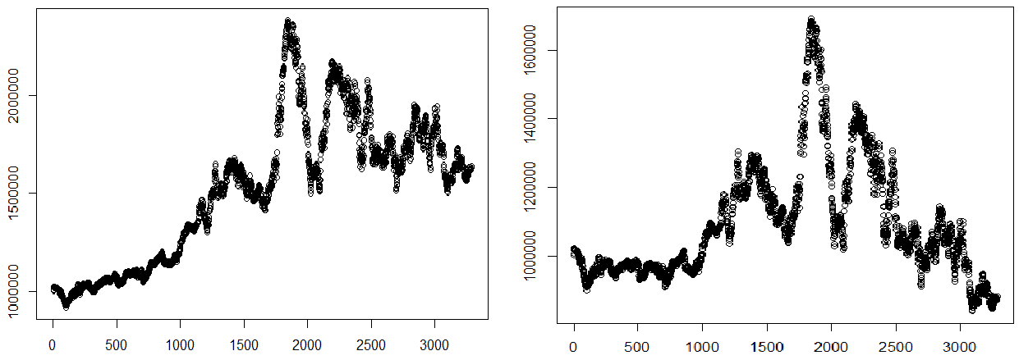

*This is a simulated trading in a perfect market *This is a simulated trading with commission

*In the simulated trading, we start with 1000,000 and the figures above show how the total amount of money changes during the trading period.

**Figure** **2: The result of simulate trading—Copper, from 1999 to 2012**

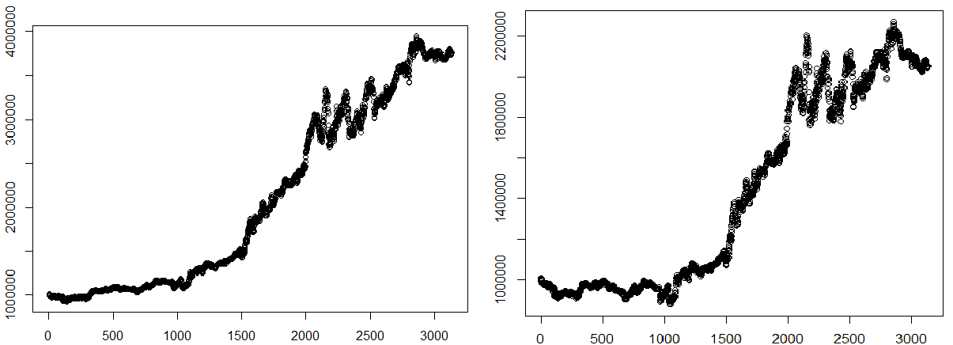

*This is a simulated trading in a perfect market *This is a simulated trading with commission

* In the simulated trading, we start with 1000,000 and the figures above show how the total amount of money changes during the trading period.

**Figure** **3: The result of simulate trading—Aluminium, from 1999 to 2012**

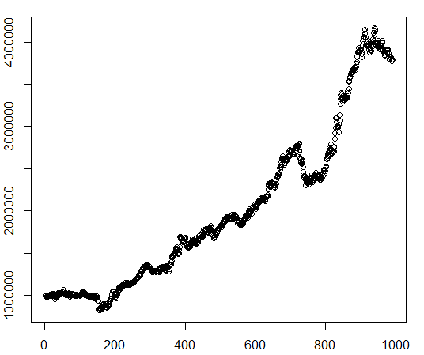

*This is a simulated trading in a perfect market *This is a simulated trading with commission

* In the simulated trading, we start with 1000,000 and the figures above show how the total amount of money changes during the trading period.

**Figure** **4** **：The result of simulate trading—Zinc, from 2007 to 2011**

The Figure 2, 3 and 4 give us a rough idea how the trading strategy works during the trading period. In the following process, we will calculate the annual return of simulate trading and the corresponded Sharp-ratios for copper, aluminium and zinc.

**Table** **8**

**The Annual Return of Simulate Trading for copper, aluminium and zinc**

|  | Copper | | Aluminum | | Zinc | |
| --- | --- | --- | --- | --- | --- | --- |
| Year | Return | Return with  commission | Return | Return with  commission | Return | Return with  commission |
| 1999 | 2.79% | -1.95% | -2.41% | -3.50% | - | - |
| 2000 | 2.68% | -2.11% | -0.10% | -4.56% | - | - |
| 2001 | 1.69% | -3.06% | 10.60% | 5.74% | - | - |
| 2002 | 9.37% | 4.75% | 1.48% | -3.06% | - | - |
| 2003 | 16.58% | 12.44% | 4.17% | -0.52% | - | - |
| 2004 | 22.71% | 18.16% | 15.75% | 10.46% | - | - |
| 2005 | -14.41% | -18.29% | 11.81% | 6.79% | - | - |
| 2006 | 59.33% | 52.27% | 42.61% | 36.16% | - | - |
| 2007 | -22.45% | -25.91% | 12.64% | 7.67% | -13.98% | -16.77% |
| 2008 | 7.66% | 3.08% | 15.80% | 10.77% | 95.94% | 87.86% |
| 2009 | -14.65% | -18.35% | 5.94% | 1.12% | 37.45% | 31.43% |
| 2010 | 13.13% | 8.19% | 13.94% | 8.78% | 58.37% | 51.29% |
| 2011 | -6.60% | -10.73% | 16.66% | 11.49% | 3.23% | 1.03% |
| 2012 | -4.91% | -9.00% | -2.68% | -6.91% | - | - |

* We suppose the commission fee here is 0.02%. This is the return of no leverage. The margin system regulate that the margin level depend on the total amount of the investment and the highest is 10%. With 10% leverage, the return can be 10 times higher theoretically.

The Sharpe ratio is named after William Forsyth Sharpe and it is also known as the Sharpe measure, the Sharpe index, and the reward-to-variability ratio. The Sharpe ratio measures the excess return or risk premium per unit of deviation in an investment asset or a trading strategy. It characterizes how well the return of an asset compensates the investor for the risk taken. When comparing two assets versus a common benchmark, the one with a higher Sharpe ratio seems to be bettersince it

Provide higher return for the same risk or, equivalently, the same return for lower risk. We can get the Sharp ratio of the trading strategy in the following way,

Sharp ratio = [E(Rp)－Rf] /σp

E (Rp): the average annual return of the trading strategy

Rf: risk free rate, use one-year deposit interest rate here, 3%σp: the standard deviation of annual return of the trading strategy

**Table** **9**

**Sharp ratio of Annual Return of Simulate Trading**

|  | Copper | Aluminum | Zinc |
| --- | --- | --- | --- |
| E(Rp) | 0.0068 | 0.0574 | 0.3097 |
| σp | 0.0374 | 0.0116 | 0.4131 |
| Sharp ratio | -0.6200 | 2.3636 | 0.6770 |

* The annual return here has already taken the commission fee0.02% in to consideration

For copper, in a perfect market this strategy can get an average annual return 5.21%, but with a high variance 0.0405. When we take the commission fee0.02% in to consideration in the simulated trading, the average annual return is 0.68%, which is smaller than the risk free rate. So, in Table 9, we can find the Sharp ratio of copper is negative,

-0.62. In the Table 8, we can find that in recent five years, the annual return turned out to be negative on average. Combine with the results of regressions after 2007, the copper market is efficient and there is no overreaction. So the strategy doesn‟t work in recent 5 years.

For aluminium, this strategy can get an average annual return 10.04% with a relative lower variance 0.0134. Taking the commission fee into consideration, we can still get an average annual return 5.74%. This is consistent with the regression result that the relationship between these two aluminiumcontracts is more significant. In Table

9, we can find the Sharp ratio of aluminium is 2.3636.

For zinc, we use the first 2.5 hours return instead of the open to close price. This strategy can get an average annual return 36.2% and 30.97% with commission fee. It seems to be a great opportunity for arbitrage. In Table 9, we can find the Sharp ratio of zinc is 0.677. However, the regression and the trading strategy are from the same historical data, so, it‟s kind of having the risk of over fitting. But somehow it‟s the solid evidence that there is overreaction.

# **Chapter 7** **Conclusion**

Overreaction happens when certain good new information release in a security market, it causes big movement of the price, which is higher than its true value. And afterwards, the price will retrace to the normal level. This paper researches the Shanghai Future Exchange markets‟overreaction to the London Metal Exchange.

Firstly, we do theoretical analysis on the psychological basis for overreaction. We find not all the investors in future markets are rational. The cognitive bias of investors is one of the main reasons for overreaction phenomena. Institutional investors may be overconfidence and try to manipulate the market, and they are regret aversion during the investment. Individual investors are lack of knowledge of the future markets and their main purpose is to speculate. Herdbehaviourand excessive panic make things even worse. Trading ruleslike T+0 transaction system, margin system, close position system and shortposition systemmake the overreaction more significant.

In the empirical study, we do granger causality tests and find that for copper, aluminum and zinc, London Metal Exchange is the Granger Cause of Shanghai Future Exchange, which is the premise for later research.

Then we deep look into how the informationtransfers from one market to anotherand figure out whether the market reacts to the information from other market rationallyand we build a trading strategy according to the results in empirical study and find there is an arbitrage opportunity.

For copper, we find it used to overreact to London market, but the market is more efficient in recent years and such overreaction no longer existed. For aluminium and zinc, there is a significant overreaction and there is an arbitrage opportunity.

# **Bibliography**

Becker, K., J. Finnerty and M. Gupta (1990), `The Intertemporal Relation Between the U. S. and Japanese Stock Markets', Journal of Finance, Vol. 45, No. 4, pp. 1297-306.

Lau S T, J D Diltz. Stock Returns and the Transfer of Information Between the New York and Tokyo Stock Exchanges [J]. Journal of International Money and Finance, 1994, 13(2): 21- 22.

Bae K H, Cha B, Cheung, Y L. The transmission of pricing information of dually-listed stocks [J]. Journal of Business Finance and Accounting, 1999(26): 709- 723.

Koch PD, Koch. Evolution in Dynamic Linkages across Daily National Stock Indexes [J]. Journal of International Money and Finance, 1991, 10(2):231-251.

华仁海、陈百助（2004）：5国内、国际期货市场期货价格之间的关联研究6, 5

经济学（季刊）6第3卷第3 期

DeBondt, W. F. M. and Richard Thaler," Does the Stock Market Overreact"[J], 1985, Journal of Finance, July.

DeBondt, W. F. M. and Richard Thaler," Furture Evidence on Investor Overreaction and Stock Market Seasonality", 1987, Journal of Finance, July.

Tse, Y. and Booth, G. G. (1995) The relationship between U. S. and Eurodollar interest rates: evidence from the futures market, WeltwirtschaftlichesArchiv,131, 28-46

Boot h, G. G., Brockman, P., and Tse, Y." The Relationship bet ween US and Canadian Wheat future markets", Applied Financial Economics, 1998, 8, 73-80.

蒋舒，吴冲锋，中国期货市场的有效性：过度反应和海内外市场关联的视角

[J]．金融研究，2007，（2）：49～62．

张人骥，朱平芳，王怀芳．上海证券市场过度反应的实证检验[J]．经济研究，

1998，(5)：58～64．

周志明，唐元虎.中国商品期货市场过度反应的实证研究[J].上海交通大学学报，2006, 40(4)：655一658

赵留彦，王一鸣. A、B股之间的信息流动与波动溢出[ J]. 金融研究, 2003(10)：37- 52.

Nicholas Barberis, Andrei Shleifer, RobertVishny. A model of investor sentiment[J]. Journal of Finance Economics,1998, 49:307~343.

Kent Daniel, David Hirshleifer, AvanidharSubrahmanyam. Investor Psychology and Security Market under- and Overreactions [J]. Journal of Finance, 1998, 53:1839~1885

Harrison Hong, Jeremy C. Stein. A Unified Theory of Under reaction, Momentum Trading, and Overreaction in Asset Markets[J], Journal of Finance, 1999, 54: 2143~2184

Eun C S, Sabherwal S. Cross-border listings and price discovery: Evidence from US-listed Canadian stocks [J]. Journal of Finance,2003, 58(2): 549- 575.

Alexander Kwok-Wah Fung. Overreaction in the Hong Kong stock market. [J].

Global FinanceJournal,1999,10:223–230.

Li Y, J F Greco, B Chavis, Lead-lag Relations between A -shares and H - shares in the Chinese Stock Markets, California State University of Fullerton Working Paper, 2001.

沈艺峰，吴世农.“我国股票市场过度反应了吗？”[J].《经济研究》,1999.2.

肖辉，伦敦金属交易所与上海期货交易所铜价格发现过程[J] 1系统工程理论方法与应用, 2004（6）

Shum, C. K. (1994), `The Impact of Cross-Trading on Hong Kong Stocks in London, M. A. Thesis (City University of Hong Kong).

致 谢

**Acknowledgments**

首先，要感谢郭明教授。本论文是在郭老师的悉心指导下完成的，没有郭老师的指导、鼓励及大力支持，论文是不可能得以顺利完成的。在半年多的论文写作过程中，我收获颇丰，感触亦深。郭老师渊博的专业知识，严谨的治学态度，精益求精的工作作风，诲人不倦的高尚师德，朴实无华、平易近人的人格魅力对我影响深远，给我们学生树立起了潜移默化的典范作用，这也是导师传授给我们最宝贵的财富。本论文从选题到确定研究方法再到最终完成，几易其稿，每一步都是在郭老师的指导下完成的，倾注了郭老师大量的心血，在此，谨向郭老师致以深切的谢意与祝福。在此，也要感谢陈松男，巨能久等多位教授在论文开题答辩时所提出的宝贵意见，让我避免了很多弯路。

另外，要感谢上海交通大学与上海高级金融学院。两年来，上海高级金融学院以其国际化的教育模式、优良的学习风气、严谨的科研氛围教我求学，上海交通大学以其博大包容的情怀胸襟、浪漫充实的校园生活育我成人。值此毕业论文完成之际，我谨向所有关心、爱护、帮助我的老师与同学表示最诚挚的感谢与最美好的祝愿。

最后，最重要的还是要感谢我的父母，在我求学生涯中你们给予我无微不至的关怀和照顾，一致默默地支持我、鼓励我，谢谢你们！

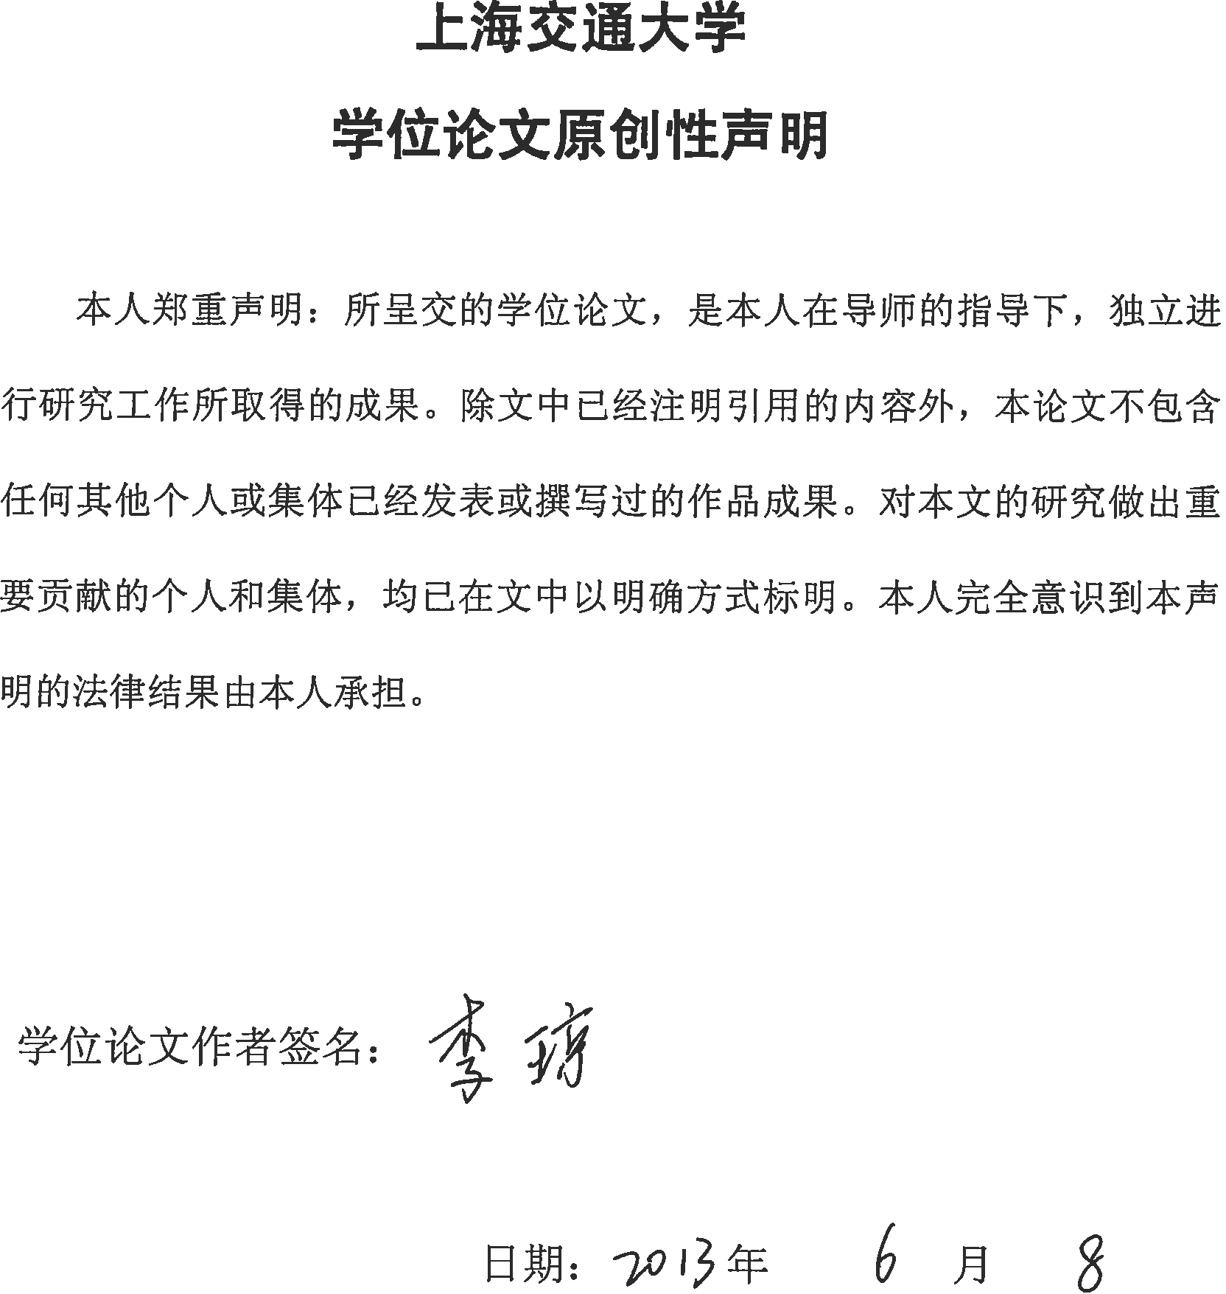

中国上海淮海西路211号邮编：200030 211 West Huaihai Road, Shanghai, P. R. China,200030



**上海交通大学学位论文答辩决议书**

**SAIF Master of Finance** Thesis Defense Decision

[http: //www. saif. sjtu. edu. cn](http://www.saif.sjtu.edu.cn/)

|  |  |  |  |  |  |  |  |  |  |  |
| --- | --- | --- | --- | --- | --- | --- | --- | --- | --- | --- |
| 姓 名  Name | | Li Qiong | | 学号  Student ID | | 1113809220 | | 所在学科  Program | 金融硕士  Master of Finance | |
| 指导教师  Supervisor | | Guo Ming | | 答辩日期  Defense Date | | 22/05/2013 | | 答辩地点  Defense Venue | Classroom 904 | |
| 论文题目  Thesis Title | | Empirical Study on Chinese Commodity Future Markets' Overreaction to Foreign Markets | | | | | | | | |
| 投票表决结果： 3 / 3 / 3 （同意票数**/**实到委员数**/**应到委员数）  Voting Result: 3 / 3 / 3 (Pass Voted/Actual Presence/Scheduled Committee)  答辩结论 Defense Result: ■通过/P □未通过/F评语和决议 Comments and Decision:  The candidate chose a topic which has not been fully investigated in Chinese market, and was able to utilize the knowledge learnt during the past two year's master study. This candidate showed the thorough understanding when applying the theories and methodologies upon this paper, and analyzed in depth about the topic discussed.  This candidate clearly presented the findings, analysis and recommendations during the thesis defense, and accurately answered all the questions raised by the committee members.  All the committee members agreed for this candidate's success of the defense, and suggest awarding the master degree.  2013 年 5 月 22 日  Date: 2013 /_5_/_22_ (yyyy/mm/dd) | | | | | | | | | | |
| **答辩委员会成员签名**  **Defense Committee Signature** | **职务**  **Role** | | **姓名**  **Name** | | **职称**  **Title** | | **单 位**  **Institute** | | | **签名**  **Signature** |
| 主席  Chair | | Yan Hong | | Professor | | SAIF | | |  |
| 委员  Member | | Charles Chang | | Associate Professor | | SAIF | | |  |
| 委员  Member | | Yu Fan | | Associate Professor | | SAIF | | |  |
| 秘书  Secretary | | Zhang Jianing | | PhD Student | | SAIF | | |  |

[**中国商品期货市场对海外市场过度反应的实证研究**](http://d.wanfangdata.com.cn/Thesis_D427264.aspx)****

作者：[李琼](http://s.wanfangdata.com.cn/Paper.aspx?q=Creator%3a%22%e6%9d%8e%e7%90%bc%22%2BDBID%3aWF_XW)

学位授予单位：[上海交通大学](http://s.wanfangdata.com.cn/Paper.aspx?q=School%3a%22%e4%b8%8a%e6%b5%b7%e4%ba%a4%e9%80%9a%e5%a4%a7%e5%ad%a6%22%2BDBID%3aWF_XW)

引用本文格式：[李琼](http://s.wanfangdata.com.cn/Paper.aspx?q=Creator%3a%22%e6%9d%8e%e7%90%bc%22%2BDBID%3aWF_XW)[中国商品期货市场对海外市场过度反应的实证研究](http://d.wanfangdata.com.cn/Thesis_D427264.aspx)[学位论文]硕士2013