**Task 2 :**

* **What do you think about its quality?**
* Code Quality can be measured in number of ways.
* In my opinion with the knowledge I have, I would classify this code as bad quality (not up to the mark). Main reason for that are, used structure & low security of code.
* **Can you find any problems?**

I have run code provided by you and got error “Failed to open stream: HTTP request failed! HTTP/1.1 404 Not Found”. For me below are the problems,

* Data is passed in GET method where in requirement it was mention to use POST method.
* Header is not passed
* I have corrected above problems and now code & Result looks like below

**Code**

* + <?php
  + $postdata = http_build_query(
  + array(
  + 'client_id' => 'ju16a6m81mhid5ue1z3v2g0uh',
  + 'email' => 'mital@gmail.com',
  + 'name' =>'Mital'
  + )
  + );
  + $opts = array('http' =>
  + array(
  + 'method'  => 'POST',
  + 'header'  => 'Content-Type: application/x-www-form-urlencoded',
  + 'content' => $postdata
  + )
  + );
  + $context  = stream_context_create($opts);
  + $result = file_get_contents('https://api.supermetrics.com/assignment/register', false, $context);
  + echo '<pre>';
  + print_r($result);
  + exit;
  + ?>

**Result:**

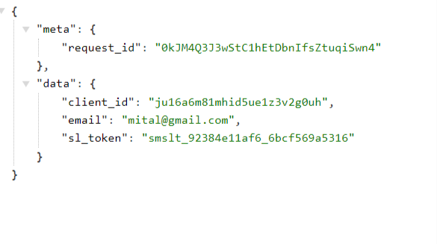

* **How would you suggest to improve it?**
* I would suggest to make below changes to the code to improve it,
  + Token to be used to access API to increase security
  + CURL needs to be used instead of file_get_contents() . CURL is more secure and faster than file_get_contents()
  + Request data need to be encrypted
  + Response generated using code is not encrypted as well (We should have used encryption method to do that)