

# **United States International University-Africa**

**Fall Semester 2023**

##### **APT 3065 MID-TERM PROJECT**

## **Bill tracking application**

**BY**

**Mutuma Miriti 661967**

**Supervisor**

**Dr. Chrispus Alukwe, PhD**

**UNITED STATES INTERNATIONAL UNIVERSITY-AFRICA**

**SCHOOL OF SCIENCE AND TECHNOLOGY**

**September 2023**

This midterm project report is submitted in partial fulfilment of the requirements of the Information System Technology (IST)

**Declaration**

I declare that this is my original work through my own effort and that it has not been presented in any form for academic or any other reason, to the best of my knowledge. Contributions to this work by any other person or literature have been duly cited.

**Student**

Mutuma Miriti, 661238

Signature………………… Date…………………

**Supervisor**

I confirm that this research project report was carried out by the student under my supervision

Signature……………………. Date…………………

Dr. Chrispus Alukwe, PhD

Professor-Information Systems,

School of Science and Technology

UNITED STATES INTERNATIONAL UNIVERSITY-AFRICA

**Acknowledgement**

First and Foremost I’d like to thank God for giving me life, good health and strength to undertake and complete this project.Finally I'd like to wish my heartfelt gratitude to my family and friends for their support and encouragement during this period.Your support has helped me achieve the goals that were set out at the start of this project. I look forward to collaborating with all of you again in the future.

**Table of Contents**

**Heading page**

**Chapter ONE INTRODUCTION 8**

1.1:Background of the Study 8

1.2: Problem Statement 8

1.3: Objectives 9

1.3.1: General Objective 9

1.3.2: Specific Objective 9

1.4: Research Questions 9

1.5: Significance of The Study 10

1.6: Scope and Limitation of study 10

**Chapter TWO LITERATURE REVIEW 11**

2.1: Review of Objective One 11

2.2: Review of Objective Two 13

2.3: Concept Map 16

**Chapter THREE METHODOLOGY 16**

3.1: Introduction 16

3.2: Research Methodology/ Research Design used 16

3.3: Data Collection Methods Used 17

3.4: Design Diagrams 18

3.4.1: Compulsory

-Context Diagram 18

-Level 1 DFD 19

-Used Case Diagram 20

3.5:Research Ethics 20

**Chapter FOUR SYSTEM IMPLEMENTATION AND DESIGN 21**

4.1: Introduction 21

4.2: System Architecture 21

4.3: Front End Development 22

4.4: User Interface Design 23

4.5: User Interface Modules (ScreenShot + Modules) 24

4.6: Backend development 30

4.1.1: Database Design Models 34

4.1.2: Tables or Data models if any CSV file 35

4.1.3: Code Testing 35

4.7: Deployment Methods 42

**Chapter FIVE REFERENCES 43**

5.1: Conclusion 43

5.2: Future Work 43

5.3: References 45

**APPENDICES**

iA Project Schedule 45

iiB Budget 47

**List of Tables**

**Chapter 2:Literature review**

2.4 Concept 16

**Chapter5: References**

iA Project Schedule 45

iiB Budget 47

**List of figures**

**Chapter 3: Methodology**

3.3.1 Context Diagram 18

3.3.2 Level 1 DFD 19

3.3.3 Used case diagram 20

**Chapter 4: Design**

4.2 System Architecture 22

**Copyright**

All the rights reserved. The report may not be photocopied, recorded or otherwise reproduced, stored in a retrieval system or transmitted in any electronic or mechanical means without prior permission of the copyright owner.

Mutuma Miriti © 2023

# 

# 

# 

# 

# 

# 

# 

# 

# **CHAPTER ONE: INTRODUCTION**

**1.0 Introduction**

The application that is being developed is intended to help people living in an estate or apartment receive updates on their phones about their water and electricity bills as well as their rental bills ahead of the day of payment.

**1.1 Background of Study**

A bill tracking application is a software programme or mobile application that keeps track of bills, expenses, and payments to assist people and organisations in managing and monitoring their financial commitments. This kind of app provides a wide range of functions to help users manage and remain on top of their financial obligations.

The development of this bill tracking application is specifically for tenants and homeowners in the real estate sector. real estate is the land and any permanent structures or improvements attached to the land. This application shall deal with the issues that homeowners and tenants face when trying to keep up with their bills and still have enough money to pay them on time and avoid any penalties that would come with it.

**1.2 Problem Statement**

Staying informed about legislative measures that directly affect their financial obligations is extremely difficult for homeowners and tenants. The lack of a specialised bill tracking app designed with homeowners and tenants' requirements in mind makes it difficult for them to comprehend and react to proposed legislation, which could result in additional financial responsibilities that might be completely unexpected. if there is a large jump for the cost of electricity and water bill for example and the tenant or apartment owner is not aware of ahead of time. they are completely blind-sided by the increase; this will cause them to either default on their bill and lose power or water or force them to move funds from other areas to pay that bill. However, some people lack that ability to move their finances around to solve that problem.

**1.3 Objectives**

Record electricity and water bills

Send messages to customers informing them of their water and electricity bills and the day they are due via SMS.

store the past bills in a database.

**1.3.1 General objective**

recording bills and keeping track of when they are due.

**1.3.2 Specific objective**

i. Determine the benefits of bill tracking application

ii. Determine the current challenges with bill recording

iii. Determine the challenges faced by homeowners when keeping track of their bills

**1.3.3 Research questions**

How are apartment billing records done now and how can the app improve it?

What are the current challenges faced by tenants and homeowners in tracking and managing their bills?

What are the bills that tenants and homeowners need to track and manage?

Are there bills that catch users by surprise and might get overlooked?

**1.4 Significance of study**

Bill monitoring software offers a unified platform for managing and organising a variety of invoices, including rent and utility payments. It does away with the necessity for manual record-keeping, lessens clutter, and aids users in managing their finances.

Timely Payments - Failure to pay bills on time may result in fines, interest charges, or even a suspension of services. To make sure customers never forget to make a payment, a bill tracking app can provide notifications and reminders about approaching due dates. It aids in preventing excessive fees by encouraging prompt payments.

Bill tracking enables consumers to more efficiently keep tabs on their spending. Users can utilize the application to gain insights into their spending habits and find areas where they can reduce expenses or make better use of their budget. It encourages fiscal responsibility and assists users in making wise financial decisions. Document Storage: Bill-related documents like contracts, invoices, and receipts can be stored digitally in a bill tracking program. Users may quickly access these documents whenever they need to, saving them the trouble of having to look through actual records.

**1.5 Scope and Limitation**

This application is intended for use by the owners of houses and tenants to track their water bills and their electricity bills and get notified when they are due. The limitation for the system is if the user does not have a phone that runs on android 5.0 or higher, they shall not be able to use the application.

# 

# 

# 

# **CHAPTER TWO:LITERATURE REVIEW**

**2.1Introduction**

In this chapter, the developers will give an analysis of existing projects providing an assessment of the various strengths and weaknesses of those existing projects. Additionally, the developers shall explain the challenges of the old systems and outline the benefits of the new systems.

**Review of objective one**

**2.2 Record electricity and water bills**

2.2.1 THE MOBILE BASED ELECTRICITY BILLING SYSTEM: (MoBEBIS) [**IJSRP, Volume 3, Issue 4, April 2013 Edition [ISSN 2250-3153]**](https://www.ijsrp.org/research-journal-0413.php)

MoBEBIS identified that the main problem with the manual process of billing was that the calculation of the bills was tedious. In addition, even though some solutions have been offered by different companies and organisations through the creation of such mobile applications that automate the billing, the organisations that have to be involved, which are the water and electricity billing companies, find the change being too expensive and would rather resort to the traditional method of manual calculation of water and electricity readings and send them to the customers. The project also noted that customers cannot give feedback to the caretakers and electricity companies if they feel like the bill is too high and they would like it to be recalculated.

This system gets the readings from the water and the electricity metre calculates them and then sends the final correct bill to the user and stores the data in a database. It also allows the user to provide feedback to the water and electricity companies regarding their bills and resolve the dispute.

**2.2.2 Electricity, water, and natural gas consumption of a residential house in Canada from 2012 to 2014**

The paper describes the AMPds2 dataset, which captures electricity, water, and natural gas consumption over a two-year period. The dataset provides 11 measurement characteristics for electricity and environmental and utility billing data for cost analysis. The authors note that residential homes contribute about 34% to the total power consumption in the USA and their consumption is projected to increase to 39% by 2030. They suggest that one way to help homeowners and occupants reduce their consumption is to monitor and present how much power their appliances are using through an effective eco-feedback device or display mechanism. The authors also acknowledge the contributions of the British Columbia Institute of Technology (BCIT), Electrical and Computer Engineering Technology students and faculty Bob Gill for their collaborations in the past. The paper provides details on the data collection process, including the use of water metres and an Obvius AcquiSuite EMB A7810 for pulse data collection. The authors note that the Obvius AcquiSuite units have a per-minute sampling limitation and that 437 readings were missing from both water metres during the data cleaning process. Overall, the AMPds2 dataset is a valuable resource for researchers and homeowners looking to better understand and optimise their energy consumption.

**Strengths**

The paper provides a detailed description of the AMPds2 dataset, including the data collection process and the types of data included.

The authors note that the dataset has been pre-cleaned to provide consistent and comparable accuracy results among different researchers and machine learning algorithms.

The paper highlights the importance of reducing energy consumption and suggests that the AMPds2 dataset can be used to test models, systems, algorithms, or prototypes on real house data.

The authors acknowledge the contributions of the British Columbia Institute of Technology (BCIT), Electrical and Computer Engineering Technology students and faculty Bob Gill for their collaborations in the past.

**weaknesses**

The paper does not provide information on how water and power bills are calculated, which may limit the usefulness of the environmental and utility billing data included in the dataset.

The authors note that 437 readings were missing from both water metres during the data cleaning process, which may affect the accuracy of the dataset.

The paper does not provide information on the demographics of the households included in the dataset, which may limit the generalizability of the findings.

The paper does not provide information on the cost of collecting and maintaining the dataset, which may be important for researchers and policymakers interested in using the dataset.

**Review of objective two**

**2.3 Send message to customers informing them of their water and electricity bills**

2.3.1 Internet of things-based energy tracking and bill estimation system

This paper discusses an energy tracking and bill estimation system that leverages the concept of Internet of Things (IoT) to provide real-time monitoring of electricity consumption. By utilising a microcontroller, binary actuators, cloud-hosted database, and IoT cloud interface, the system enables consumers to gain awareness of their electricity usage from anywhere in the world, if they have the necessary credentials and internet access. Unlike earlier methods that required manual efforts or partially automated systems, this IoT-based approach offers a convenient way to view real-time electricity consumption data. While other IoT-based systems exist, many rely on expensive components or have limitations such as monitoring specific phases of the electrical system, requiring installation for each wiring phase, and offering a single platform user interface. Furthermore, not all systems provide the capability to view real-time consumption by each load and the corresponding billing amount.

Strengths

ability to provide real-time estimated bills, monitor energy consumption, and control loads remotely. Additionally, the use of a cloud-hosted database and IoT cloud interface may make the system more accessible and user-friendly.

weaknesses

reliance on a microcontroller and relay module, which may be prone to failure or malfunction. Additionally, the system may require a certain level of technical expertise to install and operate effectively.

limitations of existing IOT based systems for electricity and water tracking.

* Limited compatibility with different utility metres: Some IoT-based systems are designed to work with specific types or brands of utility metres. This limited compatibility can be a barrier for users who have different metering systems or wish to track multiple utilities simultaneously.
* Costly infrastructure requirements: Implementing an IoT-based system for electricity and water tracking often requires additional infrastructure, such as smart metres or sensors. The cost associated with installing and maintaining this infrastructure can be a deterrent for some users, particularly in cases where retrofitting is necessary.
* Reliance on stable internet connectivity: IoT systems depend on a stable internet connection to transmit data in real-time. However, if the internet connection is unreliable or experiences frequent disruptions, it can impact the system's effectiveness and the accuracy of the tracked data.
* Privacy and security concerns: IoT systems involve the collection and transmission of sensitive data related to electricity and water consumption. Ensuring the privacy and security of this data is crucial, and existing systems may have vulnerabilities that could potentially compromise user information.
* Lack of interoperability: In some cases, IoT-based systems for electricity and water tracking may lack interoperability with other smart home devices or platforms. This limitation can prevent users from integrating their tracking system with other automation or control systems they have in place.
* Insufficient data visualisation and analytics: While many IoT-based systems provide real-time data, they may lack robust data visualisation and analytics capabilities. This can make it challenging for users to interpret and derive meaningful insights from the tracked data.
* Limited integration with utility billing systems: Integrating IoT-based tracking systems with utility billing systems can be complex, especially if the systems are not designed to work together. This limitation can hinder the seamless synchronisation of tracked data with billing processes.
* Difficulty in distinguishing individual appliance-level consumption: IoT-based systems for electricity tracking may face challenges in accurately distinguishing consumption at the appliance level. Identifying the energy usage of individual appliances can be crucial for users who want to pinpoint energy-intensive devices or optimise their consumption patterns.

**How are customers getting their bills**

information provided, the IoT-based Energy Tracking and Bill Estimation System discussed in the paper file logs the estimated bill of each month to a cloud-hosted database. It also provides real-time estimated bills on a monitor unit built-in IoT cloud interface. It is possible that customers may access their bills through the IoT cloud interface or the cloud-hosted database. So what a bill tracking application shall do is give you an accurate bill every month with the exact amount you need to pay and when and the paper doesn't provide a specific way for the customers to receive their bills.

summary of this paper

The bill tracking application is better because it has the ability to track and manage bills from multiple utilities, and set reminders for due dates in the form of an SMS . Additionally, the bill tracking application will allow users to compare their bills over time and identify trends in their energy usage. However, it doesn’t not provide real-time estimated bills or the ability to control loads remotely, which are features of the IoT-based Energy Tracking and Bill Estimation system.

**2.4 Concept map**

| Dependent | Independent |
| --- | --- |
| Bill status | Bill amount |
| Bill reminder | Due date |
| Database | Payment history |
| List of the bills | Income |

# **CHAPTER THREE:METHODOLOGY**

3.1 Introduction to the chapter

The proposed application allows clients living in estates or apartments to receive updates on their phones about their water and electricity bills ahead of the day of payment. The application allows clients to enter their water bills and electricity bills then get a message on their phones.

3.2 Research methodology/Research design used

## 

Research design approach in software refers to the methodology used to conduct research on software-related topics. It involves the systematic planning and implementation of research studies to answer research questions related to software engineering, development, testing, or maintenance.

Qualitative research design is a research approach that aims to explore and understand complex social phenomena, often through the collection of non-numerical data. Qualitative research is typically used to gain insight into people's experiences, perspectives, and beliefs, and to generate rich and detailed descriptions of social phenomena.

Quantitative research design is a research approach that involves the collection and analysis of numerical data to test hypotheses or answer research questions. Quantitative research is often used to quantify relationships between variables, make predictions, or generalise findings to a larger population.

3.3 Data collection methods used

Data collection methods are techniques or processes used to gather information or data from various sources or respondents. Some common primary data collection methods include:

* Surveys: Surveys involve asking a set of standardised questions to a sample of individuals or groups. Surveys can be conducted through various means, such as online, telephone, face-to-face, or mail.
* Interviews: Interviews involve asking questions to individuals or groups to gather information about their experiences, perceptions, or attitudes. Interviews can be structured, semi-structured, or unstructured.
* Observations: Observations involve collecting data by observing and recording events or behaviours. Observations can be conducted in a naturalistic setting or a controlled environment.
* Experiments: Experiments involve manipulating one or more variables to measure their effect on an outcome. Experiments can be conducted in a laboratory or a field setting.
* Questionnaires: A set of standardised questions used to gather information or data from individuals or groups. They can be conducted through various means, such as online, telephone, face-to-face, or mail. They are typically designed to be self-administered by the respondents, although they can also be completed with the help of an interviewer.

Based on the project needs the research shall be conducted through questionnaires. This is because they are an effective data collection method for research on a bill tracking system system because they can reach a large sample size, are cost-effective, convenient, use standardised questions and response options to reduce bias and increase reliability, and allow for anonymity to encourage honest and open responses, especially for sensitive questions.

3.4 Design Diagrams

3.3.1 Context diagram

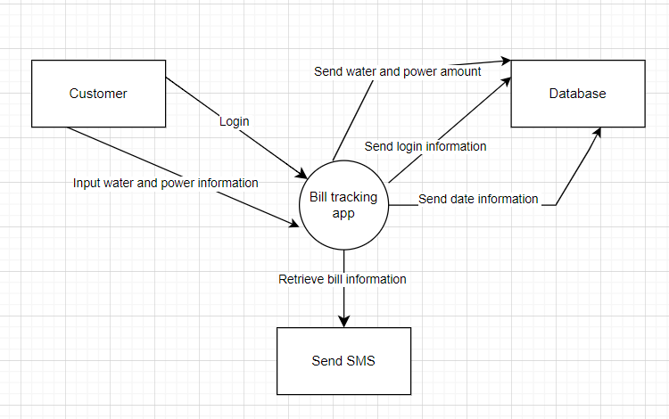

3.3.2 Level 1 DFD

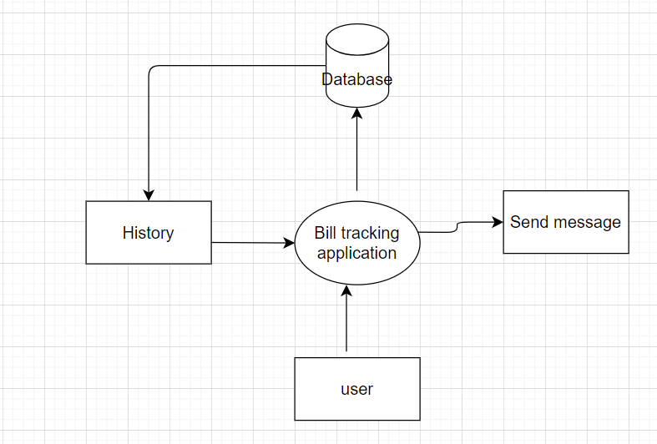

3.3.3 Used case Diagram

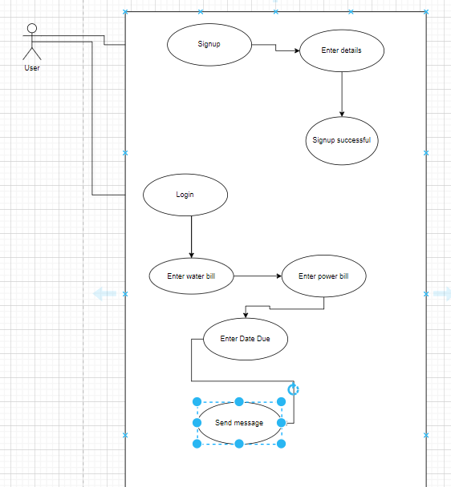

3.5 Research Ethics

For the research to take place ethically we shall need clearance from the following institutions:

Kenya power and lighting company(KPLC)

Nairobi city water and sewerage Company

# 

# **CHAPTER FOUR:SYSTEM IMPLEMENTATION AND SYSTEM DESIGN**

4.1: Introduction

My proposed application allows users to enter their water and electricity bills, send a message to themselves,and view the history of the bills that they had paid before. The application allows the user to add new bills then those bills are stored for future reference. The goal of the application is to simplify the process of managing and monitoring bills and helping users keep track of what bill is due when overall streamlining .

4.2: System Architecture

System architecture is a visual representation of the components, relationships, and interactions of a system or software application. It provides an overview of the system's structure and organisation, and helps to communicate the design of the system to stakeholders, such as developers, testers, and users. The diagram below explains the system architecture of the bill tracking application. The main actor in the system is the user that enters their two utility bills(water and power).



4.3: Front End Development

Java and SQLite were the programming languages used in the construction of this system. The front-end user interface was developed using Java. Java was also employed in the creation of Android apps because of its ease of use, readability, and maintainability. Because it is object-oriented, programmers may create reusable code and handle intricate code structures with ease. Because SQLite is cross-platform compatible, lightweight, embedded, open-source, and easy to use with a variety of APIs and a straightforward SQL syntax, it was chosen for the database connection.

4.4: User Interface Design

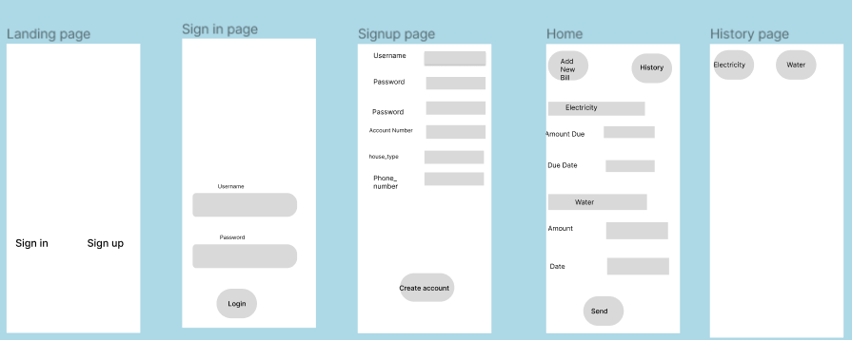

4.5: User Interface Modules (ScreenShot + Modules)

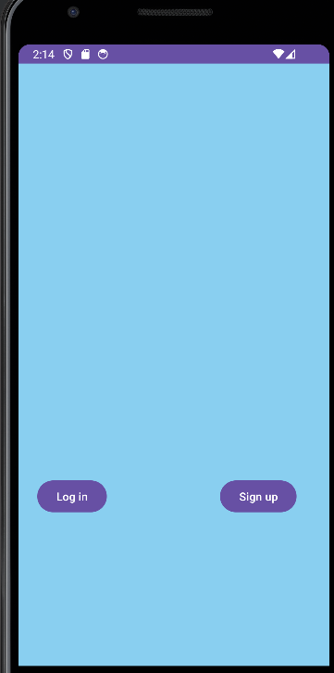

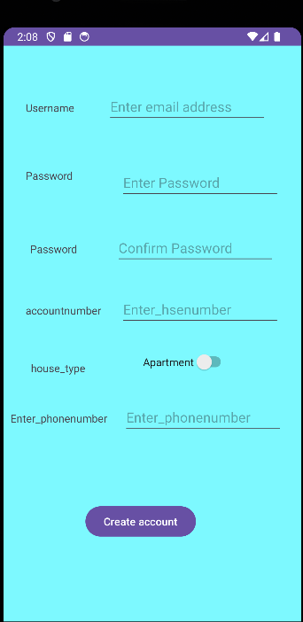

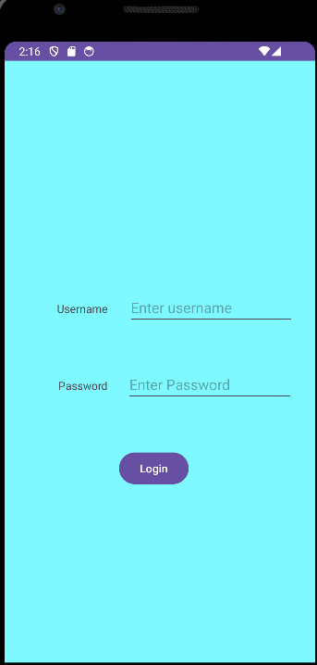

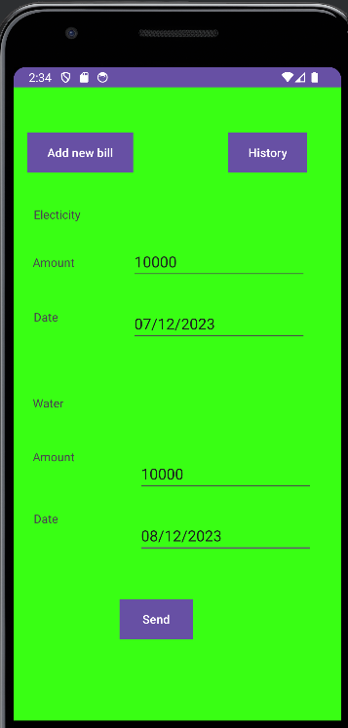

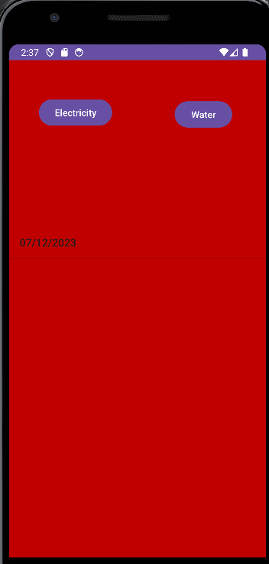

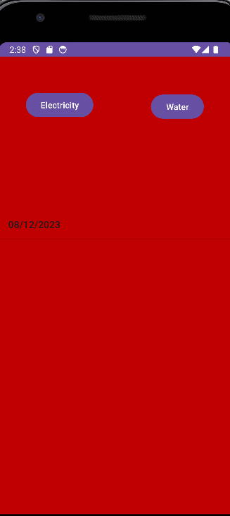

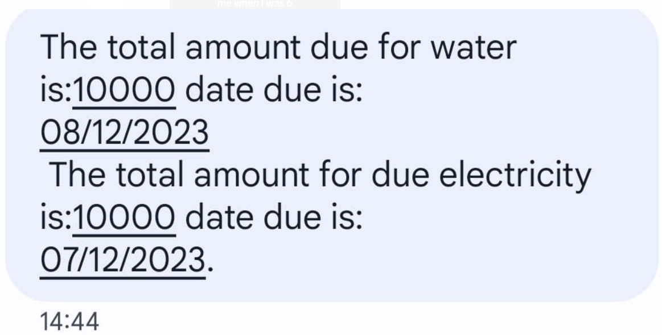

4.6: Backend development

Database code snippet

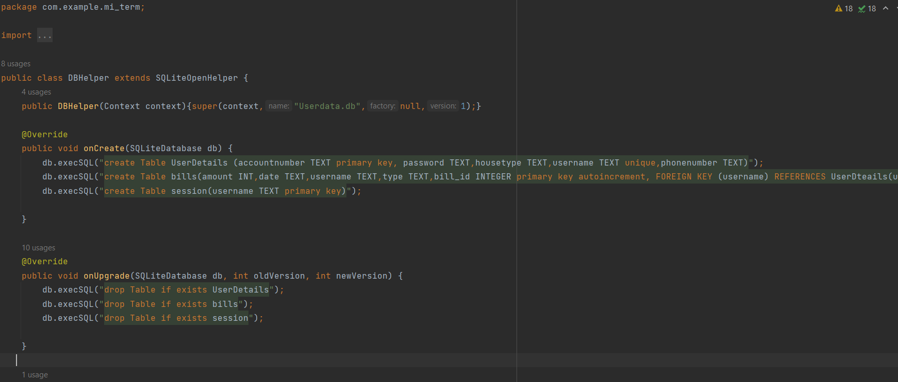

Signup code snippet

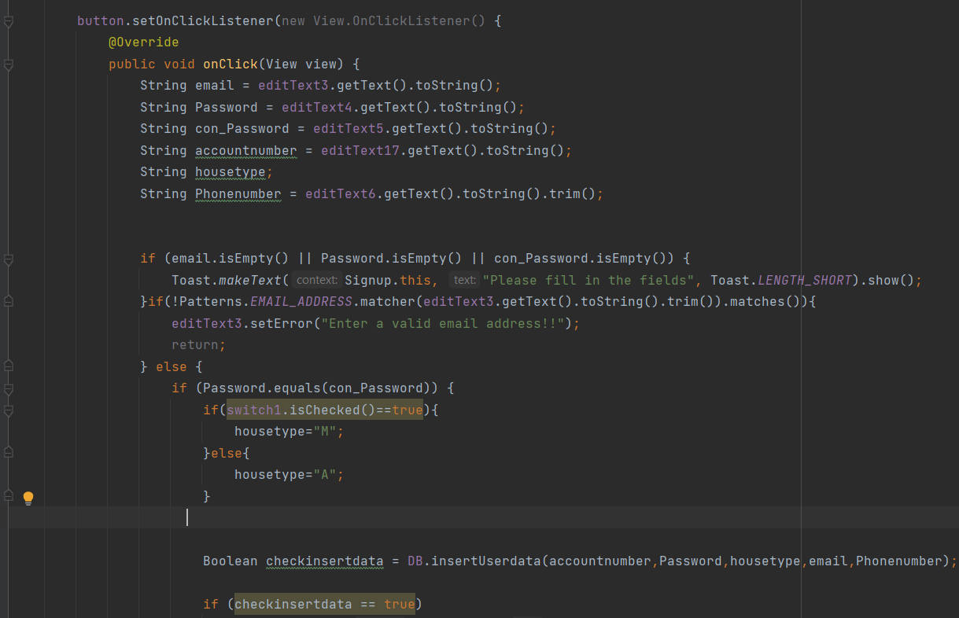

Login code snippet

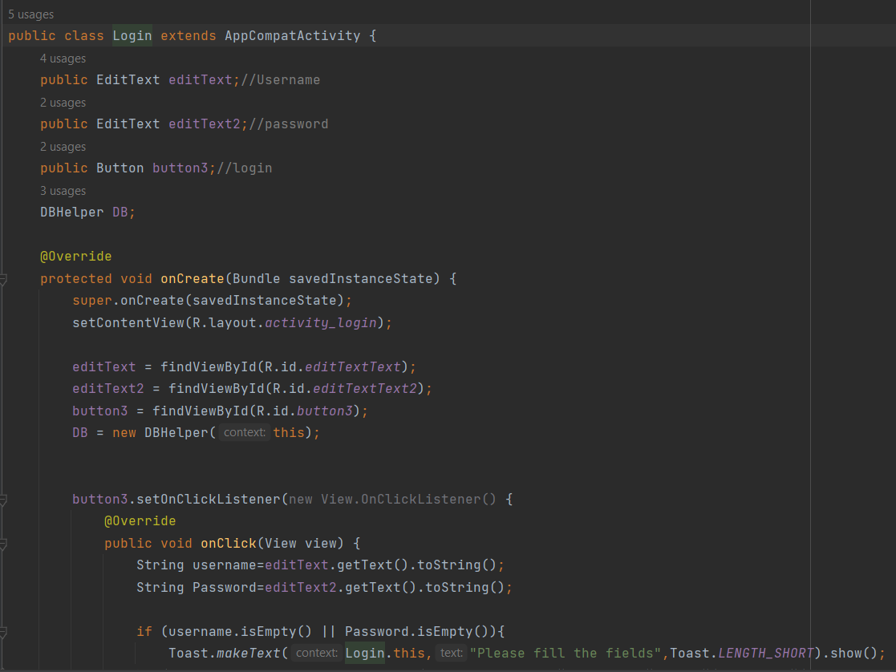

Homepage code snippet

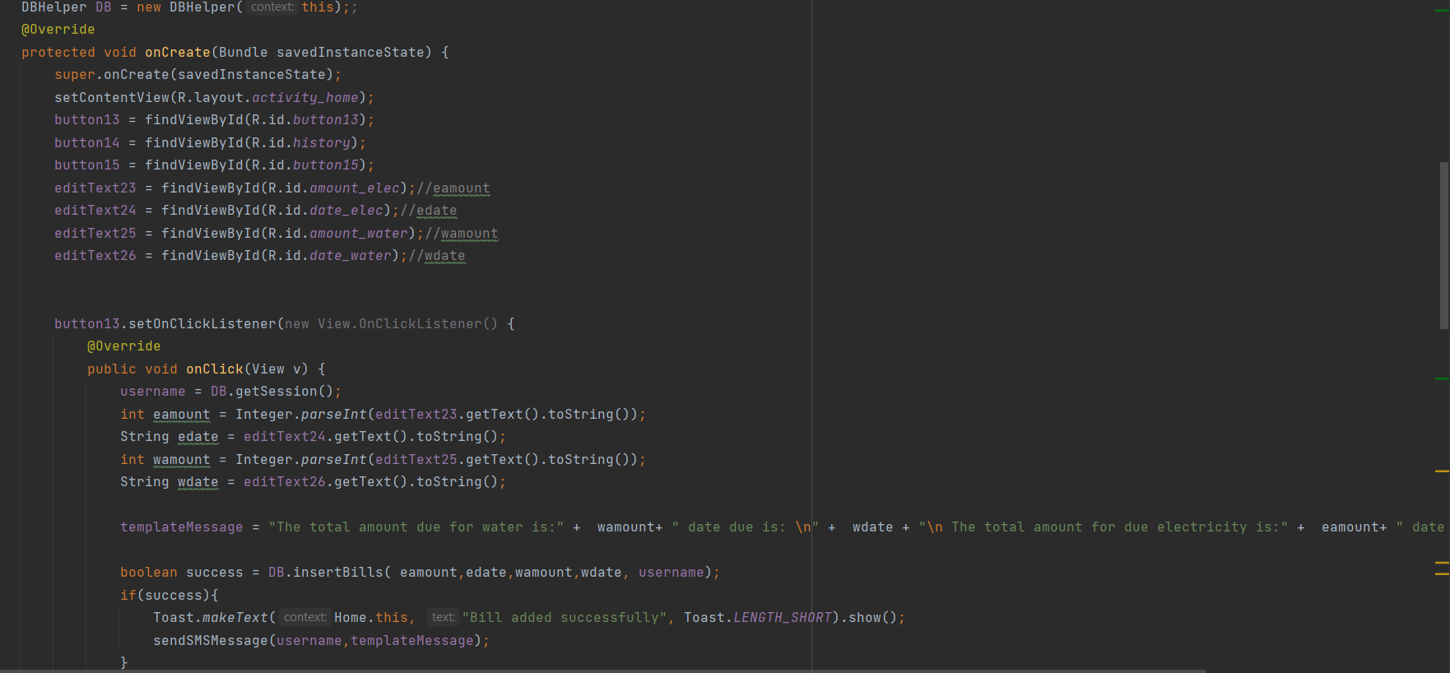

History code snippet

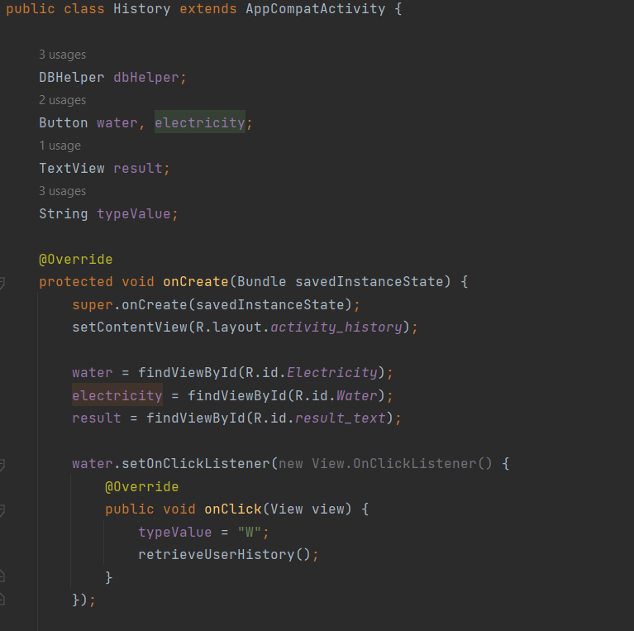

SMS code snippet

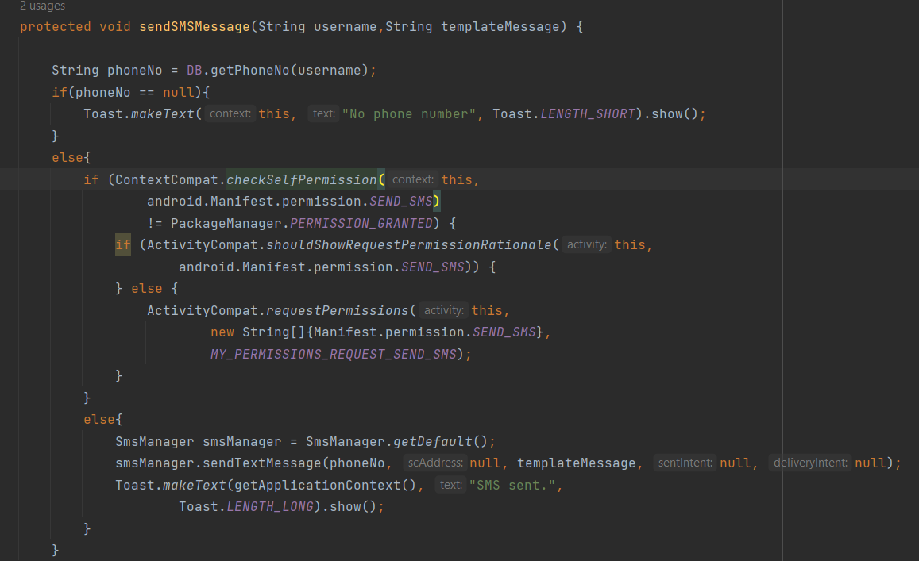

4.1.1: Database Design Models

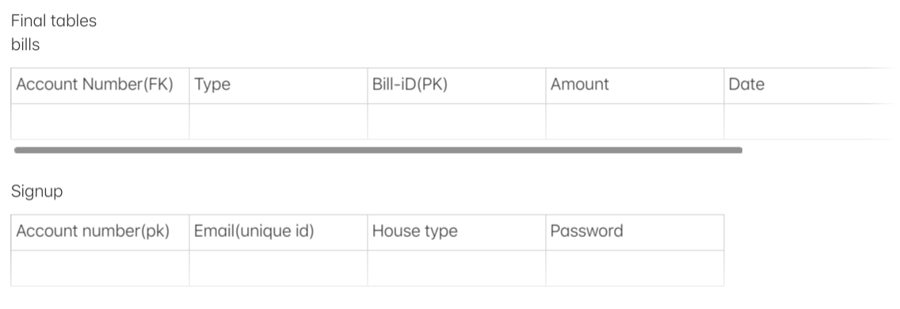

4.1.2: Tables or Data models if any CSV file

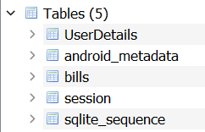

4.1.3: Code Testing

Landing Page



Sign up page

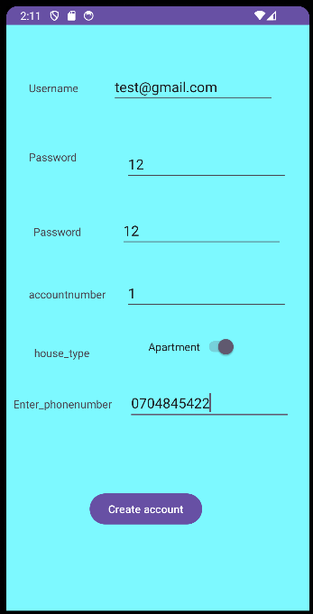

Login Page

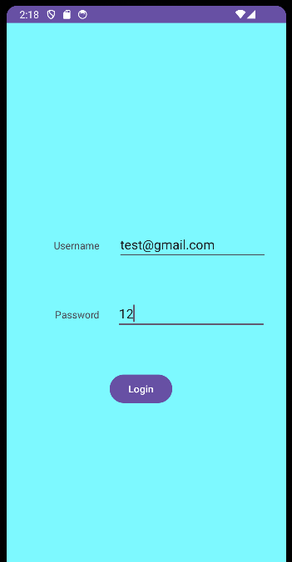

Home Page



Electricity History



Water History



SMS



4.7: Deployment Methods

When a system is deployed, it is made available to a client or the production environment. Maintenance is then performed to make sure the system keeps working properly and adapts to changing user requirements.

Methods

We shall present it to a small group of homeowners and tenants to download and test then provide feedback.

# 

# 

# 

# 

# **CHAPTER FIVE: REFERENCES AND CONCLUSION**

5.1: Conclusion

In conclusion, based on the above research in relation to recording bills my application removes the aspect of the caretaker because the bill is sent directly to the user's phone and relieves them of the duty of calculating and sending the bills. In the second paper it’s very costly, complicated and requires many moving parts to collect this information. The proposed application makes it much easier to record these bills, get the messages. Because the aspect of the calculation and billing is left to the water and power companies. The application allows users to keep records of the dates of their previous bills instead of keeping their bills as messages on their phones. This is an easier and more efficient way to store bills.

5.2: Future Work

The proposed system is designed for a smaller used case. In future the application can be upscaled to do the calculation as well. then rolled out to a larger group e.g. businesses. however the application still has room to be developed further based on consumer requirements and advancements in technology.

5.3: References

<https://www.nature.com/articles/sdata201637#citeas>

| **Article title** | Electricity, water, and natural gas consumption of a residential house in Canada from 2012 to 2014 |
| --- | --- |

| **URL** | https://www.nature.com/articles/sdata201637#citeas |
| --- | --- |

| **Website title** | Nature News |
| --- | --- |
| **Date accessed** | December 6, 2023 |
| **Date published** | June 07, 2016 |

<https://ieeexplore.ieee.org/abstract/document/9243480>

### **Internet of Things (IoT) based Energy Tracking and Bill Estimation System**

Webpage

*Internet of Things (IoT) based Energy Tracking and Bill Estimation System*. (2020, October 7). IEEE Conference Publication | IEEE Xplore. <https://ieeexplore.ieee.org/abstract/document/9243480>

Date accessed November 29, 2023

<https://www.ijsrp.org/research-paper-0413.php?rp=P161099>

| **URL** | https://www.ijsrp.org/research-paper-0413.php?rp=P161099 |
| --- | --- |

| **Website title** | Mobile Based Electricity Billing System (MoBEBIS) |
| --- | --- |

| **Date accessed** | November 29, 2023 |
| --- | --- |

**APPENDICES**

iA.)Project schedule

This project schedule is the main part of the application describing a principal investigators proposed research stating its importance and how its conducted

Project schedule September to December 2023

| Task | Activity | Sep  2023 | Oct  2023 | Nov  2023 | Dec  2023 |
| --- | --- | --- | --- | --- | --- |
| 1 | Create a concept note |  |  |  |  |
| 2 | Meeting and discussion for approval |  |  |  |  |
| 3 | Literature review |  |  |  |  |
| 4 | Review of Literature review |  |  |  |  |
| 5 | Methodology |  |  |  |  |
| 6 | System implementation and design |  |  |  |  |
| 7 | Conclusion |  |  |  |  |

iiB.)Budget

| Item | Price per item | Cost per item |
| --- | --- | --- |
| Laptop | 100,000 | 100,000 |
| Software(Android Studio) | Free | Free |
| Software(DB Browser-database) | Free | Free |
| Software(Figma - UI Design) | Free | Free |
| Software(Draw.io- UIDesign) | Free | Free |
| Developer(Work Fee) | 100,000 | 100,000 |
| Internet(Wi-Fi- For 3 months) | 5,500 | 5,500 |
|  | Total | 225,500 |