**Predicting fungal infection sensitivity of sepals in harvested tomatoes using Imaging Spectroscopy and Partial Least Squares Discriminant Analysis**

Mercedes Bertotto1, Hendrik de Villiers1, Aneesh Chauhan1, Esther Hogeveen-van Echtelt1, Manon Mensink1, Zeljana Grbovic2, Dimitrije Stefanovic2, Marko Panic2, Sanja Brdar2

Wageningen University & Research1 P.O. Box 123, 6700 AB Wageningen

Biosense Institute2, Dr Zorana Diindica 1, Novi Sad 21000, Servie

Contact: Mercedes.bertotto@wur.nl

T + 31 (0)681182807

1. **Introduction**

Tomato (Solanum lycopersicum L.) is an "ubiquitous vegetable". Tomatoes are produced globally, either for domestic consumption or as a commodity for international export. The nutritional composition of this fruit includes carbohydrates, lipids and proteins. In addition, it contains vitamins, minerals, and carotenes in smaller proportions. 1

Tomato quality is divided into different aspects, commercial, organoleptic and nutritional.2 . Market standard primarily depends on the external appeal (e.g. color, form, size), firmness and shelf life, whereas health benefits rely on relies on the nutritional value as well as on the absence of pathogenic hazards or contaminants.2-5 Pathogenic fungi can infect and spread to many different parts of a tomato plant, including the stem, calyx and skin of the fruit.6 The portion of tomatoes that go to waste after the harvesting stage can reach 42% worldwide.7 Around 30% of the harvested tomato produce may be lost during postharvest handling, primarily because of microbial decay caused by fungi such as *Rhizopus stolonifer, Alternaria alternata, and Botrytis cinerea*.8 In some countries tomatoes are sold including calyx. Fresh looking green parts of a tomato (calyx and vine) are a sign for dealing with fresh tomatoes. Older tomatoes show dehydration symptoms of the green parts. The calyx is also susceptible to infection by fungal spores. These spores may already be present on the tomato during cultivation. After harvest, under humid and poorly ventilated storage and transport conditions, these spores may germinate and grow further into visible mould on the calyx.9 This negatively affects the value of the fruit and may lead to extra food loss and waste.9,10

The timely identification of disease has the potential to avert losses since prompt actions can be implemented to mitigate more extensive damages (e.g. adapt packing strategies.9 Generally, the strategy employed in the industry to reduce pathogen attacks is the use of pesticides. However, these products can damage the food and diminish its nutritional value.2 Whenever possible, it is preferable to protect the harvested fruits by using methods that do not introduce any additional chemicals or contaminants and do not harm the food in any way.

A possible means to assess the predisposition to microscopic fungal contamination is by tracking the growing and handling conditions of tomato produce within the supply chain. This correlation may be beneficial in the detection of probable origins of fungal contamination based on historical data. However, tracking of individual tomatoes or even batches from growth to harvest and later post-harvest handling and logistics is highly difficult.

Some tomatoes are more susceptible for infection and growth of spores while others are not.11 Moreover, susceptibility of individual sepals also differs. It is not known yet, what is causing this difference. This knowledge would be useful to predict the susceptibility to this infection and growth. A more specific method is necessary which allows each calyx and sepal to be evaluated individually.

Some of the analytical methods traditionally used to evaluate the presence of fungus in plants are summarized here. Firstly, new DNA-based technology has been developed to support and replace morphology-based detections of phytopathogenic fungi. Daniel Jiménez, in 2009, developed a real-time qPCR assay for the calculation of F. oxysporum DNA in plant tissues and soil.12 Moreover, tomato samples can be tested for mycotoxins, as a high level of these compounds is caused by fungal infection.13 Some detection solutions are, for instance, chromatography coupled with detector methods, electrochemical biosensors technology and immunological techniques such as such enzyme-linked immunosorbent assay, dipsticks and flow-through membranes.14-17 Furthermore, chromatography-mass spectrometry (GC-MS) or electronic nose (e-nose) can be used to measure the shift of the composition and concentration of volatile organic compounds (VOCs) emitted by diseased tomatoes.13

Although these analytical methods are specific and accurate, they have several disadvantages. First of all, most of them destroy the sample during measurements. Furthermore, they are methods for detecting disease symptoms and not the susceptibility to fungal infection and growth. That is to say, they evaluate what is happening to the fruit exactly at the moment of the analysis. In the case of visible symptoms of the fungus, the future is already known (this state will continue and worsen in the future); however, if the fruits are not yet infected or the fungi has not germinated, these methods cannot predict what will happen to them in the future.

There is a need for a reliable, non-destructive and specific method to predict susceptibility to fungal infection in a rapid manner. This would provide additional support for quality inspectors.

Infrared spectroscopy can provide a possible solution to this problem. Paul Skolik et al, in 2019, have studied diseased progression in whole tomatoes using AFT-FTIR and have highlighted that plant-pathogen interaction can be identified through alteration in the spectra fingerprint.18

Imaging Spectroscopy (or “hyperspectral imaging”, “HSI”) can be even more useful, because spectral information can be captured across the complete product at pixel level. Huting Wang et al. in 2021 used spectral imaging to detect early decay in tomatoes.19

With similar motivation as the current article, in a previous study, Brdar et al. Investigated ensemble based machine learning methods, for early detection of sepals’ sensitivity to fungal infections on one tomato cultivar (Brioso).11 On the one hand, their research results need to be extended to multiple cultivars. On the other hand, there is a need to investigate traditional chemometric approaches to, for instance feature selection, before training the models. To the best of our knowledge, no prior research applies HSI together with chemometric analysis to predict susceptibility to fungal infection of recent harvested tomatoes.

The objective of our research was to investigate whether it was possible to predict the susceptibility of freshly harvested tomatoes to fungal infections using HSI together with chemometrics.

The methodology used for this aim included spectra extraction from HSI images, and model calibration and validation using Partial Least Squares Discriminant Analysis (PLSDA), focusing on the optimization of the model parameters.20,21

1. **Materials and Methods**

2.1 Materials

Three tomato cultivars, 'Brioso,' 'Cappricia,' and 'Provine,' were used in this study. Fresh samples were harvested from different greenhouses on the 9th and 10th of May. This last day tomatoes on the vine arrived at the Phenomea Laboratory in Wageningen, Netherlands. Tomatoes without visible fungal infection were cut from the vine (2 tomatoes from the middle of a vine, 32 samples from each cultivar). The wounds at the cut end were greased with stopcock grease to prevent dehydration at the junction.

2.2. Methods

2.2.1. Data collection

Samples were imaged in two separate groups of equal size. Hyperspectral images were recorded on day one (10th May) using a Specim FX17 NIR linescan camera with a spectral range (937.33 nm-1718 nm).22 Subsequently, tomatoes were stored on trays (7mm blue Forex plate (35x55cm2) with holes of 2.5 cm diameter) in controlled conditions encouraging fungal growth (20°C, in a closed sanitized box reaching 100% Relative Humidity, in a room at 60% RH, lights on during 7:00-19:00h, 15 μmol·s-1·m-2).

Ground truth observations were made by three experts on day three and four (12th and 13th May), comprised of severity scores from zero (no fungus) to four (severe infection). Ratings of the two days and three experts were averaged.

2.2.2. Spectra extraction from hyperspectral images

Hyperspectral images were converted to pseudo-color images. Pseudo colour images were generated after manually choosing three bands which produced visibly good contrast between sepals and the background. These images were manually annotated with a separate polygon indicating the boundary of each individual sepal. These polygons were converted to pixel masks, which indicated whether or not a pixel was included in the set of pixels belonging to the particular sepal. At sepal edges, because of blurring effects, there is some uncertainty in which pixels to include. For this annotation, we favoured keeping pixels only if they were substantially sepal containing. The spectrum of each pixel was collected and then passed to analysis.

The Darwin annotation tool from V7 labs was used to perform annotati.23 Annotations were used to extract sepal pixel spectra using a custom Python image processing pipeline.

 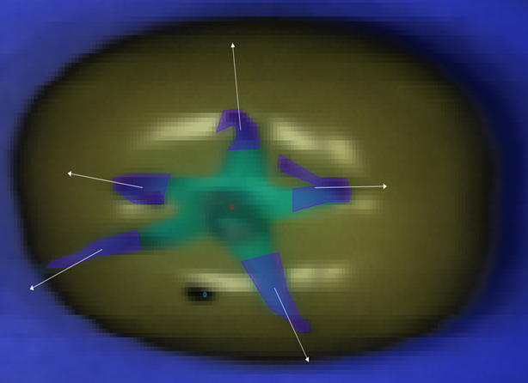

**Figure 1**: Spectra extraction from hyperspectral images. Visualization of the procedure carried out in each sepal.

2.2.3. Data analysis

A chemometric analysis was conducted with the aim of calibrating and validating models to predict the susceptibility to fungal infection in tomatoes according to their degree of disease as observed by specialists after 4 days of germination. This analysis was done using R version 4.2.1 (2022-06-23) and involved the following steps:24

1. Data visualization

Firstly, spectra were plot to have a first appreciation of the shape of the data, observe their clarity, signal-to-noise ratio, presence of obvious outliers, baseline, etc.

1. Data exploration and outlier removal

Exploratory analysis was carried out at sepal and variety level using Principal Component Analysis (PCA).25

A.1. Sepal Level. PCA was applied over all the pixels for a given sepal. In order to detect outlier pixels, Mahalanobis distances were computed between the individual projection of each score value onto the model and the center of the model. The identification of outliers was determined based on a specified confidence level (0.95), indicating the probability that a data point lies within a certain range. The cutoff for Mahalanobis distances was employed as a threshold, beyond which data samples were classified as outliers. The confidence level played a crucial role in controlling the sensitivity of the outlier detection, with higher confidence levels leading to more stringent criteria for identifying outliers.

The outliers were removed, the remaining pixels averaged, and the datasets were finally reassembled according to their labels (see Table 1).

**Table 1:** Description of the dimensionality of the initial and final datasets before and after averaging spectra that belonged to the same sepal.

|  |  |  |  |  |  |  |  |
| --- | --- | --- | --- | --- | --- | --- | --- |
| Dataset name/ Number of | Pixels per sepal | Sepals per tomato | Tomatoes per image | HSI | Spectra in the  initial dataset | Spectra in the averaged dataset | Variables |
| Provine | Between 119 and 90 | 5 or 6 | 16 | 2 | 16156 | 159 | 112 |
| Brioso | Between 45 and 53 | 5 or 6 | 32 | 1 | 6497 | 164 | 112 |
| Cappricia | Between 81 and 124 | 5 or 6 | 16 | 2 | 12816 | 165 | 112 |

Data exploration was carried out again by PCA in order to remove outliers at Cultivar level (in Provine, Brioso and Cappricia datasets). Score plots were created, outliers were detected visually and removed from dataset.

1. Pretreatments on raw spectra

Various pretreated forms of the original spectra were used to calibrate and validate different models, whose performances were compared with each other. These methods include: Detrend grades 1 and 2; Savitzky–Golay first and second derivatives, second polynomial degree and 9, 11, 15, 17 smoothing windows; Standard Normal Variate (SNV); and combinations of these.26 Only the best results will be presented in this document.

1. Data split

Three binary-class scenarios were derived from the visual scoring explained in Data collection (2.2.1):

* Scenario 1: Score of 0 was considered healthy, and any other value was considered infected;
* Scenario 2: A score of 1 or less was considered healthy and the rest infected;
* Scenario 3: scores from two consecutive days were averaged, and a healthy class was considered when score was 0.5 or lower, otherwise the sepal was considered infected

Stratified sampling was carried out in the following way. The datasets were divided into calibration (70%) and validation (30%) sets, in a representative way for each class, randomly. The number of spectra resulting from this separation, according to each labeling scenario, can be seen in Table 2.

**Table 2:** Number of spectra in each class (Healthy: Class 1; Diseased: Class 2) when dataset was split according to different labelling scenarios (Label 1: 0/123; Label 2: 01/23 and Label 3: 0.5/123).

|  |  |  |  |  |  |  |  |
| --- | --- | --- | --- | --- | --- | --- | --- |
| Cultivar | n | Label 1 | | Label 2 | | Label 3 | |
| Healthy | Diseased | Healthy | Diseased | Healthy | Diseased |
| Cappricia | 163 | 139 | 24 | 85 | 78 | 117 | 46 |
| Brioso | 153 | 145 | 8 | 78 | 75 | 126 | 27 |
| Provine | 152 | 137 | 15 | 72 | 80 | 129 | 23 |

1. Feature selection

An iterative process was used to select a sparse subset of important variables in the Training set, using CovSel algorithm.24 Iteratively top 5 to top 39 Important Variables (ivs), (numbers chosen arbitrarily), were chosen for each pretreatment, labelling and cultivar. The selected variables were then used as input for the classification model.

Dataset with measured reflectance of only the chosen variables was saved in “CovSelTrain". The same ivs were selected from the Test Set, and saved in “CovSelTest".

1. Calibration and validation of PLSDA models

The selected variables as given by CovSel were then used as input of PLSDA.

The Training set was split again, into Validation (70%) and Tuning (30%), randomly. Different models with different number of Latent Variables (LVs) were calibrated in Validation set and tested in the Tuning set. The number of LVs was selected according to the model that showed the lowest prediction error in the Tuning set.

The PLSDA model, already optimized for the number of latent variables, was tested in “CovSelTest”, and classification parameters were obtained.

1. Evaluation of results

In this study, 10 parameters were used to evaluate the results: Sensitivity, Specificity, Precision, Accuracy and Balanced Accuracy, Geometric mean, F-measure, Youden index, Positive likelihood ratio, and Negative likelihood ratio. These are explained in detail in previous publications and shown in Table 3 .27-29 The evaluation should consider all of them simultaneously, because each one of them takes into account different characteristics of the general discrimination effectiveness.Google sheets were used in order to plot the results of this study.

Table 3 : Parameters commonly used to evaluate classification models. TN: True Positives; TN: True Negatives; FN: False Negatives; FP: False Positives. Source: Akosa, 2017.

|  |  |
| --- | --- |
| Measure | Formula |
| Accuracy |  |
| Misclassification rate (1-Accuracy) |  |
| Sensitivity (or Recall) |  |
| Specificity |  |
| Precision |  |
| Balanced Accuracy (BA) |  |
| Geometric mean |  |
| Positive likelihood ratio |  |
| Negative likelihood ratio |  |
| F-measure |  |
| Youden index |  |

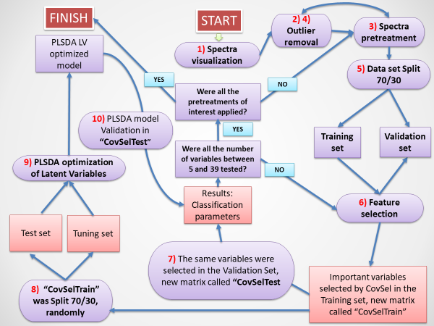

**Figure 2**: Diagram of the basic chemometric steps carried out in this work in order to optimize the parameters of the models.

The iterative process carried out in this work is shown in Figure 2, and can be summarized as follows:

A. Spectra visualization and outlier removal.

B. Model selection.

0. Start with a cultivar from a set of cultivars. Start with no "best model” for the cultivar.

1. Select labelling scenario (from 3 scenarios).

2. Select one pretreatment or combination of pretreatments;

3. Split Dataset.

4. Select important features.

5. Apply PLSDA and select the optimal number of latent variables (LVs).

6. Repeat Steps 4 and 5 selecting from 5 to 39 variables by CovSel.

7. If a model BA is higher than the previous model, keep the current model as the “best model".

Note: Results of steps 1 to 7 will give the best model per cultivar.

C. The same process was repeated for global modeling where different scenarios of variety combinations were investigated: Cappricia+Provine, Cappricia + Brioso, Brioso + Provine and Cappricia + Provine + Brioso.

1. **Results and Discussion**

3.1 Intravariety models

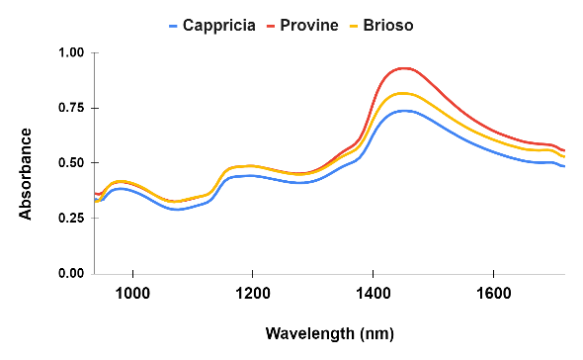 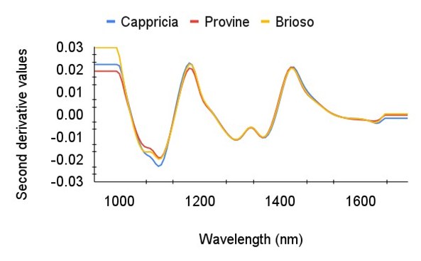

**Figure 3**. left: Average of the raw spectra for each variety, right: Average of the spectra pretreated with SNV and second derivative (2, 17, 2).

First, the raw spectra were plot immediately after being extracted from the images. This first visualization allowed us to have a first appreciation of how the spectra looked in relation to noise and scattering effects, distortions in the baselines, signal-to-noise ratio, in addition to the presence of clear outliers. In order to understand the presence of multiplicative and/or additive effects in the spectra, their intensities were plot as a function of the average spectra (graphs not shown here). The shape of these graphs (millefeuille or cone) helped distinguish effects in the spectra. In all cases, combined effects (multiplicative and additive) were found in the analyzed spectra. Figure 3 (left) shows the average of the raw spectra for each variety, and Figure 3 (right) shows the average of the spectra pretreated with SNV and second derivative (2, 17, 2). As mentioned above, other pretreatments were applied and compared as well.

It can be observed that raw spectra of Provine and Brioso overlapped up to approximately 1400 nm, while at longer wavelengths the average spectra were clearly differentiated. Cappricia spectra showed greater intensity throughout the entire spectral range.

Three bands are observed in the pure spectra of all varieties. In the following paragraphs, tentative assignments will be mentioned along with their bibliographic sources.

The maximum intensities observed were 0.7373 (Cappicia), 0.9296 (Provine) and 0.8163 (Brioso); at 1455nm, 1447.9nm and 1447.9nm respectively, at 1455nm (6872.85cm-1) in Cappricia and at 1447.9nm (6906.08cm-1) in the other two varieties. These bands can be attributed to the symmetric and asymmetric stretching vibrations of water molecules at the first harmonic of the OH stretching vibrations of water.30 More specifically, those wavelengths are included into two well-defined wavelength ranges where water shows the greatest variation of energy absorbance in response to disturbances, (Water Matrix Coordinates, “WAMACS”), called C8 and C9. *“WAMACS describe different conformations of water such as water dimers, trimers, superoxides, water solvation shells, etc”* .30,31

The mentioned peaks in spectra can be found in WAMACS C8 and C9

*C9 1458-1468nm: Water molecules with 2 hydrogen bonds (S2)*

*C8 1448-1454nm: ν2 + ν3, Water solvation shell, OH-(H2O)4,5.32-35*

The other peak in raw spectra was located at 1194.6 nm (8368.20cm-1) in all three varieties. According to M. Jakubíková et al. in 2016*: “the region from 8300 to 8600 cm-1 corresponds to the third overtone band of the bond CH”.36*

In 2003, Dalimov et al. explained that tomato has approximately 11% lignin, which has carboxylic groups that distinguish it from other plants.35. Moreover, these authors analyzed IR spectra of suspended tomato particles, and found typical absorption bands for lignin and carbohydrates. They assigned the 1194.6 nm wavelength to the second C–H str overtone of methyl groups, CH3-groups, as well as the lignin component of tomatoes.

However, other publications assign this band to glucose. Tanaka et al, in 2021, measured several glucose anomers in light and heavy water by NIR, and found a peak at 1195 nm in both solvents.38 Furthermore, Lopez et al in 2016, performed carbohydrate analysis by NIR, and assigned the same peak to the OH stretch 1st overtone of glucose.39

Finally, the three raw spectra have a peak at 978.85nm (10241.5 cm-1). It has been assigned in literature to the O–H stretching second overtones, to the hydroxide ion (980 nm) and to the hydrogen-bonded –OH, 2nd overtone (980.4 nm).40

Figure 3 (right) shows average spectra of the measured reflectance for each cultivar, after they were corrected using both the SNV and second derivative (grade=2, window width=17 and polynomial degree=2) algorithms. It should be mentioned that in this study, the most appropriate pretreatments were chosen according to the way in which they modify the performance of the models. Pretreatments depend on data, sometimes they can be beneficial but other times not.

In this example, SNV was used to remove both the scattering effects caused by the diffusion of photons and the measurement noise (random phenomena present throughout the entire measurement chain). The resulting spectra had media equal to zero and standard deviation equal to one. Furthermore, second derivative was used to find the exact location (center) of the shoulders in the original spectra, by deconvoluting and highlighting the peaks. As a result, we observed significantly narrower bands. Peaks appeared in the same locations as peaks in the original spectra.

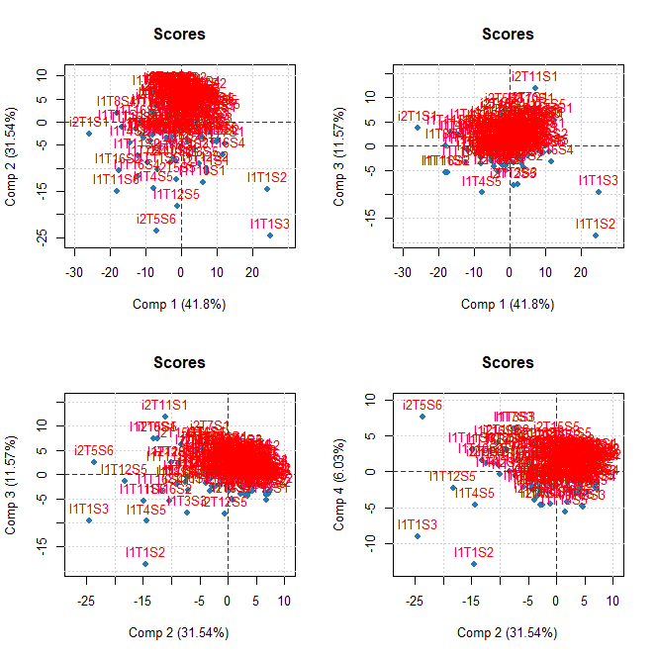

**Figure 4**: PCA score plots of Cappricia

The PCA analysis was performed in this case on the pretreated spectra, first with SNV and then with the second derivative (2, 17, 2), in all three varieties. Scores plots for Cappricia are shown in Figure 4. The number of principal components to accumulate the variance explained by the model, together with the outliers detected can be seen in Table 4.

Table 4. Results of exploration by PCA, to detect outliers at cultivar level.

|  |  |  |  |
| --- | --- | --- | --- |
| **Cultivar** | **Number of Principal Components** | **% Variance explained by the model** | **Number of extreme outliers detected visually** |
| Brioso | 8 | 99.15 | 6 |
| Cappricia | 7 | 99.02 | 6 |
| Provine | 8 | 99.13 | 4 |

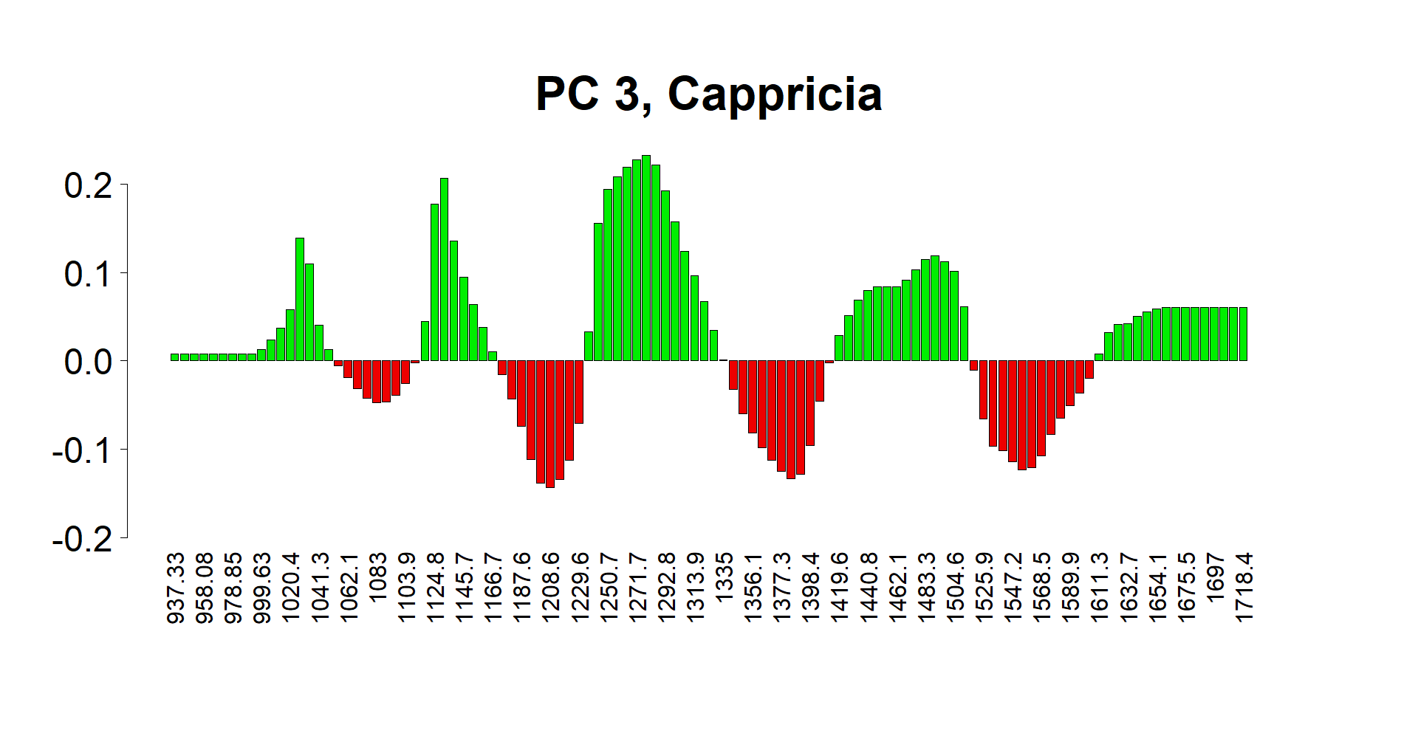

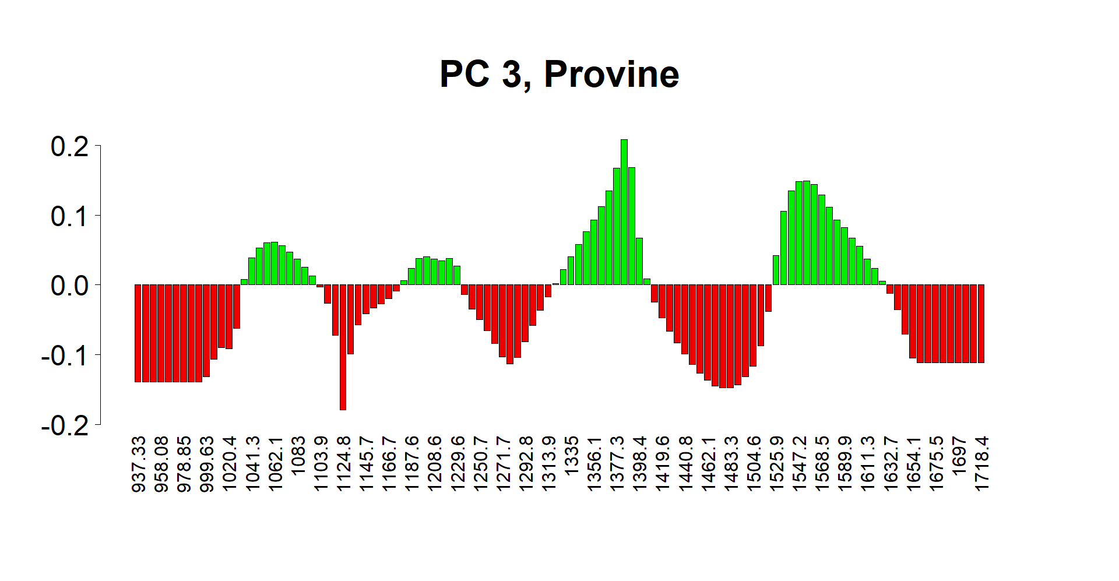

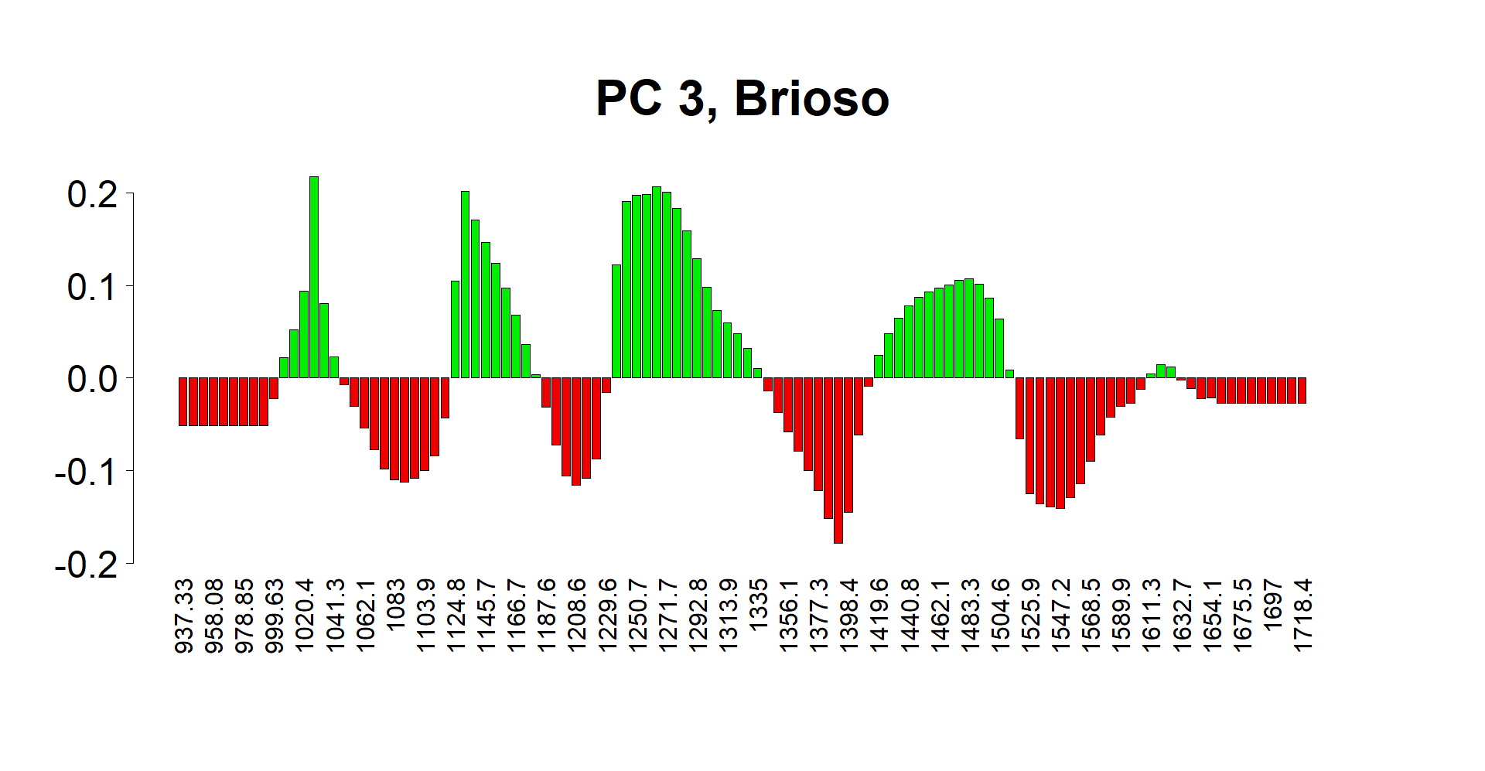

The Loadings Plots showed that there is no notable difference between varieties in PC1 and PC2 in all three varieties (graphs not shown). However, PC3 was markedly different in each variety (Figure 5), indicating that this main component is a significant carrier of the inter-varietal distinctiveness of this product.



Different results obtained using different labeling scenarios between the healthy and the diseased classes for Cappricia cultivar were compared (plots not shown). As a result, the precision metric behaved erratically when Scenario 1 was selected. This metric showed high values when less than 13 variables were chosen, but then decreased abruptly with 14 variables; and increased again when 15 variables were chosen. This counterintuitive behavior was due to the fact that the precision metric took into account false positives in the denominator, which changed abruptly with different splits. In other words, the behavior of the precision metric showed that the data were not uniformly distributed in both classes, when Scenarios 1 and 3 were chosen.

Another indicator of class balancing was the correlation between the accuracy (blue line) and the balanced accuracy (BA) (orange line). When the classes were balanced, these metrics were almost identical, and their lines overlapped as we could see in Scenario 2 (Figure B). On the other hand, in Figures 1. A and 1. C, a clear separation was observed between them, the accuracy was higher than BA.

As a rule, high BA values showed that the model performances were good for both classes. On the other hand, high accuracy metric showed that the model performed well in general. When using Scenarios 1 and 3, this was the case for the majority classes only.

It should be mentioned that there are several ways to solve data imbalance. One of them is with oversampling (adding samples from the least represented class); or with undersampling (deleting samples from the majority class). In the first case, the risk of overfitting increases, since during cross-validation, the same samples that are in the model can be used to validate it; in the second case, important information is removed from the model.

A one-class classification could also have been used, where all samples similar to the samples of one class are considered, and the others discarded by the model. However, these models are always less specific, and in the case of the present study, they showed poorer classification parameters.

Due to these reasons, Scenario 2 was chosen to calibrate and validate the models. No addition or removal of samples was made, except for the aforementioned outliers.

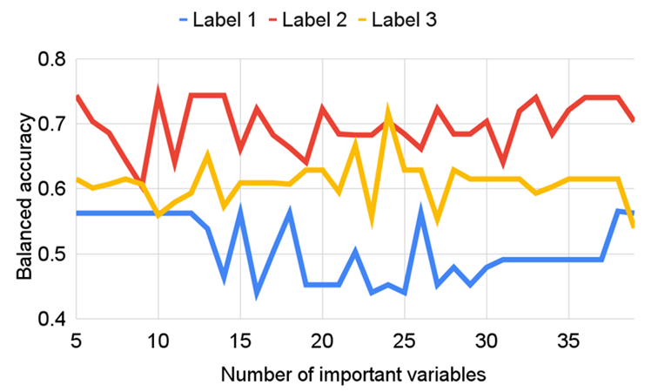

**Figure 6:** Comparison of Balanced Accuracy in different labelling scenarios according to different number of important variables as input for PLSDA.

The relationship between the BA of the models versus the number of important variables (ivs) chosen by CovSel can be seen in Figure 6, for the different Scenarios 1, 2 and 3. Once again, we can see that Scenario 2 was the best option, because it showed higher BA values.

The following parameters generated the optimal models:

Cappricia: SNV + Second Derivative (2, 15, 2) and 33 ivs

Provine: SNV and 13 ivs

Brioso: Raw spectra and 18 ivs

Cappricia: Optimal model was found with pretreated data (SNV+ SG (2,15,2)) and 33 most important variables. Provine: Optimal model was found with SNV pretreated data and 13 most ivs Brioso: Optimal model was found with raw data and 18 ivs.

3.2. Global models

**Table 4:** PLSDA Classification results of a global model, calibrated and validated with Cappricia and Provine.

|  |  |  |  |  |  |  |  |  |
| --- | --- | --- | --- | --- | --- | --- | --- | --- |
| **Data set** | **Real/**  **predicted** | **Healthy** | **Diseased** | **NA** | **Sensitivity** | **Specificity** | **Precision** | **BA** |
| **Calibration** | **Healthy** | **62** | **47** | **0** | **0.57** | **0.74** | **0.68** | **0.66** |
| **Diseased** | **29** | **81** | **0** | **0.74** | **0.57** | **0.63** | **0.66** |
| **Validation** | **Healthy** | **23** | **25** | **0** | **0.48** | **0.71** | **0.62** | **0.60** |
| **Diseased** | **14** | **34** | **0** | **0.71** | **0.48** | **0.58** | **0.60** |

Table 4 shows PLSDA classification results of a global model, calibrated and validated with cultivars Cappricia and Provine. In this model, spectra were pretreated with SNV, and then with second derivative (2, 17, 2). Then, 19 important variables were chosen by the CovSel algorithm. Finally, the PLSDA model was trained with the calibration data, and 17 latent variables were chosen. This relatively high number can be understood as being due to the complexity of adding two different varieties in one model.

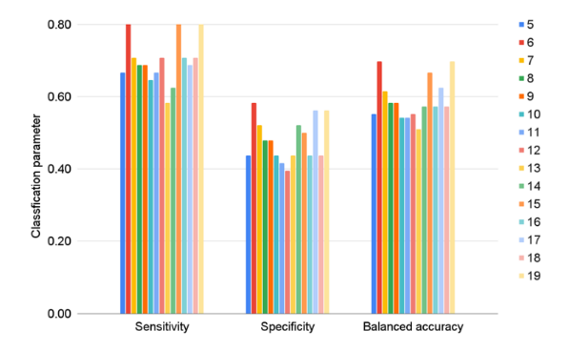

**Figure 7:** (a) Classification parameters of the validation sets for the global model trained with Cappricia and Provine according to the number of important variables as input for PLSDA. Data were pretreated with SNV + SG (2,17,2). **(b)** Classification parameters of the validation sets for the optimal models validated in this study.

In Figure 7, the values of Sensitivity, Specificity and Balanced Accuracy are shown for an increasing number of variables between 5 and 19. As can be seen, choosing only six variables produced similar results in terms of balanced accuracy as choosing 19.

**Table 5:** PLSDA Classification results of all the optimal models in this study.

|  |  |  |  |  |  |  |
| --- | --- | --- | --- | --- | --- | --- |
| **Parameter/**  **Model** | **Cappricia**  **Raw, 15v**  **Label 3** | **Cappricia**  **SNV + SG(2,15,2), 33v**  **Label 2** | **Provine**  **Raw, 14v**  **Label 3** | **Provine**  **SNV, 13v**  **Label 2** | **Brioso**  **Raw, 18v**  **Label 2** | **Global model**  **SNV, (Cap+Pro)**  **6v**  **Label 2** |
| Accuracy | 0.83 | 0.84 | 0.71 | 0.71 | 0.66 | 0.70 |
| Sensitivity or recall | 0.89 | 0.71 | 0.08 | 0.76 | 0.43 | 0.81 |
| Specificity | 0.64 | 0.89 | 0.97 | 0.65 | 0.88 | 0.58 |
| Precision | 0.89 | 0.71 | 0.50 | 0.70 | 0.77 | 0.66 |
| Balanced accuracy | 0.77 | 0.80 | 0.52 | 0.71 | 0.65 | 0.70 |
| Geometric mean | 0.75 | 0.79 | 0.27 | 0.70 | 0.62 | 0.69 |
| F-measure | 0.89 | 0.71 | 0.14 | 0.73 | 0.55 | 0.73 |
| Youden’s Index | 0.53 | 0.60 | 0.05 | 0.41 | 0.31 | 0.39 |
| Positive likelihood ratio | 2.47 | 6.45 | 2.67 | 2.17 | 3.58 | 1.93 |
| Negative  likelihood ratio | 0.17 | 0.32 | 0.95 | 0.37 | 0.65 | 0.33 |

Table 7 and Figure 8, show PLSDA modeling results of all the optimal models in this study. BA was comparable to traditional accuracy in all models created with Scenario 2, showing that the classifier performed equally well on either class.

Accurate predictions for healthy sepals were as follows: Cappricia (0.71), Provine (0.76), Global model (0.81). Similarly, for diseased sepals correctly classified as such: Cappricia (0.89), Provine (0.65), Global model (0.58).

Moreover, good performances on both positive and negative classes were found in the Cappricia Intravariety model. High positive likelihood ratio of 6.45 (above 1: increased evidence for disease-free) for the Healthy class; Low negative likelihood ratio of 0.32 (increased evidence for disease) for the Infected class.

For two-class classification, the geometric mean was calculated as the square root of the product of specificity and sensitivity. As a rule, If one of the classes cannot be recognized by the model, this parameter tends to zero. REF. This parameter showed this behavior, when its values were less than 0.5. This is was observed in the case of sample classification of the Provine variety using scenario 3: although the specificity of this model was high, the sensitivity was very low (0.08), and the GM was 0.28. In all other cases, this parameter was greater than 0.5 showing that the models were able to recognize both classes.

1. **Conclusion**

This work was carried out with the objective of developing a method to detect the susceptibility of freshly harvested tomatoes to the presence of fungi, in non-destructive ways, and before the disease can be observed visually. For this, hyperspectral images of the samples were measured, and models were developed based on their relationships with ground truth data.

The models can be divided into three general categories: those calibrated and validated using a single variety (intravariety), and finally those calibrated and validated with several varieties together (global models). In all cases, the best results were found using scenario 2 as a reference.

Within the first category, the optimal model was created with the Cappricia variety: Balanced accuracy= 0.80; Sensitivity= 0.71 and Specificity= 0.89.

As for the global models, the optimal models were calibrated using Cappricia and Provine together: Balanced accuracy=0.70, Sensitivity=0.81; Specificity=0.58.

The results from this research suggest the conclusion that discrimination between more susceptible and less susceptible samples is feasible under controlled conditions.

**Acknowledgements**

The authors would like to thank the EU commission for funding obtained through the ANTARES Horizon 2020 project (grant 664387).

**Conflicts of interest**

The authors declare no conflicts of interest.

**References**

1) Chapter 2. Tomato. DOI: https://www.oecd-ilibrary.org/docserver/9789264279728-6-en.pdf?expires=1694684540&id=id&accname=oid006406&checksum=62D03306F89450B59CFEE6DA4F9811F5

2) Nadia Bertin, M. G. (2018). Tomato quality as influenced by preharvest factors. Scientia Horticulturae, 233(15). doi:https://doi.org/10.1016/j.scienta.2018.01.056.

3) Regulation (EU) No 543/2011 {, #3}

4) CODEX STAN 293-2008 {, #4},

5) UNECE Standard FFV-36

6) E.J. Smid LH, H.A.M. Boerrigter, L.G.M. Gorris. Surface disinfection of tomatoes using the natural plant compound trans-cinnamaldehyde. Postharvest Biology and Technology. 1996;9(3):343-50.

7) Isaac Kojo Arah HA, Ernest Kodzo Kumah, and Hayford Ofori. Preharvest and Postharvest Factors Affecting the Quality and Shelf Life of Harvested Tomatoes: A Mini Review. International Journal of Agronomy. 2015;2015.

8) Yeimmy Peralta-Ruiz CDGT, Angie Sinning-Mangonez, Edgar A. Coronell, Marcos F. Marino and Clemencia Chaves-Lopez. Reduction of Postharvest Quality Loss and Microbiological Decay of Tomato “Chonto” (Solanum lycopersicum L.) Using Chitosan-E Essential Oil-Based Edible Coatings under Low-Temperature Storage. Polymers (Basel). 2020;1822.

9) Manon Mensink AC, Najim El Harchioui, Esther Hogeveen (2019). Kwaliteit van tomatenkronen na oogst. In: Research WFB, editor. projectnummer 62341268002019.

10) Jan Janse HB. Kroonschimmel bij tomaat : consultancyonderzoek. In: Wageningen UR Glastuinbouw WUAaFSG, editor. 2007.

11) Sanja Brdar, M. P., Esther Hogeveen‑van Echtelt, Manon Mensink, Željana Grbović, Ernst Woltering, Aneesh Chauhan. (2022). Predicting sensitivity of recently harvested tomatoes and tomato sepals to future fungal infections. Nature, 11:23109 doi: https://doi.org/10.1038/s41598-021-02302-2

12) Daniel Jiménez-Fernández, M. M.-B., Juan A. Navas-Cortés, & Rafael M. Jiménez-Díaz, B. B. L. (2009). Identification and quantification of Fusarium oxysporum in planta and soil by means of an improved specific and quantitative PCR assay. Applied Soil Ecology, 46(3), 372-382. doi:https://doi.org/10.1016/j.apsoil.2010.10.001

13) Mina Nan, 2 Huali Xue,1,* and Yang Bi3,*. (2022). Contamination, Detection and Control of Mycotoxins in Fruits and Vegetables. Toxins, 14(5), 309. doi:10.3390/toxins14050309

14) Margot Delavy ARDS, Clara M. Heiman and Alix T. Coste. Investigating Antifungal Susceptibility in Candida Species With MALDI-TOF MS-Based Assays. Frontiers in Cellular and Infection Microbiology. 2019;9(19).

15) Kazbek Dyussembayev PS, Ido Bar, Jeremy C. Brownlie, Muhammad J. A. Shiddiky, Rebecca Ford. Biosensor Technologies for Early Detection and Quantification of Plant Pathogens. Frontiers in Chemistry. 2021;9.

16) N. Rajeshwari MDS, M. Krishnappa, H.S. Shetty, C.N. Mortensen & S.B. Mathur Development of ELISA for the detection of Ralstonia solanacearum in tomato: its application in seed health testing. World Journal of Microbiology and Biotechnology 1998;14:697-704.

17) Shuodan Hu CY, Hong Yu, Yu Zhang, and Chuan-Qing Zhang. Establishment of the Recombinase Polymerase Amplification–Lateral Flow Dipstick Detection Technique for Fusarium oxysporum. Plant Disease. 2023;107(9):2665-72.

18) Paul Skolik, M. R. M., Francis L. Martin. (2019). ATR-FTIR spectroscopy non-destructively detects damage-induced sour rot infection in whole tomato fruit. Planta, 249(3), 925-939. doi:https://www.jstor.org/stable/48701885

19) Huting Wang, R. H., Mengyun Zhang, Zhiqiang Zhai, Ruoyu Zhang. (2021). Identification of tomatoes with early decay using visible and near infrared hyperspectral imaging and image-spectrum merging technique. Journal of Food Process Engineering 44(4). doi:https://doi.org/10.1111/jfpe.13654

21) J.M. Roger, B. P., D. Bertrand, E. Fernandez-Ahumada (2011). "CovSel: Variable selection for highly multivariate and multi-response calibration. Application to IR spectroscopy." Chemometrics and Intelligent Laboratory Systems 106(2).

23) Alessandra Biancolillo, F. M., Jean-Michel Roger. (2019). SO-CovSel: A novel method for variable selection in a multiblock framework. Journal of Chemometrics, 34(2). doi: https://doi.org/10.1002/cem.3120

24) Chu Zhang a b, L. Z. a. b., Yiying Zhao a b, Susu Zhu a b, Fei Liu a b, Yong He a b (2020). "Noise reduction in the spectral domain of hyperspectral images using denoising autoencoder methods." 203(104063).

30) Ståhle L WS. Partial least squares analysis with cross-validation for the two-class problem: A monte carlo study. Journal of chemometrics. 1987;1(3):185-96.

31) Barker M RW. Partial least squares for discrimination. Journal of Chemometrics. 2003;17(3):166-73.

36) Specim FX17 NIR linescan camera with a spectral range (937.33 nm-1718 nm).

37) The Darwin annotation tool from V7 labs was used to perform annotation (https://darwin.v7labs.com). Annotations were used to extract sepal pixel spectra using a custom Python image processing pipeline.

38) R version 4.2.1 (2022-06-23)

39) Fearn T. Principal Components Analysis is Not a Classification Method. NIR news. 2016;27(3):3-27.

40) (Davide Ballabio, 2018; “Multivariate comparison of classification performance measures”. Davide Ballabio, Francesca Grisoni, Roberto Todeschini Chemometrics and Intelligent Laboratory Systems, 2017. https://doi.org/10.1016/j.chemolab.2017.12.004

41) Akosa, 2017) “Predictive Accuracy: A Misleading Performance Measure for Highly Imbalanced Data”Paper 942-2017. Josephine Sarpong Akosa Graduate Teaching Associate Oklahoma State University josephine.akosa@okstate.edu http://statistician.wixsite.com/josephine-akosa

42) C. Luz, V. D. O., J.M. Quiles, R. Romano, J. Mañes, G. Meca (2020). Biopreservation of tomatoes using fermented media by lactic acid bacteria. 130. doi:https://doi.org/10.1016/j.lwt.2020.109618

43) Jelena Muncan RT, . Aquaphotomics—From Innovative Knowledge to Integrative Platform in Science and Technology. Molecules. 2019;24(15):2742.

44) [Aquaphotomics.com - Aquaphotomics Method](https://www.aquaphotomics.com/aquaphotomics-method/)

45) Franks, F., ed. 1973. Water: A comprehensive treatise Vol. 3. New York: Plenum Press.

46) Tsenkova, R.N., I.K. Iordanova, K. Toyoda, and D.R. Brown. 2004. “Prion protein fate governed by metal binding.”  Biochemical and biophysical research communications 325 (3):1005-1012. doi: 10.1016/j.bbrc.2004.10.135.

47) Cattaneo, T. M.P., G. Cabassi, M. Profaizer, and R. Giangiacomo. 2009. “Contribution of Light Scattering to near Infrared Absorption in Milk.”  Journal of Near Infrared Spectroscopy 17 (6):337-343. doi: .

48) Ozaki, Y. 2002. “Applications in chemistry in near-infrared spectroscopy: Principles, instruments and applications.” In, edited by H.W. Siesler, Y. Ozaki, S. Kawata and H. M. Heise. Weinheim, Germany: Wiley-VCH Verlag GmbH.49) D. N. Dalimov GND, and M. Bhatt3. CHEMICAL COMPOSITION AND LIGNINS OF TOMATO AND POMEGRANATE SEEDS. Chemistry of Natural Compounds. 2003;39(1):37-40.

49) 1.M. Jakubíková JS, A. Kleinová, P. Májek. Near-infrared spectroscopy for rapid classification of fruit spirits. Journal of Food Science and Technology 2016;56(6):2797-803.

50) Manfred Schwanningera JCR, Karin Fackler. A review of band assignments in near infrared spectra of wood and wood components. Journal of Near Infrared Spectroscopy. 2011;19:287–308.

51) Mercedes G. López ASG-G, Elena Franco- Robles. Carbohydrate Analysis by NIRS-Chemometrics. Skvaril KGKaJ, editor. Developments in Near-Infrared Spectroscopy2016.

52) Hongzhe Jiang YZ, Cong Zhang, Weidong Yuan and Hongping Zhou. . Evaluation of Dual-Band Near-Infrared Spectroscopy and Chemometric Analysis for Rapid Quantification of Multi-Quality Parameters of Soy Sauce Stewed Meat. Foods. 2023;12(15):2882.

53) Zoltan Kovacs JM, Petya Veleva , Mitsue Oshima, Shogo Shigeoka, Roumiana Tsenkova Aquaphotomics for monitoring of groundwater using short-wavelength near-infrared spectroscopy. Spectrochimica Acta Part A: Molecular and Biomolecular Spectroscopy. 2022;279(121378).

54) https://imbalancedlearn.org/stable/references/generated/imblearn.metrics.geometric_mean_score