OmniRoute for Claude Code
Free AI chat and a free fallback for Claude Code — User guide
Version 1.0 · October 2026 · macOS and Windows
Repository: github.com/MMC1410001/free-ai-setup
Written in Simplified Technical English (ASD-STE100 style).

Contents

1. What this tool does
2. What you get for free
3. Before you start
4. Get your free NVIDIA API key
5. Install
5.1 Method A: one command
5.2 Method B: double-click
5.3 Answer the questions
6. Use OmniRoute Chat
6.1 Open the app
6.2 Send a message
6.3 Attach images and files
6.4 Choose a model
6.5 Saved chats
7. Settings, keys and limits
7.1 Set a daily token limit
8. Connect Kiro (optional)
9. Use with Claude Code (developers)
9.1 Switch when your paid Claude is used up
9.2 Terminal commands
9.3 Status line
10. See the tokens you used and the tokens that are left
11. Troubleshooting
12. Update and remove
13. Security and privacy
14. Sources

1. What this tool does
This tool gives you free AI on your computer. It uses OmniRoute. OmniRoute is a free, open-source program. It sends your messages to free AI providers. When one provider is busy or has no free use left, OmniRoute tries the next one.
The installer gives you two things:
Part | For | What it does
OmniRoute Chat | Everyone. No terminal is necessary. | A chat app, like ChatGPT. You can attach images, PDF, Word, Excel and text files. You can see your token use and set limits.
Claude Code free mode | Developers | The /omni command switches a project between your paid Claude and free OmniRoute. The claude-omni command starts a free Claude Code in a terminal.

NOTE: The installer does not change your paid Claude Code. The claude command and the Claude Code extension continue to use your paid account until you type /omni free in a project.
The figure below shows how the parts work together. Everything except the AI providers runs on your computer.
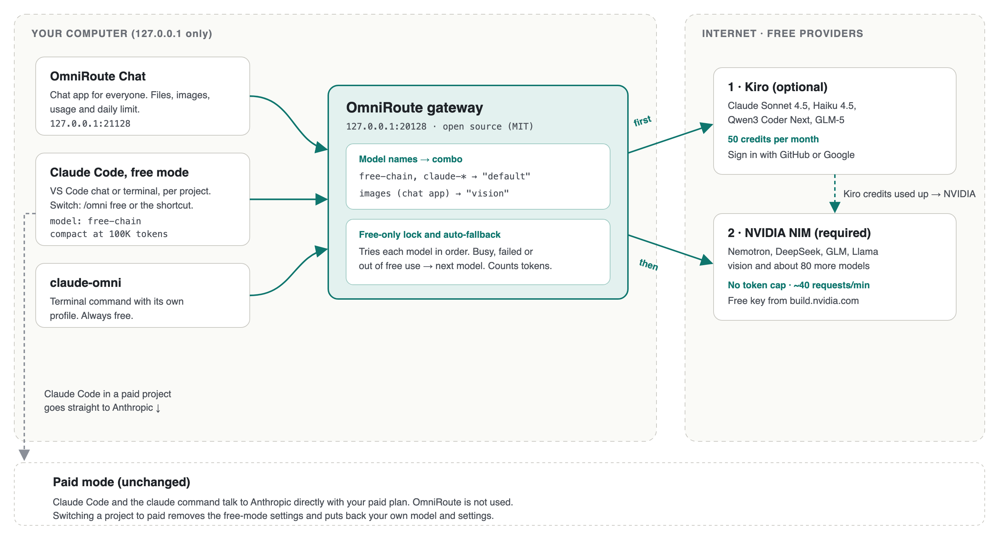
Figure 1. How it works: the apps, the OmniRoute gateway and the free providers

2. What you get for free
Provider | Free allowance | Conditions
NVIDIA NIM (required) | No token limit. About 40 requests per minute. | Free with the NVIDIA Developer Program. NVIDIA allows this use for prototyping, research, development and testing. Do not use it for production services. About 80 models are available, for example Nemotron, DeepSeek, GLM, Kimi and Llama Vision.
Kiro (optional) | 50 credits per month. The credits reset on the first day of the month. | Gives Claude Sonnet 4.5, Claude Haiku 4.5, Qwen3 Coder Next and GLM-5. Long Claude Code sessions use the credits quickly. When the credits are used, OmniRoute uses NVIDIA.
OmniRoute | Free. OmniRoute has no limits of its own. | Open source (MIT license). Its catalog lists many other free providers. In September 2026 the catalog showed about 1.5 billion free tokens per month across 34 provider pools. You can add these providers in the OmniRoute dashboard. Read the terms of each provider first.

NOTE: Providers can change their free plans at any time. Check the provider web sites for the current limits.

3. Before you start
Make sure that you have these items:
- A Mac with a recent version of macOS, or a PC with Windows 10 or Windows 11.
- About 3 GB of free disk space. OmniRoute uses about 2.5 GB.
- An internet connection.
- Your computer password. The installer can ask for it to install Node.js.
- A free NVIDIA account (step 4 tells you how to get it).
- Optional: Claude Code (VS Code extension or the claude command), if you want the developer features.

4. Get your free NVIDIA API key
- Open https://build.nvidia.com in your web browser.
- Click Sign In. If you do not have an account, create a free account. NVIDIA can ask you to verify your e-mail address or phone number.
- Open any model page, then click Get API Key. You can also open your profile menu and click API Keys.
- Click Generate Key.
- Copy the key. The key starts with nvapi-.
- Keep the key in a safe place, for example a password manager.
WARNING: Your API key is like a password. Do not send it in e-mail or chat. Do not put it in a document or in a code repository.

5. Install
Use method A or method B. Both methods do the same installation.

5.1 Method A: one command
On a Mac:
- Open Terminal (Applications → Utilities → Terminal).
- Copy this command, paste it into Terminal and press Return:
curl -fsSL https://raw.githubusercontent.com/MMC1410001/free-ai-setup/main/install.sh | bash
On Windows:
- Click Start, type PowerShell and open Windows PowerShell.
- Copy this command, paste it into PowerShell and press Enter:
irm https://raw.githubusercontent.com/MMC1410001/free-ai-setup/main/install.ps1 | iex

5.2 Method B: double-click
- Open https://github.com/MMC1410001/free-ai-setup.
- Click Code, then Download ZIP.
- Unzip the file.
- On a Mac, right-click Install-Mac.command and click Open. If macOS shows a warning, click Open again.
- On Windows, double-click Install-Windows.cmd. If Windows shows "Windows protected your PC", click More info, then Run anyway.

5.3 Answer the questions
The installer shows its progress in 8 steps. It asks these questions:
Question | What to do
Paste your NVIDIA API key | Paste the key from section 4 and press Enter. The screen does not show the key. The installer checks the key with NVIDIA.
Connect Kiro now? | Type n to skip. You can connect Kiro later in OmniRoute Chat. Type y if you want Claude Sonnet 4.5 now (see section 8).
Open OmniRoute Chat now? | Press Enter to open the chat app.

The first installation takes about 5 to 10 minutes. If Node.js is not on the computer, the installer installs it. The computer then asks for your password (Mac) or for permission (Windows).
When the installer is complete, it shows Done.
NOTE: You can run the installer again at any time. A second run updates OmniRoute and repairs the setup. It keeps your keys and settings.

6. Use OmniRoute Chat

6.1 Open the app
- Mac: open OmniRoute Chat on the Desktop or in your Applications folder (in your home folder).
- Windows: open OmniRoute Chat on the Desktop or in the Start menu.
The app starts OmniRoute if it is not running. The app opens in its own window. The address is http://127.0.0.1:21128.
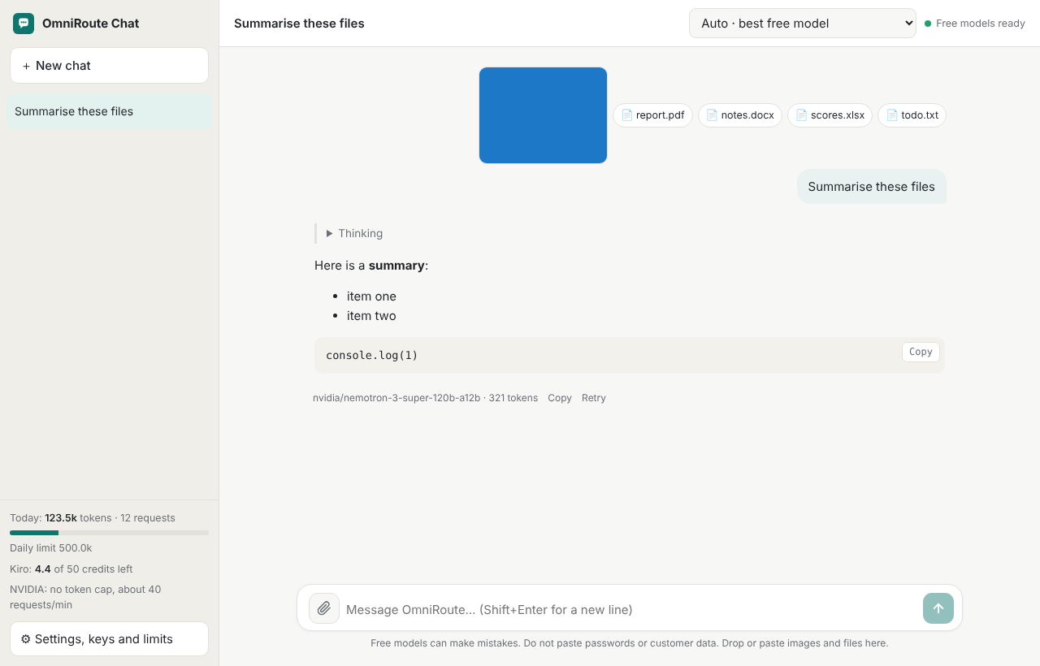
Figure 2. OmniRoute Chat with attached files (example values)

6.2 Send a message
- Type your message in the box at the bottom.
- Press Enter to send. Press Shift+Enter to start a new line.
- To stop a reply, click the square button.
- To get a new reply, click Retry below the last answer.
Some models think before they answer. Click Thinking to see this text.

6.3 Attach images and files
Click the paper clip, drag files into the box, or paste an image. You can attach these types:
Type | Files | What the app does
Images | PNG, JPG, WebP, GIF | Makes large images smaller, then sends them to a model that can read images.
Documents | PDF, Word (.docx) | Reads the text and sends the text. A scanned PDF has no text: send its pages as images.
Spreadsheets | Excel (.xlsx, .xls), CSV | Reads each sheet as rows of text.
Text and code | .txt, .md, .json, .py, .js and more | Sends the text.

The app sends a maximum of 200,000 characters from each file. A very long file can be too large for the model. Then start a new chat or attach a shorter file.

6.4 Choose a model
Use the list at the top right:
- Auto · best free model: the app tries the free models in order. This is the best choice for most work.
- Auto · for images: models that can read images. The app selects this automatically when you attach an image.
- A model name: use only this model. If it is busy, you get an error.

6.5 Saved chats
The app saves your chats in this browser on this computer. The app does not upload your chats. Your messages go only to the AI provider that answers them. To delete chats, click the ✕ next to a chat, or use Settings → General → Delete all chats.
WARNING: Free AI models can make mistakes. Do not paste passwords, personal data or customer data into the chat.

7. Settings, keys and limits
Click Settings, keys and limits at the bottom left. The settings have four tabs.
Tab | What you can do
Keys and providers | Connect or replace your NVIDIA key. Connect Kiro with GitHub or Google. Open the OmniRoute dashboard.
Usage and limits | See tokens and requests for today and this month. See the Kiro credits that are left. Set your own daily token limit.
Models | Change the order of the models for Auto and for images. Add a model from the NVIDIA list. Reset to the recommended order.
General | Write instructions for the AI, for example "Answer in simple English". Delete all saved chats.

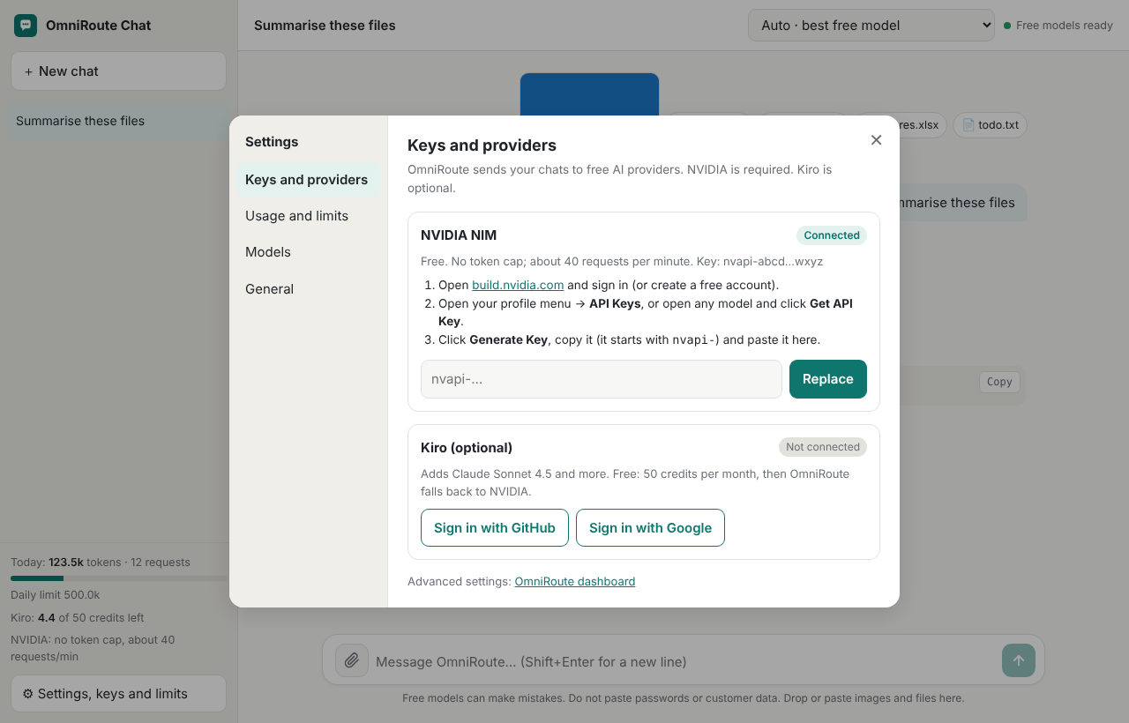
Figure 3. Settings → Keys and providers (example values)
Open the Models tab to change the order in which Auto tries the free models.
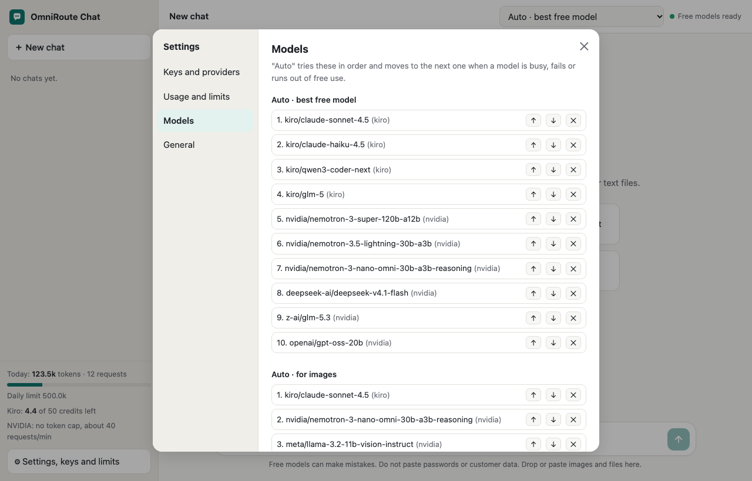
Figure 4. Settings → Models: the order of the free models (example values)

7.1 Set a daily token limit
- Open Settings → Usage and limits.
- Type a number in My daily token limit, for example 500000.
- Click Save.
When the tokens for today reach this number, the app stops sending messages until the next day. Type 0 to remove the limit.

8. Connect Kiro (optional)
Kiro adds Claude Sonnet 4.5. You get 50 free credits each month.
- In OmniRoute Chat, open Settings → Keys and providers.
- Click Sign in with GitHub or Sign in with Google.
- A browser tab opens. Sign in. If the page asks for a code, type the code that the app shows.
- Approve the access.
- Go back to the app. After a few seconds, Kiro shows Connected.
Developers can also run this command in the setup folder: node scripts/kiro-login.mjs github

9. Use with Claude Code (developers)
The installer adds the /omni command to every project. Type it in the Claude Code chat in VS Code, or in the terminal.
Command | Result
/omni free | This project uses free OmniRoute.
/omni paid | This project goes back to your paid Claude.
/omni usage | Shows tokens for today and this month, and the free allowance that is left.
/omni or /omni status | Shows the mode of this project.

After /omni free or /omni paid, reload the window: press Cmd+Shift+P (Mac) or Ctrl+Shift+P (Windows), then select Developer: Reload Window.
NOTE: The first message before you reload can show an error. This is normal. The switch is already done.
After you switch to free, start a new conversation: type /clear. The free models can read a maximum of 128,000 tokens. A long conversation from your paid Claude is too large for them.
Each project has its own mode. /omni free writes the OmniRoute settings to .claude/settings.local.json in the project and adds this file to .gitignore. /omni paid removes only these settings and puts back your own values, for example your paid model. Your permissions and other settings stay.
The figure below shows what happens when you switch a project.
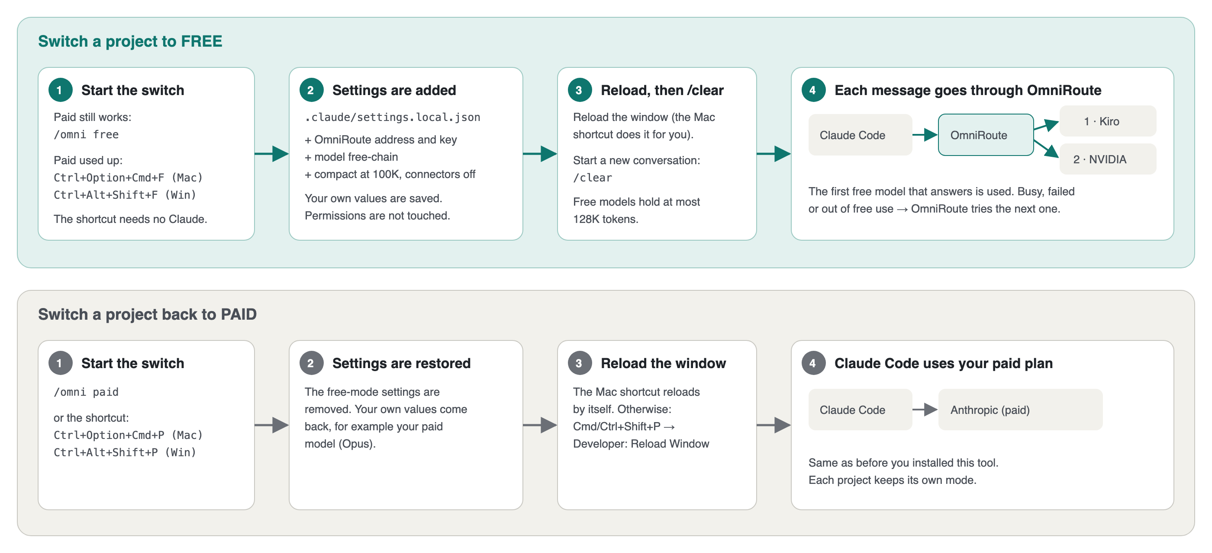
Figure 5. Workflow: switch a project between paid and free

9.1 Switch when your paid Claude is used up
/omni needs Claude to answer. When your paid Claude is used up, /omni cannot run. Use these keyboard shortcuts instead. They work in every project. On a Mac, they also reload the window.
Press | Result
Ctrl+Option+Cmd+F (Mac) or Ctrl+Alt+Shift+F (Windows) | This project uses free OmniRoute.
Ctrl+Option+Cmd+P (Mac) or Ctrl+Alt+Shift+P (Windows) | This project goes back to your paid Claude.

If a shortcut does not work, press Cmd+Shift+P (Mac) or Ctrl+Shift+P (Windows), select Tasks: Run Task, then select OmniRoute: switch to FREE. On Windows, reload the window after the switch.

9.2 Terminal commands
Command | Result
claude | Your normal paid Claude Code. The installer does not change it.
claude-omni | Claude Code through OmniRoute, with a separate profile.
omni-chat | Opens OmniRoute Chat.
omniroute | The OmniRoute command line, for advanced tasks.

9.3 Status line
In the terminal version of Claude Code, the bottom line shows the mode and the token use. Example:
FREE · OmniRoute | context 12% | today 1.2M tok · 48 req | Kiro 4.3/50 credits left | NVIDIA 40 req/min
In paid mode, the line shows how much of your 5-hour and weekly plan limits you used (Claude Pro and Max).

10. See the tokens you used and the tokens that are left
Where | What it shows
OmniRoute Chat, left side | Tokens and requests today, your daily limit, Kiro credits left, NVIDIA request limit.
Settings → Usage and limits | Today and this month, Kiro credits and reset date.
/omni usage in Claude Code | The same numbers as text.
Claude Code status line | Mode, context use, tokens today.
OmniRoute dashboard: http://127.0.0.1:20128 → Usage | Full history by model and provider.

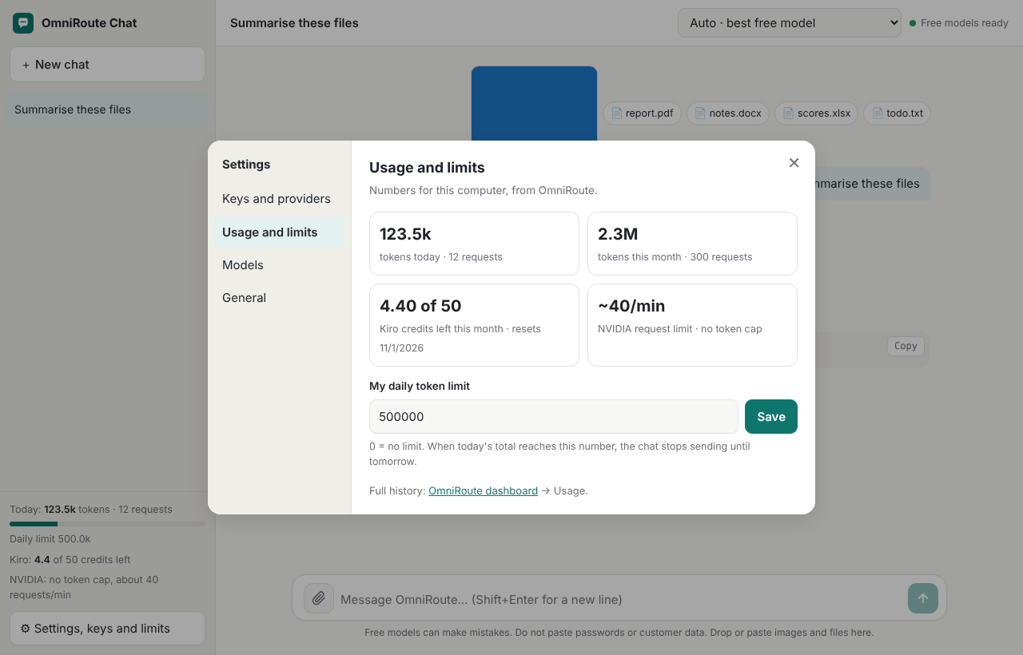
Figure 6. Settings → Usage and limits (example values)
NOTE: NVIDIA does not count tokens for the free plan. It limits requests to about 40 per minute. Kiro shows real credit numbers.

11. Troubleshooting
Problem | What to do
The chat says "OmniRoute is not running". | Close OmniRoute Chat and open it again. It starts OmniRoute. If the problem continues, restart the computer.
The chat says "Add your NVIDIA key". | Open Settings → Keys and providers. Paste your NVIDIA key and click Connect.
"Too many requests" | NVIDIA allows about 40 requests per minute. Wait one minute, then click Retry.
"This chat is too long" | Start a new chat. Or attach a shorter file.
"This model cannot read images" | Select Auto · for images, then click Retry.
A PDF gives no text. | The PDF is a scan. Take screenshots of the pages and attach them as images.
/omni is not available in Claude Code. | Run the installer again. Then restart VS Code.
Error 400 "Unable to determine provider for model". | Run the installer again. It adds the setting that fixes this.
Free mode still uses Opus, or error 400 "Ambiguous model". | The project was switched with an older version. Type /omni free again, or press the shortcut. Then reload the window.
Error "Input exceeds context window" or "automatic compaction failed". | The conversation is too long for the free models. Start a new conversation: type /clear.
Windows: node is not found. | Close all VS Code and PowerShell windows and open them again. Windows reads the new PATH only in new windows.

12. Update and remove
Update: run the install command from section 5 again.
Remove on a Mac: open Terminal and run:
bash ~/.free-ai-setup/install.sh --uninstall
Remove on Windows: open PowerShell and run:
powershell -ExecutionPolicy Bypass -File "$env:USERPROFILE\.free-ai-setup\install.ps1" --uninstall
This puts all projects back to paid mode. It removes /omni, the status line, the commands, the editor switch shortcuts, the chat shortcuts and the autostart. It keeps two folders. Delete them if you do not need them:
- ~/.free-ai-setup (Windows: %USERPROFILE%\.free-ai-setup): setup files and the .env file with your keys.
- ~/.omniroute: OmniRoute data, for example providers and usage history.

13. Security and privacy
- OmniRoute and OmniRoute Chat run on your computer. They accept connections only from your computer (address 127.0.0.1).
- Your keys are in the file .env in the setup folder. Do not share this file.
- Your messages go to the provider that answers them (NVIDIA or Kiro). Their privacy terms apply.
- The NVIDIA free plan is for development and testing. Do not use it for customer services.
- Do not paste passwords, personal data or confidential company data into a free AI model.

14. Sources
These sources were checked on 7 October 2026:
NVIDIA NIM FAQ (free API access for prototyping, Developer Program)
NVIDIA Developer Forums: free tier rate limit of 40 requests per minute
Kiro pricing (Free plan: 50 credits per month)
OmniRoute (open source, MIT license)
Claude Code status line documentation
Claude Code skills documentation

