Table of Contents

Scheme API — Requirements & Solution Document
Project | Scheme API (API 1: monthly schemes)
Consumer | Client team
Version | 1.2 — API 1 (monthly schemes)
Date | 26 October 2026
Author | Project team
Status | API 1 built and tested on sample and real SAP data.

Part A — Requirements

1. Purpose and scope
The client team needs Scheme data for individual dealers. Scheme data is produced in SAP and exported as files to Google Cloud Storage (GCS). This project builds an API that serves that data by dealer code.
In scope
- API 1 — a dealer's scheme position for a month the caller chooses (every SAP scheme component; the 10 template components as agreed).
- A daily scheduled job that loads the SAP exports from GCS into a database.
- Documentation, a Postman collection, and functional, performance and security testing.
Out of scope
- Changing data in SAP or GCS; the API is read-only.
- A user interface.

2. Business context
SAP exports scheme data every day into GCS, one folder per month. The API reads this data and returns it to the client's systems on request.
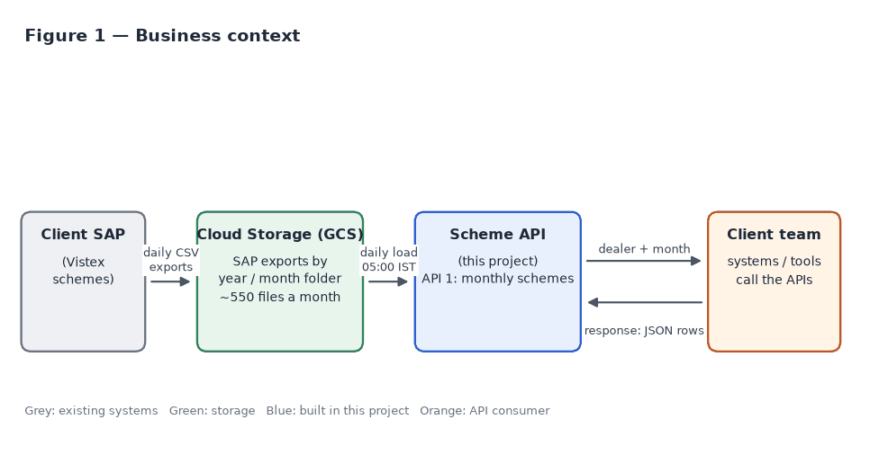

3. Functional requirements
ID | Requirement | Priority
FR-1 | API 1 takes a dealer code, a month and a year in the request body and returns that dealer's scheme rows for that month. | Must
FR-2 | API 1 returns every SAP component: the 10 agreed template ones (EB SLAB 1, EB SLAB 2, EB SLAB 3, VALUE, VALUE %, VALUE FA, LUXURY, PREMIUM 01, PREMIUM 02, EB FULL MONTH) and all others. Rows of components outside the 10 also carry QualificationBasis (GSR or INVOICE_QTY, what Qualification holds) and InvoicedQty = Invoiced Quantity (Q). | Must
FR-3 | API 1 returns the columns of the agreed API template (section 5). | Must
FR-4 | EB slabs are returned as separate rows (one row per slab). | Must
FR-5 | Qualification is the GSR value for EB (EB SLAB 1–3, EB FULL MONTH), Value (VALUE, VALUE %, VALUE FA), ROLLER, SANDPAPER and MASKING TAPE, and the invoiced quantity for every other component, Luxury and Premium included (rule of 2026-10-22). EB FULL MONTH follows the same GSR working as the EB slabs. | Must
FR-5a | Rows are ordered by Clear Cut, highest first (an empty Clear Cut last); rows with the same Clear Cut keep the template order (end date, the 10 in template order, then other components by name). Requested 2026-10-22. | Must
FR-6 | Rows with the same Clear Cut are sorted by validity (end) date (FR-5a); until 2026-10-22 this was the main order. | Must
FR-7 | Only the requested month's data is returned. A row belongs to every month its validity period (From–To) overlaps, whichever GCS folder its file came from; each component is returned once per start date (SAP's newest update, see A-5); rows without dates use their folder's month. The database keeps the current month and the two before it (A-24). | Must
FR-8 | SAP exports are loaded from GCS automatically on a schedule (daily at 05:00 India time, run by the API itself; section 10). | Must
FR-9 | Each daily file holds only that day's updates, so the API must show the latest version of every row across all of the month's files. | Must
FR-10 | Dealer code and customer code are the same identifier. | Must

4. Input data

4.1 API 1 — SAP scheme export
Property | Value
Location | gs://acme-scheme-files/sap-exports/<year>/<month>/, e.g. .../2026/10/; a new folder each month
File name | sap-exports_YYYY_MM_main_YYYYMMDD_HHMMSS_NNN.csv (NNN = part number)
Format | CSV, one header row, 53 columns
Size | Up to 50,000 rows per file; large exports are split into parts; about 550 files a month
Content | Only the rows SAP updated on that day (not a full snapshot); one file contains many dealers
Components | 66 different components ("Comp desc") in the Aug sample; 152 in the Sep 2026 folder and 102 in Oct 2026 (186 names in all, only 70 in both months: SAP renames and adds schemes monthly). All are stored and returned; 10 have agreed qualification rules
Row identity | Customer + Agreement + Deal Suffix + validity period (Valid from, To)
Dates | DD/MM/YYYY (DD.MM.YYYY and DD-MM-YYYY are also read); empty dates appear as 00/00/0000
Numbers | Trailing spaces; negative numbers have the minus sign at the end, e.g. 882.00-
SAP columns used by API 1:
SAP column | Used for
Customer | Dealer code
Agreement, Deal Suffix | Row identity
Comp desc | Component name (the 10 template components have agreed qualification rules)
Valid from, To | Validity period
GSR (Q) | Qualification for EB SLAB 1–3, Value (VALUE, VALUE %, VALUE FA), ROLLER, SANDPAPER and MASKING TAPE
Invoiced Quantity(Q) | Qualification for every other component (Luxury, Premium and the rest); InvoicedQty on components outside the 10
GSR (B) | GSR B
Rebate Rate | Rebate rate
Clear Cut CN | Clear cut
Short Fall, Short Fall % | Shortfall amount and percentage
Next Slab Rate | Next slab rate (required: a file without this column is rejected)
Last Updated Date, Last Updated Time | Deciding which version of a row is the latest
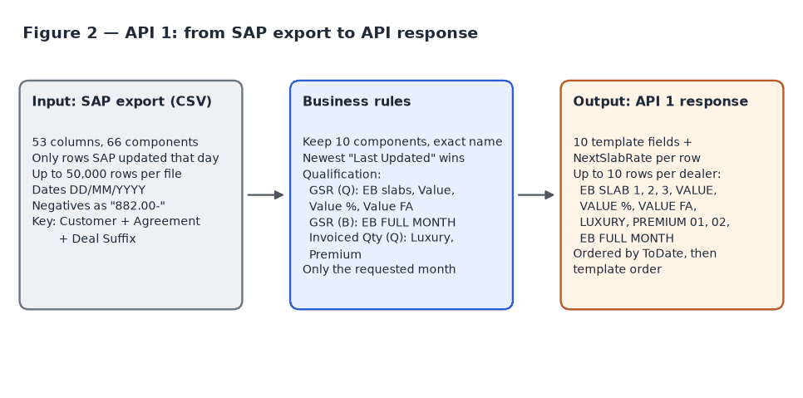

5. Output

5.1 API 1 — response template
One row per component: the columns of the agreed API template, then NextSlabRate (requested 2026-10-15). Rows of components outside the 10 also carry QualificationBasis and InvoicedQty (section 12.2):
Template column | API field | Type
Customer | Customer | string
From Date | FromDate | date (YYYY-MM-DD)
To Date | ToDate | date (YYYY-MM-DD)
Component description | ComponentDescription | string
Qualification (GSR / invoiced qty) | Qualification | number
GSR B | GsrB | number
Rebate rate | RebateRate | number
Clear cut | ClearCut | number
Shortfall Amount | ShortfallAmount | number
Short fall % | ShortfallPct | number
Next slab rate (added 2026-10-15, not in the template) | NextSlabRate | number

6. Non-functional requirements
ID | Area | Requirement | Target
NFR-1 | Performance | Response time at expected load (150 concurrent users) | p95 < 500 ms, p99 < 1 s, errors < 1%
NFR-8 | Performance | Peak load from the dealer app: planned 600 requests a minute, observed up to 1 lakh a minute | 1,700 requests/s with < 1% errors; Redis response cache (section 17.1)
NFR-2 | Availability | When overloaded, fail fast with a retryable response instead of hanging | 503 with Retry-After within 5 s
NFR-3 | Freshness | New SAP exports appear in the API without manual steps | Same day: loaded at 05:00 IST (SAP's files land around 04:30–04:51)
NFR-4 | Security | Protected against OWASP API Top 10 risks; no data leakage in errors | No ZAP failures, no bandit findings, no known CVEs
NFR-5 | Auditability | Every stored row keeps its original SAP values and source file name | Raw row stored with each record
NFR-6 | Reliability | Re-running the job or loading files out of order never produces wrong data | Idempotent loads; newest update wins
NFR-7 | Maintainability | Automated tests at unit, API, performance and security level | All suites runnable from the repository

7. Assumptions
These assumptions were made while building the solution. Please confirm or correct them.
ID | Assumption | Basis
A-1 | The caller (the client) chooses the month: month 1–12 and year 2000–2100, as JSON numbers or numeric strings (month as 1–9, 01–09, 10, 11 or 12; longer forms such as 010 or 0010 are rejected). A month whose SAP exports have not been loaded returns an empty list. The scheduled loader loads the current month, decided in India time (Asia/Kolkata); earlier months are loaded once with ingestion.run schemes --year --month. | Team decision (the client sends the month); confirmed 2026-10-21: any month may be requested, and its data is returned if present
A-2 | A row belongs to every month its validity period overlaps, not to the folder its file is in. Changed 2026-10-15: dev data showed the September folder also holds SAP updates of August schemes, so the folder rule returned August rows for September. A scheme running across two months is reported in both. A month's full report arrives around the 1st of the next month, in the next month's folder (August's on 1 September). | Decided 2026-10-15 (was: folder month); full-month report timing confirmed 2026-10-21
A-3 | The API template's date headers are swapped (the column labelled "To Date" holds start dates). The API returns FromDate = SAP "Valid from" and ToDate = SAP "To". | Template sample values
A-4 | The template is the final output, plus NextSlabRate (SAP "Next Slab Rate"), added after it as the last field of each row on 2026-10-15. Prepaid rate and customer name (from the first discussion) are not returned; "Rebate rate" is taken to be the rate that was meant. | Template confirmed; next slab rate requested 2026-10-15
A-5 | A row is identified by Customer + Agreement + Deal Suffix + Component + validity period (within a GCS month folder; the component joined the key 2026-10-19, as SAP can give two components the same suffix and period). The version with the newest "Last Updated Date/Time" is kept; with equal timestamps the file loaded later wins. The period is part of the key so a month folder can hold the same agreement and suffix for two periods (e.g. a late update of last month's scheme) without one replacing the other. The API returns one row per component and start date (Valid From): the one with the newest "Last Updated" (then the newer folder, then the higher agreement number). So when SAP corrects a row's end date (dev, Sept 2026: EB SLAB 2 1–18 Sep, then 1–19 Sep) or re-issues a dealer's schemes under a new agreement number with the same dates, only the newest version is returned (decided 2026-10-16; replaces the 2026-10-15 rule that returned every stored period). The loader deletes the older versions, so the database holds one row per dealer, component and start date (decided 2026-10-19, A-25). Agreement and deal suffix are compared as SAP writes them (zero-padded); 0010 and 10 are not treated as the same (decided 2026-10-16). | Sample file analysis: validity periods are fixed per scheme (e.g. EB SLAB 2 1–18 Aug, EB SLAB 3 1–25 Aug), not moved daily; reviewed 2026-10-15
A-6 | "Last Updated" times from SAP use one time zone and can be compared across files. | Single SAP system
A-7 | Component names are matched exactly as SAP spells them (e.g. PREMIUM 01). Every component is stored under its own name, so a renamed or new component is loaded and returned without a code change. Only the 10 template components (app/constants.py) need a code change if SAP renames one of them. SAP can give two components the same agreement, deal suffix and period (Oct 2026: ALWD FULL MONTH and ADDN TEXTURE PER 250, suffix 65), so the component is part of the row key. | Look-alikes such as ALWD EB2, ADDTNL PREMIUM 01, VALUE SCH % and VALUE SCH FA must be excluded. VALUE % and VALUE FA added on request (2026-10-16); both spellings found in the Sep/Oct 2026 SAP data
A-8 | Qualification uses GSR (Q) for EB SLAB 1–3, VALUE, VALUE %, VALUE FA, ROLLER, SANDPAPER and MASKING TAPE, and Invoiced Quantity (Q) for every other component (LUXURY, PREMIUM 01/02 and the rest; rule of 2026-10-22). Names match SAP's Comp desc exactly, so look-alikes such as ALWD EB2, EB ADD FA 02 or ALWD VALUE SCH are on invoiced quantity. EB FULL MONTH follows the EB slab working: SAP leaves its GSR (Q) empty, and on slab rows GSR (Q) always equals GSR (B), so its Qualification is GSR (B). Real sample: GSR (Q) = GSR (B) on 775 of 775 slab rows; GSR (Q) empty on all 774 EB FULL MONTH rows. VALUE % and VALUE FA follow VALUE (confirmed 2026-10-16); in the Sep/Oct 2026 SAP data their GSR (Q) is filled on 99% of rows, as on VALUE. | Discussion and template values; rule for the other components confirmed 2026-10-22
A-9 | Dealer codes are compared without leading zeros (0006100000001 = 6100000001) and contain only letters and digits, at most 20 characters. | SAP pads codes with zeros
A-10 | If a dealer has more than one agreement, one row per agreement per component is returned. The sample data has one agreement per dealer. | Sample file analysis
A-11 | An unknown dealer, or a dealer without data in the requested month, returns 200 with an empty list, not 404. | Simplest for consumers; confirmed 2026-10-21
A-12 | The API uses POST with a JSON body, and response fields use PascalCase like the existing Acme dealer APIs. | Discussion; existing Acme APIs
A-13 | SAP exports are in bucket acme-scheme-files, folder sap-exports/<year>/<month>/ (confirmed: sap-exports/2026/10). Folders for January–September are assumed to be 01–09; the job also reads 1–9, so if both exist neither is missed (changed 2026-10-16: it used to stop at the first one). | Path confirmed; QA audit 2026-10-16
A-14 | Callers authenticate with OAuth2 client credentials: each caller (the client, QA) gets a client_id and client_secret per environment, exchanges them at POST /v1/auth/token for a JWT Bearer token valid for 1 hour, and reuses it until shortly before it expires. Outside local development the API does not start without auth settings; auth can be off only when APP_ENV=local is set explicitly, so a server that forgets APP_ENV does not run open. Locally the client is local-client / local-test-secret (matching the Postman Local environment); these published values are accepted only with APP_ENV=local set explicitly (added 2026-10-16), so a server that forgets APP_ENV cannot run on them either. The X-API-Key header is no longer accepted. | Decided 2026-10-15 (was: optional X-API-Key); security review (explicit APP_ENV=local for auth off: security review of 15 October 2026)
A-15 | The project team's existing PostgreSQL database is used. A separate database can be created quickly if needed. | Decision in discussion
A-16 | The loader runs once a day at 05:00 IST (team decision 2026-10-19 for 09:00, moved to 05:00 on 2026-10-21); SAP exports arrive once a day (in October 2026 about 23 files between 04:30 and 04:51 IST), so data is up to date from 05:00. Files that land after 05:00 wait for the next day's run. | ~550 files a month
A-17 | HTTPS termination is provided by the hosting gateway or load balancer. The API itself limits each client IP to 2,500 requests a second (added 2026-10-15). The proxy appends the caller's IP to X-Forwarded-For, and its address is listed in TRUSTED_PROXIES; X-Forwarded-For from any other address is ignored, so a caller cannot choose its own IP (changed 2026-10-16). | Standard deployment; rate limit requested 2026-10-15; QA audit 2026-10-16
A-18 | Expected load is modelled as 150 concurrent users, as in the existing Acme dealer API tests. Actual client call volumes are not known. | Existing test practice
A-19 | Only .csv and .xlsx files are loaded from GCS. | Formats seen so far
A-20 | EB amounts are running totals from the 1st of the month: EB SLAB 1 (e.g. 1–10 Oct, 10 lakh) is included in EB SLAB 2 (1–15 Oct, 12 lakh), so 2 lakh were added, not 22 lakh in total. The API returns each row as SAP sends it and never adds rows together; a newer SAP update of the same row replaces it. Consumers must not sum the slabs. | Confirmed by the team; real sample: EB amounts never decrease from slab to slab (775 of 775 dealers)
A-21 | A row with no end date ("To" empty) counts as valid for its start day only, so it is returned only for the month of its "Valid from". | Confirmed correct 2026-10-16
A-22 | SAP dates use /, . or - between day, month and year. Dates written with spaces (01 08 2026) are not read: such a row is bad and its file is marked failed. | Decided 2026-10-16 (not supported for now)
A-23 | Amounts are finite numbers. NaN or Infinity in an amount column makes the row bad instead of being stored. | QA audit 2026-10-16
A-24 | Only the current month and the two before it are kept (LOADER_RETENTION_MONTHS = 3; in October: October, September, August). A scheme is deleted once its period ended before the oldest kept month: judged by its end date, so a scheme that started earlier but runs into a kept month stays. A row without an end date counts as its start day (A-21); a row without dates by its folder month. Older months return no rows. | Decided 2026-10-19; M-2 as the oldest month shown confirmed 2026-10-21
A-25 | One row per dealer, component and start date is stored: the version API 1 returns (A-5). Older versions are deleted, also when SAP re-issued the scheme under another agreement number or corrected its end date. With equal "Last Updated", folder and agreement, the later end date is kept (no end date counts as the earliest), then the higher deal suffix. A deleted version comes back only by reloading its month from GCS (--reload), where it again loses to the newer one. | Decided 2026-10-19
A-26 | Every value of the SAP row is kept in the database (raw), zeros and empty values included, so data can be checked without re-reading GCS; only the repeated column names are stored once (raw_layouts, view scheme_records_raw). Postgres compression was tried and does not apply: it compresses only rows over about 2 KB, and these are about 1.6 KB. | Decided 2026-10-19

Part B — Solution

8. Solution overview and architecture
The solution has two parts that share a PostgreSQL database:
- Ingestion job (run by the API daily at 05:00 IST). Lists new files in GCS, validates and parses them, and stores the latest version of each scheme row. Files already loaded are skipped.
- API service (FastAPI). Answers dealer lookups from the database. Each request is a single indexed query, so responses are fast and do not depend on file sizes.
Separating loading from serving means the API never parses files during a request, and a bad file cannot break the API.
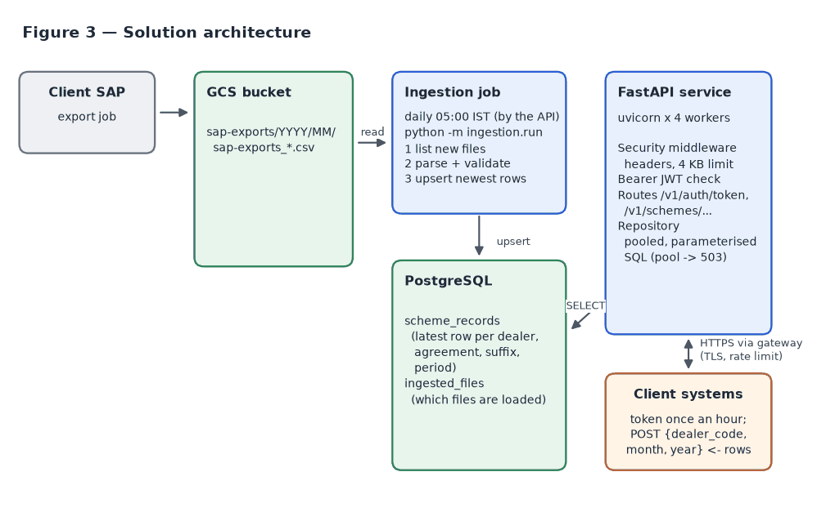

9. Technology stack
Layer | Technology | Why
Language | Python 3.10+ | Team standard; same as the existing Acme APIs
API framework | FastAPI + uvicorn | Same as the existing Acme APIs; automatic OpenAPI docs and input validation
Database | PostgreSQL 16 (psycopg 3, connection pool) | Existing team database; upserts and JSON columns
File storage | Google Cloud Storage (google-cloud-storage) | Where the SAP exports already land
Excel / CSV | openpyxl (streaming read-only mode), csv | Reads multi-row headers; streams files row by row
Packaging | uv | Locked, reproducible dependencies
Testing | pytest, Postman/newman, Playwright, k6, bandit, pip-audit, OWASP ZAP | Unit, API, performance and security coverage

10. Data ingestion design
The API runs python -m ingestion.run schemes itself (app/scheduler.py); no separate cron job is needed.
- When: once a day at LOADER_DAILY_AT (05:00 India time). On days 1–3 of a month (LOADER_CATCH_UP_DAYS) the previous month is loaded too, so files of its last day are not missed. A restart does not trigger a load.
- Isolation: each run is a child process, so a slow or failing load never blocks API requests.
- One scheduler: with several workers or servers, only the one holding a Postgres advisory lock runs the load; if it dies, another takes over the next day.
- Failures: a failed run (GCS or database down, bad file, longer than LOADER_TIMEOUT_MINUTES = 120) is logged at ERROR and tried again up to LOADER_RETRIES (3) times, LOADER_RETRY_MINUTES (30) apart, carrying on from the files already loaded. If all tries fail, the next is the next day at 05:00, or the loader can be run by hand.
- Switch: on everywhere except APP_ENV=local; LOADER_SCHEDULE_ENABLED=false turns it off where a cron job runs the loader instead.
Each run reads the current month's folder, gs://acme-scheme-files/sap-exports/<year>/<month>/ (for example .../2026/10/, then .../2026/11/). Months 1–9 are read from both 01 and 1 (if both exist, files from both are loaded), and the job logs a warning if neither has files yet. Without --year/--month the job loads the current month in India time (TIMEZONE, default Asia/Kolkata). The API itself never reads GCS: it only reads the database the job keeps up to date.
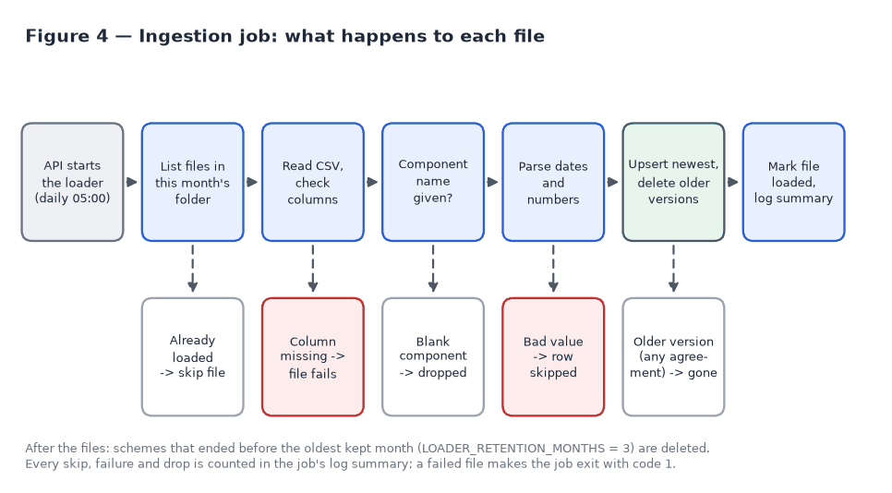
Key design points:
- Skip loaded files. Each loaded file is recorded with its GCS version ("generation"). An unchanged file is skipped; a re-uploaded file is loaded again.
- Upsert, newest wins. Rows are inserted or updated by Customer + Agreement + Deal Suffix + Component + validity period. An existing row is replaced only if the new one has a newer or equal "Last Updated" time, so files can arrive in any order. A row SAP sends again unchanged is not rewritten.
- One row per scheme. In the same transaction, every older version of the schemes in the file is deleted: per dealer, component and start date only the version API 1 returns is kept (A-5, A-25), whatever the agreement, end date or folder. Only the schemes in the file are checked, through the dealer index. Versions stored before this existed are deleted once, at the end of the first run after the upgrade (recorded in loader_maintenance).
- Compact raw row. Every value of the SAP row is kept in raw (A-26), but the 54 column names, half of each row, are stored once per file layout in raw_layouts. Rows stored by an earlier loader version are rewritten once by the first run after the upgrade (no value changes; checked row by row in tests). Real SAP rows: raw 1,399 → 483 bytes; table 7.9 MB → 3 MB for one 4,649-row file. The space freed is reused by new rows; python -m ingestion.run compact (VACUUM FULL) gives it back to the disk, locking the table for its duration (about 2.5 s per 200,000 rows), so run it at a quiet time.
- Qualification rule of 2026-10-22. The loader stores Qualification by the rule in FR-5. Rows stored before it (components outside the 10 on GSR (Q)) are corrected once by the first run after the upgrade: Qualification = the stored invoiced quantity for every component outside the GSR list, recorded in loader_maintenance. It works 2,000 dealers at a time, with a VACUUM after each batch, so the rewritten rows reuse the old rows' space instead of growing the table (dev: 5.8 of 6.8 million rows to rewrite); a stopped run carries on where it left off. Rows that already hold it are not rewritten. Checked on the real 16 Aug SAP file: 43,029 of 50,000 rows corrected, and the table after the upgrade is identical, row for row, to a fresh load by the new loader.
- Retention. At the end of each run, schemes that ended before the oldest kept month are deleted (LOADER_RETENTION_MONTHS = 3: the current month and the two before it, A-24), and the table is vacuumed after a delete. Files of older months stay listed in ingested_files, so they are not loaded again.
- One transaction per file. A file is either fully loaded or not at all.
- Unreadable rows. A row that can't be read (bad date or number) is skipped and logged. Its file is read once more; if rows are still bad, the file's good rows are loaded and the file is recorded as failed (ingested_files.status, rows_bad), the run exits with code 1, and the file is not retried until SAP re-uploads it or the month is reloaded with --reload.
- Fast loading. The next LOADER_WORKERS files (default 4) are downloaded and parsed in parallel while the current one is saved (still one at a time, in order). Each file's rows go to the database with one bulk COPY into a temporary table and one INSERT … SELECT … ON CONFLICT, which gives exactly the result of upserting the rows one by one (proved by a randomized database test). Real September files: about 6 s per file from a laptop (download-bound), against about 30 s with one statement per row; saving takes 0.3–0.5 s.
- One run at a time. A Postgres advisory lock stops a second run (e.g. the next scheduled run during a long backfill); it is released when the run's connection closes, even if the process dies. After a network drop the server may keep the old session (and the lock) alive; the run names its sessions, so on reconnect it ends its own stale session and carries on.
- Fail loudly on format changes. If a required column is missing (checked even when the file has only a header), the file isn't UTF-8, or it isn't a readable workbook, the file is read once more; if it still can't be read, it is recorded as failed with no rows (row_count = 0), the error lists the missing and available columns, the run exits with code 1, and the file is not retried until SAP re-uploads it or the month is reloaded. A failed download is not recorded, so the next run tries it again.
- Row-level tolerance. A row with an unparseable value (including NaN or Infinity in an amount) is skipped and logged; the rest of the file loads.
- Memory. Each file is held in memory while it is parsed and saved, with the next LOADER_WORKERS files: a real file (~5,500 rows) peaks at about 40 MB, a 50,000-row file at about 360 MB (up to ~1.8 GB with 4 workers). Lower LOADER_WORKERS if files grow that large.
- Summary log. Each run logs files loaded/skipped/failed and rows loaded/dropped/bad, and exits with code 1 if any file failed (so the scheduler can alert).
Performance: a 50,000-row SAP file is saved in about 2 seconds, deleting its older versions included (1.4 s without); 160,000 rows in 13 seconds. The one-off clean-up of 300,000 stored rows (86,000 older versions, 13,000 expired) took under 2 seconds on a laptop.

11. Data model
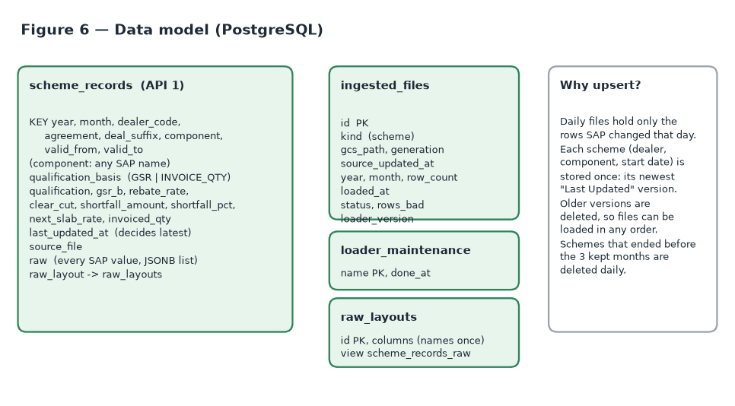
Table | Purpose | Key
scheme_records | One row per dealer, component and start date (SAP's newest version) for the kept months, plus every value of the original SAP row (raw, values only, in file order; raw_layout names the columns) | year, month, dealer_code, agreement, deal_suffix, component, valid_from, valid_to (unique index; empty dates count as equal)
ingested_files | Which files have been loaded, their GCS version, row count, status (loaded / failed) and bad-row count | kind + gcs_path
raw_layouts | The column names of SAP files, stored once instead of in every row (columns, in file order) | id; columns unique
loader_maintenance | One-off clean-ups the loader has done (e.g. deleting older versions stored by an earlier loader version), so each runs once | name
The view scheme_records_raw shows each row with raw as name → value, exactly as SAP sent it (zeros and empty values included), for checking data by hand: SELECT raw->>'remarks' FROM scheme_records_raw WHERE dealer_code = '6100000001';
python -m ingestion.run init-db creates the tables and upgrades older databases in place.

12. API specification
Conventions
Item | Value
Base path | /v1
Format | JSON request and response, UTF-8
Method | POST with a JSON body {"dealer_code", "month", "year"}
Authentication | OAuth2 client credentials: POST /v1/auth/token returns a JWT valid 1 hour; send Authorization: Bearer <token> (section 12.3)
Field naming | PascalCase in responses
Empty result | 200 with []
Specification | OpenAPI 3: docs/openapi.json and a Swagger spec in qa/swagger/; Swagger UI at /docs when enabled
Endpoints
Method | Path | Description | Auth
POST | /v1/auth/token | Get an access token (grant_type=client_credentials) | Client credentials (HTTP Basic or body)
POST | /v1/schemes/current-month | API 1 — dealer's scheme rows for the requested month | Bearer token
GET | /health | Health check: 200 {"ok": true} when the API and its database are up; 503 {"ok": false} when the database does not answer within 2 s | None

12.1 Request body
{ "dealer_code": "6100000001", "month": 10, "year": 2026 }
Field | Type | Rules
dealer_code | string or number | Required; letters and digits; 1–20 characters; leading zeros and surrounding spaces ignored
month | integer or numeric string | Required; 1–9, 01–09, 10, 11, 12, as numbers or strings (9, 09, "9", "09"); negatives, decimals, 0, 009, 010, 0010, true/false and text are rejected (422). A bare 09 works with any case of Content-Type: application/json
year | integer or numeric string | Required; four digits, 2000–2100 (2026 or "2026"); signs, decimals, spaces and 02026 are rejected (422)

12.2 API 1 — POST /v1/schemes/current-month
Example call
curl -X POST "https://<host>/v1/schemes/current-month" \
-H "Content-Type: application/json" \
-H "Authorization: Bearer $TOKEN" \
-d '{"dealer_code": "6100000001", "month": 10, "year": 2026}'
Example response — 200 OK (sample dealer: the 10 template components and two others, ROLLER and ALWD EB2; highest ClearCut first)
[
{"Customer": "6100000001", "FromDate": "2026-10-01", "ToDate": "2026-10-31", "ComponentDescription": "ROLLER", "Qualification": 11350.0, "GsrB": 11350.0, "RebateRate": 26.0, "ClearCut": 2951.0, "ShortfallAmount": 0.0, "ShortfallPct": 0.0, "NextSlabRate": 0.0, "QualificationBasis": "GSR", "InvoicedQty": 50.0},
{"Customer": "6100000001", "FromDate": "2026-10-01", "ToDate": "2026-10-31", "ComponentDescription": "LUXURY", "Qualification": 315.1, "GsrB": 159292.8, "RebateRate": 1.0, "ClearCut": 1592.93, "ShortfallAmount": 84.9, "ShortfallPct": 21.23, "NextSlabRate": 1.5},
{"Customer": "6100000001", "FromDate": "2026-10-01", "ToDate": "2026-10-11", "ComponentDescription": "EB SLAB 1", "Qualification": 405232.86, "GsrB": 405232.86, "RebateRate": 0.75, "ClearCut": 0.0, "ShortfallAmount": 0.0, "ShortfallPct": 0.0, "NextSlabRate": 1.0},
{"Customer": "6100000001", "FromDate": "2026-10-01", "ToDate": "2026-10-18", "ComponentDescription": "EB SLAB 2", "Qualification": 405232.86, "GsrB": 405232.86, "RebateRate": 0.75, "ClearCut": 0.0, "ShortfallAmount": 0.0, "ShortfallPct": 0.0, "NextSlabRate": 1.0},
{"Customer": "6100000001", "FromDate": "2026-10-01", "ToDate": "2026-10-25", "ComponentDescription": "EB SLAB 3", "Qualification": 405232.86, "GsrB": 405232.86, "RebateRate": 0.75, "ClearCut": 0.0, "ShortfallAmount": 0.0, "ShortfallPct": 0.0, "NextSlabRate": 1.25},
{"Customer": "6100000001", "FromDate": "2026-10-01", "ToDate": "2026-10-31", "ComponentDescription": "VALUE", "Qualification": 405232.86, "GsrB": 405232.86, "RebateRate": 0.0, "ClearCut": 0.0, "ShortfallAmount": 0.0, "ShortfallPct": 0.0, "NextSlabRate": 0.0},
{"Customer": "6100000001", "FromDate": "2026-10-01", "ToDate": "2026-10-31", "ComponentDescription": "VALUE %", "Qualification": 405232.86, "GsrB": 405232.86, "RebateRate": 0.5, "ClearCut": 0.0, "ShortfallAmount": 0.0, "ShortfallPct": 0.0, "NextSlabRate": 0.0},
{"Customer": "6100000001", "FromDate": "2026-10-01", "ToDate": "2026-10-31", "ComponentDescription": "VALUE FA", "Qualification": 405232.86, "GsrB": 405232.86, "RebateRate": 0.25, "ClearCut": 0.0, "ShortfallAmount": 0.0, "ShortfallPct": 0.0, "NextSlabRate": 0.0},
{"Customer": "6100000001", "FromDate": "2026-10-01", "ToDate": "2026-10-31", "ComponentDescription": "PREMIUM 01", "Qualification": 0.0, "GsrB": 0.0, "RebateRate": 0.0, "ClearCut": 0.0, "ShortfallAmount": 40.0, "ShortfallPct": 100.0, "NextSlabRate": 0.0},
{"Customer": "6100000001", "FromDate": "2026-10-01", "ToDate": "2026-10-31", "ComponentDescription": "PREMIUM 02", "Qualification": 0.0, "GsrB": 0.0, "RebateRate": 0.0, "ClearCut": 0.0, "ShortfallAmount": 8.0, "ShortfallPct": 100.0, "NextSlabRate": 0.0},
{"Customer": "6100000001", "FromDate": "2026-10-01", "ToDate": "2026-10-31", "ComponentDescription": "EB FULL MONTH", "Qualification": 405232.86, "GsrB": 405232.86, "RebateRate": 2.25, "ClearCut": 0.0, "ShortfallAmount": 0.0, "ShortfallPct": 0.0, "NextSlabRate": 0.0},
{"Customer": "6100000001", "FromDate": "2026-10-01", "ToDate": "2026-10-31", "ComponentDescription": "ALWD EB2", "Qualification": 12.5, "GsrB": 405232.86, "RebateRate": 1.0, "ClearCut": 0.0, "ShortfallAmount": 0.0, "ShortfallPct": 0.0, "NextSlabRate": 0.0, "QualificationBasis": "INVOICE_QTY", "InvoicedQty": 12.5}
]
Response fields
Field | Type | Meaning | SAP source
Customer | string | Dealer code | Customer
FromDate | date | Start of validity | Valid from
ToDate | date | End of validity | To
ComponentDescription | string | Component name as SAP spells it | Comp desc
Qualification | number | GSR (EB, Value, ROLLER, SANDPAPER, MASKING TAPE) or invoiced quantity (every other component, Luxury and Premium included) | GSR (Q); GSR (B) for EB FULL MONTH; Invoiced Quantity(Q)
GsrB | number | Gross Sales Revenue for the benefit | GSR (B)
RebateRate | number | Rebate rate | Rebate Rate
ClearCut | number | Clear-cut credit note amount | Clear Cut CN
ShortfallAmount | number | Shortfall to the next slab | Short Fall
ShortfallPct | number | Shortfall as a percentage | Short Fall %
NextSlabRate | number | Rebate rate of the next slab | Next Slab Rate
QualificationBasis | string | Only on components outside the 10: what Qualification holds, GSR (ROLLER, SANDPAPER, MASKING TAPE) or INVOICE_QTY (the others) | —
InvoicedQty | number | Only on components outside the 10: invoiced quantity (equal to Qualification when QualificationBasis is INVOICE_QTY) | Invoiced Quantity (Q)
Ordering: by ClearCut, highest first (an empty ClearCut last). Rows with the same ClearCut (most are 0): by ToDate, then in the order EB SLAB 1, EB SLAB 2, EB SLAB 3, VALUE, VALUE %, VALUE FA, LUXURY, PREMIUM 01, PREMIUM 02, EB FULL MONTH, then the other components by name. Amounts can be negative or null.

12.3 Authentication — POST /v1/auth/token
OAuth2 client credentials (RFC 6749 §4.4) with JWT Bearer tokens (RFC 6750). Request: grant_type=client_credentials, form-encoded (standard) or JSON, with the client credentials as HTTP Basic auth or as client_id and client_secret in the body (not both). scope is optional; the only scope is schemes:read.
TOKEN=$(curl -s -u <client_id>:<client_secret> -d grant_type=client_credentials \
https://<host>/v1/auth/token | jq -r .access_token)
Response 200:
{"access_token": "eyJhbGciOiJIUzI1NiIs...", "token_type": "Bearer", "expires_in": 3600, "scope": "schemes:read"}
Rule | Value
Token lifetime | expires_in = JWT_TTL_SECONDS (3600 s)
Reuse | Callers keep one token and send it until about 60 s before expiry, then get a new one; on 401 Token expired they get a new token and retry once
Token endpoint limit | TOKEN_RATE_LIMIT_PER_MINUTE (30) per client IP per minute, on top of the 2,500/s limit; a client needs one token an hour
Token format | JWT signed with HS256; claims iss, aud (scheme-api), sub (client_id), scope, iat, nbf, exp, jti
Cost per request | About 49 µs to check a token; no database or Redis lookup

12.4 Request lifecycle
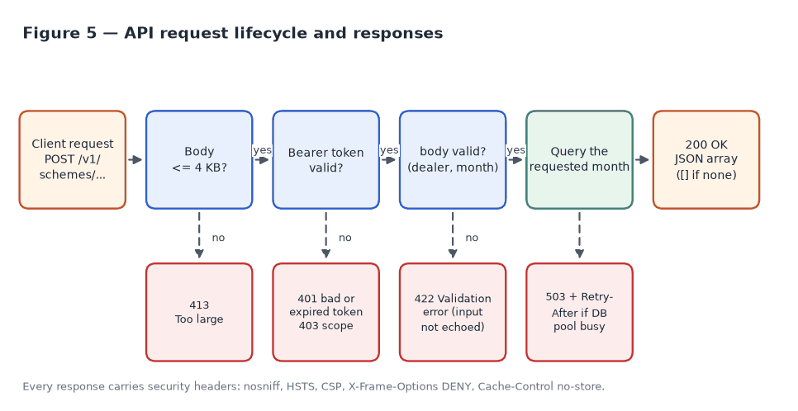

13. Error handling
All errors are JSON with a detail field, except the token endpoint's, which use the OAuth2 format {"error", "error_description"} (RFC 6749 §5.2). Errors never include stack traces, SQL, internal addresses or the caller's input.
Status | Meaning | Example body | Client action
200 | Success (possibly []) | [...] | —
401 | No Bearer token | {"detail": "Not authenticated"} | Send Authorization: Bearer <token>
401 | Token malformed, wrongly signed, or its client removed | {"detail": "Invalid token"} | Get a new token
401 | Token expired | {"detail": "Token expired"} | Get a new token, retry once
403 | Token without the schemes:read scope | {"detail": "Insufficient scope"} | Get a token without a scope parameter
404 | Unknown path | {"detail": "Not Found"} | Check the URL
405 | Wrong method | {"detail": "Method Not Allowed"} | Use POST
413 | Body over 4 KB | {"detail": "Request body too large"} | Send only dealer_code
422 | Invalid body | {"detail": [{"loc": ["body", "dealer_code"], "msg": "Field required", "type": "missing"}]} | Fix the request
429 | Over 2,500 requests a second from one IP | {"detail": "Too many requests"} + Retry-After: 1 | Retry with backoff
503 | Temporarily busy | {"detail": "Service busy, please retry"} + Retry-After: 2 | Retry with backoff
500 | Unexpected error | {"detail": "Internal server error"} | Report with time of request
401 and 403 carry WWW-Authenticate: Bearer realm="scheme-api", with error="invalid_token" for a bad or expired token and error="insufficient_scope" on 403 (RFC 6750).
Token endpoint (POST /v1/auth/token) errors:
Status | error | When
400 | invalid_request | grant_type missing; body not form-encoded or JSON, or unreadable; a parameter repeated (form field or JSON key); credentials in both Basic auth and the body
400 | unsupported_grant_type | grant_type other than client_credentials
400 | invalid_scope | scope other than schemes:read
401 | invalid_client | Missing, unknown or wrong client credentials (an unknown client and a wrong secret give the same answer); WWW-Authenticate: Basic
429 | — ({"detail": "Too many requests"}) | Over TOKEN_RATE_LIMIT_PER_MINUTE (30) a minute from one IP; Retry-After set

14. Security design
Control | Implementation
Authentication | OAuth2 client credentials (POST /v1/auth/token) and JWT Bearer tokens valid 1 hour; required on /v1/schemes, /health stays open for probes
Client secrets | Stored only as SHA-256 hashes (AUTH_CLIENTS); compared in constant time; an unknown client and a wrong secret are indistinguishable (same error, same timing); secrets are never logged (only the client_id)
Token validation | Algorithm pinned to HS256 (alg: none and other algorithms rejected); iss, aud, sub, iat, nbf, exp, jti required; 30 s clock-skew leeway; schemes:read scope required (403 without it); no database or Redis lookup (~49 µs)
Revocation and key rotation | Removing a client from AUTH_CLIENTS revokes its tokens at once. JWT_SECRET rotates without downtime: the old key moves to JWT_PREVIOUS_SECRET for one token lifetime
Safe start-up | Outside APP_ENV=local the API refuses to start unless AUTH_CLIENTS and JWT_SECRET are set and strong (32+ characters), and it refuses the example values from .env.example, also when APP_ENV is not set. Locally (APP_ENV=local set explicitly) with no auth settings, auth is off and a warning is logged; with APP_ENV unset and no auth settings the API refuses to start, so a deploy that forgets APP_ENV never runs open
Token endpoint abuse | Separate per-IP limit, TOKEN_RATE_LIMIT_PER_MINUTE (30/min); token responses are never cached (Cache-Control: no-store, Pragma: no-cache)
Input validation | dealer_code: letters and digits, 1–20 characters; month 1–12 as one or two digits and year 2000–2100 as four digits (no booleans, signs, decimals or spaces); strict JSON parsing, except that a bare zero-padded month such as 09 is accepted
SQL injection | All queries are parameterised; no user input is ever formatted into SQL
Payload limits | Request body capped at 4 KB (413), including chunked bodies
Response headers | X-Content-Type-Options: nosniff, Strict-Transport-Security (1 year), Content-Security-Policy: default-src 'none', X-Frame-Options: DENY, Cache-Control: no-store, Referrer-Policy: no-referrer, Cross-Origin-Resource-Policy: same-origin
Information disclosure | Custom error handlers: no stack traces, no echoed input; server version header disabled
Overload protection | Bounded DB connection pool; 503 + Retry-After when exhausted; per-IP rate limit (429)
Data exposure | Fixed response model; raw SAP columns are stored but never returned
Transport and rate limits | HTTPS at the gateway (assumption A-17); per-IP rate limit in the API: 2,500 requests/s per IP, then 429 + Retry-After (counted in Redis across workers, per worker without it; /health exempt)
Client IP | The connection's address, unless it is a proxy listed in TRUSTED_PROXIES; then the right-most X-Forwarded-For entry that is not a trusted proxy. The API is started with python -m app, which turns off uvicorn's own X-Forwarded-For handling (it trusts 127.0.0.1 by default), so a caller cannot get a fresh rate limit by sending a made-up X-Forwarded-For
Docs page | Swagger UI (/docs, when DOCS_ENABLED=true) loads one pinned swagger-ui-dist release (5.32.15) from the CDN with Subresource Integrity (SHA-384) hashes, and its Content-Security-Policy allows only that release, so a changed CDN file is refused by the browser
Secrets | Client secret hashes, JWT_SECRET and DB credentials come from environment variables or the environment's .env.<env> file, which is never committed

15. Configuration
All settings are environment variables or a settings file per environment, chosen by APP_ENV: .env.local (default), .env.dev, .env.uat, .env.prod. Environment variables win over the file. One template, .env.example, is committed and marks what changes per environment; DevOps fill in the database, AUTH_CLIENTS and JWT_SECRET, Redis and GCS key, and keep the real values in a secret manager. The real files are ignored by git. Branches dev, uat and prod (from main) are available for per-environment releases.
Variable | Default | Purpose
DATABASE_URL | local Postgres | Database connection
AUTH_CLIENTS | local-client in .env.example (local only) | JSON {"<client_id>": "<SHA-256 hex of its secret>"}, one entry per caller; only hashes are stored. Create with python -m app.security new-client <id>. Removing a client revokes its tokens at once. Required outside local
JWT_SECRET | local example key in .env.example (local only) | HS256 signing key, 32+ characters; separate per environment. Create with python -m app.security new-jwt-secret. Required outside local
JWT_PREVIOUS_SECRET | — | Old signing key while rotating: move JWT_SECRET here, set a new JWT_SECRET, remove this after one JWT_TTL_SECONDS
JWT_TTL_SECONDS | 3600 | Access token lifetime (60–86,400)
TOKEN_RATE_LIMIT_PER_MINUTE | 30 | POST /v1/auth/token requests per client IP per minute before 429
TRUSTED_PROXIES | empty | nginx / load balancer address(es), IPs or CIDRs, comma-separated, whose X-Forwarded-For is believed; empty ignores the header (every caller behind the proxy then shares one rate-limit count). Set per environment by DevOps
DOCS_ENABLED | true | Serve /docs and /openapi.json
DB_POOL_MAX | 10 | DB connections per worker process
GCS_BUCKET | acme-scheme-files | Bucket with the files
GOOGLE_APPLICATION_CREDENTIALS | — | Service-account key file for GCS
GCS_CREDENTIALS_JSON | — | The GCS service-account key itself (base64 of the key file, one line), instead of a mounted file; wins over GOOGLE_APPLICATION_CREDENTIALS. Dev: service account scheme-loader@example-project.iam.gserviceaccount.com
GCS_PROJECT | — | Optional Google Cloud project for the GCS client; reading the bucket works without it
SCHEME_PREFIX_TEMPLATE | sap-exports/{year}/{month:02d}/ | Folder of a month's SAP exports (tries 01, then 1)
APP_ENV | local | Which settings file to read: .env.local, .env.dev, .env.uat or .env.prod. Set it on every server; with APP_ENV unset the API starts only if auth is configured and is not the .env.example example
LOCAL_DATA_DIR | — | Read files from a local folder instead of GCS (development)
LOADER_WORKERS | 4 | Files the loader downloads and parses in parallel while saving the current one
TIMEZONE | Asia/Kolkata | Decides the loader's default month (the current month in this timezone); the API always takes the month from the request
LOADER_SCHEDULE_ENABLED | on outside local | The API runs the loader on a schedule (section 10); false where a cron job runs it instead
LOADER_DAILY_AT | 05:00 | Daily run time (HH:MM in TIMEZONE)
LOADER_RETRIES | 3 | Tries again after a failed daily run
LOADER_RETRY_MINUTES | 30 | Wait between those tries
LOADER_TIMEOUT_MINUTES | 120 | A scheduled run taking longer is stopped; the next one carries on
LOADER_CATCH_UP_DAYS | 3 | On days 1 to this of a month the previous month is loaded too
LOADER_RETENTION_MONTHS | 3 | Months of schemes kept, the current one included (A-24); 0 keeps everything
CACHE_ENABLED | false | Turns the Redis response cache on or off (section 17.1)
REDIS_URL | — | Redis for the cache, e.g. redis://host:6379/0; the cache runs only when this is set and CACHE_ENABLED=true
CACHE_TTL_SECONDS | 900 | Longest a cached response lives; new data replaces it sooner
RATE_LIMIT_ENABLED | true | Per-IP rate limit on or off
RATE_LIMIT_PER_SECOND | 2500 | Requests per second from one client IP before 429; counted in Redis when REDIS_URL is set, else per worker

16. Project structure
scheme-api/
├── app/ FastAPI service
│ ├── __main__.py `python -m app`: starts uvicorn (proxy headers off)
│ ├── main.py app setup, error handlers, /health
│ ├── docs.py Swagger UI at /docs, pinned release with SRI
│ ├── routes.py API 1 endpoint
│ ├── schemas.py request and response models
│ ├── repository.py SQL queries (connection pool)
│ ├── security.py OAuth2 token endpoint, JWT Bearer check, client/key generator CLI
│ ├── middleware.py security headers, body size limit, zero-padded month
│ ├── ratelimit.py per-IP rate limit (429)
│ ├── constants.py the 10 components and qualification rules
│ └── config.py settings from environment variables
├── ingestion/ loader (run by the API's schedule)
│ ├── run.py entry point: init-db, schemes
│ ├── sources.py list/read files in GCS (or a local folder)
│ ├── excel.py CSV/Excel streaming reader, header joining
│ ├── schemes.py SAP business rules and parsing (API 1)
│ └── load.py upsert / batched insert into PostgreSQL
├── sql/001_init.sql tables and indexes
├── docs/ this document, API guide, OpenAPI spec, figures
├── qa/ QA guide and test results
│ ├── postman/ API 1 collection + Local/Dev environments
│ │ (built by build_collection.py)
│ ├── swagger/ API 1 OpenAPI spec (built by build_specs.py)
│ ├── api-tests/tests/ Playwright: api1_current_month.spec.js, common.spec.js,
│ │ helpers.js
│ ├── k6/ performance tests
│ └── security/ bandit, pip-audit, OWASP ZAP
├── tests/ unit tests (incl. checks that Postman and Swagger cover the endpoint)
└── scripts/ sample data, OpenAPI export, figures

17. Deployment and operations
Local development and testing: follow Getting started (step by step) in the repository README.md (install, sample data, run, try a request, troubleshooting). QA follow the step-by-step QA guide in qa/README.md.
Run the API in Dev/Production (one worker per CPU core; server version header disabled; uvicorn's own X-Forwarded-For handling off):
APP_ENV=<env> uv run python -m app --host 0.0.0.0 --port 8000 --workers 4
Set TRUSTED_PROXIES to the nginx / load balancer address(es) and have nginx append the caller's address: proxy_set_header X-Forwarded-For $proxy_add_x_forwarded_for;. If the platform must call uvicorn directly, use uvicorn app.main:app … --no-server-header --no-proxy-headers.
Create tables once; the API then runs the loader daily at 05:00 IST:
uv run python -m ingestion.run init-db
The API needs the GCS settings too (the key file at GOOGLE_APPLICATION_CREDENTIALS must exist on the server, or the key is in GCS_CREDENTIALS_JSON; dev uses service account scheme-loader@example-project.iam.gserviceaccount.com, which can read acme-scheme-files). After a deploy the log shows Loader schedule on: daily at 05:00 Asia/Kolkata, and Scheduled load of <year>-<month> finished after 05:00 each day.
Operational checks
- GET /health for health probes; it also checks the database, so a deploy that cannot reach it fails the probe.
- Scheduled load of <year>-<month> exited with code 1 in the API log means at least one file failed; the loader's lines above it name the file and the reason.
- A dropped database connection is retried (5 attempts, 10 s apart); the job resumes from the first file not yet loaded, since each file is saved in one transaction.
- Total database connections = workers × DB_POOL_MAX (default 40 for 4 workers).

17.1 Response cache (Redis)
The dealer app loads data with many parallel requests: about 600 a minute were planned, up to 1 lakh a minute (≈ 1,700 a second) were seen. The data only changes when the loader loads new files, so API responses are cached in Redis, as Dev did for the dealer APIs on UAT.
- Switch: CACHE_ENABLED=true and REDIS_URL turn it on; either one missing turns it off (default off).
- Key: API, dealer code (normalised), month and year; empty answers are cached too.
- Freshness: every key includes a data version; after loading anything the loader bumps it, so the next request reads the new data. CACHE_TTL_SECONDS (900) is the upper bound.
- Failure: Redis calls time out after 0.25 s; on an error the API answers from the database and does not try Redis again for 30 s. Redis is never required for the API to work.
- Observability: X-Cache: HIT, MISS or BYPASS on responses while the cache is on.
- HTTP caching stays off (Cache-Control: no-store): only the server caches.
Measured on a laptop at 1,700 requests/s for 2 minutes (qa/k6/rate.js): without the cache 1,596/s got through, p95 1.4 s; with a warm cache 1,695/s, median 1.3 ms, p95 92 ms; 0 errors in both (details in section 19).

18. Postman collection and Swagger spec
Files in qa/postman/: the API 1 collection and its environments. They are generated by qa/postman/build_collection.py (edit requests and tests there, then regenerate); a unit test fails if an API endpoint has no request. A copy is kept in the QA automation repository (tests/api/scheme_api/) and updated automatically whenever the collection changes.
File | Purpose
Scheme_API1_Current_Month.postman_collection.json | API 1: requests, automatic tests, example responses (65 requests, 308 assertions)
Local.postman_environment.json | Local development settings
Dev.postman_environment.json | Dev settings (base URL, client credentials and dealer code set per environment)
The collection has these folders:
Folder | Requests
1. Health | Health check
2. (the API) | Dealer code as string, as number, with leading zeros; month/year as strings; zero-padded month (09), also with Content-Type: Application/JSON; a month with no data; unknown dealer
3. Negative cases | Missing month, missing year, month 13, year 1999, boolean month, month/year formats (-9, 009, 010, 0010, 9.0, 02026, "+2026", …); then missing, empty, whitespace, null, special characters, too long, invalid JSON, wrong method, unknown route
4. Security | No token, invalid token, SQL injection, script injection, pinned Swagger UI with integrity hashes, oversized body, security headers
5. Auth | Token endpoint: form, JSON and Basic credentials; wrong or unknown client; bad grant type or scope; a parameter repeated (form or JSON); GET; no caching
Swagger spec. qa/swagger/ holds an OpenAPI 3.1 file, for Swagger Editor/UI or any OpenAPI tool: Scheme_API1_Current_Month.openapi.json. It has the API's request and /health, the Local and Dev servers, the OAuth2 client-credentials scheme (token URL /v1/auth/token), named request examples (valid ones, and invalid_… ones that return 422), example responses, and every error status (401, 403, 413, 422, 429, 500, 503). It is cut from the app's own spec by qa/swagger/build_specs.py; the examples live in app/openapi_examples.py, so /docs shows the same ones. A unit test fails if the spec is stale or an example does not behave as its name says.
Variables: baseUrl, clientId, clientSecret (secret), dealerCode, unknownDealerCode, authEnabled, sampleData (true locally; false skips the checks of sample values). Requests send month and year: the current month in India time unless the environment sets month and year.
How to use:
- In Postman choose Import and select the collection and an environment file.
- Select the environment. For local testing choose Scheme API - Local (baseUrl http://localhost:8000, clientId local-client, clientSecret local-test-secret, matching the local .env.local). For Dev, fill in baseUrl, clientId, clientSecret and a dealerCode with data. The collection's pre-request script gets a token from /v1/auth/token, keeps it until shortly before it expires, and every request inherits Authorization: Bearer <token> from the collection, so nothing is set per request.
- Send any request. Saved examples are under each request's Examples.
- Choose Run collection to run every request with its tests.
Command line:
npx newman run Scheme_API1_Current_Month.postman_collection.json -e Local.postman_environment.json

19. Testing and quality results
QA audit, 16 October 2026 (local, auth on). Exploratory testing against the Swagger spec, a review of the API and loader code, then fixes with regression tests. Full findings: qa/TEST_RESULTS.md.
Suite | Result
Unit + database tests (pytest) | 349 / 349 passed (66 new regression tests)
Postman / newman — API 1 collection | 308 / 308 assertions passed (65 requests)
Playwright — API 1 + common | 97 passed, 3 skipped of 100 (HTTPS check; API1_TC_69_SEC and COMMON_TC_19_SEC need rate-limit settings; COMMON_TC_19_SEC passed when run on its own)
Swagger UI in Chrome | Authorize → Try it out → 200; pinned files load with their integrity hashes
bandit | No new findings (5 known low-risk notes on example strings in the API docs)

Finding (16 October 2026) | Fix
A made-up X-Forwarded-For got a fresh token rate limit (uvicorn trusts 127.0.0.1 by default) | TRUSTED_PROXIES; client IP decided by the app; start with python -m app
With both …/01/ and …/1/ month folders, the second was skipped | Both are read
NaN / Infinity amounts stored and returned as null | The row is bad (counted, logged, file marked failed)
A file that can't be read at all (not UTF-8, missing columns, header only) was downloaded and failed again on every run | Read once more, then recorded as failed; not retried until re-upload or --reload
With APP_ENV unset, the API started on the published example credentials | Example values need APP_ENV=local set explicitly
"month": 09 failed when Content-Type was not lower-case | Media type compared case-insensitively
A JSON token request with a repeated key used the last value | 400 invalid_request
A non-numeric cache version in Redis made every cached request fail (500) | The cache is bypassed and the database answers
Swagger UI loaded any 5.x release from the CDN without an integrity check | Pinned release with SRI hashes; CSP limited to it
Reviewed and kept as designed: a row without an end date is one day (A-21), dates with spaces are not read (A-22), month and year may be sent as strings.
Regression after the final changes (19–21 October 2026, local): Playwright 98 passed, 3 skipped (same skips as above); Postman / newman 308 / 308 assertions; pytest 377 unit tests passed.
Regression after the qualification rule and ClearCut order (22 October 2026, local, auth on): pytest 462 passed (unit + database tests); Playwright 99 passed, 3 skipped (deployed-only checks); Postman / newman 308 / 308 assertions (65 requests). An existing database upgraded by the new loader is identical to a fresh load, on the sample data (200,024 rows) and the real 16 Aug SAP file (50,000 rows).
Test run of 15 October 2026 on a local environment (Apple M2, PostgreSQL in Docker, API with 4 workers and auth enabled, 20,000 test dealers / 160,017 rows). Performance and the ZAP scan were measured with the earlier X-API-Key check; the suites below were re-run after the switch to OAuth2 + JWT on the same day.
Suite | Result
Unit tests (pytest) | 254 passed after the APP_ENV start-up check (29 database tests need TEST_DATABASE_URL; they passed against local Postgres in the loader change's run)
Postman / newman — API 1 collection | 278 / 278 assertions passed (58 requests, auth on); 207 / 207 with auth off
Playwright — API 1 + common | 93 passed, 3 skipped of 96 with auth on (skipped: HTTPS check needs the deployed URL; API1_TC_69_SEC and COMMON_TC_19_SEC run only with RATE_LIMIT / TOKEN_RATE_LIMIT set, and passed when run that way)
bandit (static analysis) | 0 issues (re-run 15 October 2026 with the rate limiter)
pip-audit (dependencies) | No known vulnerabilities
OWASP ZAP API scan | 119 passed, 0 failures, 0 warnings
Performance (k6):
Test | Requests | Errors | p95 | p99 | Result
API 1 load: 150 users, 3 min | 60,229 | 0.00% | 5.5 ms | 8.6 ms | Pass
API 1 stress: up to 600 users | 174,316 | 0.00% | 253.9 ms | 374.8 ms | Pass
API 1 spike: 20 → 500 users | 68,715 | 0.00% | 150.5 ms | 401.9 ms | Pass
API 1 at 1,700 requests/s (1 lakh/min), 2 min, no cache | 192,986 | 0.00% | 1,385 ms | 1,546 ms | Missed latency (1,596/s achieved)
API 1 at 1,700 requests/s, Redis cache warm | 203,345 | 0.00% | 92 ms | 303 ms | Pass (1,695/s achieved)
API 1 at 1,700 requests/s, 20 s, cache on, rate limiter on (Redis) | 33,733 | 0.01% (3 connection resets while workers started) | 186 ms | 355 ms | Pass, no 429s (1,687/s; 1,658/s with the limiter off)
Issues found by testing and fixed before this release:
Issue | Found by | Fix
Database connection pool deadlock under concurrent load (0.35% timeouts) | k6 load test | Connections borrowed per query; bounded pool; 503 when busy
Validation errors echoed the caller's input | Security review | Custom error handler without input
Missing security headers | Security tests, ZAP | Security headers middleware
No request size limit | Security tests | 4 KB body limit
No rate limiting in the app | Security review (OWASP API4) | Per-IP limit, 2,500/s (above the 1 lakh/min peak); k6 at 1,700/s: no 429s, no slowdown
SAP negative numbers (882.00-) would have been rejected | Real SAP file test | Trailing-minus parsing
API could not keep up with 1 lakh requests a minute | k6 rate.js | Redis response cache; plain-ASGI headers middleware and async light dependencies (cache-hit ceiling 1,705/s → 2,922/s)
Loading a month took hours over the VPN (~30 s per file) | Live load of September | Parallel downloads + one bulk COPY per file (~6 s per file); one run at a time; --limit
Performance figures come from a laptop and show relative behaviour; they should be re-measured on the deployed environment.

Appendices

A. Example API calls
Minimal calls: get a token, then call API 1. Real clients keep the token for its hour and get a new one about 60 s before expiry or after 401 Token expired; the integration guide (docs/API_GUIDE.md, section 1.8) has full Python and JavaScript clients that do this.
Python
import requests
token = requests.post(
"https://<host>/v1/auth/token",
data={"grant_type": "client_credentials"},
auth=("<client_id>", "<client_secret>"),
timeout=15,
).json()["access_token"]
response = requests.post(
"https://<host>/v1/schemes/current-month",
json={"dealer_code": "6100000001", "month": 10, "year": 2026},
headers={"Authorization": f"Bearer {token}"},
timeout=15,
)
response.raise_for_status()
for row in response.json():
print(row["ComponentDescription"], row["Qualification"], row["GsrB"])
JavaScript (Node 18+)
const tokenResponse = await fetch('https://<host>/v1/auth/token', {
method: 'POST',
body: new URLSearchParams({
grant_type: 'client_credentials', client_id: '<client_id>', client_secret: '<client_secret>',
}),
});
const { access_token } = await tokenResponse.json();
const response = await fetch('https://<host>/v1/schemes/current-month', {
method: 'POST',
headers: { 'Content-Type': 'application/json', Authorization: `Bearer ${access_token}` },
body: JSON.stringify({ dealer_code: '6100000001', month: 10, year: 2026 }),
});
if (!response.ok) throw new Error(`HTTP ${response.status}`);
const rows = await response.json();
Error example — invalid dealer code
curl -X POST "https://<host>/v1/schemes/current-month" \
-H "Content-Type: application/json" -H "Authorization: Bearer $TOKEN" \
-d '{"dealer_code": "6100-0001", "month": 10, "year": 2026}'
{"detail": [{"loc": ["body", "dealer_code"], "msg": "String should match pattern '^[A-Za-z0-9]+$'", "type": "string_pattern_mismatch"}]}

B. Glossary
Term | Meaning
SAP | Acme's ERP system where schemes are calculated
GCS | Google Cloud Storage, where SAP exports are stored
EB | Early Bird scheme, paid in slabs within the month (SLAB 1–3) and for the full month
GSR | Gross Sales Revenue
Component | One scheme line for a dealer (SAP "Comp desc")
Agreement / Deal Suffix | SAP identifiers of a dealer's scheme agreement and its component line
Upsert | Insert a row, or update it if it already exists
VU | Virtual user in a k6 load test
p95 / p99 | Response time that 95% / 99% of requests are faster than
Cron | Unix scheduler; an optional alternative to the API's built-in daily loader (LOADER_SCHEDULE_ENABLED=false)

C. User guide: calling API 1
For the client team calling API 1. It covers trying the API in a browser, calling it from code, reading the answer and what to do when a call fails. Section 12 has the full specification.

C.1 What you need
Item | Value
Base URL | Dev: https://dev.example.com. Production: shared when it is ready
Client ID and client secret | Sent to you separately by the project team, one pair per environment. Keep the secret in a secret store; never put it in code, URLs, logs or e-mail
Dealer code | The SAP customer code, e.g. 6100000001
Month and year | The month you want, e.g. 10 and 2026. The current month and the two before it are kept

C.2 Try the API in a browser (Swagger UI)
The API's interactive page lets you call it without writing code. The screenshots below were taken on a local copy of the API with made-up sample data; Dev looks the same.
- Open <base URL>/docs, e.g. https://dev.example.com/docs. The page lists three calls: get a token, API 1, and the health check.
- 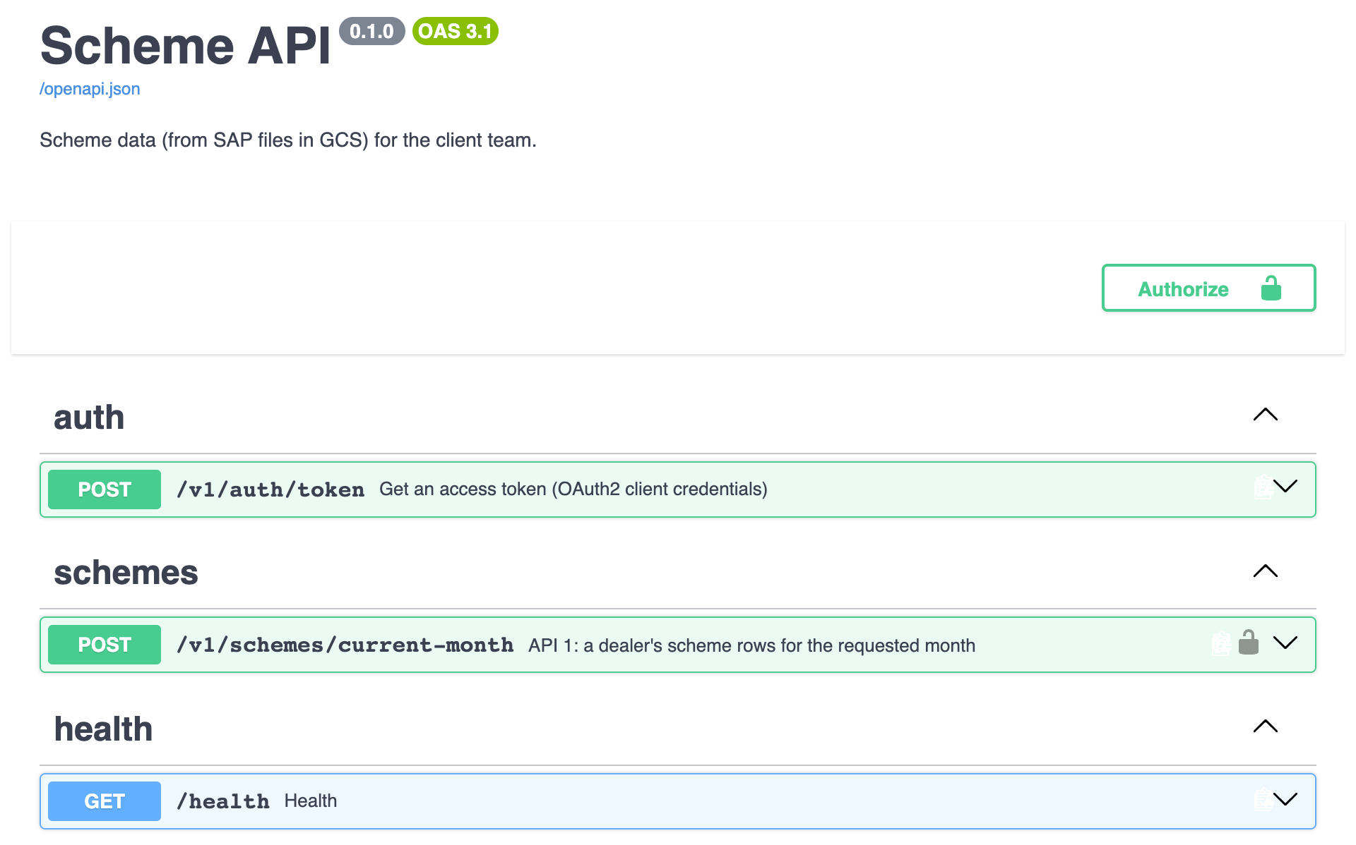
- Click Authorize (top right). In the window that opens, enter your client_id and client_secret, tick schemes:read, and click Authorize.
- 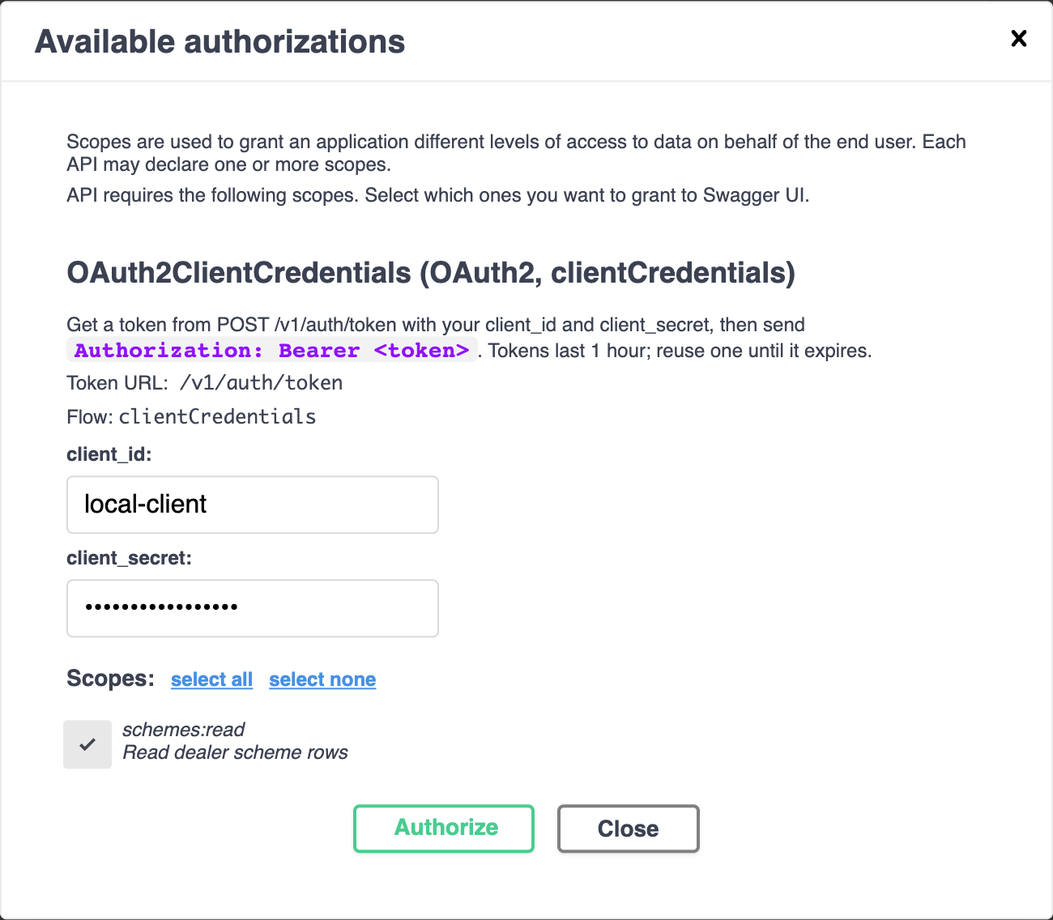
- The window now shows Authorized: the page has fetched a token for you and sends it with every call for the next hour. Click Close. If you see an error instead, the client ID or secret is wrong.
- 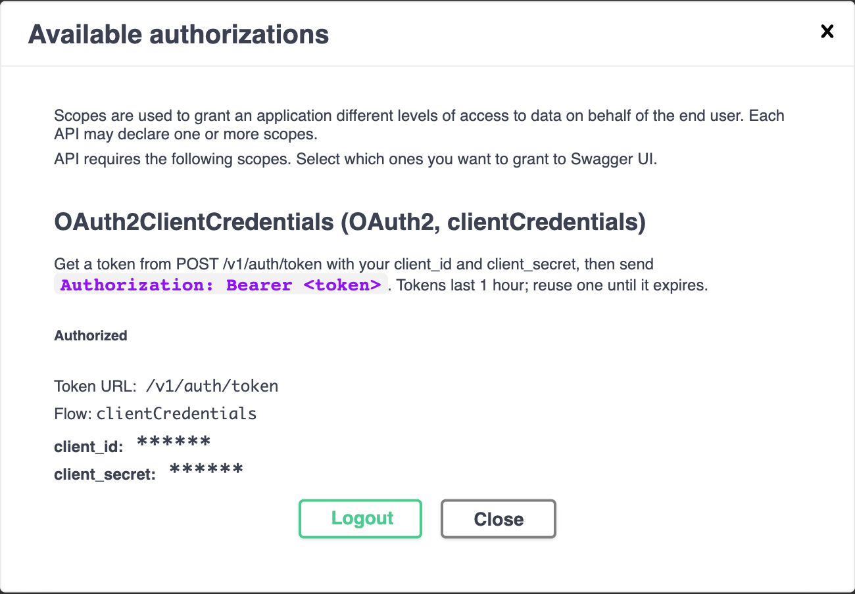
- Click POST /v1/schemes/current-month to open it, then Try it out. Replace the request body with your dealer code, month and year:
- {"dealer_code": "6100000001", "month": 10, "year": 2026}
- 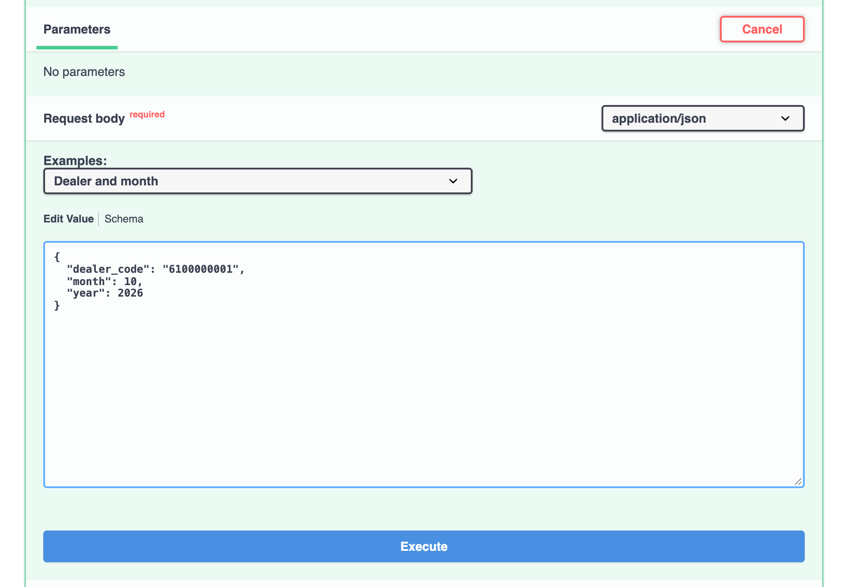
- Click Execute. Under Server response, code 200 and a list of rows means success; the Download button saves the answer as a file. An empty list [] means the dealer has no data for that month.
- 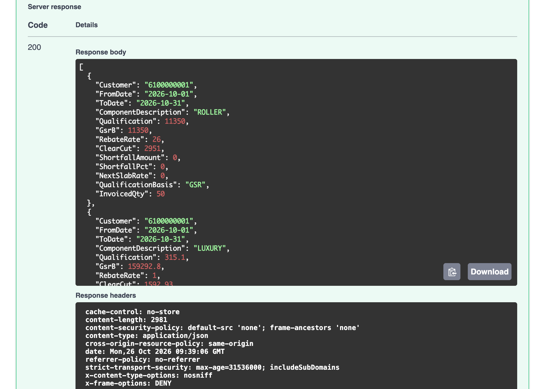
- After an hour the token expires and calls return 401. Click Authorize, then Logout, and authorize again.

C.3 Call the API from your code
- Get a token. Send your client ID and secret to POST /v1/auth/token with grant_type=client_credentials (form-encoded). The answer holds access_token and expires_in (3,600 seconds).
- Call API 1. Send POST /v1/schemes/current-month with the header Authorization: Bearer <access_token> and the JSON body {"dealer_code": "...", "month": 10, "year": 2026}.
- Reuse the token for all calls during its hour. Get a new one about a minute before it expires, or when a call returns 401, and then repeat that call once. Do not get a token per call: the token endpoint allows 30 requests a minute from one address.
The same two steps with curl:
TOKEN=$(curl -s -X POST "https://dev.example.com/v1/auth/token" \
-d grant_type=client_credentials -d client_id="$CLIENT_ID" --data-urlencode client_secret="$CLIENT_SECRET" \
| jq -r .access_token)
curl -s -X POST "https://dev.example.com/v1/schemes/current-month" \
-H "Authorization: Bearer $TOKEN" -H "Content-Type: application/json" \
-d '{"dealer_code": "6100000001", "month": 10, "year": 2026}'
Appendix A has the same in Python and JavaScript. The Postman collection (section 18) does the token step for you: import it, choose the environment, fill in your client ID and secret, and send.

C.4 Read the answer
- One row per component and validity period, ordered by ClearCut, highest first. Rows with the same ClearCut are ordered by end date (ToDate), then by the template's component order (EB SLAB 1–3, VALUE, VALUE %, VALUE FA, LUXURY, PREMIUM 01/02, EB FULL MONTH), then every other component by name. Section 5 explains each field.
- Qualification is GSR for EB, Value, ROLLER, SANDPAPER and MASKING TAPE, and invoiced quantity for every other component. Rows of components outside the 10 also carry QualificationBasis ("GSR" or "INVOICE_QTY") and InvoicedQty.
- EB slab amounts are running totals from the 1st of the month, not amounts for the slab alone.
- [] means no data for that dealer and month: check the dealer code, and that the month is the current one or one of the two before it.
- SAP sends updates every morning (around 04:30–05:00 India time) and the API loads them at 05:00, so today's answer can differ from yesterday's.

C.5 When a call fails
You get | Meaning | What to do
401 Not authenticated | No token sent | Add Authorization: Bearer <token> (in Swagger UI: Authorize)
401 Token expired / Invalid token | Token over an hour old, or not valid | Get a new token and repeat the call once
401 invalid_client (token call) | Wrong client ID or secret | Check both; ask the project team if they still fail
422 | The body is not valid; detail says which field and why | Fix the field, e.g. a month of 13 or a dealer code with a dash
429 Too many requests | Too many calls from your address | Wait the Retry-After seconds, then slow down
503 Service busy, please retry | The API could not reach its database in time | Retry after Retry-After seconds; if it lasts more than a few minutes, tell the project team
500 Internal server error | Unexpected error | Tell the project team the time of the call
GET <base URL>/health (no token) answers {"ok": true} when the API and its database are up, and 503 when the database cannot be reached, so it is a quick check before reporting a problem.

