**A PROJECT REPORT**

**ON**



“LOCATION RECOMMENDATION USING SCALABLE CONTENT-AWARE”

SUBMITTED TO THE

SAVITRIBAI PHULE PUNE UNIVERSITY, PUNE

IN PARTIAL FULFILLMENT FOR THE AWARD OF THE DEGREE

OF

BACHELOR OF ENGINEERING

IN

INFORMATION TECHNOLOGY

BY



Dipali Doke

(B150458515)

(B150458519)

Pooja Giri

(B150458536)

UNDER THE GUIDANCE OF

Mrs. SHITAL KAKAD

Pratiksha Pawar

DEPARTMENT OF INFORMATION TECHNOLOGY

MARATHWADA MITRA MANDAL'S COLLEGE OF ENGINEERING

KARVENAGAR, PUNE-411052, MAHARASHTRA, INDIA

2018 – 2019

**CERTIFICATE**

This is to certify that the project report entitled

**“ Location Recommendation Using Scalable Content-Aware Collaborative Filtering ”**

Submitted by

**Dipali Doke Examination Seat No. : B150458515**

**Pooja Giri Examination Seat No. : B150458519**

**Pratiksha Pawar Examination Seat No. : B150458536**

Is a bonafide work carried out by them under the supervision of Prof. Shital Kakad and it is approved for the partial fulfillment of the requirement of Savitribai Phule Pune University for the award of the Degree of Bachelor of Engineering (Information Technology).

This project report has not been earlier submitted to any other Institute or University for the award of any degree or diploma*.*

|  |  |
| --- | --- |
| **Mrs.Shital Kakad** | **Dr.V.S.Bidave** |
| Internal Guide | Head of Department |
| Department of Information Technology | Department of Information Technology |
|  | **Dr.S.M.Deshpande** |
| External Examiner | Principal |
| Date : | MMCOE,Karvenagar,Pune |

**CONTENTS**

**CERTIFICATE I**

**ACKNOWLEDGEMENT II**

**LIST OF FIGUERS III**

**LIST OF TABLES IV**

**CHAPTER**

**PAGE NO**

**CHAPTER TITLE**

1. **INTRODUCTION 8**

* 1. **BACKGROUND 9**
  2. **RELEVANCE 9**
  3. **PROJECT UNDERTAKEN 10**

1. **BACKGROUND 11**
2. **SPECIFICATION 12**
   1. **H/W REQUIRMENTS 12**
   2. **S/W RQUIREMENTS 12**
   3. **USER INTERFACE 13**
3. **DESIGN 14**
4. **IMPLEMENTATION 18**
   1. **NAVIE BAYES 19**
   2. **COLLABORATIVE FILTERING 20**
5. **RESULT EVALUTION 21**
6. **CONCLUSION 37**
7. **REFERENCE 38**

**LIST OF FIGURES**

|  |  |  |
| --- | --- | --- |
| Content No | Diagram Name | Page No |
| 4.1 | DFD | 12 |
| 4.2 | SEQUENCE DIAGRAM | 13 |
| 4.3 | CLASS DIAGRAM | 14 |
| 4.4 | USE CASE DIAGRAM | 15 |
| 4.5 | COMPONENT | 16 |
| 4.6 | DEPLOYMENT | 16 |
| 5.1 | SYSTEM ARCHITECTURE | 17 |

**Acknowledgement**

For completion of our project, we had to take help and guideline of some respected persons, who deserve our greatest gratitude. The completion of this project gives ous much pleasure.

We would like to show our gratitude to our principal **Dr. S. M. Deshpande** and our project guide **Mrs. Shital Kakad** and our project coordinator **Mr. Nikhil Dhavase** and the head of Department **Dr. V. S. Bidve** as well as other teaching staff of **Department of Information Technology of MARATHWADA MITRA MANDAL COLLEGE OF ENGINEERING KARVENAGAR,PUNE** for providing us a guideline throughout the project work.

Many people, especially our classmates have made valuable help through different suggestion on implementation which gave us an inspiration to improve our project working.

We would also like to thank our families for their kind and patient support, which helped us to provide attention to our work. Finally we thank you all the people who have directly and indirectly guided us in this project.

Dipali Doke

Pooja Giri

Pratiksha Pawar

**ABSTRACT**

The Location recommendation plays an essential role in helping people find interesting places. Although recent researchers has studied how to advise places with social and geographical information, some of which have dealt with the problem of starting the new cold users. Because mobility records are often shared on social networks, semantic information can be used to address this challenge. There the typical method is to place them in collaborative content-based filters based on explicit reviews using machine learning, but require a positive design samples for a better learning performance, since the positive user preference is not observable in human mobility. However, previous studies have demonstrated empirically that sampling-based methods do not work well. To this end, we propose a system based on implicit scalable comments Content-based collaborative filtering framework (ICCF) to incorporate semantic content and avoid negative sampling. We also establish its relationship with the factorization of the plate matrix plating. Finally, we evaluated ICCF with a large-scale hotel data set in which users have text and content profiles. The results show that ICCF surpasses many competitors’ baselines and that user information is not only effective for improving recommendations, but also for managing cold start scenarios.

**1.INTRODUCTION**

As we think about the title of this paper is related to Recommender System which is part of the Data mining technique. Recommendation systems use different technologies, but they can be classified into two categories: collaborative and content-based filtering systems. Content-based systems examine the properties of articles and recommend articles similar to those that the user has preferred in the past. They model the taste of a user by building a user profile based on the properties of the elements that users like and using the profile to calculate the similarity with the new elements. We recommend location that are more similar to the user's profile. Recommender systems, on the other hand, ignore the properties of the articles and base their recommendations on community preferences. They recommend the elements that users with similar tastes and preferences have liked in the past. Two users are considered similar if they have many elements in common.

One of the main problems of recommendation systems is the problem of cold start, i.e. when a new article or user is introduced into the system. In this study we focused on the problem of producing effective recommendations for new articles: the cold starting article. Collaborative filtering systems suffer from this problem because they depend on previous user ratings. Content-based approaches, on the other hand, can still produce recommendations using article descriptions and are the default solution for cold-starting the article. However, they tend to get less accuracy and, in practice, are rarely the only option.

The problem of cold start of the article is of great practical importance Portability due to two main reasons. First, modern online the platforms have hundreds of new articles every day and actively recommending them is essential to keep users continuously busy. Second, collaborative filtering methods are at the core of most recommendation engines since then tend to achieve the accuracy of the state of the art. However, to produce recommendations with the predicted accuracy that require that items be qualified by a sufficient number of users. Therefore, it is essential for any collaborative adviser to reach this state as soon as possible. Having methods that producing precise recommendations for new articles will allow enough comments to be collected in a short period of time, Make effective recommendations on collaboration possible.

In this paper, we focus on providing location recommendations novel scalable Implicit-feedback based Content-aware Collaborative Filtering (ICCF) framework. Avoid sampling negative positions by considering all positions not visited as negative and proposing a low weight configuration, with a classification, to the preference trust model. This sparse weighing and weighting configuration not only assigns a large amount of confidence to the visited and unvisited positions, but also includes three different weighting schemes previously developed for locations.

* 1. **BACKGROUND**

The Admin can view the number of users, those are register themselves into system. Users themselves provide with username and password which they can use to login in the system. Cold start users don’t know anything about places and hotels. So it is necessary for user to register himself in the system. Admin have all the rights to view number of users and their details. Admin activate to the users and help to users to login into system. Admin recommends the hotel and places by using Collaborative Filtering Algorithm according to city.

* 1. **Relevance**

**Project aims**

* To find hotels and Places according to his current location.

**Project objectives**

* Improve the recommendation accuracy using advanced content aware collaborative filtering technique.
* Providing location recommendations from positive examples is based on the explicit feedback.

**State of Art applications**

**1.** Find attractive locations on reviews.

2. Third party recommendation system.

**Advantages:**

* Improve accuracy using machine learning.
* Working on reviews.
* Improve recommendation using collaborative filtering.
  1. **PROJECT UNDERTAKEN**

The Location recommendation plays an essential role in helping people find interesting places. This project will be helpful for people to search interesting and attractive palces and hotels. The recommendation of hotels and places are based on positive reviews of other people. Depending on the views specific hotels and places are displayed on top for recommendation. We propose a system based on implicit scalable comments Content-based collaborative filtering framework (ICCF) to incorporate semantic content and avoid negative sampling using machine learning and Naive Bayes algorithm.

**2. BACKGROUND**

**Literature Survey**

1. X. Liu, Y. Liu, and X. Li describe the “Exploring the context of locations for personalized Location recommendations”. In this paper, we decouple the process of jointly learning latent representations of users and locations into two separated components: learning location latent representations using the Skip-gram model, and learning user latent representations Using C-WARP loss [1].
2. Shuyao Qi, Dingming Wu, and Nikos Mamoulis describe that ,” Location Aware Keyword Query Suggestion Based on Document Proximity” In this paper, we proposed an LKS framework providing keyword suggestions that are relevant to the user information needs and at the same time can retrieve relevant documents Near the user location [2].
3. H. Li, R. Hong, D. Lian, Z. Wu, M. Wang, and Y. Ge describe the “A relaxed ranking-based factor model for recommender system from implicit feedback,” in this paper, we propose a relaxed ranking-based algorithm for item recommendation with implicit feedback, and design a smooth and scalable optimization method for model’s parameter Estimation [3].
4. D. Lian, Y. Ge, N. J. Yuan, X. Xie, and H. Xiong describe the “Sparse Bayesian collaborative filtering for implicit feedback,” In this paper, we proposed a sparse Bayesian collaborative filtering algorithm best tailored to implicit feedback, And developed a scalable optimization algorithm for jointly learning latent factors and hyper parameters [4].
5. X. He, H. Zhang, M.-Y. Kan, and T.-S. Chua describe the “Fast matrix factorization for online recommendation with implicit feedback,” We study the problem of learning MF models from implicit feedback. In contrast to previous work that applied a uniform weight on missing data, we propose to weight Missing data based on the popularity of items. To address the key efficiency challenge in optimization, we develop a new learning algorithm which effectively learns Parameters by performing coordinate descent with memorization [5].

**3.Specification**

**3.1 Hardware Requirements:**

# Processor - Pentium –III

1. Speed - 1.1 GHz
2. RAM - 256 MB(min)
3. Hard Disk - 20 GB
4. Floppy Drive - 1.44 MB

**3.2 Software Requirements:**

1. Operating System - Windows95/98/2000/XP/2007/2010
2. Application Server - Tomcat7.0/8.X
3. Front End - HTML, JDK 1.8, JSP
4. Scripts - JavaScript.
5. Server side Script - Java Server Pages.
6. Database - My SQL 5.0
7. IDE - Eclipse Oxygen
8. External Interface Requirements

## **3.3 User Interfaces**

* **Front-End software:**
  + 1. Eclipse IDE
    2. Java
* **Back-End software:**
  + 1. MySQL Database
    2. Apache tomcat server

**4.Design**

**4.1 DFD Diagram:** 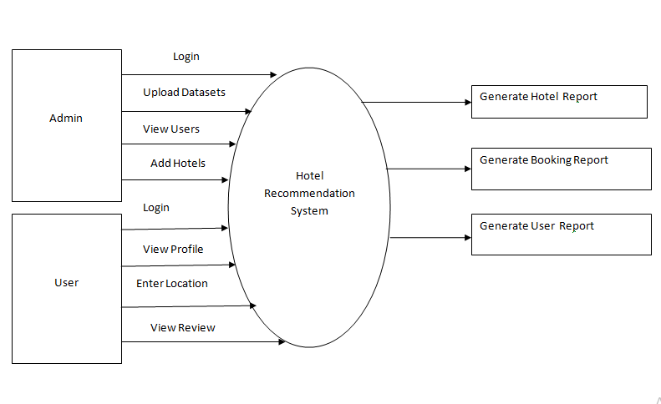

**4.2 Sequence Diagram:**

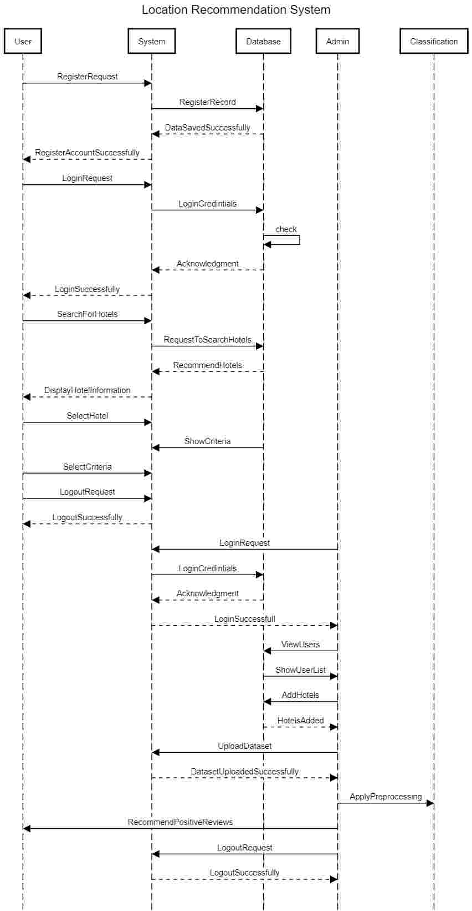

**4.3 Class Diagram:**

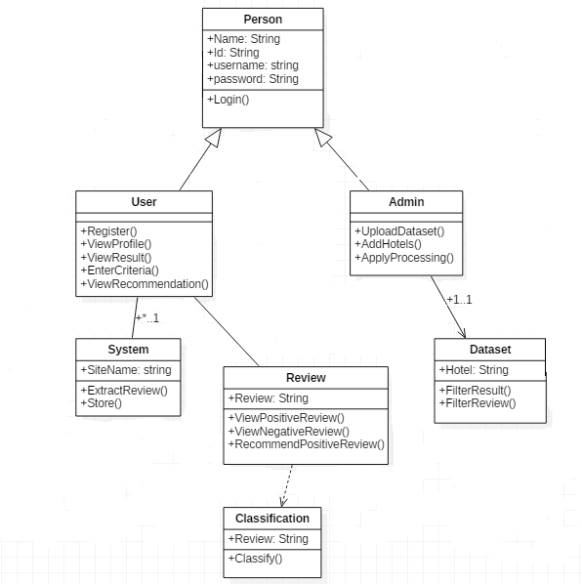

**4.4 Use Case Diagram:**

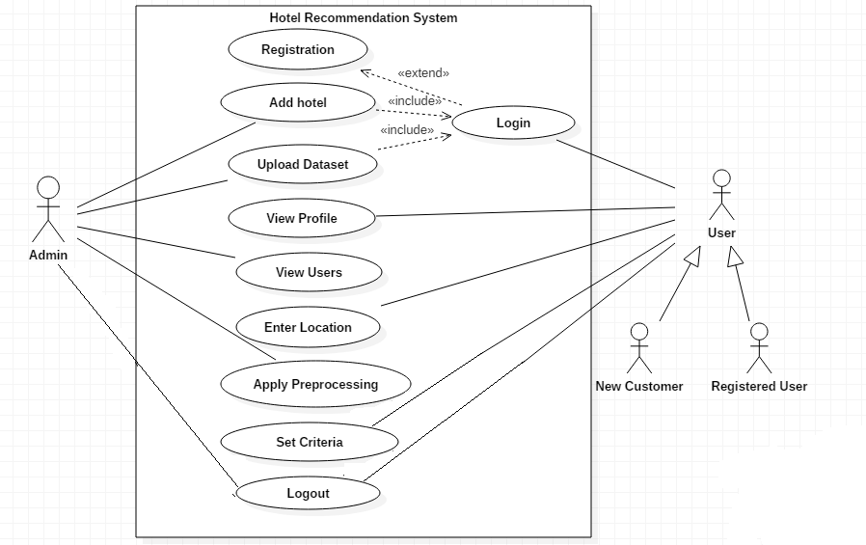

**4.5 Component Diagram:**



**4.6 Deployment Diagram:**

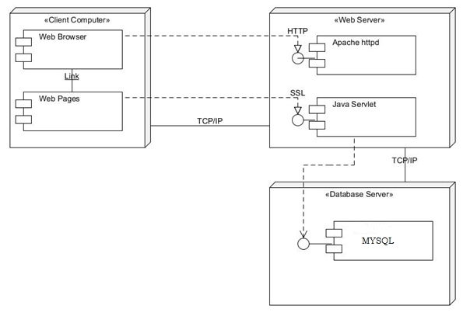

**5.Implementation**

Fornew cold start user Location Recommendation is essential role in finding the interesting places by applying appropriate machine learning algorithm on the input hotel dataset reviews are classified in positive and negative reviews. After that, using collaborative filtering algorithm, interesting places of hotels are recommended to the cold start user on the basis of positive reviews avoiding negative sampling.

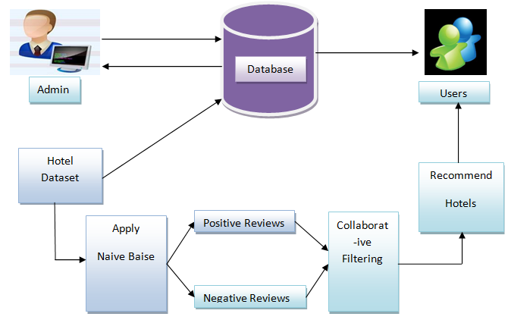

**5.1 Fig. System Architecture**

In this system, particular Recommendation of places for new users. Some popular recommendation frameworks, have been recently Proposed, but designed on the basis of explicit feedback with favourite samples both positively and negatively. Such as Only the preferred samples are implicitly provided in a positive way. Feedback data while it is not practical to treat all unvisited locations as negative, feeding the data on mobility together. With user information and location in these explicit comments Frames require pseudo-negative drawings. From places not visited. The samples and the lack of different levels of trust cannot allow them to get the comparable top-k recommendation.

***Algorithms:***

**5.1. Naive Bayes**

**Steps:**

1. Given training dataset D which consists of documents belonging to different class say Class A and Class B
2. Calculate the prior probability of class A=number of objects of class A/total number of objects

Calculate the prior probability of class B=number of objects of class B/total number of objects

1. Find NI, the total no of frequency of each class

Na=the total no of frequency of class A

Nb=the total no of frequency of class B

1. Find conditional probability of keyword occurrence given a class:

P (value 1/Class A) =count/ni (A)

P (value 1/Class B) =count/ni (B)

P (value 2/Class A) =count/ni (A)

P (value 2/Class B) =count/ni (B)

…………………………………..

…………………………………..

…………………………………..

P (value n/Class B) =count/ni (B)

1. Avoid zero frequency problems by applying uniform distribution
2. Classify Document C based on the probability p(C/W)
3. Find P (A/W) =P (A)*P (value 1/Class A)* P (value 2/Class A)……. P(value n /Class A)
4. Find P (B/W) =P (B)*P (value 1/Class B)* P(value 2/Class B)……. P(value n /Class B)
5. Assign document to class that has higher probability.
   1. **Content Aware collaborative filtering:**

* Content-aware collaborative filtering is the integration of content-based recommendation and collaborative filtering.
* Our proposed algorithm targets content-aware collaborative filtering from implicit feedback and successfully addresses the disadvantages by treating the items not preferred by users as negative while assigning them a lower confidence for negative preference and achieving linear time optimization.
* Accuracy is high.

**Steps:**

1. Given data of M users visiting N Locations
2. Location recommendation first converts it into a user-location frequency matrix
4. Each entry indicating the visit frequency of a user u to location i.
5. Is a preference matrix, for which each entry is set to 1.
6. If the user u has visited the location i otherwise is set to 0.
7. Weighed matrix factorization being performed on the preference matrix R.
8. Maps both users and locations into a joint latent space of dimension
9. Where, each user and each location is represented by user latent factor and location latent factor.
10. Preference of a user u for a location i is estimated.
11. **RESULT EVALUTION**

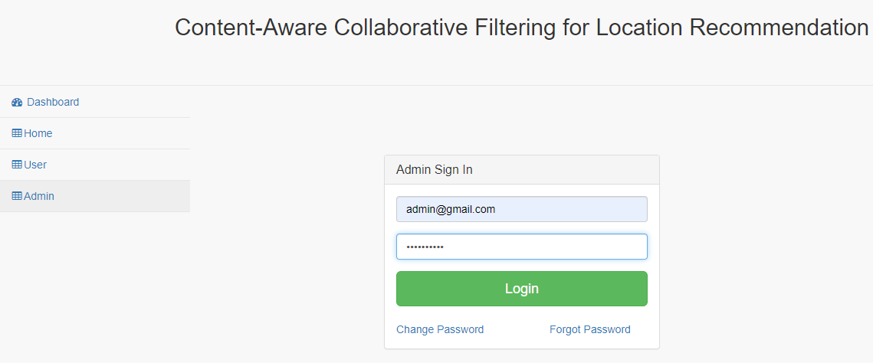

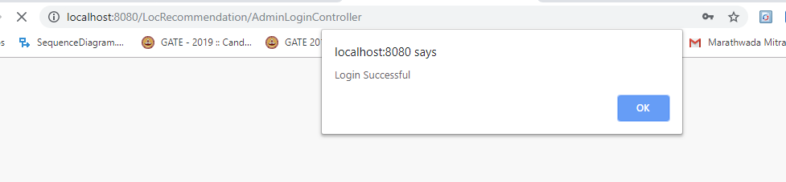

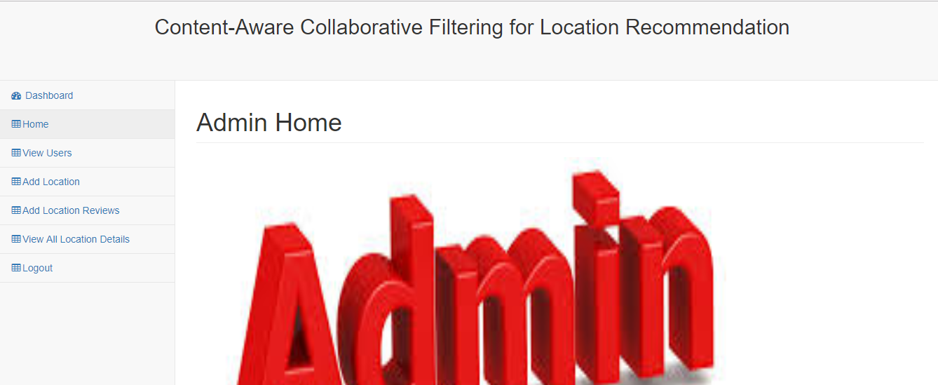

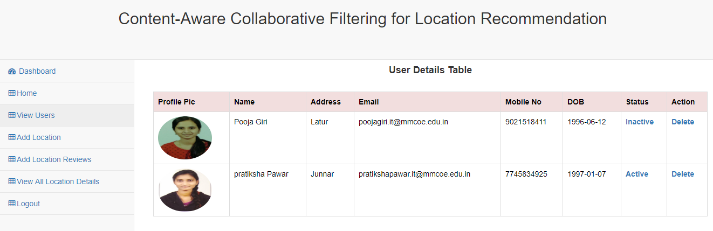

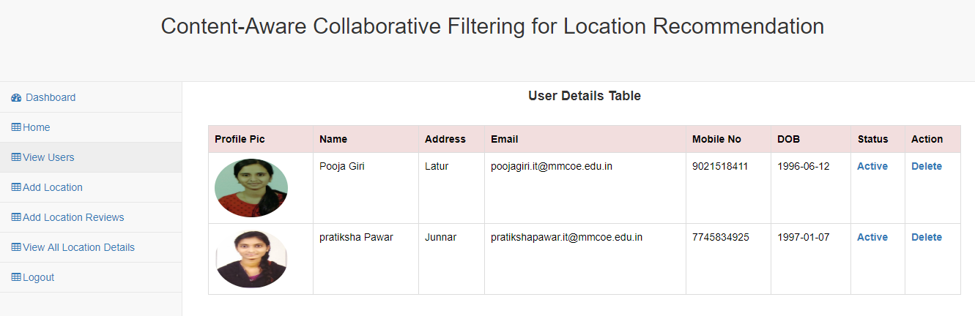

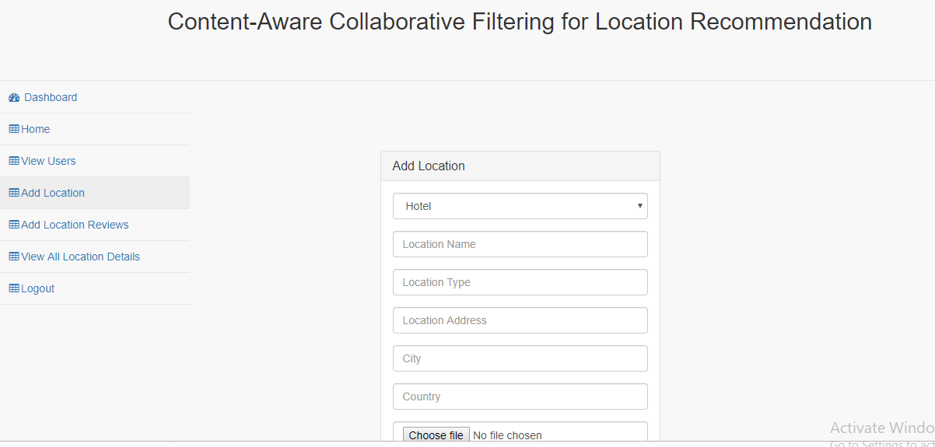

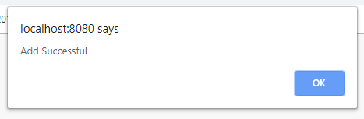

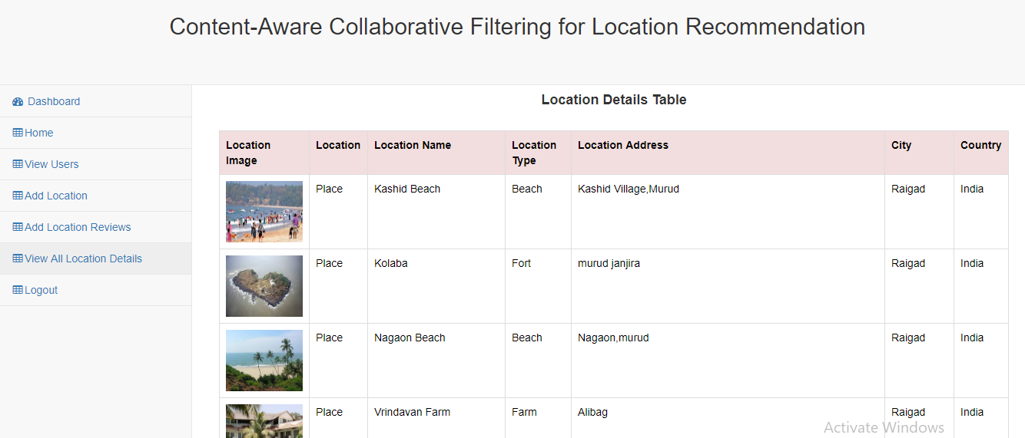

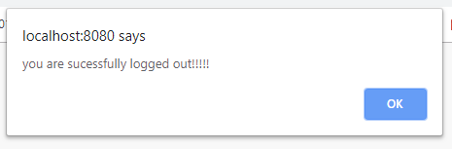

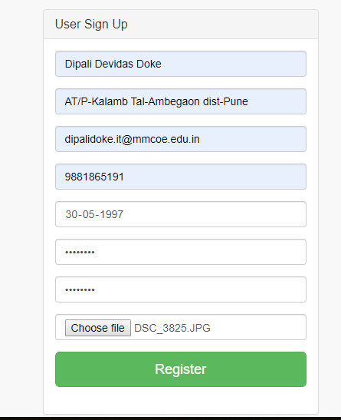

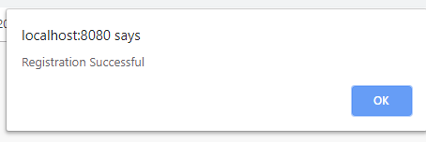

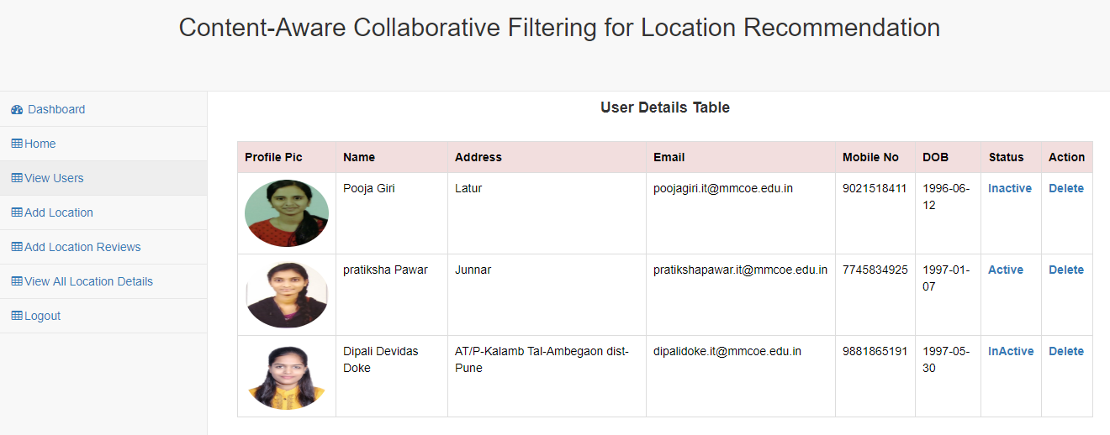

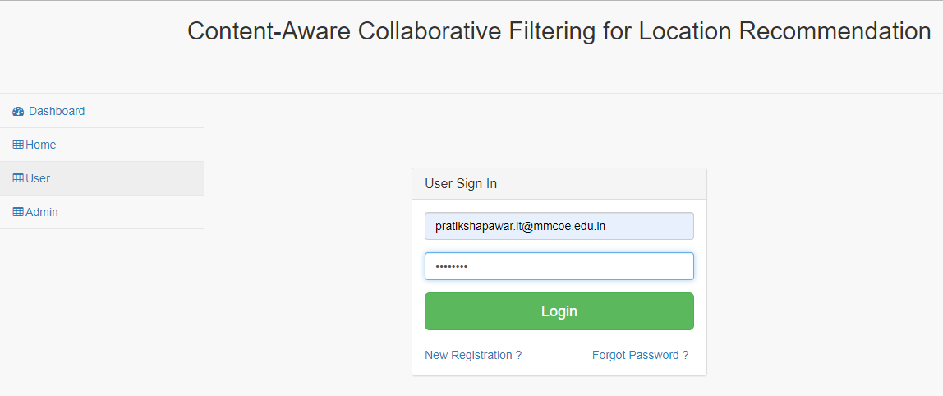

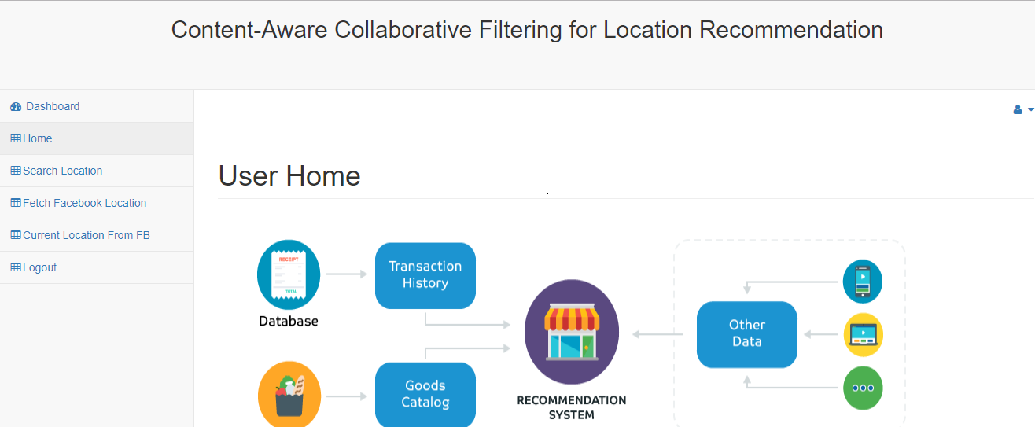

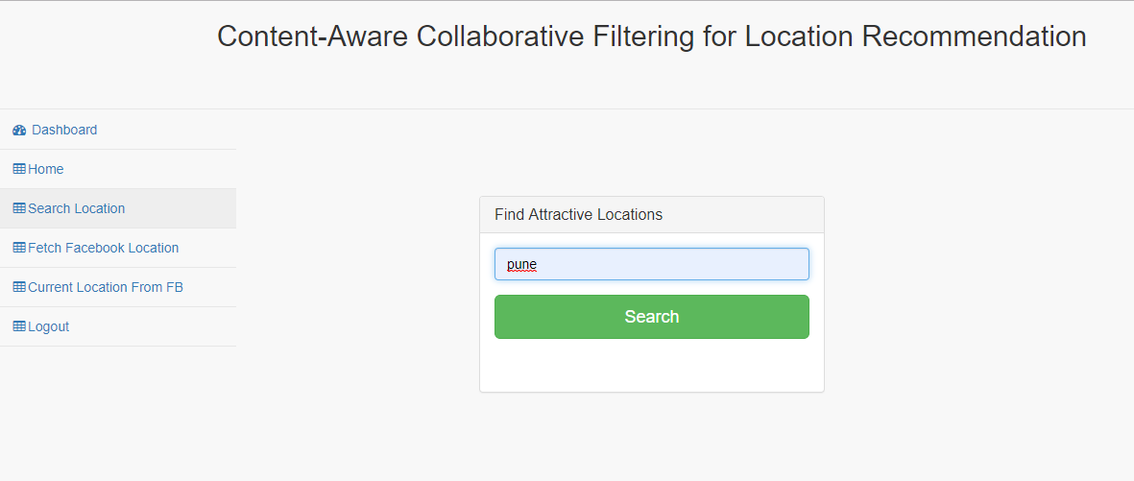

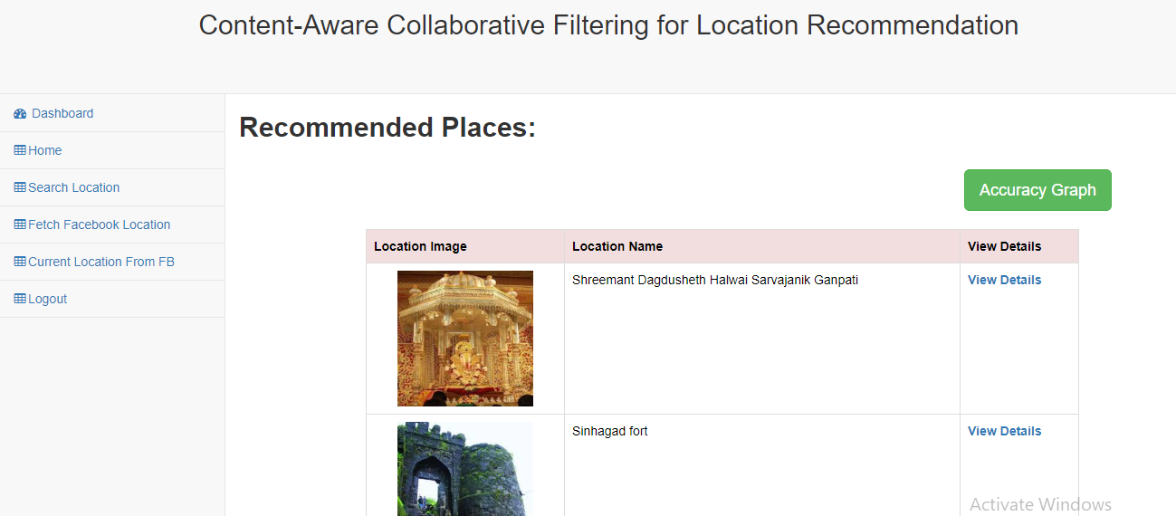

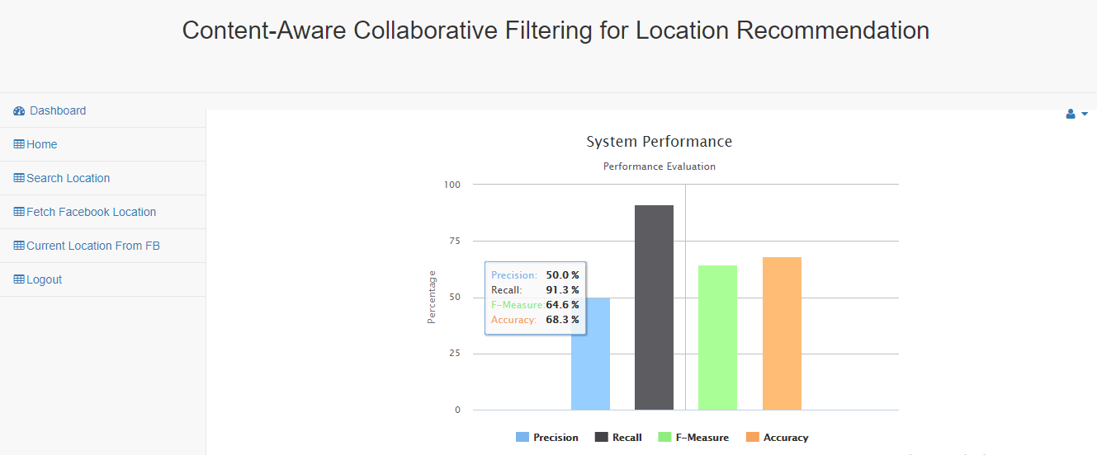

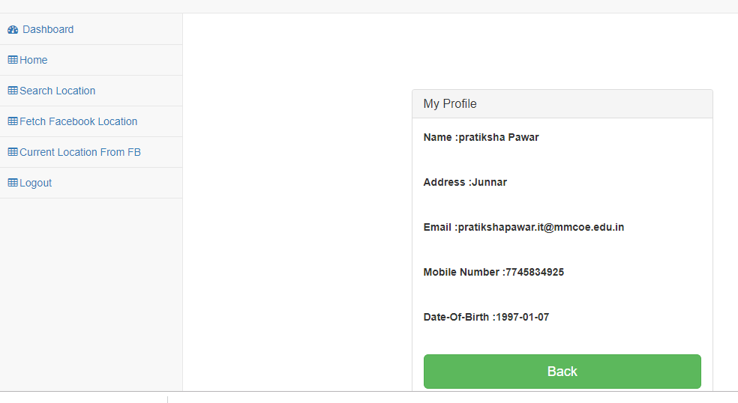

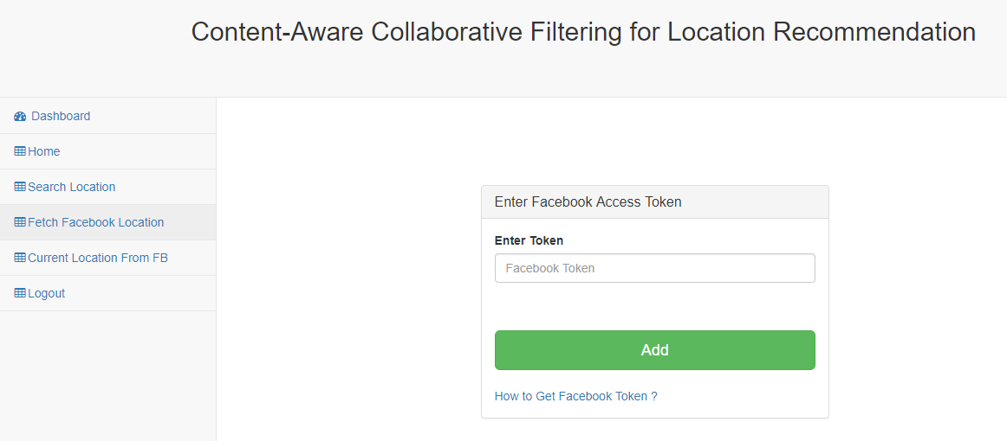

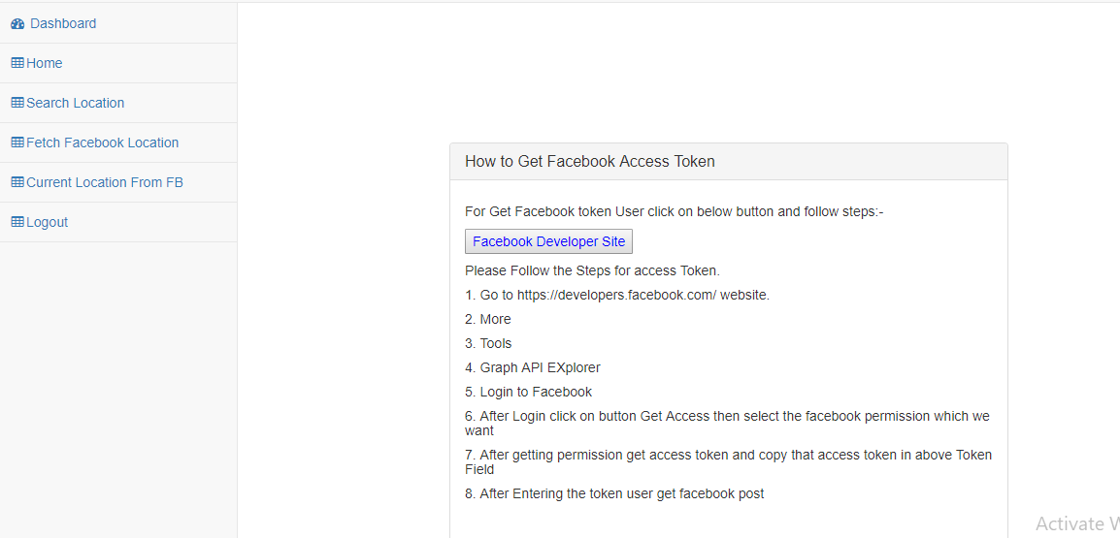

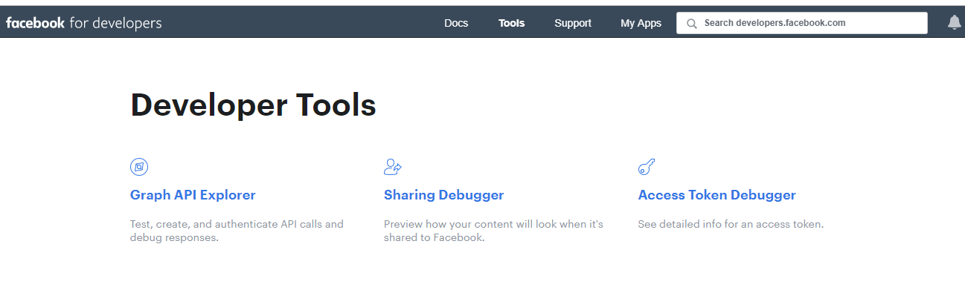

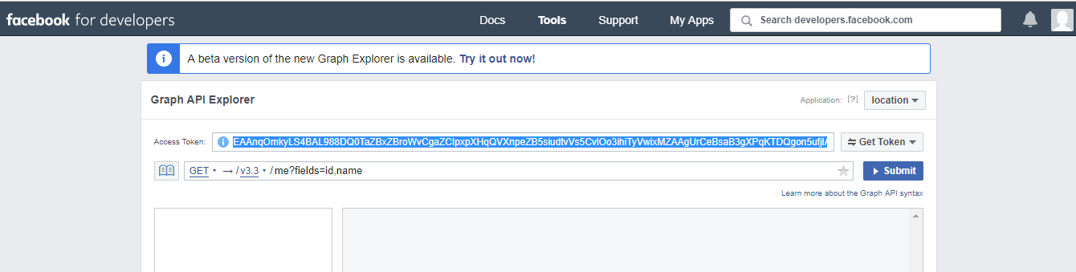

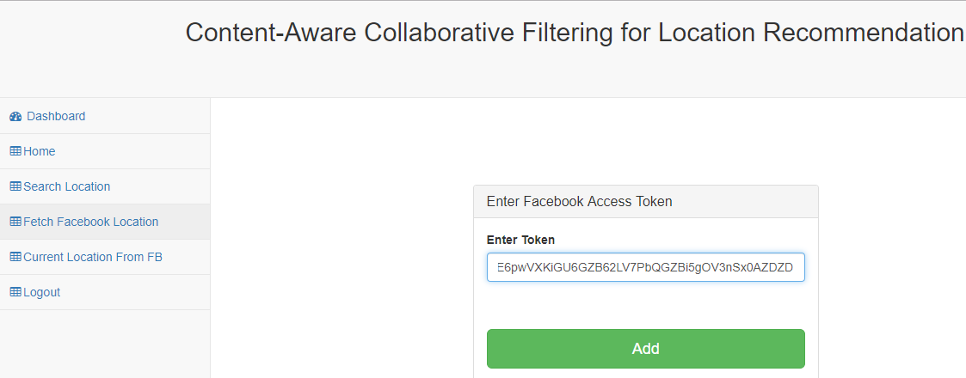

**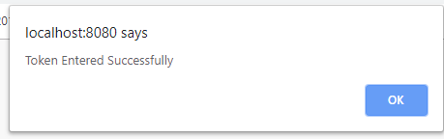  
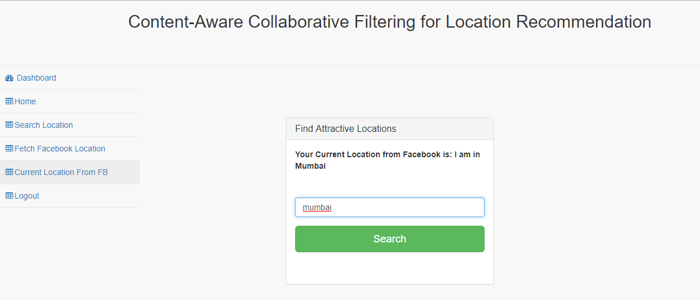**

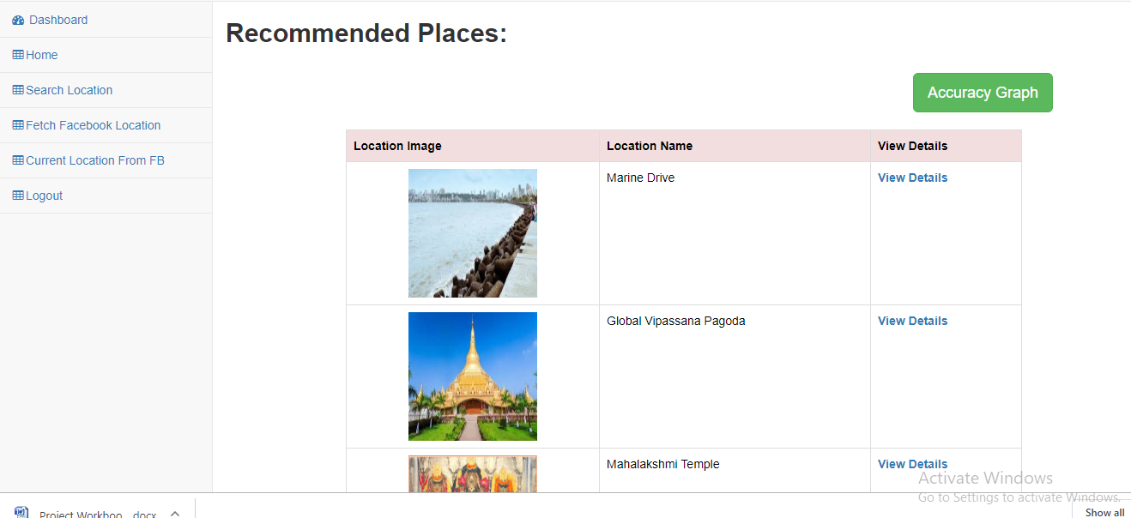

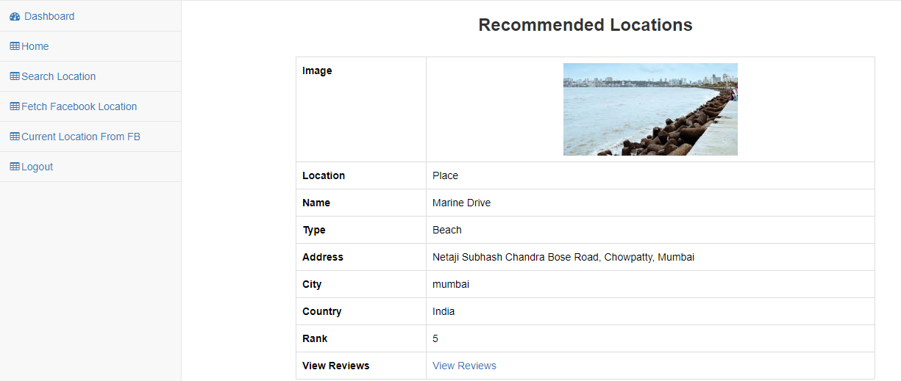

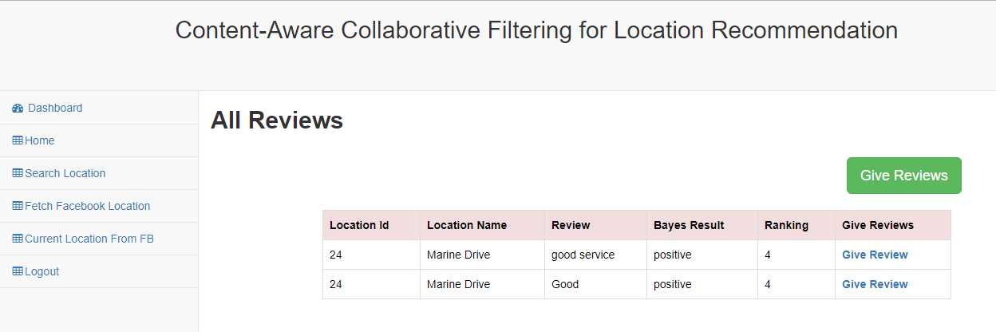

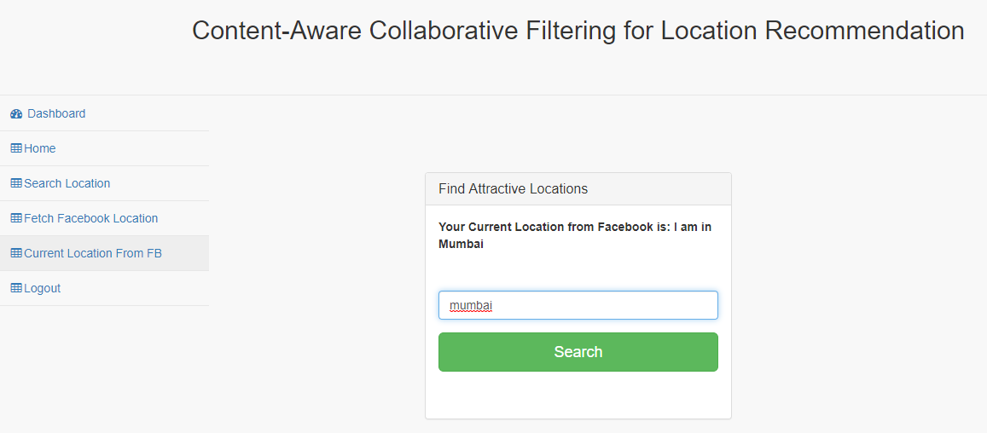

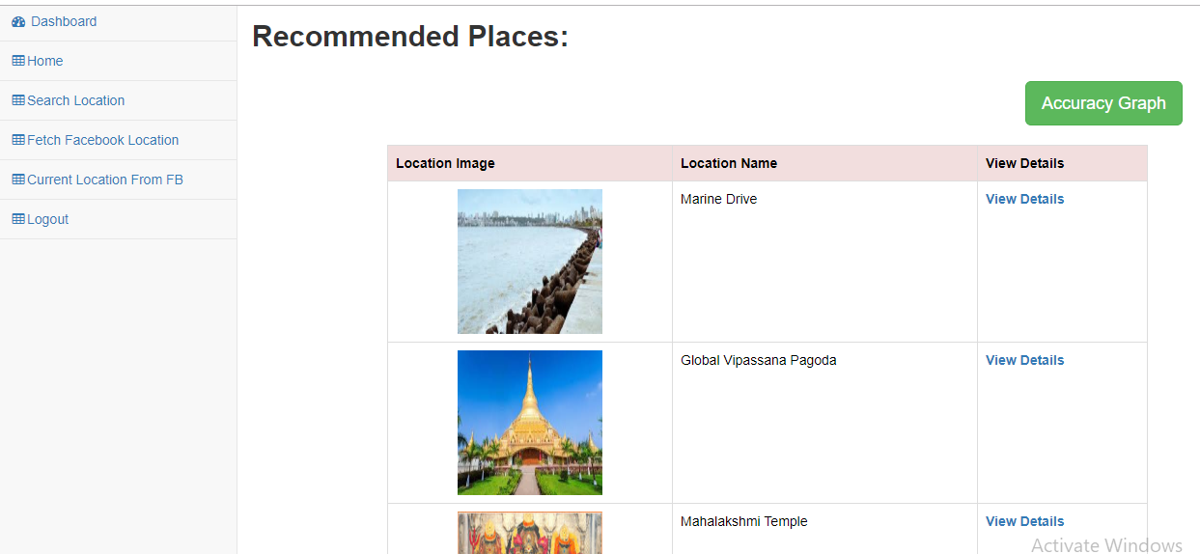



**7.Conclusion**

In this Paper, we propose a new framework for collaborative filtering based on explicit and implicit feedback set of data and develop the coordinates of the offspring for effective learning of parameters. We establish the close relationship of matrix graphical factorization and shows that user functions really improve mobility Similarity between users. So we apply proposed system for the Location recommendation on a large-scale LBSN data set. our the results of the experiment indicate that proposed system is greater than five competing baselines, including two leading positions recommendation and factoring algorithms based on the ranking machine. When comparing different weighting schemes for negative preference of the unvisited places, we observe that the user-oriented scheme is superior to that oriented to the element scheme, and that the sparse configuration and rank one significantly improves the performance of the recommendation*.*

8.REFERENCES

* Y. Y, Chen, A. J, Cheng, and W. H. Hsu, “Travel recommendation by mining people attributes and travel group types from community-contributed photos,” IEEE Transactions on Multimedia, vol. 15, no. 6, pp. 1283-1295, Oct. 2013.
* P. Kefalas, P. Symeonidis, and Y. Manolopoulos, “A graph-based taxonomy of recommendation algorithms and systems in LBSNs,” IEEE Transactions on Knowledge and Data Engineering, vol. 28, no 3, pp.604-622, Mar. 2016.
* P. Peng, L. Shou, K. Chen, G. Chen, and S. Wu, “KISS: knowing camera prototype system for recognizing and annotating places-of-interest,”IEEE Transactions on Knowledge and Data Engineering, vol. 28, no 4, pp.994-1006, Apr. 2016.
* Personalized Travel Sequence Recommendation on Multi-Source Big Social Media Shuhui Jiang, Xueming Qian *, Member, IEEE, Tao Mei, Senior Member, IEEE and Yun Fu, Senior Member, IEEE
* X. Wang, Y. L. Zhao, L. Nie, Y. Gao, W. Nie, Z. J. Zha, and T. S. Chua, “Semantic-based location recommendation with multimodal venue semantics,” IEEE Transactions on Multimedia, vol. 17, no. 3, pp. 409-419, Mar. 2015.
* Shuyao Qi, Dingming Wu, and Nikos Mamoulis,” Location Aware Keyword Query Suggestion. Based on Document Proximity” VOL. 28, NO. 1, JANUARY 2016.
* H. Gao, J. Tang, X. Hu, and H. Liu, “Content-aware point of interest recommendation on location-based social networks,” in Proceedings of AAAI’15. AAAI, 2015.
* H. Li, R. Hong, D. Lian, Z. Wu, M. Wang, and Y. Ge, “A relaxed ranking-based factor model for recommender system from implicit feedback,” in Proceedings of IJCAI’16, 2016, pp. 1683–1689.
* D. Lian, Y. Ge, N. J. Yuan, X. Xie, and H. Xiong, “Sparse Bayesian collaborative filtering for implicit feedback,” in Proceedings of IJCAI’16. AAAI, 2016.