***Report***

**Mini project**

**Project name :- Bank Management System in C with Source Code**

**Introduction**

The Mini Project for Bank Management System in C is a consoled based application and created using c programming language. This system is a simple mini project and compiled in vs code using GCC compiler. In this system it is centered around client account administrations in bank, so it is named “Client Account Bank Management System”. Here, you can make another record, update data of a current record, see and oversee exchanges, check the information of a current record, eliminate existing record and view clients’ lists. The source code for Bank Management System is generally short and straightforward. I have partitioned this C smaller than expected task into numerous capacities, a large portion of which are identified with various financial exercises.

**Design**

**• Structural-**

In Bank Management System in C Programming language has many data structures like an array, stack, queue, linked list, tree, etc. A programmer selects an appropriate data structure and uses it according to their convenience

**Benefits –**

Record Maintenance.  
Web-Based Solution.  
Saves Time and Cost.  
Secure and Reliable.  
Increases Efficiency.  
Simple and Easy to Use.

**• Implement-**

**C program base on implementation-**

We use the following steps to create and execute C programs in Windows OS  
• Step 1: Creating a Source Code. Source code is a file with C programming instructions in a high-level language  
• Step 2: Compile Source Code (Alt + F9)  
• Step 3: Executing / Running Executable File (Ctrl + F9)  
• Step 4: Check Result (Alt + F5)

**Test plan and outcome-  
![OUTCOME](**[**https://user-images.githubusercontent.com/101090081/161246804-7428131c-4df6-4db1-9c16-79217616a4b3.png**](https://user-images.githubusercontent.com/101090081/161246804-7428131c-4df6-4db1-9c16-79217616a4b3.png)**)**

**Defining our system-**

**1)create a bank account**

**2)Already a User? sign in**

**3)Exit**

**![BANK SYSTEM OUT PUT ](**[**https://user-images.githubusercontent.com/101090081/161246289-d264bef8-b884-4960-a515-18d2e610abc6.png**](https://user-images.githubusercontent.com/101090081/161246289-d264bef8-b884-4960-a515-18d2e610abc6.png)**)**

**Swot Analysis –**

**Strengths-**

**1)Simple & Easy to Use.**

**2)Increased Billing Efficiency.**

**3)Efficient Cloud Data Management.**

**4)Highly Secure, Scalable & Reliable.**

**5)Mobile Access.**

**Weakness-**

**The data stored is prone to cyber hacks.**

**May be complicated to operate.**

**Risk of computer virus.**

**High Level Requirements –  
[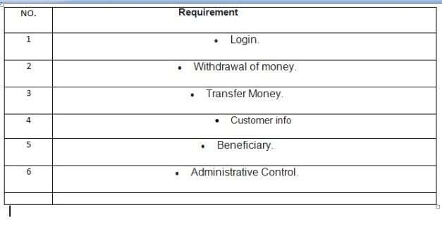](https://user-images.githubusercontent.com/101090081/161253296-1dc9bf72-e855-44bb-84e1-18a503a06b45.jpeg)**

**Low Level Requirements –  
[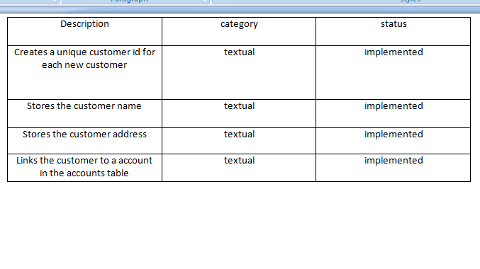](https://user-images.githubusercontent.com/101090081/161253504-9a4acc76-6b6a-4511-9477-dd90436dc354.png)**

**Image and Video-**

**[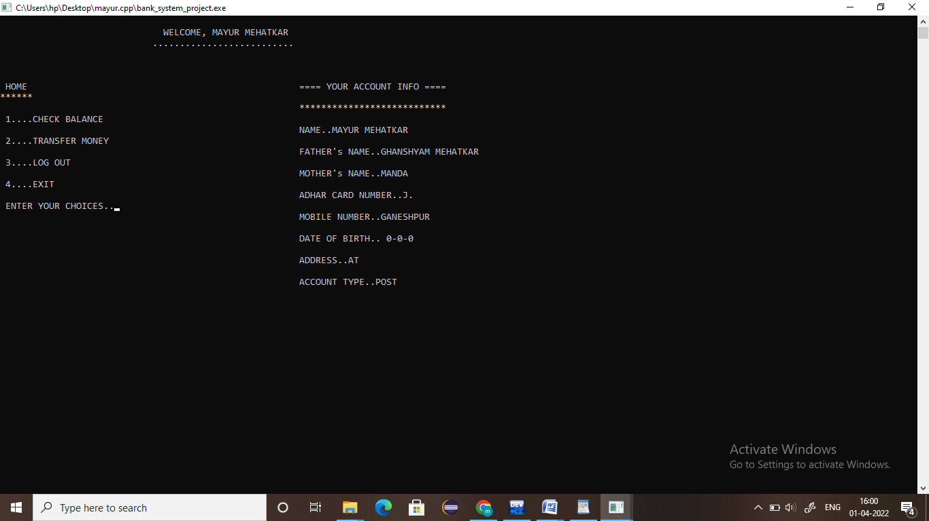](https://user-images.githubusercontent.com/101090081/161318746-b0eb9667-cdd4-401e-8c19-48d0ee66cfd3.png)**