IT-015: IT Security Tracker Maintenance
Prepared by: Erik Demchuk
Reviewed by: _______________________________
QA Approval: _______________________________
Effective Date: March 6, 2026

Department: | Information Technology
SOP ID: | IT-015
Version: | 1.4
Resources: | - Security & GMP Connection Tracker: https://docs.google.com/spreadsheets/d/1WBzed_RMtPC3kii-ybJ3lE4Fo1pAqWBt9OJyCSVR-mQ/edit  - Slack request commands: /gmp-request-access and /it-alert  - 1Password credential records
Important Notes: | - - Passwords are stored only in 1Password; never in the tracker.  - - Presence Status shows whether the account exists; Activity Status shows whether use is evidenced.  - - Review Checks are generated every 120 days and for missing or unmanaged accounts.

1. Purpose
To define the day-to-day process for receiving, approving, provisioning, verifying, reviewing, and closing GMP-related system access in the Security & GMP Connection Tracker.

2. Scope
This SOP applies to IT, managers, and QA personnel responsible for maintaining access records, quarterly reviews, and incidents for GMP-connected systems managed by MyMagicHealer.
It covers the current workbook structure: Access Control, Review Checks, and Incidents, plus the supporting Slack intake and tracker automation.

3. Responsibilities
Role | Responsibility
IT Administrator | Monitors Slack intake, reviews access requests, maintains the account register, and triages incidents.
Provisioning Owner | Creates, changes, or removes access in the target system and records the real account identifier in the tracker.
Manager / System Owner | Approves or denies business access where required and supports review decisions for unusual or privileged access.
IT Manager | Owns escalations, approves workflow changes, and ensures the tracker remains operational.
QA Manager | Approves SOP revisions and confirms the process remains aligned with GMP expectations.

4. Definitions (if applicable)
Term | Definition
Access Control | Primary operating tab containing ACCESS REQUESTS and ACTIVE GMP ACCOUNTS.
Review Checks | Action queue used to review due, missing, unmanaged, or no-evidence accounts.
Incidents | Tab used to record and manage system issues and access-related incidents.
Presence Status | Whether the account currently exists in the system: Provisioning, Present, Missing, Unmanaged, or Revoked.
Activity Status | Whether there is real usage evidence: Verified Active, Some Evidence, No Evidence, or Unknown.
120-Day Review Cycle | Standard review cadence for all non-revoked GMP accounts unless an earlier exception review is required.

5. Procedure
Step 1 - Receive and Review the Request
1.1 Open the Access Control tab and review the new request row in ACCESS REQUESTS.
1.2 Confirm the target user, company email, department, system, access level, reason, manager, and GMP impact are complete.
1.3 Confirm the request type, required access level, and business reason are appropriate for the user role.
1.4 Enter the Provisioning Owner who will complete the access setup if the request is approved.
1.5 If the request is unusual, privileged, or unclear, confirm approval with the manager or system owner before moving forward.

Step 2 - Approve or Deny the Request
2.1 Set Approval to Approved or Denied.
2.2 If denied, document the reason in Notes and stop processing.
2.3 If approved, confirm the request can move to provisioning.

Step 3 - Provision Access
3.1 Create or update the account in the target system.
3.2 Record the real account identifier in Access ID. Do not store passwords in the tracker. Passwords remain only in 1Password.
3.3 Set Provisioning to Provisioned when the account is ready for use.

Step 4 - Verify and Maintain the Active Account Register
4.1 Confirm the related account appears in ACTIVE GMP ACCOUNTS and that the request remains in ACCESS REQUESTS as the audit trail.
4.2 Use Presence Status to track whether the account currently exists in the system: Provisioning, Present, Missing, Unmanaged, or Revoked.
4.3 Use Activity Status only when there is real usage evidence. If no reliable activity source exists, leave Activity Status as Unknown.
4.4 Review any account marked Missing or Unmanaged promptly and keep Platform Account, Access Level, Dept, Next Review Due, and Notes current.

Step 5 - Complete 120-Day Review Checks
5.1 Review Checks are generated automatically every 120 days for non-revoked GMP accounts and earlier when exceptions are detected.
5.2 Work only from OPEN REVIEW QUEUE. Completed items are kept below in COMPLETED REVIEWS for history.
5.3 Read Why In Review, Presence Status, Activity Status, System, Person, and Access Level before making a decision.
5.4 Select Reviewer Action: Keep, Reduce, Remove, or Need Info.
5.5 Set Decision Status to Done when complete, or Waiting when follow-up is required. Completed reviews update the next due date and move to the completed section.

Step 6 - Log and Manage Incidents
6.1 Receive issues through /it-alert or record them manually in Incidents if Slack is unavailable.
6.2 Confirm Severity, System, Reported By, Summary, Assigned To, and Status are complete.
6.3 Keep investigation notes and the current fix status in the same incident row and Slack thread.
6.4 Set Status to Resolved when the issue is closed and record the closing details in Resolution or Notes.

Step 7 - Routine Monitoring
7.1 Check new access requests, open incidents, due reviews, and any accounts marked Missing or Unmanaged.
7.2 Confirm the tracker is updating correctly and that new requests, reviews, and incidents are appearing in the expected sections.
7.3 If the tracker stops updating as expected, escalate the issue to the IT Manager or tracker owner for correction.
7.4 Confirm that the tracker link in the Resources section still points to the live workbook used by the team.

6. References
2026 Security & GMP Connection Tracker: https://docs.google.com/spreadsheets/d/1WBzed_RMtPC3kii-ybJ3lE4Fo1pAqWBt9OJyCSVR-mQ/edit
IT-008 - IT Security & Access Control
IT-010 - Cyber Security Incident Response
FDA 21 CFR Part 11 - Electronic Records; Electronic Signatures

7. Attachments
Attachment | Summary
Attachment A | Request log reference view from the tracker workbook.
Attachment B | Review queue reference view from the tracker workbook.
Attachment C | Incident tracking reference view from the tracker workbook.
Attachment D | Current access directory reference view from the tracker workbook.
Attachment E | Automation register reference view from the tracker workbook.

Attachment A - Request Log Reference View
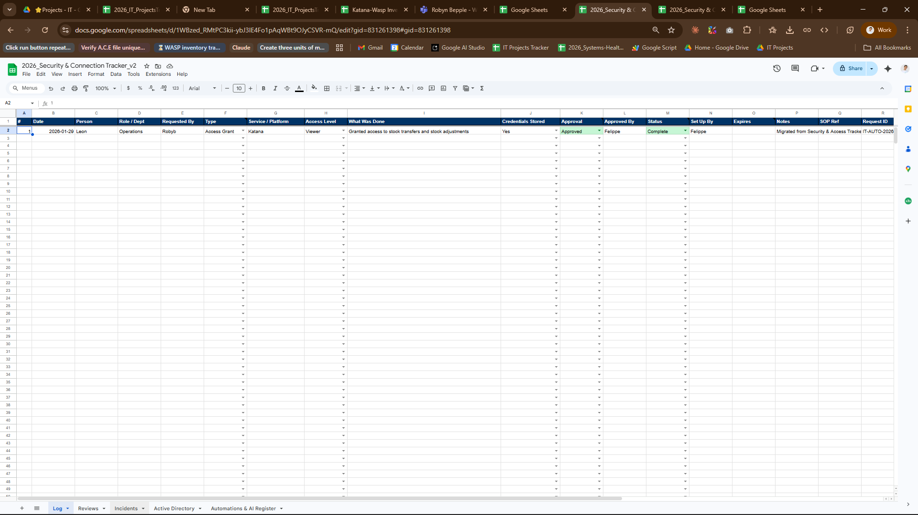

Attachment B - Review Queue Reference View
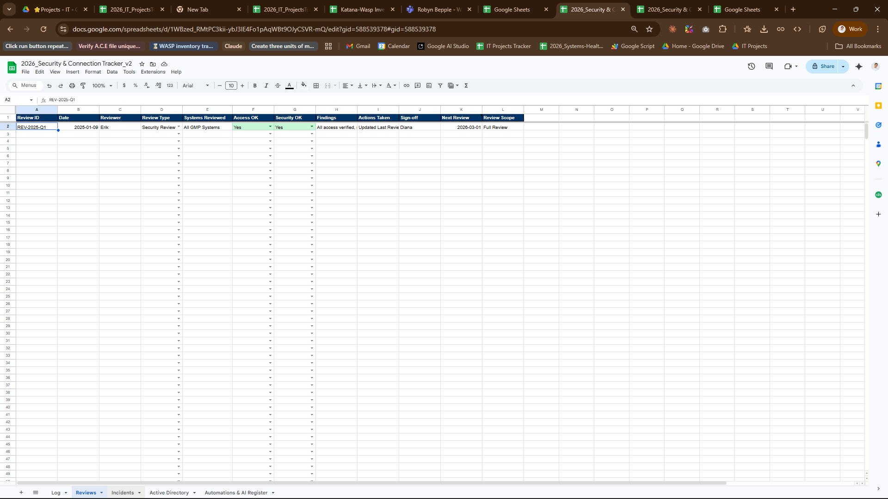

Attachment C - Incident Tracking Reference View
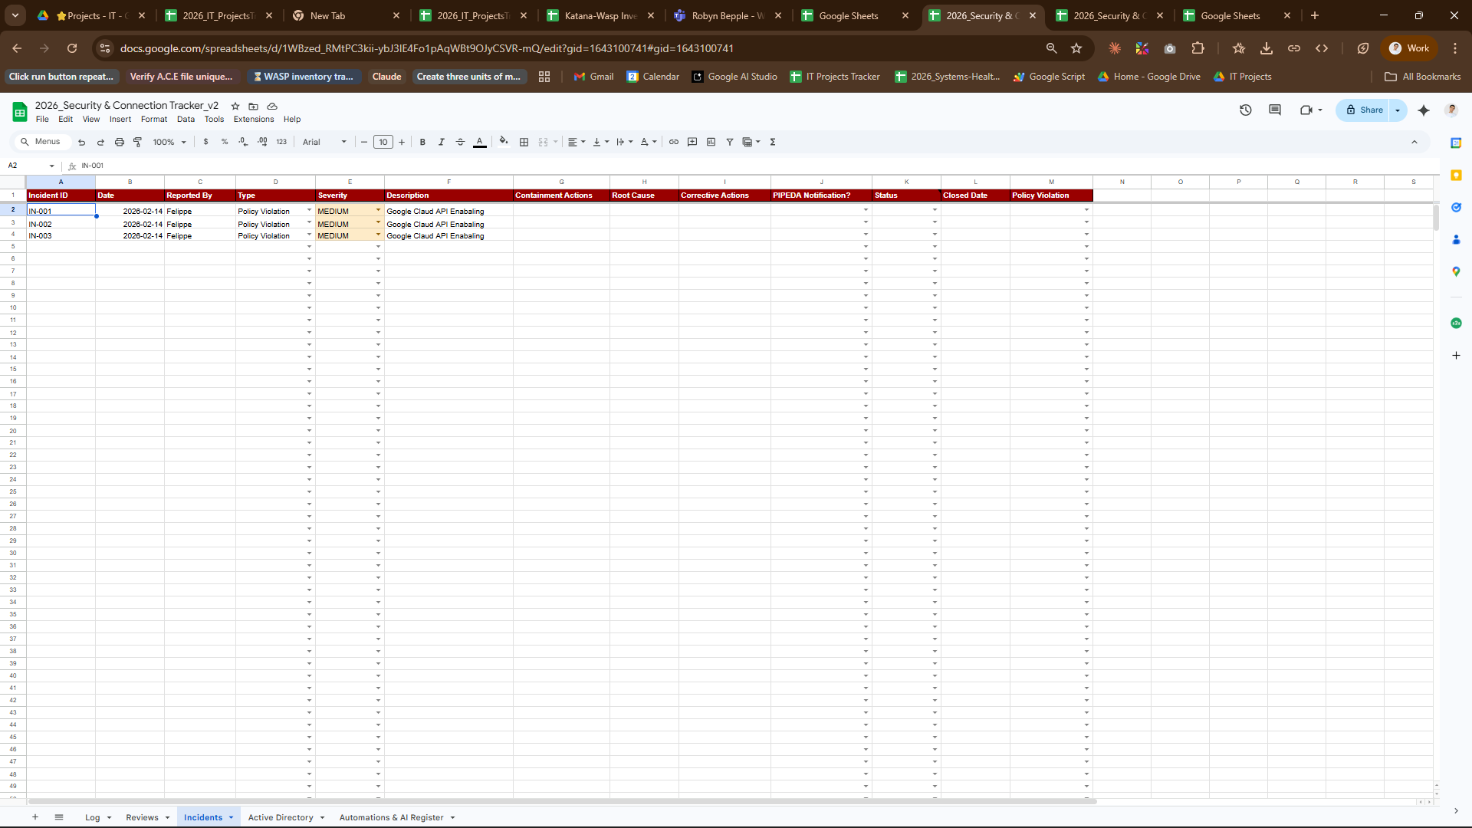

Attachment D - Current Access Directory Reference View
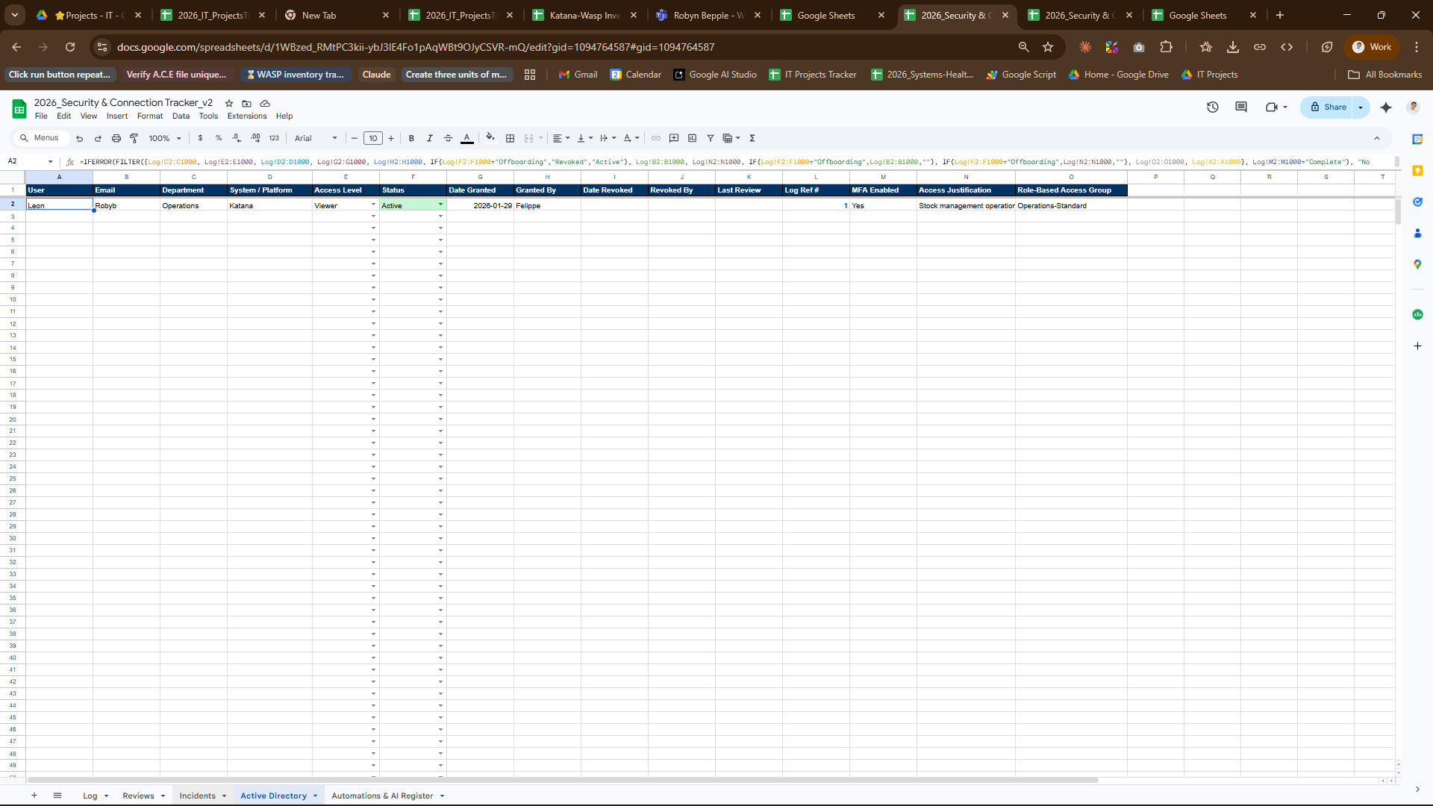

Attachment E - Automation Register Reference View
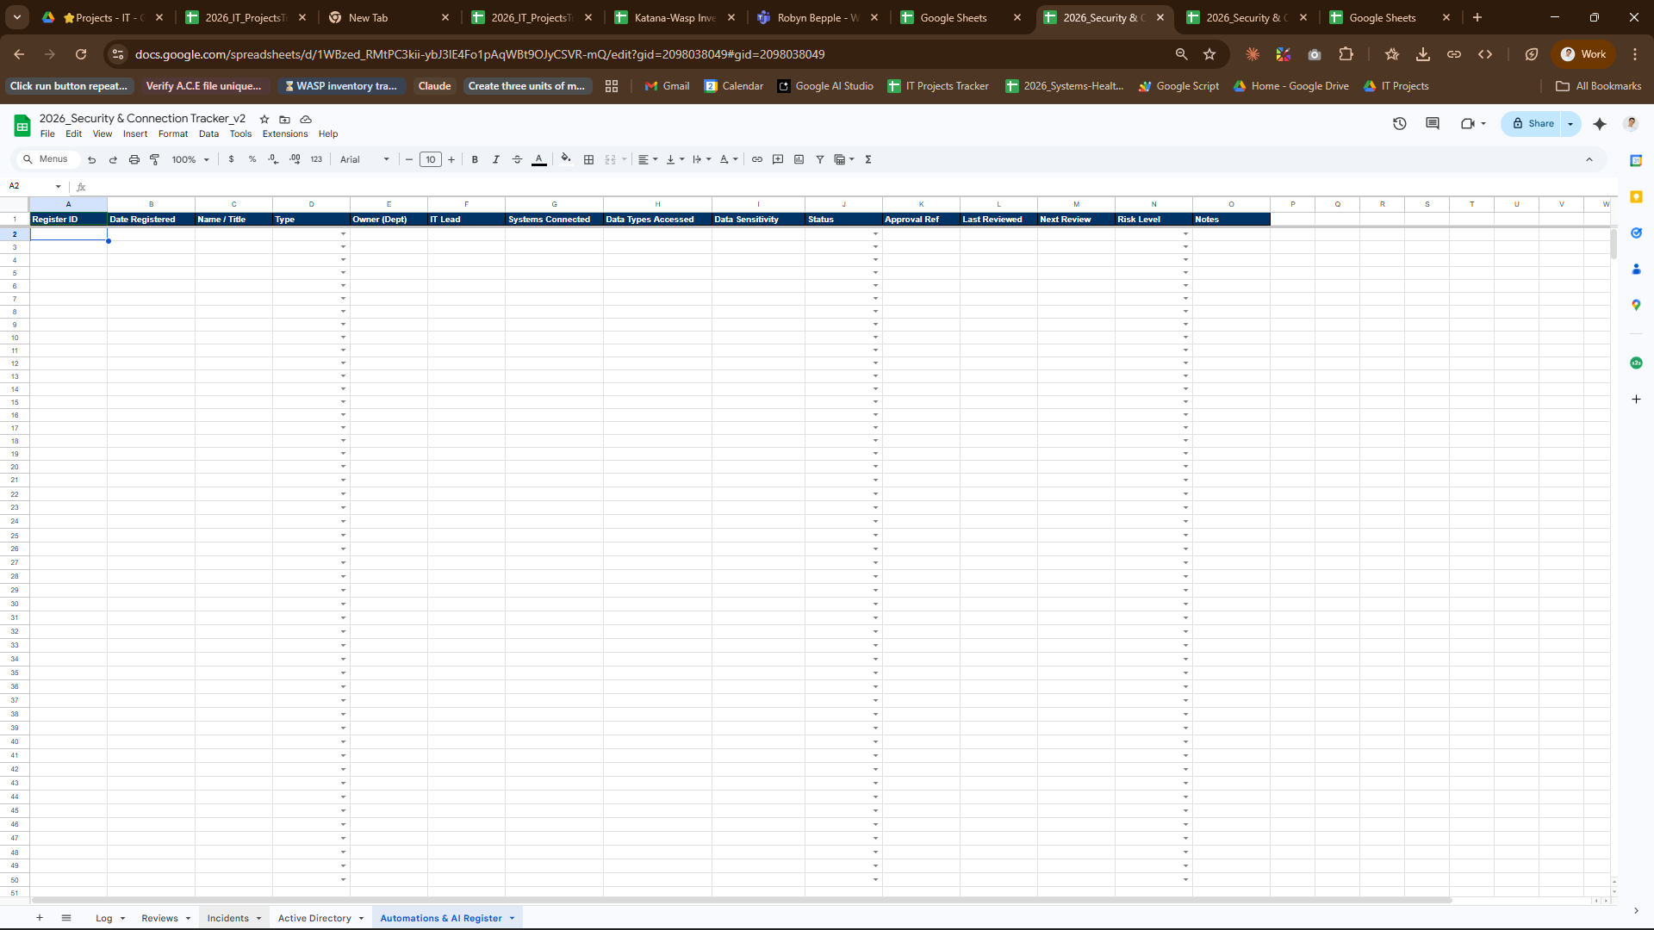

8. Revision History
Version | Effective Date | Description of Change | Change Control #
1.4 | March 6, 2026 | Removed Google Apps Script and function detail, added the live tracker link, and tightened the procedure flow for operations use. | Pending
1.3 | March 6, 2026 | Added embedded tracker screenshots to the formatted SOP attachments and aligned the document package to the corporate template format. | Pending
1.2 | March 6, 2026 | Reformatted SOP to the corporate template, simplified the operating flow, aligned content to Access Control, Review Checks, and Incidents, and documented the 120-day review cycle. | Pending
1.1 | March 6, 2026 | Updated SOP to the 3-tab workbook model and clarified presence versus activity tracking. | Pending
1.0 | January 30, 2026 | Initial release based on the earlier tracker layout. | n/a

