Café la Crème

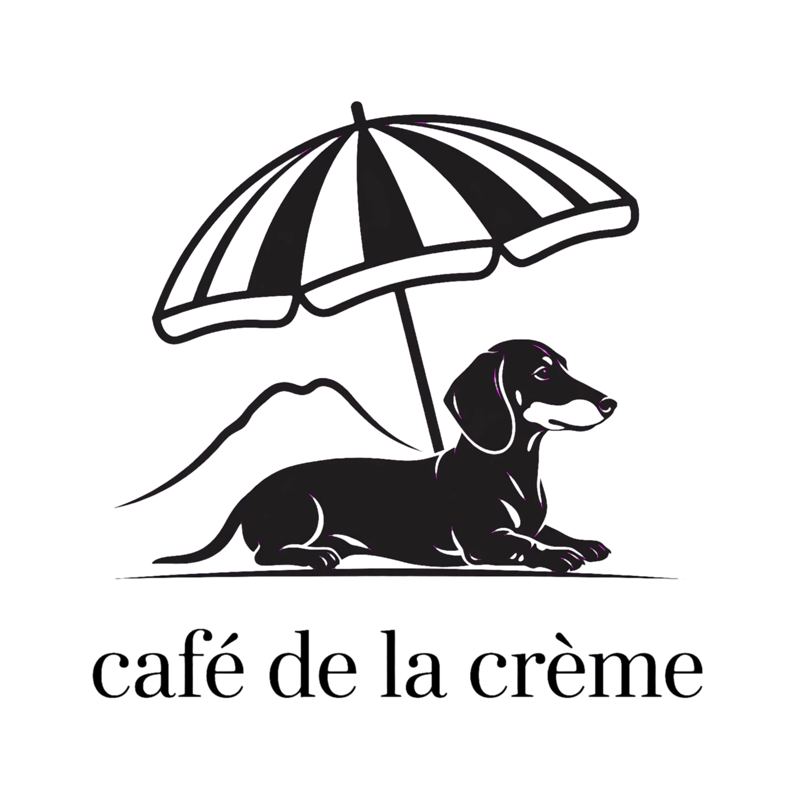
project 2

Café la Crème sounds elegant, classic, and highly indulgent. It immediately evokes a rich, upscale French bistro vibe and suggests a focus on high-quality coffee, creamy lattes, and premium pastries.
However, I started with Café la Crème (Cafe the Cream), and made no sense so to make it grammatically perfect in French, it should be Café de la Crème (Coffee of the Cream) or Café à la Crème (Coffee with Cream).
Here is how the variations stack up against each other:
Name Variation | Vibe & Perception | Grammatical Correctness
Café la Crème | Sounds rhythmic and chic to English speakers, but reads as slightly broken French ("Café the Cream"). | Informal / Stylised
Café de la Crème | Sounds highly sophisticated and exclusive. It plays on the famous phrase "crème de la crème" (the best of the best). | Correct
Café à la Crème | Sounds literal, cozy, and culinary. It translates directly to coffee served with cream. | Correct
💡 Tips if you use this name:
- Visual Identity: Pair it with a color palette of warm creams, soft beige, and gold accents.
- The Menu: Lean heavily into artisanal cream-topped drinks (like Viennese coffee or creamEinspänner) and French baked goods (croissants, éclairs).
To help you finalize the name, let me know:
- I am going for a modern minimalist look or a traditional French bistro aesthetic?

- Café de la Crème is a spectacular choice for Mount Maunganui's beach front. The name perfectly bridges classic French sophistication with an indulgent, beachside escape.
Blending a traditional French indoor bistro with modern, floral-forward coastal seating creates a striking, highly Instagrammable contrast. The rich timber, brass, and glass of an indoor espresso bar and food cabinet will flow beautifully into an outdoor terrace softened by vibrant floral over-arches, white-and-navy rattan chairs, and sweeping ocean views.
📍 The Perfect Coastal Paris Match
The boardwalk atmosphere along Marine Parade is ideal for this concept.
Map data ©2026 GoogleTerms
500 m
☕ Elevating the Concept for The Mount
To successfully anchor a French bistro aesthetic right on New Zealand's premier surf beach, consider these styling and operational harmonies:
- The Material Bridge: Inside, use traditional dark timbers, zinc or marble countertops, and a glass-enclosed pastry cabinet packed with almond croissants and mille-feuille. Outside, transition to modern French coastal decor—think white-washed wood, lightweight linen umbrellas, and lush, sun-tolerant floral arches (like bougainvillaea or white wisteria) that can handle the coastal breeze.
- The "Crème" Specialty: Lean hard into your name. Make a signature line of iced cream-topped coffees (like Viennese or Einspänner coffee) and decadent milkshakes. They will be massive hits for beachgoers walking off the hot sand.
- The Cabinet Balance: Mount Maunganui crowds love fresh, grab-and-go options. Balance classic French savory tarts, quiches, and croque monsieurs with fresh, Kiwi-friendly salads and baguettes that people can easily take across the road to the beach.
Would you like to brainstorm ideas for the logo and branding style (such as font choices or exact color codes), or should we look at creating a signature menu item list that blends French pastry with beachside vibes?

Café la Crème sounds elegant, classic, and highly indulgent. It immediately evokes a rich, upscale French bistro vibe and suggests a focus on high-quality coffee, creamy lattes, and premium pastries.
However, to make it grammatically perfect in French, it should be Café de la Crème (Coffee of the Cream) or Café à la Crème (Coffee with Cream).
Here is how the variations stack up against each other:
Name Variation | Vibe & Perception | Grammatical Correctness
Café la Crème | Sounds rhythmic and chic to English speakers, but reads as slightly broken French ("Café the Cream"). | Informal / Stylised
Café de la Crème | Sounds highly sophisticated and exclusive. It plays on the famous phrase "crème de la crème" (the best of the best). | Correct
Café à la Crème | Sounds literal, cozy, and culinary. It translates directly to coffee served with cream. | Correct

- Visual Identity: Pair it with a colour palette of warm creams, soft beige, and gold accents.
- The Menu: Lean heavily into artisanal cream-topped drinks (like Viennese coffee or cream Einspänner) and French baked goods (croissants, éclairs).

Cafe de la Creme, in the traditional French bistro outlook, ie bar and food cabinet, outside in a modern French decor seating with floral over arches, but set on the main beach of Mount Maunganui.
Café de la Crème is a spectacular choice for Mount Maunganui's main beach front. The name perfectly bridges classic French sophistication with an indulgent, beachside escape.
Blending a traditional French indoor bistro with modern, floral-forward coastal seating creates a striking, highly Instagrammable contrast. The rich timber, brass, and glass of an indoor espresso bar and food cabinet will flow beautifully into an outdoor terrace softened by vibrant floral over-arches, white-and-navy rattan chairs, and sweeping ocean views.
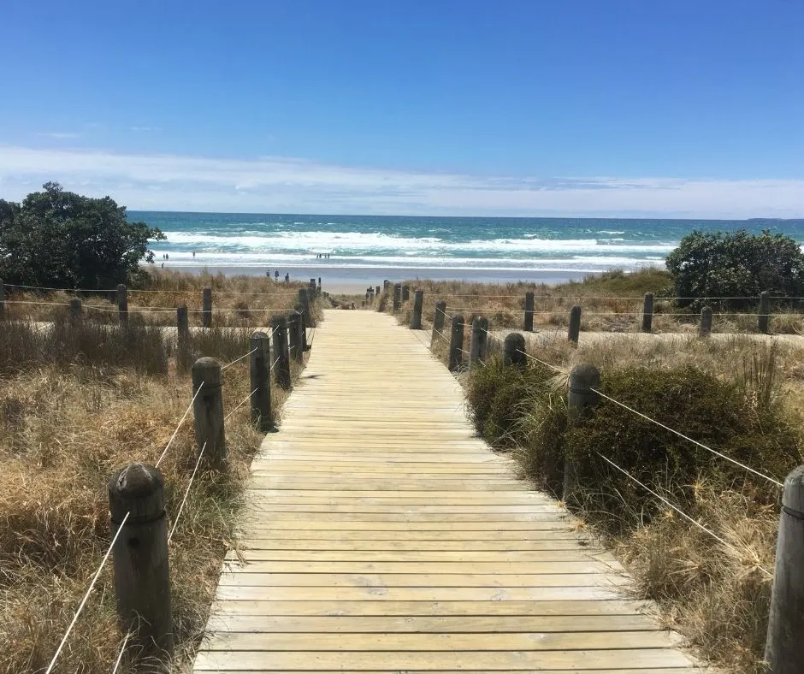
📍 The Perfect Coastal Paris Match
The boardwalk atmosphere along Marine Parade is ideal for this concept.
☕ Elevating the Concept for The Mount
To successfully anchor a French bistro aesthetic right on New Zealand's premier surf beach, consider these styling and operational harmonies:
- The Material Bridge: Inside, use traditional dark timbers, zinc or marble countertops, and a glass-enclosed pastry cabinet packed with almond croissants and mille-feuille. Outside, transition to modern French coastal decor—think white-washed wood, lightweight linen umbrellas, and lush, sun-tolerant floral arches (like bougainvillaea or white wisteria) that can handle the coastal breeze.

- The "Crème" Specialty: Lean hard into your name. Make a signature line of iced cream-topped coffees (like Viennese or Einspänner coffee) and decadent milkshakes. They will be massive hits for beachgoers walking off the hot sand.

- The Cabinet Balance: Mount Maunganui crowds love fresh, grab-and-go options. Balance classic French savory tarts, quiches, and croque monsieurs with fresh, Kiwi-friendly salads and baguettes that people can easily take across the road to the beach.
🥪 The Menu Blueprint: French Crust Meets Beachside Comfort
Cabinet "Club" Baguette Bites
Instead of soft, triangular club sandwiches, offer miniature, pre-cut baguette rounds or "mini batons." They look incredibly chic in a cabinet and are perfect for beachgoers to grab and share.
- The Parisian Club: Shaved ham, Gruyère cheese, salted French butter, and dijon mustard.
- The Mount Coastal: Smoked salmon, herbed cream cheese, capers, and fresh dill in a seeded baguette.
- The Garden Vine: Roasted heirloom tomatoes, fresh mozzarella, basil pesto, and a balsamic glaze.
The "Bistro" Cooked Breakfast
Elevate the standard Kiwi big breakfast by swapping out toast for decadent French pastries.
- The Grand Croissant Benny: A sliced, toasted croissant topped with crispy bacon, poached eggs, and a rich, velvety hollandaise sauce.
- Baguette Breakfast Board: A toasted baguette split open, served with scrambled eggs, local artisan sausages, blistered vine tomatoes, and French butter on a wooden board.
- The Sweet Escape: French toast made using thick slices of brioche or baguette, topped with berry compote and vanilla bean crème fraîche.
🧒 Kids' Playful Bistro Menu
- The "Le Dog": A premium frankfurter tucked inside a soft, toasted mini-baguette, topped with mild French mustard, sweet pickle relish, and optional melted cheese.
- Little Crêpe Roll-Ups: Simple, rolled-up crêpes with Nutella or maple syrup, cut into fun bite-sized wheels.

☕ The Drinks: Heavy on the "Crème"
Your drink menu can perfectly balance traditional Kiwi coffee culture with your signature French theme.
Drink Style | The French "Crème" Twist | The Kiwi Standard
Hot Coffee | Café au Lait (Served in a classic wide porcelain bowl) | Flat White, Latte, Cappuccino (Using premium local beans)
Signature Iced | The Crème Einspänner (Iced long black topped with a thick layer of heavy, sweetened vanilla cream) | Standard Iced Latte & Iced Americano
Sweet Treats | Chocolat Chaud (Thick, decadent Parisian-style melted hot chocolate) | Fluffy for the kids with a dusting of chocolate

To make Café de la Crème a truly inclusive staple at Mount Maunganui, integrating robust dietary safety and year-round coastal comfort is a fantastic move.
By having a dedicated celiac preparation station and a dog-friendly, weatherproof outdoor space, you capture two of the largest and most loyal demographics in the Bay of Plenty.
🌾 Coeliac & Diabetic-Friendly Bistro Menu
To ensure 100% safety for celiacs, the kitchen design will feature a dedicated gluten-free zone with its own hotplate, cutting boards, knives, and a separate toaster/fryer to completely eliminate cross-contamination.
Celiac-Safe & Diabetic-Friendly (Low GI / Sugar-Free) Options
- The Beachside Galette (GF / Low GI): A traditional savory French crêpe made from 100% buckwheat flour (naturally gluten-free and low-glycemic index). Filled with smoked chicken, spinach, and goat’s cheese.

- The Keto/Diabetic Croque "Bowl" (GF / Sugar-Free): A crustless, baked egg-and-cream custard bowl loaded with shaved ham, Gruyère cheese, and fresh nutmeg, served with a crisp side salad.

- The Mount Breakfast Skillet (GF): Chorizo, halloumi, spinach, and poached eggs cooked on the dedicated GF hotplate, served with a toasted gluten-free baguette slice.

- The "Crème" Diabetic Shake: A blended iced coffee or vanilla shake made with unsweetened almond milk, heavy cream, and a natural sugar substitute (like erythritol or stevia).

🐾 The French "Chien" & Winter Comfort Experience
Mount Maunganui's main beach promenade gets beautiful winter sun but crisp, biting offshore winds. Transforming your floral terrace into a cozy winter haven will keep your outdoor seats full year-round.
Dog-Friendly Elements
- The "Toutou" Refresh Station: An aesthetic, brass water fountain or marble bowls at the entrance of the floral archway for dogs to hydrate.
- Puppuccino à la Crème: A tiny espresso cup filled with lactose-free whipped cream, topped with a dehydrated liver treat.
- Leash Anchors: Beautifully integrated brass rings on the modern French outdoor tables so owners can secure their dogs hands-free.
- Dog beds: and comfits to make their stay as welcome as any.
Winter Coziness
- Plush "Bistro" Blankets: A basket of rolled, cream-colored wool or fleece blankets placed near the door for guests to wrap around their legs.
- Overhead & Table Heaters: Sleek, flush-mounted infrared heaters hidden inside the floral arches, paired with gas pyramid heaters to mimic an ambient Parisian street terrace at dusk.
- Winter Warmer Menu Addition: Greet outdoor winter guests with a complimentary mini shot of the thick Parisian Chocolat Chaud or a warm spiced berry coulis.

🍳 1. Back of House: The Kitchen Layout
- The Divider Wall / Air Gap: Place the standard cook line (grill, ovens, bakery prep) on the far-left side of the kitchen. Place the Dedicated Celiac Zone on the far-right side. Use the dishwashing station or a physical partition wall in the middle as a neutral buffer zone to block drifting flour dust.
- The Dedicated Celiac Zone: This self-contained pod must contain:
  - An exclusive electric hotplate (strictly no standard bread or gluten allowed on it).
  - A dedicated GF commercial toaster for gluten-free baguette slices.
  - Bright purple or green colour-coded tools (knives, tongs, cutting boards) stored in a sealed container when not in use.
  - Under-counter refrigeration exclusively for GF ingredients (GF bread, gluten-free crepes, separate blocks of cheese, and fresh fillings).
🛎️ 2. The Pass (The Connection Point)
The "Pass" is the benchtop where the kitchen hands the food over to the front-of-house staff.
- The Double-Sided Pass: Split the pass into two physical zones. Standard plates go to the left.
- The Celiac Safe-Zone: All celiac orders go to the far right. Use brightly coloured plates or a custom bamboo flag ("Coeliac-Safe") on the dish so front-of-house staff instantly know it requires clean hands and isolated handling.
🥐 3. Front of House: The Serving Bench Layout
The front counter needs to look beautiful and Parisian, while remaining highly functional for beach crowds. Arrange it from left to right to match the natural customer flow:
- Station 1: Point of Sale (POS) & Ordering (Far Left)
  - Guests line up, look at the menu, and order.
  - The POS terminal is clearly marked with prompts to ask guests about allergies before sending tickets to the kitchen.
- Station 2: The Glass Display Cabinet (Centre)
  - A stunning, chilled, brass-rimmed glass cabinet.
  - Top/Middle Shelves: Your signature Baguette Bites, croissants, and club halves.
  - Bottom Sealed Shelf: A dedicated, enclosed section for gluten-free and low-GI/diabetic baked goods to ensure crumbs from the standard pastries above cannot fall into them.
- Station 3: Espresso Bar & The "Crème" Station (Right)
  - The coffee machine face-on to the customers so they can see the barista craft.
  - A separate, small under-bench fridge here holds the specialized dairy, heavy creams for the Einspänner tops, and alternative milks to prevent cross-contamination during rush hour.

To accommodate a 100% celiac-safe prep zone alongside a high-volume beachside baguette operation, the kitchen layout needs strict spatial division. The biggest risk for celiacs is airborne flour dust and shared contact surfaces, so the gluten-free (GF) station must be completely isolated from the standard bread assembly area.
Here is a conceptual floor plan and serving bench layout designed for a seamless, cross-contamination-free workflow.
That blend of concepts is incredibly unique and full of character. Mixing the long, low silhouette of a dachshund with the iconic, dramatic outline of Mauao (Mount Maunganui), wrapped in a chic French minimalist aesthetic, creates an unforgettable visual identity.
To keep it simple, clean, and elevated, a fine line-art style is your best direction. It feels instantly high-end, uncluttered, and translates beautifully onto everything from coffee cups to linen uniforms.
Here are a few ways to merge the beach, the dog, and the French vibe into a single, cohesive logo concept:
📐 1. The Continuous Line Concept (The Ultimate Minimalist)
- The Design: A single, unbroken fluid line that mimics the cresting wave or the profile of Mount Maunganui, which seamlessly transitions directly into the long, elegant back and snout of a dachshund.
- The French Twist: The dog is wearing a tiny, subtly tilted French beret.
- The Layout: A delicate, fine-line circle framing the illustration, with Café de la Crème written underneath in a classic, spaced-out French serif font (like Didot or Bodoni).
🕶️ 2. The Sun Lounger Concept (Playful & Chic)
- The Design: A sleek, minimal dachshund silhouette lounging under a classic striped beach umbrella right on the shoreline, with the soft outline of the Mount rising in the background.
- The French Twist: The beach umbrella uses classic cream and navy Breton stripes, channeling the French Riviera.
- The Layout: Clean, geometric alignment. It is modern, uncluttered, and feels like a luxury resort logo, but with a whimsical, dog-loving heart.
☕ 3. The "Bistro Table" Emblem
- The Design: A dachshund sitting perfectly upright on a Parisian bistro chair, peaking up at a cup of coffee sitting on a marble table.
- The Beach Twist: Through a simple, arched line behind the chair (alluding to your floral arches), you see the sun setting over the Mount Maunganui horizon line.
- The Layout: A classic circular stamp or emblem layout, perfect for stamping onto takeaway brown paper bags and stickers.

🎨 The Aesthetic Colour Palette
To tie the beach and the French bistro look together, the brand colours should lean into natural, premium tones:
- Primary Accent: Rich Navy Blue or Deep Forest Green (French coastal elegance).
- The Base: Cream / Warm Alabaster (representing the sand and your namesake, la crème).
- The Metal: Polished Gold or Brass accents (for signage, menu brackets, and lighting).

