====================
REVIEWER COMMENTS
====================
Review #0
Overall Rating: Fair
Assessment and Summary: This is a new proposal that plans on using metadynamics simulations to study the binding of small molecule inhibitors to polo-kinase 1 (PLK1) which has an important role in the cell cycle and overexpression has been associated with numerous types of cancer. The binding free energy profiles and conformational properties will be evaluated to identify specific and selective inhibitors with the goal of designing anticancer drugs. Complementary experimental studies, in their lab, will also be conducted to measure ligand strength and structural changes. Their previous ACCESS Discover and Accelerate allocations resulted in two manuscripts that are under peer-review in ACS journals. The work is funded by an NIH grant and involves a strong mentoring program with deaf and hard-of-hearing students. The proposed studies involve studies of 150 ligand molecules with a subset, 46, of those were identified as plausible inhibitors and their binding evaluated experimentally.
Comment: It is not clear to this reviewer that all 150 simulations are necessary to obtain the insights needed for their binding affinity evaluations and ligand design.
Response: We appreciate the reviewer's thoughtful inquiry regarding the necessity of simulating all 150 candidate molecules. Although not all 150 simulations may be essential for initial insights into binding affinity and ligand design, a comprehensive exploration provides several key advantages. Simulating a larger pool of candidates allows us to identify a broader range of potential inhibitors with diverse binding modes and potencies. This increases the likelihood of discovering truly promising leads for further development. While we may have initial hypotheses about favorable binding interactions, simulations can reveal unforeseen binding modes or functionalities that could be advantageous. A broader exploration allows for serendipitous discoveries that might not be predicted by traditional methods of trimming down potential molecules as the screening proceeds. By simulating a larger library of molecules, we create a valuable resource for future research. Should the initial leads pan out, or if the research focus shifts, this data can be readily repurposed to identify alternative inhibitors within the same chemical space. To address concerns about computational efficiency, we propose a two-phased approach:
- Phase 1: Prioritization and Initial Screening: We will utilize filtering techniques (e.g., docking scores, physicochemical properties, ADMET) and potentially a smaller subset of initial simulations to prioritize the most promising candidates.
- Phase 2: In-Depth Analysis with Classical MD and Metadynamics: Based on the results of Phase 1, we will focus the more resource-intensive cMD and Metadynamics simulations on a select group of high-priority candidates (around 100-150 molecules). This will allow for a deeper exploration of their binding mechanisms and optimization for further development.
This two-phased approach strikes a balance between comprehensiveness and computational efficiency. It allows us to explore a diverse set of candidate molecules while ensuring we dedicate the most intensive computational resources to the most promising leads from various databases.
Comment: The calculations will use the AMBER program with the FF14SB/GAFF force field but use of NAMD is also mentioned for their MD simulations and as a backup. It is discussed that if the results do not match the experimental results the ligand parameters will be tweaked by comparing with the CGENFF. It also isn't clear if this is how NAMD will be used as a "backup" and if the calculations would be rerun with the CHARMM force field with CGENFF or if the GAFF parameters would be modified using the CGENFF parameters.
Response: We appreciate the reviewer's keen observation. Our primary computational tool for this study is AMBER, specifically the GPU-enabled AMBER20 with the FF14SB (switching to FF19SB) force field for the protein and GAFF for the ligand. NAMD was initially considered as a potential alternative, but it is now excluded from the current protocol due to the computational efficiency and robustness of AMBER for our specific objectives. The mention of CGENFF was included as a potential contingency plan for ligand parameterization if initial simulations with GAFF yielded unsatisfactory results. However, based on our previous experience and the success of GAFF in similar studies, we are optimistic that GAFF will be sufficient for our ligand models.
Comment: The SUs requested for all the calculations are based on 1 GPU on Anvil, no scaling studies are provided. The system size is small, less than 100K atoms, and is not clear how the calculations would scale on CPU vs GPU resources. This reviewer recommends a provisional allocation to allow work to begin. The following webinar on preparing scaling studies is recommended, https://allocations.access-ci.org/prepare-requests
Response: Thank you for your valuable feedback. We appreciate the provisional allocation. We acknowledge the limitation of our initial resource request based solely on single GPU usage, plus the importance of demonstrating scalability for our simulations and addressing the efficiency of CPU versus GPU resources. While the individual protein-ligand complexes may be less than 100,000 atoms, the total number of simulations we intend to perform (150 complexes for PLK1) translates to a significantly larger cumulative system size. With sister protein structures PLK2 and PLK3 simulation for selectivity prediction, we will require a maximum credit unit to achieve our goal. This emphasizes the need for substantial computational resources, especially considering the required 200 ns production run per replicate for adequate sampling.
Our scaling study of CPU vs. GPU resources to benchmark simulations on both nodes (1 node) of Delta using the same system size and simulation parameters shows that GPU is efficient for our proposed study (Figure 1). The simulation time stamps are 0.7, 1, 1.3, and 1.6 ns with respective numbers of atoms 51619, 60223, 69448, and 79663 on a single node with 2 GPUs/CPUs microprocessors. We have limited the MD run to a few nanoseconds to avoid restarting the simulations severally after exceeding the maximum wall time (48 hours) for standard jobs on the Delta NCSA computing resource. The GPU and CPU wall clock times scale linearly as the number of atoms increases. The CPU will not be efficient for our simulations because it will demand massive wall time. The required wall times to simulate 69448 atoms for 1.3 ns on CPU and GPU are 43 hours and 0.08 hours, respectively.
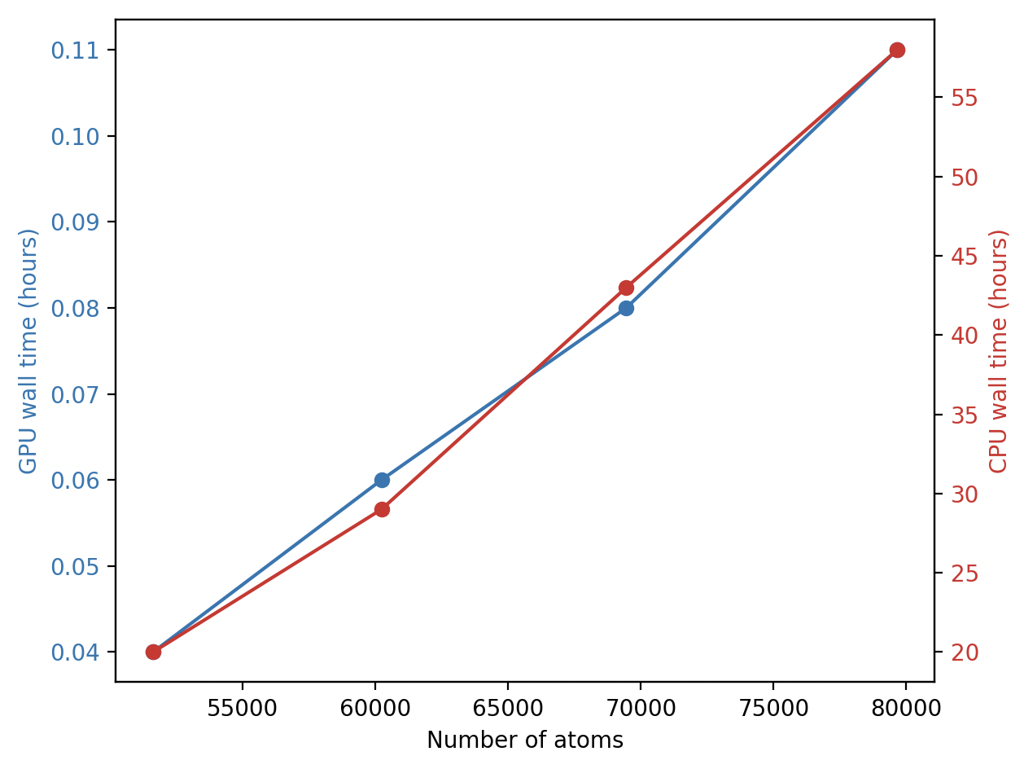
Figure 1: Comparison of GPU (blue, axis y1) and CPU (red, axis y2) wall clock time for molecular dynamics simulations as a function of system size. AMBER MD simulations on CPU versus GPU for PLK1 bound inhibitor #3 with 3682 solute atoms and varying water box sizes 6, 8, 10, and 12 yielding respective numbers of atoms 51619, 60223, 69448, and 79663.
Comment: Appropriateness of Methodology: The use of all-atom metadynamics simulations is appropriate for the studies planned Appropriateness of Plan for Resource Use: The appropriateness of the plan for resources is difficult to determine because of the missing scaling studies.
Response: We have performed a scaling study to assess the performance of MD simulations on Delta with 1 to 4 GPUs on a single node of NVIDIA A100-SXM4-40GB. Jobs remained in the queue for days after selecting 2 Nodes, so we killed this trial. Although we specified up to 8 GPUs during AMBER installation/configuration, attempts to run these test simulations on 5 to 8 GPUs failed because the facility did not support the task. While speculating this failure as an effect of self-installing AMBER22 GPU on the Delta NCSA, our trail shows that 5 to 8 GPUs are also not supported on Anvil Purdue with admin-installed AMBER20.
Figure 2 displays the scaling behavior of the MetaD simulation as the number of atoms increases. Both simulation time and GPU memory usage grow linearly with the number of atoms. This implies that the simulation's computational cost and memory requirements increase proportionally to the system size. Larger systems (more atoms) require longer simulation times with more GPU memory demand. The relationship between system size, simulation time, and memory usage is almost linear.
Table 1 shows the detailed code performance and scaling for ligand-coupled PLK1-PBD metadynamics simulation. As the number of atoms increases, GPU memory usage and MetaD wall time increase. This is expected as larger systems require more computational resources. The number of GPUs used generally increases with simulation time, suggesting that longer simulations benefit from more computational power. Also, GPU memory usage projects linearly with the number of atoms, indicating efficient memory utilization.
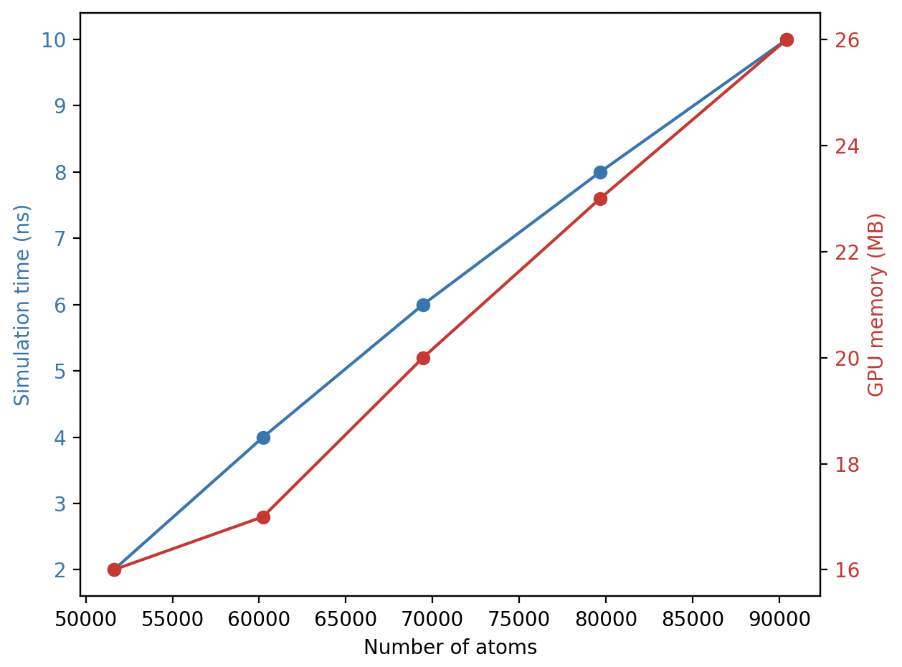
Figure 2: MetaD simulation scaling of PLK1-PBD on GPU-enabled AMBER showing simulation time (blue, axis y1) and GPU memory usage (red, axis y2) versus total atoms in the system.
Table 1: Effect of system size and number of GPUs on MetaD simulation time and memory usage on Delta NCSA.
Simulation time (ns) | Number of atoms | GPU memory (MB) | MetaD wall time (hours) | GPUs
2 | 51619 | 16 | 0.22 | 1
4 | 60223 | 17 | 0.5 | 2
6 | 69448 | 20 | 1.83 | 3
8 | 79663 | 23 | 2.03 | 4
10 | 90424 | 26 | 3.17 | 4
10 | 102280 | 29 | 5.41 | 3

Comment: Efficient Use of Resources: No scaling studies are provided as discussed above and as such it is difficult to evaluate the efficiency of use of resources requested for these calculations
Response: We acknowledge the reviewer's point about the absence of scaling studies. While we have not included comprehensive scaling data in the previous submission, preliminary results from our test simulations suggest promising scaling behavior on GPU architectures. Due to the queuing time when using 3 or 4 GPUs, we simulated a single system (69448 atoms) at varying time scales and GPUs. The test study also includes unified simulation time for the system (Table 2). At 2 ns only or increasing simulation time and GPUs, the wall time increases linearly, except with 3 GPUs. Although this scaling approach is inefficient, MetaD simulations with 1 GPU seem enough considering the required wall time for the test 2 ns simulation and queueing time on the facility. The code performance and scaling enabled us to select better than our initial proposal.
Table 2: Scaling of metadynamics of a single system at increasing simulation time and number of GPUs plus uniform simulation time.
No. of GPUs | Simulation time (ns) | Wall clock time (hours) | Simulation time (ns) | Wall clock time (hours)
 | Different simulation run |  | The same simulation run
1 | 2 | 0.26 | 2 | 0.26
2 | 4 | 0.61 | 2 | 0.30
3 | 6 | 1.95 | 2 | 0.64
4 | 8 | 1.66 | 2 | 0.42
Review #1
Overall Rating: Fair
Assessment and Summary: New proposal from a PI that has used ACCESS resources previously via discover and accelerate pathways. The main thrust of the proposal is to use metadynamics to characterize the binding free energy of small molecule drug candidates to the PLK1 kinase polo box domain and then carry out companion metadynamics simulations on the PLK2/3 isoforms to test for selectivity. The research plan is pretty straightforward, although there is little justification provided as to why metadynamics is chosen over other free energy methods typically used for small molecule binding energies (e.g. thermodynamic integration in AMBER). The critical flaw in the proposal is a lack of performance data in the code and performance document, which makes it impossible to properly evaluate the appropriateness of the quantity of this request.
Suggested provisional allocation with transfer to NCSA Delta GPU to accommodate the larger request. Reduction in allocation with the opportunity for an expanded award contingent upon:
Comment: 1) providing benchmarking data (code performance timing on a single GPU and scaled to a full node)
Response: Thank you for your feedback. We agree that benchmarking data is crucial for evaluating code performance. We have incorporated detailed performance measurements, including timings on a single GPU, and scaled to a full node, providing a comprehensive understanding of the code's scalability and efficiency.

Comment: 2) providing justification for the large number of ligands to be run on PLK1, 2, and 3) detailed storage request.
Response: We appreciate the reviewer's question regarding the number of ligands screened against PLK1. The decision to screen a large and diverse ligand library was driven by the critical need to identify novel chemotypes and explore a wide chemical space for potential inhibitors. Given the therapeutic importance of PLK1 and the challenges associated with developing selective inhibitors, we speculate that a comprehensive screening approach is essential to maximize the likelihood of discovering promising drug candidates.

Comment: Storage request was not provided.
Response: The generated data will primarily consist of ligand structures (in PDB or MOL2 format), docking scores, and potential binding poses. Based on the estimated number of ligands and simulations, we anticipate approximately 3-4 terabytes of data. The data will be stored in a compressed format on high-performance storage systems. Regular backups will be implemented to ensure data integrity and redundancy.

Comment: Appropriateness of Methodology: Somewhat appropriate. Metadynamics is one of many enhanced sampling techniques that can be used to characterize the free energy of binding of small molecules. However, the PI does not indicate if these studies will be to obtain relative binding free energies or absolute binding free energies -- the nature of the small molecule library to be tested was not well-described.
Response: Thank you for the constructive feedback. We have simulated an inhibitor (Thymoquinone, TQ) from the literature to benchmark our choice of advanced sampling approach with metadynamics/adaptively biased MD. By unbiasing the data, Figure 3 depicts the potential of mean force (PMF) of TQ-bound PLK-PBD at various binding sites (BS). Besides capturing the detailed energy landscape, we used data from the reconstructed PMF to estimate a rough absolute free energy of binding. Researchers have used the difference between the free energy of the bound and unbound state minima on the PMF profile to estimate the binding free energy of ligands to proteins (Buch et al., 2011). The adaptive biasing approach in AMBER has been implemented to compute free energy maps as a function of all free energy modules, including umbrella sampling. It accounts for independent “colvars” using the multiple-walker method (Moradi et al., 2015). While we hope to ensure accuracy, the reconstructed free energy of binding with the PMF depth approach is approximately relevant to the ligand binding affinity prediction. The large ligand library was carefully curated to represent a diverse chemical space, enabling the identification of potential PLK1 inhibitors with distinct structural features. Apart from the 46 compounds from Atomwise, we have obtained 50 potential PLK1-PBD inhibitors through a series of computational approaches from the SuperNatural (Gallo et al., 2023), 108 compounds from the Zinc Natural Product (Irwin et al., 2012), and another 50 natural compounds from the COCONUT database (Sorokina et al., 2021). The small molecule libraries have been assembled based on virtual screening, pharmacokinetic properties, ligand-based design, and commercial availability, ensuring a balanced representation of chemical diversity.

Comment: The PI needs to provide justification for why metadynamics is being chosen over other FE techniques such as TI (implemented in AMBER) or FEP, as metadynamics tends to be more computationally expensive than TI/FEP, with no guarantee that it will produce superior results.
Response: Thank you for the insightful comment. We appreciate the reviewer's suggestion to consider alternative free energy calculation methods. While TI and FEP are powerful techniques, metadynamics was chosen for this study due to several advantages. Metadynamics is well-suited for exploring complex free energy surfaces, such as those encountered in protein-ligand interactions. Although computationally demanding, metadynamics can often converge faster than TI or FEP, especially for systems with multiple energy minima. Metadynamics allows for studying a wide range of collective variables, enabling a more comprehensive exploration of the conformational space. We acknowledge the computational cost associated with metadynamics. However, we view that the benefits of sampling efficiency and the ability to capture complex free energy landscapes outweigh the additional computational expense in this specific case.
Figure 3: The average PMF profiles for TQ binding to PLK1-PBD at 300 ns by 4 replicas biasing for each binding pose (a) and energy comparison across the various computational approaches docking, MMGB/PBSA, and metadynamics (b). The binding scores correlate (R² = 0.9) with the MetaD free energies.
Comment: In addition, the PI states several times that fluorescence polarization experiments can be conducted in the PI's lab, but none of these references occur in the actual computational research plan. Please include additional discussion in the research plan how experiment will be used to validate the computational results.
Response: Please see the revised proposal for details about the experiment (page 11).

Comment: Appropriateness of Plan for Resource Use: Difficult to determine, since no benchmarking data was provided.
Response: Please see the code performance above.

Comment: The PI does a decent job of explaining how the metadynamics simulations will require 200 ns of production time per simulation. And the GPU implementation of AMBER on Anvil is an appropriate choice of resources.
Efficient Use of Resources: Unacceptable. The PI simply copied and pasted Table 2 -- a detailed resource request -- from the main document into the code performance and scaling document (there is only one table in the C&P document and the PI STILL named it Table 2). There is no performance or scaling data in this table.
Response: Kindly see the code performance and scaling under Reviewer #0 comments.

Comment: The only instance of code performance is in the resource request from the online proposal portal: "Using 2 GPUs per node, PLK1-PBD simulations with known inhibitors run at approximately 12.5 hours per 200 ns production on this infrastructure with the option to submit six jobs in a row."
Comment: 1. How can a reviewer know that Amber scales linearly across 2 GPUs instead of 1, 2, 3, or 4 GPUs per node on Anvil? The PI needs to provide a scaling plot showing performance of AMBER per GPU across 1, 2, 3, and 4 GPUs.
Response: Please see the code performance above and Figure 2.

Comment: 2. How can a reviewer estimate what an appropriate request is if the only number given is 12.5 hours across 2 GPUs for 200 ns? The PI needs to provide benchmarking data in ns/day/GPU.
Response: Kindly see the code performance above, thank you.

