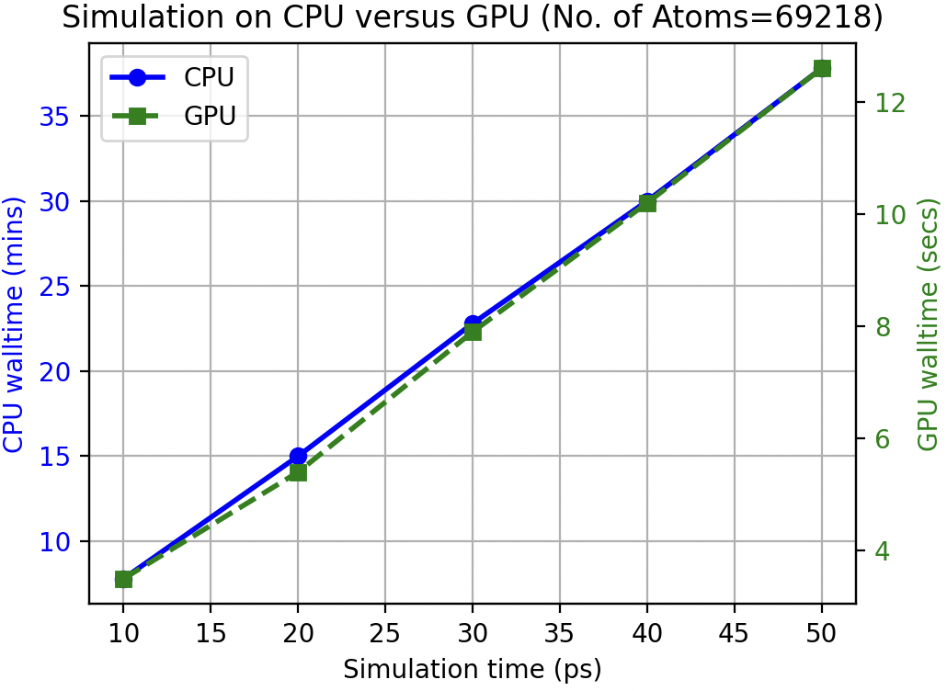
Figure 1: AMBER MD simulations on CPU versus GPU. This simulation uses the Supercomputer of the Drug Discovery Lab at Gallaudet University, courtesy of the president’s grant awarded to Prof. Tugba Kucukkal. The number of CPUs and GPUs used in both cases are the same (2 CPUs/GPUs per 1 node).

Summary: The CPU and GPU times increase linearly as the simulation time increases, suggesting that the computational cost scales linearly with the simulation duration. The GPU performs significantly faster than the CPU measured in minutes, the GPU finishes the same task in seconds, emphasizing its higher computational efficiency. This comparison shows that offloading calculations to a GPU can significantly reduce wall time for molecular dynamic simulations, making it a better choice for performance-intensive tasks.

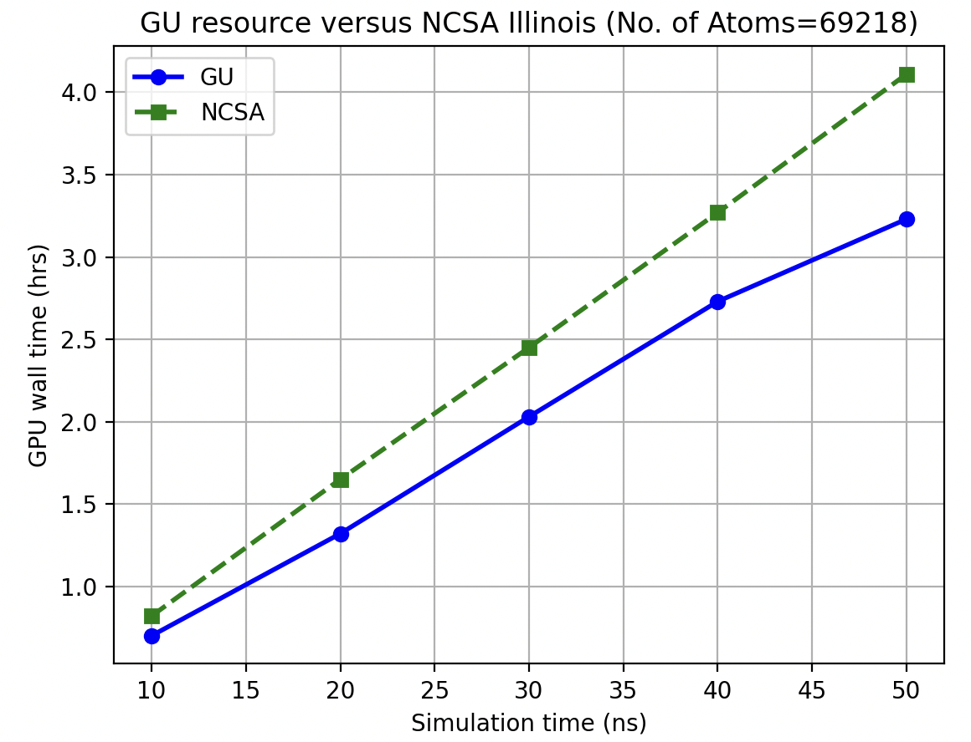
Figure 2: AMBER MD simulations on NCSA Illinois (https://operations.access-ci.org/node/593) and Gallaudet supercomputing facility. The resource specifications for running these simulations are the same on both facilities (1 GPU per 1 node).

Summary: The graph compares the GPU wall time for simulations using two different computational resources: GU (Gallaudet University) and NCSA Illinois (National Center for Supercomputing Applications) for a system containing 69218 atoms. Both resources show a linear increase in GPU wall time as the simulation time increases from 10 ns to 50 ns. The GPU resource at NCSA takes slightly longer for the same task than the GU resource, especially at higher simulation times. For example, at 50 ns, GU takes approximately one hour faster (3.23 hours) than NCSA, which completes the same task at 4.11 wall time hours. Both resources exhibit linear scaling, but GU provides better computational efficiency for this specific simulation task and most likely other AMBER MD simulations.

