Progress report for ACCESS resource BIO230137 (09/03/2024)
Topic: Free energy calculations of PLK1-ligand complexes using Molecular Dynamics with Advanced Sampling
Goal: The overarching goal of our study is to understand the detailed free energy surface during the binding of identified novel nonpeptide-based selective inhibitors for the polo-box domain (PBD) of polo-like kinase 1 (PLK1). Specifically, MetaD simulations will be performed for two sets of molecules. First, we will study the previously identified inhibitors with known experimental binding sites. Then, the newly identified possible PLK1-PBD molecules will be explored with metadynamics.
Summary: Polo-like kinase 1 (PLK1) is a critical regulator of cell division and a promising anticancer target. This study employs advanced molecular dynamics simulations to elucidate the binding mechanisms of potential inhibitors to the PLK1 polo-box domain (PBD). Through enhanced sampling techniques, we aim to identify novel binding sites and inhibitors and characterize the dynamic nature of ligand-protein interactions. This computational approach will provide valuable insights into the structure-activity relationships of PLK1 inhibitors, facilitating the discovery of potent and selective drug candidates.
Ligand selection: This research is multicomponent. The first part involves studying some selected existing PLK1-PBD inhibitors to understand the detailed binding profile of potential inhibitors to the protein (Figure 1) as a benchmark for subsequent novel molecule simulations.
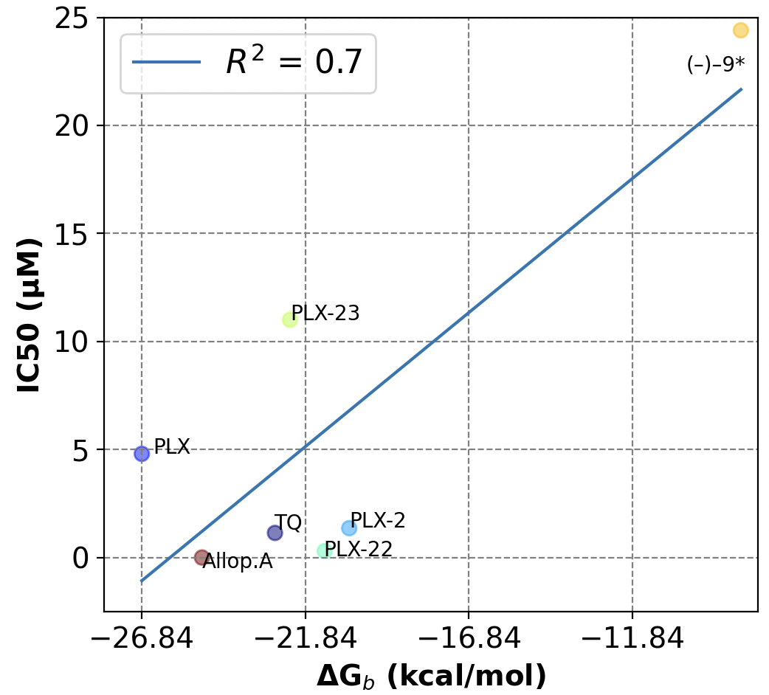
Figure 1. Correlating experimental IC₅₀ (in µM) values with ΔG_{bind} (in kcal/mol), including thymoquinone (TQ), poloxin (PLX), and Allopole-A (Allop.A).
Second, students screened the SuperNatural(Gallo et al., 2023) database using various protocols (Figure 2). Currently, students are exploring about 50 compounds from SuperNatural and writing their outcome titled “A Bilingual Computational Workflow for Identifying PLK1 Inhibitors: Integrating American Sign Language and English” as a video journal and full article for consideration in JoVE (https://www.jove.com/). They are also using Anvil for these simulations.
Third, another set of students identified potential inhibitors from the COCONUT(Sorokina et al., 2021) in a virtual screening through physicochemical properties trimming and docking analysis. The protocol identified 45 small natural compounds with promising affinity for the PLK1-PBD.
Metadynamics: With the provisional allocation, we have simulated potent existing inhibitors thymoquinone (TQ)(Reindl et al., 2008), poloxin(Scharow et al., 2015), poloxin-2, poloxin-22, poloxin-23(Scharow et al., 2015), (–)–9*, (+)–9*(Huggins et al., 2019), and allopole-A(Park et al., 2023) as a benchmark for our study. By unbiasing the data, Figure 3 depicts the potential of mean force (PMF) of TQ-bound PLK-PBD at various binding sites (BS). We employed metadynamics simulations to generate the Potential of Mean Force (PMF) profiles for multiple binding sites to characterize the binding landscape. While PMF depths provide insights into relative binding affinities, we estimate the absolute binding free energies for ligands at each binding pocket. Using a reference state, typically the unbound state, where the binding pocket distance expanded most (at 30 Å) in this analysis. The adaptive biasing approach within AMBER was instrumental in constructing these free energy maps, accommodating multiple degrees of freedom through independent collective variables and the multiple-walker method(Moradi et al., 2015). Besides capturing the detailed energy landscape, the estimated rough absolute free energy of binding is relevant to the research goal. Researchers have used the difference between the free energy of the bound and unbound state minima on the PMF profile to estimate the binding free energy of ligands to proteins(Buch et al., 2011). This resource will enable us to complete this project.
Figure 2: Computational identification of potential PLK1-PBD inhibitors with improved affinity and selectivity.
Figure 3: Experimentally identified binding sites (BS, 1 to 3) in PBD, top five pockets identified through blind docking revealed inhibitor binding to five possible pockets, including the active site, phospho-peptide pocket (a), the free energy profiles constructed from center of mass (CoM) distance between opposite binding residues of PLK1-PBD binding to allopole-A (b), –(–)9* (c), –(+)9* (d), poloxin (e), poloxin-2 (f), thymoquinone (g), and comparison across the various computational approaches for TQ (h). The binding scores correlate (R² = 0.9) with the MetaD binding energies.

