Progress report for ACCESS resource BIO240026 (07/29/2024)
Topic: Molecular Dynamics Simulations with Advanced Sampling to Identify Novel PLK1 Inhibitors
Goal: The overarching goal of our study is to understand the detailed free energy surface during the binding of identified novel nonpeptide-based selective inhibitors for the polo-box domain (PBD) of polo-like kinase 1 (PLK1). Specifically, MetaD simulations will be performed for two sets of molecules. First, we will study the previously identified inhibitors with known experimental binding sites. Then, the newly identified possible PLK1-PBD molecules will be explored with metadynamics.
Summary: Polo-like kinase 1 (PLK1) is a critical regulator of cell division and a promising anticancer target. This study employs advanced molecular dynamics simulations to elucidate the binding mechanisms of potential inhibitors to the PLK1 polo-box domain (PBD). Through enhanced sampling techniques, we aim to identify novel binding sites and inhibitors and characterize the dynamic nature of ligand-protein interactions. This computational approach will provide valuable insights into the structure-activity relationships of PLK1 inhibitors, facilitating the discovery of potent and selective drug candidates.
Ligand selection: This research is multicomponent. The first part involves calculating the electronic properties of small molecules identified as potential PLK1-PBD inhibitors by an Atomwise^{1,2} scientist who screened a molecular library of several million compounds using AtomNet®, its proprietary technology. We have screened these compounds' physicochemical, medicinal chemistry, and ADMET properties to predict their implications as drug candidates and potential as PLK1-PBD inhibitors. Stability represents a critical part of the pharmacokinetic properties, ADMET/S—absorption, distribution, metabolism, excretion, toxicity, and stability. Our team performed optimization with DFT (B3LYP^{3,4}) and the Def2-TZVP⁵ basis set within the ORCA package⁶ to estimate the molecular stability of these potential drug candidates. The calculations use DARWIN infrastructure accessible through the MED230016 allocation. The study entails calculating the difference between the highest occupied molecular orbital (HOMO) and the lowest unoccupied molecular orbital (LUMO) of the fully optimized structures to derive the band gap as a chemical stability index. The detailed outcome of this study is under revision (ID: ed-2024-00082y) as a potential article in the Journal of Chemical Education (ACS). Figure 1 shows HOMO, LUMO, and band gap energies (in eV) of these compounds.
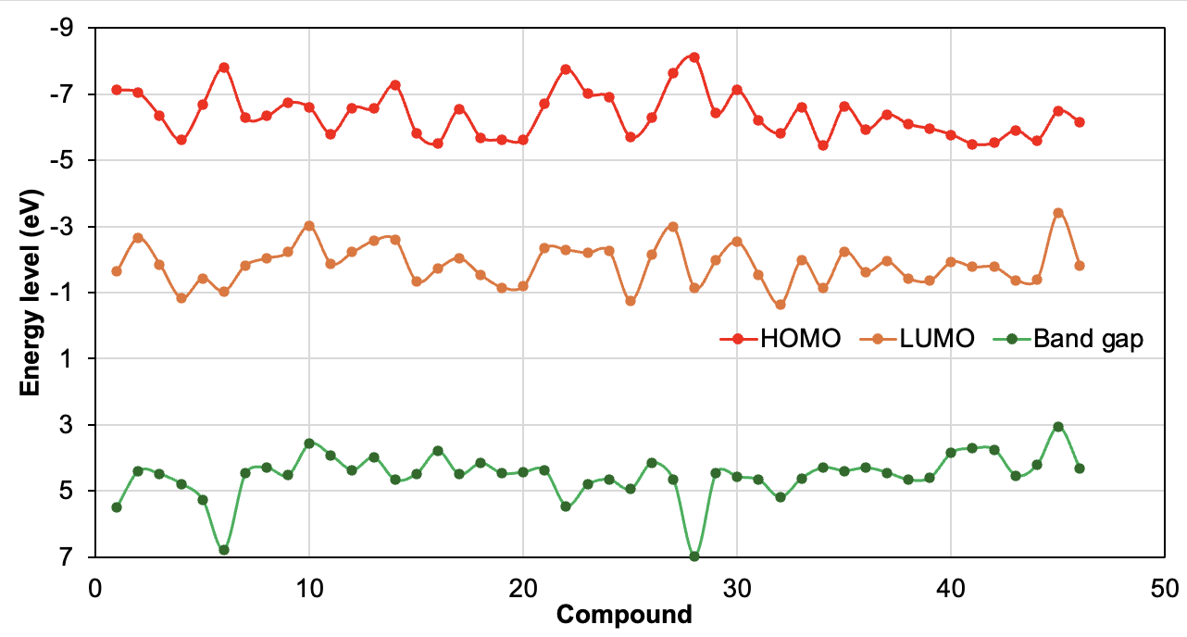
Figure 1. HOMO, LUMO, and band gap energies (in eV) of 46 newly identified potential PBD inhibitors
The second phase includes five natural products identified through a literature search of experimental studies with characteristics as candidate PLK1 inhibitors. Students performed a structural similarity search in the ZINC⁷ natural product database to identify other compounds similar to these 5 parent natural compounds. The protocol showed small molecules totaling 108 compounds as potential PLK1-PBD inhibitors grouped under Quercetin, Xanthatin, Chaetoglobosin E, Luteolin, and Resveratrol derivatives, respectively. These molecules have been screened for potential druggability ADMET properties with calculated stability using MED230016 allocation (Figure 2). Although the ligand property prediction looks promising, we are refining these 258 compounds by removing structurally similar ones using the Tanimoto coefficient and affinity prediction through docking in PLK1, 2, and 3 before proceeding with some selections (40-50 molecules) for metadynamics simulations. The ADMET-S/docking analysis manuscript is under preparation for potential consideration in the Biophysical Journal (https://www.biophysics.org/biophysical-journal).
Third, during this summer, students have screened the SuperNatural⁸ database using various protocols (Figure 3) Currently, students are exploring about 50 compounds from SuperNatural and writing their outcome titled “A Bilingual Computational Workflow for Identifying PLK1 Inhibitors: Integrating American Sign Language and English” as a video journal and full article for consideration in JoVE (https://www.jove.com/).
Fourth, another set of students identified potential inhibitors from the COCONUT⁹ in a virtual screening through physicochemical properties trimming and docking analysis. The protocol identified 45 small natural compounds with promising affinity for the PLK1-PBD.
Figure 2. Energy gap (in eV) of potential PLK1-PBD inhibitors from Quercetin, Xanthatin, Chaetoglobosin E, Luteolin, and Resveratrol derivatives.
Metadynamics: With the provisional allocation, we have simulated potent existing inhibitors thymoquinone (TQ)¹⁰, poloxin¹¹, poloxin-2, poloxin-22, poloxin-23¹¹, (–)–9*, (+)–9*¹², and allopole-A¹³ as a benchmark for our study. By unbiasing the data, Figure 3 depicts the potential of mean force (PMF) of TQ-bound PLK-PBD at various binding sites (BS). We employed metadynamics simulations to generate the Potential of Mean Force (PMF) profiles for multiple binding sites to characterize the binding landscape. While PMF depths provide insights into relative binding affinities, we estimate the absolute binding free energies for ligands at each binding pocket. Using a reference state, typically the unbound state, where the binding pocket distance expanded most (at 30 Å) in this analysis. The adaptive biasing approach within AMBER was instrumental in constructing these free energy maps, accommodating multiple degrees of freedom through independent collective variables and the multiple-walker method¹⁴. Besides capturing the detailed energy landscape, the estimated rough absolute free energy of binding is relevant to the research goal. Researchers have used the difference between the free energy of the bound and unbound state minima on the PMF profile to estimate the binding free energy of ligands to proteins¹⁵. Figure 4 depicts the free energy of ligand-bound PLK1-PBD at various binding sites (BS). Allopole-A preferentially binds at the cryptic binding W-F pocket (BS3) with appreciable free energy of approximately –65 kcal/mol. The region is the experimentally determined binding cleft for this ligand that perturbs inhibition via allosteric modulation¹³. We have started the 46 ligands MD simulations on the provisional NCSA allocation. Considering the large ligand library curated from different sources to represent a diverse chemical space, updating our allocations to enable us to continue this research is critical to achieving our aims.
Figure 3: Computational identification of potential PLK1-PBD inhibitors with improved affinity and selectivity.
References
1. Atomwise – Better medicines faster. https://www.atomwise.com/.
2. AIMS Awards Program – Atomwise. https://blog.atomwise.com/tag/aims.
3. Becke, A. D. Density‐functional thermochemistry. I. The effect of the exchange‐only gradient correction. J. Chem. Phys. 96, 2155–2160 (1992).
4. Lee, C., Yang, W. & Parr, R. G. Condens. Matter Mater Phys Phys Rev B 37, 785–789 (1988).
5. Weigend, F. Accurate Coulomb-fitting basis sets for H to Rn. Phys. Chem. Chem. Phys. 8, 1057–1065 (2006).
6. Neese, F. Software update: The ORCA program system—Version 5.0. Wiley Interdiscip. Rev. Comput. Mol. Sci. 12, e1606 (2022).
7. Irwin, J. J., Sterling, T., Mysinger, M. M., Bolstad, E. S. & Coleman, R. G. ZINC: A Free Tool to Discover Chemistry for Biology. J. Chem. Inf. Model. 52, 1757–1768 (2012).
8. Gallo, K. et al. SuperNatural 3.0—a database of natural products and natural product-based derivatives. Nucleic Acids Res. 51, D654–D659 (2023).
9. Sorokina, M., Merseburger, P., Rajan, K., Yirik, M. A. & Steinbeck, C. COCONUT online: collection of open natural products database. J. Cheminformatics 13, 1–13 (2021).
10. Reindl, W., Yuan, J., Krämer, A., Strebhardt, K. & Berg, T. Inhibition of polo-like kinase 1 by blocking polo-box domain-dependent protein-protein interactions. Chem. Biol. 15, 459–466 (2008).
11. Scharow, A. et al. Optimized Plk1 PBD inhibitors based on poloxin induce mitotic arrest and apoptosis in tumor cells. ACS Chem. Biol. 10, 2570–2579 (2015).
12. Huggins, D. J. et al. Development of a Novel Cell-Permeable Protein–Protein Interaction Inhibitor for the Polo-box Domain of Polo-like Kinase 1. ACS Omega 5, 822–831 (2019).
13. Park, J.-E. et al. Specific inhibition of an anticancer target, polo-like kinase 1, by allosterically dismantling its mechanism of substrate recognition. Proceedings of the National Academy of Sciences vol. 120 e2305037120 (2023).
14. Moradi, M., Babin, V., Roland, C. & Sagui, C. The Adaptively Biased Molecular Dynamics method revisited: New capabilities and an application. in Journal of Physics: Conference Series vol. 640 012020 (IOP Publishing, 2015).
15. Buch, I., Sadiq, S. K. & De Fabritiis, G. Optimized potential of mean force calculations for standard binding free energies. J. Chem. Theory Comput. 7, 1765–1772 (2011).
Figure 4: Experimentally identified binding sites (BS, 1 to 3) in PBD, top five pockets identified through blind docking revealed inhibitor binding to five possible pockets, including the active site, phospho-peptide pocket (a), the free energy profiles constructed from center of mass (CoM) distance between opposite binding residues of PLK1-PBD binding to allopole-A (b), –(–)9* (c), –(+)9* (d), poloxin (e), poloxin-2 (f), thymoquinone (g), and comparison across the various computational approaches for TQ (h). The binding scores correlate (R² = 0.9) with the MetaD binding energies.

