Setting up your complex in CHARMM-GUI
- Search CHARMM-GUI (https://www.charmm-gui.org/)
- Click input generator 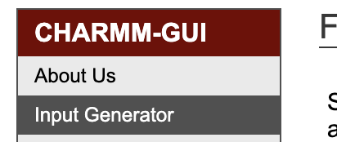
- It will pop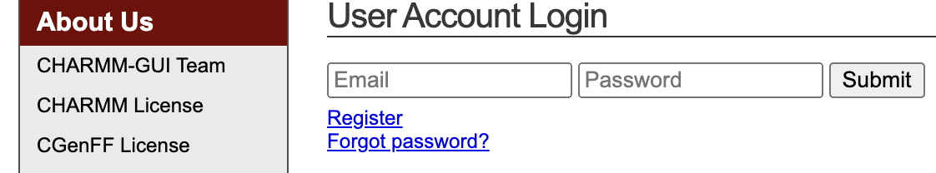
- Register (if this is your first time)
- Check your email for your approval as a user. Login, click Input Generator
- Click 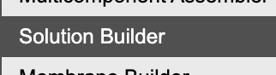, scroll down, and upload your protein-ligand complex or the PDB code (I am using 4HCO as an example) 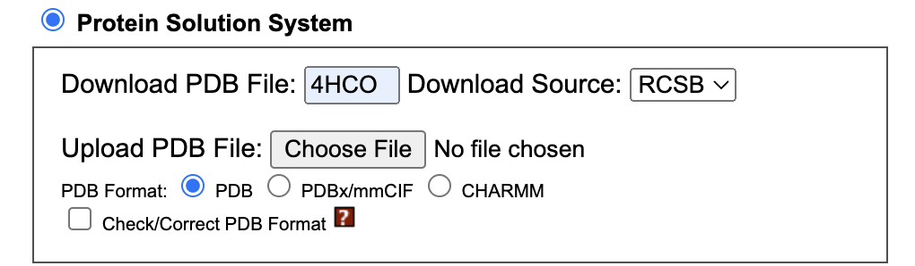
- Error: my PDB file failed to load because it is unrecognizable by CHARMMGUI.
- Solution: Ensure your PDB file has a chain ID. You can open it in VMD and resave it. VMD will add chain ID information.
- Click Next Step in the right-hand corner, select the protein and ligand to be simulated. 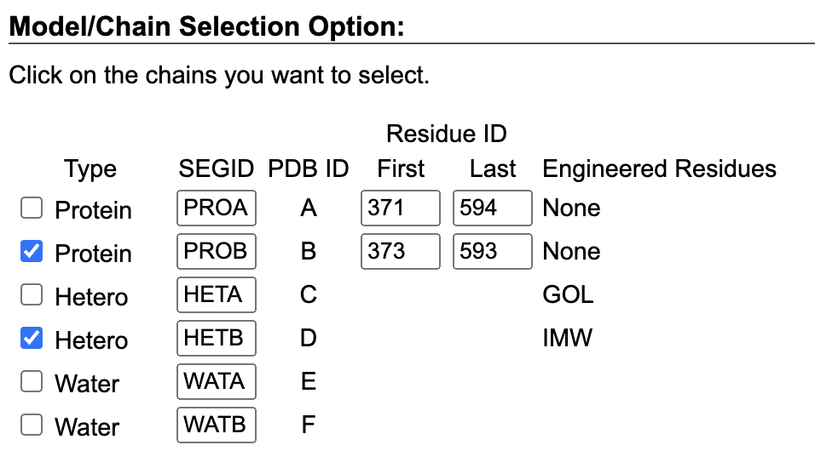
- Click Next Step, it will pop a running window for PDB modeling and ligand forcefield selection
- Click CSML Search or upload the SDF or MOL2 file of your ligand
For CSML
CSML Search will pop up a window like the one below. Click if you want to parameterize ligand FF….., then Next Step. This will take you back to the main page, you may want to model any missing loop, click appropriately, and click Next Step on the main page.
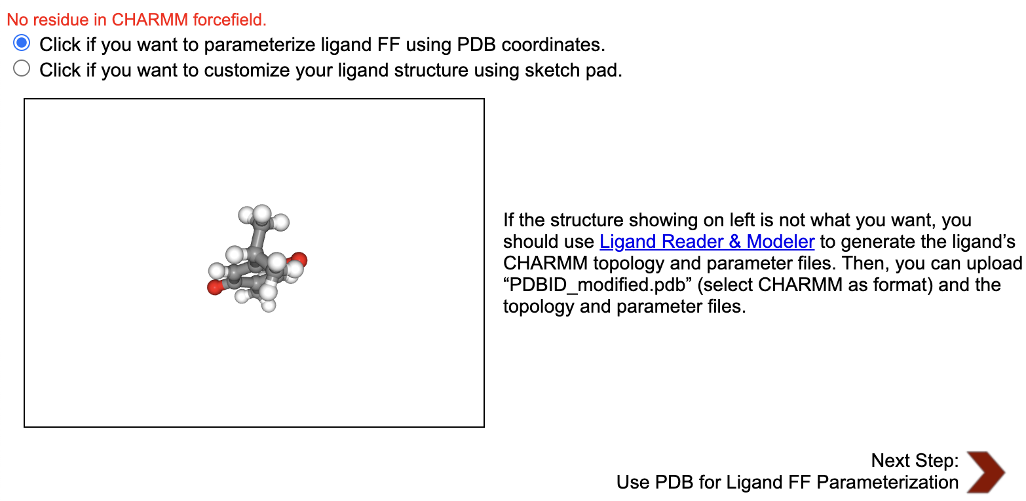
- The next page is for solvation, click NaCl, Add Simple Ion Type, deselect KCl, and Calculate Solvent Composition. Click Next Step
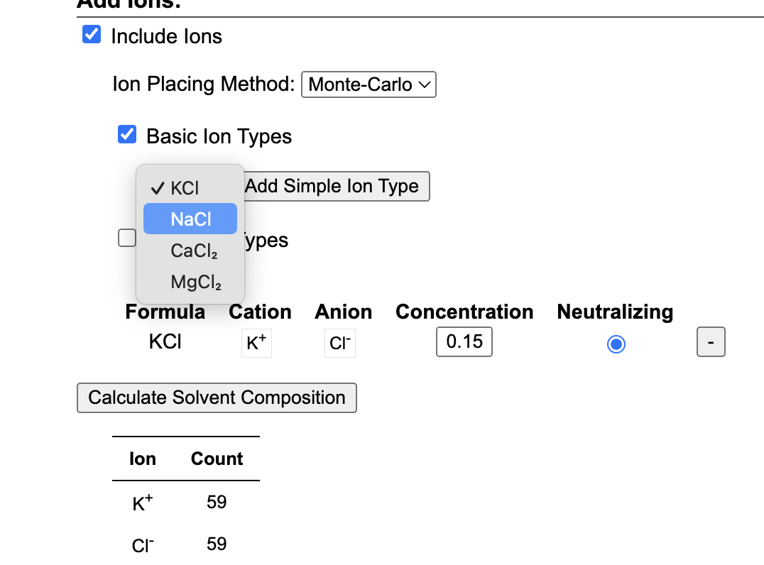
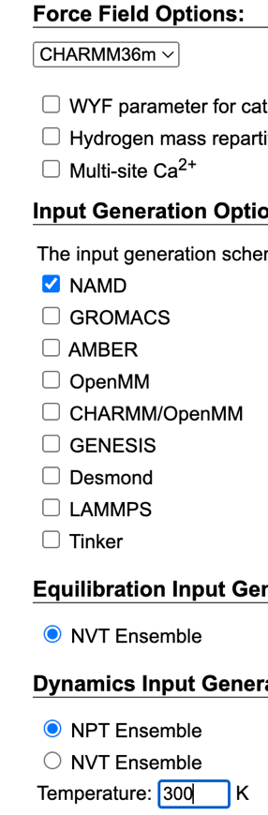
- Click for the next stage 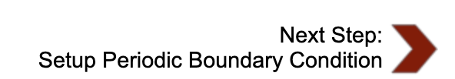
- Select force field and software to use, and dynamics operation (I changed my temperature to 300 K)
- You can view your structure to be sure the setup looks accurate.
- Download 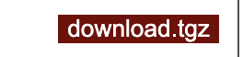
- Unzip 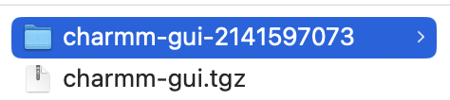, rename as desired, and drag to your remote directory.
- Put your running script (run_namd.sh, create one like the below) in the namd folder
- Open (step5_production.inp) to adjust the production simulation time to the desired run time (200 ns will be completed in 28 hours or so)
# run
numsteps 500000;
run 500000; # 1ns change desired time
- Submit your run_namd.sh

#!/bin/bash
#FILENAME: jobsubmit
#SBATCH -A bio230137-gpu
#SBATCH --nodes=1
#SBATCH --ntasks-per-node=2
#SBATCH --gpus-per-node=2
#SBATCH --time=48:00:00
#SBATCH -J prot1_tq1
#SBATCH -o myjob.o%j
#SBATCH -e myjob.e%j
#SBATCH -p gpu
#SBATCH --mail-user=youremail
#SBATCH --mail-type=all

#Manage processing environment, load compilers and applications
module purge
module load modtree/gpu
module load ngc
module load namd/3.0-alpha3-singlenode
module list

#launch namd
namd3 step4_equilibration.inp > step4_equilibration.log
namd3 step5_production.inp > step5_production.log

MD and MMPBSA in AMBER
Our group often uses NAMD software for molecular dynamics (MD) simulations, but we are currently using AMBER (https://ambermd.org/) because of its robustness. The AMBER tutorial is here: https://ambermd.org/tutorials/ while examples of analysis for various metrics are offered through AmberTools (https://amberhub.chpc.utah.edu/). In most cases, Advanced computing resources or supercomputers facilitate MD simulations. The accessible resources for MD simulations in our lab are Anvil (https://www.rcac.purdue.edu/knowledge/anvil) and NCSA Delta (https://docs.ncsa.illinois.edu/systems/delta/en/latest/index.html). See the summary below to set up and simulate a protein-ligand complex using classical MD (cMD) simulations. Amber is available for all users in Anvil, its installation on NCSA-Delta is still under consideration but an individual installation guide (GPU and MPI-enabled) is available here (https://github.com/MMLawal/DDLab_Gallaudet/blob/main/AMBER/install_amber.txt).
- Ligand and protein preparation for AMBER simulation
  - Use the docked pose of the desired ligand retrieved from CB-Dock2 docking, other docking software, or co-complexed 3D protein-ligand structure from an experiment.
  - Add hydrogen back to the ligand in Avogadro by clicking BuildAdd HydrogensFileSave As… to save in a preferred folder as a pdb file lig.pdb.
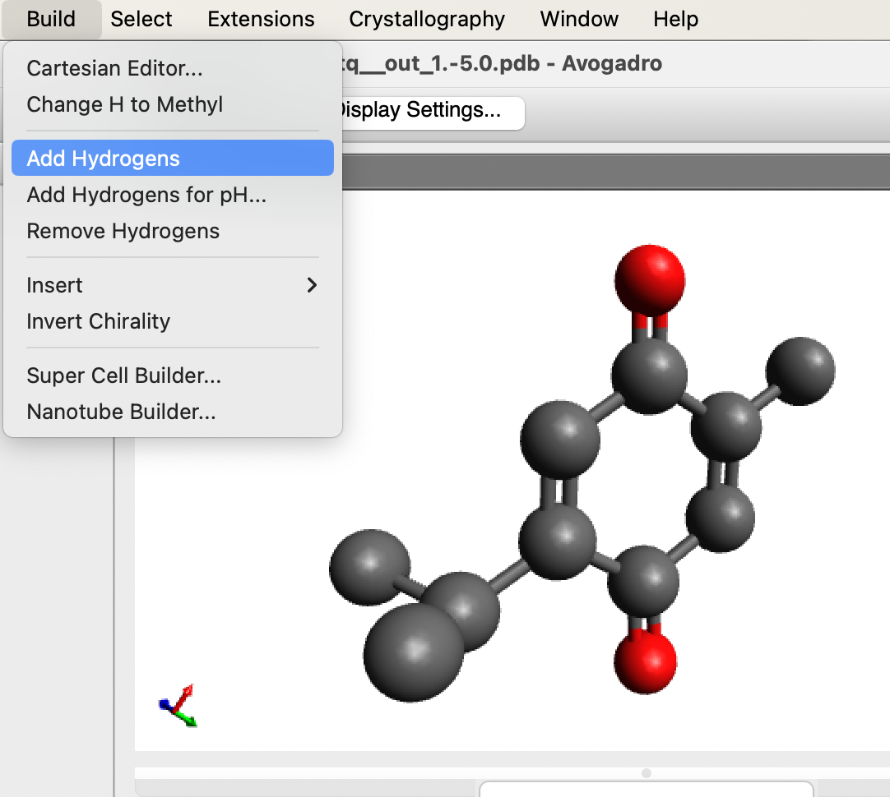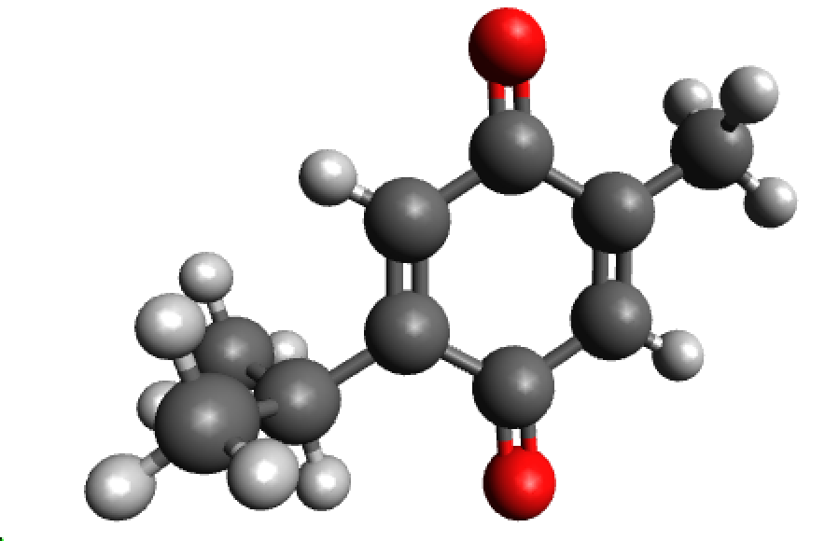
  - Upload your ligand and protein to your remote work directory.
  - View the lig.pdb in the terminal and edit the resid (1 vs 2), resname (UNL vs LIG), and ATOM description (ATOM vs HETATM) to be the same using :%s/HETATM/ATOM /g and :%s/UNL 1/LIG A 2/g
You can also change the resid from 2 to the exact index after the last protein resid.
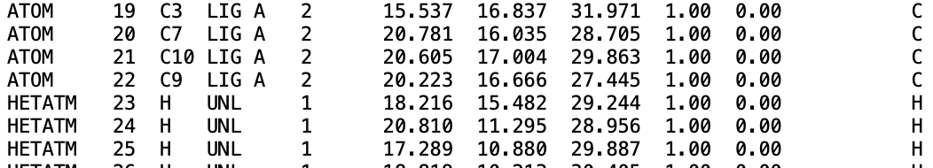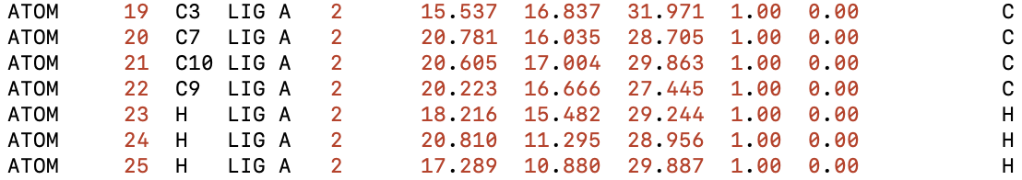
  - Load required modules to activate AmberTools/Amber
  - Generate forcefield parameter for ligand with antechamber module (https://ambermd.org/tutorials/basic/tutorial4b/index.php) “antechamber -i lig.pdb -fi pdb -o lig.mol2 -fo mol2 -j 5 -at gaff -c bcc -nc 0” then “parmchk2 -i lig.mol2 -f mol2 -o lig.frcmod.” Change “-nc 0” to whatever charge your ligand has.
  - Prepare your protein – the structure uploaded for docking. Remove all the hydrogen atoms to avoid imminent connectivity issues, tleap will add them later and assign appropriate protonation. Type “reduce -Trim step1_protein.pdb > rec.pdb” to remove hydrogen.
  - Final tleap.in file to prepare a solvated protein-ligand complex for MD simulation. “tleap -s -f tleap.in” The first 5 lines are the forcefield parameters for protein, ligand, water, and ionizing atoms. Delete the comments (!to be used later for MMGBSA) in the file if it pops an error. The total charge of this protein (PBD) is 0, hence the equimolar 0.15M NaCl addition. See this tutorial for clarity https://ambermd.org/tutorials/basic/tutorial8/index.php.
source leaprc.protein.ff19SB
source leaprc.gaff
source leaprc.water.tip3p
loadamberparams frcmod.ionsjc_tip3p
loadamberparams lig.frcmod
LIG = loadmol2 lig.mol2
receptor = loadPDB rec.pdb
complex = combine {receptor LIG}
set default PBRadii mbondi2
saveAmberParm LIG lig.top lig.rst7 !to be used later for MMGBSA
saveAmberParm receptor rec.top rec.rst7 !to be used later for MMGBSA
saveAmberParm complex com.top com.rst7 !to be used later for MMGBSA
saveAmberParm complex step2_input.parm7 step2_input.rst7
savepdb complex step2_input.pdb
charge complex
solvatebox complex TIP3PBOX 10 iso
addionsRand complex Na+ 75.0 Cl- 75.0
saveAmberParm complex step3_input.parm7 step3_input.rst7 !use VMD to view for accuracy
savepdb complex step3_input.pdb !easy visualization of the input file
quit

- MD simulations in AMBER
- Simulating with AMBER usually follows this protocol minimization🡪heating/equilibration🡪 production (https://ambermd.org/tutorials/basic/tutorial0/index.php). The parameter and coordinate files are step3_input.parm7 and step3_input.rst7 required for the simulation. Other extension formats for parameter files are parm, prmtop, and top while other coordinate formats are inpcrd, crd, and rst. Based on a recent study, here are the input files for cMD simulation involving step4.0_minimization.in, step4.1_equilibration.in, and prod.in (300 ns) with a submitting script amber_run.sh. You must learn to work with Linux and understand a few batch scripting concepts.
Examples:
Submit your simulation with sbatch run_amber.sh.
Cancel with scancel jobid
Check your submitted job progress with squeue -u username
Or all jobs on the infrastructure with squeue

- Read/search the Amber manual (https://ambermd.org/doc12/Amber24.pdf) to understand the meaning of each parameter in the input files.

Minimization input file in explicit solvent
&cntrl
! Minimization options
imin=1, ! Turn on minimization
maxcyc=5000, ! Maximum number of minimization cycles
ncyc=2500, ! 100 steepest-descent steps, better for strained systems
! Potential energy function options
cut=9.0, ! nonbonded cutoff, in Angstroms
! Control how often information is printed to the output file
ntpr=100, ! Print energies every 100 steps
ntxo=2, ! Write NetCDF format
! Restraint options
ntr=1, ! Positional restraints for proteins, sugars, and ligands
! Set water atom/residue names for SETTLE recognition
watnam='WAT', ! Water residues are named WAT
owtnm='O', ! Water oxygens are named O
/
Protein posres
1.0
RES 1 224 225 225
END
END

A NVT simulation for common production-level simulations
&cntrl
imin=0, ! No minimization
irest=0, ! This is NOT a restart of an old MD simulation
ntx=1, ! So our inpcrd file has no velocities
! Temperature control
ntt=3, ! Langevin dynamics
gamma_ln=1.0, ! Friction coefficient (ps^-1)
tempi=300, ! Initial temp -- give it some small random velocities
temp0=300, ! Target temperature
! Potential energy control
cut=9.0, ! nonbonded cutoff, in Angstroms
! MD settings
nstlim=125000, ! 125K steps, 125 ps total
dt=0.001, ! time step (ps)
! SHAKE
ntc=2, ! Constrain bonds containing hydrogen
ntf=2, ! Do not calculate forces of bonds containing hydrogen
! Control how often information is printed
ntpr=1000, ! Print energies every 1000 steps
ntwx=5000, ! Print coordinates every 5000 steps to the trajectory
ntwr=10000, ! Print a restart file every 10K steps (can be less frequent)
! ntwv=-1, ! Uncomment to also print velocities to trajectory
! ntwf=-1, ! Uncomment to also print forces to trajectory
ntxo=2, ! Write NetCDF format
ioutfm=1, ! Write NetCDF format (always do this!)
! Wrap coordinates when printing them to the same unit cell
iwrap=0,
! Restraint options
ntr=1, ! Positional restraints for proteins, sugars, and ligands
! Set water atom/residue names for SETTLE recognition
watnam='WAT', ! Water residues are named WAT
owtnm='O', ! Water oxygens are named O
/
Protein posres
1.0
RES 1 224 225 225
END
END

Production Step: stage-1
&cntrl
imin= 0,
irest=1,
iwrap=1,
NTX=5,
ntb=2,
ntp=1,
barostat=2,
PRES0=1.0,
TAUP=2.0,
NTPR=50000,
NTWX=50000,
NTPR=50000
ntr=0,
Tempi=300.0,
Temp0=300.0,
NTT=3,
gamma_ln=1.0,
NTC=2,
NTF=2,
cut=9.0,
ntxo=2,
ioutfm=1,
nstlim=150000000, ! 300 ns
dt=0.002
/

#!/bin/bash
#FILENAME: jobsubmit
#SBATCH -A bio230137-gpu
#SBATCH --nodes=1
#SBATCH --ntasks-per-node=2
#SBATCH --gpus-per-node=2
#SBATCH --time=48:00:00
#SBATCH -J prot-tq-bs3
#SBATCH -o myjob.o%j
#SBATCH -e myjob.e%j
#SBATCH -p gpu
#SBATCH --mail-user=youremail
#SBATCH --mail-type=all

#Manage processing environment, load compilers and applications
module purge
module load modtree/gpu
module load gcc/8.4.1 openmpi/4.0.6-cu11.0.3 amber/20
module list

#Launch code

pmemd.cuda -O -i step4.0_minimization.mdin -o step4.0_minimization.log -c step3_input.rst7 -p step3_input.parm7 -r step4.0_input.rst7 -ref step3_input.rst7
pmemd.cuda -O -i step4.1_equilibration.mdin -o step4.1_equilibration.log -c step4.0_input.rst7 -p step3_input.parm7 -r step4.1_equilibration.rst7 -ref step4.0_input.rst7 -x step4.1_equilibration.nc
mpirun -np 2 pmemd.cuda.MPI -O -i prod.in -o step5_production.log -c step4.1_equilibration.rst7 -p step3_input.parm7 -r step5_production.rst7 -x step5_production.nc

  - Analyses – There are various metrics used to depict information from the simulated trajectories. Usually, water and ions co-simulated with the protein-ligand system will be stripped off to reduce the file size and speed up the post-simulation analyses. Here is an example of a strip.in file to execute using the command cpptraj strip.in
parm step3_input.parm7
trajin prod.nc
autoimage
center :1-225 mass
strip !(:1-225) outprefix stripped
trajout pbd_tq_bs1_200ns.dcd
go

- MMGBSA/PBSA calculation
  - The AmberTools has several packages for various analyses, including the cpptraj (https://amberhub.chpc.utah.edu/cpptraj/) and MMPBSA.py for end-point binding free energy calculation (https://ambermd.org/tutorials/advanced/tutorial3/py_script/section1.php). See template mmgbsa.in and mmgbsa.sh files. You can create a separate directory for your analyses.
Input file for running PB and GB in serial
&general
startframe=1, endframe=14000, keep_files=0, entropy=1,
/
&gb
igb=5,saltcon=0.15,
/
  - Installing AmberTools in your HPC home directory, load Anaconda with "module load anaconda" or whatever module spider anaconda suggests. Anaconda is available in most computing infrastructures. Follow the instructions in this link https://ambermd.org/GetAmber.php.
#!/bin/bash
#FILENAME: jobsubmit
#SBATCH -A bio230137-gpu
#SBATCH --nodes=1
#SBATCH --ntasks-per-node=2
#SBATCH --gpus-per-node=2
#SBATCH --time=48:00:00
#SBATCH -J mmgb-tq-bs1
#SBATCH -o myjob.o%j
#SBATCH -e myjob.e%j
#SBATCH -p gpu
#SBATCH --mail-user=monsurat.lawal@gallaudet.edu
#SBATCH --mail-type=all

#Manage processing environment, load compilers and applications
module purge
module load modtree/gpu
module load gcc/8.4.1 openmpi/4.0.6-cu11.0.3 amber/20
module load anaconda #MMPBSA.py was not found in the installed Amber on Anvil, had to install Ambertools to get it running
conda activate AmberTools23 #to activate it for the calculation

#Launch code
MMPBSA.py -O -i mmgbsa.in -cp com.top -rp rec.top -lp lig.top -y pbd_tq_bs1_1.4us.dcd -o mmgbsa.dat > mmpbsa.log

