MISSING PERSON SYSTEM

1st Anas alaa
Department of Computer Science, Misr University for Science and Technology,6th of October City, Egypt
2nd Marwan Alaa
Department of Computer Science, Misr University for Science and Technology,6th of October City, Egypt

Ahmed A.Mahmoud Department of computer science,misr University for science and technology, 6th of October City, Egypt Ahmed.asoliman@must.edu.eg
3rd Ahemd Mahmoud
Department of Computer Science, Misr University for Science and Technology,6th of October City, Egypt
4th Mohamed Seddik
Department of Computer Science, Misr University for Science and Technology,6th of October City, Egypt

khaled Abd El Salam Department of Computer Science, Misr University for Science and Technology,6th of October City, Egypt khaled.abdelsalam@must.edu.eg
5th Yazed Abdelwahed Department of Computer Science, Misr University for Science and Technology,6th of October City, Egypt
6th Yousef Nasr Department of Computer Science, Misr University for Science and Technology,6th of October City, Egypt

Rojena Mohamaden Department of computer science,misr University for science and technology, 6th of October City, Egypt

Abstract— Missing people cases represent a critical global issue where time plays a vital role in increasing the chances of rescue. Traditional methods such as manual searching and posters are often slow and prone to human error. This paper presents an advanced intelligent system for detecting missing individuals using Artificial Intelligence and computer vision. To optimize system complexity and computational efficiency, we utilize the DeepFace framework, which provides an integrated pipeline for both face detection and recognition using the ArcFace model. The system integrates real-time surveillance data with a high-performance Flutter-based mobile application. Due to computational constraints, this streamlined approach replaces separate models with a unified pipeline, maintaining reliable performance while reducing overhead. Experimental results, yielding an mAP@50 of 0.984, demonstrate that this integrated approach provides high-fidelity recognition required for operational deployment..
Introduction :-

Every year, thousands of people go missing due to accidents, kidnapping, or getting lost. Rapid response is critical, as delays significantly reduce the likelihood of successful recovery. The "Golden Hour" in these cases refers to the initial period where the probability of finding an individual is highest. This research proposes a smart system that utilizes an integrated deep learning pipeline to enhance the efficiency of missing person detection in real-time environments, transforming standard surveillance into an active rescue network.

Problem Definition & Motivation
Current approaches to locating missing individuals suffer from slow manual processes and a high dependency on human observation. Modern cities generate massive amounts of camera data that humans cannot fully review accurately due to fatigue and distraction. The motivation behind this work is the time-sensitivity of such cases. By utilizing an integrated AI pipeline, we can process large datasets instantly on standard hardware, ensuring a 24/7 reliable search tool for families and authorities.measurement and others are deliberate, using specifications that anticipate your paper as one part of the entire proceedings, and not as an independent document. Please do not revise any of the current designations.

Methodology :-

a. System Architecture:-

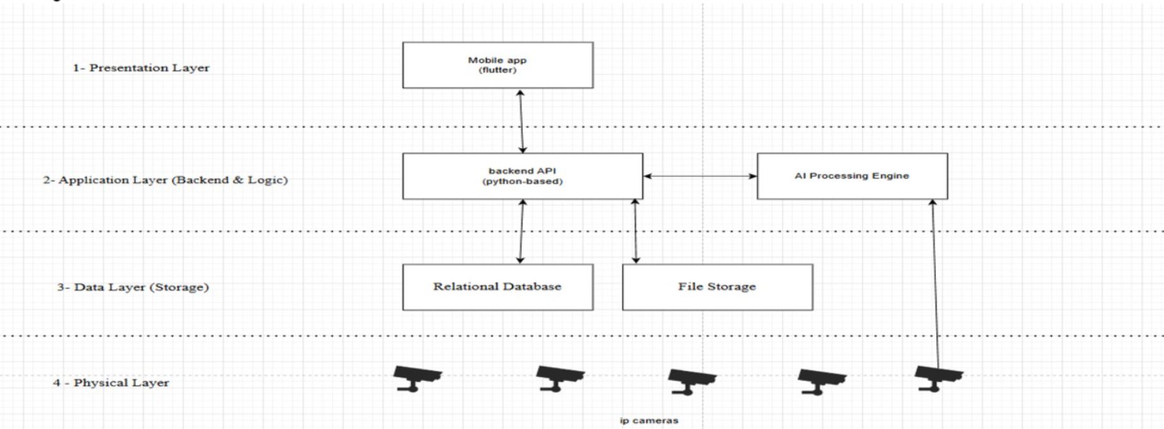

. Mobile Application (Flutter):-

The mobile interface is built using Flutter for several technical reasons:
Cross-Platform Consistency: A single codebase for Android.
High Performance: Compiles to native ARM machine code, crucial for real-time notifications.
Reactive UI: Utilizing state management allows the app to update match results instantly.
Key Features: Users can register missing persons, upload high-resolution images for ArcFace embedding, and receive immediate alerts via Firebase Cloud Messaging (FCM). [1]

. Backend & AI Module:-
The backend, built using Python and FastAPI, handles high-concurrency API communication. By utilizing FastAPI’s asynchronous capabilities, the system ensures low-latency data transfer. Due to computational constraints, we replaced YOLO with DeepFace, providing a unified pipeline for both detection and recognition (ArcFace). This integration significantly reduces the system's memory footprint while maximizing accuracy on a hypersphere embedding space.[2]
. Camera and NVR Integration:-
The system captures live streams from IP cameras connected to a Network Video Recorder (NVR). The AI module analyzes these frames in real-time, comparing detected faces against the database using Cosine Similarity.

. Evaluation and Results:-
Metric | Value
mAP @ 50-95 | 0.750
mAP @ 50 | 0.984
Precision | 0.975
Recall | 0.939
F1-Score | 0.956

Analysis: The high precision (0.975) ensures minimal false alarms, preventing "Alert Fatigue." The F1-Score (0.956) proves that simplifying the system to an integrated DeepFace pipeline does not compromise reliability. Confusion Matrix analysis confirmed high True Positives and minimal missed cases.[3]

IV - Related Work:-

Recent advancements in computer vision and deep learning have significantly improved the performance of surveillance and face recognition systems. This section reviews the most relevant works in object detection, face recognition, and intelligent monitoring systems.

1- Object Detection and Surveillance Systems:-
Object detection has become a fundamental component in modern surveillance systems. Redmon and Farhadi [4] introduced the YOLO framework, which formulates object detection as a single regression problem, enabling real-time performance. YOLO achieves high speed and efficiency, making it suitable for real-time applications such as video surveillance. However, it may suffer from reduced accuracy when detecting small objects or objects in crowded environments.
Subsequent improvements in object detection models have focused on enhancing accuracy while maintaining real-time performance. Zou et al. [5] provided a comprehensive survey of object detection techniques, highlighting the evolution from traditional methods to deep learning-based approaches. Despite these advancements, challenges such as occlusion, illumination variation, and scene complexity remain significant in surveillance scenario

2- Face Recognition Techniques:-
Face recognition has witnessed substantial progress due to deep learning. Schroff et al. [6] proposed FaceNet, which learns a mapping from face images to a compact Euclidean embedding space using triplet loss. This approach enables efficient face verification and clustering. However, it requires careful selection of training samples and is computationally expensive during training.

Deng et al. [7] introduced ArcFace, which improves recognition performance by incorporating an additive angular margin penalty into the loss function. This method enhances the discriminative power of facial embeddings, resulting in better separation between classes. Nevertheless, its performance may degrade under challenging conditions such as low-resolution images and occlusions.

3- Intelligent Surveillance and Monitoring Systems:-
Recent research has explored intelligent surveillance systems that integrate computer vision with real-time monitoring. These systems aim to automatically detect suspicious activities and track individuals across multiple cameras. While many approaches successfully utilize object detection and tracking, they often lack integration with user-generated data and external reporting mechanisms.
Additionally, existing systems typically focus on detection accuracy without considering spatial and temporal analysis of incidents. The absence of data-driven risk assessment limits their ability to provide proactive insights for decision-making.
4- Research Gap:-

Despite the significant progress in object detection and face recognition, existing approaches do not provide a unified framework that integrates real-time user reporting, AI-based surveillance analysis, and spatial risk evaluation. Most systems operate independently without leveraging user input or analyzing incident patterns over time.

To address these limitations, the proposed system combines mobile-based reporting, deep learning-based surveillance analysis, and data-driven risk detection into a single integrated platform. This approach enables more efficient identification of missing persons and supports proactive decision-making for law enforcement.
F- Future Work:-
Future improvements will focus on:
Generative Age Progression (AG-GANs): To simulate facial changes in long-term missing cases.[8]
Dataset Expansion: Including wider varieties of ethnicities and environmental conditions.
National Security Integration: Establishing secure API bridges with official databases.
Privacy Mechanisms: Implementing data encryption to ensure the privacy of citizens.

V-Conclusion
This research successfully implemented a scalable, AI-driven rescue system. By combining an integrated DeepFace/ArcFace pipeline with a FastAPI backend and a Flutter interface, we created a tool that is both technologically advanced and practically usable for saving lives.
VI-References
1-Google Developers (2023). Flutter Documentation. https://docs.flutter.dev.
2-Serengil, S. I., & Ozpinar, A. (2020). LightFace: A Hybrid Deep Face Recognition Framework. IEEE.
3-Wang, M., & Deng, W. (2021). Deep Face Recognition: A Survey. Neurocomputing.
4-J. Redmon and A. Farhadi, "YOLOv3: An Incremental Improvement," 2018
5-Z. Zou et al., "Object Detection in 20 Years: A Survey," 2019
6-F. Schroff et al., "FaceNet: A Unified Embedding for Face Recognition and Clustering," 2015

7-Deng, J., et al. (2019). ArcFace: Additive Angular Margin Loss for Deep Face Recognition. CVPR.
8-Goodfellow, I., et al. (2014). Generative Adversarial Nets. NeurIPS.

