 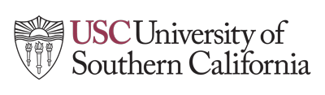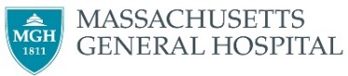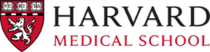

Name: ___________

**Invitation to attend the 1st International Workshop on Multiscale Multimodal Medical Imaging (MMMI 2019), 13th October 2019, Shenzhen, China**

MMMI 2019 will be held on 13th October 2019 in Shenzhen, China, in conjunction with the 22nd International Conference on Medical Image Computing and Computer Assisted Intervention (MICCAI).

MMMI 2019 is expected host over 100 attendees from the research field of medical image analysis, machine learning, data fusion, and clinical practice. The workshop will feature invited keynote talks, as well as oral sessions selected from full-length, 8-pages paper submissions.

The workshop will be held at the InterContinental Hotel Shenzhen, No. 9009 Shennan Road, Overseas Chinese Town: Shenzhen, GD, 518053, China, Telephone: +86-755-33993388.

Participants in this meeting receive no financial benefit from the workshop organizers or the sponsored organizations. Should you require any further details on this workshop, please visit our website at https://mmmi2019.github.io/.

Yours sincerely,

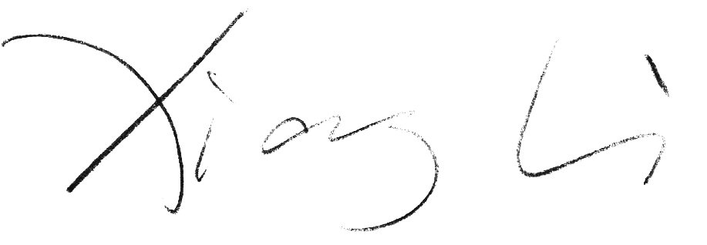

Dr. Xiang Li

Program Chair, MMMI 2019

Department of Radiology, Massachusetts General Hospital and Harvard Medical School

Email: xli60@mgh.harvard.edu