 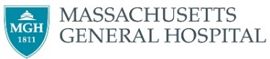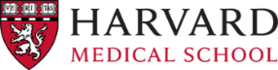

Name: ___________

**Invitation to attend the 3rdst International Workshop on Multiscale Multimodal Medical Imaging (MMMI 2023), September 22nd, 2022, Singapore**

MMMI 2022 will be held on September 22nd, 2022, in Singapore, in conjunction with the 25th International Conference on Medical Image Computing and Computer Assisted Intervention (MICCAI 2022).

MMMI 2022 is expected to host over 100 attendees from the research field of medical image analysis, machine learning, data fusion, and clinical practice. The workshop will feature invited keynote talks, as well as oral sessions selected from full-length paper submissions. The workshop will be held at the Resorts World Convention Centre Singapore.

Participants in this meeting receive no financial benefit from the workshop organizers or the sponsored organizations. Should you require any further details on this workshop, please visit our website at https://mmmi2022.github.io/.

Yours sincerely,

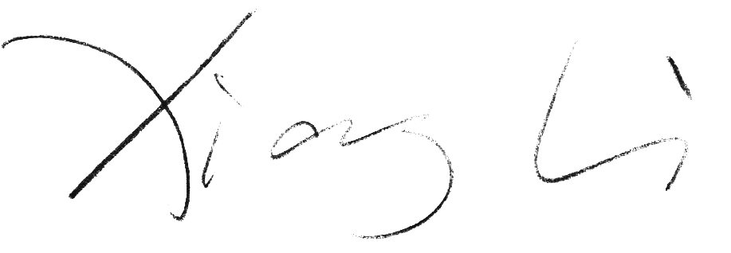

Dr. Xiang Li

Program Chair, MMMI 2022

Department of Radiology, Massachusetts General Hospital and Harvard Medical School

Email: xli60@mgh.harvard.edu