 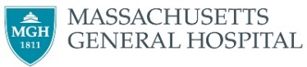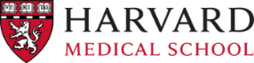

Name: ___________

**Invitation to attend the 4th International Workshop on  
Multiscale Multimodal Medical Imaging (MMMI 2023),  
August 8th, 2023, Vancouver, Canada**

MMMI 2023 will be held on August 8th, 2023, in Vancouver, Canada, in conjunction with the 26th International Conference on Medical Image Computing and Computer-Assisted Intervention (MICCAI 2023).

MMMI 2023 is expected to host over 100 attendees from the research field of medical image analysis, machine learning, data fusion, and clinical practice. The workshop will feature invited keynote talks as well as oral sessions selected from full-length paper submissions. The workshop will be held at the Vancouver Convention Centre.

Participants in this meeting receive no financial benefit from the workshop organizers or the sponsored organizations. Should you require any further details on this workshop, please visit our website at https://mmmi2023.github.io/.

Yours sincerely,

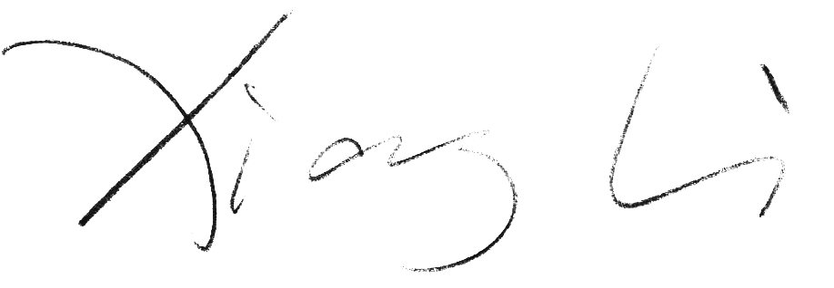

Dr. Xiang Li

Program Chair, MMMI 2023

Department of Radiology, Massachusetts General Hospital and Harvard Medical School

Email: xli60@mgh.harvard.edu