 

Name: ___________

**Invitation to attend the 5th International Workshop on Multiscale Multimodal Medical Imaging (MMMI 2024) and the 1st Workshop on Machine Learning for Multimodal/-sensor Healthcare Data (ML4MHD 2024),  
October 10th, 2024, Marrakech, Morocco**

MMMI/ML4MHD 2024 will be held on October 10th, 2024, in Marrakech, Morocco, in conjunction with the 27th International Conference on Medical Image Computing and Computer-Assisted Intervention (MICCAI 2024).

MMMI/ML4MHD 2024 is expected to host over 100 attendees from the research field of medical image analysis, machine learning, data fusion, and clinical practice. The workshop will feature invited keynote talks as well as oral sessions selected from full-length paper submissions. The workshop will be held at the Hotel du Golf Rotana.

Participants in this meeting receive no financial benefit from the workshop organizers or the sponsored organizations. Should you require any further details on this workshop, please visit our website at https://mmmi2024.github.io/.

Yours sincerely,

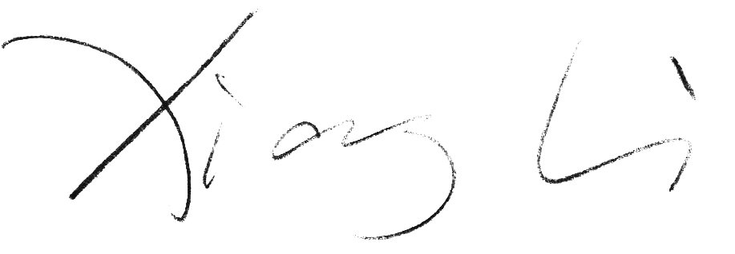

Dr. Xiang Li

Program Chair, MMMI 2024

Assistant Professor, Department of Radiology, Massachusetts General Hospital and Harvard Medical School

xli60@mgh.harvard.edu