User’s guide & tutorial

M3 framework

|  |  |
| --- | --- |
| Creator | Amelie Gyrard |
| Last updated | March 6th 2015 |
| Status | Work in progress |
| URL | http://www.sensormeasurement.appspot.com/documentation/UserGuide.pdf |

Do not hesitate to ask for help or give us feedback, advices to improve our tools or documentations, fix bugs and make them more user-friendly and convenient:



Table of contents

I. Introduction 1

II. Generating Semantic Web of Things templates 2

III. Interpreting IoT data 3

IV. Reusing domain knowledge? 4

V. Simulating SenML sensor measurements 5

VI. Converting senML sensor data 7

VII. Testing our scenarios 8

## Introduction

The M3 framework enables assisting to (see Figure 1):

* Develop Semantic Web of Things (SWoT) applications with the SWoT generator.
* Interpret IoT data with S-LOR
* Find & reuse domain knowledge already designed by domain experts with LOV4IoT
* Find attacks & security mechanisms related to specific technologies employed in IoT with STAC

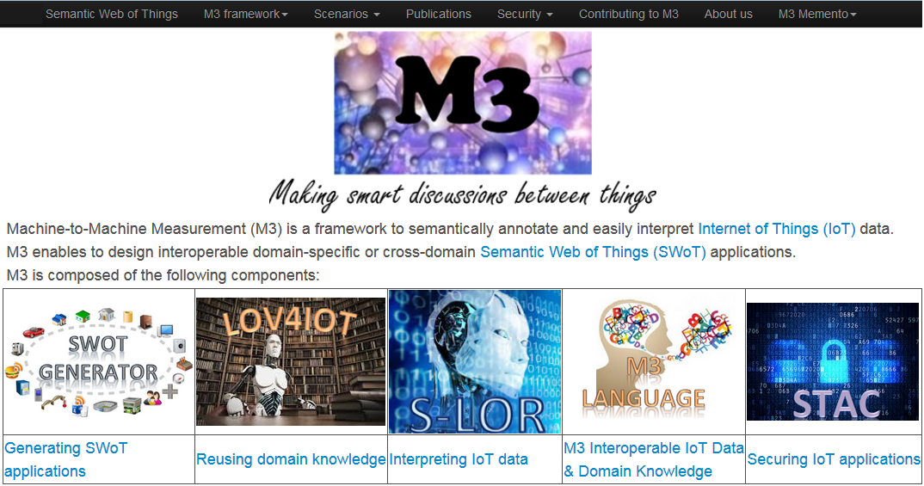

Figure . Home page

## Generating Semantic Web of Things templates

The main purpose of the template generated is to interpret IoT data to provide suggestions.

* Go to this web page: <http://www.sensormeasurement.appspot.com/?p=m3api> (see Figure 2)
* Choose a sensor (e.g., Precipitation)
* Choose a domain (e.g., Weather)
* Click on the button “Search IoT application template”
* The drop-down list in STEP 2 is not empty anymore
* Choose a template (e.g., Precipitation, Transportation and Safety devices)
* Click on the button “Generate zip file”
* A zip file has been generated with interoperable M3 and domain ontologies, rules and datasets (Figure 3).

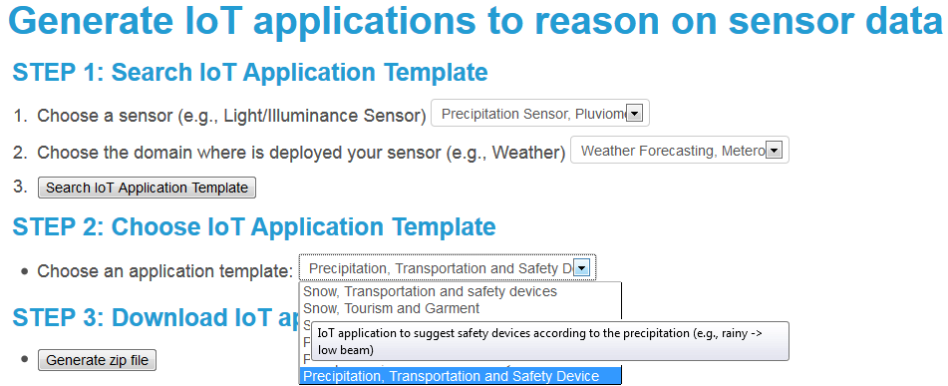

Figure . Generating Semantic Web of Things templates

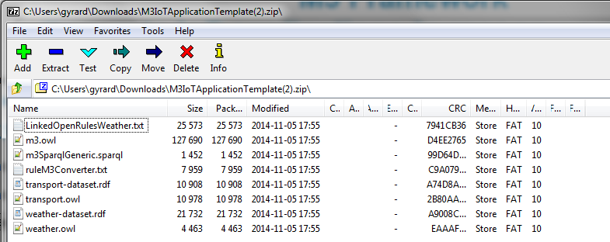

Figure . Zip file generated with domain knowledge for interpreting sensor data

## Interpreting IoT data

Go to this web page: <http://www.sensormeasurement.appspot.com/?p=swot_template>

* Select a sensor to find all rules interpreting sensor values as depicted in Figure 4 (e.g., Precipitation)
* The demonstration will show all rules related to the sensor chosen by the user to interpret sensor values.

(e.g., if precipitation = 0 mm/h then NoPrecipitation)

* You have both the rule for humans and for machines (click on the LinkedOpenRules link)

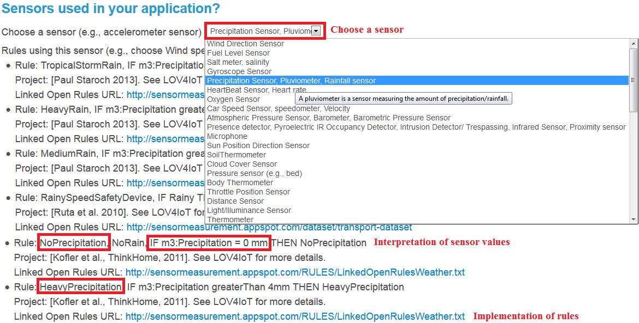

Figure . Finding rules to interpret sensor data with S-LOR

## Reusing domain knowledge

* Go to the Linked Open Vocabularies for Internet of Things (LOV4IoT) web page (see Figure 5): <http://www.sensormeasurement.appspot.com/?p=ontologies>
* Choose 1 domain by clicking on the image (e.g., transportation) as depicted in Figure 5.

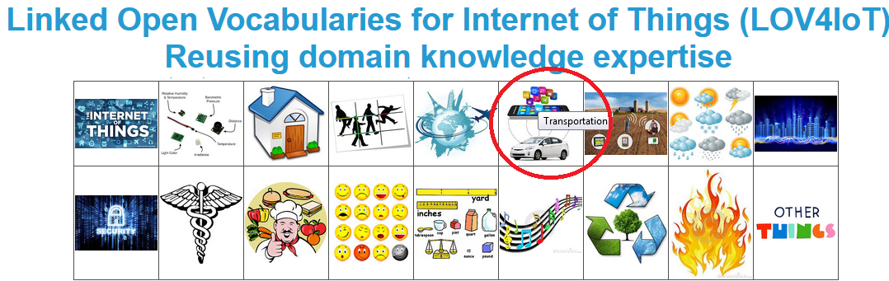

Figure . Ontologies classified in various domains

* You will find a table with the following information as depicted in Figure 7:
  + Domain experts names (authors)
  + Year of publication
  + Research articles
  + Ontology URL of available
  + Technologies used in their project
  + Sensors used in their project
  + Rules designed

-Ontologies and projects have been classified according to different colors (see Figure 6):

* Red: the ontology is not available
* White: we do not have any links to get the ontology
* Orange: we contacted authors to get their ontologies. They answered us they will share ontologies and rules soon.
* Yellow: we retrieve the ontology URL or get a copy
* Green: Ontologies published online, cannot be referenced on the Linked Open Vocabularies (LOV)[1] project due to a lack of best practices.
* Dark green: The ontology is referenced on the Linked Open Vocabularies project. It checks best practices.

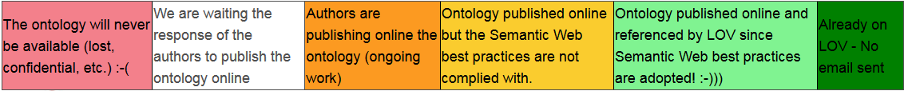

Figure . Classification of projects according to the reusability

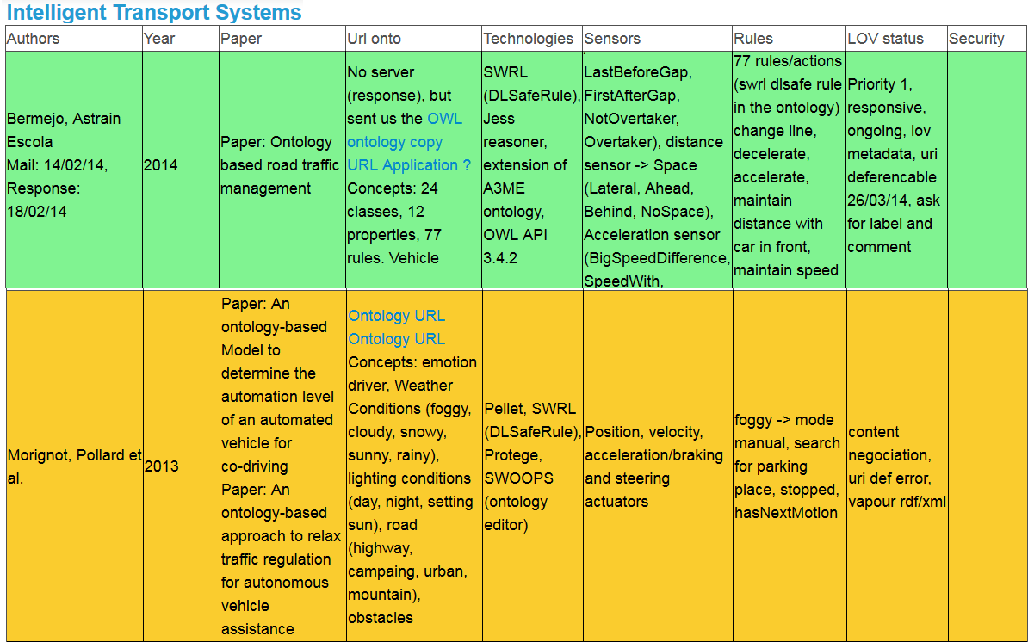

Figure . Screenshot of LOV4IoT

## Simulating SenML sensor measurements

The following interface enables to simulate sensor data:

<http://emulator-box-services.appspot.com/senmladmin/zones>

These data are compliant with the SenML[2] format.

You can simulate heterogeneous domains (healthcare, smart kitchen, smart home, etc.), as you can see in Figure 8. You can create a new domain (Add sub zone button).

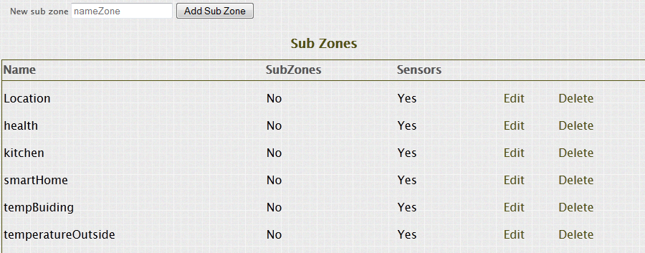

Figure . Simulate M2M area networks

Click on the button “Edit” associated to the kitchen zone.

You go to the following URL:

<http://emulator-box-services.appspot.com/senmladmin/ahdzfmVtdWxhdG9yLWJveC1zZXJ2aWNlc3IWCxIJWm9uZUFkbWluIgdraXRjaGVuDA/edit>.

You can simulate smart devices (sensors, actuators, transducer, controllers and RFID tags).

In this use case, we simulate RFID tags embedded on ingredients.

We simulate SenML measurements (in XML or JSON).

A measurement has a name, a value, a unit, and the date.

Example 1: Measure name: Temperature, Unit: Degree Celsius, Value: 35

Example 2: Measure name: banana, Unit: Gram, Value: 1000

**Use the M3 nomenclature[3] to describe sensor measurements.**

**To be sure that the M3 converter will semantically annotate correctly the sensor measurements.**

**It will ease the process to build the application with the Semantic Web of Things template.**

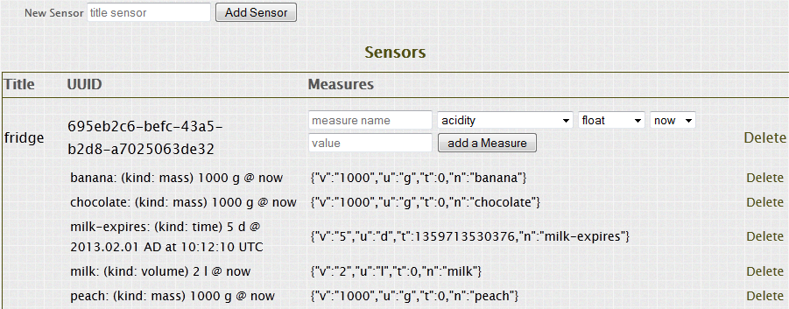

Figure . Simulating sensor measurements

## Converting senML sensor data

Go to the M3 converter to semantically annotate SenML data with RDF according to the M3 ontology.

Web page: <http://www.sensormeasurement.appspot.com/?p=senml_converter>

**Use Chrome to get the data in a text format, with Firefox you only have the JavaScript alert popup.**

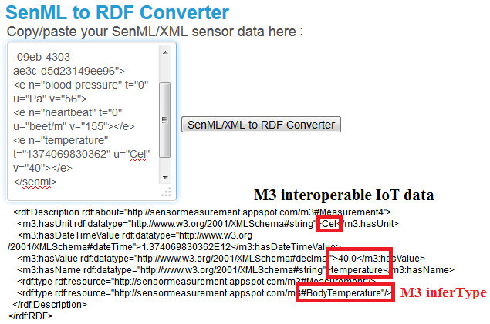

Figure . Semantically annotating IoT data with the M3 converter user interface

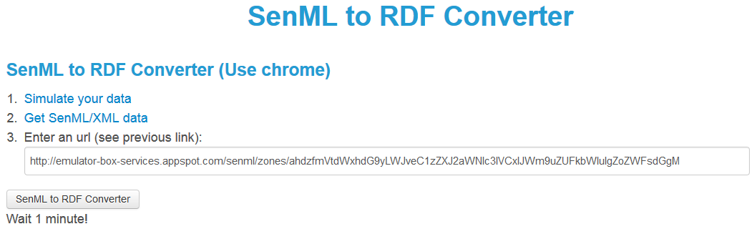

Figure . Semantically annotating sensor data

## Testing our scenarios

* Go to the menu bar
* Go to the tab called “Scenarios”.
* Choose a scenario (e.g. tourism)

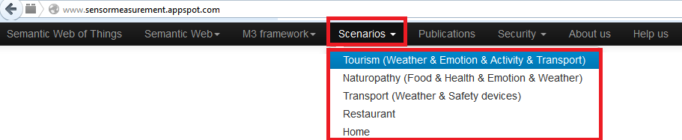

Figure . Testing our scenarios

If you choose the tourism scenario. You will have the following web page.

* Click on the “Activity & Precipitation” button.
* It will display the M3 results after the reasoning process

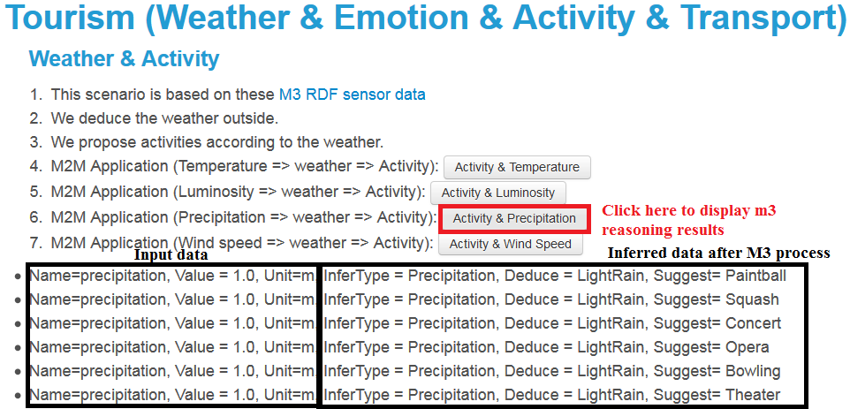

Do not hesitate to try other scenarios.

1. http://lov.okfn.org/dataset/lov/
2. http://www.ietf.org/archive/id/draft-jennings-senml-10.txt
3. www.sensormeasurement.appspot.com/documentation/NomenclatureSensorData.pdf