Sri Lanka Institute of Information Technology



IT3060 Human Computer Interaction
Milestones 01–03 – Final Report
RoadAssist – Vehicle Breakdown and Roadside Assistance Request App
Group: IT_WE_04.01_WE_166
Academic Year: Year 3, Semester 2 – 2026

Student ID | Name | Workload
IT23689930 | Sabra MFF | 25%
IT23731028 | Munshif MMM | 25%
IT23712072 | Zimthi MAA | 25%
IT23715356 | Fawdhan MSM | 25%

Assignment: Milestone 03 – Mobile App Implementation & Final Evaluation
Submission date: 9 October 2026

Table of Contents
Table of Contents 2
Executive Summary 4
1. Milestone 01 Summary 5
1.1 Problem statement and justification 5
1.2 Stakeholders 5
1.3 Research methodology and participants 5
1.4 Key findings 5
1.5 Personas, empathy maps, stories and journey 5
1.6 How Might We statements 6
1.7 Functional and non-functional requirements 6
2. Milestone 02 Summary 7
2.1 Design objectives 7
2.2 Alternative sketches and Variant A 7
2.3 Wireframes and low-fidelity prototype 7
2.4 High-fidelity prototype and design consistency 7
3. Technology Stack Selection and Justification 9
4. System Architecture 10
4.1 Architecture overview 10
4.2 Implemented request workflow 10
4.3 Database and data flow 11
5. Mobile Application Implementation 12
5.1 Project organization 12
5.2 Driver and provider functionality 12
5.3 CRUD analysis 12
5.4 Deviations and evidence gaps 13
5.5 Working-application screenshot placeholders 14
6. Requirement Traceability Matrix 17
7. Functional Testing 18
7.1 Current automated-test status 18
7.2 Blank execution record 18
8. Usability Testing 19
8.1 Objectives and methodology 19
8.2 Proposed participants 19
8.3 Task scenarios and success criteria 19
8.4 Observation and feedback template 19
9. Issues, Fixes and Recommendations 20
10. Overall Gantt Chart 21
11. Conclusion and Lessons Learned 22
References 23
Appendix A – Evidence and Completion Checklist 24
A.1 Repository and evidence boundary 24
A.2 Authoritative group details 24
Appendix B – Extended Interface Audit 25
Appendix C – Blank Functional Test Evidence Log 26
Appendix D – Blank Usability Session Record 26
Appendix E – Final Validation Record 26

Executive Summary
Roadside breakdowns create a time-critical coordination problem: a driver must identify suitable help, communicate the vehicle fault and exact location, understand the likely cost, and remain informed while assistance travels. RoadAssist addresses this problem through a Flutter application for drivers, mechanics and towing operators. The application combines role-based authentication, structured request capture, nearby-provider discovery, provider quotations, real-time lifecycle updates, location tracking, messaging, emergency contacts and request history.
Milestone 01 used a Google Forms questionnaire and reported 50 participants: 31 driver-side respondents and 19 roadside-service providers. Findings included strong demand for GPS location sharing (83.9% of driver-side respondents), real-time tracking and ETA information (96.8%), and cost visibility (96.8%). Provider-side evidence emphasized exact location, breakdown type, contact details, instant notification and in-app communication. These findings produced FR01–FR10 and five quality requirements.
The supplied Milestone 02 report documents selected Variant A and alternative Variant B sketches, wireframes, low- and high-fidelity prototype sections, and selection rationales. Variant A prioritizes explicit role selection, structured breakdown entry, location confirmation, provider comparison and visible assistance progress. The final report now uses this primary evidence; original prototype figures and an accessible project-specific Figma link still need to be incorporated.
Repository inspection confirms an extensive Flutter/Firebase implementation. Retained automated logs show 148 selected Flutter tests passed and 68 Firestore emulator tests passed. These results establish automated coverage only; manual functional outcomes and working-app usability results remain to be recorded. The job-start OTP API is awaiting deployment by the existing Vercel owner and new OTP requests remain disabled. New notification functions were not deployed because the project remains on Firebase Spark.

Milestone 01 Summary

Problem statement and justification
Vehicle breakdowns are unexpected, stressful and often handled through disconnected phone calls, personal contacts or manual searches. These methods can delay assistance and leave uncertainty about provider suitability, arrival time and cost. Providers also need accurate location, contact, vehicle and fault information. A centralized mobile workflow is therefore justified by both the urgency of the scenario and the coordination needs of multiple stakeholders.

Stakeholders
Category | Stakeholder | Role
Primary | Vehicle owner / driver | Requests help, shares location and vehicle details, tracks progress and receives cost/status information.
Secondary | Roadside mechanic / assistance provider | Reviews requests, quotes, travels, communicates and updates service progress.
Secondary | Tow truck operator | Responds to towing needs using vehicle and location details.
Tertiary | Vehicle service-centre representative | Provides subsequent inspection, repair or maintenance when roadside work is insufficient.

Research methodology and participants
The Milestone 01 report identifies an online questionnaire built with Google Forms. It combined closed questions for frequencies/percentages with open questions for experiences and suggestions. The report states 50 total participants and later analyses 31 driver-side responses and 19 provider responses. Raw responses were said to be retained as CSV; that dataset was not supplied for this audit, so the published report remains the evidence source.

Key findings
Evidence | Reported finding | Design implication
F01 | 83.9% of drivers selected GPS sharing; 78.9% of providers required exact location. | Capture GPS plus manual correction.
F02 | 71.0% wanted nearby-mechanic search; 51.6% waited 30+ minutes. | Filter suitable providers and expose availability.
F03 | 96.8% rated tracking and ETA important/very important. | Show live position, route and status.
F04 | 96.8% wanted estimated cost before confirmation. | Require itemized provider offer and driver approval.
F05 | Providers requested breakdown type, vehicle type and media evidence. | Use structured fault/vehicle forms and photo evidence.
F06 | Providers preferred notifications, accept/reject and in-app communication. | Use real-time request streams, quotes/rejection and chat.
F07 | Night-time stranding and safety concerns were reported. | Provide emergency contacts and location sharing.

Personas, empathy maps, stories and journey
The original report contains three stakeholder personas and accompanying empathy-map figures for a driver/vehicle owner, roadside mechanic and vehicle service-centre representative. Their images are not recreated here. Five evidence-linked stories focus on GPS sharing, ETA, real-time tracking, estimated cost and complete provider information. The principal journey is: breakdown → seek assistance → describe fault → share location → wait and track → receive service. Pain points are uncertainty, delay, location difficulty and cost ambiguity.

How Might We statements
- How might we help stranded drivers quickly discover suitable nearby providers?
- How might we reduce uncertainty and stress while drivers wait?
- How might we give mechanics/tow operators accurate location and breakdown information?
- How might we improve communication and cost transparency?

Functional and non-functional requirements
FR01–FR10 cover request/location creation, provider discovery, structured breakdown evidence, provider response, tracking/ETA, communication, progress, cost visibility, emergency contact and history. NFR01–NFR05 address usability, performance, location accuracy, reliability/availability, and security/privacy. Section 6 traces each requirement to current code and planned verification.

Milestone 02 Summary

Design objectives
The design needed to reduce cognitive load in an emergency, make location/cost/status visible, separate driver and provider responsibilities, and keep primary actions reachable on a narrow mobile viewport. These objectives align with Milestone 01.

Alternative sketches and Variant A
Milestone 02 compares Variant A with Variant B across driver and provider workflows. Variant A was selected for dedicated role selection, visual assistance cards, a structured breakdown form, map-based location confirmation with manual correction, informative provider cards, request review, explicit searching feedback and a tracking timeline. Provider variants prioritize complete request context, customer location, communication, service documentation and completion summaries. These are reported design rationales rather than measured working-app outcomes.
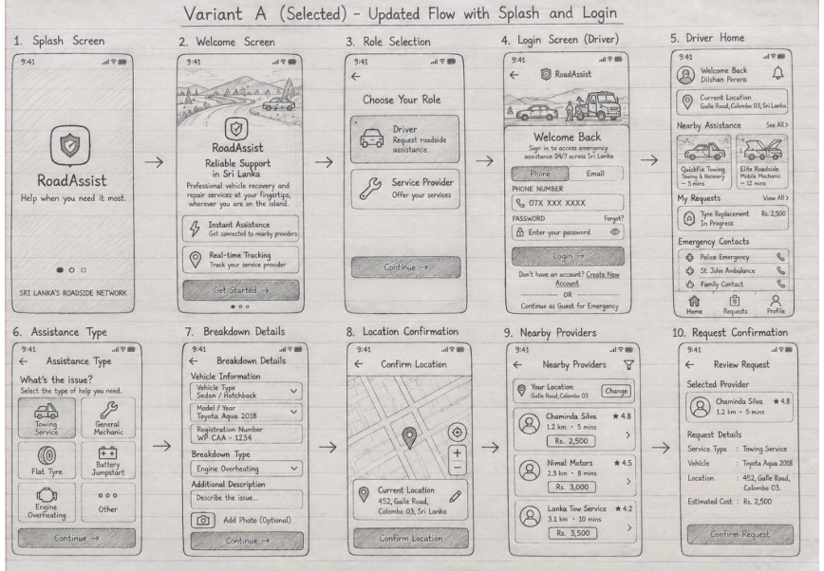
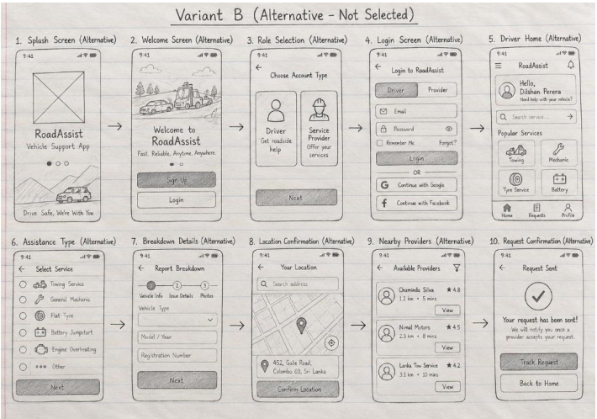

Wireframes and low-fidelity prototype
The supplied M2 report includes wireframe and low-fidelity prototype figure sections. Its driver flow covers sign-in/role selection, home, assistance details, location, provider selection and confirmation; mechanic and towing flows cover sign-in, requests, acceptance and completion. Insert selected original figures with captions. Correct the phrase ?select nearby driver? to ?select nearby provider? in the consolidated explanation.

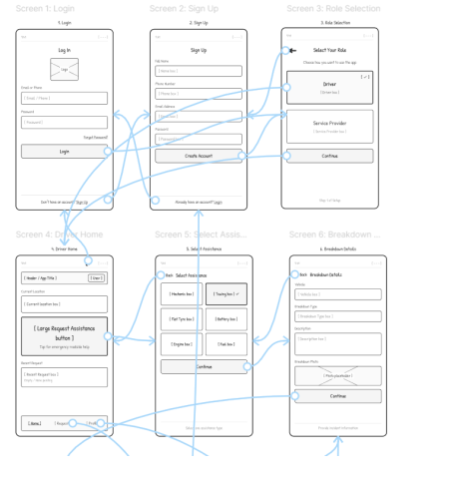
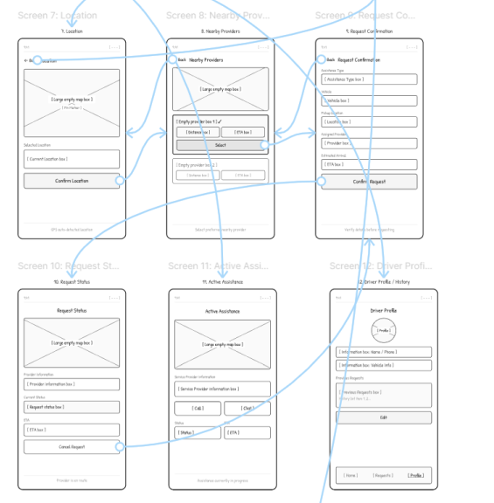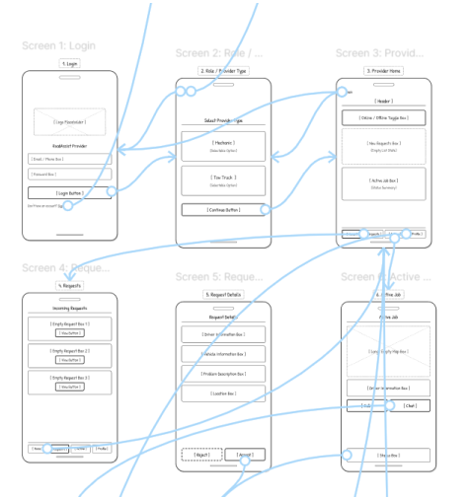
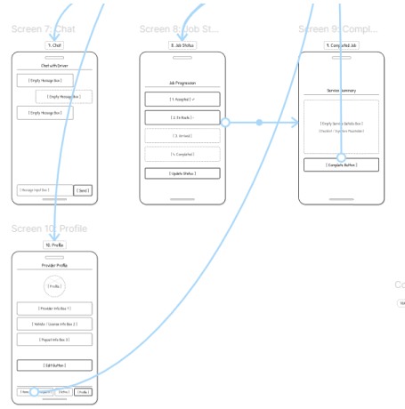

High-fidelity prototype and design consistency
M2 contains authentication, driver and provider high-fidelity interface sections. The implementation retains role-specific navigation and blue/teal visual cues while extending the design with light/dark road backgrounds, provider review, itemized quotes, repair revisions, driver-approved completion and downloadable invoices. Document these as implementation refinements and compare actual app captures with original prototype figures. M2 describes five proxy participants testing the Figma prototype; that activity must not be presented as the required five-participant working-app evaluation.

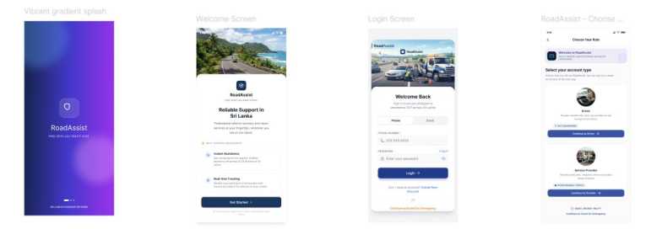
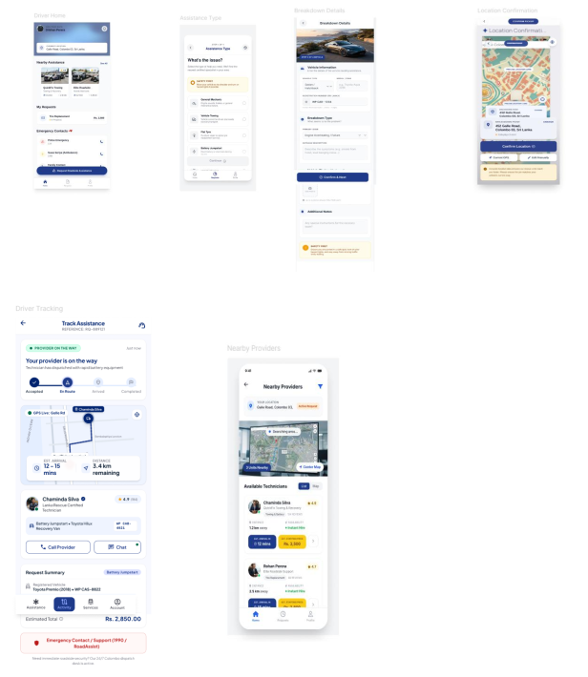
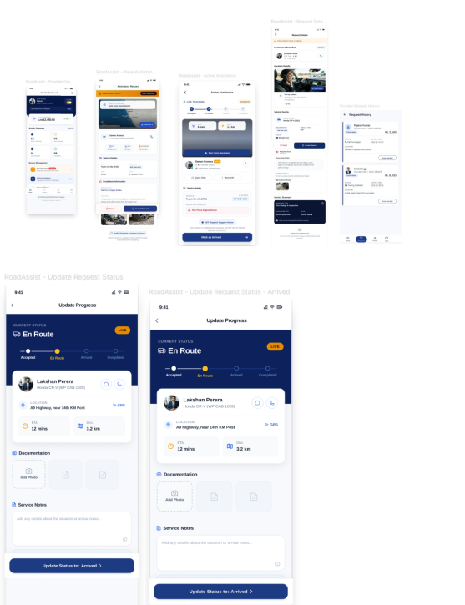

Technology Stack Selection and Justification
Versions below are taken from the repository’s declared dependencies/lock material. A declared version confirms intended configuration, not successful installation in this audit.
Technology / version | Actual purpose | Why suitable / relationship | Advantages and limitations
Flutter / SDK constraint  ^3.11.5 | Cross-platform client UI | Single codebase for driver/provider/admin surfaces | Reactive widgets and broad plugins; current toolchain/dependency resolution must be refreshed.
Dart / ^3.11.5 | Application language | Typed async/stream code for UI and services | Sound typing; version must match installed Flutter SDK.
Firebase Core 4.14.0 | Firebase initialization | Connects platform apps to backend services | Simple integration; configuration/deployment remains external.
Firebase Auth 6.6.1 | Email/password identity | Role access and accountable CRUD | Mature SDK; secure rules and verification still require deployment/testing.
Cloud Firestore 6.9.0 | NoSQL persistence and streams | Requests, profiles, quotes, messages, history | Realtime listeners/transactions; document cost/limits and rules complexity.
Firebase Messaging 16.6.0 | Push client and token lifecycle | Provider offers/status/chat alerts | Cross-platform; delivery requires permission, credentials and deployed functions.
flutter_map 8.3.1 + latlong2  0.10.1 | Map display and coordinates | Breakdown/provider maps without vendor-locked UI | Flexible; tile service policy/SLA must be respected.
geolocator 14.0.3 / geocoding 5.0.0 | GPS, distance and addresses | FR01, FR02, FR05 and NFR03 | Native capability; permission, signal and platform accuracy vary.
http 1.6.0 + Google  Routes/OSRM | Route, distance and ETA | FR05 routing with fallback | Traffic-aware option; network/quota/public-service availability limits.
camera 0.12.0+2 /  image_picker 1.2.3 / image  4.9.2 | Photo capture and compression | FR03 evidence and service documentation | Useful on mobile; permissions and Firestore/Base64 size constraints.
SharedPreferences 2.5.5 | Theme and request-draft persistence | Supports continuity under interruption | Simple local store; not secure database/sync.
url_launcher 6.3.2 | Dialer and external navigation | FR06 and FR09 | Uses installed apps; behaviour varies by device.
Cloud Functions / Node 22 code | Event-driven push processing | Background notification path | Server enforcement possible; deployed state not verified.

System Architecture

Architecture overview
RoadAssist is a feature-organized Flutter client with stateful widgets and explicit service/model classes. Firebase Authentication supplies identity; Cloud Firestore is the primary system of record and synchronization channel. The client calls device plugins for location, camera and dialing, and HTTP route services for road geometry/ETA. Firebase Messaging and backend function code form the push path. Firestore security rules provide data-level authorization.

Driver
interfaces
Provider
interfaces
Admin
interfaces
Flutter client
Stateful widgets
Service classes
Firebase Auth
Cloud Firestore
Firebase Messaging
+
Functions
GPS / OSM /
Routes / OSRM
Figure 4.1 – Code-derived RoadAssist architecture.

Implemented request workflow
Driver creates
request
Providers receive
and quote
Driver selects
offer
Provider travels
and updates
Driver confirms
completion
History / invoice
stored
Firestore snapshot streams synchronize request, quote, message and status changes.
Incomplete/runtime-dependent: deployed push delivery, field GPS accuracy and external route availability.
Figure 4.2 – Implemented quote-based request lifecycle.

Database and data flow
Path | Purpose | Principal operations
users/{uid} | Private identity/profile, roles, settings, active request | Create/read/update; account delete
users/{uid}/vehicles/{id} | Saved vehicles | Create/read/update/archive
providerDirectory/{uid} | Discoverable availability, capability and location metadata | Read/filter/update
requests/{id} | Assistance lifecycle, location, quote selection and completion | Create/read/transactional update/logical cancellation
requests/{id}/quotes/{providerId} | Current provider offer before selection | Create/update/read
requests/{id}/messages/{id} | Request-scoped chat | Create/read; seen markers on request
requests/{id}/repairQuotes/{id} | Immutable proposed price/work revision | Create/read
requests/{id}/repairDecisions/{id} | Driver decision for revision | Create/read
requests/{id}/disputes/case | Complaint evidence/state | Create/read/update
providerApplications / accountModeration / adminAudit | Provider verification and governance | Create/read/update/audit
State management is intentionally lightweight: Firestore streams and stateful widgets drive the UI; service classes encapsulate backend operations. No Bloc, Riverpod, Redux or Provider framework was found. This reduces dependencies but leaves some screens large and tightly coupled to UI state.

Mobile Application Implementation

Project organization
lib/main.dart initializes Firebase and launches RoadAssistApp. lib/src/app.dart contains the app shell, notification navigation and theme tokens. lib/src/features groups authentication, driver, provider, request, chat, billing, complaints, settings, vehicles and admin screens. lib/src/services contains authentication, request, routing, media, device and administrative logic. Models represent drafts, vehicles, availability, analytics and repair revisions.

Driver and provider functionality
Area | Source evidence | Verified operations / limitation
Authentication | main.dart; auth_service.dart; auth screens | Create account/profile, read auth/profile, update roles, delete account. Runtime pending.
Driver request | assistance_type, breakdown_details, location, providers, review | Structured draft, GPS/manual correction, provider filter and transactional request creation.
Offers/cost | searching_screen; quote_offers; RequestService | Provider creates itemized offer; driver reads/selects it; assignment uses transaction.
Provider work | provider_home, request_details, active_job | Read open jobs, quote/reject, update status/location/docs, submit completion.
Tracking/maps | tracking_screen; route_service.dart | Watch provider coordinates; show route/distance/duration. External service runtime pending.
Communication | chat_screen; customer_contact_screen | Create/read text/photo messages; seen marker; call/navigation actions.
History/invoice | history screens; invoice_screen.dart | Read completed/cancelled work; payment declarations and rating updates.
Profile/availability | driver/provider profile; AuthService | Read/update profile; provider services/hours/radius/online state.
Media | photo_upload, vehicle_image services | Compressed Base64 media; no video; Firestore document-size risk.

CRUD analysis
CRUD is evaluated as persisted data operations, not button navigation. Hard deletion is deliberately rare because requests, quotes, repair decisions and disputes require an audit trail.
 | Interface | Create | Read | Update | Delete / retention
 | Registration/profile | Auth user + profile | Current profile | Personal/contact/role/photo | Authenticated account deletion
 | Assistance request | Request document | Driver/provider request streams | Draft fields, search, lifecycle | Logical cancellation; retained for audit
 | Provider request/offer | Quote | Request and competing offer context | Quote before selection; rejection list | No hard delete after selection
 | Active assistance | Repair proposal and messages | Request/location/messages | Status, GPS, notes/photos, completion | No hard delete
 | Saved vehicles | Vehicle | Owner vehicles | Vehicle/default/archive state | Archive rather than erase
 | History/invoice | Payment/rating declaration | Completed/cancelled records | Payment confirmation/rating | No history deletion
 | Provider profile | Verification/application records | Profile/application/directory | Services, hours, radius, availability | Application withdrawal/reset path

Deviations and evidence gaps
Area | Observed implementation | Prototype comparison status / justification
Request pricing | Quote-based marketplace; driver approves provider offer | Fidelity unverified. This supports FR08 and avoids invented prices.
Completion | Provider submits; driver confirms; arrival verification required | Fidelity unverified. Adds accountability and reduces unilateral closure.
Media | Still photos and annotations; no video | Partial FR03. Video omitted from current code.
Provider roles | Mechanic/tow capabilities share provider screens | Avoids duplicate interfaces while capability matching changes content.
Admin portal | Substantial administration workflow present | Beyond FR01–FR10; supports verification/security.
Visual system | Current blue/white/dark theme and shared tokens | Cannot claim Figma match without prototype evidence.

Working-application screenshot placeholders
Only genuine captures from a running build may replace the placeholders. Each image should include a figure number, platform/device, date and test account role.

[INSERT ACTUAL FLUTTER DRIVER DASHBOARD SCREENSHOT HERE]
Replace with a genuine screenshot from the running Flutter application.
Figure 5.1 – Driver dashboard (pending genuine capture).

[INSERT ACTUAL FLUTTER REQUEST ASSISTANCE SCREENSHOT HERE]
Replace with a genuine screenshot from the running Flutter application.
Figure 5.2 – Assistance request flow (pending genuine capture).
[INSERT ACTUAL FLUTTER PROVIDER DASHBOARD SCREENSHOT HERE]
Replace with a genuine screenshot from the running Flutter application.
Figure 5.3 – Provider dashboard (pending genuine capture).

[INSERT ACTUAL FLUTTER REQUEST DETAILS SCREENSHOT HERE]
Replace with a genuine screenshot from the running Flutter application.
Figure 5.4 – Provider request details (pending genuine capture).
[INSERT ACTUAL FLUTTER ACTIVE ASSISTANCE SCREENSHOT HERE]
Replace with a genuine screenshot from the running Flutter application.
Figure 5.5 – Active assistance (pending genuine capture).
[INSERT ACTUAL FLUTTER UPDATE PROGRESS SCREENSHOT HERE]
Replace with a genuine screenshot from the running Flutter application.
Figure 5.6 – Update progress (pending genuine capture).

Requirement Traceability Matrix
‘Code-verified’ means a corresponding implementation was inspected. It is not a Passed test result. Prototype mappings use the expected interface name; fidelity remains pending because the Milestone 02 artefact is missing.
ID | User requirement | Prototype interface | Implemented feature | Source file | Test | Verification
FR01 | Submit an assistance request and share current GPS location | Assistance Type →  Breakdown Details →  Location → Review | RequestService.createRequest;  GPS/manual coordinates | TC-05, TC-06 | Implemented and code verified; runtime not recorded
FR02 | Display suitable nearby mechanics and towing providers | Providers | Online/verified/capability/radius filtering | TC-07 | Implemented and code verified; live data not recorded
FR03 | Specify assistance, vehicle, breakdown and attach photos/videos | Breakdown Details | Issues, vehicle, narrative, photos and annotations | TC-08 | Partially  implemented: video not found
FR04 | Notify providers and allow accept/reject | Provider Dashboard /  Request Details | Open-request stream, quote and reject operations | TC-09, TC-10 | Implemented in code; push deployment unverified
FR05 | Track assigned provider and show  ETA | Tracking | Live coordinates, route distance and duration | TC-11 | Implemented in code; field test pending
FR06 | In-app driver/provider communication | Chat / Customer Contact | Request-scoped text/photo messages and call prompt | TC-12 | Implemented and code verified; runtime pending
FR07 | Provider updates Accepted, En Route,  Arrived, Completed | Active Assistance / Update  Progress | Guarded lifecycle and two-party completion | TC-13, TC-14 | Implemented and code verified; runtime pending
FR08 | Show estimated cost before assistance confirmation | Offers / Review / Invoice | Itemized quote approved before provider assignment | TC-15 | Implemented and code verified
FR09 | Emergency contact option | Emergency / Driver Profile | 119, 1990, saved contact and location copy | TC-16 | Implemented and code verified
FR10 | Completed request history for both roles | Driver and Provider  History | Role-filtered request streams and detail/invoice | TC-17, TC-18 | Implemented and code verified
NFR01 | Usability | Shared themes and guided workflows | Labels, validation, design tokens | UT-01–UT-05 | Partially evidenced; usability results absent
NFR02 | Performance | Realtime screens | Snapshot streams and indexed queries | TC-19 | Partially evidenced; latency not measured
NFR03 | Location accuracy | Location / Tracking | Accuracy capture and manual correction | TC-06, TC-11 | Partially evidenced; field accuracy pending
NFR04 | Reliability and availability | Drafts and lifecycle | Transactions, persisted drafts, fallback routes | TC-20 | Partially evidenced; recovery/uptime me pending
NFR05 | Security and privacy | Authentication/access gates | Auth, roles and Firestore rules | TC-01–TC-04 | Implemented in code; deployed  rules test pending

Functional Testing
The following cases are definitions, not executed results. For every case, Actual Result, Pass/Fail, Execution Date, Tester Name and Evidence remain: Not yet recorded. A valid execution should identify build/commit, device/OS, Firebase environment and evidence filename.
ID | Req. | Objective | Preconditions | Procedure | Test data | Expected result
TC-01 | NFR05 | Register a driver | No account exists | Choose Driver; enter valid name, phone, email and password; submit | New unique email | Auth account and driver profile are created; verification path appears
TC-02 | NFR05 | Register a provider | No account exists | Choose Provider; enter valid details; submit verification information | New unique email | Provider profile/application is created and access gate reflects status
TC-03 | NFR05 | Login with valid role | Verified seeded account | Select matching role; enter credentials; sign in | Driver test account | Correct role shell opens
TC-04 | NFR05 | Reject invalid login | Account exists | Enter wrong password or mismatched role | Wrong password | Access is denied with actionable feedback
TC-05 | FR01 | Create assistance request | Driver signed in; no active request | Complete request wizard and submit | Flat tyre; sedan | A searching request and profile lock are stored
TC-06 | FR01/NFR  03 | Confirm/correct GPS | Location permission available | Use GPS; inspect accuracy; move pin or use manual address | Device coordinates | Draft stores confirmed coordinates, label and available accuracy
TC-07 | FR02 | Discover suitable providers | Verified providers seeded | Open provider selection | Online matching and offline provider | Only suitable available providers appear with distance context
TC-08 | FR03 | Attach breakdown photo | Camera/gallery permission | Add photo; preview; remove/re-add; continue | JPEG image | Compressed photo persists in draft/request within limits
TC-09 | FR04/FR08 | Provider sends quote | Open matching request; provider online | Open details; enter itemized charges and notes; send | 1000+500+0 LKR | Quote subdocument is visible to driver; assignment has not yet occurred
TC-10 | FR04 | Provider rejects request | Open request | Tap reject | Provider account | Provider ID is added to rejectedBy without cancelling for others
TC-11 | FR05 | Track provider and ETA | Driver selected quote; provider sharing GPS | Open tracking and observe movement | Two physical devices | Marker, route, distance/ETA and timestamp update
TC-12 | FR06 | Exchange chat messages | Assigned request; two accounts | Send text and photo from both roles; reopen inbox | Text + image | Messages appear in order; seen indicators update
TC-13 | FR07 | Advance job status | Assigned provider | Mark En Route then Arrived | Accepted request | Only allowed transitions persist and driver view updates
TC-14 | FR07 | Complete with confirmation | Arrived; driver confirmed arrival; notes/photo added | Provider submits completion; driver confirms | Approved total | Request becomes completed and provider reservation clears
TC-15 | FR08 | Review and approve quote | At least two quotes | Compare itemized offers and select one | Direct/inspection quotes | Selected immutable offer assigns available provider transactionally
TC-16 | FR09 | Use emergency option | Dialer-capable device | Open Emergency; choose  119/1990/saved contact; confirm call | Valid phone | Dialer opens only after confirmation; saved location can be copied
TC-17 | FR10 | View driver history | Driver has completed/cancelled requests | Open History; filter; open detail | Seeded history | Only driver records appear with accurate status and detail
TC-18 | FR10 | View provider history | Provider has assigned records | Open History; filter; open detail/invoice | Seeded history | Only provider records appear
TC-19 | NFR02 | Measure realtime delay | Two devices and timestamp capture | Change status; measure until peer UI updates; repeat | 10 trials | Target threshold must be agreed; observed values recorded
TC-20 | NFR04 | Resume interrupted request | Draft/request in progress | Close/restart app and sign in | Active draft/request | Correct account draft or Firestore active request is recovered

Current automated-test status
Retained local execution logs from 9 October 2026 show 148 selected Flutter widget/unit tests passed and 68 Firestore workflow emulator tests passed. The inspected analyzer log contains 40 diagnostics, including warnings/information; this is not a clean zero-diagnostic result. These selected automated checks do not establish that TC-01 through TC-20 passed on physical devices. Record build identity, test scope and evidence links before submission.

Blank execution record
Test ID | Actual Result | Pass/Fail | Execution Date | Tester Name | Evidence
________ | Not yet recorded | Not yet recorded | Not yet recorded | Not yet recorded | Not yet recorded

Usability Testing

Objectives and methodology
Evaluate whether representative users can complete the principal driver and provider tasks safely, efficiently and with understandable feedback. Use moderated task-based sessions on the working app, think-aloud where appropriate, observation notes, post-task ease ratings (1 very difficult to 5 very easy), error counts and a short debrief. Obtain consent and avoid collecting unnecessary personal data.

Proposed participants
Participant | Role | Experience / screening | Consent | Session status
UT-P01 | Driver | To be recorded | Pending | Not conducted/recorded
UT-P02 | Driver | To be recorded | Pending | Not conducted/recorded
UT-P03 | Driver | To be recorded | Pending | Not conducted/recorded
UT-P04 | Mechanic | To be recorded | Pending | Not conducted/recorded
UT-P05 | Tow Truck Operator | To be recorded | Pending | Not conducted/recorded

Task scenarios and success criteria
Task | Participant goal | Success criterion | Result / ease / errors
UT-01 | Register/login and identify role home | Completes without moderator takeover | Not yet recorded
UT-02 | Create request with vehicle, photo and location | Valid request reaches searching/offers | Not yet recorded
UT-03 | Compare quotes and track assigned provider | Chooses intentionally and locates ETA/status/chat | Not yet recorded
UT-04 | Provider reviews, quotes and rejects another request | Correct operations without workflow confusion | Not yet recorded
UT-05 | Provider progresses job; driver confirms completion | Valid transitions and two-party completion | Not yet recorded
UT-06 | Find emergency help and history | Correct contact/history detail found | Not yet recorded

Observation and feedback template
Participant / task
Completed?
Time
Ease 1–5
Errors / observed difficulty
Comment / recommendation
____________
Results summary fields: completion rate ______; median task time ______; mean ease rating ______; total critical errors
______; overall satisfaction ______; recurring themes ______. These fields must remain blank until supported by
signed/recorded sessions.

Issues, Fixes and Recommendations
Issue | Interface | Description | Severity | Evidence | Fix implemented | Recommendation
I-01 | Report/prototype | Milestone 02 supplied; authentic figures and project-specific prototype link still need integration. | High | Workspace document search | No | Integrate supplied M2 design evidence and obtain working-app testing evidence.
I-02 | Breakdown media | Video attachment required by FR03 was not found. | Medium | Request draft/media source | No | Either implement bounded video storage or document agreed scope change.
I-03 | Build environment | google_fonts is declared/locked but absent from local generated package config/cache. | High | Direct analyzer output | No | Run flutter pub get in a clean supported SDK, then analyze/test.
I-04 | Verification | Selected automated tests passed; physical-device test execution is still pending. | High | Flutter launcher blocked | No | Resolve tool lock/dependencies and record fresh logs/evidence.
I-05 | Media storage | Base64 images in Firestore face document-size/cost limits. | Medium | Photo services/request model | No | Move production media to object storage with secured URLs.
I-06 | Push notifications | Client/function code exists but deployment and device delivery are unverified. | Medium | push_notifications.md and function source | No | Deploy approved config and run background two-device tests.
I-07 | CRUD marking | Some display/navigation interfaces do not independently expose two CRUD operations. | High | Screen/service audit | No | Create member-interface CRUD map and obtain lecturer clarification.
I-08 | External maps/routes | Public OSM/OSRM availability has no application SLA. | Medium | route_service.dart / OSM policy | Partial fallback | Use production tile/route provider, caching/policy compliance and monitoring.

Overall Gantt Chart
Dates are shown only where supported by assignment briefs or Git history. No undocumented task dates have been invented.
Activity | 24 Jul–9 Aug | 10 Aug–27 Sep | 28–30 Sep | 1–4 Oct | 5–9 Oct | Status/evidence
Milestone 01 research/stakehold ers/requirements | Official assignment window |  |  |  |  | M1 report supplied; internal dates unavailable
Milestone 02  variants/wireframes/prototype | Official M2 window |  |  |  |  | M2 report supplied; final-report integration in progress.
Milestone 03 implementation |  |  | Initial commits and request workflow | Quotes/profiles/admi n integration | UI/integration/report work | Git history: 28 Sep–9 Oct
Functional testing |  |  | Test source added | Further tests documented | Fresh execution pending | Not yet recorded
Usability testing |  |  |  |  | Pending | No participant evidence supplied
Refinements |  |  | Lifecycle/location | Quote/completion workflows | UI integrations | Code history; runtime validation pending
Report preparation |  |  |  |  | 9 Oct | Current evidence-based draft

Conclusion and Lessons Learned
RoadAssist converts Milestone 01’s principal findings into a broad Flutter/Firebase workflow. Code inspection verifies structured request capture, suitable-provider filtering, itemized offers, guarded assignment, location/status synchronization, request-scoped chat, two-party completion, emergency access and role-specific history. Transactions and security rules show attention to integrity; shared design tokens and validation support consistency.
The strongest HCI lesson is that uncertainty—not merely dispatch—is the central problem. Location confirmation, cost approval, visible state transitions and communication directly answer the reported anxiety around waiting and unclear service. The implementation also illustrates how safety-oriented constraints can improve trust: providers cannot silently overwrite selected offers, completion requires evidence and driver confirmation, and cancellation preserves an audit trail.
The submission evidence remains incomplete. Milestone 02 has now been supplied and supports design selection and prototype comparison. Working-application screenshots, physical-device functional outcomes and at least five working-app usability sessions still need to be recorded. FR03 video support remains outside the current implementation. The OTP backend and background notification deployment limitations must be disclosed.
Subject to those pending checks, the repository demonstrates substantial implementation coverage. The report deliberately separates source-code verification from runtime and user validation so that the final viva can be accurate, reproducible and ethically defensible.

Submission constraint: maximum 35 pages including the cover. The supplied brief does not explicitly exclude references or appendices; keep the entire submitted PDF within 35 pages unless the lecturer confirms otherwise.

References
- RoadAssist Group IT_WE_04.01_WE_166, “Vehicle Breakdown and Roadside AssistanceRequest App – Milestone 01,” IT3060 Human Computer Interaction, SLIIT, 2026.
- SLIIT, “IT3060 Milestone 03: Mobile App Implementation & Final Evaluation,” officialassignment brief, published 28 Sep. 2026.
- Flutter, “Flutter architectural overview,” Flutter Documentation. https://docs.flutter.dev/resources/architectural-overview (accessed 9 Oct. 2026).
- Flutter, “Guide to app architecture,” Flutter Documentation. https://docs.flutter.dev/app-architecture/guide (accessed 9 Oct. 2026).
- Google, “Welcome to Firebase for Flutter,” Firebase Documentation. https://firebase.google.com/docs/flutter (accessed 9 Oct. 2026).
- Google, “Get started with Firebase Authentication on Flutter,” Firebase Documentation.https://firebase.google.com/docs/auth/flutter/start (accessed 9 Oct. 2026).
- Google, “Get realtime updates with Cloud Firestore,” Firebase Documentation. https://firebase.google.com/docs/firestore/query-data/listen (accessed 9 Oct. 2026).
- Google, “Get started with Firebase Cloud Messaging in Flutter apps,” Firebase Documentation.
- https://firebase.google.com/docs/cloud-messaging/flutter/get-started (accessed 9 Oct. 2026).
- flutter_map contributors, “flutter_map Documentation.” https://docs.fleaflet.dev/ (accessed 9 Oct.2026).
- OpenStreetMap Foundation, “Tile Usage Policy.” https://operations.osmfoundation.org/policies/tiles/ (accessed 9 Oct. 2026).
- Project OSRM, “OSRM API Documentation.” https://project-osrm.org/docs/v5.24.0/api/(accessed 9 Oct. 2026).

Appendix A – Evidence and Completion Checklist

Required evidence | Current status | Action before final submission
Milestone 01 report | Available and summarized | Confirm figures/raw-data link and correct legacy member mapping
Milestone 02 group report/Figma | Missing | Insert authentic artefacts and trace design decisions
Working application screenshots | Placeholders only | Capture genuine driver/provider flows with captions
Functional test logs | Not yet recorded | Execute cases and attach result/evidence log
Five usability sessions | Not yet recorded | Obtain consent, conduct sessions and analyze results
Automated test/analyzer logs | Selected tests passed; see retained logs. Manual testing pending. | Resolve SDK/dependencies and retain fresh logs
APK/live demo | Not verified | Build/install and rehearse role-specific viva

A.1 Repository and evidence boundary
Repository: https://github.com/MMMMunshif/roadassist-vehicle-breakdown-app. Audit source: current local working tree on 9 October 2026. Code-verified findings must not be presented as Passed runtime tests.

A.2 Authoritative group details
Student ID | Name | Workload
IT23689930 | Sabra MFF | 25%
IT23731028 | Munshif MMM | 25%
IT23712072 | Zimthi MAA | 25%
IT23715356 | Fawdhan MSM | 25%

Appendix B – Extended Interface Audit
Interface | Main source | CRUD summary | Status
Login/Registration | auth_form.dart; auth_service.dart | C profile; R auth/profile; U roles; D account | Code-verified
Driver request wizard | features/request/*; RequestService | C request; R settings/providers; U draft/search; cancellation retained | Code-verified
Tracking | tracking_screen.dart; route_service.dart | R request/route; U confirmation/rating/payment | Code-verified; runtime pending
Provider dashboard/details | provider_home/request_details | R requests; C/U quote; U reject/availability | Code-verified
Active job | provider_active_job_screen.dart | R job; C repair/message; U GPS/status/docs/completion | Code-verified
Chat | chat_screen.dart | C/R messages; U seen marker; no delete | Code-verified
Profiles/vehicles | profile and vehicles features | C/R/U and account/vehicle logical delete | Code-verified
History/invoice | history + invoice screens | R records; U rating/payment | Code-verified
Emergency/contact | emergency/customer_contact | R contact/location; device actions | Code-verified; limited  CRUD
Admin | features/admin/* | C/R/U moderation/audit; controlled deletion API | Code-verified; outside core FRs

Appendix C – Blank Functional Test Evidence Log
Test ID | Actual result | Pass/Fail | Execution date | Tester | Evidence file/link
TC-01 | Not yet recorded | Not yet recorded | Not yet recorded | Not yet recorded | Not yet recorded
TC-02 | Not yet recorded | Not yet recorded | Not yet recorded | Not yet recorded | Not yet recorded
TC-03 | Not yet recorded | Not yet recorded | Not yet recorded | Not yet recorded | Not yet recorded
TC-04 | Not yet recorded | Not yet recorded | Not yet recorded | Not yet recorded | Not yet recorded
TC-05–TC-20 | Use one row per execution

Appendix D – Blank Usability Session Record
Participant code: ______ Role: ______ Date/time: ______ Device/build: ______ Moderator: ______ Consent reference: ______
Task | Completed | Time | Ease 1–5 | Errors | Observation/comment
UT-01
UT-02
UT-03
UT-04/05/06

Debrief: What worked well? ____________________. What was confusing?
____________________. What should change first? ____________________. Overall satisfaction (1–5): ______. Participant comments: ____________________.

Appendix E – Final Validation Record
Validation check | Result
Correct four names/IDs/workloads | Confirmed against supplied master prompt
Project/group/module title | Confirmed
FR01–FR10 and NFR01–NFR05 mapped | Confirmed
No fabricated test/usability results | Confirmed
Screenshot placeholders present | Confirmed
PDF opens and page count readable | Validated programmatically after generation
Main report ≤35 pages | Recorded in assignment3/README.md after generation
Milestone 02 comparison and figure integration | Pending
Fresh automated/device/usability evidence | Pending

