**PROJECT REPORT TEMPLATE**

**1.INTRODUCTION**

1.1 Overview

Customer relationship management (CRM) is **the combination of practices, strategies and technologies that companies use to manage and analyze customer interactions and data throughout the customer lifecycle**. The goal is to improve customer service relationships and assist in customer retention and drive sales growth.

1.2 Purpose

Education institutes, colleges, universities need [lead management software](https://www.whsuites.com/) in order to manage the data. The data includes student’s data, teachers’ data, partner’s data, franchisor’s data, etc. This tool used to manage the relationship and interaction between the customers and the organization. customer relationship management helps companies stay connected to customers to increase their profitability. It uses data analysis about the customer’s history with a company to improve business relationships with customers.

**2.PROBLEM DEFINITION & DESIGN THINKING**

2.1 Empathy map

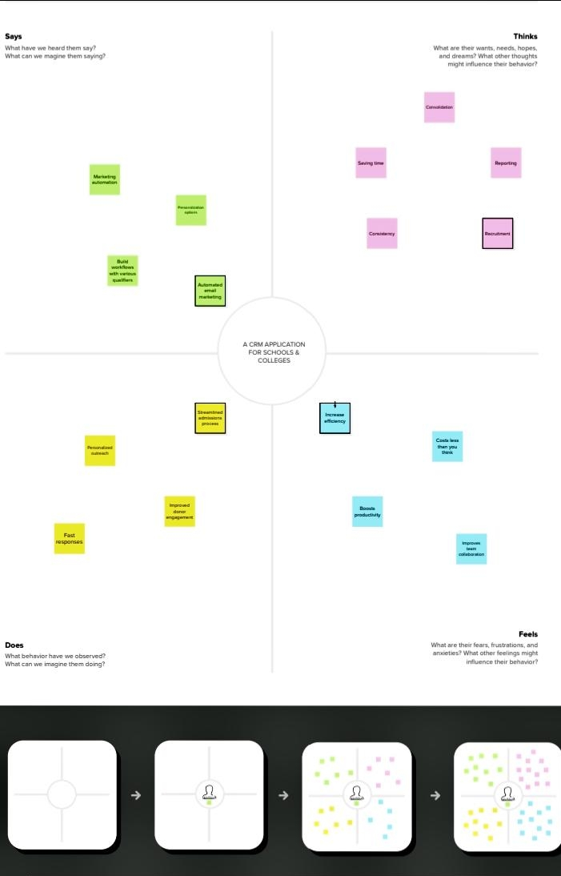

2.2 Ideation & Brainstorming map

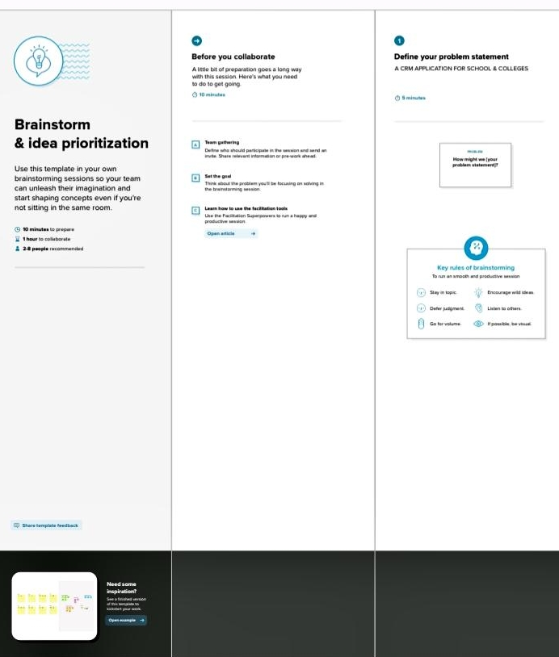

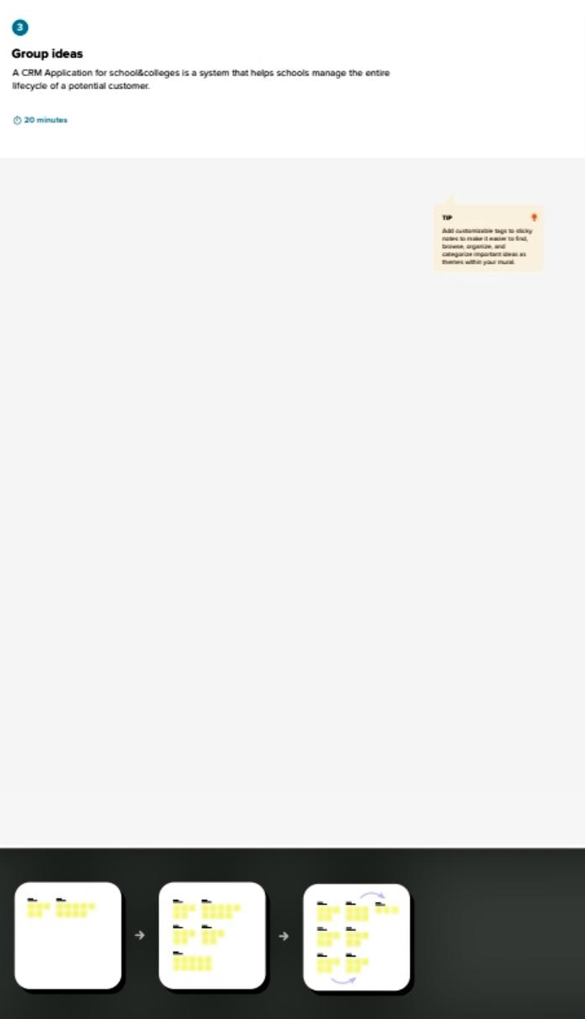

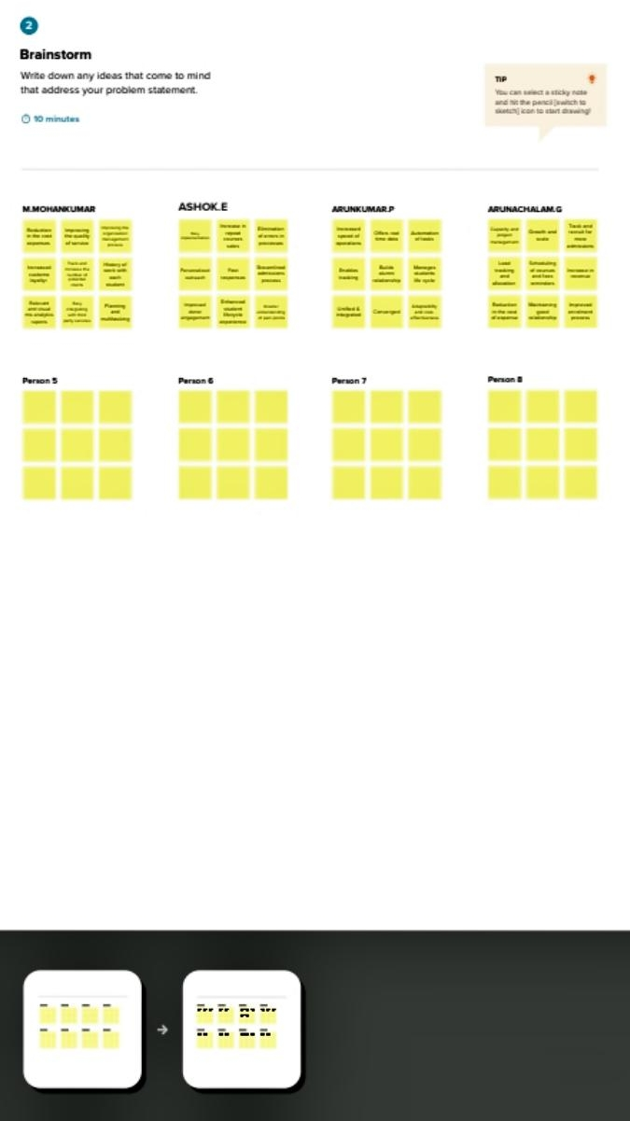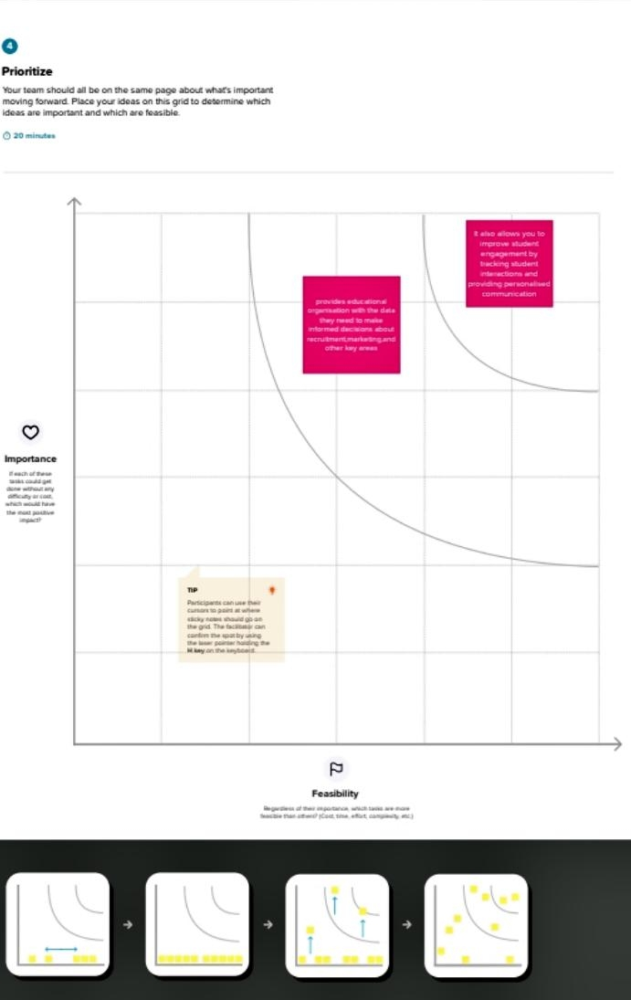

**3.RESULT**

3.2 ACTIVITY & SCREENSHOT



**4.TRAILHEAT PROFILE PUBLIC URL**

Team lead - https://trailblazer.me/id/mohan7603

Team member 1 - https://trailblazer.me/id/ashok1011

Team member **2 -** https://trailblazer.me/id/arun2662

Team member **3** - **-** https://trailblazer.me/id/arun2805

**5.ADVANTAGES & DISADVANTAGES**

**Advantages**

* **Provide customer services**: Customer relationship management is a helpful technology that provides services to customers through call centers, or contact centers. It helps the organization collect data on customer satisfaction and enhances the productivity of the organization.
* **Customers are retained**: With a fully satisfied customer, an organization can retain its customer and can progress and maximize its profit. A happy customer is a key to the success of the organization. No business could run for longer if the customers are dissatisfied.
* **Revenue is increased:**With the increased satisfaction of the customer revenue of the organization will increase and thus will help make a profit. Revenue is considered a great asset for the business. Only earning profit without satisfying customers would not make the organization progress.
* **Campaigning in the market**: One of the best uses of Customer relationship management is it not only helps bonding with the customer but also helps in campaigning in the market about the product of the organization. It helps in building a brand and customers get easily attracted to the brand.
* **Communication:**Since a business or any organization can only run through the customer’s demand and sales thus communication plays a major role in the process of selling. Customer relationship management or CRM helps in communication and maintaining good relationships with the customer.

**DISADVANTAGE**

* **Training is required**: For a CRM system a well-trained staff is required and for the training of these staff organizations have to spend a high cost on the training of the CRM staff members. They have to learn and acquire knowledge related to CRM systems. Both efforts in terms of money and in terms of time are required to acquire knowledge of CRM.
* **High cost:**As we have already seen that training requires a high cost as well as the whole system of CRM an expensive cost. Setting and implementation of CRM system costs are high. Also, the cost of software is very high.
* **Issue related to the protection:**Since all the data is located in the centralized system location thus the chances that the data may get lost are high and security related to software and data is one of the disadvantages of CRM.
* **Access by the third party:**Since data is not secured in CRM the third party can access the data anytime. There are chances that data may get hacked and employees may also adulterate the data which may provide inaccurate information to the management.
* **The human element is eliminated:**Since CRM is a system of fully automated software thus the involvement of humans is the least. As human involvement is the least it lacks the personal touch of humans and therefore can reduce sales and revenue.

**6.APPLICATIONS**

Tracking Customers.

Collecting Data for Marketing.

Improving Interactions and Communications.

Streamlining Internal Sales Processes.

**7.CONCLUSION**

Customer Relationship Management **enables a company to align its strategy with the needs of the customer in order to best meet those needs and thus ensure long-term customer loyalty**.

**8.FUTURE SCOPE**

**Customers will become a company's best sales reps through superior products and services as well as customer-oriented messaging**. The future of CRM is more than just the future of Customer Relationship Management software. It is really the future of business.