0

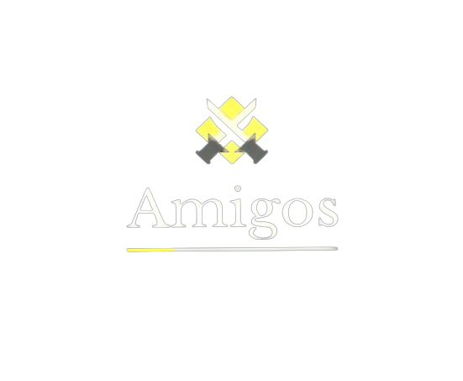

Картина, която съдържа стрелка

Описанието е генерирано автоматично

Table of contents

1. Team members 3

2. Summary 3

2.1 Goal 3

2.2 Stages of Realization 3

2.3 Used Technologies 4

2.4 Difficulties we encountered 4

3. Block Diagram 4

4. Functions 5

5. Conclusion 6

# **Team members**

Martin Mechkov – Scrum Trainer

* [MMMechkov19@codingburgas.bg](mailto:•%09MMMechkov19@codingburgas.bg)

Polya Dimitrova – Front-End Developer

* [PDDimitrova@codingburgas.bg](mailto:•%09PDDimitrova@codingburgas.bg)

Martin Martinov – Back-End Developer

* [MVMartinov19@coingburgas.bg](mailto:•%09MVMartinov19@coingburgas.bg)

Kristian Tsvetkov – QA Engineer

* [KPTsvetkov@codingburgas.bg](mailto:•%09KPTsvetkov@codingburgas.bg)

# **Summary**

## **Goal**

* + The main goal of our project is to present C++ History Application. We have created an amazing algorithm and an easy to use and understand styled UI.

## **Stages of Realization**

* + First, we discussed ideas related with the project.
  + We assigned roles, tasks and scheduled meetings.
  + The Back-End and Front-End developers started writing the code for our application.
  + The QA Documentation was made by the QA Engineer and Front-End developer.
  + Our Scrum Trainer made the presentation, documentation and README.

## **Used Technologies**

|  |  |
| --- | --- |
| Visual Studio | Used as a base where to write the code. |
| Icon  Description automatically generatedIcon  Description automatically generatedVisual Studio Code | Used to make the README file. |
| Icon  Description automatically generatedGitHub | To synchronize the team and upload the project’s files. |
| Transparent Discord Logo PNG Square 2021 | PnggridDiscord | For communication. |
| Download Microsoft Word (Multi-Tool Word) Logo in SVG Vector or PNG File  Format - Logo.wineWord | For documentation. |
| Download Microsoft Excel Logo in SVG Vector or PNG File Format - Logo.wineExcel | For QA documentation. |
| Icon  Description automatically generatedPowerPoint | For presentation. |
| Krita - WikipediaKrita | For logo. |

## **Difficulties we encountered**

|  |  |
| --- | --- |
| Team Configuration | 6/10 |
| Code Development | **9/10** |
| Roles Distribution | **6/10** |
| Team Organization | **6/10** |

# **Block Diagram**

# **Functions**

|  |  |  |  |  |
| --- | --- | --- | --- | --- |
|  |  |  |  |  |
| File | **Name** | **Type** | **Parameters** | **Purpose** |
| Admin.cpp | addEvent() | void | - | Function for adding to the linked list |
| getFirstKingdomEvents() | EVENT_LIST* | - | Function for getting first Kingdom events |
| getSecondKingdomEvents() | EVENT_LIST* | - | Function for getting second Kingdom events |
| initialiseEvents() | void | - | Function for initializing events |
| AccountSystem.cpp | addAccount() | void | ACCOUNT account | Function for adding account to the linked list |
| isNameValid() | bool | std::string name | Function for checking validity of name |
| isPassValid() | bool | std::string password | Function for passing the validity |
| isMailValid() | bool | std::string email | Function for mail validity |
| countSymbols() | int | char symbol, std::string word | Function for counting symbols |
| isEmailStartsWith() | bool | std::string email | Function for starting email typing |
| AccountSystem.cpp | counterUpperCase() | int | std::string password | Function for counting upper symbols |
| isNameContainsNumbers() | bool | std::string name | Function for checking for containing numbers |
| searchAccount() | ACCOUNT | std::string email, std::string password | Function for searching account |
| initialiseAccounts() | void | - | Function for initializing accounts |
| Admin.cpp | removeFirstKingdomEvents() | void | - | Remove First Kingdom events |
| removeSecondKingdomEvents() | void | - | Remove Second Kingdom events |

# **Conclusion**

The project taught us how to work in a team, take responsibility and gave us the skill to allocate our time properly. We also developed a lot in writing in C++.