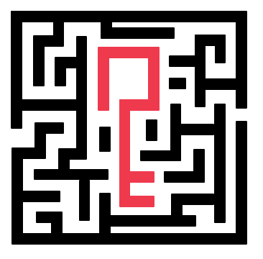

U N T I T L E D

Documentation

Contents

1. Team 1

2. Roles 1

3. Used Technologies 1

4. Resume 1

5. Steps Of Realisation 1

# **Team**

* Vanina Teneva (QA Engineer) – [VNTeneva19@codingburgas.bg](mailto:VNTeneva19@codingburgas.bg)
* Maria Ilcheva (Back-End Developer) – [MZIlcheva19@codingburgas.bg](mailto:MZIlcheva19@codingburgas.bg)
* Hristo Kovachev (Front-End Developer) – [HPKovachev19@codingburgas.bg](mailto:HPKovachev19@codingburgas.bg)
* Martin Mechkov (Scrum Trainer) – [MMMechkov@codingburgas.bg](mailto:MMMechkov@codingburgas.bg)

# **Used Technologies**

* Visual Studio – Application
* Teams – Communication
* GitHub – Organization
* Miro – Game Diagram
* Adobe Illustrator – Logo
* Microsoft Word – Documentation
* Microsoft PowerPoint – Presentation
* Microsoft Excel – QA Documentation
* TestCaseLab.com – QA Documentation

# **Resume**

This is a game of C++, made for the school project - "Maze Sprint". The aim of the game is to get out of a maze with 3 levels of difficulty - easy, medium and difficult. Each time, the program generates a new maze for the user using Recursive Backtracking Algorithm.

# **Stages of development**

# **4.1 Idea**

After forming a team, we chose everyone’s roles, and we organized the team’s meetings. We talked about our idea and how we were going to fulfill it.

# **4.2 Organisation**

For our organization we used planners in GitHub, where we have 3 different projects for meetings, the code and QA testing. All the tasks were assigned to the team, and we started working on them.

# **4.3 Realisation**

Occasionally we held meetings where we talked about what we were going to do next on the code and we tried to neutralize any mistakes or problems and to talk about where everyone is at and how much work is left.

# **4.4 Testing**

Our QA Engineer did the necessary tests to check if the program has any problems or mistakes on the code.

# **4.5 Polishing**

We had a meeting for one last time to check everything for any last mistakes and to finish the project

# **4.6 Presenting**

After we finished the presentation, we assigned everyone to different slides. Everyone wrote script for each slide, they were assigned to. We made the presentation automated such as adding each person’s voice to the slide.

# **Diagram**

# 