Technical Documentation
Automatic Temperature Controlled Motor Driver PCB

1. Project Overview

1.1 Key Features
- Temperature sensing using a National Semiconductor LM35DZ precision linear sensor (10 mV/°C).
- Op-amp based threshold comparator (LM741N) referenced against an adjustable voltage divider.
- Quad comparator (LM339J) providing four independent threshold outputs for multi-level detection.
- CD4052B dual 4-channel analog multiplexer for switching between automatic and manual control paths.
- 2N2222 NPN transistor output stage with a 1N4007 flyback diode for inductive (motor) load protection.
- Screw-terminal connectors for power input and motor output, allowing easy field wiring.
- Two-layer PCB, CNC-milled prototype, silkscreen-labelled functional blocks.

1.2 Schematic Diagram
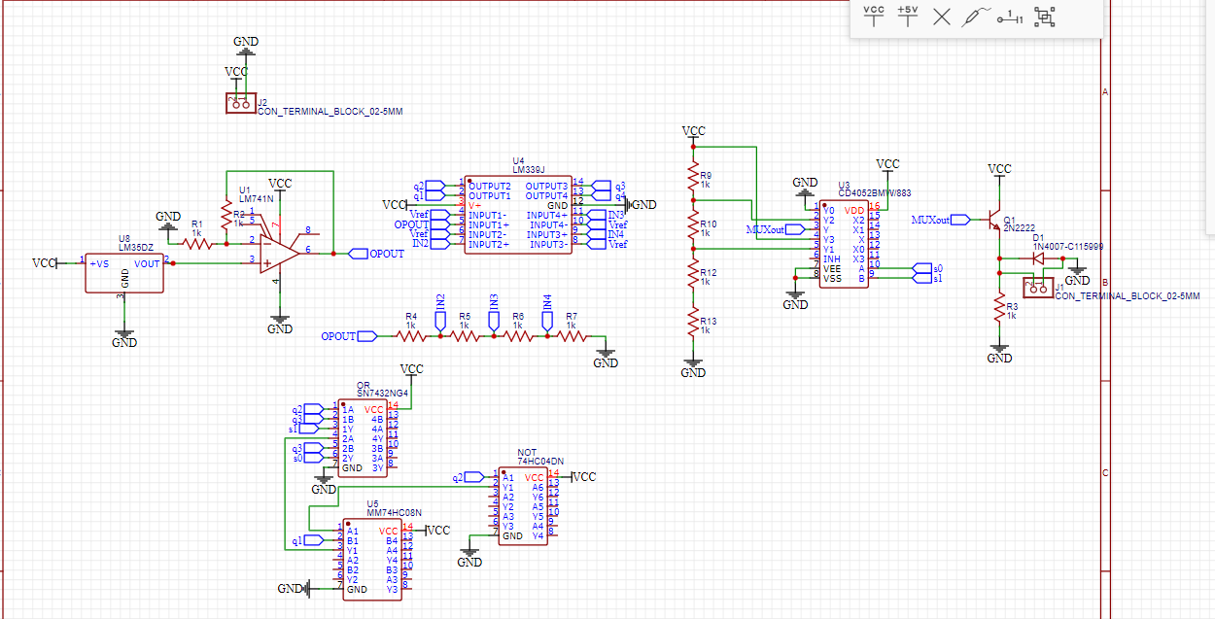
Figure 1 — Full schematic of the Auto-Mode Motor Driver board.

2. PCB Layout

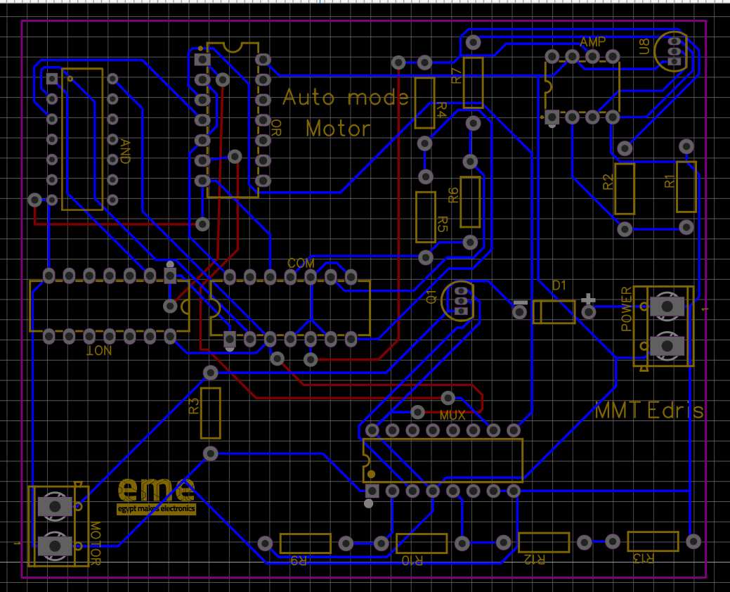
Figure 2 — PCB layout / routing view (top copper: blue, bottom copper: red).

2.1 Assembled Board
The photograph below shows the assembled prototype board.
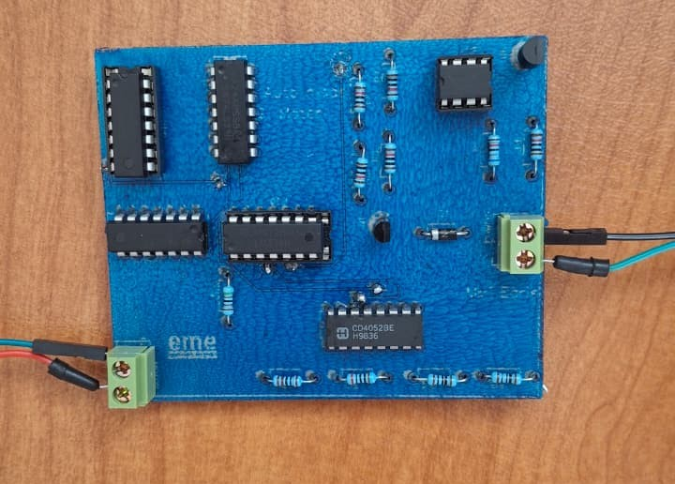
Figure 3 — Assembled Auto-Mode Motor Driver PCB (top view).

3. PCB Design Rules & Manufacturing Constraints
The board was routed and checked against the following design rule (DRC) constraints, applied globally to all nets in the CAD tool:
Design Rule Parameter | Minimum Value | Unit
Track width | 0.30 | mm
Clearance | 0.50 | mm
Via diameter | 0.61 | mm
Via drill diameter | 0.305 | mm

- Real-time DRC and DRC-boundary display were enabled while routing.
- Design rules were applied automatically during routing and auto via placement.
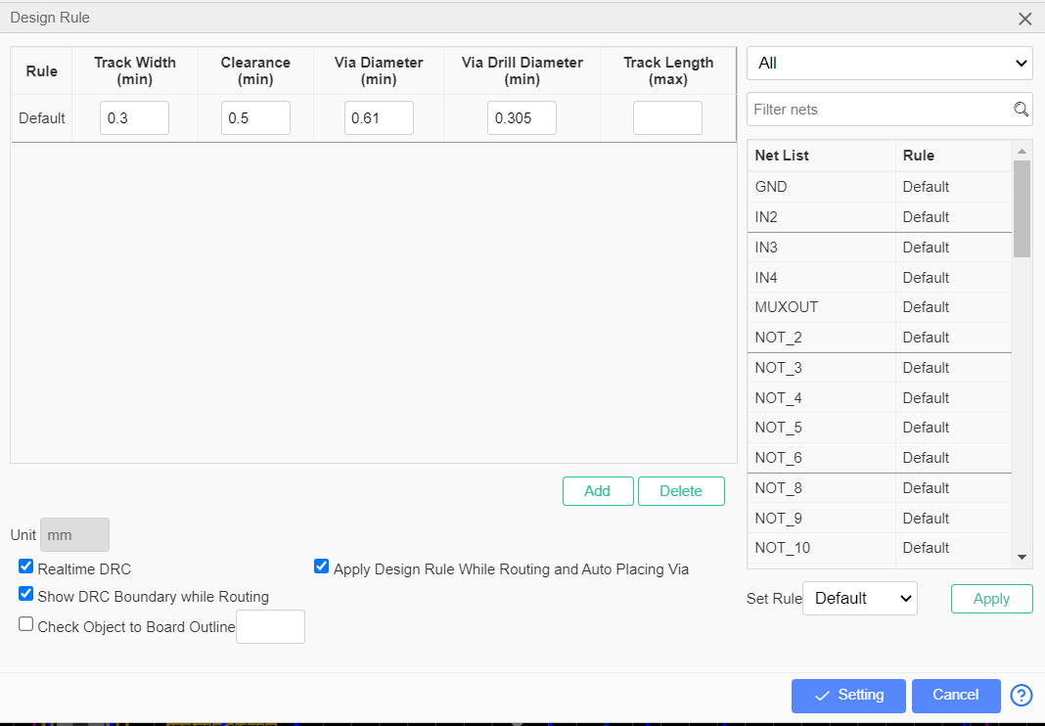
Figure 4 — CAD tool Design Rule configuration used for routing and DRC.

3.1 Minimum Conductor Spacing Verification
Trace clearance was cross-checked against IPC-2221 using the Saturn PCB Toolkit "Min Conductor Spacing" calculator, for uncoated external conductors at altitudes above 3050 m (worst-case class B3) and a working voltage in the sub-500 V range. The calculated minimum conductor spacing requirement was 0.10 mm, comfortably below the 0.50 mm clearance rule actually applied in the CAD design, providing design margin.
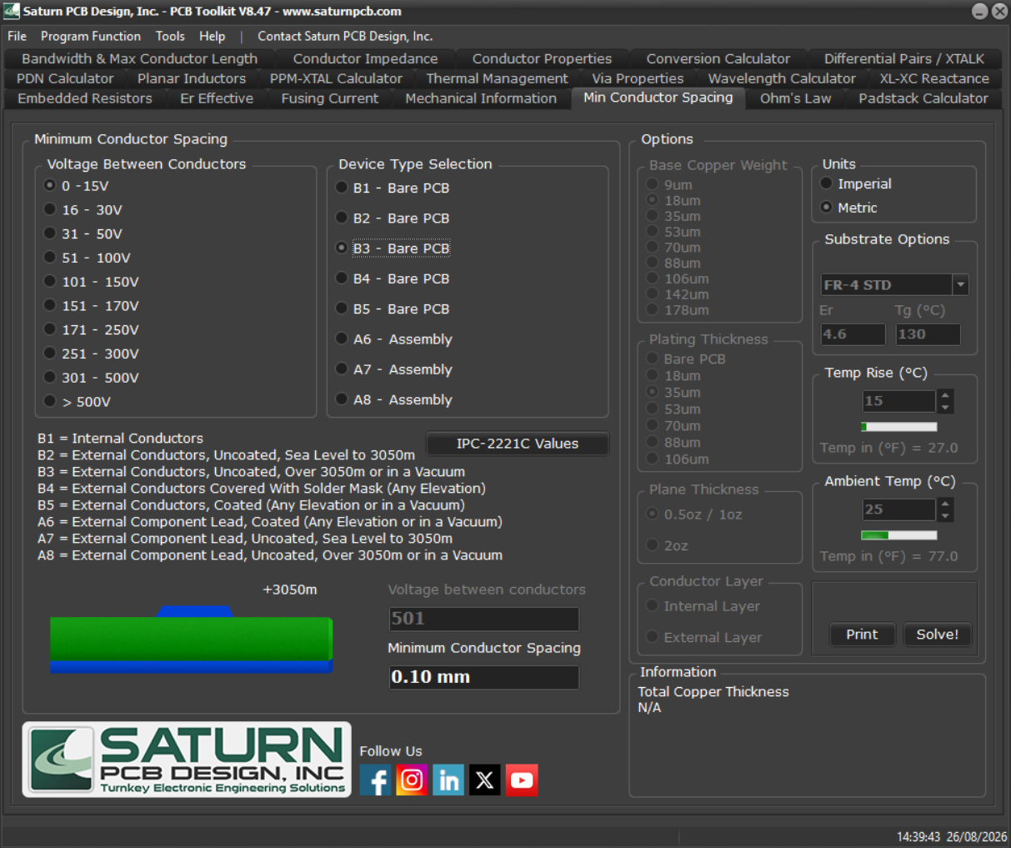
Figure 5 — IPC-2221 minimum conductor spacing calculation (Saturn PCB Toolkit).

3.2 Conductor Width / Current-Carrying Capacity Verification
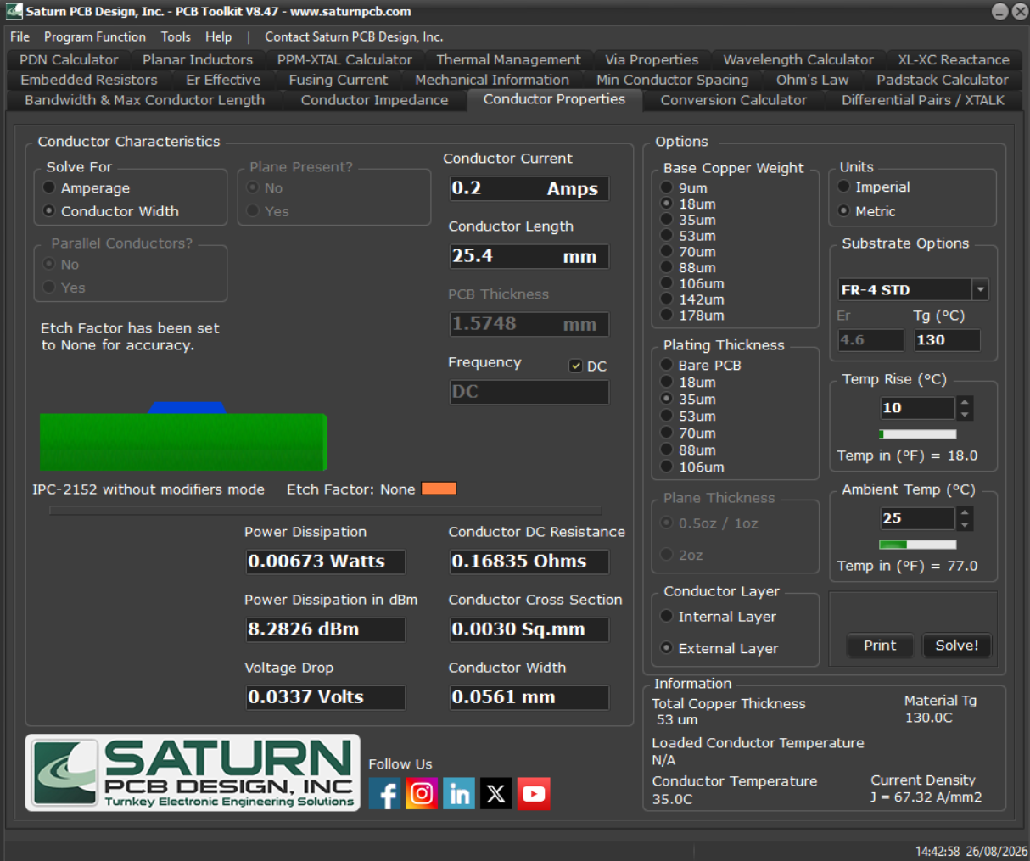
Figure 6 — Conductor width / current-capacity calculation (Saturn PCB Toolkit).

