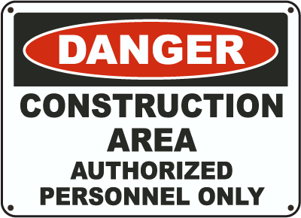

What to do/must to do: This area is a construction authorized personnel only.

Context: construction area

Its origin/purpose: This sign can be found in KMUTT at counstruction area such as repair drain and build a building this sign use for alert people because this area authorized peronnel only

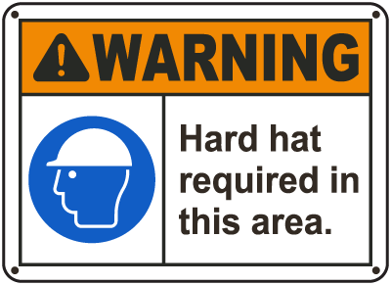

What to do/must to do: You must to wear a hard hat in this area.

Context: construction area

Its origin/purpose: this sign can be found in construction area because this area maybe something fall

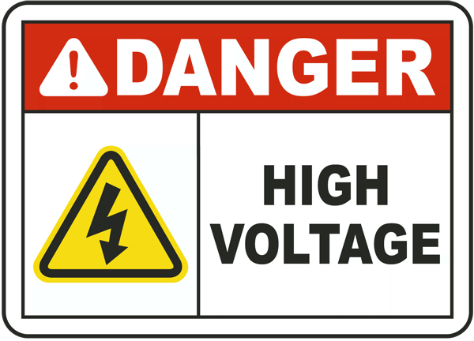

What to do/must to do: You must beware of the high voltage.

Context: construction area

Its origin/purpose: this sign can be found in KMUTT because this area danger about electric such as have a wire and electric Transformers