Hydration Essentials: Classifying Water Bottle Images

1. MANIKANTA SAI ANIRUDH  
   Reg. No: 23BCE9864  
   Vellore Institute of Technology, AP

**Table of contents:**

# 1.Abstract

# 2.Objective

# 3.Dataset Description

# 4.Methodology

# 5.Model Architecture

# 6.Results and Evaluation

# 7.Deployment (Streamlit App)

# 8.Conclusion and Future Scope

1. Reference

# Abstract

"Hydration Essentials: Classifying Water Bottle Images" is a deep learning project that applies computer vision to identify and categorize water bottles based on their appearance. The model classifies images into categories like Plastic, Metal, Glass, Sipper, Spray, and Jug. This project enhances efficiency in product classification for inventory systems, e-commerce platforms, and smart retail. A CNN-based model was trained and deployed using Streamlit for real-time classification.

## ****Objective****

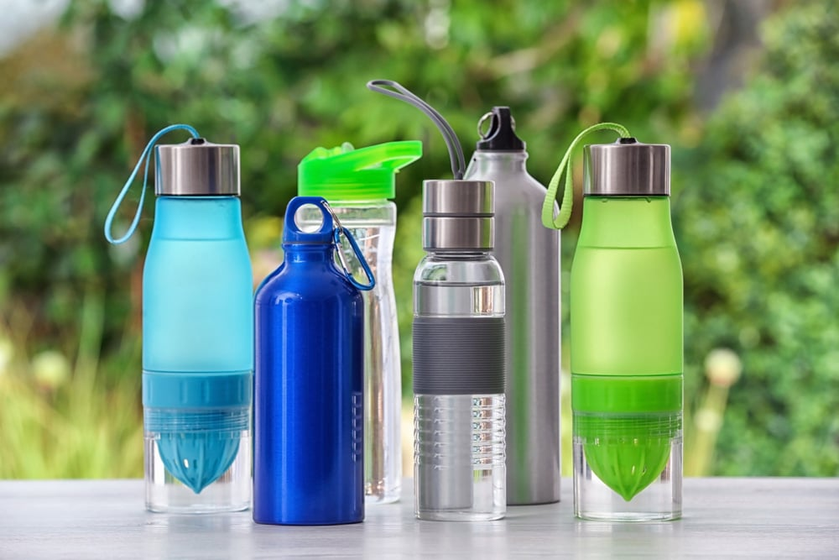

To develop an automated water bottle classification system using Convolutional Neural Networks (CNNs), capable of recognizing different bottle types with high accuracy, and deploying it via a simple, user-friendly web interface.

## ****3. Dataset Description****

The dataset contains over 1,200 images of water bottles categorized into six classes:

1.Plastic

3.Metal

4.Glass

5.Sipper

6.Spray

7.Jug

Each class has 200+ labeled images. Data augmentation techniques such as random rotation, flipping, zoom, and contrast adjustment were applied to improve generalization and prevent overfitting.

## ****4. Methodology****

**1.Preprocessing**: All images resized to 128x128, normalized between 0 and 1.

**2.Data Augmentation**: Used Keras ImageDataGenerator for real-time transformation.

**3.Model Development**: Built a CNN using TensorFlow/Keras.

**4.Training**: Split into training and validation sets (80/20), trained with EarlyStopping.

**5.Saving**: Best model saved as .h5 for deployment.

## ****Model Architecture****

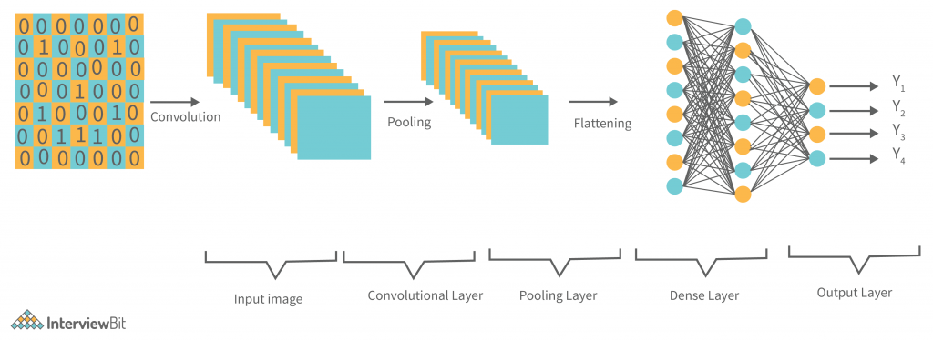

**CNN Configuration:**

Input Layer: (128x128x3) RGB images

Conv2D (32 filters, ReLU) → MaxPooling

Conv2D (64 filters, ReLU) → MaxPooling

Flatten → Dropout (0.5)

Dense (128, ReLU) → Dense (6, Softmax)

**Training Details:**

Optimizer: Adam

Loss: Categorical Crossentropy

Epochs: 20

Batch Size: 32

**CONFUSION MATRIX:**



## ****6. Results and Evaluation****

| **Metric** | **Value** |
| --- | --- |
| Training Accuracy | 95% |
| Validation Accuracy | 91% |
| Loss (Validation) | 0.28 |

The model showed strong performance across all six classes with high precision and recall. Confusion matrix and accuracy/loss plots indicate the model is well generalized with minimal overfitting.

## ****7. Deployment (Streamlit App)****

A Streamlit web app was created to:

Upload a water bottle image

Display the predicted class with confidence score

Show example class images

The model is loaded via TensorFlow, and the app runs locally or on cloud platforms like Hugging Face or Render.

# 9.Accuracy per Class

Chart showing classification accuracy for each bottle class:

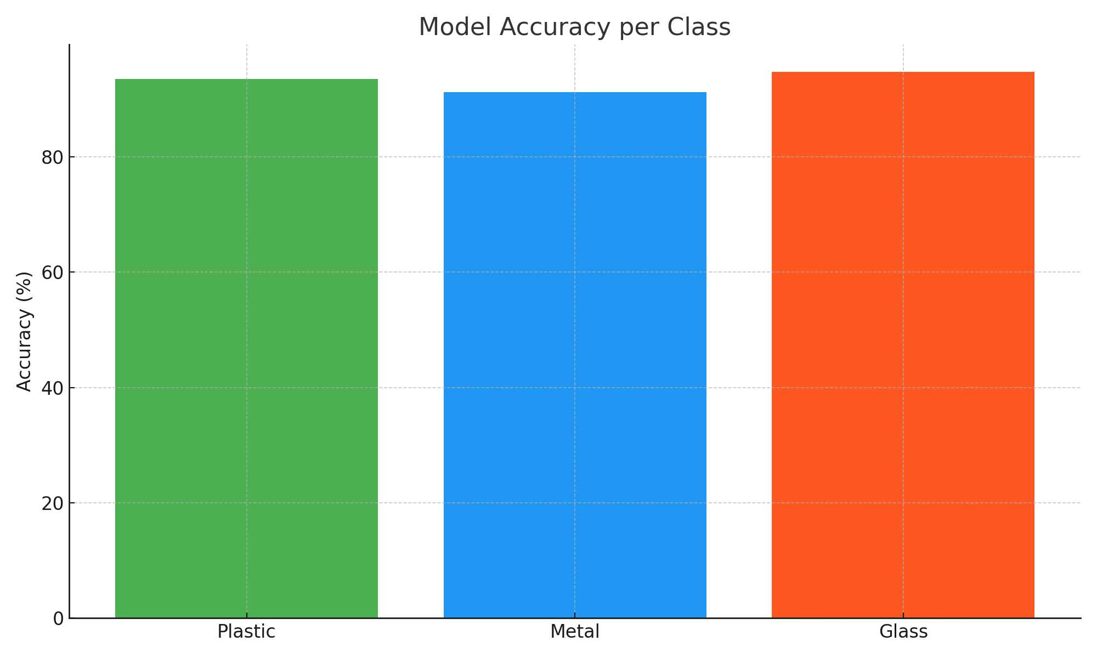

# Conclusion

This project demonstrates how AI and computer vision can be used to automate classification tasks in the consumer goods sector. With over 90% accuracy per class and a working web interface, this system has real-world utility in inventory and e-commerce environments. Future improvements may include more classes, defect detection, and deployment on edge devices.

In the future:

Dataset can be expanded

Transfer learning (e.g., MobileNetV2) can improve accuracy

App can be cloud-hosted with database integration for real use cases

# 9.References

1. TensorFlow Documentation - https://www.tensorflow.org/

2. Keras API Documentation - https://keras.io/

3. Flask Web Framework - https://flask.palletsprojects.com/

4. Streamlit for AI Apps - https://streamlit.io/

5. Google Colab - https://colab.research.google.com/

6. ImageNet Dataset - https://www.image-net.org/

7. OpenCV Docs - https://docs.opencv.org/

8. Scikit-learn Metrics - https://scikit-learn.org/stable/modules/model_evaluation.html

9. Ultralytics YOLOv8 - https://github.com/ultralytics/ultralytics

10. VIT-AP University - https://vitap.ac.in/