HUMAN-COMPUTER  
INTERACTION (HCI)

**INDEX**

- Manuel Marcelo Sánchez Salgado, 2DAW IES TEIS 2025-26

# 1. HISTORY OF HUMAN-COMPUTER INTERACTION

During the advent of computation in 1945, *Human-Computer Interaction* was known as Man-Machine Interaction, and was a necessity in the computation field as the earliest mainframes required a specialist team to be operated, closing conections with cables, cranking levers and flicking switches as the machine needed. This was not deliberate design, but a physical neccesity — the interaction was usually one-directional, except in the cases that the machines physically reacted to their input.

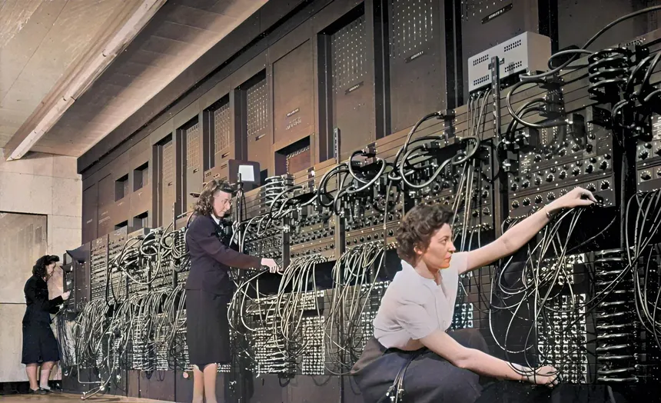The ENIAC computer in 1946, being operated by closing connections between different points.

Systems like the ENIAC (Electronic Numerical Integrat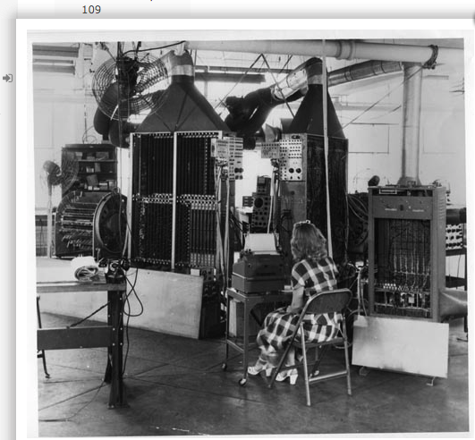or and Computer, 1945) used rudimentary punchcards as physical inputs, yet its contemporary BINAC (BINary Automatic Computer, 1948) had a typewriter-keyboard unit that allowed the crew to input numbers from 0 to 7 directly into it’s systems – a second typewriter, electromecanically controlled by the BINAC, handled the output of the machine. This could be understood as the predecesor of keyboards and CLI output.

As soon as 1963, we can already find studies on more precise interaction with a machine. The concept of Graphical User Interface beings to float in the minds of early hardware developers, specially on Ivan Sutherland's mind, who developed a light pen for direct interaction with computer displays as his Ph. D thesis. This light pen, the Sketchpad, is the earliest precursor to the computer mouse.

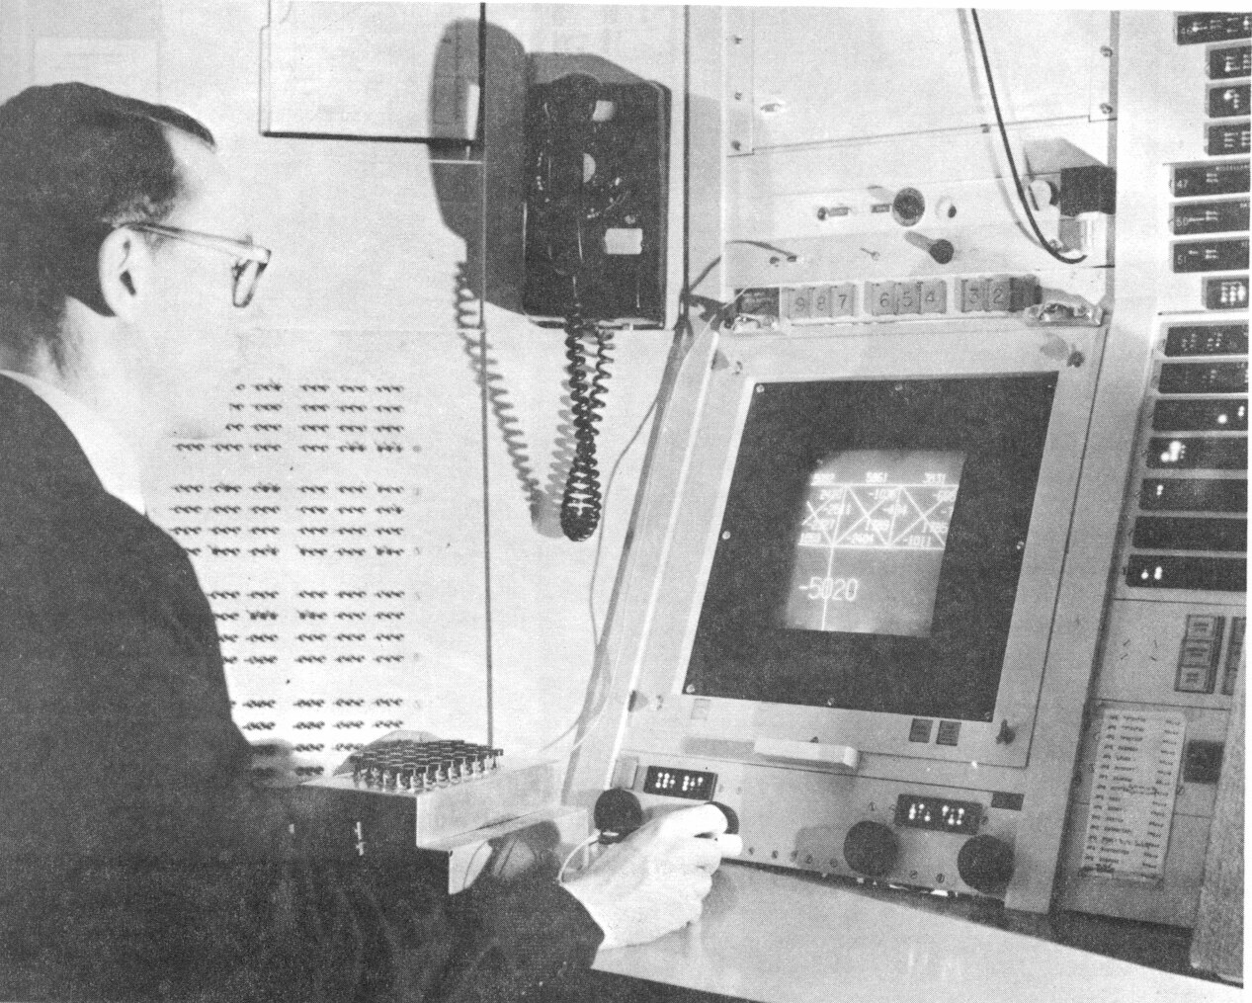 Sutherland and his Sketchpad, MIT 1963.

The first mouse prototype was born the next year by the hands of Bill English, who also fathered hypertext, videoconferencing and graphical user interfaces by 1968 in his conference *"mother of all demos"*.

During the 1970's decade, there was a shift of vision: computers b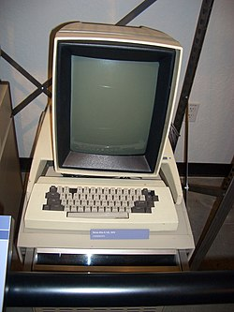ecame smaller devices, built with the goal of being operated by a single individual instead of a team of specialists. The advent of the microprocessors facilitated this transition. Naturally, the computer industry changed its focus to service this new market – it was still rather restrictive due to high prices and busines focus, but inventions like the Xerox Alto, a computer that integrated a mechanical keyboard, mouse and a screen to display a GUI, served as an inspiration for the ones coming i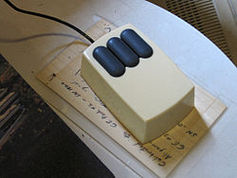n the next decade.

Even before the Xerox foundation was even created, Alan Kay started to theorise about a computer that could be moved. He had children in mind while creating it – an interactive book was the blueprint. This materialized as the Dynabook, which today is regarded as the precursor to tablets and laptops despite the fact that it was never fully produced.

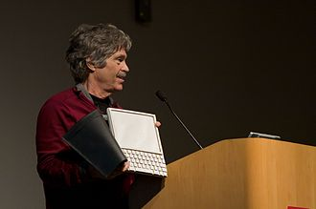 Key and one of the old prototypes of the Dynabook 40 years after its conception, 2008.

Production of personal computers sped up in the 80s, with