DRIVING SCHOOL
MANAGEMENT SYSTEM
Database Design, Implementation & Data Analysis

DATA MANAGEMENT COURSE — 2025/2026 A.Y.

PREPARED BY
MOHAMMAD MAHDI SARWARI
Student ID: 81818

PROJECT SUBMITTED TO
PROFESSOR CIRO RUSSO

Date
June 14, 2026

Table of Contents
Table of Contents 2-3
1. Project Objective 4
Key Project Goals 4
2. Main Phases of the Project 4
2.1 Conceptual Modeling (ER Model) 4
2.2 Logical Modeling (Relational Model) 4
2.3 SQL Implementation 5
2.4 Graphical User Interface (GUI) 5
2.5 Data Analysis 5
2.6 Report and Presentation 5
3. Phase 1: Conceptual Modeling (ER Model) 6
3.1 Design Process 6
3.1.1 Requirement Analysis 6
3.1.2 Entity Identification 6
3.2 Relationships and Cardinalities 7
3.3 Key Design Decisions 8
Resolving the Many-to-Many Relationship Between Students and Packages 8
The Lesson Entity as the Central Hub 8
Exam Independence from Lessons 8
Payment Independence from Lessons and Packages 8
Package Catalogue vs. Student Enrolment 8
3.4 Entity-Relationship Diagram 9
4. Phase 2: Logical Modeling (Relational Model) 9
4.1 Transformation Process 9
4.2 Relational Schema 9
4.3 Data Types and Constraints 10
Primary Keys 10
Foreign Keys 10
Data Type Selection 10
4.4 Normalization 10
5. Phase 3: SQL Implementation 12
5.1 Database Creation 12
5.2 Table Creation 12
5.3 Sample Data Insertion 12
5.4 Key SQL Queries 14
Query 1: Revenue Generated by Each Package 14
Query 2: Instructor Teaching Hours 15
Query 3: Exam Pass / Fail Statistics 15
Query 4: Vehicle Utilization 15
Query 5: Package Effectiveness (Pass Rate by Package) 15
6. Phase 4: Graphical User Interface (GUI) 17
6.1 Purpose and Technology 17
6.2 Application Structure 17
6.3 Design Principles 18
7. Phase 5: Data Analysis and Visualization 19
7.1 Analysis Methodology 19
7.2 Data Loading and Overview 19
7.3 Data Cleaning 19
7.4 Data Integration 19
7.5 Revenue Generated by Each Package 21
7.6 Instructor Teaching Hours 22
7.7 Exam Pass and Fail Statistics 23
7.8 Vehicle Utilization 24
7.9 Package Effectiveness (Pass Rate by Package) 25
8. Conclusion and Future Work 26-27
8.1 Conclusion 26
8.2 Future Work 27
1. Automated Reporting and Notifications
2. Instructor Scheduling and Workload Balancing
3. Expanded Exam Tracking
4. Multi-Branch Support
5. Web-Based Access

1. Project Objective
The objective of this project is to design and implement a comprehensive Driving School Management System that models the core entities and relationships involved in operating a driving school. The system encompasses the management of students, instructors, vehicles, lessons, examinations, payments, and training packages.
The system is implemented using a relational database (MySQL) and SQL to support accurate data storage, efficient querying, and robust data integrity. A custom desktop GUI application, built with PyQt6, was also developed on top of the database to allow non-technical staff to manage day-to-day operations without writing SQL. The project follows a systematic approach, progressing from conceptual design through physical implementation, to a graphical interface, and finally to data analysis.

Key Project Goals
- Revenue Analysis: evaluate the total revenue generated by the driving school overall and broken down by training package, to understand which services contribute most to income.
- Instructor Workload: examine the distribution of teaching hours among instructors to identify workload imbalances and support fairer scheduling.
- Exam Performance: monitor the proportion of students who pass or fail their driving examination, providing an overall measure of training quality.
- Vehicle Utilization: identify how frequently each vehicle in the school is used for lessons, supporting better planning and maintenance scheduling.
- Package Effectiveness: assess whether students enrolled in different training packages achieve different examination pass rates, in order to evaluate the educational value of each package.
By achieving these objectives, the system provides actionable insights that enable the driving school's administration to make data-driven decisions regarding instructor scheduling, vehicle management, package pricing, and overall service quality.

2. Main Phases of the Project

2.1 Conceptual Modeling (ER Model)
In this phase, the system was analyzed at a high level by identifying the main entities, their attributes, and the relationships and cardinalities that connect them. An Entity-Relationship (ER) diagram was created to represent the structure of the driving school system and how its different entities interact.

2.2 Logical Modeling (Relational Model)
The conceptual ER model was translated into a relational schema using MySQL Workbench. Tables were defined along with their primary keys, foreign keys, and data types to ensure data integrity and proper normalization.

2.3 SQL Implementation
The database was implemented using SQL by creating the database schema and all eight tables. Sample data representing students, instructors, vehicles, lessons, exams, payments, and packages was inserted, and various SQL queries were written to retrieve, aggregate, and analyze the data, including joins and grouping operations.

2.4 Graphical User Interface (GUI)
A desktop application was developed using Python and PyQt6 to provide an intuitive, professional interface for managing the system. The GUI allows staff to add, search, edit, and delete records for students, instructors, vehicles, lessons, exams, payments, and packages, and presents a live dashboard of key statistics.

2.5 Data Analysis
Data stored in the database was extracted into Python using Pandas and analyzed using multiple approaches: SQL aggregate queries for quantitative summaries, Pandas for data cleaning and integration, and Matplotlib for graphical visualization. The analysis focused on revenue, instructor workload, exam outcomes, vehicle utilization, and package effectiveness.

2.6 Report and Presentation
The final phase involves documenting the entire project, summarizing the design process, implementation, GUI development, and analytical results. This written report communicates the objectives, methodology, and findings of the project.

3. Phase 1: Conceptual Modeling (ER Model)

3.1 Design Process

3.1.1 Requirement Analysis
The design process began by identifying the main requirements of a driving school management system. This included understanding the core operations such as managing students, instructors, vehicles, lessons, exams, payments, and training packages, as well as determining what information needed to be stored and analyzed to support administrative decision-making.

3.1.2 Entity Identification
The following main entities were identified for the Driving School Management System:
STUDENT
Attributes: StudentID (PK), FirstName, LastName, Phone, Email, RegistrationDate.
Description: Represents an individual enrolled in the driving school. Each student has a unique identifier, contact information, and a registration date marking when they joined the school.
INSTRUCTOR
Attributes: InstructorID (PK), InstructorName, Phone, HireDate, ExperienceYears.
Description: Represents a staff member responsible for teaching driving lessons. Each instructor has a unique identifier, contact information, the date they were hired, and their number of years of driving-instruction experience.
VEHICLE
Attributes: VehicleID (PK), Model, PlateNumber, Year, Instructor ID (FK).
Description: Represents a car belonging to the driving school, used to conduct lessons. Each vehicle has a unique identifier, a model name, a registration plate number, a manufacturing year and an instructor ID who is using the vehicle.
LESSON
Attributes: LessonID (PK), StudentID (FK), InstructorID (FK), VehicleID (FK), LessonDate, DurationHours.
Description: Represents a driving lesson session linking a student, an instructor, and a vehicle for a specific date and duration.
EXAM
Attributes: ExamID (PK), StudentID (FK), ExamDate, Score, Result.
Description: Records the outcome of a driving examination taken by a student, including the date of the exam, the numerical score obtained, and the final result (Passed or Failed).
PAYMENT
Attributes: PaymentID (PK), StudentID (FK), Amount, PaymentDate, PaymentMethod.
Description: Records a payment transaction made by a student to the driving school, including the amount paid, the date of payment, and the method used (Cash, Card, Bank Transfer, or Online).
PACKAGE
Attributes: PackageID (PK), PackageName, NumberOfLessons, Price.
Description: Represents a training package offered by the driving school (for example: Basic, Standard, Advanced, Premium, or VIP), defining a bundle of lessons sold at a fixed price.
STUDENT_PACKAGE
Attributes: StudentPackageID (PK), StudentID (FK), PackageID (FK), PurchaseDate.
Description: An associative entity that records which training package each student has purchased and when. This entity resolves the many-to-many relationship between STUDENT and PACKAGE, since a package may in principle be purchased by many students, and the school may wish to track repeat purchases over time.

3.2 Relationships and Cardinalities
The following relationships were identified between entities, with their respective cardinalities:
STUDENT TAKES LESSON (1:M)
One student can take multiple lessons over time, but each lesson is associated with exactly one student.
INSTRUCTOR TEACHES LESSON (1:M)
One instructor can teach multiple lessons, but each lesson is taught by exactly one instructor.
VEHICLE IS USED IN LESSON (1:M)
One vehicle can be used in multiple lessons, but each lesson uses exactly one vehicle.
STUDENT TAKES EXAM (1:M)
One student can take multiple exams (for example, if they fail and retake the test), but each exam record belongs to exactly one student.
STUDENT MAKES PAYMENT (1:M)
One student can make multiple payments over time, but each payment is made by exactly one student.
STUDENT PURCHASES PACKAGE (M:N, via STUDENT_PACKAGE)
A student may purchase one or more training packages over time, and a package may be purchased by many students. This many-to-many relationship is resolved through the STUDENT_PACKAGE associative entity, which records each individual purchase along with its date.

3.3 Key Design Decisions

Resolving the Many-to-Many Relationship Between Students and Packages
The STUDENT_PACKAGE entity serves as an associative entity that resolves the many-to-many relationship between STUDENT and PACKAGE. This design allows the system to track exactly which package each student purchased and on what date, while still allowing the same package definition to be reused across many students. By explicitly modeling this relationship, the system can also support future features such as tracking package renewals or upgrades.

The Lesson Entity as the Central Hub
LESSON acts as the central transactional entity of the system, connecting STUDENT, INSTRUCTOR, and VEHICLE through three separate one-to-many relationships. Rather than modeling lessons as a three-way relationship, each lesson record stores three foreign keys (StudentID, InstructorID, VehicleID) plus its own attributes (date and duration). This keeps the schema simple and avoids redundancy.

Exam Independence from Lessons
EXAM is linked directly to STUDENT rather than to a specific LESSON. This reflects the real-world business rule that a driving examination is a separate event from regular training lessons, often administered by an external authority rather than the school's own instructors. Linking exams directly to students simplifies tracking of pass/fail history and allows a student to have multiple exam attempts without needing to associate each attempt with a particular lesson.

Payment Independence from Lessons and Packages
PAYMENT is linked directly to STUDENT rather than to a specific lesson or package purchase. This design choice provides flexibility for handling instalment payments, deposits, and balance top-ups independently of any single transaction. It simplifies financial tracking for students who may have an ongoing package, occasional extra lessons, and exam fees all billed over time.

Package Catalogue vs. Student Enrolment
Separating PACKAGE (the catalogue of available training bundles) from STUDENT_PACKAGE (the record of who bought what, and when) follows standard relational design practice. The PACKAGE table can be managed independently. Packages can be added, repriced, or retired, without affecting historical purchase records stored in STUDENT_PACKAGE. This also allows the system to report on package popularity and revenue without duplicating package details for every student.

3.4 Entity-Relationship Diagram
The diagram below summarizes the eight entities of the Driving School Management System and the relationships between them, following the same notation style used in the conceptual design phase (crow's-foot style cardinality labels).

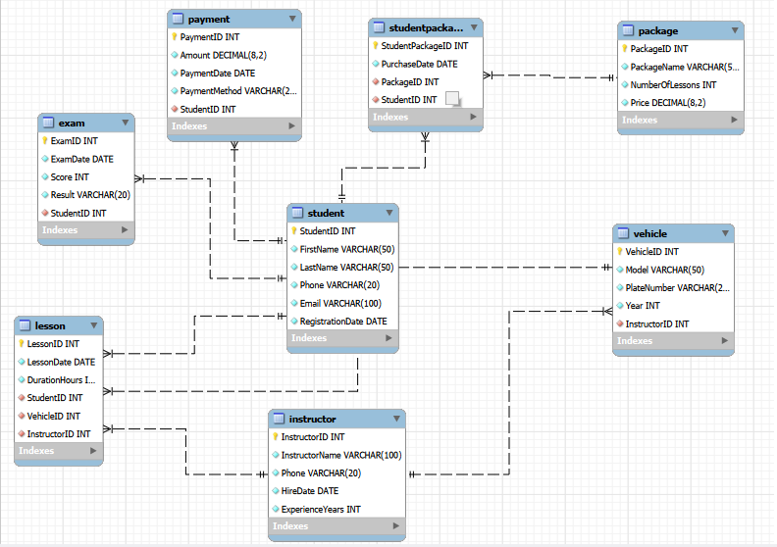
Figure 3.1 — Entity-Relationship Diagram of the Driving School Management System

4. Phase 2: Logical Modeling (Relational Model)

4.1 Transformation Process
The ER model was systematically converted into a relational schema following standard normalization principles. Each entity became a table, and each relationship was implemented through a foreign key. The associative entity STUDENT_PACKAGE was implemented as its own table with two foreign keys (StudentID and PackageID), resolving the many-to-many relationship between students and packages.

4.2 Relational Schema
The table below summarizes the eight tables of the database, their primary keys, foreign keys, and the remaining key attributes of each table.

Table Name | Primary Key | Foreign Keys | Key Attributes
Student | StudentID | — | FirstName, LastName, Phone, Email, RegistrationDate
Instructor | InstructorID | — | InstructorName, Phone, HireDate, ExperienceYears
Vehicle | VehicleID | InsructorID | Model, PlateNumber, Year
Lesson | LessonID | StudentID, InstructorID, VehicleID | LessonDate, DurationHours
Exam | ExamID | StudentID | ExamDate, Score, Result
Payment | PaymentID | StudentID | Amount, PaymentDate, PaymentMethod
Package | PackageID | — | PackageName, NumberOfLessons, Price
StudentPackage | StudentPackageID | StudentID, PackageID | PurchaseDate

4.3 Data Types and Constraints

Primary Keys
All primary keys are defined as INT with AUTO_INCREMENT, ensuring unique identification of every record and simplifying data entry, since the database generates new identifiers automatically when records are inserted.

Foreign Keys
Foreign key constraints enforce referential integrity between tables. For example, the Lesson table cannot reference a non-existent student, instructor, or vehicle, and the StudentPackage table cannot reference a non-existent student or package. This guarantees that the data stored in the database remains consistent at all times.

Data Type Selection
- VARCHAR: used for text fields such as FirstName, LastName, Email, Instructor Name, Model, and Plate Number.
- INT: used for identifiers (all primary and foreign keys), as well as for Experience Years, Year, Score, and Number of Lessons.
- DECIMAL: used for monetary and measurement values: Price, Amount, and Duration Hours, to ensure precision and avoid the rounding errors associated with floating-point types.
- DATE: used for all temporal data: Registration Date, Hire Date, Lesson Date, Exam Date, Payment Date, and Purchase Date.

4.4 Normalization
The database schema adheres to the Third Normal Form (3NF):
- 1NF: all attributes contain atomic values; there are no repeating groups or multi-valued fields. For example, a student's package is not stored as a comma-separated list inside the Student table, but as separate rows in Student Package.
- 2NF: there are no partial dependencies every non-key attribute depends on the entire primary key. Since all primary keys in this schema are single-column surrogate keys, partial dependency cannot occur.
- 3NF: there are no transitive dependencies non-key attributes depend only on the primary key. For instance, PackageName and Price are stored once in Package and referenced from StudentPackage via PackageID, rather than being repeated for every student who purchases that package.
Adhering to 3NF avoids data redundancy and update anomalies for example, if the price of the Basic package changes, it only needs to be updated in a single row of the Package table, and every student associated with that package automatically reflects the new price through the foreign-key relationship.

5. Phase 3: SQL Implementation

5.1 Database Creation
The implementation phase began with the creation of the driving school database using MySQL.

CREATE DATABASE mydb;
USE mydb;

5.2 Table Creation
All eight tables were created based on the ER diagram and the relationships defined in Section 3.2. Primary keys, foreign keys, and constraints were implemented in MySQL Workbench to enforce the cardinalities identified during the design phase, and forward engineering was used to automatically generate the SQL statements from the model. This ensures that the tables, data types, and relationships are fully consistent with the conceptual design.

5.3 Sample Data Insertion
Sample data was inserted into all eight tables to validate the database design and illustrate the relationships between entities. The dataset represents a realistic small driving school and contains:
- 30 students, with realistic Italian names, contact details, and registration dates spread across January 2025
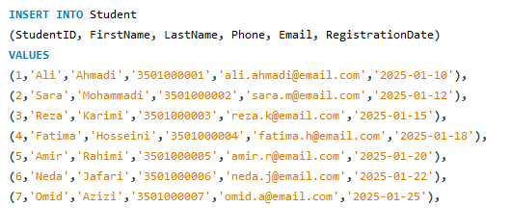
- 5 instructors, each with different hire dates and between 4 and 12 years of experience
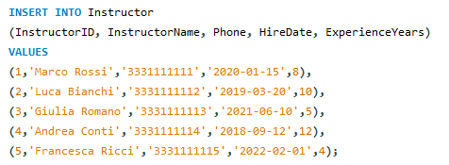
- 4 training vehicles (Toyota Yaris, Fiat Panda, Volkswagen Polo, and Renault Clio)
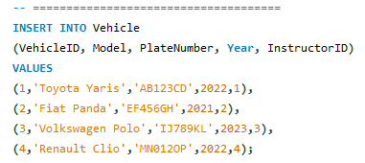
- 100 lessons, linking students, instructors, and vehicles across February and March 2025
- 17 exam records, recording each student's score and Passed / Failed result
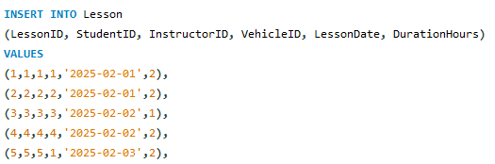
- 30 payments, covering the various package purchases and payment methods
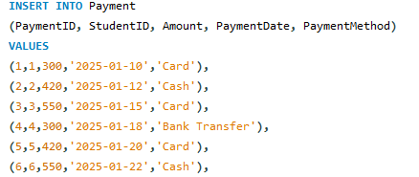

- 5 training packages (Basic, Standard, Advanced, Premium, and VIP), each with a different number of lessons and price
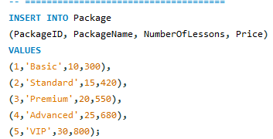

- 30 student-package records, linking each student to the package they purchased
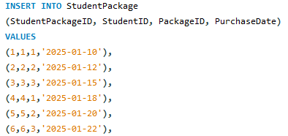

5.4 Key SQL Queries
The following queries demonstrate the analytical capabilities of the database, combining joins, aggregation, and grouping to answer key business questions.

Query 1: Revenue Generated by Each Package
Purpose: calculate the total amount paid by students enrolled in each training package, by joining payments to packages through the student-package relationship.
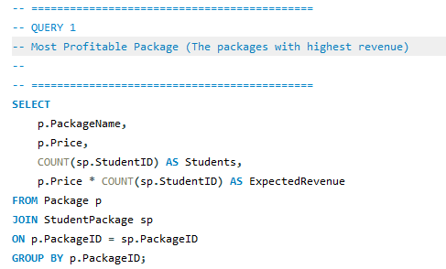

Query 2: Instructor Teaching Hours
Purpose: calculate the total number of teaching hours delivered by each instructor, to evaluate workload distribution.

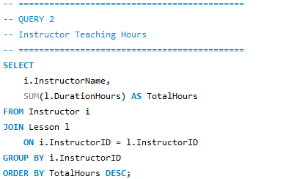

Query 3: Exam Pass / Fail Statistics
Purpose: count how many students passed and how many failed their driving exam, and compute the overall pass rate.

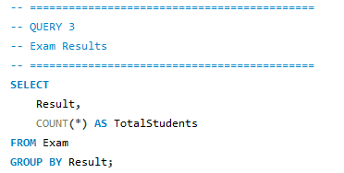

Query 4: Vehicle Utilization
Purpose: show how many lessons were conducted with each vehicle in the training fleet, to support vehicle planning and maintenance scheduling.
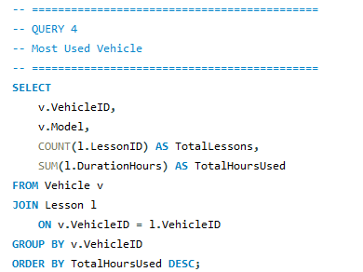

Query 5: Package Effectiveness (Pass Rate by Package)
Purpose: determine whether students enrolled in different training packages achieve different examination pass rates, by joining StudentPackage, Package, and Exam.

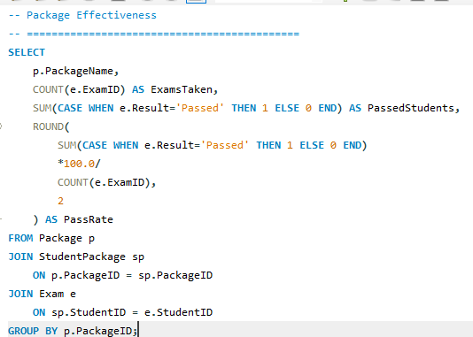

6. Phase 4: Graphical User Interface (GUI)

6.1 Purpose and Technology
To make the database accessible to non-technical staff, a desktop management application was developed using Python and the PyQt6 framework, connecting directly to the MySQL database via the mysql-connector-python library. The application replaces the need to write raw SQL for everyday administrative tasks, while still relying on the same relational schema and constraints described in Phase 2 and Phase 3.

6.2 Application Structure
The interface follows a single-window design with a fixed navigation sidebar on the left and a content area on the right that switches between nine pages. Every data-management page shares a consistent layout: a searchable, sortable table at the top, and a form below it for adding, editing, and deleting records, so that the same interaction pattern applies across the whole application.

Page | Purpose and Key Features
Dashboard | Live overview of the school's key metrics: total students, instructors, vehicles, lessons, revenue, and exam pass rate. Includes quick-action buttons to jump directly to the relevant page, a table of lessons scheduled in the next 7 days, and tables of the most recent payments and exam results.
Students | Full student directory showing each student's contact details, registration date, assigned training package, most recent exam result, and total amount paid. A dedicated form allows adding or editing a student and assigning them a package from a dropdown of available packages. A ‘View Full Profile’ button opens a detailed window with the student's complete lesson history, exam history, and payment history.
Instructors | Manage instructor records (name, phone, hire date, experience) and view, for each instructor, the total number of lessons they have taught.
Vehicles | Manage the training fleet (model, plate number, year) and view how many lessons each vehicle has been used for.
Lessons | Schedule and review driving lessons. Student, instructor, and vehicle are selected from dropdowns populated directly from the database, and the lesson date and duration can be set with a calendar picker and a numeric spinner.
Exams | Record exam results for any student, selecting the date, score, and Passed / Failed outcome. Results are color-coded (green for Passed, red for Failed) directly in the table for quick visual scanning.
Payments | Record and review payments made by students, including the amount, date, and payment method (Cash, Card, Bank Transfer, or Online).
Packages | Maintain the catalogue of training packages (name, description, price, number of lessons included), and see at a glance how many students are currently enrolled in each package.
Statistics | Aggregated reporting view with key-performance-indicator cards (students, instructors, vehicles, lessons, revenue, pass rate, average exam score), plus tables of recent payments, recent exams, and the students with the most lesson hours.

6.3 Design Principles
- Consistency: every management page (Students, Instructors, Vehicles, Lessons, Exams, Payments, Packages) follows the same table-plus-form layout, so users only need to learn the interaction pattern once.
- Live search: each page includes a search box that filters the table in real time across all visible columns, without requiring a separate ‘search’ button.
- Guided data entry: wherever a field refers to another table (for example, the Student, Instructor, or Vehicle on a Lesson, or the Package assigned to a Student), the form presents a dropdown populated from the database rather than a free-text field. This prevents invalid foreign-key values from ever being entered, and ensures that only existing, available packages can be assigned to a student.
- Visual feedback: successful additions, updates, and deletions trigger a temporary confirmation message (a ‘toast’), deletions require explicit confirmation, and exam results and payment amounts are color-highlighted directly in their tables.
- Stable layout: tables and forms are arranged using resizable splitters, so that resizing the application window does not reorder or hide any content.
- Cross-referenced information: rather than showing raw foreign-key numbers, every table displays human-readable joined information for example, the Lessons table shows student and instructor names and the vehicle model instead of their numeric IDs, mirroring the joins used in the SQL queries.
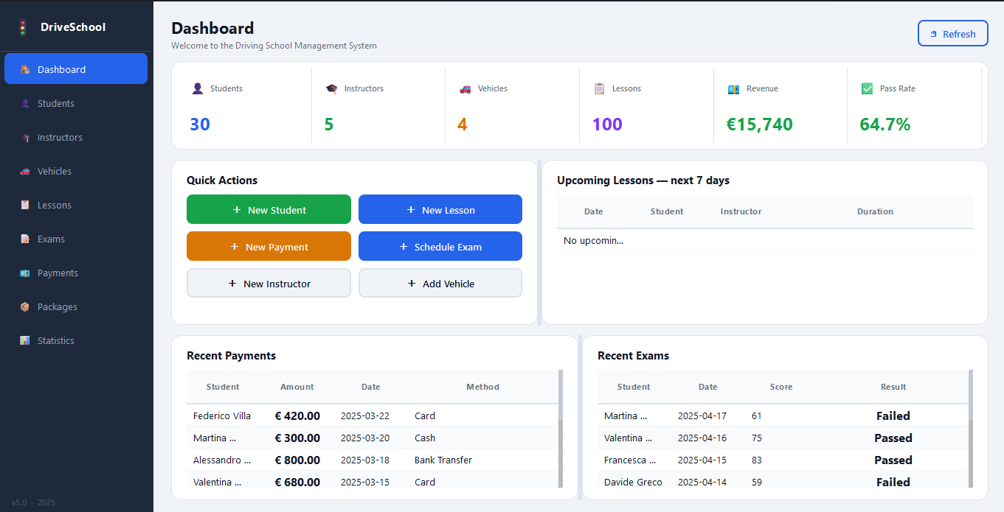
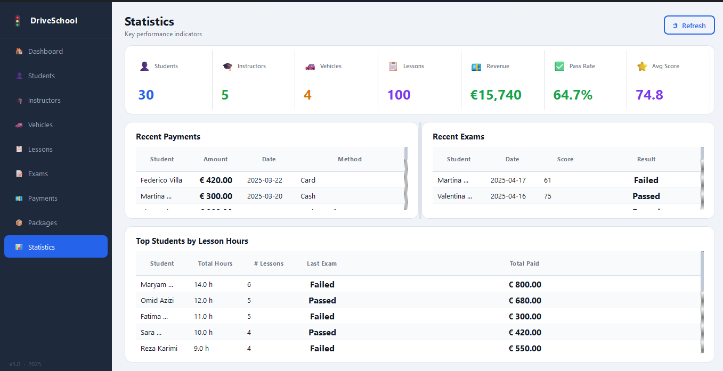

7. Phase 5: Data Analysis and Visualization

7.1 Analysis Methodology
Data analysis was performed using multiple approaches:
- SQL aggregate queries for quantitative summaries directly against the MySQL database
- Python with Pandas for data loading, cleaning, and integration
- Matplotlib for graphical visualization of the integrated datasets
- The custom PyQt6 GUI application (Section 6) for interactive, day-to-day reporting

7.2 Data Loading and Overview
All eight tables were loaded from MySQL into Pandas DataFrames using read_sql, giving the following record counts:

Table | Records | Description
Student | 30 | Enrolled students
Instructor | 5 | Driving instructors
Vehicle | 4 | Training vehicles
Lesson | 100 | Driving lesson sessions
Exam | 17 | Exam attempts and results
Payment | 30 | Payment transactions
Package | 5 | Available training packages
StudentPackage | 30 | Package purchased by each student

The dataset therefore represents 30 students, 5 instructors, 4 vehicles, 100 lessons, 17 exams, 30 payments, and 5 training packages, with each of the 30 students having chosen exactly one package.

7.3 Data Cleaning
Before analysis, the following cleaning steps were applied to ensure consistency and accuracy:
- LessonDate and PaymentDate were converted into proper datetime format using pandas.to_datetime, with invalid values coerced to missing rather than causing errors
- DurationHours and Amount were converted into numeric format using pandas.to_numeric, again coercing any invalid entries to missing values
- Duplicate lesson records were removed using drop_duplicates
Data cleaning improves data quality and reduces the risk of incorrect analysis. The cleaned dataset provides a reliable foundation for the integration and visualization steps that follow.

7.4 Data Integration
Multiple tables were combined into two integrated datasets using common identifiers (foreign keys), mirroring the relationships defined in the ER diagram:
- Integration A — Lesson Activity: the Lesson table was merged with Student (on StudentID), Instructor (on InstructorID), and Vehicle (on VehicleID), producing a single dataset where every lesson row also shows the student's name, the instructor's name, and the vehicle's model. This dataset is the basis for the instructor-workload and vehicle-utilization analyses.
- Integration B — Business Operations: the Student table was merged with StudentPackage and Package (to obtain each student's chosen package), then with Payment (to obtain their payment history), and finally with Exam (to obtain their exam results). This dataset is the basis for the revenue-by-package and package-effectiveness analyses.
Separating the data into these two integrated datasets keeps the training-activity analysis (lessons, instructors, vehicles) distinct from the business-operations analysis (packages, payments, exams), which improves the efficiency and clarity of the overall analysis process.
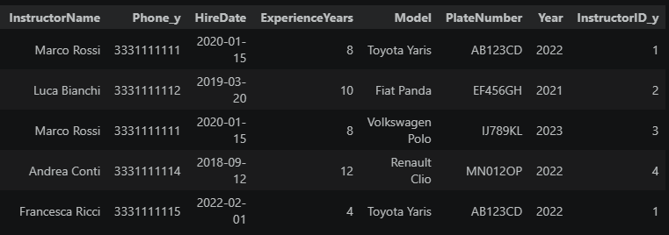
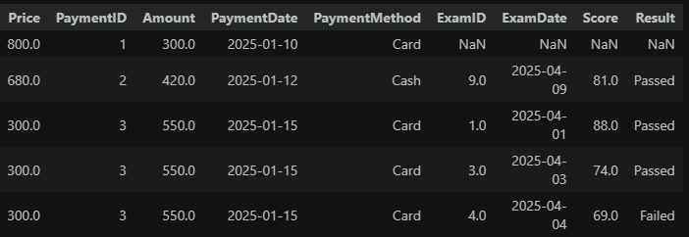
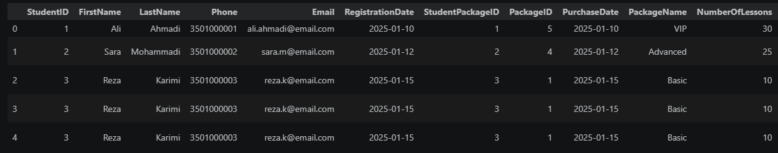
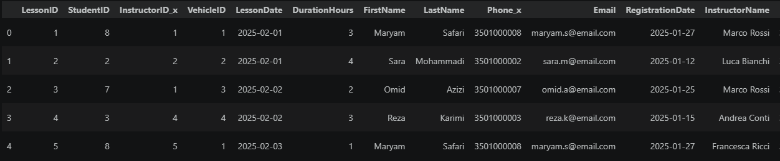

7.5 Revenue Generated by Each Package
This analysis investigates which training packages generate the highest revenue for the driving school, by summing the payments made by students enrolled in each package.

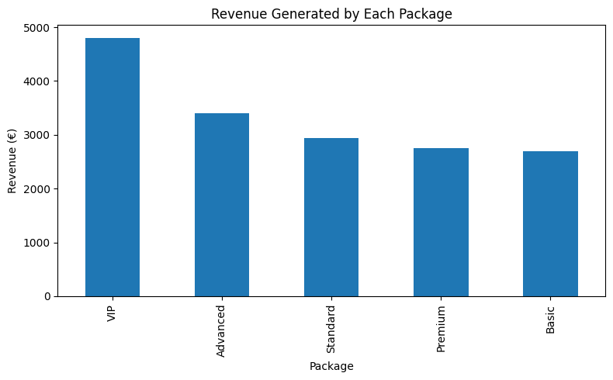
Figure 7.1 — Revenue Generated by Each Package (€)

Analysis and Findings
This bar chart displays the total revenue generated by each training package offered by the driving school. The analysis reveals the following insights:
Key Finding 1: The VIP package generated the highest revenue, Aalmost €5,000, making it the single most profitable package for the driving school.

Key Finding 2: The Advanced package ranked second with approximately €3,500, while the Standard and Premium packages generated similar (around €3,000).

Key Finding 3: The Basic package produced the lowest revenue among all available packages, at approximately €2,700.

Business Implications:
The VIP package generates the highest revenue, making it the most profitable package offered by the driving school. This suggests that students are willing to invest in premium training options. Promoting higher-value packages could help increase overall revenue while maintaining lower-cost packages to attract new customers.

7.6 Instructor Teaching Hours
This analysis evaluates the workload distribution among instructors, by summing the DurationHours of all lessons taught by each instructor.

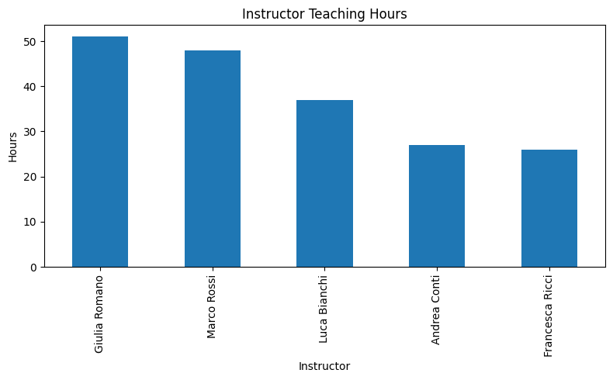
Figure 7.2 — Total Teaching Hours per Instructor

Analysis and Findings
The chart shows the total number of teaching hours delivered by each instructor.
Key Finding 1: Giulia Romano recorded the highest workload with approximately 51 teaching hours, followed closely by Marco Rossi with 48 hours.

Key Finding 2: Luca Bianchi delivered a moderate number of hours (approximately 37), while Andrea Conti and Francesca Ricci had the lowest workloads, with approximately 27 and 26 hours respectively.

Business Implications: The results indicate that teaching responsibilities are not distributed equally among instructors. Giulia Romano and Marco Rossi appear to be the most active instructors in the driving school, conducting a significantly higher number of lesson hours than the others. This imbalance could be addressed by redistributing future lesson bookings more evenly, or by investigating whether it reflects differences in instructor availability, student demand for specific instructors, or scheduling preferences.

7.7 Exam Pass and Fail Statistics
This analysis examines student performance in driving examinations, by counting the number of Passed and Failed results recorded in the Exam table.

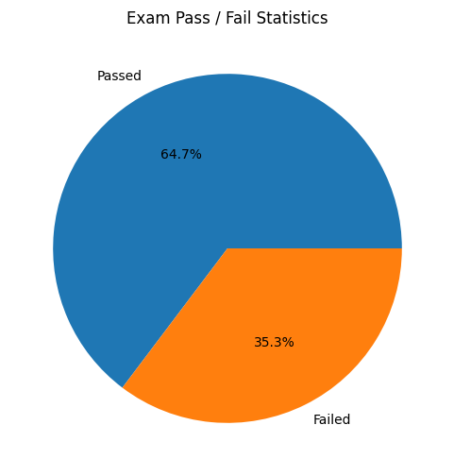
Figure 7.3 — Exam Pass / Fail Statistics

Analysis and Findings
The pie chart illustrates the distribution of examination outcomes among students who took the driving test.
Key Finding: Approximately 64.7% of students passed the examination (11 out of 17 exams), while 35.3% failed (6 out of 17). This indicates that nearly two-thirds of the students successfully met the requirements to obtain their driving license.

Business Implications: An overall pass rate of approximately 65% provides a useful baseline for evaluating the effectiveness of the school's training program.

7.8 Vehicle Utilization
This analysis evaluates how frequently each vehicle is used during driving lessons, by counting the number of lesson records associated with each vehicle model.

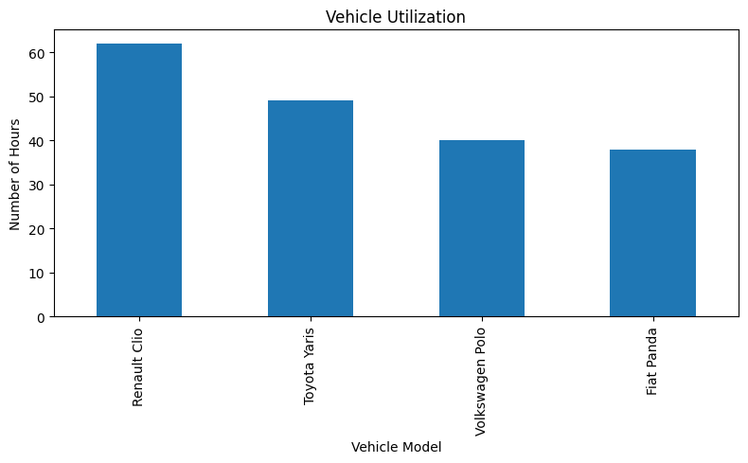
Figure 7.4 — Vehicle Utilization (Number of Lessons per Model)

Analysis and Findings
The chart compares the number of lessons conducted using each training vehicle.
Key Finding 1: Renault Clio recorded the highest utilization with approximately 62 lesson hours, followed by Toyota Yaris with around 49 hours.

Key Finding 2: Volkswagen Polo and Fiat Panda were used less frequently, with approximately 40 and 38 lesson hours respectively.

Business Implications: The Renault Clio is the most heavily utilized vehicle in the fleet, indicating a higher demand for this vehicle during training sessions. While vehicle usage is reasonably balanced, the driving school should monitor the most frequently used vehicles to ensure timely maintenance and maintain service reliability.

7.9 Package Effectiveness (Pass Rate by Package)
This analysis investigates whether certain training packages achieve higher examination success rates, by joining StudentPackage with Exam and Package, then calculating the proportion of Passed results for each package.

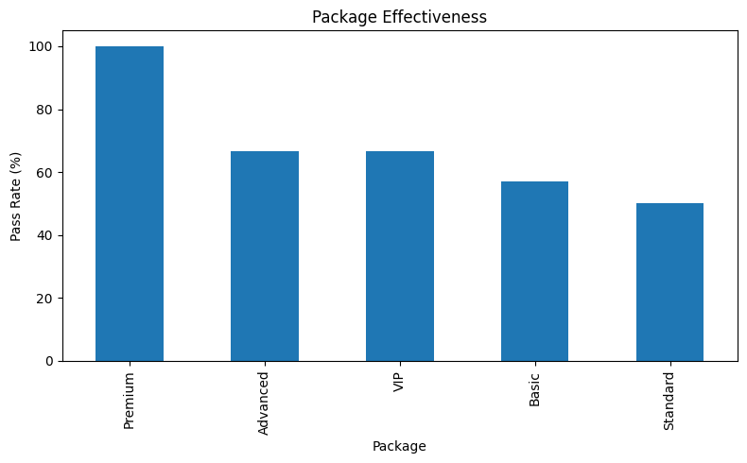
Figure 7.5 — Package Effectiveness: Exam Pass Rate by Package (%)

Analysis and Findings
The chart presents the examination pass rate associated with each training package.
Key Finding 1: The Premium package achieved the highest success rate, with 100% of its students passing the examination.

Key Finding 2: The Advanced and VIP packages also performed well, each achieving a pass rate of approximately 66.7%.

Key Finding 3: The Basic package achieved a pass rate of approximately 57.1%, while the Standard package recorded the lowest success rate at exactly 50%.

Business Implications: The results suggest that more comprehensive training packages are associated with higher exam success rates. The Premium package achieved the highest pass rate, while the Standard and Basic packages showed lower performance. This indicates that students who receive additional training are more likely to pass their exams, providing valuable insight for package recommendations and future training program development.

8. Conclusion and Future Work

8.1 Conclusion
This project successfully demonstrated the design, implementation, and analysis of a Driving School Management System using MySQL, PyQt6, and Python. The system models and manages the core entities of a driving school business, covering Student, Instructor, Vehicle, Lesson, Exam, Payment, Package, and StudentPackage. The database design reflects the business rules of the driving school through clearly defined relationships and cardinalities, ensuring data integrity and consistency throughout.
Through the use of forward-engineered table creation, primary and foreign keys enforce referential integrity, while a realistic sample dataset of 30 students, 5 instructors, 4 vehicles, 100 lessons, 17 exams, 30 payments, and 5 training packages validated the relationships and supported meaningful testing and analysis. A custom PyQt6 desktop application was built on top of the database, providing an intuitive, professional interface that allows non-technical staff to manage students, instructors, vehicles, lessons, exams, payments, and packages without writing SQL.
The data analysis phase, carried out with Python, Pandas, and Matplotlib, revealed several important findings:
- The VIP package generated the highest revenue (€5,000) and represents the primary source of income for the driving school, driven by the premium pricing.
- Instructor workloads were not evenly distributed: Giulia Romano and Marco Rossi each delivered roughly 48–51 teaching hours, nearly double the workload of Andrea Conti and Francesca Ricci.
- The overall examination pass rate was approximately 64.7% (11 out of 17 exams), indicating generally successful, but improvable, student preparation.
- Vehicle utilization was relatively balanced across the four-vehicle fleet. The Renault Clio recorded the highest usage with approximately 62 lesson hours, followed by the Toyota Yaris with 49 hours, while the Volkswagen Polo and Fiat Panda recorded 40 and 38 hours respectively.
- Training packages showed a strong relationship with exam performance. The Premium package achieved a 100% pass rate, while the Advanced and VIP packages achieved approximately 66.7%. In contrast, the Basic and Standard packages recorded the lowest pass rates at 57.1% and 50%, suggesting that more comprehensive training packages may improve student success rates.
Overall, the implemented database, GUI application, and analysis pipeline demonstrate a robust, scalable, and consistent approach to managing the core aspects of a driving school business, while supporting accurate reporting, day-to-day administration, and data-driven decision-making. The combination of MySQL, PyQt6, Python, Pandas, and Matplotlib enabled the transformation of operational data into meaningful business information that can support instructor scheduling, package design, fleet management, and overall service quality improvement.

8.2 Future Work

1. Automated Reporting and Notifications
The Statistics page could be extended to generate periodic reports (weekly or monthly) automatically, and the Dashboard's ‘upcoming lessons’ view could be paired with automated reminder notifications (for example, by email or SMS) sent to students and instructors ahead of scheduled lessons.

2. Instructor Scheduling and Workload Balancing
Building on the instructor workload analysis, the lesson scheduling module could automatically recommend the least-utilized instructor when a new lesson is booked. This would help distribute teaching hours more evenly, improve resource utilization, and ensure a balanced workload across the instructor team.

3. Expanded Exam Tracking
The Exam entity could be extended to record additional details such as the examining authority, the specific test centre, and the number of previous attempts by the same student, enabling deeper analysis of factors that influence exam success beyond the training package alone.

4. Multi-Branch Support
Should the driving school expand to multiple locations, the schema could be extended by introducing a Branch entity that owns vehicles and employs instructors, allowing per-branch reporting alongside the school-wide statistics already supported.

5. Web-Based Access
While the current PyQt6 desktop application provides a professional administrative interface, a complementary web-based portal could allow students to view their own lesson schedule, exam results, and payment history directly, reducing the administrative burden on staff for routine status enquiries.

