* System Requirement
  + Outline the aim and objective of system
    - Basically our system is developed to benefit those user who would like to buy or rent video/CD in an easiest way which is online shopping. We also aim to produce quality system to public so that the user can enjoy and at the same time developer also enjoy with the positive feedback
  + Clarify potential user and specific requirement
    - Customer
      * Normal customers can visit pages and products page.
      * Before renting or buying products, customer must register as subscriber.
      * Only subscribed customer are allow to rent maximum 5 products at a time.
      * Subscribed customer can buy as many products they wished.
    - Admin
      * Admin can view all user list.
      * Admin has privilege to disable the customers.
      * Admin can keep updating data to system.
  + Evaluate the required hardware, software platform
    - Hardware
      * Desktop
      * Laptop
      * Internet access
    - Software
      * Browser
      * Web Server
  + Consider delivery platform – running on network or stand alone
    - Standalone
    - Google Chrome
    - Xampp
* Design Issues (provide the appropriate interface design(s) that are applicable to your project)
  + Visitor Layout

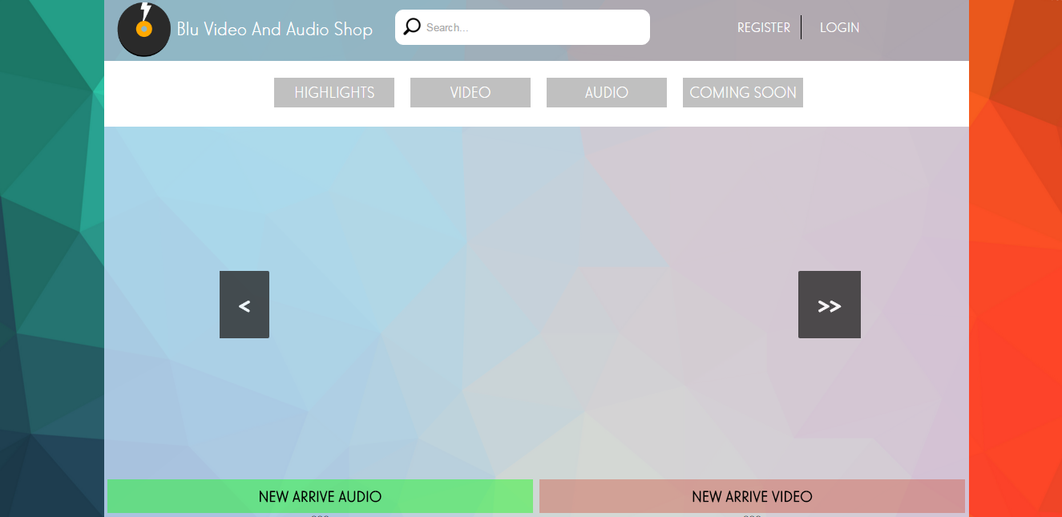

**Figure 1: Visitor index page**

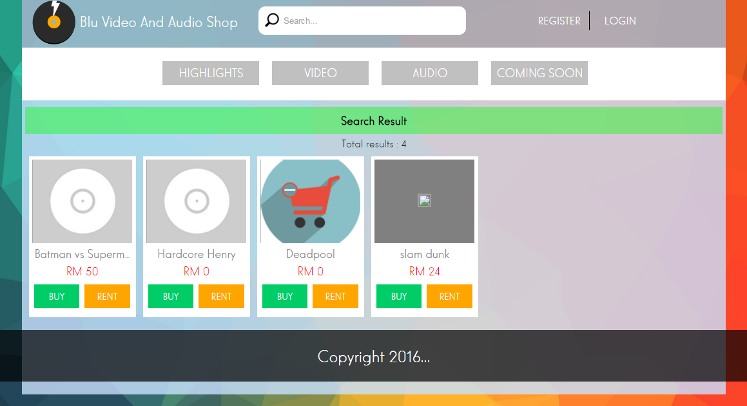

**Figure 1.1: Visitor is allowable to search any relevant product which available**

* + Admin Layout

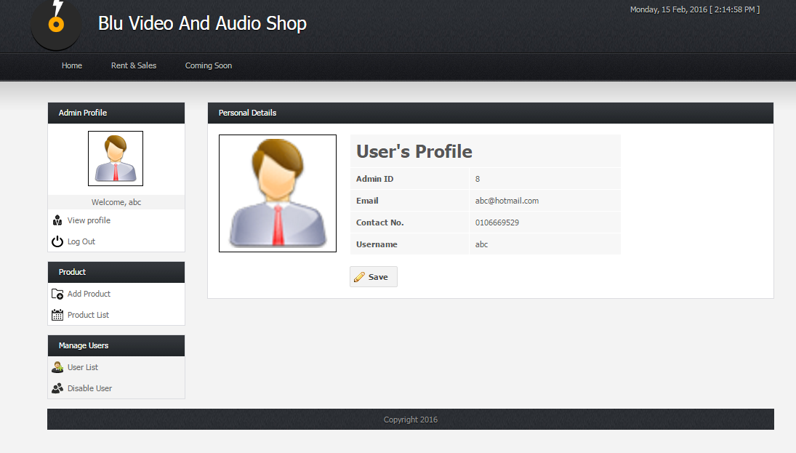

**Figure 1.2: Admin user profile that display admin information**

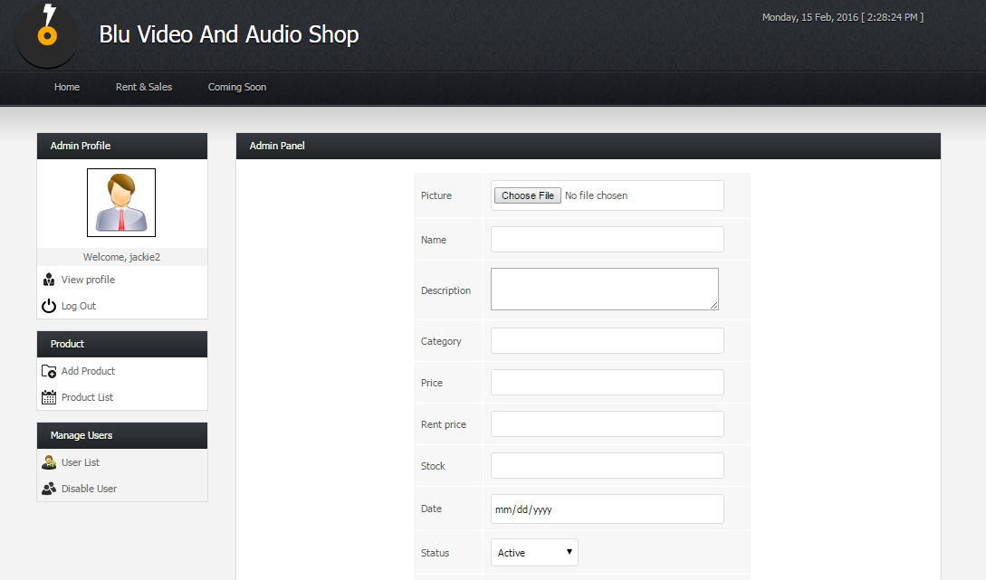

**Figure 1.3: Admin is allowable to add product so that user able to buy product**

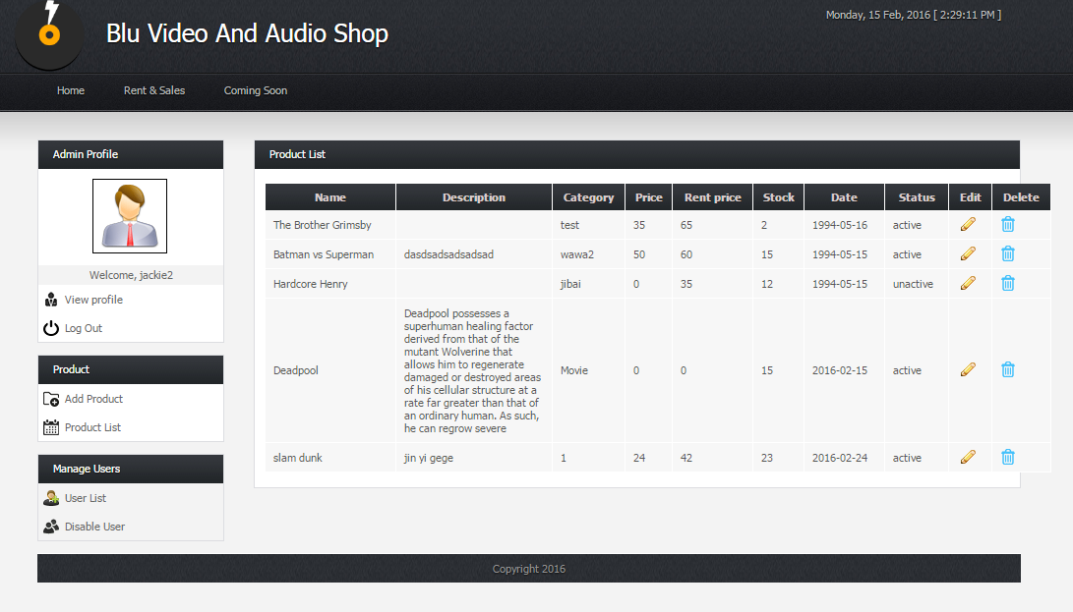

**Figure 1.4: After product added, admin can view list of product that had been added**

* + User Layout

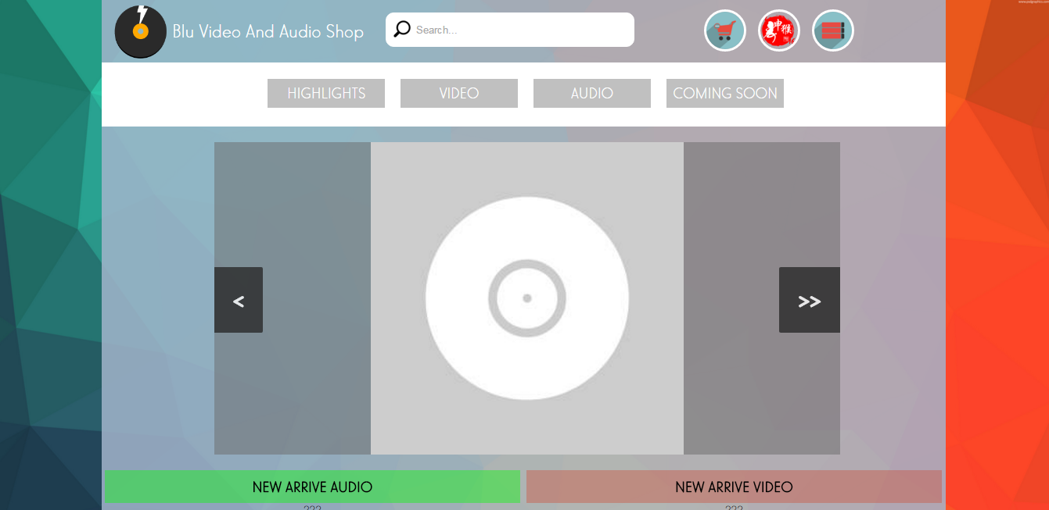

* Implementation
  + Coding
    - Php coding - to making function.
    - Html coding - making basic structure of system.
    - Css coding - making layout design.
    - Jquery - making the control on design.
    - Ajax - real time update.
    - Javascript - doing some validation.
    - MySQL- using for calling the data from database.
  + Integration and unit testing
    - Customer
      * Customer register to system.
      * Customer login to system.
      * Customer can view profile.
      * Customer can edit profile.
      * Customer can view products.
      * Customer can search products.
      * Customer can view cart.
      * Customer can buy and rent products.
    - Admin
      * Admin can add, edit, delete products.
      * Enable and disable user status
      * View recent registered user and added product
      * Edit user profile
* Evaluation
  + Evaluate whether it meets the aims and goals of your proposed system
    - So far we had achieved the most important things which is user able to make payment, after they choose their purchase type such as buy items or rent items. Since our title is regarding video/CD rent sales, so I assume we achieved a important purpose. This function will be declare as our core features.
    - Other that that, admin also playing an important role since we need admin to add product only that customer able to view and buy product.
    - I would like to conclude that we meet the aims and goals of this project based on above premises.