**Introduction**

Electronic Medical Records (EMR) system is used to record all the details and the treatment in each patient in the hospital. This EMR is very important to know the history health of each patient, what types of medicines that he takes what type of sickness and many more. This information will be covered all department that involve in the hospital. In Malaysia this system is still new, but in the overseas this system has been used in some healthy care center. This EMR system can be used to view and to give many functions for those who applied it.

Another facet of these systems is an Electronic Medical Record (EMR), which differs slightly from the standard electronic medical record. [EMR’s are defined as](http://www.healthit.gov/buzz-blog/electronic-health-and-medical-records/emr-vs-ehr-difference/) electronic medical records that “focus on the total health of the patient—going beyond standard clinical data collected in the provider’s office and inclusive of a broader view on a patient’s care.” The information housed on these systems can be shared across healthcare organizations providing physicians with a complete look at patient treatment and medical history.

As medical care gets more and more complex and new information is already overwhelming physician‘s capacity to treat patients with the latest information, physicians need new technologies to help them cope. There is great need for a digital record to allow capture of patient data that can then be processed and mined for insights into better treatment for patients. The EMR is the tool that promises to provide the platform from which new functionality and new services can be provided for patients.

Objective

To create a medical record this is confidential and kept for each patient by a healthcare professional or organization.

The record should contain the patient's personal details (such as name, address, date of birth), a summary of the patient's medical history, and documentation of each event, including symptoms, diagnosis, treatment and outcome. Relevant documents and correspondence are also included.

The main purpose of the medical record is to provide a summary of a person's contact with a healthcare provider and treatment provided to ensure appropriate healthcare.

Information from medical records also provides the essential data for monitoring patient care, clinical audits and assessing patterns of care and service delivery. In the current environment the medical record also forms the first link in the information chain producing the depersonalized aggregated coded data for statistical purposes. It is possible to store the entire medical record, or any part of it, on computer.

Scope of Electronic Medical Records (EMR)

 Information in EMRs doesn’t travel easily outof the practice. In fact, the patient’s record might even have to be printed out and delivered by mail to specialists and other members of the care team. In that regard, EMRs are not much better than a paper record.

The use and scope of electronic medical records (EMRs) is being changed by evolving technology and the way it is being used by doctors, patients and people who are sometimes referred to as individual self being. This latter category includes people who are using a growing number of devices to record data about their physical wellbeing, data that can be harnessed for better healthcare and healthcare research.

The scopes for EMR system are:

* This system is used by registration phase to records the patient details.
* These records have included patient age between 1 to 10 years old mainly emphasizing childrens and level of the sickness involve records patient, list the patient and register profile.
* This system has been used by the medical staff

Traditionally, healthcare has taken one of two paths:

* Patient problem e.g., illness-> Data: treatment-> Solution
* Solution e.g., new medication-> Data: who needs it-> Application

For people in the QS category, there is now a third option:

* Data-> Problem or opportunity-> Solution

The first two paths are largely driven by a doctor and their patient. They lend themselves to the capabilities of traditional EMRs.

* The first challenge is the data is originated by a patient (or potential patient who may or may not have a primary care physician.) What do they do with the data? One option is to store it until needed, but patients typically don’t have the knowledge or experience to know when it would be useful or is needed.
* The second challenge is the potential amount of data that will be collected relative to the limited amount of data involved in traditional EMRs.
* The third challenge is finding useful information (needles) in haystacks of data. The ability to collect data does not carry with it the ability to analyze that data.
* The fourth challenge is managing the interface between the regulated environment in which EMRs.

Contribution of the Project

EMRs and the ability to exchange health information electronically can help you provide higher quality and safer care for patients while creating tangible enhancements for your organization. EMRs help providers better manage care for patients and provide better health care by:

* Providing accurate, up-to-date, and complete information about patients at the point of care
* Enabling quick access to patient records for more coordinated, efficient care
* Securely sharing electronic information with patients and other clinicians
* Helping providers more effectively diagnose patients, reduce medical errors, and provide safer care
* Improving patient and provider interaction and communication, as well as health care convenience
* Enabling safer, more reliable prescribing
* Helping promote legible, complete documentation and accurate, streamlined coding and billing
* Enhancing privacy and security of patient data
* Helping providers improve productivity and work-life balance
* Enabling providers to improve efficiency and meet their business goals
* Reducing costs through decreased paperwork, improved safety, reduced duplication of testing, and improved health.

Conclusion

We found that the EMR in an academic family medicine clinic significantly changed the volume of communication between pharmacists and patients in significant ways. Crucially, the amount of clarifications and incorrect dosing communications were reduced suggesting that EMRs improve prescribing safety. This may represent improved capture or propensity of the EMR to change prescription patterns at patient visits. These findings are important as they establish that EMRs may have a beneficial impact on patient safety and efficiency. By reducing the amount of time pharmacists spend clarifying prescriptions, workflow can be greatly improved. This is greatly beneficial in a community pharmacy setting where it is common to find only one pharmacist on duty at certain times in the day. Further technological advances in how prescriptions are created, managed, and how pharmacists and prescribers communicate should take improving efficiency and reducing error into account as important benefits. These data suggest an overall positive change post EMR implementation with further improvements in prescribing technology needed to fully realize the benefits digitization in primary care.

Appendices

1) Source code.

ADMIN PAGE

<!DOCTYPE html>

<html>

<head>

<title><?php echo $user;?> - EMR</title>

<link rel="stylesheet" type="text/css" href="style/mystyle.css">

<link rel="stylesheet" href="style/style.css" type="text/css" media="screen" />

<link rel="stylesheet" href="style/table.css" type="text/css" media="screen" />

<script src="js/function.js" type="text/javascript"></script>

<style>#left-column {height: 477px;}

#main {height: 477px;}

h1{

font-family : "Goudy Stout";

color: black;

text-align: center;

}

body {

background-color: grey;

}

h3{

font-family : "Copperplate Gothic Bold";

color: red;

text-align: center;

}

</style>

</head>

<body>

<div id="content">

<div id="header">

<h1></a> Admin EMR</h1></div>

<div id="left_column">

</div>

<h3>Registration</h3><p>

<form name="myform" onsubmit="return validateForm(this);" action="admin.php " method="post" >

<table align="center" width="420" height="106" border="0" >

<tr><td align="center"><input name="patient_ic" type="text" style="width:170px" placeholder="IC Number" required="required" id="patient_ic" /></td></tr>

<tr><td align="center"><input name="first_name" type="text" style="width:170px" placeholder="First Name" required="required" id="first_name" /></td></tr>

<tr><td align="center"><input name="last_name" type="text" style="width:170px" placeholder="Last Name" required="required" id="last_name"/></td></tr>

<tr><td align="center"><input name="age" type="text" style="width:170px" placeholder="Age" required="required" id="age" /></td></tr>

<tr><td align="center"><input name=" address" type="text" style="width:170px" placeholder="Address" required="required" id="address" /></td></tr>

<tr><td align="center"><input name="country" type="text" style="width:170px" placeholder="country" required="required" id="country" /></td></tr>

<tr><td align="center"><input name="date_of_birth" type="bday" style="width:170px" placeholder="D.O.B" required="required" id="date_of_birth" /></td></tr>

<tr><td align="center"><input name="gender" type="text" style="width:170px" placeholder="Gender" required="required" id="gender" /></td></tr>

<tr><td align="center"><input name="username" type="text" style="width:170px" placeholder="username" required="required" id="username" /></td></tr>

<tr><td align="center"><input name="psw" type="password" style="width:170px" placeholder="password" required="required" id="password" /></td></tr>

<tr><td align="center"><input name="medical_history" type="text" style="width:170px" placeholder="Medical History" required="required" id="medical_history" /></td></tr>

<tr><td align="center"><input name="submit" type="submit" value="Submit" id="submit"/></td></tr> </p>

</table>

</form>

</div>

</div>

<div class="grid_7">

<a href=" " class="dashboard-module">

<input type="submit" value="Back">

</a>

<br>

<br>

<br>

<br>

<br>

<br>

<br>

<br>

<?php include('view.php'); ?>

</body>

</html>

Patient Registration

<!DOCTYPE html>

<html>

<head>

<title><?php echo $user;?> - EMR</title>

<link rel="stylesheet" type="text/css" href="style/mystyle.css">

<link rel="stylesheet" href="style/style.css" type="text/css" media="screen" />

<link rel="stylesheet" href="style/table.css" type="text/css" media="screen" />

<script src="js/function.js" type="text/javascript"></script>

<style>#left-column {height: 477px;}

#main {height: 477px;}

h1{

font-family : "Goudy Stout";

color: black;

text-align: center;

}

body {

background-color: grey;

}

h3{

font-family : "Copperplate Gothic Bold";

color: red;

text-align: center;

}

</style>

</head>

<body>

<div id="content">

<div id="header">

<h1></a> Admin EMR</h1></div>

<div id="left_column">

</div>

<h3>Registration</h3><p>

<form name="myform" onsubmit="return validateForm(this);" action="admin.php " method="post" >

<table align="center" width="420" height="106" border="0" >

<tr><td align="center"><input name="patient_ic" type="text" style="width:170px" placeholder="IC Number" required="required" id="patient_ic" /></td></tr>

<tr><td align="center"><input name="first_name" type="text" style="width:170px" placeholder="First Name" required="required" id="first_name" /></td></tr>

<tr><td align="center"><input name="last_name" type="text" style="width:170px" placeholder="Last Name" required="required" id="last_name"/></td></tr>

<tr><td align="center"><input name="age" type="text" style="width:170px" placeholder="Age" required="required" id="age" /></td></tr>

<tr><td align="center"><input name=" address" type="text" style="width:170px" placeholder="Address" required="required" id="address" /></td></tr>

<tr><td align="center"><input name="country" type="text" style="width:170px" placeholder="country" required="required" id="country" /></td></tr>

<tr><td align="center"><input name="date_of_birth" type="bday" style="width:170px" placeholder="D.O.B" required="required" id="date_of_birth" /></td></tr>

<tr><td align="center"><input name="gender" type="text" style="width:170px" placeholder="Gender" required="required" id="gender" /></td></tr>

<tr><td align="center"><input name="username" type="text" style="width:170px" placeholder="username" required="required" id="username" /></td></tr>

<tr><td align="center"><input name="psw" type="password" style="width:170px" placeholder="password" required="required" id="password" /></td></tr>

<tr><td align="center"><input name="medical_history" type="text" style="width:170px" placeholder="Medical History" required="required" id="medical_history" /></td></tr>

<tr><td align="center"><input name="submit" type="submit" value="Submit" id="submit"/></td></tr> </p>

</table>

</form>

</div>

</div>

<div class="grid_7">

<a href=" " class="dashboard-module">

<input type="submit" value="Back">

</a>

<br>

<br>

<br>

<br>

<br>

<br>

<br>

<br>

<?php include('view.php'); ?>

</body>

</html>

Search

<?php

mysql_connect("localhost", "root", "") or die(mysql_error());

mysql_select_db("medical") or die(mysql_error());

if(isset($_POST['submit']))

{

$query = $_POST['query'];

?>

<html>

<style>

body {

background-color: orange;

}

h1 {

font-family: "Cooper Black";

color: black;

text-align: center;

}

</style>

<head>

<title><?php echo $query;?></title>

<link href="style.css" rel="stylesheet" type="text/css" />

</head>

<body>

<?php

$min_length = 1;

if(strlen($query) >= $min_length)

{

$query = htmlspecialchars($query);

$query = mysql_real_escape_string($query);

$raw_results =

mysql_query("SELECT * FROM patient_data WHERE (`first_name` LIKE '%".$query."%') OR (`last_name` LIKE '%".$query."%')");

if(mysql_num_rows($raw_results) > 0)

{

while($results = mysql_fetch_array($raw_results))

{

echo "<tr align='middle' bgcolor='#0f7ea3'>

<td> First Name-> ".$results['first_name']."</td>

<br>

<br>

<td>Last Name-> ".$results['last_name']."</td>

<br

<br>

<td>Patient-> ".$results['patient_ic']."</td>

<br>

<br>

<td>Age-> ".$results['age']."</td>

<br>

<br>

<td>DOB-> ".$results['date_of_birth']."</td>

<br>

<br>

<td>Address-> ".$results['address']."</td>

<br>

<br>

<td>Country-> ".$results['country']."</td>

<br>

<br>

<td>Gender-> ".$results['gender']."</td>

<br>

<br>

<td>Medical History-> ".$results['medical_history']."</td>

</tr>" ;

}

}

else{

echo "<tr align='center' bgcolor='#6C0000'>

<td colspan='2' height='25px'>No results</td><tr>";

echo "</table>";

}

}

else{

echo "Minimum length is ".$min_length;

}}

?>

</body>

</html>

2) Sample Interface screen

Main

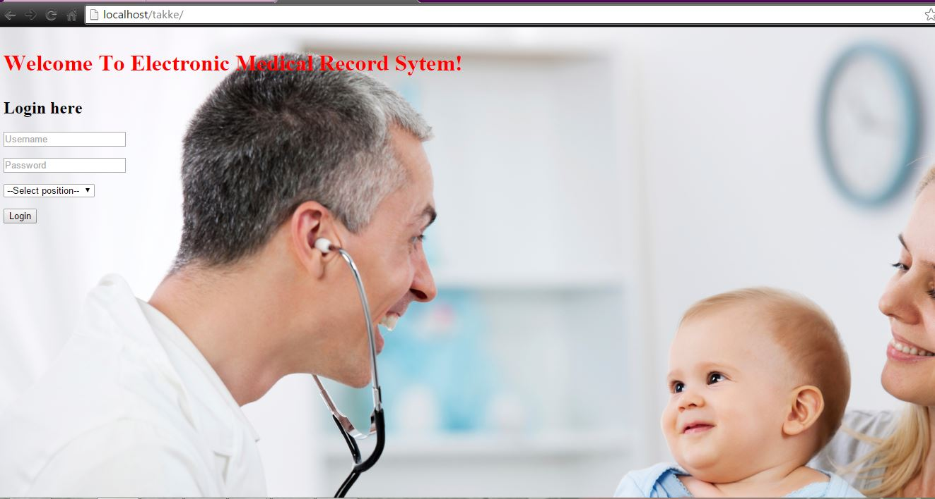

ADMIN EMR (after login)

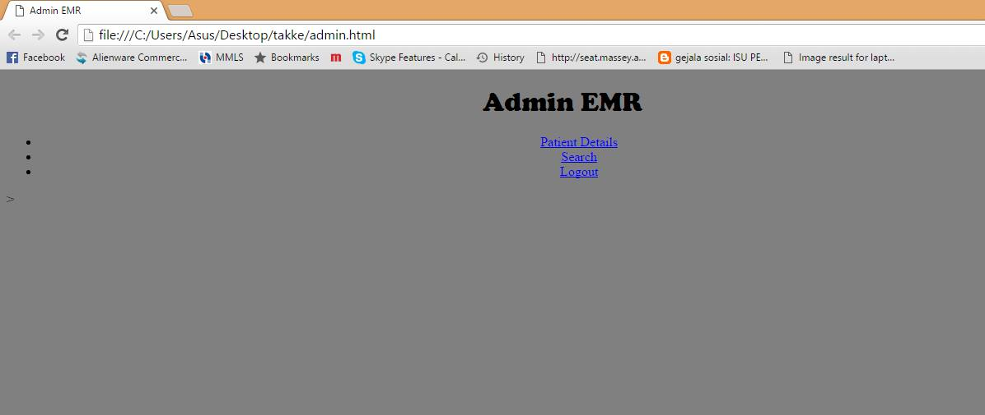

Patient Registration

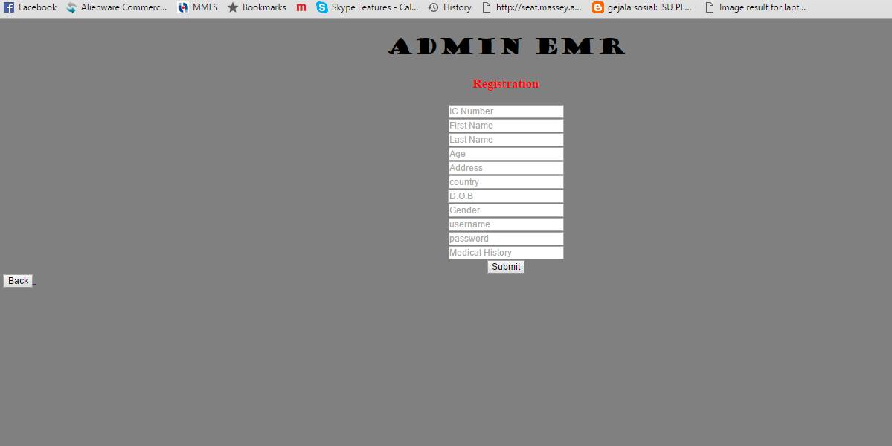

3) Sample input /output screens

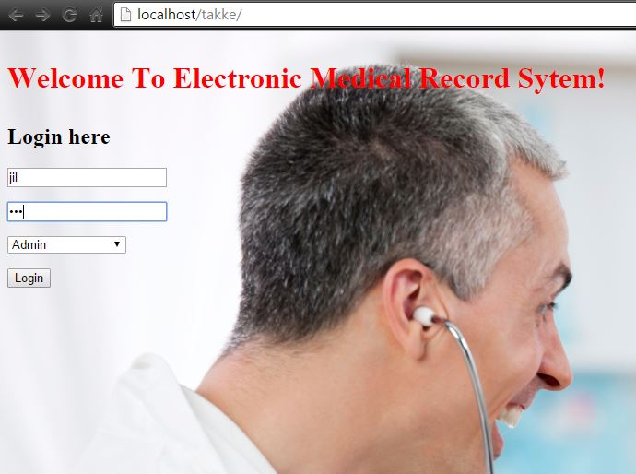

(Username and Password)