MULTIMEDIA UNIVERSITY

TDS 3301 DATA MINING

ASSIGNMENT 2

ASSOCIATION RULE MINING

GROUP DETAILS

|  |  |  |
| --- | --- | --- |
| NAME | ID | EMAIL |
| Darrel Shakri Bin Ahmad Shakri | 1141327906 | menubearer@gmail.com |
| Nur Nadhirah Bt. Nazarudin | 1142700151 | nazanadhirah@gmail.com |
| Andy Yong Jun Jie | 1142701565 | Andyyong9611@gmail.com |
| Kirbashini Naidu a/p Ragavelu | 1141127226 | Kirba4796@gmail.com |

**Domain**

Retail

**Potential Benefits from association rule mining**

- Manage the position of products in the bakery store. in such a way, to the point that customers can sensibly discover things he/she may purchase which expands the consumer loyalty and subsequently the benefit.

- To diminish the search issue to a more sensible size.

- Reports with respect to expectation of item deals patterns and client customer behaviour. To let retailers to make hands-on, learning driven choices.

**Improvement**

Build up an application with a plan to observe and measure execution utilizing key execution pointers (KPIs) in light of recorded data, current conditions and future objectives, dissect sales patterns and client purchasing examples to help benefit and make exact figures about future deals.

**About the bakery dataset**

The extended bakery datasets stores receipts of various amounts and the goods present in each receipts. The goods are from the items table of the bakery datasets, and consists of 50 different items.

There are other data in the dataset as well, such as store locations and employee information.

**Pre-processing for market basket analysis**

To perform market basket analysis, a binary vector between the receipts and bakery goods bought in the receipts must be made.

Because the dataset is in the form of SQL, construction of the database is necessary, the construction is detailed in *construction.R* on the GitHub page.

When the tables have been constructed, we first extract the names of the goods with the following code:

library**(**sqldf**)**

db **<-** dbConnect**(**SQLite**()**, dbname**=**"bakery1000"**)**

options**(**warn**=-**1**)**

# read goods table to a dataframe

goods **<-** dbGetQuery**(**db,'select * from goods'**)**

With the, the dataframe goods has been extracted. After this process, we extract the names to a vector:

# get the list of goods in database

goodsList **<-** paste**(**goods**$**Flavor, goods**$**Food**)**

This results in the vector of item names in a proper format.

Next, we create an empty vector with row size 1000 ( for the receipts ) and column size 50 ( for the items ):

# create empty matrix as binary vector

binaryVector **<-** matrix**(**0, ncol **=** nrow**(**goods**)**, nrow **=** max**(**items**$**Receipt**))**

To fill out the vector, we extract the items table, and use it as an index to fill out the correct locations:

# get vector of goods id in item

# must plus one because database ID is zero-indexed

# while R matrices are one-indexed

goodsVector **<-** as.vector**(**items**$**Item **+** 1**)**

# combine id and goods vector for indexing

idx **<-** cbind**(**idVector,goodsVector**)**

# setup vector

binaryVector**[**idx**]** **<-** 1

binaryDF **<-** data.frame**(**binaryVector**)**

Finally, we insert the goods name vector as column names, and the binary vector is ready for association rule mining:

# setup binary vector columns

colnames**(**binaryVector**)** **<-** goodsList

Full details on constructing the binary vector can be found on the file *binaryVector.R****,*** though you need to perform *construction.R* first in order to build the necessary database tables.

**Performing Association Rules Mining**

Based on the binary vector, we perform association rule mining based on these parameters:

Parameter settings: minlen=2, support = 0.005, confidence = 0.8

Choice of algorithm : Apriori

Time required:  0.03 seconds

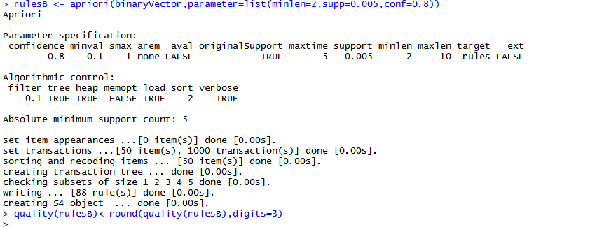

*Execution of apriori with the given parameters*

**Results**

The quality measures are tabulated below:

|  |  |  |  |
| --- | --- | --- | --- |
|  | **Support** | **Confidence** | **Lift** |
| **Minimum** | 0.005 | 0.80 | 8.4 |
| **Maximum** | 0.04 | 1.00 | 19.608 |
| **Mean** | 0.024 | 0.937 | 12.49 |
| **Median** | 0.024 | 0.95 | 12.516 |

The associations gathered have a high level of confidence, allowing us to recommend any of the frequent itemsets discovered. However, due to the relatively low support, usefulness may be limited.

We would recommend the following associations to be used for product placement:

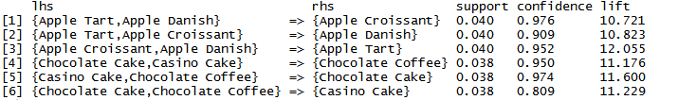

*Recommended associations*

**Recommendations**

According to the selected rules, the customers tend to buy items of the same or similar flavour. Therefore, the bakery should separate the items by distinct bakery good type and keep items of the same flavour separate so that the customers would have to walk through the entire store to get their normal items, leading to increased chance of looking and purchasing other items.