MULTIMEDIA UNIVERSITY

TDS 3301 DATA MINING

ASSIGNMENT 3

CLASSIFICATION

GROUP DETAILS

|  |  |  |
| --- | --- | --- |
| NAME | ID | EMAIL |
| Darrel Shakri Bin Ahmad Shakri | 1141327906 | menubearer@gmail.com |
| Nur Nadhirah Bt. Nazarudin | 1142700151 | nazanadhirah@gmail.com |
| Andy Yong Jun Jie | 1142701565 | Andyyong9611@gmail.com |
| Kirbashini Naidu a/p Ragavelu | 1141127226 | Kirba4796@gmail.com |

**Dataset Choice**

The dataset chosen for this assignment is the Occupation Detection Dataset located at:

https://archive.ics.uci.edu/ml/datasets/Occupancy+Detection+#

It is a dataset divided into 3 files, the training data and two test data. It has 7 attributes consisting of the class variable, the data variable representing the row identifier, and 5 continuous attributes.

The following table details the attributes:

|  |  |  |  |
| --- | --- | --- | --- |
| NAME | FEATURE TYPE | ROLE | COMMENT |
| date | Date/Time, String | None/Identifier | Formatted according to year, month , day and then hour, minute, second |
| Temperature | Numeric,continuous | Descriptor | Feature is in Celsius |
| Humidity | Numeric,continuous | Descriptor | Feature is in percentage ( % ) |
| Light | Numeric,continuous | Descriptor | Feature is in Lux |
| CO2 | Numeric,continuous | Descriptor | Feature is in parts-per-million ( ppm ) |
| HumidityRatio | Numeric,continuous | Descriptor | Derived quantity from temperature and humidity |
| Occupancy | Integer,discrete | Response | 0 = not occupied  1 = occupied |

**Exploratory Data Analysis**

To load the training data for model construction, the following code is executed:

# load library

library**(**ggplot2**)** # plotting

library**(**caret**)** # scaling

library**(**rpart**)** # decision tree

library**(**rpart.plot**)** # plotting decision tree

library**(**ROCR**)** # ROC curve

library**(**arules**)** # discretize

library**(**e1071**)** # bayes

library**(**'neuralnet'**)** # ANN

# dates are not factors

datatraining **<-** read.table**(**"datatraining.txt",header**=TRUE**,sep**=**",",stringsAsFactors **=** **FALSE)**

# convert dates to POSIXct

datatraining**$**date **<-** as.POSIXct**(**strptime**(**datatraining**$**date, "%Y-%m-%d %H:%M:%S"**))**

Once executed, the class distribution, and box-plot of the continuous variables are performed and shown below:

Class Distribution:

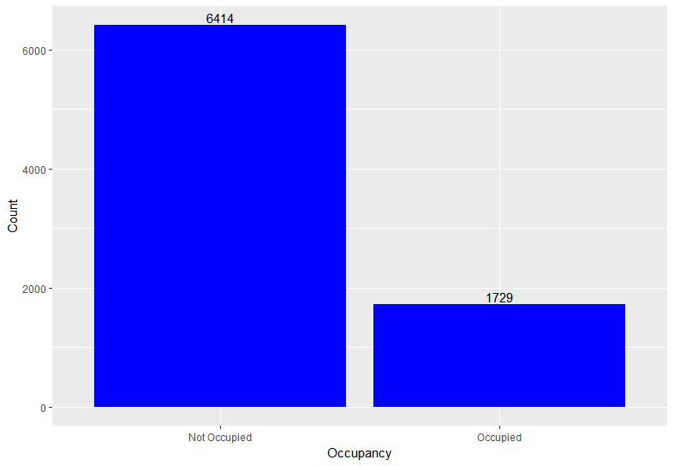

Temperature:

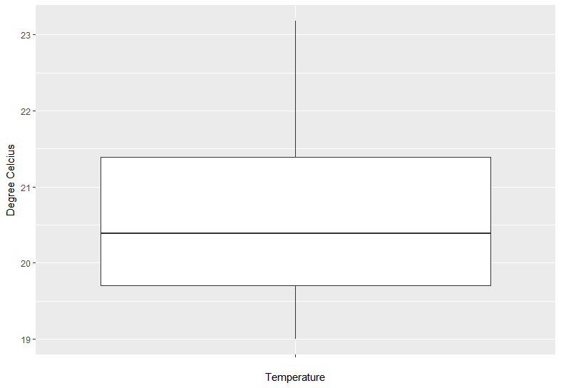

Humidity:

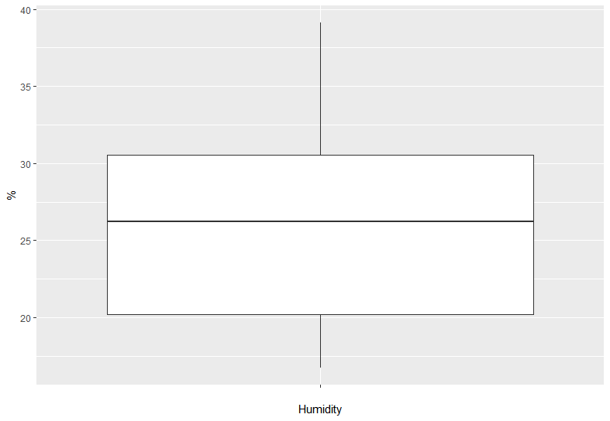

Light:

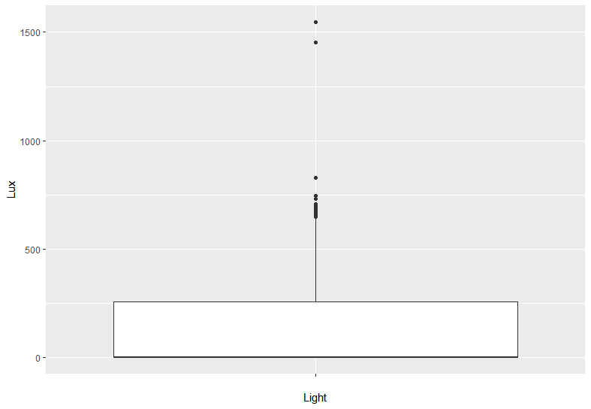

CO2:

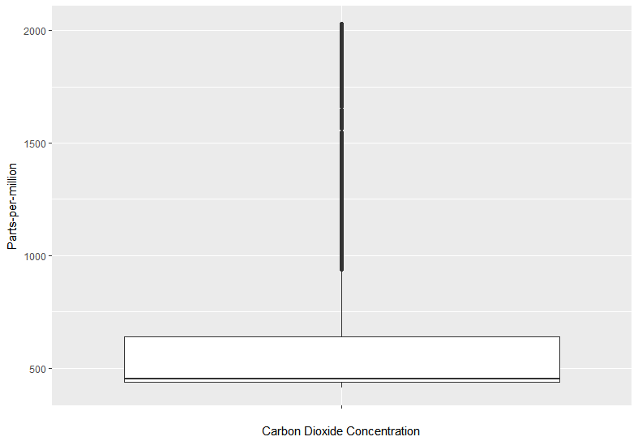

HumidityRatio:

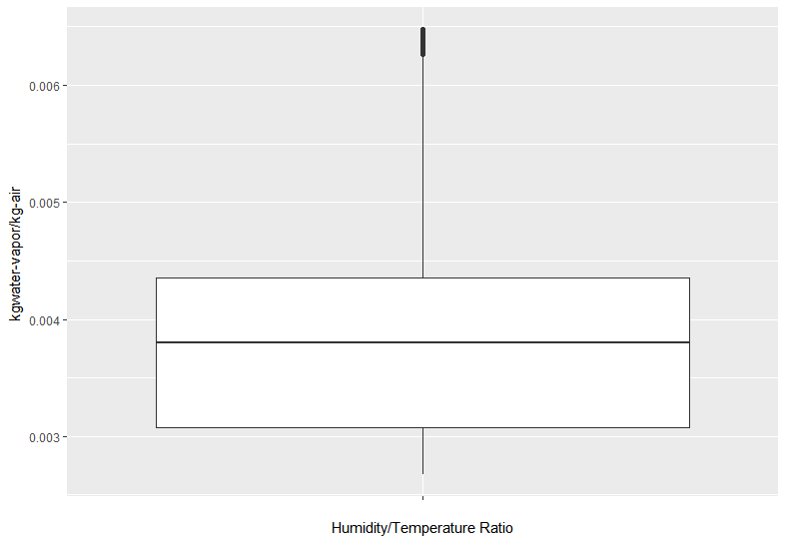

**Pre-processing tasks**

The training data seems to have no quality issues nor null values. Therefore, no data cleaning is necessary.

For **Decision Tree**, no pre-processing tasks are done because attribute splits are not affected by any kind of normalization.

For **Naive Bayes**, the continuous variables are discretized into categories based on the ranges of the continuous values. The same will be done to the test data.

For **Artifical Neural Network**, the continuous variables must be scaled between -1 and 1 and normalized to have a mean of 0 and standard deviation of 1. The same will be done to the test data.

The pre-processing tasks will be done on the section below, when constructing the model for testing.

**Performance measures**

For this exercise, we will do the ROC curve, and Sensivity/Specificity curve.

**Constructing Classification Models**

The following code creates the decision tree model:

# factorize the class variable

datatraining**$**Occupancy **=** as.factor**(**datatraining**$**Occupancy**)**

# create decision tree

dTree **<-** rpart**(**Occupancy **~** . **-** date, datatraining,control **=** rpart.control**(**cp **=** 0.001**))**

prp**(**dTree, faclen **=** 0, cex **=** 0.8, extra **=** 1**)**

# pruning post-tree

bestcp **<-** dTree**$**cptable**[**which.min**(**dTree**$**cptable**[**,"xerror"**])**,"CP"**]**

# Step3: Prune the tree using the best cp.

tree.pruned **<-** prune**(**dTree, cp **=** bestcp**)**

prp**(**dTree, faclen **=** 0, cex **=** 0.8, extra **=** 1**)**

The following code creates the Naïve Bayes model:

datatrainingNB **=** datatraining

# discretize the continuous values

datatrainingNB**$**Temperature**<-** discretize**(**datatrainingNB**$**Temperature, method **=** "interval",4,labels**=**c**(**"Low","Medium","High","Very High"**))**

datatrainingNB**$**Humidity **<-** discretize**(**datatrainingNB**$**Humidity, method **=** "interval",4,labels**=**c**(**"Low","Medium","High","Very High"**))**

datatrainingNB**$**HumidityRatio **<-** discretize**(**datatrainingNB**$**HumidityRatio, method **=** "interval",4,labels**=**c**(**"Low","Medium","High","Very High"**))**

datatrainingNB**$**Light **<-** discretize**(**datatrainingNB**$**Light, method **=** "interval",4,labels**=**c**(**"Low","Medium","High","Very High"**))**

datatrainingNB**$**CO2 **<-** discretize**(**datatrainingNB**$**CO2, method **=** "interval",4,labels**=**c**(**"Low","Medium","High","Very High"**))**

bayesPred **<-** naiveBayes**(**Occupancy**~** . **-**date, datatrainingNB**)**

The following code creates the ANN model:

# get maximum and minimum of column values

maximums **<-** apply**(**datatraining**[**,2**:**6**]**,2, max**)**

minimums **<-** apply**(**datatraining**[**,2**:**6**]**,2, min**)**

# begin scaling

# Use scale() and convert the resulting matrix to a data frame

datatrainingANN **<-** as.data.frame**(**scale**(**datatraining**[**,2**:**6**]**,center **=** minimums, scale **=** maximums **-** minimums**))**

# add the class variable to the ANN training

datatrainingANN **<-** cbind**(**Occupancy**=**as.numeric**(**datatraining**$**Occupancy**)-**1, datatrainingANN**)**

# getting the formula

feats **<-** names**(**datatrainingANN**)**

# Concatenate strings

f **<-** paste**(**feats**[**2**:**6**]**,collapse**=**' + '**)**

f **<-** paste**(**feats**[**1**]**, ' ~ ',f**)**

# Convert to formula

f **<-** as.formula**(**f**)**

nn **<-** neuralnet**(**f,datatrainingANN,hidden**=**c**(**3,2,1**)**, linear.output **=** **FALSE)**

**Testing and Performance**

The following code loads the test data (testdata.txt) and use the constructed decision tree for predicting the class attribute:

# load test data

datatestTREE **<-** read.table**(**"datatest2.txt",header**=TRUE**,sep**=**",",stringsAsFactors **=** **FALSE)**

# convert dates to POSIXct

datatestTREE**$**date **<-** as.POSIXct**(**strptime**(**datatestTREE**$**date, "%Y-%m-%d %H:%M:%S"**))**

# do prediction

predT **<-** predict**(**dTree, newdata **=** datatestTREE, type **=** 'class'**)**

# get confusion matrix

confusionMatrix**(**predT, datatestTREE**$**Occupancy**)**

# get ROC curve

# need to turn factors to binary values

roc_predDT **<-** ROCR**::**prediction**(**as.numeric**(**predT**)**, as.numeric**(**datatestTREE**$**Occupancy**))**

plot**(**performance**(**roc_predDT, measure**=**"tpr", x.measure**=**"fpr"**)**, colorize**=TRUE)**

# precision recall curve

plot**(**performance**(**roc_predDT, measure**=**"sens", x.measure**=**"spec"**)**, colorize**=TRUE)**

Then we do the same with the Naive Bayes models, including discretizing the test data:

# load test data

datatestNB **<-** read.table**(**"datatest2.txt",header**=TRUE**,sep**=**",",stringsAsFactors **=** **FALSE)**

# factorize the class variable

datatestNB**$**Occupancy **=** as.factor**(**datatestNB**$**Occupancy**)**

# discretize the continuous values

datatestNB**$**Temperature**<-** discretize**(**datatestNB**$**Temperature, method **=** "interval",4,labels**=**c**(**"Low","Medium","High","Very High"**))**

datatestNB**$**Humidity **<-** discretize**(**datatestNB**$**Humidity, method **=** "interval",4,labels**=**c**(**"Low","Medium","High","Very High"**))**

datatestNB**$**HumidityRatio **<-** discretize**(**datatestNB**$**HumidityRatio, method **=** "interval",4,labels**=**c**(**"Low","Medium","High","Very High"**))**

datatestNB**$**Light **<-** discretize**(**datatestNB**$**Light, method **=** "interval",4,labels**=**c**(**"Low","Medium","High","Very High"**))**

datatestNB**$**CO2 **<-** discretize**(**datatestNB**$**CO2, method **=** "interval",4,labels**=**c**(**"Low","Medium","High","Very High"**))**

# convert dates to POSIXct

datatestNB**$**date **<-** as.POSIXct**(**strptime**(**datatestNB**$**date, "%Y-%m-%d %H:%M:%S"**))**

# do prediction

predB **<-** predict**(**bayesPred, newdata **=** datatestNB**[**,2**:**6**])**

# get confusion matrix

confusionMatrix**(**predB, datatestNB**$**Occupancy**)**

# get ROC curve

# need to turn factors to binary values

roc_predNB **<-** ROCR**::**prediction**(**as.numeric**(**predB**)**, as.numeric**(**datatestNB**$**Occupancy**))**

plot**(**performance**(**roc_predNB, measure**=**"tpr", x.measure**=**"fpr"**)**, colorize**=TRUE)**

# precision recall curve

plot**(**performance**(**roc_predNB, measure**=**"sens", x.measure**=**"spec"**)**, colorize**=TRUE)**

Finally, we load the test data, and modify it so that the ANN can be used for prediction:

# load test data

datatestANN **<-** read.table**(**"datatest2.txt",header**=TRUE**,sep**=**",",stringsAsFactors **=** **FALSE)**

# numerize the class variable

datatestANN**$**Occupancy **=** as.numeric**(**datatestANN**$**Occupancy**)**

# get maximum and minimum of column values

maximums **<-** apply**(**datatestANN**[**,2**:**6**]**,2, max**)**

minimums **<-** apply**(**datatestANN**[**,2**:**6**]**,2, min**)**

# begin scaling

# Use scale() and convert the resulting matrix to a data frame

scaled.dataANN **<-** as.data.frame**(**scale**(**datatestANN**[**,2**:**6**]**,center **=** minimums, scale **=** maximums **-** minimums**))**

# add the class variable to the ANN training

datatestANN **<-** cbind**(**Occupancy**=**datatestANN**$**Occupancy, scaled.dataANN **)**

# prediction

predN **<-** compute**(**nn,datatestANN**[**,2**:**6**])**

# round off results

predN **<-** sapply**(**predN**$**net.result,round,digits**=**0**)**

# get confusion matrix

confusionMatrix**(**predN, datatestANN**$**Occupancy**)**

The following graphs show the performance measures:

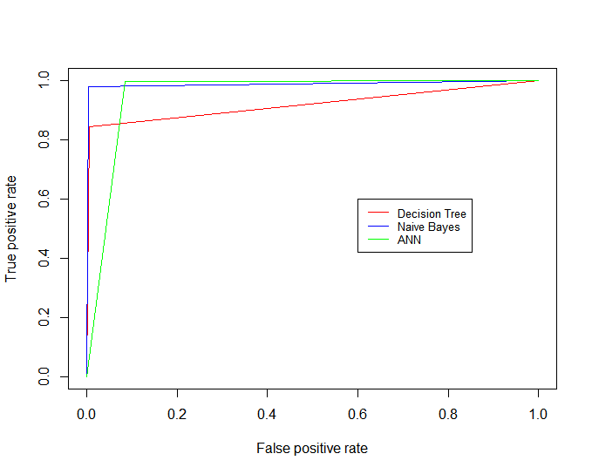

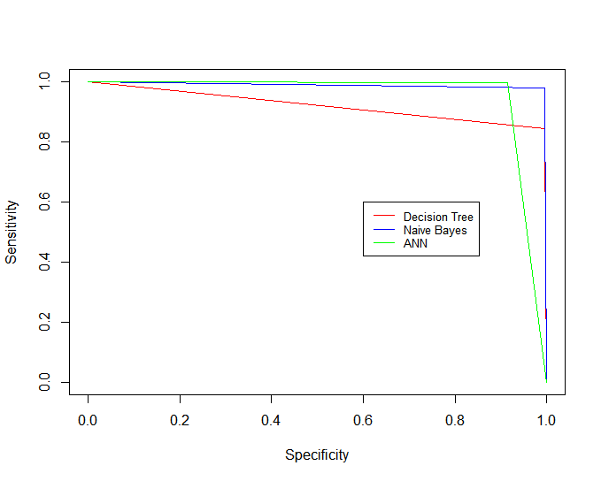

**Conclusion**

Decision trees perform the worst because continuous variables do not lend easily to attribute splitting. Other classification models work better after performing some pre-processing of the data in order to discretize data for Naive Bayes, and normalization and scaling for the ANN.

**Other information**

The code can be viewed at *work.R* in the same GitHub directory including data reading, pre-processing, model construction, evaluation and visualization.

There is also a Shiny app showing the performances measures at https://mmudsask.shinyapps.io/classifierperf/