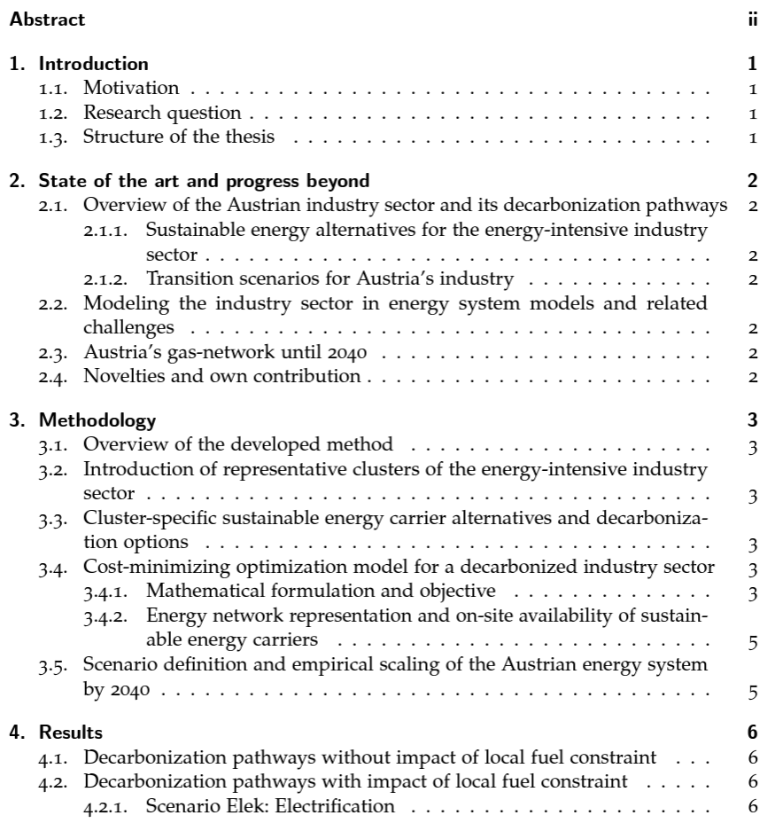
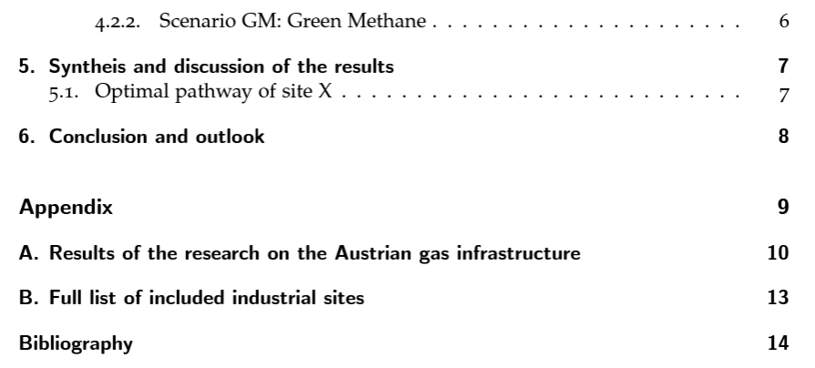
- Introduction
  - Xx
- State of the art and progress beyond
  - Overview
- Methodology
  - Overview
- Results
- Synthesis
- Conclusion and outlook

