Worksheet 4

Manish Mahato

The British College Student ID: 23085136

**WORKSHEET 4**

1. STL Container Practice: Write a program using STL containers that
   1. Uses vector<string> to store names
   2. Uses map<string, int> to store age against each name
   3. Implements functions to:
      1. Add new name-age pair
      2. Find all people above certain age
      3. Sort and display names alphabetically

**Source code for this:**

#include <iostream>  
#include <vector>  
#include <map>  
#include <algorithm>  
  
using namespace std;  
  
void addPerson(map<string, int>& people, vector<string>& names) {  
 string name;  
 int age;  
  
 cout << "Enter name: ";  
 cin.ignore(); // Clear leftover input  
 getline(cin, name);  
  
 cout << "Enter age: ";  
 cin >> age;  
  
 people[name] = age;  
 names.push_back(name);  
}  
  
void showPeopleAboveAge(const map<string, int>& people, int limit) {  
 bool found = false;  
 cout << "People older than " << limit << ":\n";  
 for (auto& person : people) {  
 if (person.second > limit) {  
 cout << person.first << " (" << person.second << ")\n";  
 found = true;  
 }  
 }  
 if (!found) cout << "No one found above that age.\n";  
}  
  
void showSortedNames(const vector<string>& names) {  
 if (names.empty()) {  
 cout << "No names to display.\n";  
 return;  
 }  
  
 vector<string> sortedNames = names;  
 sort(sortedNames.begin(), sortedNames.end());  
  
 cout << "Names in alphabetical order:\n";  
 for (const string& name : sortedNames) {  
 cout << name << endl;  
 }  
}  
  
int main() {  
 map<string, int> people;  
 vector<string> names;  
 int choice;  
  
 do {  
 cout << "\nMenu:\n";  
 cout << "1. Add person\n";  
 cout << "2. Show people above a certain age\n";  
 cout << "3. Show sorted names\n";  
 cout << "4. Exit\n";  
 cout << "Enter choice: ";  
 cin >> choice;  
  
 if (cin.fail()) {  
 cin.clear();  
 cin.ignore(1000, '\n');  
 cout << "Invalid input. Try again.\n";  
 continue;  
 }  
  
 switch (choice) {  
 case 1:  
 addPerson(people, names);  
 break;  
 case 2: {  
 int age;  
 cout << "Enter age limit: ";  
 cin >> age;  
 showPeopleAboveAge(people, age);  
 break;  
 }  
 case 3:  
 showSortedNames(names);  
 break;  
 case 4:  
 cout << "Goodbye!\n";  
 break;  
 default:  
 cout << "Invalid option. Try again.\n";  
 }  
  
 } while (choice != 4);  
  
 return 0;  
}

**Output:**

1. Stack Problem: Implement a stack using arrays (not STL) that:
   1. Has basic push and pop operations
   2. Has a function to find middle element
   3. Has a function to reverse only bottom half of stack
   4. Maintain stack size of 10

**Source Code for this:**

#include <iostream>  
using namespace std;  
  
class Stack {  
private:  
 int stack[10];  
 int top;  
  
public:  
 Stack() { top = -1; }  
  
 void push(int value) {  
 if (top == 9) {  
 cout << "Stack is full!" << endl;  
 return;  
 }  
 stack[++top] = value;  
 }  
  
 void pop() {  
 if (top == -1) {  
 cout << "Stack is empty!" << endl;  
 return;  
 }  
 cout << "Popped value: " << stack[top--] << endl;  
 }  
  
 void findMiddle() {  
 if (top == -1) {  
 cout << "Stack is empty!" << endl;  
 return;  
 }  
 cout << "Middle element: " << stack[top / 2] << endl;  
 }  
  
 void reverseBottomHalf() {  
 if (top < 1) {  
 cout << "Not enough elements to reverse bottom half!" << endl;  
 return;  
 }  
  
 int mid = top / 2;  
 for (int i = 0; i <= mid / 2; i++) {  
 swap(stack[i], stack[mid - i]);  
 }  
  
 cout << "Bottom half reversed." << endl;  
 }  
  
 void display() {  
 if (top == -1) {  
 cout << "Stack is empty!" << endl;  
 return;  
 }  
  
 cout << "Stack elements: ";  
 for (int i = 0; i <= top; i++) {  
 cout << stack[i] << " ";  
 }  
 cout << endl;  
 }  
  
 int spaceLeft() {  
 return 9 - top;  
 }  
};  
  
int main() {  
 Stack s;  
 int choice, value, count;  
  
 do {  
 cout << "\nMenu:\n";  
 cout << "1. Push up to 5 numbers\n";  
 cout << "2. Pop\n";  
 cout << "3. Find Middle\n";  
 cout << "4. Reverse Bottom Half\n";  
 cout << "5. Display Stack\n";  
 cout << "6. Exit\n";  
 cout << "Enter choice: ";  
 cin >> choice;  
  
 switch (choice) {  
 case 1:  
 cout << "How many numbers do you want to push (max 5)? ";  
 cin >> count;  
  
 if (count < 1 || count > 5) {  
 cout << "Please enter a number between 1 and 5." << endl;  
 break;  
 }  
  
 if (count > s.spaceLeft()) {  
 cout << "Not enough space in stack. You can push up to " << s.spaceLeft() << " more." << endl;  
 break;  
 }  
  
 cout << "Enter " << count << " number(s): ";  
 for (int i = 0; i < count; ++i) {  
 cin >> value;  
 s.push(value);  
 }  
 break;  
  
 case 2:  
 s.pop();  
 break;  
  
 case 3:  
 s.findMiddle();  
 break;  
  
 case 4:  
 s.reverseBottomHalf();  
 break;  
  
 case 5:  
 s.display();  
 break;  
  
 case 6:  
 cout << "Goodbye!" << endl;  
 break;  
  
 default:  
 cout << "Invalid choice." << endl;  
 }  
  
 } while (choice != 6);  
  
 return 0;  
}

**Output:**

1. Queue Problem: Implement a queue using arrays (not STL) that:
   1. Has basic enqueue and dequeue operations
   2. Has a function to reverse first K elements
   3. Has a function to interleave first half with second half
   4. Handle queue overflow/underflow

**Source code for this:**

#include <iostream>  
using namespace std;  
  
class Queue {  
private:  
 int queue[10];  
 int front, rear, size;  
  
public:  
 Queue() {  
 front = rear = size = 0;  
 }  
  
 void enqueue(int value) {  
 if (size == 10) {  
 cout << "Queue is full!\n";  
 return;  
 }  
 queue[rear] = value;  
 rear = (rear + 1) % 10;  
 size++;  
 }  
  
 int dequeue() {  
 if (size == 0) {  
 cout << "Queue is empty!\n";  
 return -1;  
 }  
 int val = queue[front];  
 front = (front + 1) % 10;  
 size--;  
 return val;  
 }  
  
 void reverseFirstK(int k) {  
 if (k > size || k < 1) {  
 cout << "Invalid value of K.\n";  
 return;  
 }  
  
 int temp[10];  
 for (int i = 0; i < k; i++) temp[i] = dequeue();  
 for (int i = k - 1; i >= 0; i--) enqueue(temp[i]);  
 }  
  
 void interleave() {  
 if (size % 2 != 0) {  
 cout << "Queue size must be even to interleave.\n";  
 return;  
 }  
  
 int half = size / 2;  
 int first[5], second[5];  
  
 for (int i = 0; i < half; i++) first[i] = dequeue();  
 for (int i = 0; i < half; i++) second[i] = dequeue();  
  
 for (int i = 0; i < half; i++) {  
 enqueue(first[i]);  
 enqueue(second[i]);  
 }  
 }  
  
 void display() {  
 if (size == 0) {  
 cout << "Queue is empty.\n";  
 return;  
 }  
  
 int index = front;  
 cout << "Queue: ";  
 for (int i = 0; i < size; i++) {  
 cout << queue[index] << " ";  
 index = (index + 1) % 10;  
 }  
 cout << endl;  
 }  
};  
  
int main() {  
 Queue q;  
 int choice, value, k;  
  
 do {  
 cout << "\nMenu:\n";  
 cout << "1. Enqueue\n";  
 cout << "2. Dequeue\n";  
 cout << "3. Reverse First K Elements\n";  
 cout << "4. Interleave Halves\n";  
 cout << "5. Display Queue\n";  
 cout << "6. Exit\n";  
 cout << "Enter choice: ";  
 cin >> choice;  
  
 switch (choice) {  
 case 1:  
 cout << "Enter value: ";  
 cin >> value;  
 q.enqueue(value);  
 break;  
 case 2:  
 value = q.dequeue();  
 if (value != -1) cout << "Dequeued: " << value << endl;  
 break;  
 case 3:  
 cout << "Enter K: ";  
 cin >> k;  
 q.reverseFirstK(k);  
 break;  
 case 4:  
 q.interleave();  
 break;  
 case 5:  
 q.display();  
 break;  
 case 6:  
 cout << "Exiting...\n";  
 break;  
 default:  
 cout << "Invalid choice.\n";  
 }  
  
 } while (choice != 6);  
  
 return 0;  
}

**Output:**

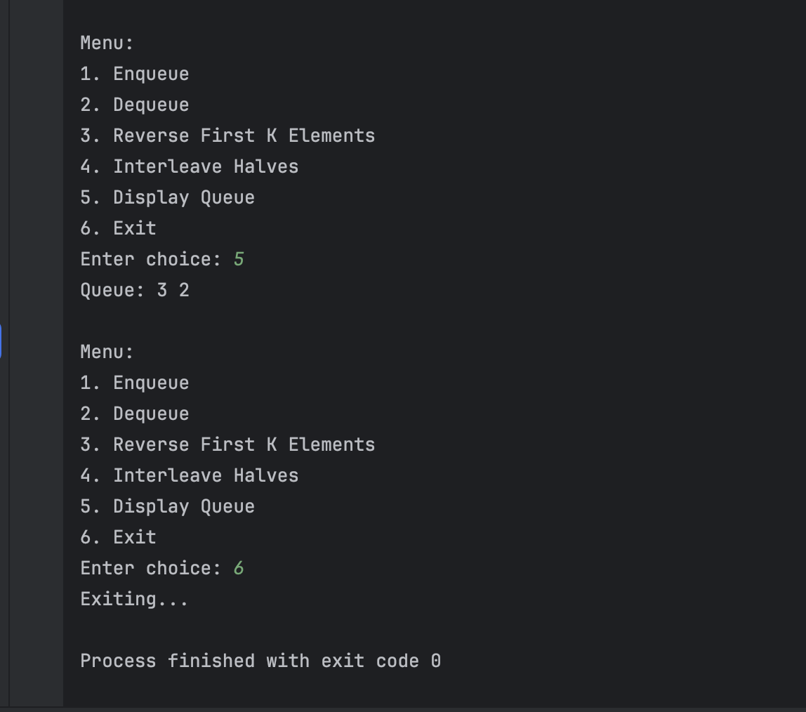

1. Linked List Problem: Create a singly linked list (not STL) that:
2. Has functions to insert at start/end/position
3. Has a function to detect and remove loops
4. Has a function to find nth node from end
5. Has a function to reverse list in groups of K nodes

**Source code for this:**

#include <iostream>  
using namespace std;  
  
class Node {  
public:  
 int data;  
 Node* next;  
 Node(int val) {  
 data = val;  
 next = nullptr;  
 }  
};  
  
class LinkedList {  
private:  
 Node* head;  
  
public:  
 LinkedList() { head = nullptr; }  
  
 void insertAtStart(int val) {  
 Node* newNode = new Node(val);  
 newNode->next = head;  
 head = newNode;  
 }  
  
 void insertAtEnd(int val) {  
 Node* newNode = new Node(val);  
 if (!head) {  
 head = newNode;  
 return;  
 }  
 Node* temp = head;  
 while (temp->next) temp = temp->next;  
 temp->next = newNode;  
 }  
  
 void insertAtPosition(int val, int pos) {  
 if (pos <= 1) {  
 insertAtStart(val);  
 return;  
 }  
 Node* newNode = new Node(val);  
 Node* temp = head;  
 for (int i = 1; temp && i < pos - 1; ++i) temp = temp->next;  
  
 if (!temp) {  
 cout << "Position out of range.\n";  
 return;  
 }  
 newNode->next = temp->next;  
 temp->next = newNode;  
 }  
  
 void findNthFromEnd(int n) {  
 Node *main = head, *ref = head;  
 for (int i = 0; i < n; ++i) {  
 if (!ref) {  
 cout << "Position too big.\n";  
 return;  
 }  
 ref = ref->next;  
 }  
 while (ref) {  
 main = main->next;  
 ref = ref->next;  
 }  
 cout << n << "th node from end: " << main->data << endl;  
 }  
  
 void reverseInGroups(int k) {  
 head = reverseK(head, k);  
 }  
  
 Node* reverseK(Node* node, int k) {  
 Node *prev = nullptr, *curr = node, *next = nullptr;  
 int count = 0;  
  
 while (curr && count < k) {  
 next = curr->next;  
 curr->next = prev;  
 prev = curr;  
 curr = next;  
 count++;  
 }  
 if (next) node->next = reverseK(next, k);  
 return prev;  
 }  
  
 void detectAndRemoveLoop() {  
 Node *slow = head, *fast = head;  
 while (fast && fast->next) {  
 slow = slow->next;  
 fast = fast->next->next;  
 if (slow == fast) {  
 removeLoop(slow);  
 cout << "Loop removed.\n";  
 return;  
 }  
 }  
 cout << "No loop detected.\n";  
 }  
  
 void removeLoop(Node* loopNode) {  
 Node* ptr1 = head;  
 while (ptr1->next != loopNode->next) {  
 ptr1 = ptr1->next;  
 loopNode = loopNode->next;  
 }  
 loopNode->next = nullptr;  
 }  
  
 void createLoop(int pos) {  
 if (pos <= 0) return;  
 Node *loopNode = nullptr, *temp = head;  
 int count = 1;  
 while (temp->next) {  
 if (count == pos) loopNode = temp;  
 temp = temp->next;  
 count++;  
 }  
 if (loopNode) temp->next = loopNode;  
 }  
  
 void display() {  
 Node* temp = head;  
 while (temp) {  
 cout << temp->data << " -> ";  
 temp = temp->next;  
 }  
 cout << "NULL\n";  
 }  
};  
  
int main() {  
 LinkedList ll;  
  
 ll.insertAtEnd(10);  
 ll.insertAtEnd(20);  
 ll.insertAtEnd(30);  
 ll.insertAtEnd(40);  
 ll.insertAtEnd(50);  
 ll.display();  
  
 ll.insertAtStart(5);  
 ll.insertAtPosition(15, 3);  
 ll.display();  
  
 ll.findNthFromEnd(3);  
  
 ll.reverseInGroups(2);  
 cout << "After reversing in groups of 2:\n";  
 ll.display();  
  
 ll.createLoop(3);  
 ll.detectAndRemoveLoop();  
 ll.display();  
  
 return 0;  
}

**Output:**

