**MIMI**

Your loyal personal assistent

Student: Măcean Marius

Group: 30433

Prof: Rednic Ana

13/01/2022

Contents

2.**Introduction**................................................................................................................................3

3.**Bibliographic** **Research** .............................................................................................................3

4.**Proposed Solution and Implementation** ..................................................................................5

5.**Testing and Validation** ..............................................................................................................8

6.**Conclusion** ..................................................................................................................................9

7.**Future Developments** ................................................................................................................9

7.**Bibliography** .............................................................................................................................10

Introduction

The aim of this work is to analyze a current developing technology and to reproduce it in a genuinely basic and cheap project. The subject of interest is well-known as the AI (**Artificial Intelligent**) human-like robots. More specifically, the final state of the project should represent a small and cute robot, called **Mimi**. It is going to be a re-creation of the already on the markets “personal assistant” robots. The main feature we are going to work on is **the personality** of our little friend, expressed thourgh the interaction with the user/ (the person).

Bibliographic Research

**First of all, what is the actual defintion of the Artificial Inteligence? In a few words, AI** represents the ability of a digital [computer](https://www.britannica.com/technology/computer) or computer-controlled [robot](https://www.britannica.com/technology/robot-technology) to perform tasks commonly associated with intelligent beings. The main “task” our prototype is going to fulfill is to cheer up its owner!

Before we start working on the project, some research into the existent AI companions. The two robots of interest are **Vector** and **Emo**. They are shown and described below.

Vector is a palm-sized robot that is made from a black plastic material and he has a body that's filled with various sensors and electronics to detect and respond to the environment around him. Most of Vector's personality is expressed through his small front display, which is always on and is where his eyes are located.

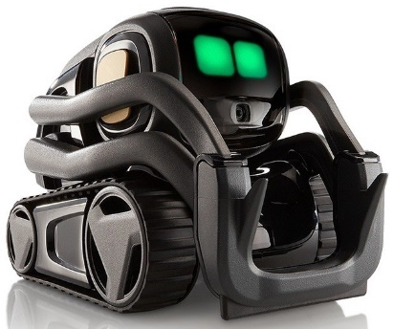

Built with multiple sensors and cutting-edge techs, Emo is a cool desktop AI robot pet with characters that can self-explore the world and react to you with 1000+ faces and movements. Like a loyal companion, Emo cheers you up with music, dance movements, and online games! Emo is also a great helper that wakes you up, turns on the light, takes pictures and answers to your questions, for a truly life-like pet on your desktop!

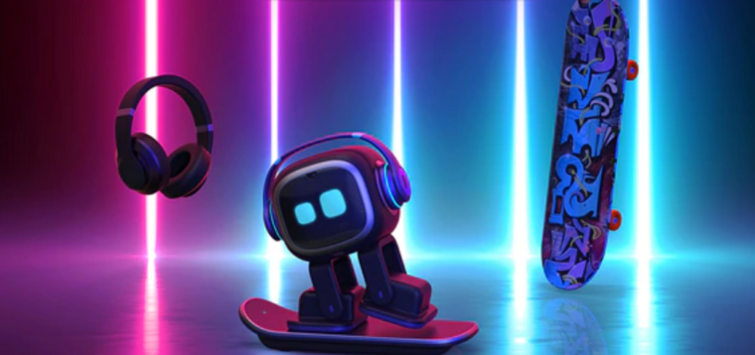

Having these examples into consideration, we can start building our own personal companion! Of course, its features will represent the very basics of what the presented robots are capable of. We are also aware that this use of the AI technology does not directly solve the main problems in the world (in politics, in energy consumption and so on). However, the most important aspects of our life are ruled by our everyday mood.

So what does every person need the most in their life? Clearly, it is a cute and tiny robot that is always on their side, cheer them up and make their day as efficient as possible. Now this is a **real** solution for every nowadays society problem.

At this level, we are ready to prepare our tools and start the actual project. The main components we need are a small display, a speaker and maybe some sensors that receive information from the user. In the end, we will need some type of shell (a body), to give our friend a pleasing look.

**The display.** There are lots of choices, but we have to go for the best price. However, we also need to display two big eyes on it so a little quality is required. The two main types of displays are LCD displays and OLED displays. **LCD** (liquid crystal display) is the technology used for displays in notebook and other smaller computers. Like light-emitting diode (LED) and gas-plasma technologies, LCDs allow displays to be much thinner than cathode ray tube (CRT) technology. LCD display is a flat-panel display or other electronic visual display that uses the light-modulating properties of liquid crystals. **OLED** is an organic light emitting diode in which the emissive electroluminescent layer is a film of organic compound that emits light in response to an electric current. An OLED display works without a backlight; it can display deep black levels and can be thinner and lighter than a liquid crystal display. Thus, it is provides better contrast than the LCD choice but it becomes a bit more expensive.

On this small display, we want to print a face (only two big eyes) that will represent different feelings. For example, in the following image are some emotions expressed through the eyes. Of course, our prototype will have a little more simplistic eyes.

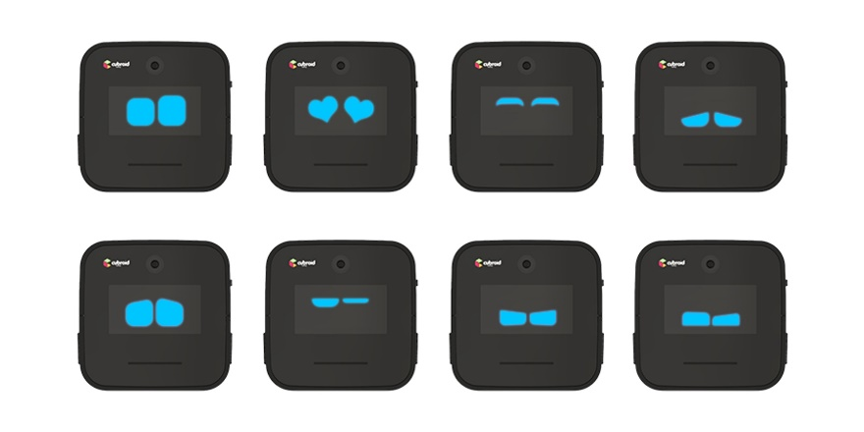

**The speaker** is going to augment the eyes in expressing the personality. In this way, the owner will be able to hear Mimi from distance if it has something to say!

Proposed Solution and Implementation

After the discussion over the way the robot has to be implemented, we came to a decision. Beside the display (an lcd one) and the speaker (a buzzer), it will also have two input sensors: a motion sensor and an ultrasonic sensor. This way, the robot will receive relevant information about its owner (whether or not they are in the same room with Mimi and how close they are to it).

The robot will be able to “know” if someone is in the same room with him. Otherwise, it will go to **sleep**. However, if it knows that a person is in the room, but he cannot see them (through its ultrasonic sensor), he will become **suspicious** after a time**.** Also, when no emotion is triggered, the robot will also **blink** from time to time.

In case of Mimi seeing the owner in the room, but far away from him, he will become **upset**. If more time passes in the same scenario, it will become **extremely upset.**

Mimi is a clingy and affectionate companion. It needs lots of attention and loves being around you! When you bring it close to you, it becomes **happy**. Moreover, when you take it in your arms and hold it, Mimi becomes **extremely happy**.

**Hardware**.

Now let’s move on to the technical part. The hardware components used in implementation are shown and described in the following section. Also, all of the wire connetions are presented below.

The LCD module is perfect of the projects where you need a small display. It uses 4 pins for the SPI communication and it has its own buffer for the pixels addresses. Easy to use on every Arduino board. The 1.8’’ screen has a resolution of 128x160 colored pixels. In comparison with other similar LCD displays, this one is a real TFT. The TFT driver can display colors on 16 bits (65536 in total).

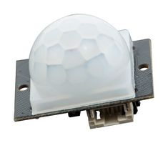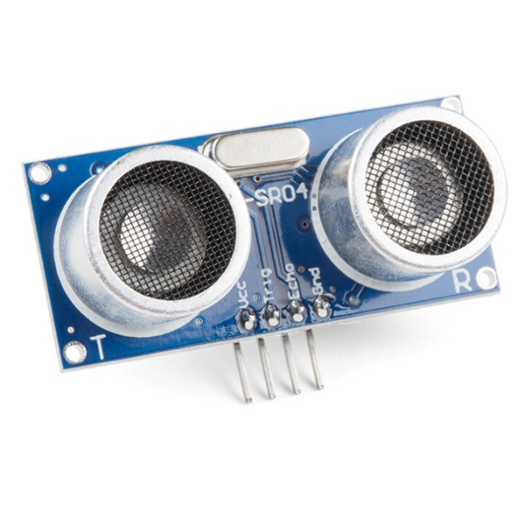

Only a buzzer that produces musical notes.

Ultrasonic Sensor is a sensor that can measure **distance**. It emits an **ultrasound**at **40 000 Hz (40kHz)** which travels through the air and if there is an object or obstacle on its path It will bounce back to the module. Considering the travel time and the speed of the sound you can calculate the distance.

This is a simple to use arduino motion sensor. Power it up and wait 1-2 seconds for the sensor to get a snapshot of the still room. If anything moves after that period, the 'alarm' pin will go low. This sensor checks for infrared heat in it's detecting angle. Human body, pets and several other things emit energy that the sensor is looking for, it compares with the snapshot and if there is a recent change it triggers.

Next, an image of the wiring is presented on the right side. The only differences from the real configuration is that the LCD module in the picture has other names for the pins (because it is another model) and the motion sensor has only 3 functional pins in reality.

**Software**.

For the display part (showing the eyes), we have implemented one function for each eye movement (emotion): **sleep**, **open_eyes**, **blink**, **annoyed**, **extra_annoyed**, **happy**, **extra_happy**, **suspicious**. The robot’s eyes are not similar to a simple shape (as a circle or a polygon). They are structured using more complex outlines. Therefore, we had to color every single pixel separately, more or less. The code could be a little overwhelming at this part.

The speaker is coded to play notes (or group of notes, in order to express a certain feeling) each time an emotion is triggered and the eyes’ shape changes.

As inputs, we have the infrared sensor and ultrasonic one. Of course, a lot of ifs helped to get the result described in the beggining of the section. Also, the **millis**() function was used to keep the track of time, so the robot gets some feelings only after several seconds. The **random**() function was used to make Mimi blink only from time to time, as it is natural. Finally, none of the specified functions will be called when the motion sensor does not get any movement (nobody is in the room). All that time, Mimi will just sleep.

After the hardware part was set and software part was uploaded and tested, we crafted Mimi’s body from an old **shoe box**. You can observe the final result in the picture.

Testing and validation

There was a lot of work put into this project. We had to test the code and program it again a lot of times. For example, creating the eyes’ shapes from pixel to pixel leaded to a lot of mistaken forms. Then the synchronization of all of the emotions and of the display with the speaker was also a little hard to achieve. Fortunately, we managed to solve all the bugs and the robot finally worked as planned. The only visible part (the eyes) are presented below. The rest of the functionalities are shown in the video presentation of the project.

Conclusion

Bulding this project was really nice. It helped me understand the basics of a technology so much used nowadays, espacially in the development of human-like robots or human’s assitant robots: Artificial Intelligence. Moreover, I have gained a lot of knowledge on how to work with Arduino, both on the hardware and the software part. Overall, I really enjoyed working at this project and I am proud of the result, even if it needs a lot of upgrades.

Future Developments

Obviously, Mimi personal assistent can be improved. There are a lot of features that can be added to it. For example, some motors with wheels could be a nice upgrade, so that it can move around. Also, more input sensors (camera, voice recognition) and output sensors (human voice reproduction) can be implemented. Even the eyes can be made more fluidity and liveliness in motion. Doubtlessly, I will continue working on this project and achieve better results in the future.

Bibliography

* https://fritzing.org/users
* https://ardushop.ro/ro/home/865-modul-lcd-spi-128x160.html?gclid=Cj0KCQiAuP-OBhDqARIsAD4XHpehXNM5zi2xYbWY3tNOUHRcPaiejjJR4AYxjvSv31LFnkK9iXGskW4aAv84EALw_wcB
* https://ardushop.ro/ro/home/865-modul-lcd-spi-128x160.html?gclid=Cj0KCQiAuP-OBhDqARIsAD4XHpehXNM5zi2xYbWY3tNOUHRcPaiejjJR4AYxjvSv31LFnkK9iXGskW4aAv84EALw_wcB
* https://ro.farnell.com/dfrobot/sen0018/digital-infrared-motion-sensor/dp/2946113?gclid=Cj0KCQiAuP-OBhDqARIsAD4XHpdbQMieGzwy91jYroI1qnj38GQBN-WTIRTPwbxvN4QumCMU1dF4sZsaAu15EALw_wcB&mckv=hERY1tBS_dc|pcrid|574334316399|&CMP=KNC-GRO-GEN-SHOPPING-Whoop-7-June-2021&gross_price=true
* https://www.farnell.com/datasheets/2700148.pdf
* https://create.arduino.cc/projecthub/abdularbi17/ultrasonic-sensor-hc-sr04-with-arduino-tutorial-327ff6
* https://www.sparkfun.com/products/15569