**NEFSC *Echosounder Calibration System***

***(EchoCAL)***

**Microcontroller Firmware Installation Manual**



Table of Contents

1.0 Introduction: - 3 -

2.0 Installing Microcontroller Firmware: - 4 -

3.0 Programming the *EchoCAL* Control Box Serial Number: - 7 -

# Introduction:

The *EchoCAL* Control Box (Figure 1) uses a custom-built printed circuit board (PCB) which incorporates a ***Parallax Propeller*** microcontroller (<https://www.parallax.com/product/p8x32a-d40>) to interact with the Canon Downriggers as well as provide wireless communications with the controlling PC. This microcontroller is programmed using the ***Propeller Tool*** Integrated Development Environment (IDE). (<https://www.parallax.com/downloads/propeller-tool-software-windows-spin-assembly>) Each *EchoCAL* Control Box requires a unique serial number to allow the *EchoCAL* Graphical User Interface (GUI) software to reliably interact with each downrigger station. The following instructions will tell the user how to program the microcontroller as well as assign a unique serial number to the box.

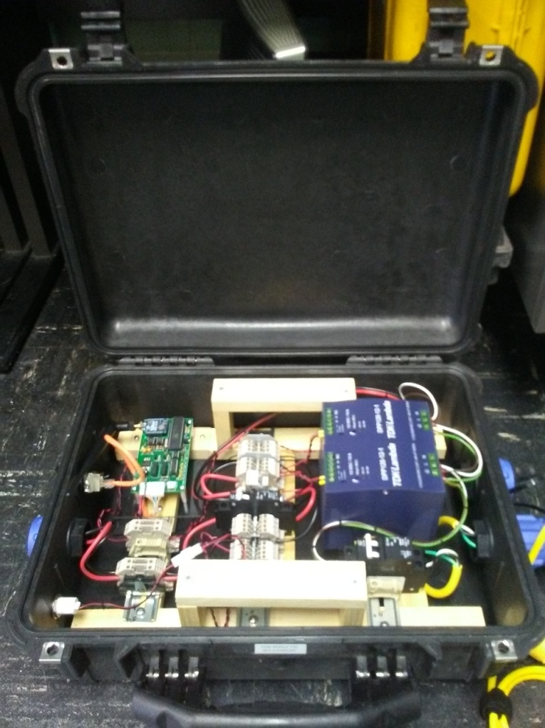

Figure : EchoCAL Control Box Assembly.

# Installing Microcontroller Firmware:

* Prior to firmware installation, open the *EchoCAL* Control Box, and connect the *EchoCAL* Control Box PCB serial header to a Window’s based PC’s serial port using the **ECHOCAL-10550** Programming cable. (See Figure 2.)

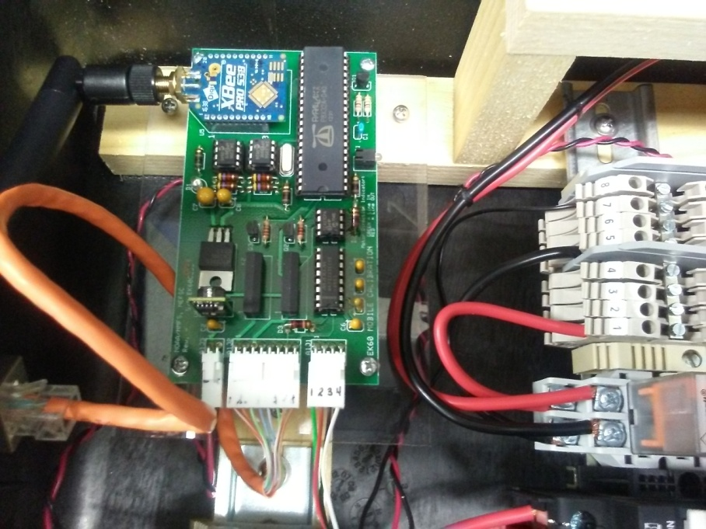

Figure : PCB Serial Header Location.

* Connect the **ECHOCAL-10500** AC Power cable to the control box, and plug into a standard AC outlet. Verify that the Red LED light illuminates on the PCB. If not, check that the AC circuit breakers inside the control box are in the ON position.

(**Warning:** 115 VAC power is applied to the control box at this time. Use caution when handling components inside the control box.)

* Install the Propeller Tool IDE on the PC as per manufacturer’s instructions. Double click on the Propeller Desktop Icon to launch the software.

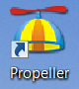

* The main Propeller Tool window will open. Select **File/Open** menu item to access the “Open” dialog window. Browse to the latest folder location of the *EchoCAL* firmware (…/EchoCAL_firmware_v1.2) and open file “EchoCAL.spin”.

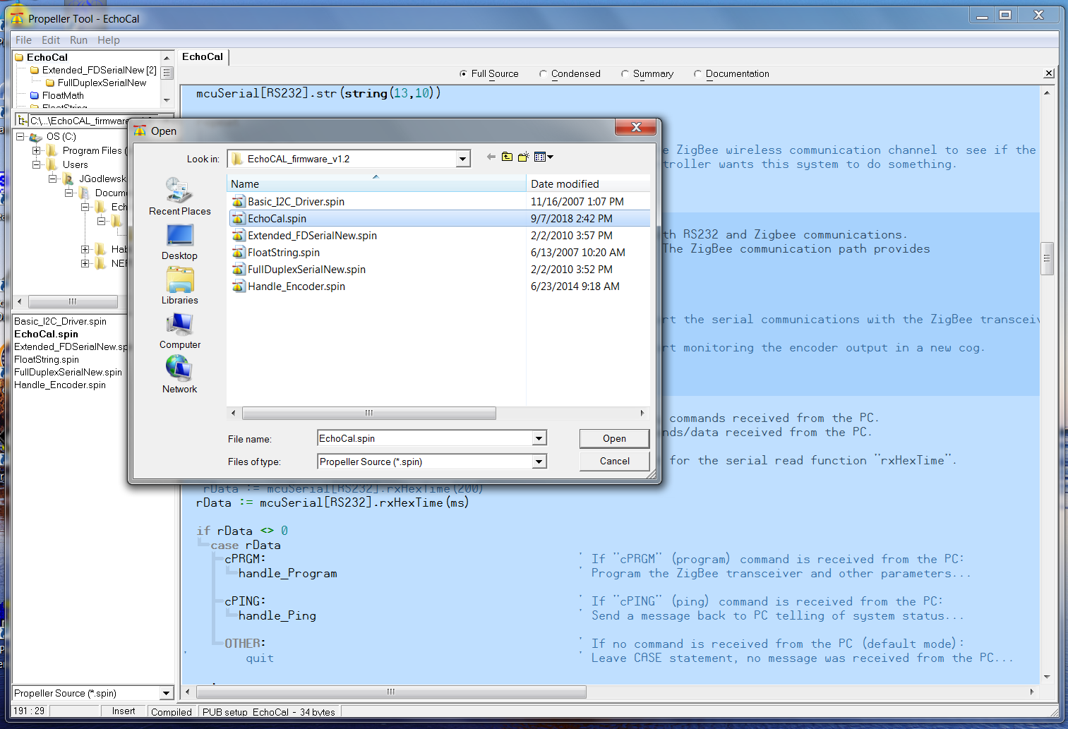

* Select the **Run->Compile Current->Load EEPROM** menu item to install the firmware.

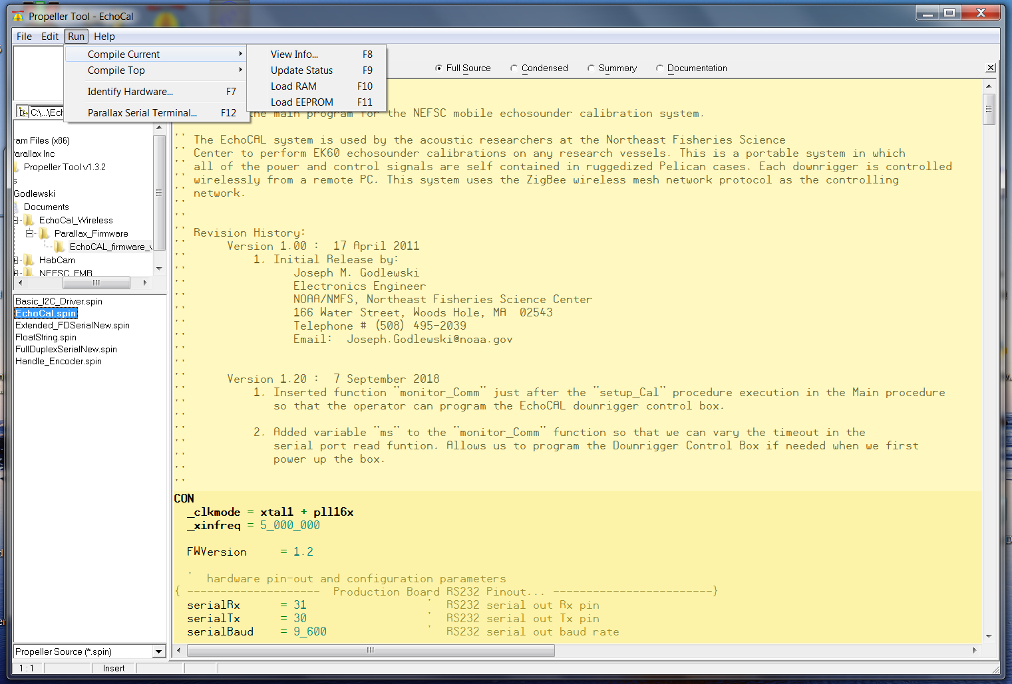

* At this point, the firmware will be loaded in the EEPROM on the PCB. Proceed to the next section to program the *EchoCAL* Control Box serial number.

# Programming the *EchoCAL* Control Box Serial Number:

* If power is applied to the *EchoCAL* Control Box, remove power from the device by either unplugging the power cord, or switch the AC circuit breakers to the OFF position.
* Connect the **EchoCAL-10550** Programming Cable from the serial header on the *EchoCAL* Control Box PCB to a spare COM port on any Window’s based PC. (Note: If no COM ports are available, you can use a USB to Serial adapter cable instead.)
* Launch the **Parallax Serial Terminal** (<https://www.parallax.com/downloads/parallax-serial-terminal>) application on the Window’s PC, and open the COM port that *EchoCAL* is attached to. (Serial port parameters should be set to: Baud Rate = 9600 baud, Data Bits = 8 bits, Parity = None, Stop Bits = 1, Flow Control = None.)
* Apply power to the *EchoCAL* Control box and verify that the LED on the PCB is illuminated. (Note: When power is first applied to the PCB, the firmware will slave to the RS232 serial port to wait for programming commands from the user’s PC. The user will have 10 seconds to put the microcontroller into “Programming” mode. After 10 seconds, the microcontroller will start its regular firmware routines.)
* Type the character “**a**” without quotes, and press the return key. You should see a menu similar to the following:

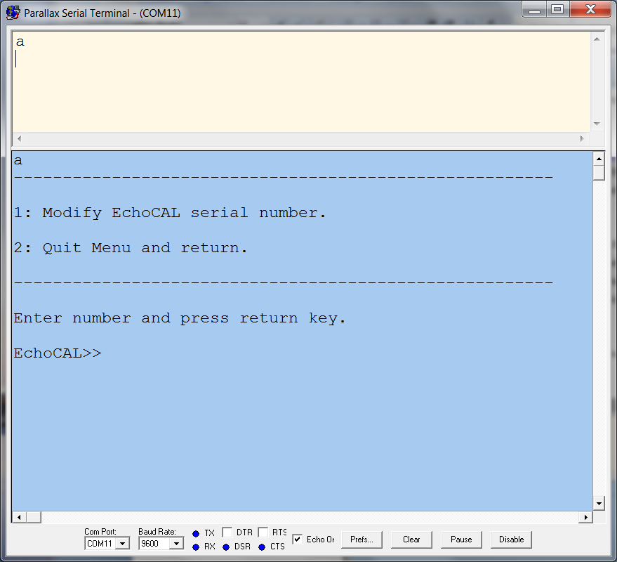

* Select menu item “1” and press the return key. A new menu should be displayed allowing the user to change the *EchoCAL* Control Box serial number.

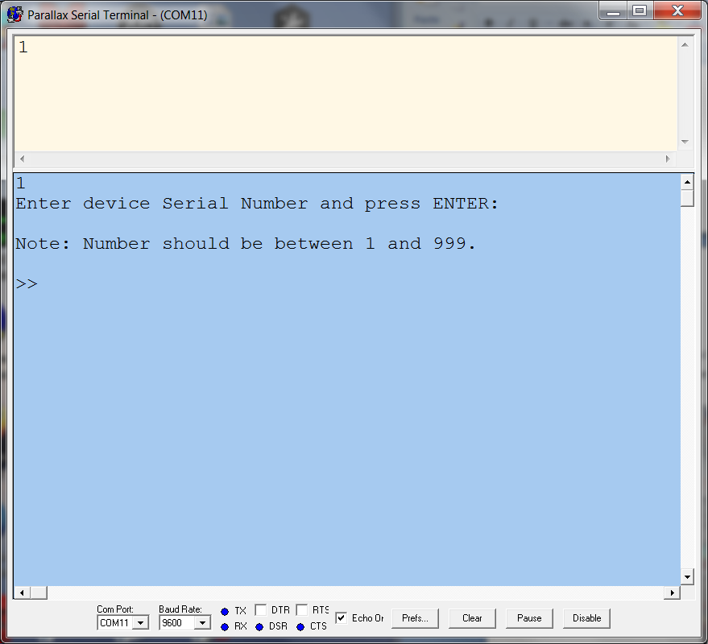

* Enter the serial number for the control box. The integer number should be from 1 to 999. Press return key to continue. (Notice that the serial number will be prefaced with the characters “EK60C”. The *EchoCAL* Graphical User Interface (GUI) uses this serial number representation to determine which downrigger to talk to. This step will also change the Node ID of the ZigBee Pro wireless transceiver to the same serial number as the control box.)

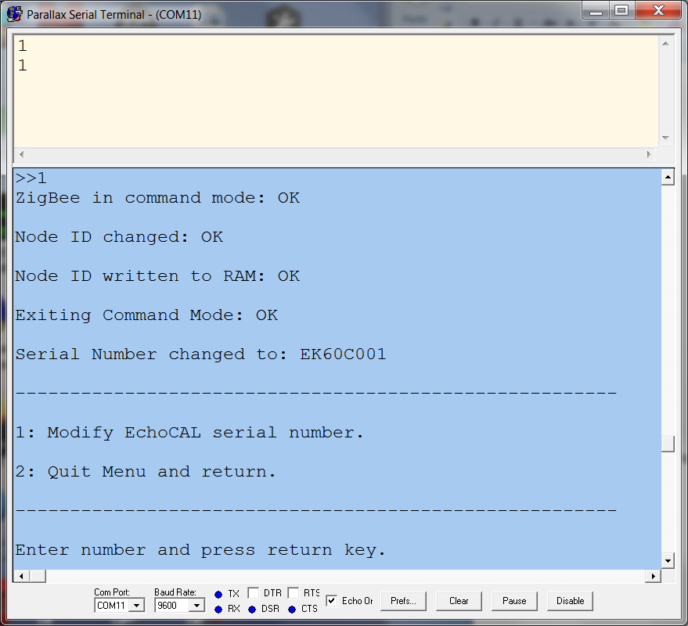

* Once the serial number has been changed, select menu item “2” to exit the Modify Serial Number menu. The control box’s serial number should now be changed. At this point, the *EchoCAL* Control Box should be ready for echosounder calibration activities.