**NEFSC *Echosounder Calibration System***

***(EchoCAL)***

**GUI Software Installation Manual**



Table of Contents

1.0 Introduction: - 3 -

2.0 Installing *EchoCAL* Graphical User Interface (GUI) from binaries: - 4 -

3.0 Installing *EchoCAL* Graphical User Interface (GUI) from source code: - 7 -

4.0 Creating *EchoCAL* executable from *EchoCAL* Graphical User Interface (GUI) source code: - 13 -

# Introduction:

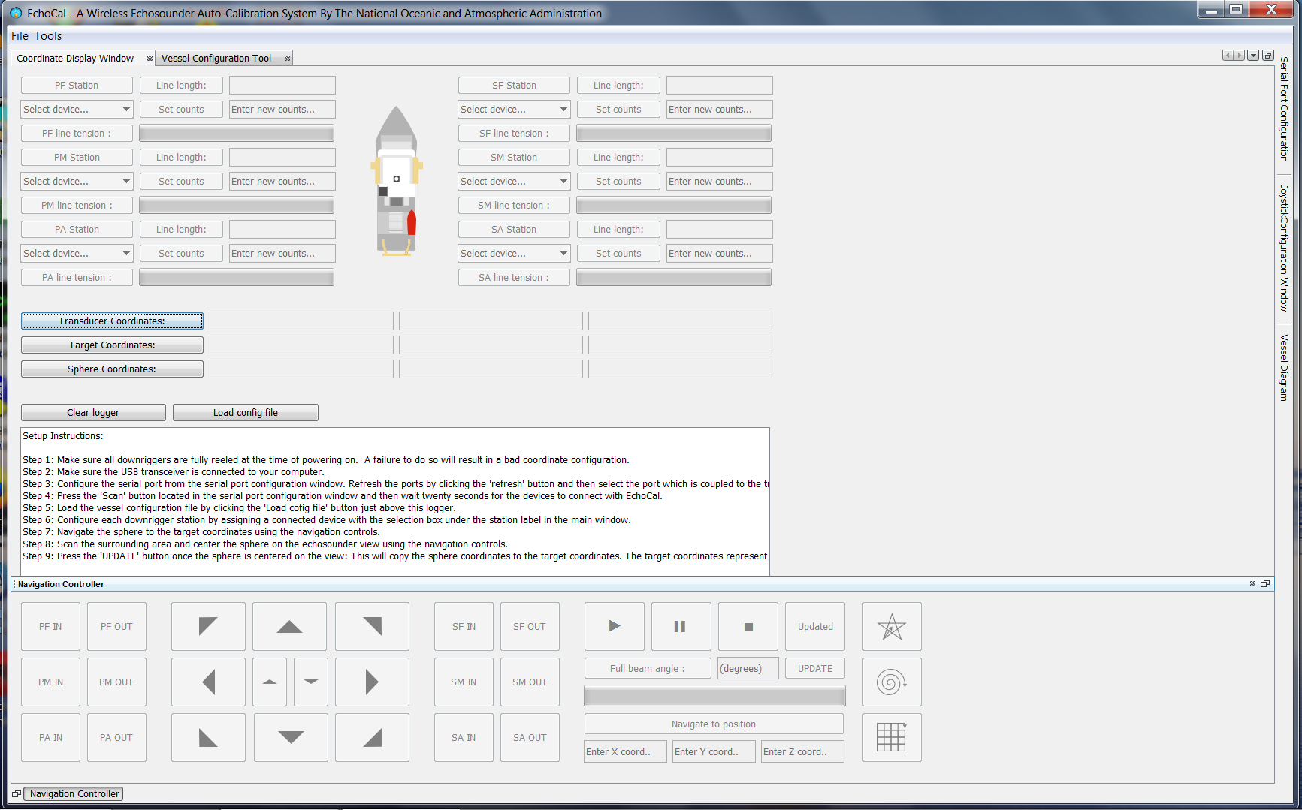

Figure 1. *EchoCAL* Graphical User Interface (GUI)

The *EchoCAL* Graphical User Interface (GUI) provides the software interface which controls the system of powered downriggers for echosounder calibrations. This GUI can be installed on any 64-bit Linux or Windows based PCs in three different ways. The first method is by downloading the executable binary files that are installed in the “**bin**” folder on the *EchoCAL* GitHub site.  
 (<https://github.com/jmgodlewski/EchoCAL>)  
See **Section 2** of this manual on how to install *EchoCAL* from binaries.

The second method is to download all of the *EchoCAL* GUI JAVA project files and open them in the [Netbeans Integrated Development Environment (IDE)](https://netbeans.org/). These project files are located in the “**EchoCAL_GUI_Source/EchoCal_Ver1.2**” folder on the *EchoCAL* GitHub site. See **Section 3** of this manual on how to load the project files into the Netbeans IDE and run the *EchoCAL* application.

The user can also create the *EchoCAL* executable binaries using the *EchoCAL* GUI project files. This will come in handy if the user needs to fix problems or add features to the code at a later date. See **Section 4** of this manual for instructions on creating a packaged executable distribution of the *EchoCAL* software.

# Installing *EchoCAL* Graphical User Interface (GUI) from binaries:

Installing *EchoCAL* using the binaries developed for this system is the easiest and quickest method of testing the hardware and conducting echosounder calibrations. The *EchoCAL* application contains a copy of the JAVA Runtime Environment (JRE) embedded with the application. The user can run *EchoCAL* on any PC, even if a version of JAVA is not installed on that machine. To install *EchoCAL*, perform the following steps:

1. Download the *EchoCAL* executable files from the *EchoCAL* GitHub web site depending on which operating system that the researcher is using. For example, if a researcher is using a Windows 64-bit Operating System, download the *EchoCAL* files from the “**bin/Win64**” folder on the GitHub site.
   1. Navigate to the *EchoCAL* GitHub site (<https://github.com/jmgodlewski/EchoCAL>) using any web browser, and select the “bin/Win64” folder. (See Figure 2.)

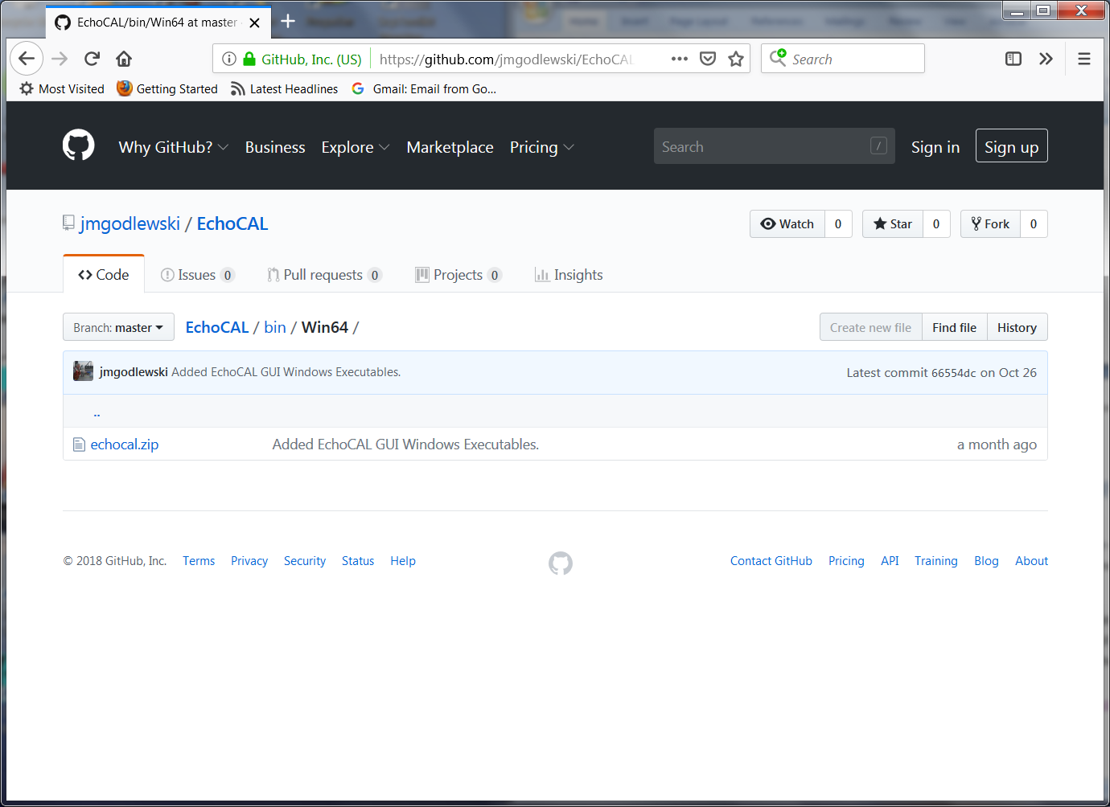

Click on echocal.zip.

Figure 2. EchoCAL GitHub Site: /bin/Win64 Folder.

* 1. Click on the “echocal.zip” file in the web browser’s window. A new page will open which will allow you to download the “echocal.zip” file. Select the **Download** button to download the ZIP file to your PC. (See Figure 3.)   
     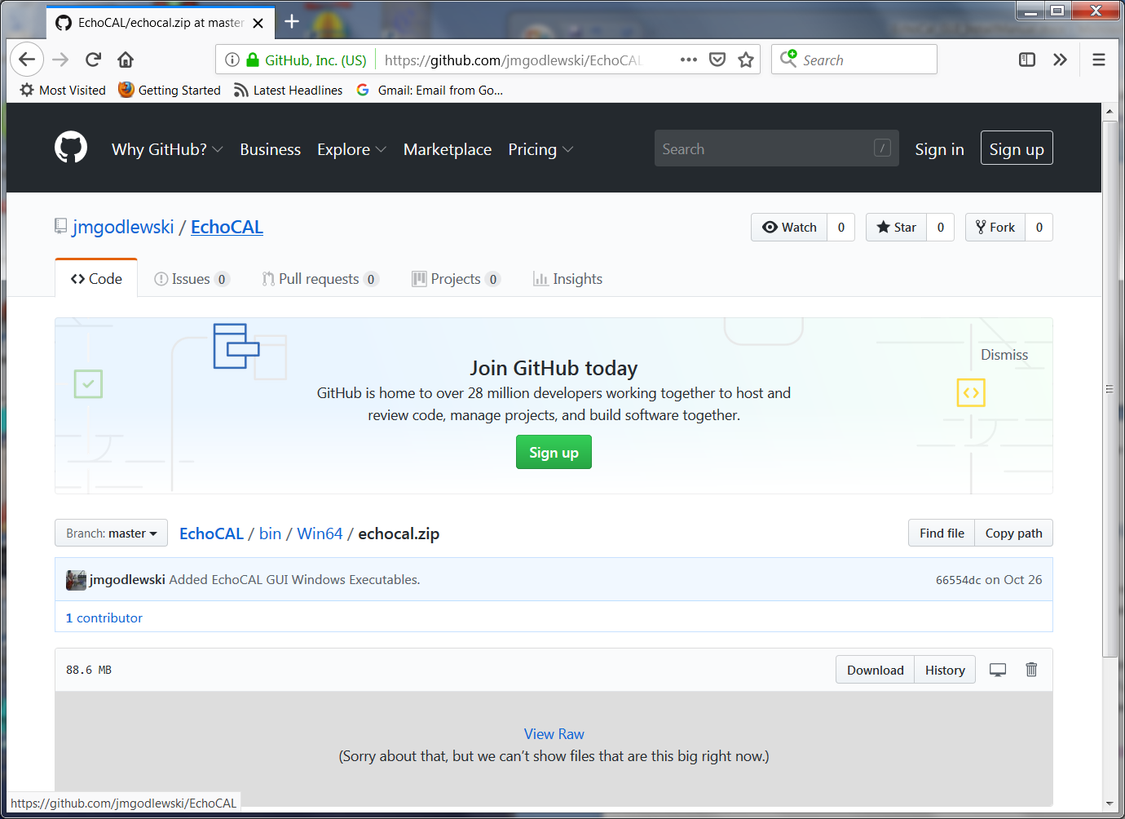

Figure 3. Download "echocal.zip" file from GitHub.

Click Download button.

* 1. When the ZIP file finishes downloading to your PC, navigate to the **Downloads** folder and extract the “echocal.zip” file to a local folder that the user has write privileges to. (See Figure 4 for ZIP file contents.)  
     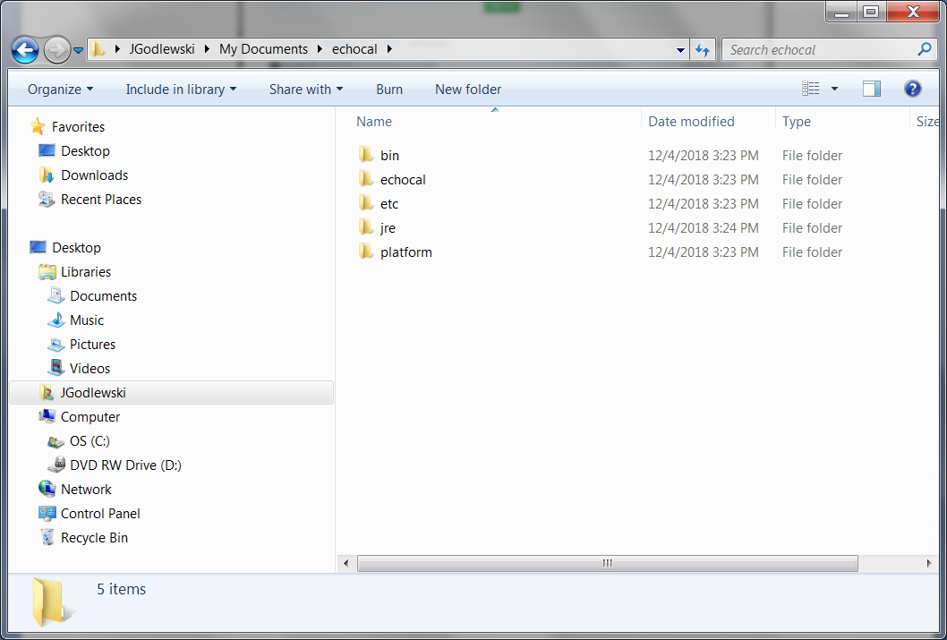

Figure 4. Unzipped EchoCAL folder.

* 1. Navigate to the “**bin**” folder and double-click on the “**echocal64**” executable to launch the *EchoCAL* GUI application. (See Figure 5.) Note: For the Linux version of the software, there will be a shell script called “**echocal**”. Make sure this script is set with proper run permissions on the Linux PC, and double-click the icon to launch the *EchoCAL* GUI.  
     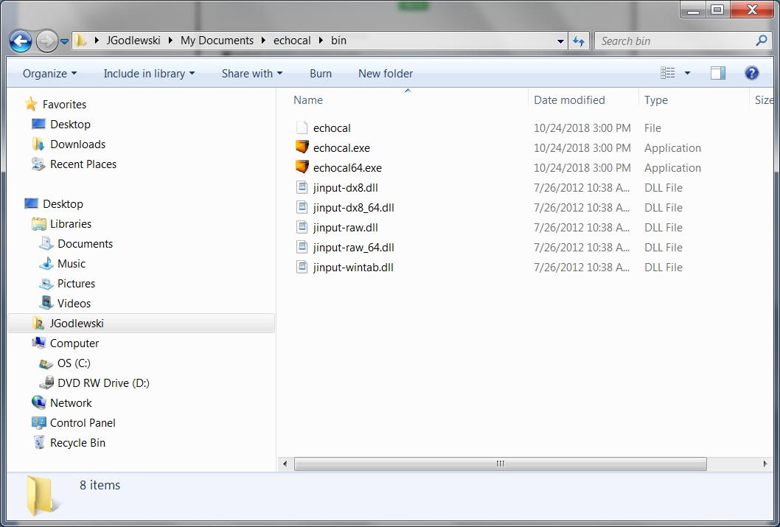

Double-click echocal64.exe to  
launch the EchoCAL GUI app.

Figure 5. EchoCAL Bin folder.

1. See the *EchoCAL* Users Manual for information on how to use the software.

# Installing *EchoCAL* Graphical User Interface (GUI) from source code:

The *EchoCAL* Graphical User Interface (GUI) is a JAVA based application which was developed using the Netbeans IDE 8.1 (<https://netbeans.org>) and JAVA JDK 1.8 (64 bit) from Oracle (<https://www.oracle.com/technetwork/java/javase/downloads/index.html>). Prior to downloading the *EchoCAL* source files, install both the latest Netbeans IDE and the JAVA JDK to your PC according to developers’ instructions. Once the JAVA development environment is installed, perform the following steps to setup the *EchoCAL* project:

1. Download the complete *EchoCAL* project from the *EchoCAL* GitHub site (<https://github.com/jmgodlewski/EchoCAL>) by clicking on the green “Clone or download” button in the main EchoCAL GitHub window. (See Figure 6.)

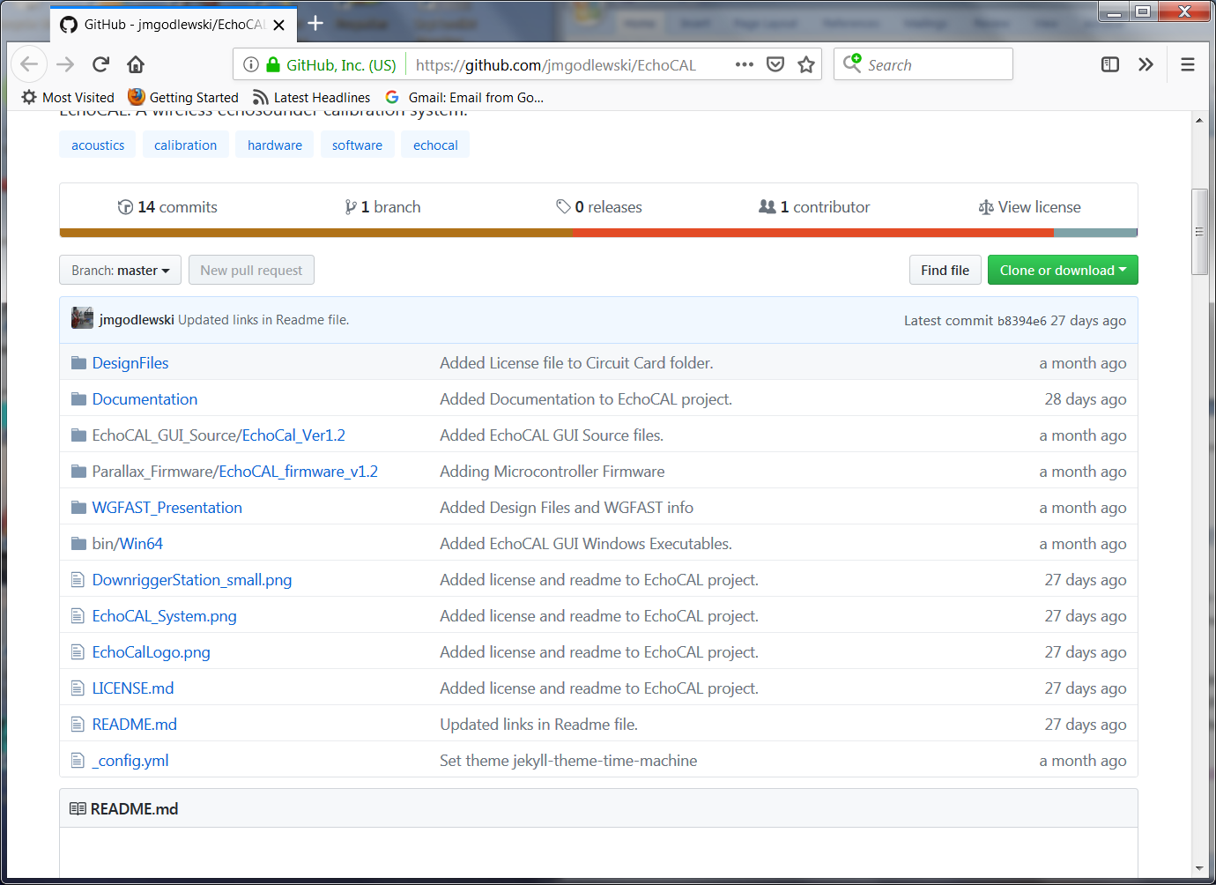

Figure 6. EchoCAL main GitHub project folder.

1. Select the “**Download ZIP**” option to download a ZIP archive of the complete *EchoCAL* project. Extract all files from the “**EchoCAL-master**” ZIP archive to a folder that the user has read/write access to.
2. The *EchoCAL* GUI application uses a third party module called **RXTX,** which provides an interface to the serial ports of a PC. Libraries for **RXTX** must be copied into the local JAVA JDK folder so that the GUI application can make use of the **RXTX** serial port modules. This can be done by performing the following steps:
   1. Navigate to the folder “**EchoCAL-master/EchoCAL_GUI_Source/EchoCAL_Ver1.2/EchoCalCustonFiles**”. (See Figure 7.)  
      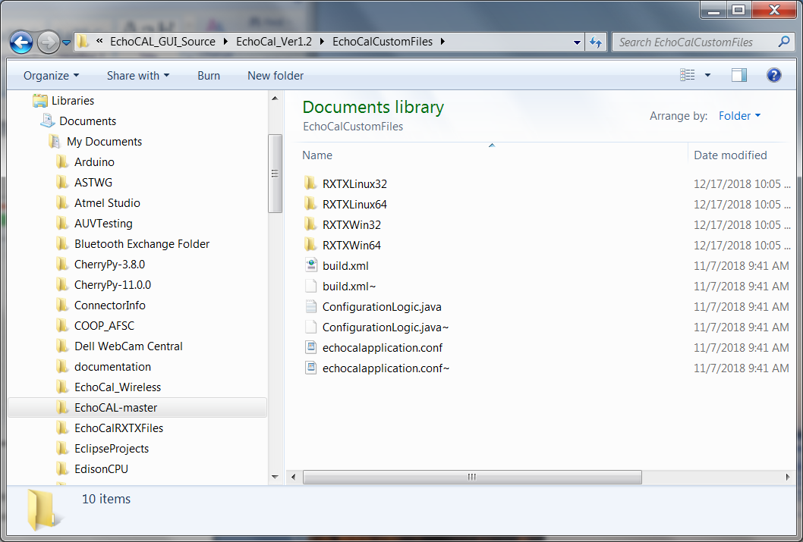

Figure 7. “EchoCalCustomFiles” folder contents.

* 1. This folder contains RXTX modules for the Linux and Windows operating systems, both 32- and 64-bit versions. Select the version that will work for your current operating system. For a Windows 64-bit OS, open the **RXTXWin64** folder to access the RXTX modules for that operating system. (See Figure 8.)  
     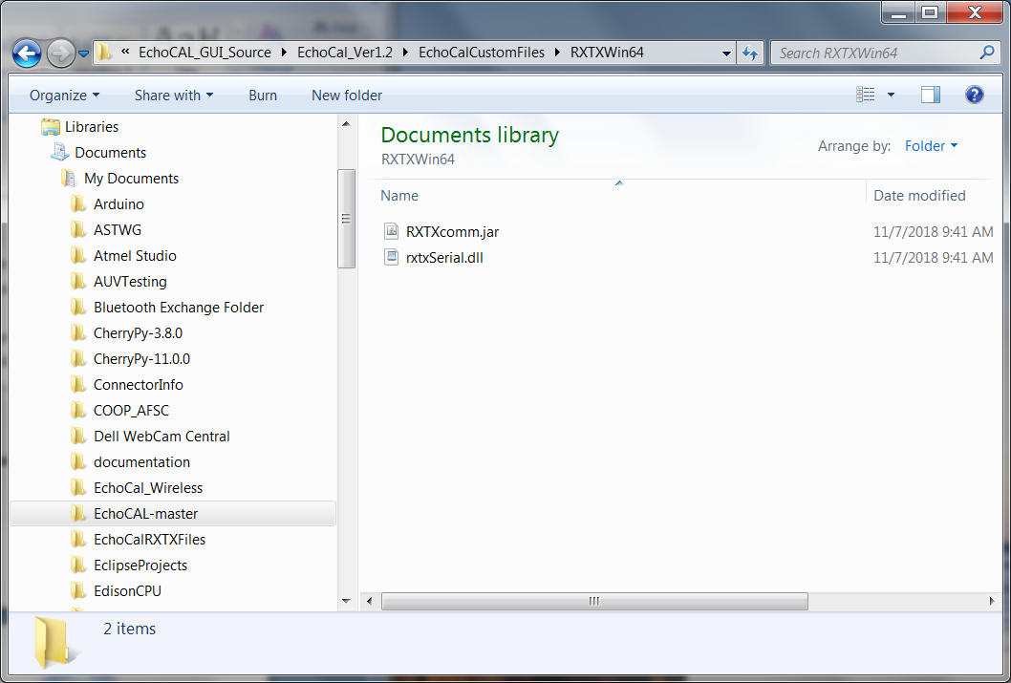

Figure 8. "RXTXWin64" folder contents.

* 1. Copy the “**rxtxSerial.dll**” file to the PCs local JAVA JDK folder. For example, the file should be copied to “**C:/ProgramFiles/Java/jdk1.8.0_101/jre/bin**” for Windows JAVA JDK version 1.8.0.101. (See Figure 9.)  
     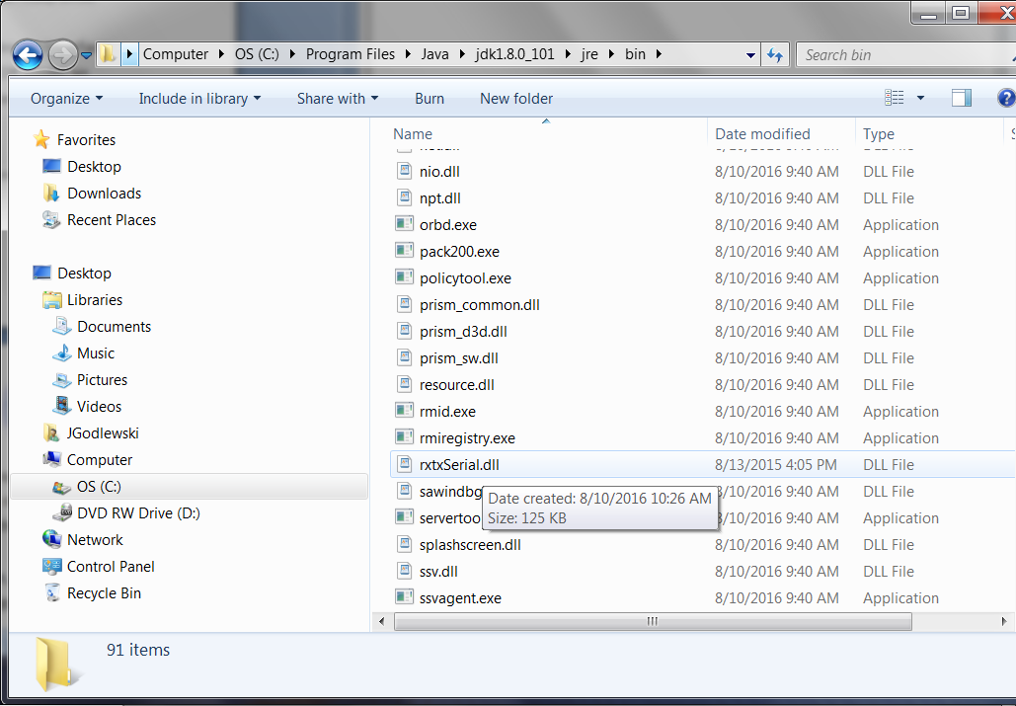

Figure 9. Local JAVA JDK folder for rxtxSerial.dll file.

* 1. Copy the “**RXTXcomm.jar**” file to the “**C:/ProgramFiles/Java/jdk1.8.0_101/jre/lib/ext**” folder. (See Figure 10.)

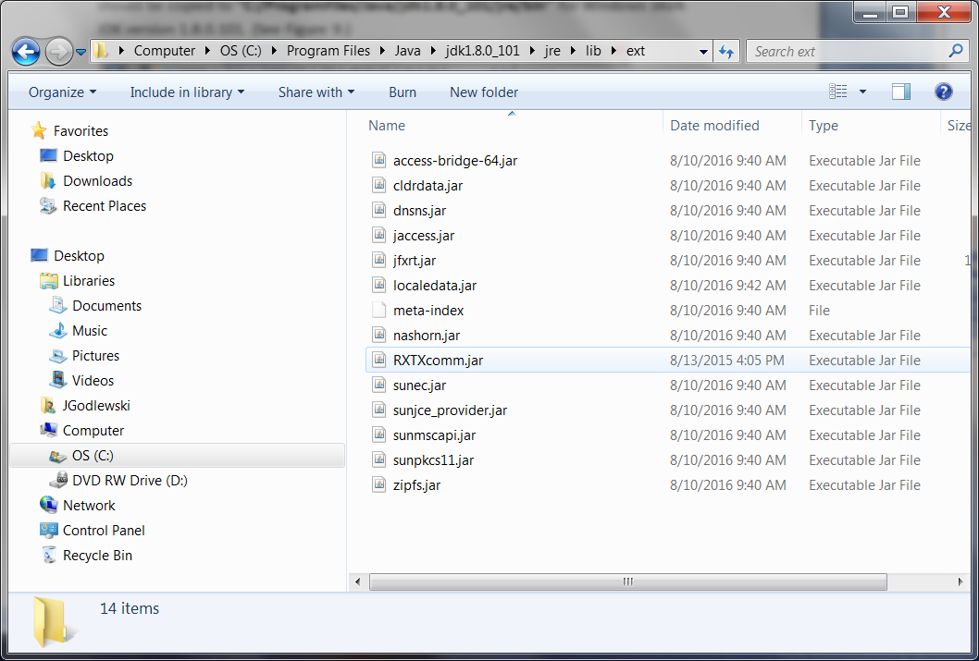

Figure 10. Local JAVA JDK folder for RXTXcomm.jar file.

1. Launch the Netbeans IDE. From the main Netbeans IDE window, select “**File/Open Project**” menu item to open the *EchoCAL* GUI project. (See Figure 11.)

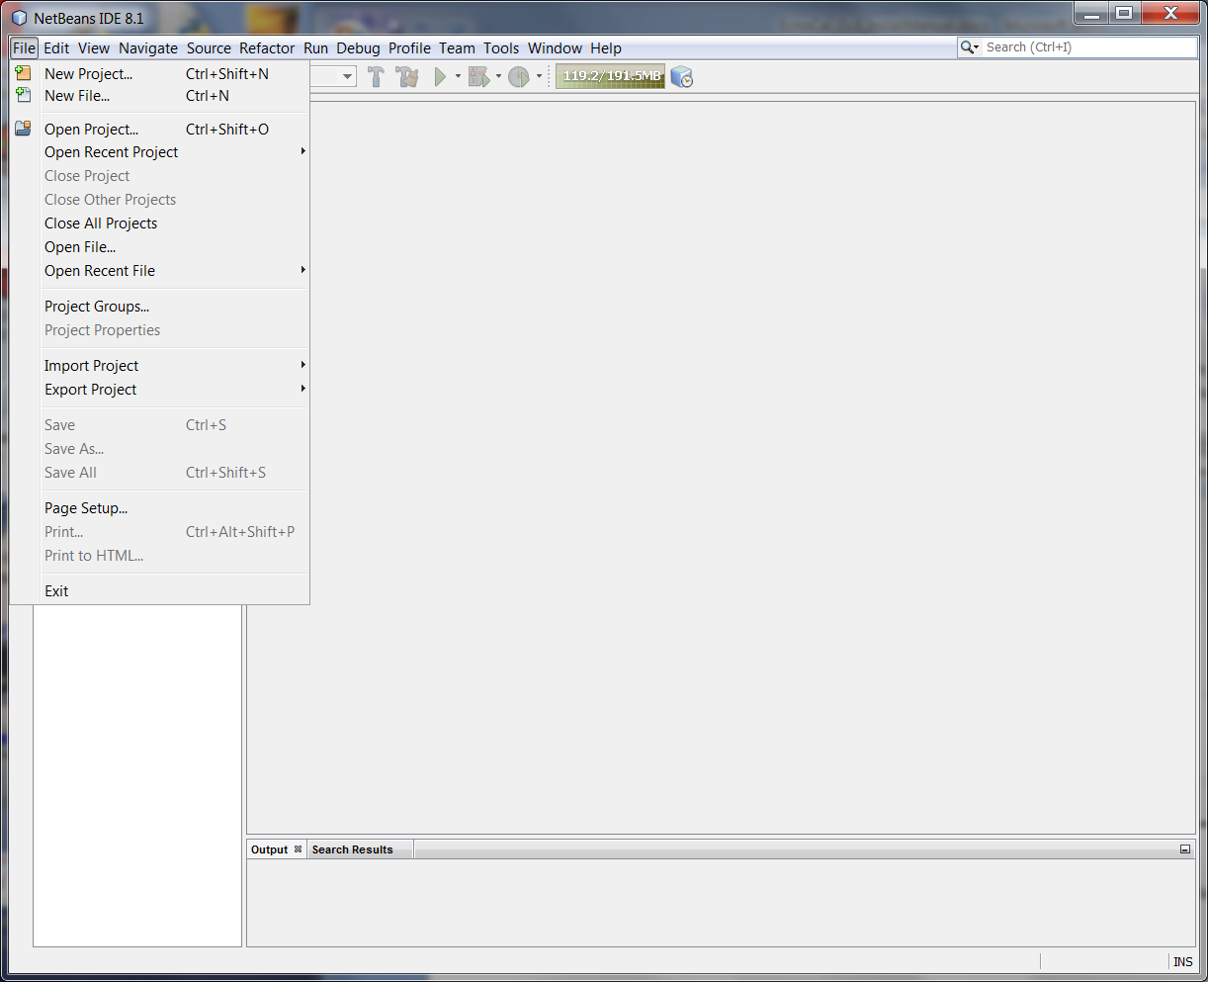

Open Project menu item.

Figure 11. Open Project menu item.

1. The **Open Project** dialog box will open. Browse to the “**EchoCAL-master/EchoCAL_GUI_Source**” folder and select the “**EchoCal_Ver1.2**” project. (See Figure 12.)

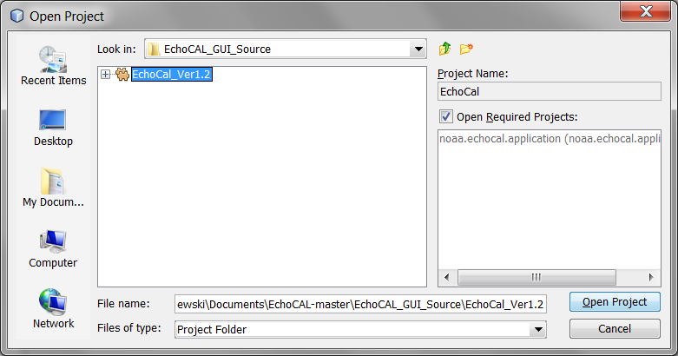

Figure 12. Open Project Dialog Box.

1. Click on the **Open Project** button. The *EchoCAL* GUI project will open in the main Netbeans window. (See Figure 13.)

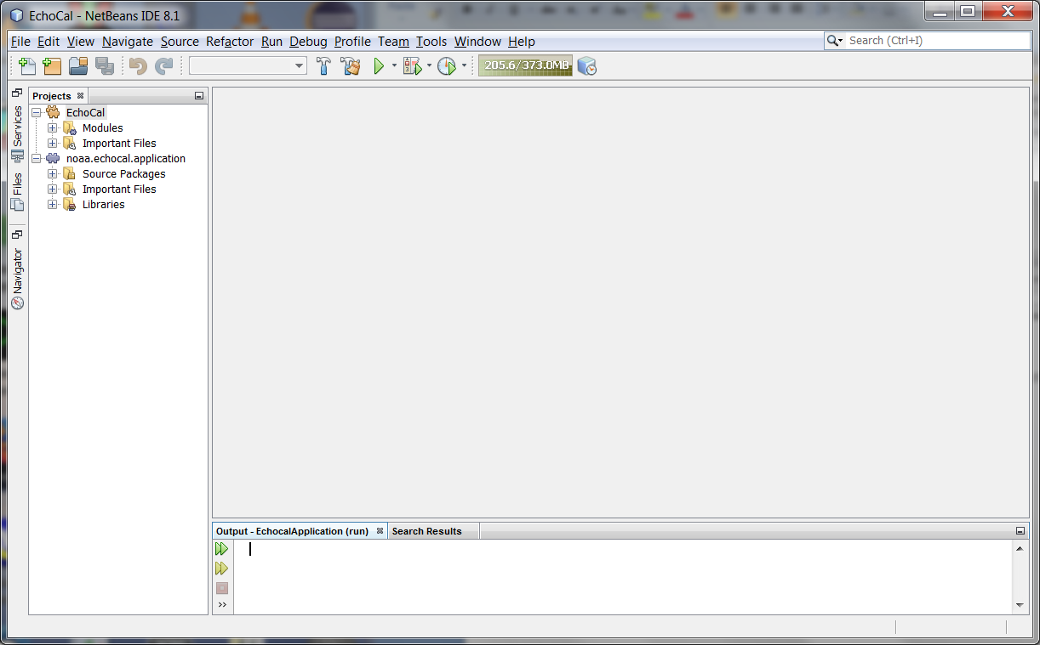

Clean & Build button.

Run Project button.

Figure 13. EchoCAL Project Main Window.

1. Select the “**Clean and Build Project**” button in the toolbar to compile and clean the project. To run the application, select the “**Run Project**” toolbar button. (See Figure 13.) This will launch the *EchoCAL* GUI application.
2. See the *EchoCAL* Users Manual for details on using the *EchoCAL* software.

# Creating *EchoCAL* executable from *EchoCAL* Graphical User Interface (GUI) source code:

The Netbeans Integrated Development Environment (IDE) can create executable packages that the user can run independent of the Netbeans IDE. The *EchoCAL* GUI application should be packaged as a “**ZIP**” distribution so that the software can be ported to other PCs that do not have the Netbeans IDE or JAVA installed. To create the *EchoCAL* GUI application, perform the following steps:

1. Make all software changes and test the application as shown in **Section 3** of this document.
2. In the main Netbeans Project window, right-click on the **EchoCal** module in the **Projects** tab portion of the main window and select **Package as**/**ZIP Distribution**. (See Figure 14.)

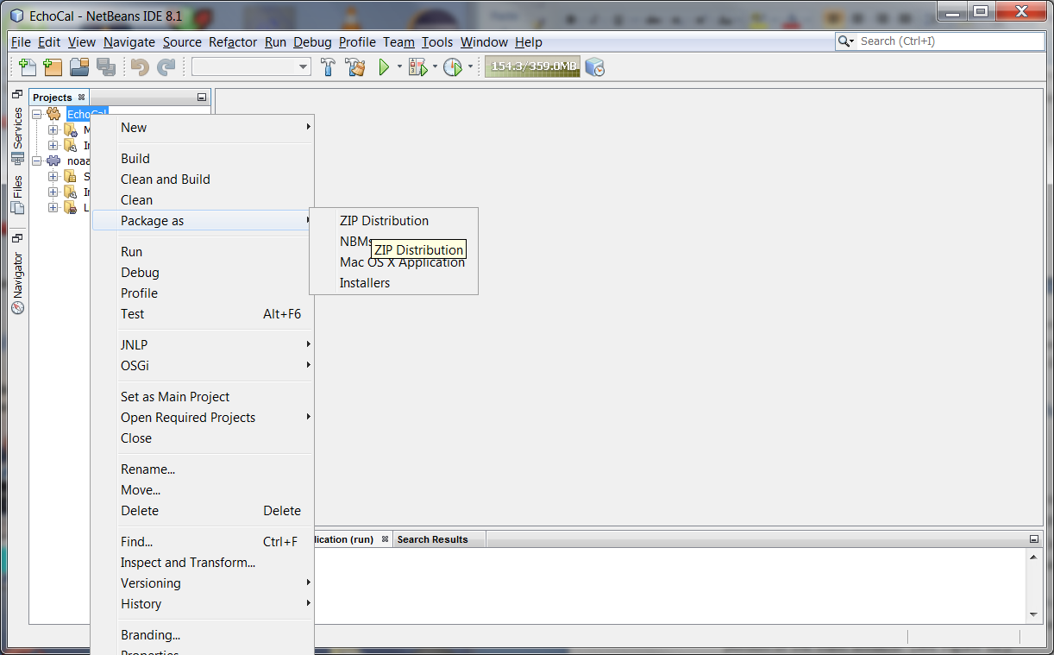

Figure 14. Packaging EchoCAL as a ZIP distribution.

1. The *EchoCAL* GUI application will be packaged as a ZIP file which can then be extracted at a later time. At this point, the GUI application does not have a JAVA Runtime Environment (JRE) packaged with it. It is a good idea to package the JRE with the application so that it can be installed on user PCs without the need to install a separate JAVA JRE on the PC. To add the JRE to the ZIP package, assuming that the developer is using a Windows machine, perform the following steps: (Note: Steps should be similar in a Linux OS as well.)
   1. In Windows Explorer, navigate to the Java Development kit (JDK) that was used to develop the application. In this example, navigate to the “**C:/ProgramFiles/Java/jdk1.8.0_101/**” (See Figure 15.)

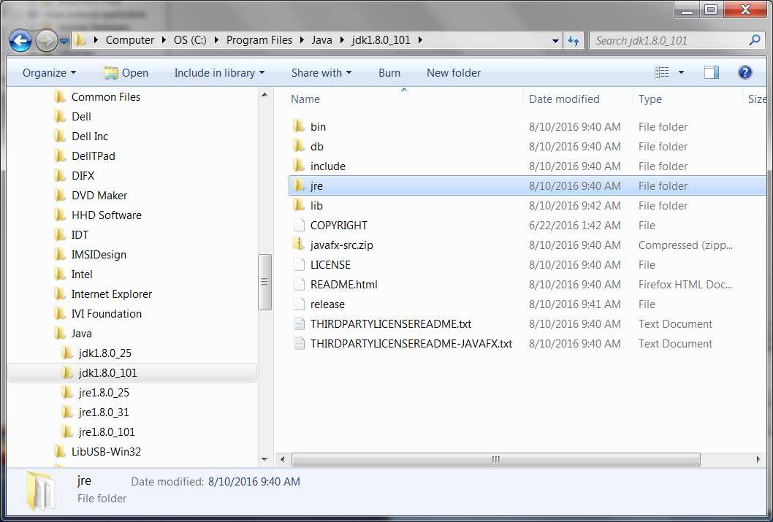

Figure 15. Java Development Kit (JDK) Folder.

* 1. Right-Click on the “**jre**” folder and select “**Copy**”.
  2. Navigate back to the “**EchoCAL-master/EchoCAL_GUI_Source/EchoCAL_Ver1.2/**” project folder. When Netbeans created the ZIP distribution of the *EchoCAL* GUI, it created a new “**dist**” folder in the main project folder. (See Figure 16.) This folder contains the “**echocal.zip**” application file.

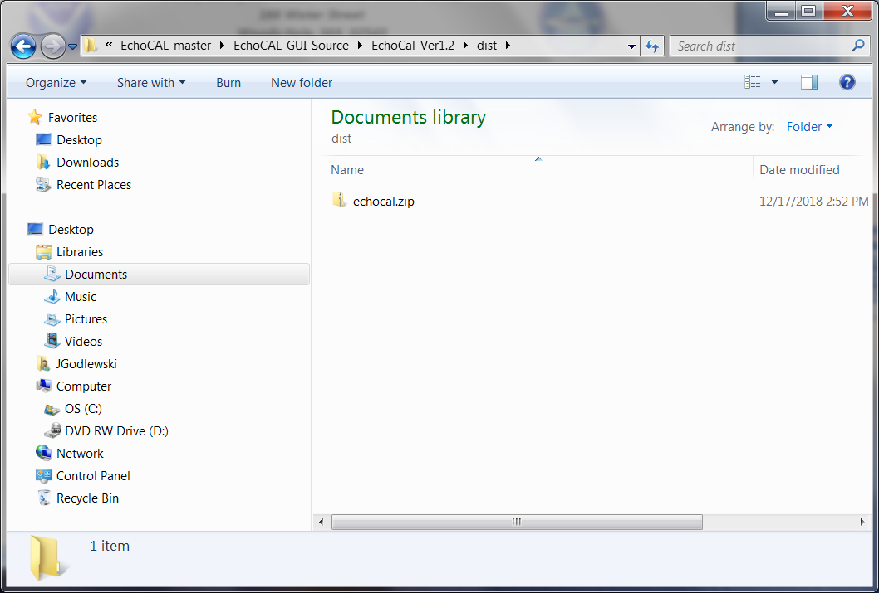

Figure 16. ZIP Distribution Folder for EchoCAL.

* 1. In Windows Explorer, double-click on the “**echocal.zip**” file to open the ZIP file in an Explorer window. Double-Click on the “**echocal**” folder to open the application folder. (See Figure 17.)

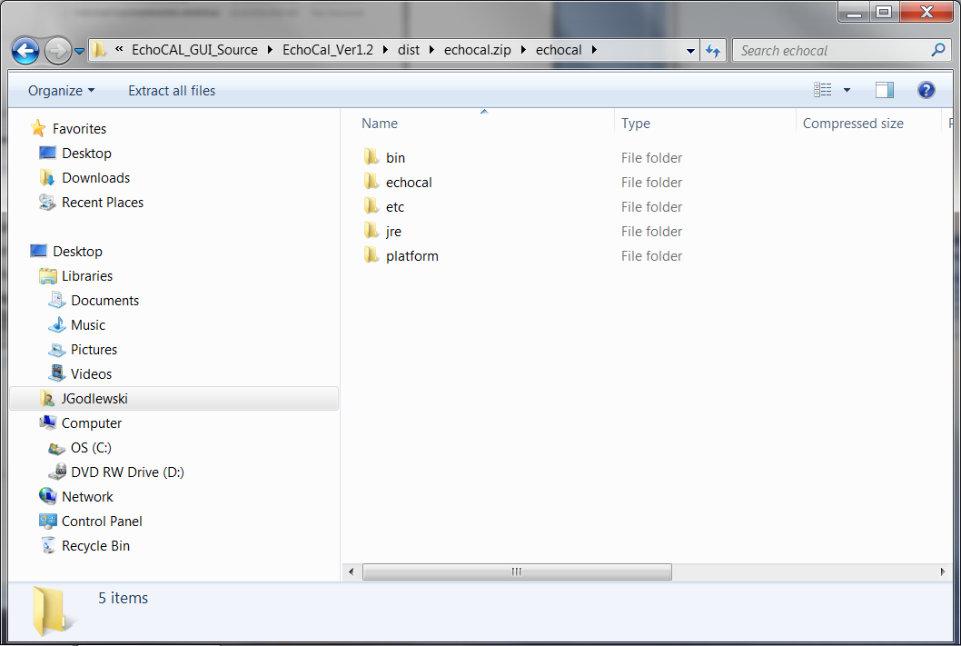

Figure 17. New JRE folder inside "echocal.zip" file.

* 1. Right-Click in this window, and select “**Paste**” from the contextual menu. The JRE folder will be compressed/copied into the “**echocal.zip**” distribution file. (See Figure 17).

1. Now that the JAVA Runtime Environment has been copied into the *EchoCAL* GUI distribution package, we now need to copy the Dynamic Link Libraries (DLLs) for the USB Joystick functionality. Navigate to the “**EchoCAL-master/EchoCAL_GUI_Source/EchoCAL_Ver1.2/jinput**” folder. Select the following DLLs: **jinput-dx8.dll**; **jinput-dx8_64.dll**; **jinput-raw.dll**; **jinput-raw_64.dll**; and **jinput-wintab.dll**. Right-Click on the files, and select “**Copy**”. (See Figure 18.) (Note: If the ZIP package was developed in Linux, copy the files **libjinput-linux.so** and **libjinput-linux64.so**.)

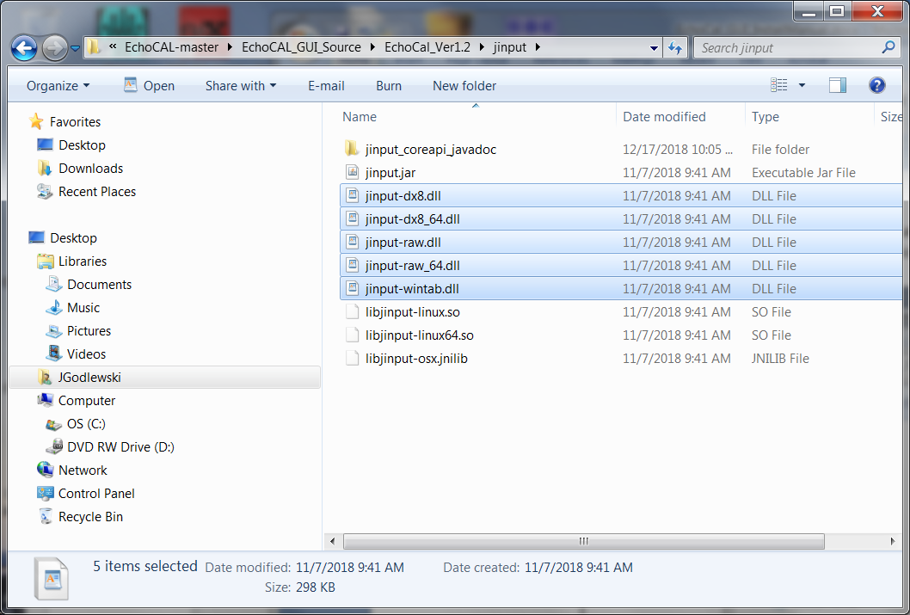

Figure 18. JInput Dynamic Link Libraries.

1. Next, navigate to the “**EchoCAL-master/EchoCAL_GUI_Source/EchoCAL_Ver1.2/dist/echocal.zip/echocal/bin**” folder. Right-click in the folder and select “**Paste**”. This will add the libraries to the **EchoCAL** executable folder for use by the application. (See Figure 19.)

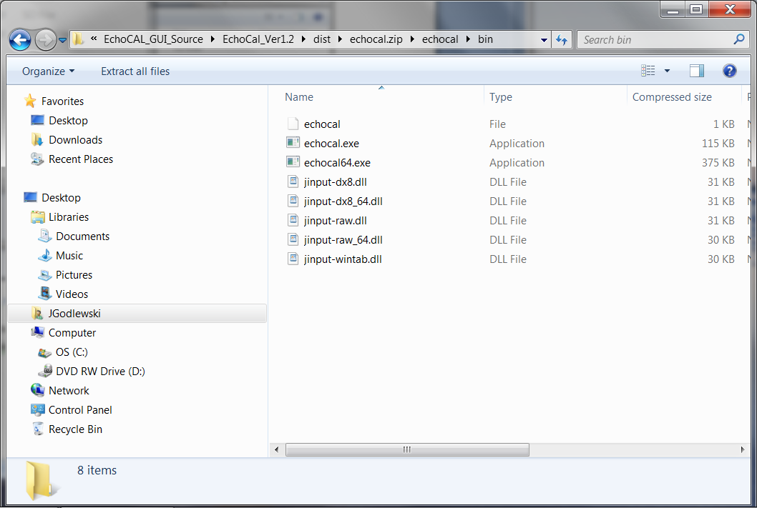

Figure . DLLs copied to ZIP distribution folder.

1. At this point, the *EchoCAL* ZIP distribution package is ready for deployment.