Mtg Date: 05/21/2020

**Input from Team**

→ Meeting topics:

Progress based on different groups (API, Front End, DB, PM)

Expected completion dates and timetable for completing subsections

→ Meeting time:

30 min?

→ Requirements:

Fields: first name, last name, email, phone number and date created

Ability to Create, Read, Update, Delete

Ability to search first and last name

Confirmation of deleting an item

**Status**

**→** Front End:

Gaspar-

Search (Update and Delete) button and page, Create Contact button and page

Completed skeleton for creating contact. Waiting on Team agreement to fully develop the design (CSS). Then get with DB team to figure out how to pull the list of stored contacts.

Suggestions from team on design and colors? Ideas was utilizing something similar to <http://mamba-contacts.herokuapp.com/contacts/5ec6b118e7f70d0017ca550d> without a home button. Search would pull the info as read only and have a button for deleting/editing, save and cancel.

Daniel-

Login, Signup and forgot password

→ API

Mirette- The following API endpoints are finished,

* Login.php: test the ability for a user to input Login and password

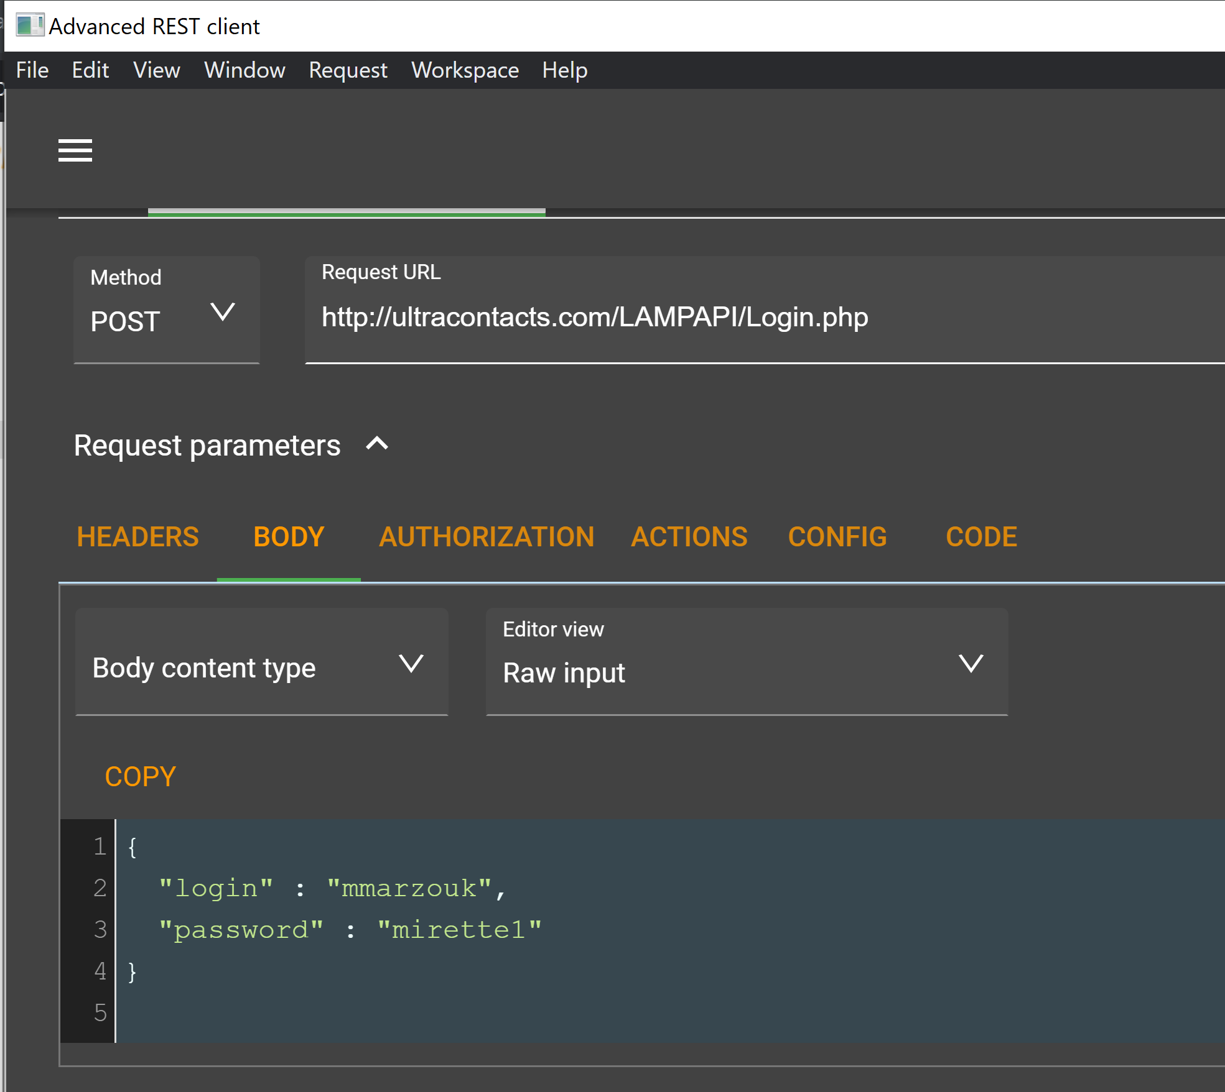

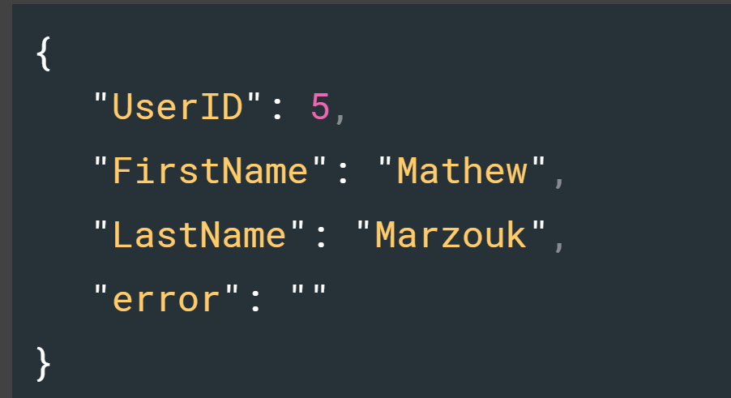-->output from the test

* Signup.php: test the ability for a user to signup

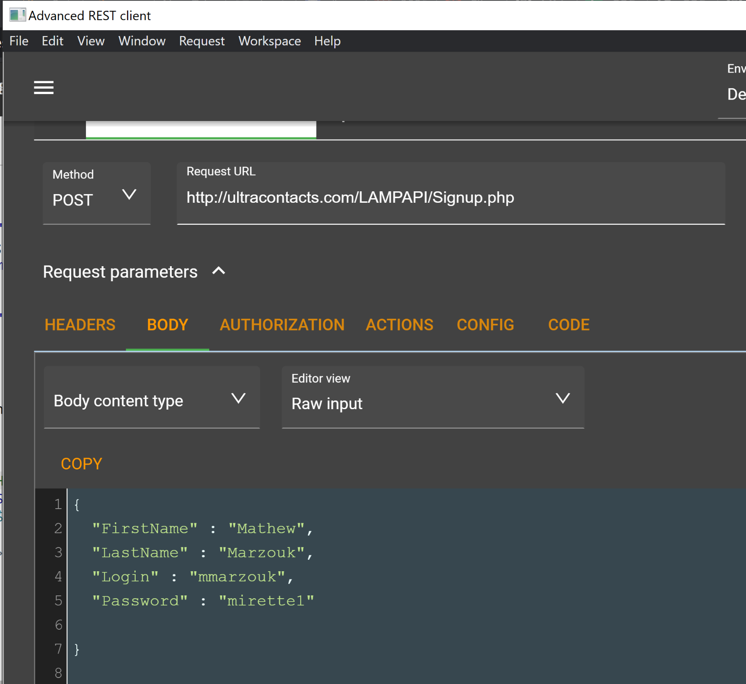

* CreateContacts.php: test the ability for a user to create a new contact in user’s contact table

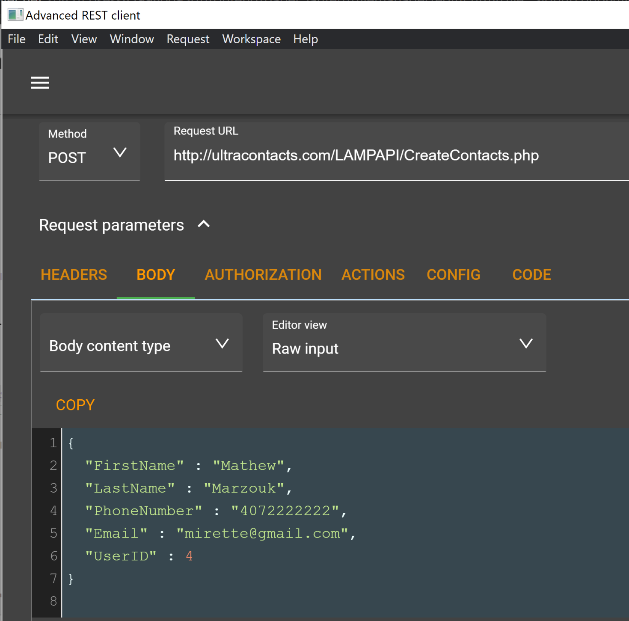

* DeleteContatcts.php: test the ability for a user to delete a contact from user’s contact table, using ContatctID

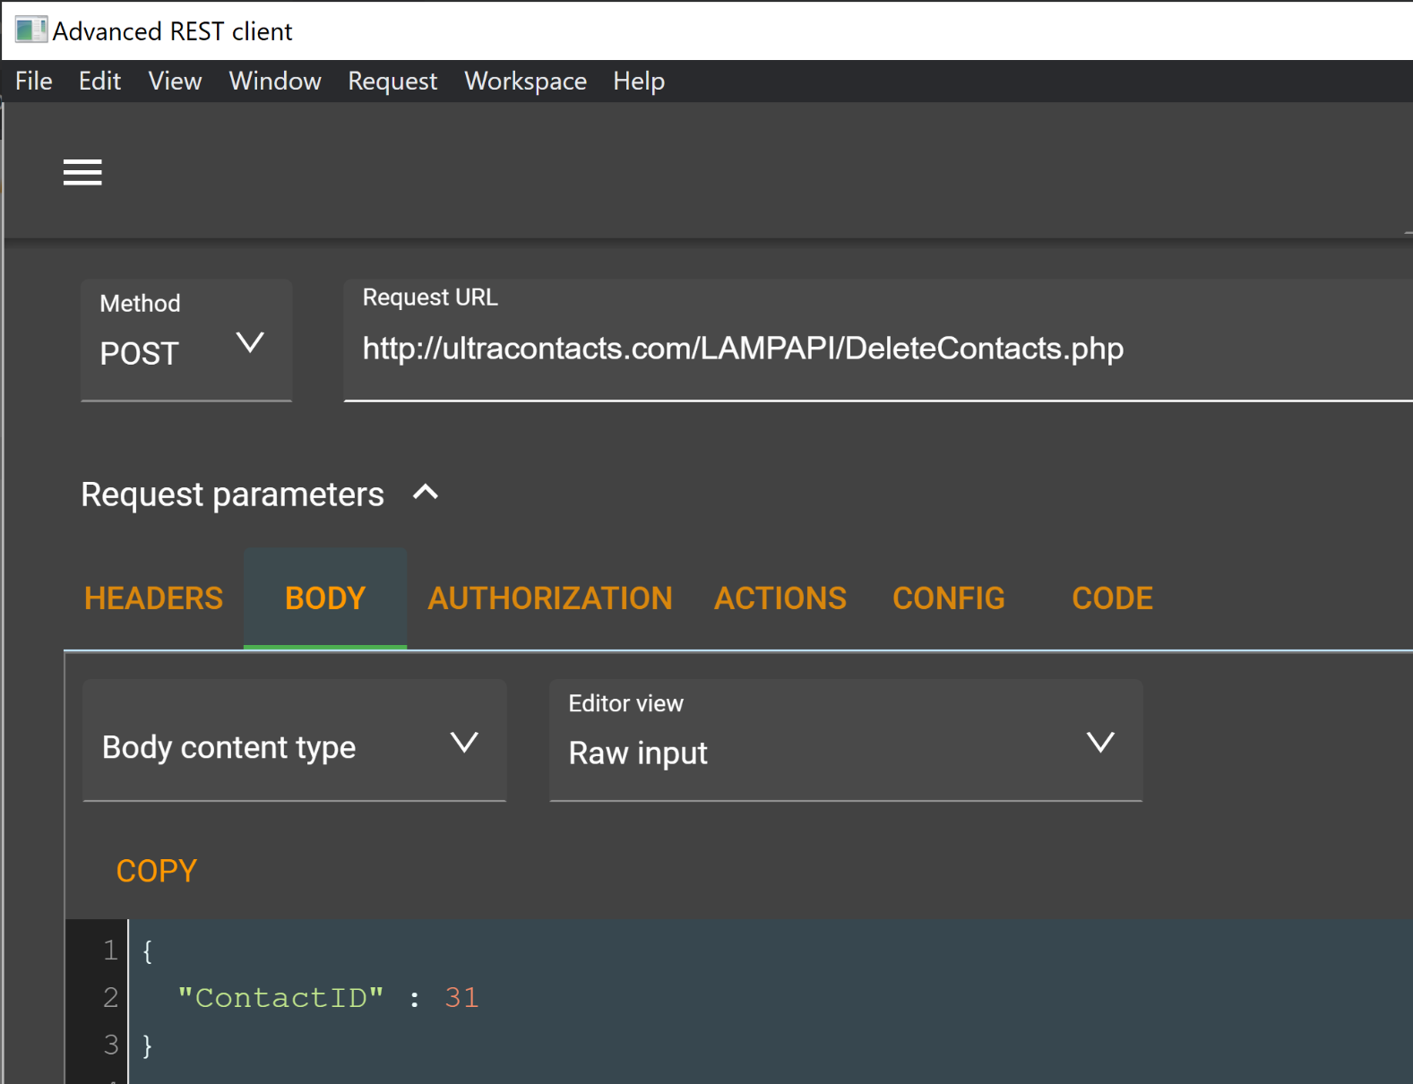

Jack-

→ DB

David-

→ PM

Cade-